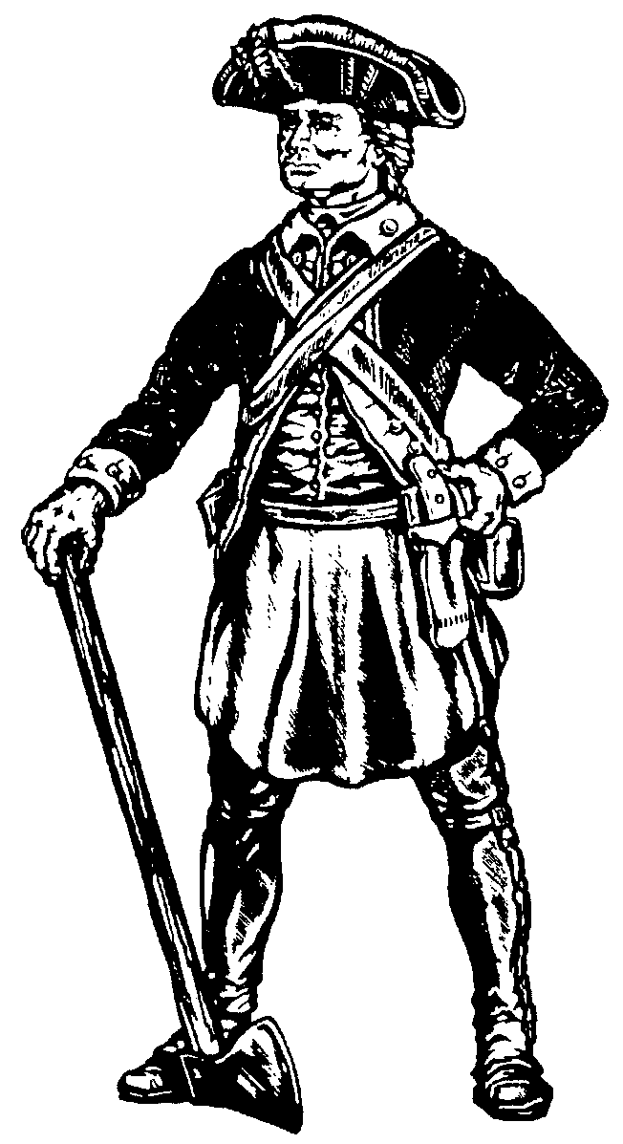
The Army Engineer Association
PO Box 634 Fort Leonard Wood, MO 65473
Phone: 573-329-6678 email: aeaflw@webound.com www.armyengineer.com
9 December 2015

To Whom It May Concern

SUBJECT: Wear of the de Fleury Medal

1. Specific guidance for the wear of the de Fleury Medal with the Army uniform is governed by AR 670-1, dated 10 April 2015, Wear and Appearance of Army Uniforms and Insignia.

2. The de Fleury medal may be worn at any official Army, Service, or Department of Defense formal event or occasion that will not detract from the dignity of the award, or other specific event or occasion approved by the United States Army Engineer School Commandant.

3. The Soldier Policy Branch (responsible for AR 670-1) of the Office of the Deputy Chief of Staff for Personnel, (703) 697-6912, states that is the only guidance to be forthcoming regarding the de Fleury Medal wear. They have determined that medals such as the de Fleury, St Joan, and St Barbara are considered to be a badge.

4. Army Regulation 670-1 defines a badge as an award to an individual for identification purposes or for attaining a special skill or proficiency.

5. The proper wear of de Fleury Medal is described as indicated below:

Army Blue Mess or Army White Mess Uniform: the Medal will be worn with the ribbon around the neck, outside the shirt collar and inside the coat collar. The medal should hang at the full length of the ribbon.

Army Service Uniform and white Mess Uniform: The medal will be worn with the ribbon around the neck, outside the shirt collar and inside the coat collar. The medal will hang over the four-in –hand necktie near the collar and above the top button of the coat or just under the bow tie or neck tab near the collar and above the top button of the coat. Proper positioning may necessitate pinning the ribbon together approximately three inches from the ribbon ends.

Civilian Attire: Men will wear the Medal around their neck with the ribbon over the shirt collar and inside the coat collar. Whether it is worn with a bow tie or necktie, the medal should hang at the full length of the ribbon. When the necktie is worn, the medal will hang over the tie.

Women should wear the Medal around their neck, outside the shirt collar and inside the coat collar with the medal hanging the full length of the ribbon.

General Information: The medal is worn around the neck with the helmeted soldier facing out and in view.

ESSAYONS!

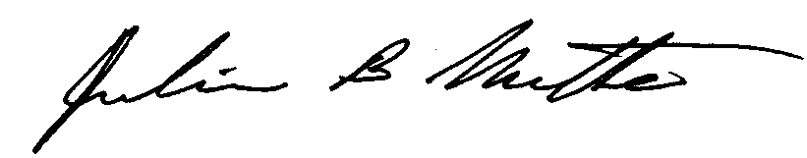

Julius B. Nutter

CSM, US Army Retired

Director, Regimental Operations

