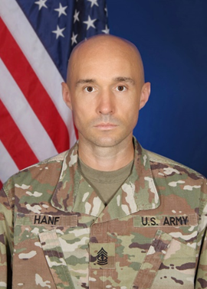
First Sergeant Kelly D. Hanf entered military service in the United States Army as a Technical Engineer Specialist in 2006. He earned an Associate of Arts in Liberal Arts, and completed his Bachelor of Science in Liberal Arts degree in 2020.

In 2006, he attended Basic Combat Training and Advance Individual Training (AIT) at Fort Leonard Wood, Missouri. Upon graduation from AIT, he was assigned to the 555th Engineer Brigade. His positions included Technical Engineer Specialist, Enlisted Aide to the Brigade Commander, and Technical Engineer NCO. In 2011 he was assigned as an Operations Sergeant on the 1st Engineer Battalion Staff. In 2014, the Department of the Army selected him to serve as an AIT Platoon Sergeant, where he served for two years in the 554th Engineer Battalion. In April of 2016 he was promoted to Sergeant First Class and shortly after served as the Senior Technical Engineer for the 84th Engineer Battalion Survey and Design. In May of 2018 to June of 2019, 1SG Hanf was selected by the 8th Theatre Sustainment Command’s Commanding General and Command Sergeant Major to serve as the Command Group Operations Sergeant. He has served as the Senior Instructor for the Technical Engineer Skills Division, 169th Engineer Battalions, Operations Sergeant for the 554th Engineer Battalion, First Sergeant for Alpha Company, 31st Engineer Battalion, and First Sergeant for Engineer Senior Leader Course.

1SG Hanf’s military education includes the Basic Leader Course, Advance Leader Course, Senior Leader Course, where he earned the title Distinguished Honor Graduate, and Master Leader Course. He also successfully completed Common Faculty Developmental – Developmental Instructor Course, Joint Engineer Operations Course, Unit Movement Officer Course, Bus Driver Course, Unit Prevention Leader Course, Master Fitness Trainer Course, Master Resiliency Trainer Course, Combat Lifesaver Course, Physical Readiness Training Leader Course, Retention Training Course, and Combatives Level 1.

His awards and decorations include the Bronze Star Medal, the Meritorious Service Medal, the Army Commendation Medal (3rd Award), the Army Achievement Medal (2nd Award), the Meritorious Unit Citation (2nd Award), the Army Good Conduct Medal (4th Award), National Defense Service Medal, the Iraqi Campaign Medal, the Global War on Terrorism Medal, the Army Service Ribbon, and the Overseas Service Ribbon.

