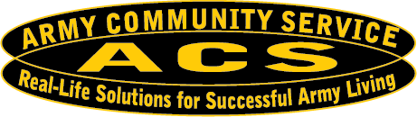





2024
U.S. ARMY
GARRISON ALASKA
RESOURCE GUIDE
FORT WAINWRIGHT AND FORT GREELY, ALASKA

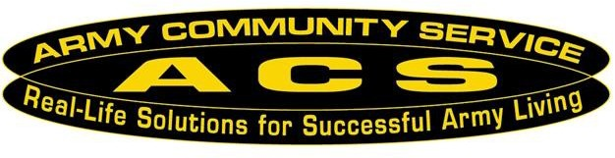
ACS Vision
ACS will foster a sustained, resilient and cohesive Total Army Family Community.

ACS Mission
Empower and advocate for the total Army Family to be self-sufficient and resilient through the provision of innovative services.

Fort Wainwright, Alaska ACS Tag Line
Customer First! Mission Always!

This Publication is Provided By:

Army Community Service
Information, Referral and Follow-Up
Bldg. 3401 Santiago Ave
Fort Wainwright, Alaska 99703

Telephone Number: (907) 353-4ACS (4227)

Disclaimer:

Every effort has been made to provide accurate and current information. However, we recommend calling to verify services, location and hours of operation before visiting any agency. Presentation of direct or indirect links to products, services, or vendors does not constitute endorsement by the Department of Defense or Fort Wainwright Army Community Service. We have provided these sites because they contain information that might be of interest to our users. The links are presented for informational purposes only. Users are encouraged to thoroughly investigate and evaluate items of interest prior to entering into contractual obligation

Soldiers and Family Members

Army Community Service (ACS) would like to welcome you to Fort Wainwright, Alaska. We hope that you are as excited about your new assignment as we are to have you here. We at ACS have established a centrally located, responsive service for furnishing information, assistance, guidance, and referral program to members of the military. This guide is designed to assist you in locating information regarding programs and other vital information that is important to your well-being here in Alaska. If you are unable to locate information or resources in the guide, please call us at 907-353-4ACS (4227).

Sincerely,

Army Community Service

QUICK REFERENCE PHONE NUMBERS
FORT WAINWRIGHT

Army Community Service............................................................................
Army Emergency Relief (AER).....................................................................
Army Family Action Plan (AFAP).................................................................
Army Family Team Building (AFTB)...........................................................
Army Volunteer Corps (AVC)......................................................................
Better Opportunities for Single Soldiers (BOSS)........................................
Employment Readiness Program (ERP)....................................................
Exceptional Family Member Program (EFMP)............................................
Family Advocacy Program (FAP)................................................................
Financial Readiness Program (FRP)……....................................................
Information, Referral & Follow-Up (IR&F)...................................................
Lending Closet.............................................................................................
Mobilization and Deployment, Stability and
Support Operations (MDSSO)....................................................................
New Parent Support Program (NPSP).........................................................
Relocation Readiness Program ……..........................................................
Sexual Harassment/Assault Response
& Prevention Program (SHARP) HOTLINE................................................
Soldiers Against Drunk Driving (SADD) .....................................................
Survivor Outreach Services (SOS).............................................................
Victim Advocacy Program 24/7 HOTLINE..................................................

FORT GREELY

Army Community Service....... ...................................................................
Army Family Action Plan (AFAP)................................................................
Army Family Team Building (AFTB)...........................................................
Army Volunteer Corps (AVC)......................................................................
Better Opportunities for Single Soldiers (BOSS)........................................
Employment Readiness Program (ERP)....................................................
Exceptional Family Member Program (EFMP)...........................................
Family Advocacy Program..........................................................................
Financial Readiness Program (FRP)..........................................................
Information, Referral & Follow-Up (IR&F)...................................................
Lending Closet............................................................................................
Mobilization and Deployment.
Readiness Program (MOBDEP).................................................................
New Parent Support Program (NPSP)........................................................
Relocation Readiness Program (RRP).......................................................
Sexual Harassment/Assault Response and Prevention Program
(SHARP) HOTLINE....................................................................................
Survivor Outreach Services (SOS).............................................................
Victim Advocacy Program 24/7 HOTLINE..................................................

907-353-4227
907-353-4369/3459
907-353-4332
907-353-4332
907-353-4337
907-353-4145
907-353-4337
907-353-4335/4460
907-353-4336
907-353-4459
907-353-4227
907-353-7908

907-353-4332
907-353-2101/7519
907-353-7908

907-353-7272
907-353-4145
907-384-0272
907-799-9770

907-873-2479
907-873-2479
907-873-2479
907-873-2479
907-873-4058
907-873-2479
907-353-4335
907-873-2479
907-873-2479
907-873-2479
907-873-2479

907-353-2479
907-353-2101
907-873-2479

907-505-0275
907-353-0272
907-799-9770

TABLE OF CONTENTS

1
14
17
21
22
25
29
30
31
35
38
39
40
43
44
48
49
52
53
54
56
58
59
62
65
68
72

Army Community Service ……………………………………………………………………………
Child & Youth Services ……………………………………………………………………………
Crisis & Emergency Services ………………………………………………………………….
Police, Fire, & Ambulance Services ………………………………………………………..
Healthcare Resources ……………………………………………………………………………
Mental Health & Counseling Services ………………………………………………………..
Religious Support ……………………………………………………………………………………..
Single Soldier Resources ……………………………………………………………………………
Support Services ……………………………………………………………………………………..
Food resources ……………………………………………………………………………………..
Clothing Resources ……………………………………………………………………………………..
Childcare, Licensing & Referral Services …………………………………………………………
Child Development and Education Services ……………………………………………….
Youth Programs ……………………………………………………………………………………..
Services for Special needs ……………………………………………………………………………
Libraries ……………………………………………………………………………………………….
Family & Parenting Services ………………………………………………………………….
Pregnancy Resources ……………………………………………………………………………
Nutrition Resources ……………………………………………………………………………
Finance & Budget information ………………………………………………………..
Housing Information ……………………………………………………………………………
Emergency Housing ……………………………………………………………………………
Legal Resources ……………………………………………………………………………
Life Skills ………………………………………………………………………………………………
Employment Resources ………………………………………………………………….
Substance Abuse Programs ………………………………………………………………….
Miscellaneous Resources ………………………………………………………………….

ARMY COMMUNITY SERVICE
ACS will assist commanders in maintaining readiness of individuals, Families, and communities within America's Army by developing, coordinating, and delivering services, which promote self-reliance, resiliency, and stability during war and peace.

Service Description
The Army Community Service Center services and programs include Army Emergency Relief, Financial Readiness, Family Advocacy, Exceptional Family Member Program, New Parent Support Program, Prevention and Education Resources, Survivor Outreach Services, Information, Referral and Follow-up, Relocation Assistance Program, Mobilization and Deployment Readiness Program, Employment Readiness Program, Army Volunteer Corps, Army Family Team Building, and Army Family Action Plan.

Fort Wainwright Army Community Service Fort Greely Army Community Service
Bldg. 3401|Fort Wainwright, AK Bldg. 661| Fort Greely, AK
(907) 353-4227 (907) 873-2479
Mon-Fri: 8:00 am-4:00 pm Mon-Fri: 8:00 am-4:00 pm

Family Advocacy Program Survivor Outreach Services
Bldg. 3414|Fort Wainwright, AK Bldg. 600, Room 128| JBER, AK
(907) 353-4336 (907) 384-0272
Mon-Fri: 8:00 am-4:00 pm Mon-Fri: 8:00 am-4:00 pm

Need more information?
(907) 353-4ACS (4227)
https://wainwright.armymwr.com/programs/army-community-service


Army Emergency Relief

Fort Wainwright / Fort Greely | 907-353-4369 or 3459

Service Description:
Army Emergency Relief (AER) provides interest-free loans, grants and scholarships to promote readiness and help relieve financial distress of Soldiers and their Families. AER provides assistance for unexpected emergency financial needs that include: Emergency travel, housing, car repairs, utilities, dental expenses, food, vehicle winterization upon PCS, PCS-related expenses, funeral costs, and disaster relief (limited furniture, clothing, food). The Quick Assist Program allows command teams to approve up to $2,000.

AER has a national agreement with the American Red Cross to process AER loans for emergency travel and to avoid privation after normal duty hours by calling
1-877-272-7337.


Eligibility
Active duty Army, retirees, and their dependents, orphans and widows of active duty or retired personnel, ARNG and USAR Soldiers (while on Title 10 Orders) and their Family members are eligible for AER services. Military identification and documentation are required. Clients must show a need and the need must fall within categories established by regulations and AER policy. For more information about AER, visit the AER website: http://www.armyemergencyrelief.org/

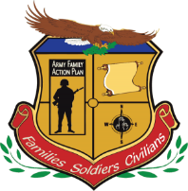
Army Family Action Plan (AFAP)

Fort Wainwright | 907-353-4332; Fort Greely| 907-873-2479

Service Description:
A grassroots, Army-wide initiative to identify and prioritize issues to enhance standards of living for Soldiers and their Families by giving them an opportunity to voice what works, what doesn't, and how to create solutions. It is responsible for many of the great benefits that make the Army a great career Soldiers and their Families. AFAP is responsible for: minimum standards for Army child care, development of first policy for the Better Opportunities for Single Soldiers (BOSS) Program, established Military Thrift Savings Plan (TSP), reformed military pay table (targeted pay raises) increased military annual leave carryover from 60-75 days and many more improvements that you enjoy today. Submission forms are available at IMS - Submit Issue (armyfamilywebportal.com).

Army Family Team Building (AFTB)

Fort Wainwright | 907-353-4332; Fort Greely| 907-873-2479

Service Description:
Army Family Team Building strives to educate and encourage Service Members, Military Families and DA/DOD Civilians to become active participants and leaders in their community. AFTB Family training and readiness program that provides participants with an understanding of Army culture and the skills and resources they need to become self-sufficient members of the military community.

Army Volunteer Corps (AVC)

Fort Wainwright | 907-353-4337; Fort Greely | 907-873-2479

Service Description:
Unites all volunteers and organizations who rely on them. Strengthens volunteerism by enhancing the career mobility of volunteers, establishing partnerships, and promoting a life-long commitment to service. This assists in maintaining readiness, sustaining communities, and enriching lives throughout the Army.


Emergency Family Assistance Center (EFAC)

Fort Wainwright | 907-353-4332; Fort Greely| 907-873-2479

Service Description:
EFAC Centers operating 24/7, established by garrison commanders with the help of ACS in response to deployments, natural disasters or catastrophic events to assist Soldiers and Family Members with basic services. Other agencies may be asked to participate in the EFAC as local needs dictate. The National Guard operates FACs for Families who are geographically dispersed and located in remote sites. Operated as needed and as directed by the garrison command.

Employment Readiness Program (ERP)

Fort Wainwright | 907-353-4337; Fort Greely | 907-873-2479

Service Description:
The Employment Readiness Program provides employment assistance to active duty, reserve component, transitioning and retired Soldiers, Family members, and DOD civilian employees in acquiring skills, networks, and resources that will allow them to participate in the work force and develop a career/work plan.
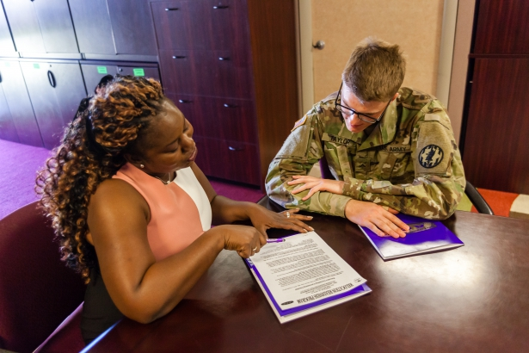

Military Spouse Employment Partnership Program (MSEP)

Services available through https://msepjobs.militaryonesource.mil
A self-sustaining and expanding partnership between the US Army and corporate America. The partnership provides Army spouses the opportunity to attain financial security and achieve employment/career goals through mobility and enhanced employment options. MSEP is a core component of the Employment Readiness Program to enhance and develop employment opportunities for spouses.

Exceptional Family Member Program

Fort Wainwright and Fort Greely| Bldg. 3414 Rhineland Ave| 907-353-4335

System Navigator| 907-353-4460
Bassett Army Community Hospital EFMP Office
907-361-5959|907-361-5825

Service Description:
The Exceptional Family Member program (EFMP) is a mandatory enrollment program for any Army Family member with special needs. Program objectives are to advocate resources for Families with special needs, act as a command resource for helping Exceptional Family Member Families, and to work with Families to resolve special needs issues to include: resources, housing, education, and child services.

The EFMP provides support services, transition information and liaison services between Families, schools, and social service agencies in Alaska. The EFMP team works closely with its MEDDAC EFMP partners. Some examples of special needs might include asthma, depression, anxiety, food allergies, behavioral concerns or speech delay. For Command Sponsorship questions, please reach out to the Bassett Army Community Hospital EFMP Office.
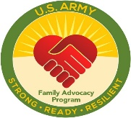

Family Advocacy Program (FAP)

Fort Wainwright and Fort Greely | 907-353-4336

Service Description:
The ACS Family Advocacy Program (FAP) is designed to preserve and protect the family unit. The emphasis is on the physical, emotional and spiritual well-being of family members through the development of programs that promote healthy family life. This program aims to prevent, identify, and treat those families involved in incidents of spouse and child maltreatment. The FAP provides programs to educate Commanders, Units, Family Members and others in the military community about family violence prevention and family wellness.

The ACS FAP offers family enrichment programs that cover the life cycle of the family, infants, children, teens, couples, parents. The classes include parenting, stress management, child development, step- family life, support groups and deployment issues. Services are available to unit support groups and family organizations. Call for listing of upcoming classes.

Victim Advocacy

Fort Wainwright and Fort Greely| 24/7 HOTLINE 907-799-9770

Service Description:
Provides 24/7 services for victims of domestic violence. Victims have access to emergency assistance, information, referrals, and ongoing support in accessing medical, behavioral health, legal, and law enforcement services on and off garrisons. Available for both RESTRICTED (no command or law enforcement involvement) and UNRESTRICTED reports (full investigative process).

Transitional Compensation (TC) Program for Abused Dependents

A congressionally-mandated program for abused dependents of military personnel. Legislation authorizes temporary payments for Families in which the Active Duty Soldier has been separated administratively or by court-martial for a dependent-abuse offense. The TC Program offers benefits and entitlements for 12-36 months to eligible Family Members. During this benefit period, beneficiaries are provided temporary financial compensation and are eligible to receive medical care including behavioral health services as TRICARE beneficiaries. Recipients will also have commissary and exchange privileges during this period.

New Parent Support Program (NPSP)

Fort Wainwright and Fort Greely| 907-353-2101

Service Description:
Provides professional social workers and nurses who offer supportive and caring services to military Families with children from birth to three years of age. Through a variety of programs including home visits and parenting classes, the NPSP provides opportunities to learn to cope with stress, isolation, post-deployment, reunions and the everyday demands of parenthood. The program is committed to developing strong Army Families and the prevention and treatment of Family violence. Its coordinated efforts are designed to prevent and intervene in cases of Family distress and to promote healthy Family life.

Financial Readiness

Fort Wainwright |907-353-4459; Fort Greely | 907-873-2479

Service Description:
Provides education, training and counseling in personal financial readiness. Topics include: wealth building, financial life skills training, retirement planning, indebtedness, consumer advocacy and protection, money management, credit, financial planning, insurance, identity theft, and consumer issues. Other services offered are mandatory personal financial readiness training for first-termers, the Thrift Savings Plan, Blended Retirement System Planning, Smooth Move (PCS) and financial readiness for deployed Soldiers and their Families. Personal Financial Counselors are nationally accredited financial counselors (AFC) and are available for individual, couple and family sessions. Unit trainings are available upon request.

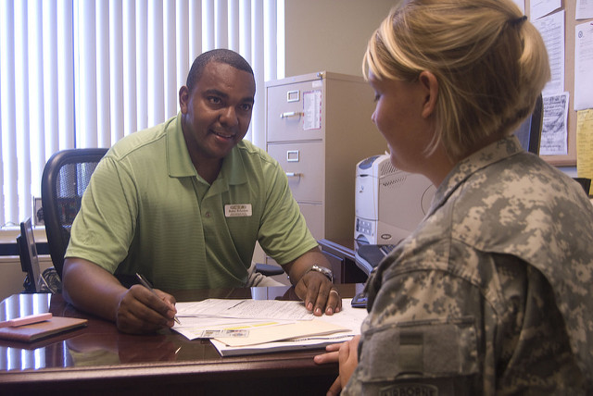

Information, Referral and Follow-up (IR&F)

Fort Wainwright | 353-4227; Fort Greely| 907-873-2479

Service Description:
The Army Community Service Information, Referral and Follow-up (IR&F) Program assists clients who are seeking answers or resources to address specific needs. The IR&F staff assesses the scope of the problem and provides resources for developing solutions. If necessary, referrals to other military and civilian agencies are provided to assist with personal, financial, family and marital problems. IR&F Strives to provide Soldiers and Families with timely, comprehensive information on both military and community resources that will assist in meeting basic needs and improve quality of life

Eligibility:
Active duty and retired Soldiers, their Family members, and DOD civilians.



Mobilization and Deployment, Stability
And Support Operations (MDSSO)

Fort Wainwright | 907-353-4332; Fort Greely| 907-873-2479

Service Description:
The Mobilization and Deployment Readiness Program (MDRP) provides active component (AC) and reserve component (RD) Soldiers, Family members and DoD Civilians with assistance and services in support of mission readiness. MDRP provides a variety of classes, interactive workshops, Pre- Deployment Expos, Reintegration Workshops, and support services to assist Soldiers and their Family Members through the Contingency Response Force (CRF) Readiness Cycle, ensures Soldier awareness of ACS Educational and Prevention Programs; Family Readiness Resources, Soldier Readiness Processing (SRP), and Reverse SRP.

Master Resiliency Training (MRT)

Fort Wainwright | 907-353-4332; Fort Greely| 907-873-2479

Service Description:
This training replaces Battle Mind Training. MRT training offers strength-based, positive psychology tools to aid Soldiers, Leaders and Families in their ability to grow and thrive in the face of challenges and bounce back from adversity. Family Resilience Training trains the Soldiers’ Families in preparing for and managing the realities of the deployment and the transition back home. Operational Resilience trains Soldiers and Leaders in preparing for and managing the realities of the deployment and the transition back home.

Relocation Readiness

Fort Wainwright | 907-353-7908; Fort Greely | 907-873-2479

Service Description:
The Relocation Readiness Program provides services to inbound and outbound Soldiers and Family Members with resources to ease the stressors that are often associated with relocating. Specialized programs and services include: individual or group counseling, sponsorship and pre-arrival information, Newcomer Expo for all newly-arrived Soldiers and Family members and a Levy briefing for those departing, lending closet services (i.e. household kitchen items and appliances, mattresses, ironing boards, vacuum cleaners, flat screen TV’s and more), Citizenship Immigration Services, and multi-cultural programs. The Relocation Program Manager chairs the Relocation Assistance Coordinating Committee (RACC) and advises the Garrison Commander on relocation issues beyond the authority of individual RACC members.

Eligibility: Active duty and retired Soldiers, their Family members, and DOD civilians on PCS orders

Lending Closet

Basic household items are loaned at no charge to Soldiers and Family members in transition. For more information on Lending Closet please call (907) 353-7908.


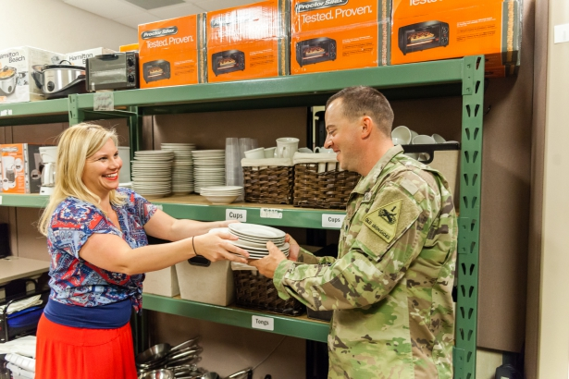

Soldier and Family Readiness Group (SFRG) Training

Fort Wainwright | 907-353-4332; Fort Greely| 907-873-2479

Service Description:
This training is designated for targeted positions within the Soldier and Family Readiness Group (SFRG) with six different modules: Foundations, Command Team, Command Family Readiness Representative (CFRR), SFRG Leader, Key Contact, and Informal Funds Custodian. Training focuses on mission-essential tasks and builds on the concept of Family readiness through the SFRG Mission. The SFRG Mission: act as an extension of the unit in providing official, accurate command information. Provide mutual support between command and the SFRG membership. Advocate for efficient use of available community resources. Help Families solve problems at the lowest level.
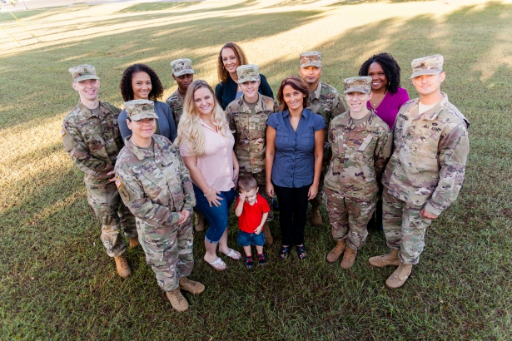

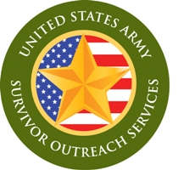
Survivor Outreach Services (SOS)

Fort Wainwright and Fort Greely | 907-384-0272

Service Description:
The Survivor Outreach Services program provides long-term support to Families who have lost their Active Duty Soldier. SOS works to build a unified support system for Surviving Families that links them to the Army Family and private organizations for as long as they desire. SOS is committed to providing local, convenient support, information, and services and to serve as a single point of contact for questions and concerns. SOS also provides support groups, events, and activities for Families to help them connect and heal. Financial counseling and grief resources are available to Families through SOS.

Eligibility:
Survivor Outreach Services is available to all spouses, children, parents, siblings, and anyone grieving the loss of a Soldier. Survivor Outreach Services will not turn anyone away and will tailor services based on the person’s eligibility.



CHILD & YOUTH SERVICES



Parent Central Services

Phone: 907-353-7713/7826 | 3414 Rhineland Ave. Fort Wainwright
Phone: 907-873-4593 | Bldg. 847, Fort Greely, AK
Hours of Operation: Monday - Friday 0800 - 1700, closed federal holidays

Services Provided:
One stop registration for all CYS patrons, full day and part-day preschool waiting lists for on-post care; vacancies filled as they occur, referral list for off-post childcare, providers, and babysitters, referral list for teenage babysitters 13-18 years of age who are certified in CPR and first aid, and Parent Education Services.

Registration requirements:
Proof of age, current immunization record for children from birth to 5th grade, current sports
physical (within last year) for enrollment in sports, health assessment for Child and Youth Services & School Age Service (SAS) programs (required 30 days after registration), medical documentation and/or Individual Education Plan (IEP) or evaluations.

Child Development Center I

Phone: 907-361-4190 | 4024 600th Street, Fort Wainwright, AK
Phone: 907-873-4593 | Bldg. 847, Fort Greely, AK
Hours of Operation: Monday – Friday 0600-1800

Child Development Center II

Phone: 907-361-9056 | 4176 Neely Road, Fort Wainwright
Hours of Operation: Monday – Friday 0600-1800

Services Provided: Child care provisions can be made for children six weeks of to 12 years of age for full day, part day, hourly, extended, long term and special needs care. It is our belief that a high quality early childhood program enhances the physical, social, emotional, cognitive and language development of young children while responding to their individual needs.

Family Child Care (FCC) Program

Phone: 353-7595 | BLDG 1045 Gaffney Road, Fort Wainwright, Alaska

Services Provided:
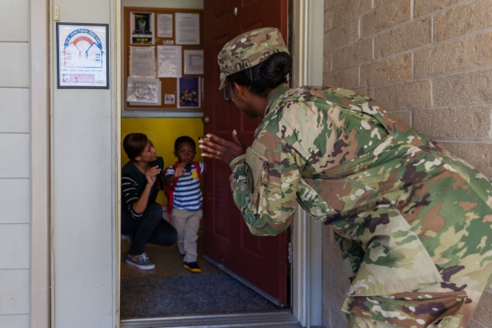
Available for children 6 weeks through 12 years. Smaller environment with a maximum of six children, more intimate surroundings where providers really get to know your child on a personal basis fostering your child’s home away from home, FCC homes have activity centers, such as dramatic play area, arts, manipulative games, blocks and reading areas. Providers have a daily lesson plan that parents can view to keep up with their child’s learning opportunities through the week. Nationally accredited and state certified, providers and homes meet the same Department of the Army regulatory requirements including monthly inspection by fire, and safety, USDA food program, and health program. Extended care hours for early mornings, evenings, over nights, weekends, and long term care options are available as well as before and after school. Some FCC providers are even available on holidays.

School Liaison Officer

Phone: 907-353-1043 | Fort Wainwright, AK

Services Provided: Transition Support; Partnership in Education; Installation/School communications; Home School Linkages; Post- Secondary Prep Opportunities

School Age Center (SAC)

Fort Wainwright Phone: 361-7394 | 4166 Neely Road, Fort Wainwright
Hours of Operation: Monday – Friday 0600-1800

Services Provided: School Age Services (SAS) offers care before and after school with options for before school only or after school only. Each of these options entitles program participants to full day care services during out of school periods, excluding Federal Holidays, during the school year. Additionally, separate SAS camps are operated during Christmas and Spring breaks for those patrons who normally do not require daily before and after school care. During the summer months, SAS operates a full day camp option, in ten, one-week sessions and eight, one-week half-day sessions.



Youth Center

Phone: 361-5437 | 4109 Neely Road, Fort Wainwright
Hours of Operation: School Days:
Monday -Friday 1400 - 2000
Saturday 1300 – 2200

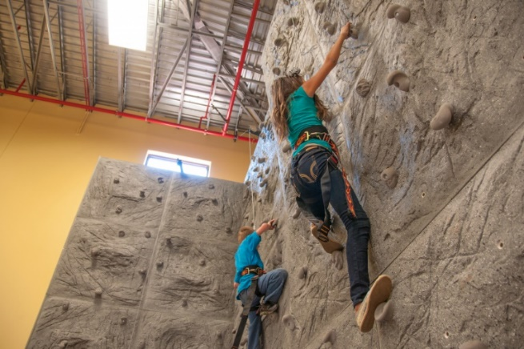

CRISIS & EMERGENCY SERVICES
If you have a medical emergency, please call 911 or contact your local hospital right away.

National Hotlines

988 Suicide and Crisis Lifeline, 988 and select 1 (for Veterans)
or
Veterans Suicide Prevention Hotline, 1-800-273-TALK (8255)
988 Suicide and Crisis Lifeline, 988
or
National Suicide Prevention Hotline, 1-800-SUICIDE (1-800-784-2433)
DOD Safe Helpline, 1-877-995-5247
U.S. Army Wounded Soldier & Family Hotline, 1-800-984-8523
Wounded Warrior Resource, 1-877-746-8563
Military One Source, 1-800-342-9647
Poison Control, 1-800-222-1222 (24 hours)

Alaska Behavioral Health Crisis, (907) 563-3200 (24 Hours)

Mobile Outreach for Children and Families (907) 371-1359 (7 days a week, 0800-2000)

Bassett Army Community Hospital

Fort Wainwright|4076 Neely Road Fort Wainwright, AK
Phone: 907-361-4000

A premier healthcare organization in the Department of Defense located on Fort Wainwright, AK.

Victim Advocacy

Fort Wainwright and Fort Greely|24/7 HOTLINE 907-799-9770

Provides 24/7 services for victims of domestic violence. Victims have access to emergency assistance, information, referrals, and ongoing support in accessing medical, behavioral health, legal, and law enforcement services on and off garrisons. Available for both RESTRICTED (no command or law enforcement involvement) and UNRESTRICTED reports (full investigative process).

Careline

Phone: 907-452-HELP (4357) or 877-266-4357
Text: 4help to 839863
Website: www.carelinealaska.com

Service Description:
24 hour crisis intervention and suicide prevention hot line. Provides emotional support for all ages experiencing life problems.
An online resource guide with agency information for Fairbanks.

Emergency Management- Fairbanks and North Star Borough

Phone: 907- 459-1481
Website: https://www.cofairbanks.ak.us/27/Government

Service Description:
The emergency management department coordinates the management of emergency operations in the Fairbanks area. They provide assistance and information to the citizens of Fairbanks and to the general public.

Fort Wainwright Emergency Management

Phone: 907-353-9755

Service Description:
Provides education and outreach services to Soldiers, Families, Army Civilians and Contractors to prepare for natural disasters and man-made hazards. They provide information and assistance ensuring the safety of Service Members, Families, and Government Employees.

Poison Control

1-800-222-1222 (24 hours)
Website: https://www.poison.org

Agency advises what to do in suspected or actual poisoning. Information needed will include:
1) Poison brand name 5) Weight of person involved
2) Amount of poison eaten 6) Email
3) How long ago the poison was eaten 7) Zip Code
4) Age of person involved

Sexual Harassment/Assault Response and Prevention (SHARP)

24/7 HOTLINE: 907-353-7272| Fort Wainwright, AK
24/7 HOTLINE: 907-505-0275| Fort Greely, AK
Department of Defense (DOD) SHARPHOTLINE: 1-877-995-5247

Service Description:
The Army’s SHARP program exists to prevent sexual harassment and sexual assaults before they occur. This program reinforces the Army’s commitment to eliminate incidents of sexual assault through a comprehensive policy that centers on awareness and prevention, training and education, victim advocacy, response, reporting, and accountability. Services are available for RESTRICTED (no command or law enforcement involvement) and UNRESTRICTED (full investigative process).

Golden Valley Electric Association

Phone: 907-452-1151 or 1-800-770-4382| 758 Illinois Street, Fairbanks, AK 99701
Website: www.gvea.com

The Golden Valley Electric Company provides emergency electric services during power outages 24 hours a day.

Fairbanks Rescue Mission

Phone: 907-331-6292 | 723 27th Avenue, Fairbanks, AK 99701
Website: www.fairbanksrescuemission.org

Service Description
The Fairbanks Rescue Mission operates the only overnight men's emergency shelter and women's emergency shelter in the interior of Alaska. They provide emergency housing, food, clothing, a residential recovery and relapse prevention program, job program, veteran's program, case management, transition support, bible studies and chapel services.

Red Cross of Alaska

Service Description:
The Red Cross provides temporary relief for disaster victims of natural or other disasters. They can provide clothing, food and temporary shelter services. They provide training on water safety, First Aid, CPR and babysitting classes. American Red Cross also provides Reconnection Workshops held in small groups and facilitated by licensed, trained Red Cross mental health workers to help service members reconnect with their families.

24/7 Emergency Communication Line: 1-877-272-7337
Fort Wainwright
Phone: 907-444-9529| 3401 Santiago Ave, Fort Wainwright
Phone: 907-456-5937| 3501 Lathrop St, Fairbanks, AK
Website: www.alaska.redcross.org/local/alaska.html
Hours of Operation: 0900-1700
(Calling before stopping in is highly encouraged)

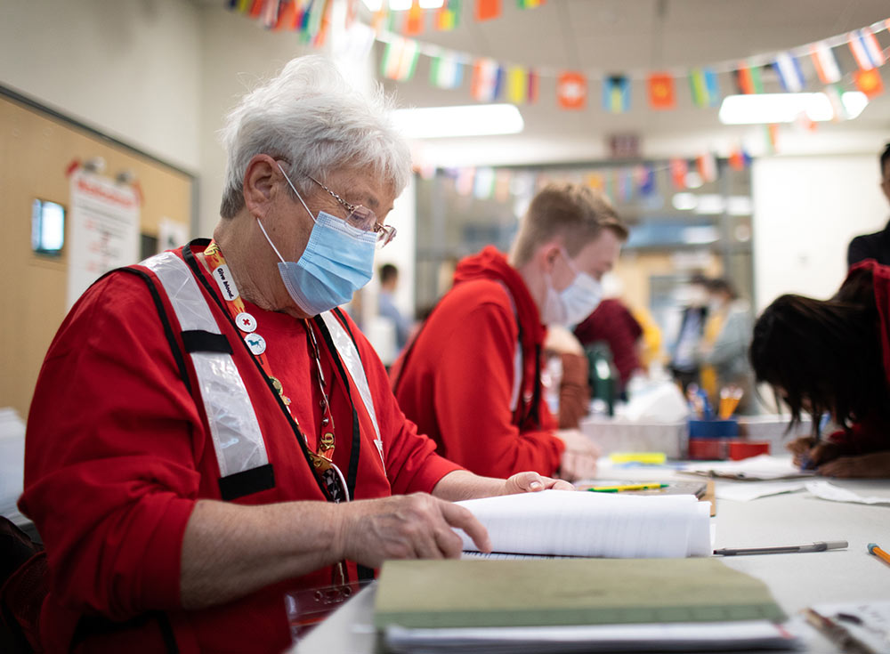

POLICE, FIRE, & AMBULANCE SERVICES

Bassett Army Community Hospital (BACH)
Phone: 907-361-4000 | 4076 Neely Road, Fort Wainwright, AK

Website: https://bassett-wainwright.tricare.mil/
Hours: Emergency and Inpatient open 24/7

Fire Chief of Fairbanks
Phone: 907-450-6604
Emergency/Non-Emergency Services

Fairbanks Fire Department
Phone: 907-450-6600 | 1101 Cushman Street, Fairbanks, AK 99701
Website: https://fairbanksalaska.us/fire

Fairbanks Memorial Hospital
Phone: 907-452-8181 | 1650 Cowles Street, Fairbanks, AK 99701
Website: https://www.foundationhealth.org/fmh

Fairbanks Police Department
Phone: 907-459-6500 | 911 Cushman Street, Fairbanks, AK 99701
Website: https://www.fairbanksalaska.us/police

Fort Wainwright Police
Phone: 907-353-7536 | 3025 Montgomery Rd, Fort Wainwright, AK
Website: https://home.army.mil/alaska.index.php/garrison/des

Fort Wainwright Ambulance Service
Phone: 907-353-7535
Emergency/Non-Emergency Service

Fort Wainwright Fire Department
Phone: 907-353-9170 | 3004 Santiago Ave, Fort Wainwright, AK
Website: https://home.army.mil/alaska.index.php/garrison/des

Fort Greely Fire Division
Phone: 907-873-4625/4627 | Bldg. 111, Fourth Ave, Fort Greely, AK

HEALTHCARE RESOURCES

Breast Cancer Detection Center

Phone: 907-479-3909 | 1905 Cowles Street, Fairbanks, Alaska

Service Description:
Services are all free of charge and include breast examination by medical doctors, mammograms, and referral services.

Chief Andrew Isaac Health Center

Phone: 907-451-6682 | 1717 W. Cowles, Fairbanks, Alaska
Website: www.tananachiefs.org

Service Description:
Services include OB/GYN care, well child, dental, mental health counseling, general medical, immunizations and school physicals. Must be Alaska Native or American Indian, must show tribal enrollment at first visit.

Denali KidCare/ Info and Guidance

Phone: 1-800-780-9972 | Public Assistance 907-478-7778
Website: Alaska Denali KidCare (CHIP) | Benefits.gov

Service Description:
A State of Alaska program that provides health insurance coverage for children through the age of 18 and pregnant mothers.

Alaska Behavioral Health (Fairbanks Community Behavioral Health Center)

Phone: 907-371-1300 | 1423 Peger Rd, Fairbanks, AK
Website: https://alaskabehavioralhealth.org/

Service Description:
Offering health services for adults and children such as for aliments and well child checks. Not providing prenatal care or immunizations. Medicaid, Medicare and Denali KidCare accepted.

Stone Soup Group

Phone: 907-561-3701
Website: https://www.stonesoupgroup.org

Stone Soup Group works with families of children with special needs from birth up to age 26. Our services are available statewide to help families with medical, disability, mental health, and special education issues, most are at no cost to families.

Interior AIDS Association

Phone: 907-452-4222 | 710 3rd Avenue, Fairbanks, Alaska

Service Description:
HIV/Aids prevention and education for youth and adults, free condoms, Sexually Transmitted Disease and HIV testing are available at no charge. All visits and client information is strictly confidential.

Interior Community Health Clinic

Phone: 907-455-4567 | 1606 23rd Avenue, Fairbanks, AK
Website: https://www.interiorcommunityhealth.org

Service Description:
Clinic provides comprehensive medical care for the entire family (from babies to seniors).. Clinic accepts most insurance (Medicaid and Medicare) and offers a schedule of discounts on fees to eligible clients (based on household size and income).

Planned Parenthood of Alaska

Phone: 800-769-0045 | 1867 Airport Way, Suite 160B, Fairbanks, AK
Website: https://www.plannedparenthood.org

Provides confidential and affordable reproductive health care services to men, women and teens. Fees are based on a sliding scale according to individual’s income and family size.

FYNDout Free Pregnancy Center

Phone: 907-455-8255 | 4474 Pikes Landing Rd, Fairbanks, AK

Website: https://fyndoutfree.com

Provides free pregnancy tests, limited OB ultrasounds and parenting support.

Epilepsy/Seizure Support Network

Phone: 1-844-721-3369
Website: https://www.epilepsy.com/local/alaska

The Epilepsy Foundation Alaska provides programs and services that support people and families impacted by epilepsy.

Fairbanks Regional Public Health Center

Phone: 907-452-1776 | 1025 W. Barnette Street, Fairbanks, Alaska

Service Description:
Services include general health screening and developmental assessment for children, immunization services for adults and children, services for sexually transmitted diseases, family planning services, and teen clinic – including reproductive health education, communicable disease information and referral. In addition, public health nurses provide home visits for health promotion services to individuals/families. Such as prenatal; infant and child health; and elder health services.

accountability.

MENTAL HEALTH & COUNSELING SERVICES
• There are many Therapists in private practice offering services such as play therapy for children and marriage/relationship counseling for couples. Many accept insurance.

Military and Family Readiness Center

Phone: 907-377-2178 | 2631 Wabash Ave 1st Floor, Eielson AFB

Service Description:
Provides recourse required to support active duty Airmen, their family members, DoD civilians, retirees and single airmen. Programs include: Employment Assistance, Personal and Family Readiness, Personal and Work Life, Financial Readiness, Relocation Assistance, Transition Assistance, Exceptional Family Member Program, and Military and Family Life Counselors.

National Alliance for the Mentally, Fairbanks

Phone: 907-456-4704 | 3504 Industrial Ave, Rm 104, 2nd Floor, Fairbanks, AK

Service Description:
NAMI provides advocacy, education, support and public awareness so that all individuals and families affected by mental illness can build better lives.

Fairbanks Centered Services of Alaska, Inc.

Phone: 907-474-0890 | 1825 Marika Rd. Fairbanks, AK

Service Description:
Family Centered Services of Alaska, Inc. is a mental health center that serves severely emotionally disturbed children and their families.

Alaska Behavioral Health (Fairbanks Community Behavioral Health Center)

Phone: 907-371-1300 |1423 Peger Rd, Fairbanks, Alaska
Website: https://alaskabehavioralhealth.org

Service Description:
Comprehensive community mental health center providing diagnosis and evaluation, psychiatric services, individual, group, marital and family therapy for people experiencing grief, depression, suicidal thoughts, phobias, anxiety, relationship problems or personality disorders. Adjustable payment schedule, Medicaid and TRICARE accepted; no one is denied due to inability to pay.

Steven A Cohen Military Family Clinic at Alaska Behavioral Health

Phone: 907-762-8668 | 926 Aspen St, Fairbanks, Alaska

Service Description:
The Steven A. Cohen Military Family Clinic at Alaska Behavioral Health provides confidential, high-quality behavioral healthcare services and local resource connection to post-9/11 veterans (including National Guard and Reserves), their families, active duty service members and the families of active duty service members, which includes spouse or partner, children, parents, siblings, caregivers, and others. Services are available regardless of discharge status, role while in uniform, combat experience, ability to pay or insurance.

Fairbanks Vet Center

Phone: 907-456-4238 | 540 4th Avenue, Suite 100, Fairbanks, Alaska

Service Description:
Provides counseling to veterans, counseling to family members of certain eligible veterans, outreach and public education. Assists vets with military related problems, educational benefits and substance abuse counseling.

Fairbanks Psychiatric and Neurological Clinic

Phone: 907-452-1739 | 1919 Lathrop St., Suite 220, Fairbanks, Alaska

Service Description:
Provides private medical care specializing in psychiatric and neurological disorders in children and adults.

Continuing Hope Counseling

Phone: 907-451-8208 | 534 10th Ave, Fairbanks, Alaska
Website: https://www.continuinghope.org

Service Description:
Offers trained professionals who work with individuals and offer comprehensive services including psychological testing and assessment as well as counseling. Most insurance accepted and a client assistance program is available.

Foundation Health Partners Hospice Services

Address: 907-458-3090 | 2001 Gillam Way, Fairbanks, Alaska
Website: https://www.foundationhealth.org/services/assisted_longterm_care/hospice

Service Description:
Hospice of the Tanana Valley provides support for people who are dying, their families and their loved ones. Support groups and community support for those who have experienced loss through death. Bereavement counselors are available for one-on-one counseling.

Interior Alaska Center for Non-violent Living

Phone: 907-452-2293 or 800-478-7273 | 726 26th Ave. Suite 1, Fairbanks, Alaska
Website: https://www.iacnvl.org

Service Description:
Provides counseling services to women who have been victims of assault, abuse, incest, elder abuse and to people who are in a crisis. The program provides shelter care for women and children as well as a legal advocate.

LEAP Alternatives to Violence Programs

Phone: 907-452-2473 | 600 University Ave. Suite 3, Fairbanks, Alaska
Website: https://www.leapfbks.com

Service Description:
LEAP is an agency that provides a state-approved batterer’s intervention program for men, groups for women who use violence, an alternative to violence program for adolescents, and an anger management program.

Military & Family Life Consultants (MFLC)

Service Description:
Whether you want to strengthen a relationship or talk through a difficult situation, non-medical,
short–term, solution focused counseling can help you thrive in your military life. MFLC’s are available to help service members, spouses, family members, children and staff with marriage and relationships, stress and anxiety, depression, grief and loss, as well as daily life issues.

Please Contact Army Community Services for the most up to date number (907)-353-4227.

Resource center for Parents and Children, Stevie’s Place

Phone: 907-374-2850 | 726 26th Avenue, Fairbanks, Alaska
Website: https://www.rcpcfairbanks.org/stevies-place

Service Description:
A program of the Resource Center for Parents and Children, offers child sexual abuse response, evaluation and information center.

Grace in Motion Counseling

Phone: 907-452-4673 | 3504 Industrial Avenue Suite 214, Fairbanks, Alaska
Website: https://www.graceinmotioncounseling.com

Service Description:
Professional Faith-based Counseling for individuals, couples, groups and families dealing with life challenges.

Arctic Resource Center for Suicide Prevention

Phone: 907-987-6829 | 816 28th Ave, Fairbanks Alaska

Service Description:
ARCSP believes that openly discussing the topic of suicide lowers the stigma surrounding the issue and brings health to those suffering with suicidal related concerns. Speaking on suicide is a life-saving act. Discussing suicide, however, needs to be done in a safe manner.

Tanana Chiefs Conference Counseling Services

Phone: 907-459-3800 | 122 1st Ave, Fairbanks, Alaska
Website: https://www.tananachiefs.org/services/behavioral-health

Service Description:
Provides outpatient behavioral health services, behavioral health screening and referral and crisis intervention to Indian Health Services beneficiaries.

UAF Community Mental Health Clinic

Phone: 907-474-1999 | Gruening Building, UAF campus, Fairbanks, Alaska
Website: https://www.uaf.edu/mentalhealth

Service Description:
Graduate Student Therapists from UA Psychology Doctoral Program (supervised by licensed psychologist) offer individual and couple therapy for adults. This service is available to everyone and you do not need to be a student. For appointments or questions call.

RELIGIOUS SUPPORT
Service Description:
The Chaplains' Offices provide religious services and sacraments, including worship, marriage, baptism, retreats and more. Religious education and pastoral care (i.e. visitation, hospital confinement counseling) are also offered.
For information on worship services and events please visit: Religious Support Office (army.mil)

Chapels

Northern Lights Chapel  3430 Luzon Ave, Fort Wainwright, AK  (907) 353-6112  Southern Lights Chapel  4107 8th Street, Fort Wainwright, AK  (907) 353-4375 | Bassett Army Community Hospital  4706 Neely Road, Fort Wainwright, AK  (907) 361-5002  Fort Greely Chapel  845 Big Delta Ave, Fort Greely, AK  (907) 873-2476

Chaplain Contact Information
Garrison Religious Support Office: 353-6112  FWA Family Life Chaplain: 353-3476  Religious Support Resource Management: 353-4261  Religious Education Director: 353-2702  Catholic Parish Coordinator: 361-4261 |  | 1-11th SBCT Brigade: 353-6100  Bassett Army Community Hospital Chaplain: 361-5002  1-24 IN: 353-2420  3-21 IN: 353-4610  5-1 CAV: 353-6908  2-8 FA: 353-1506  The Emergency On-Call Duty Chaplain can be reached during off duty hours (evenings, weekends and holidays) through the Arctic Warrior Operations Center (AWOC) at 353-1899 | 70th BEB: 353-7019  1-25 AB: 353-2514  1-52 GSAB: 353-4419  25th BSB: 353-2687  1-5 IN:353-2534

Better Opportunities for Single Soldiers (B.O.S.S)

SINGLE SOLDIER RESOURCES

Fort Wainwright |
Phone: 907-353-4145
Fort Greely |
Phone: 907-873-4058
Service Description:
BOSS supports the overall quality of life for single and unaccompanied
Soldiers (including single parents) focusing on three core components:
1. Quality of Life
2. Recreation and Leisure Activities
3. Community Service

On Fort Wainwright, BOSS meetings are held the first and third Tuesday of each month.



Soldiers Against Drunk Driving (SADD)

Fort Wainwright
Phone: 907-353-4145

Service Description:
A key BOSS program at Fort Wainwright, SADD is a volunteer-driven designated driver and call-in program to aid in preventing Soldiers from driving while intoxicated. NO COST SERVICE. Services available on Friday and Saturday from 2300-0330; Holiday schedule varies.

Alaska 211

SUPPORT SERVICES

Service Description:
No matter where you live in Alaska, Alaska 2-1-1 is your one-stop resource for connecting with a wide variety of vital resources in your community including emergency food and shelter, disability services, counseling, senior services, healthcare, child care, drug and alcohol programs, legal assistance, transportation needs, educational opportunities, and much more.

American Red Cross of Alaska

Phone: 1-888-316-4272 | 3501 Lathrop St, Fairbanks, AK
Website: https://www.redcross.org/local/alaska.html

Service Description:
Temporary help for disaster victims of fire, earthquake and flooding. They can provide clothing, food and shelter. Also teaching people how to respond to an emergency. They provide training on water safety, First Aid & CPR and baby-sitting classes.

Fairbanks Native Association

Phone: 907-452-1648 | 3830 S. Cushman Suite 100, Fairbanks, Alaska
Website: https://www.fairbanksnative.org

Service Description:
FNA is a nonprofit organization which conducts a wide variety of programs intended to serve the Native community of Fairbanks and the community of Fairbanks as a whole.

Fairbanks Resource Agency (FRA)

Phone: 907-456-8901 | 805 Airport Way, Fairbanks, Alaska
Website: https://fra-alaska.org

Service Description:
Fairbanks Resource Agency is a community-based nonprofit organization dedicated to providing supportive services, housing, referrals, employment and information for individuals who experience a disability and their family or caregiver.

Lifeline Phone Program

Call one of the following local phone carriers for more information:
• ACS at 1-800-808-8083 GCI at 907-770-3022

Service Description:
The Life Line program provides $1.00 per month basic telephone and is offered by several local phone carriers to families who are enrolled in one of the following programs: Head Start Programs (under income qualifying eligibility only), National School Lunch Program (free meals program only), Supplemental Security Income (SSI), Food Stamps, Medicaid, Public Housing, Low-Income Home Energy Assistance, Alaska Temporary Assistance Program (ATAP), Adult Public Assistance (APA), or Tribally Administered Temporary Assistance.

Helping Alaska

Phone: 907-452-3876 | 609 3rd Street, Fairbanks, Alaska
Website: www.helpingalaska.org

Service Description:
Network of local, Christian churches committed to helping people in need. It operates numerous programs including a Telephone Clearinghouse that connects people in need with community and church resources that can address many different needs through programs such as the Budget Counseling Program, Furniture Garage, Personal Needs Closet, and Firewood Project.

Resource Center for Parents and Children (RCPC)

Phone: 907-456-2866 | 726 26th Avenue Suite 2, Fairbanks, Alaska
Website: www.rcpcfairbanks.org/

Service Description:
The prevention of child abuse and neglect begins with strengthening the family structure, helping parents with parenting skills, and providing a safe place for parents to share and deal with parenting issues.

Safe Rider Program

Phone: 907-458-7233 | 1650 Cowles Street, Fairbanks, Alaska

Service Description:
Call to schedule a car seat safety check to ensure that your child’s car seat is properly installed. Free car seats are available.

Salvation Army Emergency Family Services

Phone: 907-452-3103 |1602 10th Avenue, Fairbanks, AK 99701
Website: https://www.fairbanks.salvationarmy.org

Service Description:
The Salvation Army provides comprehensive emergency services for people in need. Services include food boxes, clothing and household goods, utility assistance, literacy services, disaster relief and casework services.

Salvation Army Thrift Store

Phone: 907-456-2085 | 2222 S. Cushman St, Fairbanks, Alaska

Tanana Chiefs Conference

Phone: 907-452-8251 | 122 First Avenue, Fairbanks, Alaska
Website: https://www.tananachiefs.org/services/#client

Service Description:
A multi-service agency providing information, support and services to tribal members enrolled and living in Interior tribal communities. They provide a wide range of family services to the outlying villages, and Alaska natives living in the Fairbanks community.

Combat Fishing Tournament

For more information or to register visit: Armed Services ASYMCA Combat Fishing Tournament

Service Description:
The annual ASYMCA Combat Fishing Tournament gives thanks to Alaska’s junior enlisted with a day of deep-sea fishing in Seward’s Resurrection Bay! The tournament is held annually in May and made possible thanks to corporate partners and Seward’s many charter fleets.

Started in 2007 by Captain Bob Candopoulos and Alaska business owner Keith Manternach, the ASYMCA Combat Fishing Tournament is the largest military appreciation tournament in the U.S., providing 165+ service members the opportunity to experience one of Alaska’s favorite pastimes—fishing!


Armed Service YMCA

Fort Wainwright
Phone: 907-353-5962|1047 Nysteen Road, #4, Fort Wainwright, AK

Service Description:
Our focus is to provide needed programs and services for single or married junior enlisted personnel and their family members. The Armed Services YMCA Alaska empowers military families, no matter who they are or where they’re from, by ensuring access to resources, relationships, and opportunities for all to learn, grow, and thrive.

ASYMCA of Alaska provides community resources and critical services including health and resiliency programs for service members and military families, access to food and household goods, and early learning opportunities for children.
For more information visit: https://www.asymca.org/alaska

Kid Comfort Quilts
Phone: 907-353-5962|1047 Nysteen Road, #4, Fort Wainwright, AK

Service Description:
Kid Comfort is a program for children ages 0–18 of deployed service members of any rank and service branch. Service members must be stationed in Alaska during the time of deployment.
Custom quilts with nine (9) photos are available for children ages 0–6
Custom pillowcases with five (5) photos are available for children 7+
Each keepsake is hand-made by a volunteer and donated with love and good wishes for the recipient child. These quilts bring can help serve as a surrogate for a deployed parent by providing warmth, memories, and comfort to children who are separated from their deployed parent.
Request a quilt online: Kid Comfort Quilts - Alaska ASYMCA

ASYMCA Bargain Shop
Phone: 907-356-1211 | 1031 102nd Street, Fort Wainwright, Alaska.

Service Description:
Special deals are available to DoD ID card holders. Our Bargain Shops feature weekly deals, seasonal sales, and everyday low prices designed to help military families’ dollar go further.
The ASYMCA Bargain Shops accept donations year-round of household goods, apparel, military uniforms, furniture, and other serviceable items that thrifty families can use. This regular influx of donations also creates flexible volunteer opportunities for those who’d like to donate their time toward supporting military families.

After 5 Boutique
Phone: 907-353-5962| 1031 102nd Street, Fort Wainwright, Alaska.

Service Description:
The ASYMCA After 5 Boutique lends formal gowns to service members and their families at no charge. This lending closet offers a selection of dresses in all lengths, colors, and styles, as well as accessories, shoes, and clutches to complete your look. Formal wear may be kept for up to two weeks.
No appointment required. Walk-ins welcome!

Y On Wheels Shuttle
Please register at: Armed Services YMCA Alaska Search (myvscloud.com)

Service Description:
Y on Wheels offers weekly Lyft codes to active duty service members and their families to meet their transportation needs. Whether attending medical appointments, getting groceries, conducting in- or out-processing, or accessing recreational facilities and activities, Y on Wheels can get you there and home.
Lyft codes are for $30 and valid for a 7-day period beginning every Saturday. New codes are available weekly.
Riders must be 18+ or accompanied by a parent/guardian. All rides must start or end at JBER, Fort Wainwright, or Eielson Air Force Base.

Guardian Angel Program (GAP)

Service Description:
When the unexpected happens, service members and families may suddenly face emotional, physical, or financial burdens. The U.S. military offers a range of resources to support service members during crisis. At times, though, additional support may be needed. The ASYMCA of Alaska’s Guardian Angel Program (GAP) assists service members and military families with transportation, housing, and other necessities during times of crisis.

GAP is available to service members and military families in times of crisis. A referral from immediate military leadership (such as a first sergeant) is required. To initiate a GAP request, first sergeants (or equivalent) should contact ASYMCA by calling 907-552-9622 during business hours or emailing our director if support is needed outside of business hours.
Food Pantry
Fort Wainwright ASYMCA Market Place

Phone: 907-353-5962| 1047 Nysteen Rd, #4, Fort Wainwright, Alaska.

Service Description:
From groceries to laundry detergent and diapers to personal care items, ASYMCA Marketplaces have everything your family needs to keep bellies full and households running smoothly. Marketplaces and Mobile Marketplaces are available at no cost to active duty, guard, and reserve service members. Marketplace inventory varies based on location and season. All Marketplaces offer a variety of nonperishable food items, frozen goods (including meat), diapers, and personal care products.

ASYMCA Marketplaces are available at no cost to active duty, guard, and reserve service members and their dependents – no questions asked. Military ID is required. Any information collected during sign-in is completely confidential.

Appointments are required at FWW. Operating hours, 8am-5pm. Please contact director@akasymca.org for after hour emergencies!

Fairbanks Community Food Bank

Phone: 907-457-4273 | 725 26th Ave, Fairbanks, Alaska

Programs include:
• Church of the Day – A 3 day supply of groceries ordered through the Church of the Day between 10 am and noon. (Call the Food Bank. Up to 4 orders per year.)
• Temporary Emergency Food Assistance Program (TEFAP) – Apply with your Family Advocate or at the Food Bank to receive a monthly supplemental box of nonperishable foods on the 3rd Saturday of each month from 12-2pm.
Commodity Supplemental Food Program (CSP)– For ages 60 and over.


Women, Infants, and Children (WIC)

Phone: 907-500-8451 | Midnight Sun State of Alaska
Website: https://health.alaska.gov/dpa/pages/nutri/wic/default.aspx

Service Description:
WIC Supplementary Food Program is a nutrition program that helps pregnant women, postpartum/breastfeeding mothers, and young children under the age of 5 eat well, learn about nutrition, and stay healthy. WIC provides free milk, cheese, eggs, tuna fish, cereal, fruit juice, infant formula, peanut butter, carrots, dried beans and dried peas to families with children under the age of 5.

The Breadline, Inc. Stone Soup Café

Phone: 907-452-1974 | 507 Gaffney Road, Fairbanks, Alaska
Serving hot meals Monday-Friday from 7:30am-9:30am

Service Description:
Five days a week, Stone Soup Cafe serves free, nutritious breakfasts and sack lunches to those in need. Volunteers serve an average of 28,000 meals per year. Our guests teach us that poverty does not discriminate. We serve mothers and young children, the elderly, homeless, unemployed, and those who are working but can’t make ends meet.

Fairbanks Rescue Mission

Phone: 907-331-6292 | 723 27th Ave, Fairbanks, Alaska
Breakfast 0800-0830; Lunch 1200-1230; Dinner 1730-1800; Hot meals are only available to those staying at the Rescue Mission. Sack lunches are available to anyone needing food.

Immaculate Conception Church

Phone: 907-452-3533, then press 5 | 2 Doyon Place, Fairbanks, Alaska
Serving hot meals Wednesday-Sunday from 11:00-1300. Sack lunches available on the weekends.
The Well

Phone: 907-452-2406| 547th Ave First Presbyterian Church, Fairbanks, AK
Free hot meals on Wednesdays, 6 p.m.-7:00 p.m. Open to the community, available September-May.

Operation Helping Hands

Phone: 907-353-6278/907-353-1899 | 1051 Gaffney Rd. Unit 10, Ft. Wainwright AK
Operation Helping Hands provides commissary voucher cards to Service Members and families who are in need of extra assistance for food and necessities.
Service Members Must Coordinate with Unit Chaplain

CLOTHING RESOURCES
Armed Services YMCA

Phone: 907-356-1211 | 1031 102nd Street, Fort Wainwright, AK
Website: https://www.asymca.org/alaska-bargainshop

Service Description:
The Armed Services YMCS provides a variety of activities and events for Military Families to participate in throughout the year. ASYMCA Bargain Shops offer weekly deals for feature items at deep discounts.

Fairbanks Rescue Mission

Phone: 907-331-6292 | 723 27th Ave, Fairbanks, Alaska
Website: https://www.fairbanksrescuemission.org

Service Description:
Offers both a men’s and women’s center providing a bed and three meals a day. They also offer counseling, clothing, and long term Recovery programs for men and women. There are no fees for these services.

Salvation Army Thrift Store

Phone: 907-456-2085 | 2222 S. Cushman St, Fairbanks, Alaska

Value Village Thrift Store
Phone: 907-474-4828 | 3023 Airport Way, Fairbanks, Alaska

CHILD CARE, LICENSING & REFERRAL SERVICES

Parent Central Services

Phone: 907-353-7713/7826 | 3414 Rhineland Ave. Fort Wainwright
Phone: 907-873-4593 | Bldg. 847, Fort Greely, AK
Hours of Operation: Monday - Friday 0800 - 1700, closed federal holidays

Service Description:
Child and Youth Services provides a variety of child care and youth services to meet the needs of the Army Family. CYS programs include day care centers, Family Child Care (FCC), and before/after school programs.

THREAD Child Care Assistance

Phone: 907-479-2212 | 1949 Gillam Way, Suite G, Fairbanks, Alaska
Website: https://www.threadalaska.org

Service Description:
Children’s Advocates, Resources and Education Services (CARES). Providing training and resources to child care providers, parents, students, educators and others working with young children. Also serves as a referral service for child care providers.

Tanana Chiefs Conference Childcare Information & Assistance

Phone: 907-452-8251 x 3362 | 122 1st Avenue, Suite 600, Fairbanks, Alaska

Service Description:
Provide services to children who are enrolled members of or eligible for enrollment in a federally recognized Tribe.

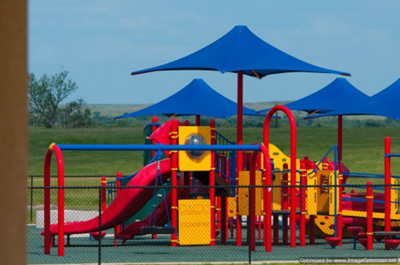

Child Development and Education Services

Alaska 4H Club

Phone: 907-474-2427 | 1000 University Ave, Rm. 109, Fairbanks, Alaska
Website: https://www.alaska4h.org

Service Description:
The Alaska 4-H program reaches thousands of young Alaskans. The youth learn a wide range of life skills while enjoying the activities. As in Alaska's other Extension programs, district agents maintain the programs in their community.

Big Brothers Big Sisters

Phone: 907-202-8529
Website: https://www.bbbsak.org

Service Description:
Big Brother Big Sisters focus on providing children facing adversity with strong and enduring, professionally supported 1-to-1 relationships that change their lives for the better, forever. They partner with parents/guardians, volunteers and others in the Community.

Boy Scouts of America- Midnight Sun Council

Phone: 907-452-1976 | 1400 Gillam Way, Fairbanks, Alaska
Website: https://www.midnightsunbsa.org

Service Description:
The mission of the Midnight Sun Council, Boy Scouts of America is to serve others by helping to instill values in young people to prepare them to make ethical choices during their lifetime in achieving their full potential.

Fairbanks Native Association - Early Head Start

Phone: 907-451-8814 | 3830 South Cushman St, Fairbanks, Alaska
Website: https://www.fairbanksnative.org/our-services/education/head-start

Service Description:
Offers parenting classes, child, family, community and staff development. Home-visits for ages 0-5 and expectant mothers. Full-day and part-day center-based childcare for ages 3-5. Provides family support and advocacy.

Fairbanks Native Association –Tribal Home Visiting

Phone: 907-451-1005 | 3830 South Cushman Ave, Fairbanks, Alaska
Website: https://www.fairbanksnative.org/our-services/tribal-home-visiting-thv

Service Description:
FNA Tribal Home Visiting offers early childhood education and family support for families with children from birth to age five. They serve Alaskan Native/American Indian residing in the Fairbanks North Star Borough, teen parents regardless of ethnicity, Foster Parents of Alaskan Native/American Indian children and parents who have adopted Alaskan Native/American Indian children. There are no income requirements.

Girl Scouts Fairbanks

Phone: 907-456-4782
Website: www.fairbanksgirlscouts.org

Service Description:
The Girl Scout Program is an informal educational experience where girls learn to work together cooperatively and as part of a team. Girls engage their interests, and are exposed to new challenges and develop leadership skills. There are many types of activities girls can do as Girl Scouts. Girls are exposed to a variety and balance of program choices and encouraged to build upon each experience in Girl Scouting.



Military Child and Education Coalition

Phone: 254-953-1923
Website: www.militarychild.org

Service Description:
The Military Child and Education Coalition provides educational services and opportunities for Military children through advocacy, education and individualized support services. Staff work closely with students and Families to ensure that a meaningful and successful school year is experienced by every student.

School Liaison Officer

Phone: 907-353-1043

Service Description:
Transition Support; Partnership in Education; Installation/School Communications; Home School Linkages; Post- Secondary Prep Opportunities

4-H Club

Youth Programs

Phone: 907-474-2427 | 1000 University Ave, Rm. 109, Fairbanks, Alaska
Website: https://www.alaska4h.org

Service Description:
The Alaska 4-H program reaches thousands of young Alaskans. The youth learn a wide range of life skills while enjoying the activities. As in Alaska's other Extension programs, district agents maintain the programs in their community.

Alaska Job Corps

Phone: 907-861-8800
Website: https://alaska.jobcorps.gov

Service Description:
Comprehensive residential education and vocational training program for youth ages 16-24.

Young Life

Phone: 907-456-7029/253-355-0680 | P.O. Box 80786, Fairbanks, Alaska
Website: https://fairbanks.younglife.org/find-us

Service Description:
Adults reaching out to teenagers and walking with them through adolescence with an emphasis on Christian spirituality.



SERVICES FOR SPECIAL NEEDS

Access Alaska

Phone: 907-479-7940 | 3399 Peger Rd, Fairbanks, Alaska
Website: https://www.accessalaska.org

Service Description:
Full range of disability assistance: referral, independent living skills, advocacy, accessibility assessments, modification of homes and businesses, service orientation, rural services, adaptive equipment and loan closet, Americans with Disabilities Act information, peer support groups, consumer directed Personal Care Attendant (PAC) program, benefits counseling, and vision program.

Alaska Autism Resource Center

Phone: 907-334-1331
Website: https://www.alaskaarc.org

Service Description:
Supporting Alaskans with autism spectrum disorders, their families, and communities through education, collaboration, communication and resources.

Autism-Learn the Signs, Act Early

Website: https://health.alaska.gov/dhp/wcfh/pages/autism/overview.aspx

Alaska Center for Children and Adults (ACCA)

Phone: 907-456-4003 | 1020 Barnette Street, Fairbanks, Alaska
Website: https://alaskacenter.org

Service Description:
Alaska Center for Children and Adults assists in improving the lives of people with disabilities and their families by providing quality diagnostic, therapeutic, educational and referral services in conjunction with other community providers without regard to ability to pay.

Building Blocks Rehab

Phone: 907-374-4911 | 398 Hamilton Ave, Fairbanks, Alaska
Website: https://www.bbrehabak.com
Service Description:
Provides occupational therapy, physical therapy and speech therapy.

Disability Law Center of Alaska

(Listed under Legal Services)

Division of Vocational Rehab

(Listed under Employment Resources)

Exceptional Family Member Program (EFMP)

Fort Wainwright and Fort Greely
Phone: 907-353-4335/4460 | Bldg. 3414 Rhineland Ave, Fort Wainwright, Alaska

Service Description:
A mandatory enrollment program that works with other military and civilian agencies to provide comprehensive and coordinated community support, housing, educational, medical, personnel, and respite care services to Families with special needs.

Fairbanks North Star Borough School District (FNSBSD) Special
Education Department

Phone: 907-452-2000
Website: https://www.k12northstar.org

Service Description:
A special Education Parent Resource Center for parents of children with special needs. Also provides Individualized Education Program or special needs services to children 3-5 in a preschool setting. Call 907-452-2000 ext. 11448 to schedule a screening.

Special Education Service Agency

Phone: 907-334-1300/907-313-2029 | 2600 Denali St., Suite 200, Anchorage, Alaska
Website: https://www.sesa.org

Service Description:
SESA is an educational service agency comprised of a low incidence disability service inclusive of a statewide lending library. Low incidence disabilities include autism, deaf and hard of hearing (DHOH), vision impairment, emotional disabilities and multiple disabilities.

Phone: 907-456-8901 | 805 Airport Way, Fairbanks, Alaska
Website: https://fra-alaska.org

Service Description:
Fairbanks Resource Agency is a community-based nonprofit organization dedicated to providing supportive services, housing, referrals, employment and information for individuals who experience a disability and their family or caregiver.

Infant Learning Program through ACCA

Phone: 907-456-4003 | 1020 Barnette Street, Fairbank, Alaska
Website: www.acca-ilp.org

Service Description:
Provides early intervention services for children ages birth to 3 years such as developmental assessments, early education and therapy, family services coordination, speech therapy for all ages, adaptive equipment and loan closet.

Senior Disability Services of Alaska

Phone: 907-451-5045 | 751 Old Richardson Hwy, Suite 100a, Fairbanks, Alaska
Website: https://dhss.alaska.gov/dsds/Pages/default.aspx

Service Description:
To promote health, well-being and safety for individuals with disabilities, seniors and vulnerable adults by facilitating access to quality services and supports that foster independence, personal choice and dignity.

Tanana Chiefs Early Infant Program and Head Start

Phone: 907-452-8251| 122 1st Avenue, Suite 500, Fairbanks, Alaska
Website: https://www.tananachiefs.org/services/infant-learning-program

Service Description:
Early Infant program for 0-3 year olds who live outside the Fairbanks/North Pole area. The child must have a developmental measurable delay or a diagnosed condition. There is no income guideline requirement and both native as well as non-native are served. The head start preschool program offers both center-based and home-base programs in various villages in the in the interior.


Social Security Administration- Income for Individuals with a Disability

Phone: 1-800-478-0391 or 800-772-1213 | 101 12th Avenue, Room 138, Fairbanks, Alaska
Website: https://www.ssa.gov

Special Olympics of the Tanana Valley

Phone: 907-222-7625 or 1-88-499-7625

Service Description:
Special Olympics Alaska provides year-round sports training and athletic competition in a variety of Olympic-type sports for children and adults with intellectual disabilities.

Stone Soup Group

Phone: 907-561-3701
Website: https://www.stonesoupgroup.org

Stone Soup Group works with families of children with special needs from birth up to age 26. Our services are available statewide to help families with medical, disability, mental health, and special education issues, most are at no cost to families.
Talkabout, Inc.

Phone: 907-452-4517 | 1327 Kalakaket Street, Fairbanks, Alaska
Website: https://www.talkaboutinc.com

Service Description:
A locally owned private therapy clinic, composed of occupational and speech therapists who are experienced, caring professionals dedicated to improving the quality of life of children with special needs. Services include evaluations and assessments of all aspects of speech, language, and communication behavioral issues, as well as all aspects of occupational therapy.

Therapeutic Recreation Program
(FNSB Parks & Recreation)

Phone: 907- 459-1070 | Big Dipper Building, 1920 Lathrop St., Fairbanks, Alaska
Website: https://www.fairbanksak.myrec.com

Service Description:
The Parks & Recreation program provides recreational opportunities adapted for people with
any disability.

LIBRARIES

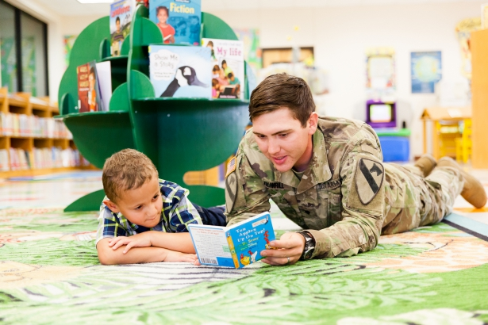

Noel Wien Public Library

Phone: 907-459-1020 | 1215 Cowles, Fairbanks, Alaska

North Pole Branch Library

Phone: 907-488-6101 | 601 Snowman Lane, Fairbanks, Alaska

North Star Imagination Library

Phone: 907-374-7030
Website: www.imaginationlibrary.com

Service Description:
This free program provides a new, carefully selected book each month for children birth-five years. It will be mailed in your child’s name directly to your home.

FAMILY & PARENTING RESOURCES

Department of Health & Social Services, Office of Children Services (OCS)

Phone: 907-451-2650 | 751 Old Richardson Highway, Suite 300, Fairbanks, Alaska

Service Description:
This State agency provides for child protection, licensed day care facilities, adoptions, foster care, and elder abuse enforcement. The State Respite Care program provides for child care assistance for families with children having special needs as well as those families who may be at high risk of abuse or neglect.

Department of Mental Health and Developmental Disabilities

Website: Division of Behavioral Health (alaska.gov)

Service Description:
This State agency provides mental health services to individuals who are Alaska residents.

USO Alaska Fort Wainwright

Phone: 907-370-0009

Service Description:
USO centers offer service members the chance to record themselves reading a favorite story to their child, or “Stronger Families” workshops for military couples. They support troop deployments and homecomings, host baby showers, meals and many other supportive programs.

New Parent Support Program (NPSP)

907-353-2101 | Fort Wainwright and Fort Greely

Service Description:
Provides professional social workers and nurses who offer supportive and caring services to military Families with children from birth to three years of age. Through a variety of programs including home visits and parenting classes, the NPSP provides opportunities to learn to cope with stress, isolation, post-deployment, reunions and the everyday demands of parenthood. The program is committed to developing strong Army Families and the prevention and treatment of Family violence. Its coordinated efforts are designed to prevent and intervene in cases of Family distress and to promote healthy Family life.

Fairbanks Native Association

Phone: 907-452-1648 | 3830 Cushman Suite 100, Fairbanks, Alaska

Service Description:
FNA is a non-profit organization which conducts a wide variety of programs intended to serve the Native community of Fairbanks and the community of Fairbanks as a whole.

Fairbanks North Star Borough Parks & Recreation

Phone: 907-459-1070

Mothers of Preschoolers (MOPS)

Eielson Air Force Base and North Pole Locations
Website: https://www.mops.org

Service Description:

At MOPS, we gather and support moms. A MOPS meeting includes practical teaching through speakers, demonstrations and videos.

Resource Center for Parents & Children (RCPC)

Phone: 907-456-2866 | 726 26th Avenue Suite 2, Fairbanks, Alaska
Website: www.rcpcfairbanks.org

Service Description:
Promotes life-long healthy families through a variety of services and programs. RCPC offers parenting education resources, family support services, parenting classes, case management, respite services, information and referrals, babysitter training, grand parenting groups, divorce and separation classes, lending library. RCPC has a lending library full of books, articles, and videos on a range of topics: Positive Discipline, Age/Stage Development and Special Needs Children.

Tanana Chiefs Conference

Phone: 907-452-8251 | 122 First Avenue, Fairbanks, Alaska
Website: https://www.tananachiefs.org/services/#client

Service Description:
A multi-service agency providing information, support and services to tribal members enrolled and living in Interior tribal communities. They provide a wide range of family services to the outlying villages, and Alaska natives living in the Fairbanks community.

Women, Infants and Children (WIC)

Phone: 907-500-8451 | Midnight Sun State of Alaska
Website: https://health.alaska.gov/dpa/pages/nutri/wic/default.aspx

Service Description:
WIC Supplementary Food Program is a nutrition program that helps pregnant women, postpartum/breastfeeding mothers, and young children under the age of 5 eat well, learn about nutrition, and stay healthy.

PREGNACY RESOURCES

New Parent Support Program (NPSP)

Phone: 907-353-2101 | Fort Wainwright and Fort Greely

Service Description:
Provides professional social workers and nurses who offer supportive and caring services to military Families with children from birth to three years of age. Through a variety of programs including home visits and parenting classes, the NPSP provides opportunities to learn to cope with stress, isolation, post-deployment, reunions and the everyday demands of parenthood. The program is committed to developing strong Army Families and the prevention and treatment of Family violence. Its coordinated efforts are designed to prevent and intervene in cases of Family distress and to promote healthy Family life.

FYNDout Free Pregnancy Center

Phone: 907-455-8255 | 4474 Pikes Landing Rd, Fairbanks, AK

Website: https://fyndoutfree.com

Provides free pregnancy tests, limited OB ultrasounds and parenting support, free diapers, wipes and clothing.

Fairbanks Regional Public Health Center

Phone: 907-452-1776 | 1025 W. Barnette Street, Fairbanks, Alaska
Website: https://www.health.alaska.gov/dph/nursing

Service Description:
The Public Health Center provides children’s immunizations and well-baby examinations on a sliding scale. Breastfeeding support, and child health information is available. Pregnancy testing, counseling, and referral for medical care. Confidential Sexually Transmitted Infections and HIV testing are available. Transportation assistance is also available for medical appointments.

Women, Infants, and Children (WIC)

(See Health & Nutrition)

Helping Alaska

Phone: 907-452-3876 | 609 3rd Street, Fairbanks, Alaska
Website: www.helpingalaska.org

NUTRITION RESOURCES

Bassett Nutrition Clinic

Phone: 907-361-5178

Alaska Cooperative Extension

Phone: 907-474-2426/2437| 1000 University Avenue, Fairbanks, Alaska

Service Description:
This free program provides information about nutrition and cooking, menu planning, low-cost meals and how to use your WIC food items.

Women, Infants, and Children (WIC)

Phone: 907-500-8451 | Midnight Sun State of Alaska
Website: https://health.alaska.gov/dpa/pages/nutri/wic/default.aspx

Service Description:
WIC Supplementary Food Program is a nutrition program that helps pregnant women, postpartum/breastfeeding mothers, and young children under the age of 5 eat well, learn about nutrition, and stay healthy. WIC provides free milk, cheese, eggs, tuna fish, cereal, fruit juice, infant formula, peanut butter, carrots, dried beans and dried peas to families with children under the age of 5.

Nutrition Assistance Program

Phone: 907-474-2437 | 1000 University Avenue, Fairbanks, Alaska
Website: http://www.uaf.edu/ces/hhfd/fnp/

Service Description:
The University of Alaska Fairbanks (UAF) Cooperative Extension Health, Home and Family Development program and the Food Nutrition Program provide training and education to Families and children about health eating and nutrition. Nutrition Educators can meet with Families or provide trainings to Families about health, food choices and nutrition assistance programs.

Army Finance

FINANCE & BUDGET INFORMATION

Phone: 907-353-1307 | Bldg. 3401 Fort Wainwright, AK

Service Description:
The Defense Military Pay Office helps Soldiers stationed at Fort Wainwright and Fort Greely.
The Finance Office provides the following services:
- Assists units with the proper preparation and timely submission of pay-related documents.
- Resolves pay-related problems with the ability to make check payments for health and comfort items, and casual payments or advance payments as appropriate.
- In-processes soldiers upon their arrival in the command. Computes and prepares settlement payments for Permanent Change of Station (PCS) travel, Family member travel and in-bound Temporary Lodging Allowance (TLA) payments.
- Assists soldiers prior to their departure from the command. Provides advance payments for PCS travel, family member travel and out-going TLA settlements.
- Computes and prepares miscellaneous payments to qualified soldiers or their family members. These payments include all reenlistment bonuses, accrued leave payments upon reenlistment, and death gratuity payments to family members of deceased soldiers.
- No check cashing services are available.

Eligibility:
Active duty military and reservist. Family members may inquire about service member pay issues as long as the Family member has a current and eligible power of attorney.

THREAD Child Care Assistance

Phone: 907-479-2212 | 1949 Gillam Way, Suite G, Fairbanks, Alaska
Website: https://www.threadalaska.org

Service Description:
Children’s Advocates, Resources and Education Services (CARES). Providing training and resources to child care providers, parents, students, educators and others working with young children. Also serves as a referral service for child care providers.

Child Support Enforcement Division

Phone: 907-269-6900 | 655 F Street, Anchorage, Alaska

Service Description:
Services include assisting parents in the collection of child support owed to them by the non-custodial parent. They will establish administrative orders for the collection of child support payments, establish paternity, and enforce the child support orders. The absent parent does not need to reside in Alaska for these services to be provided. There are no fees for these services.

Division of Public Assistance/Food Stamps

Phone: 1-800-478-7778 Fax: 1-888-269-6520
Website: https://www.health.alaska.gov/dpa/pages/default.aspx

Service Description:
Services include, cash, food stamps, Medicaid, Denali KidCare, Alaska Temporary Assistance Program (ATAP), health preventative screening services and pregnancy health care to eligible persons. Anyone living outside of Fairbanks area can communicate by mail. Pickup application for energy assistance (fuel and electricity bills) October 1-September 30.

Financial Readiness Program (FRP)

Fort Wainwright |907-353-4459; Fort Greely | 907-873-2479

Service Description:
Provides comprehensive educational and counseling programs in personal financial readiness. The program covers indebtedness, consumer advocacy and protection, money management, credit, financial planning, insurance and consumer issues. Other services offered are mandatory personal financial readiness training for first-termers and financial counseling for deployed Soldiers and their Families. Personal Financial Counselors are nationally accredited financial counselors (AFC).

HOUSING INFORMATION

North Haven Communities

Phone: 907-356-7000 | 3401 Santiago Ave, Fort Wainwright, Alaska
Website: www.fw.nhcalaska.com

Service Description:
North Haven Communities is a vibrant, master-planned development with communities at Fort Wainwright and Fort Greely. Our more than 2,500 homes offer families the convenience of being close to work, schools, and important support services as well as modern community amenities and engaging activities for the whole family. Throughout our communities our team of property management professionals will personally work with you to ensure an outstanding experience

Alaska Housing Finance Corp.

Phone: 907-456-3738 or 1-800-478-2432 | 1441 22nd Avenue, Fairbanks, Alaska
Website: https://www.ahfc.us

Service Description:
Assistance with housing/rent and Section 8 program to provide Alaskans access to safe, quality, affordable housing. Eligibility is based on income and program criteria.

Family Housing in Fairbanks and North Pole

Contact each independently for availability and eligibility requirements
Chenana Apartments- 5190 Amherst Drive | 907- 479-3655
Park West Apartment - 2006 Sandvik | 907-479-4918
Executive Estates - 1620 Washington Drive | 907-479-3655
Tanana Apartments - 350 Santa Claus Lane #14 | 907-488-3215
Rental Assistance: Department of Public Assistance | 1-800-478-7778

Fairbanks Neighborhood Housing Services

Phone: 907-451-7230 | 1427 Gillam Way, Fairbanks, Alaska
Website: https://www.fnhs.org

Service Description:
Counsels families on the home purchase process, providing funding and technical assistance for home improvement and loans and grants to help people get into affordable housing.

Interior Regional Housing Authority

Phone: 907-452-8315 | 828 27th Avenue, Fairbanks, Alaska
Website: https://www.irha.org

Service Description:
Provides affordable HUD housing for Alaska Native and American Indians in the Tanana Chiefs Conference region. Programs include rental assistance, home rehabilitation and mortgage assistance.

Interior Weatherization Program

Phone: 907-452-5323 | 713 15th Avenue, Fairbanks, Alaska

Service Description:
Provides weatherization work such as thermal doors, windows, insulation, air sealing and heating system repair of homes. The program covers homes, apartments and trailers for both owners and renters.

USDA, Rural Development

Phone: 907-479-6767 | 590 University Avenue, Fairbanks, Alaska

Service Description:
Assists families who qualify, purchase a home with zero-down loans and interest subsidized programs.

EMERGENCY HOUSING

Fairbanks Rescue Mission

Phone: 907-331-6292 | 723 27th Ave, Fairbanks, Alaska
Website: https://www.fairbanksrescuemission.org

Service Description:
Offers both a men’s and women’s center providing a bed and three meals a day. They also offer counseling, clothing, and long term Recovery programs for men and women. There are no fees for these services.

Interior Alaska Center for Non-violent Living (IACNVL)

Phone: 907-452-2293 or 1-800-478-7273 (24 hours) | 726 26th Ave. Suite 1, Fairbanks, Alaska
Website: https://www.iacnvl.org

Service Description:
A 24-hour shelter providing advocacy, crisis intervention, support groups, legal advocacy for individuals who have endured domestic violence and sexual assault. Also offering community education and training on the prevention and effects of domestic violence and sexual assault.

Fairbanks Native Association Community Services

Phone: 907- 452-5225 | 319 First Avenue, Fairbanks, Alaska
Website: www.fairbanksnative.org

Service Description:
The Fairbanks Native Association Community Services provides human and social services to individuals in need. Services include assistance with housing and shelter, weekly food boxes, assistance with financial services for venerable adults, referrals for clothing and house hold items, outreach and advocacy and adult protective services.

LEGAL RESOURCES

JAG Office Fort Wainwright

Phone: 907-353-6518/6518 | 1562 Gaffney Rd., Bldg, 1562, Fort Wainwright, Alaska

Service Description:
The Fort Wainwright Consolidated Legal Assistance Office provides worldwide support to United States Army Alaska and the Fort Wainwright military community. Its mission is to enhance combat readiness by providing a number of client and preventative law services, during both routine office appointments and pre-deployment processing. The office provides free advice and assistance to eligible clients on personal legal matters. We encourage you to bring leases, agreements, contracts, etc. to the Legal Assistance Office for review before you sign them. Eligible clients include soldiers, retirees and their family members (military ID card holders).
Alaska Lawyers Referral Service

Phone: 907-272-0352 or 800-770-9999
Website: https://alaskabar.org

Service Description:
All lawyers are members of the Alaska Bar Association and provide services for general, civil, and criminal matters. The Alaska Lawyer Referral Service is organized by types of law, such as real estate, adoption, etc. Call for cost information.

Alaska Legal Services

Phone: 907-452-5181 or 800-478-5401 | 100 Cushman Street, Suite 500, Fairbanks, Alaska
Website: https://alsc-law.org

Service Description:
Provides free legal counsel in certain types of civil matters to applicants who meet the financial eligibility criteria. Conducts clinics on self-representation in divorce and custody matters and seminars on other legal topics.

Child Support Services Division

Phone: 907-269-6900 | 655 F Street, Anchorage, Alaska

Service Description:
Services include assisting parents in the collection of child support owed to them by the non-custodial parent. They will establish administrative orders for the collection of child support payments, establish paternity, and enforce the child support orders. The absent parent does not need to reside in Alaska for these services to be provided. There are no fees for these services.

Disability Law Center of Alaska

Phone: 907-456-1070
Website: https://dlcak.org

Service Description:
Provides rights protection for children and adults with disabilities through legal-based advocacy, services include special education advocacy and entitlements.

Human Rights Commission

Phone: 1-800-478-4692
Website: https://humanrights.alaska.gov

State of Alaska Department of Corrections (Adult Probation)

Phone: 907- 458-6830 I 455 3rd Avenue, Suite 130, Fairbanks, Alaska
Website: https://www.correct.state.ak.us

Service Description:
Felon court-mandated supervision and parole supervision.

State of Alaska Ombudsman

Phone: 1-800-478-3257

Service Description:
Investigates complaints of administrative actions of State of Alaska agencies.

Tanana Chiefs Conference

Phone: 907-452-8251 | 122 First Avenue, Fairbanks, Alaska
Website: https://www.tananachiefs.org/services/#client

Service Description:
A multi-service agency providing information, support and services to tribal members enrolled and living in Interior tribal communities. Departments include: Family Services, Education, Employment, Natural Resource, Village Government, Realty and Health.

Violent Crimes Victim’s Compensation

Phone: 1-800-764-3040
Website: https://www.dps.alaska.gov/VCCB/Home

Service Description:
The Violent Crimes Compensation Board provides limited financial help to victims. The financial loss has to be the direct result of a violent crime and not reimbursable through another source such as insurance or worker’s compensation. The maximum that may be awarded is $40,000.

LIFE SKILLS

Army Volunteer Corps (AVC)

Fort Wainwright Phone: 907-353-4337; Fort Greely Phone: 907-873-2479

Service Description:
Unites all volunteers and organizations using volunteers, and strengthens volunteerism by enhancing the career mobility of volunteers, establishing partnerships, and promoting a life-long commitment to service. This in turn assists in maintaining readiness, sustaining communities, and enriching lives throughout the Army.

Employment Readiness Program (ERP)

Fort Wainwright Phone: 907-353-43377; Fort Greely Phone: 907-873-2479

Service Description:
Provides employment assistance to active duty, reserve component, transitioning and retired Soldiers, Family members, and DoD civilian employees in acquiring skills, networks, and resources that will allow them to participate in the work force and develop a career/work plan.

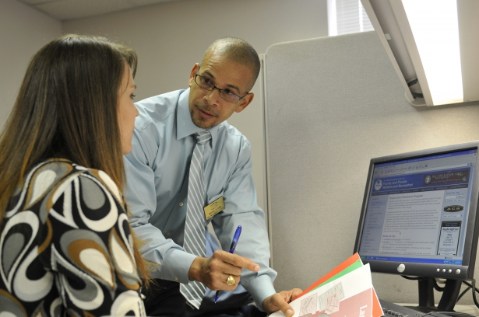



Financial Readiness Program (FRP)

Fort Wainwright Phone: 907-353-4459/7453; Fort Greely Phone: 907-873-2479

Service Description:
Provides comprehensive educational and counseling programs in personal financial readiness. The program covers indebtedness, consumer advocacy and protection, money management, credit, financial planning, insurance and consumer issues. Other services offered are mandatory personal financial readiness training for first-termers, and financial counseling for deployed Soldiers and their Families. Personal Financial Counselors are nationally accredited financial counselors (AFC).

Hutchinson Career Development Center

Phone: 907-479-2261 | 3750 Geist Road, Fairbanks, Alaska
Website: https://www.k12northstar.org/page/6375

Service Description:
Services include career counseling, employment assistance, vocational training in office occupation, cook/chef, aircraft mechanics, auto mechanics, welding and drafting. The programs are open to those 16 years and older. There are no fees for students in grades 9 - 12, but there are fees for adults

Literacy Council of Alaska

Phone: 907-456-6212 | 517 Gaffney Road, Fairbanks, Alaska
Website: www.literacycouncilofalaska.org

Service Description:
Offering one-on-one tutoring in reading, writing, math and English Services include English as a second language, and reading, writing and math instruction for adults and children; help for those with dyslexia and other reading disorders. The Literacy Council gives away thousands of books each year through their book recycling program. They also give away hundreds of computers through their computer recycling program. Computer literacy classes are available.





Fairbanks Job Center
EMPLOYMENT RESOURCES

907-451-5967 | 675 7th Avenue, Fairbanks, Alaska
Website: https://jobs.alaska.gov

Service Description:
Employment training, typing test, resource room for computer availability, workshops for interviewing skills and resume building, vocational counseling, individual employment counseling and access to internet.

Fairbanks Vet Center

Phone: 907-456-4238 | 571 Old Richardson Hwy, Fairbanks, Alaska
Website: https://www.va.gov/fairbanks-vet-center/

Service Description:
Offers confidential help for Veterans, service members, and their families at no cost in a non-medical setting. Our services include counseling for needs such as depression, post-traumatic stress disorder (PTSD), and the psychological effects of military sexual trauma (MST). We can also connect you with more support in VA and your community.

Alaska Works Partnership

Phone: 907-457-2597 | 3580 Cartwright Court, Fairbanks, Alaska
Website: https://www.alaskaworks.org

Service Description:
A non-profit organization that gives Alaskans access to jobs and careers in the construction industry, where the you can learn skills that last a lifetime and earn good pay with health care and retirement benefits.

Division of Vocational Rehabilitation

Phone: 907-451-3150| 455 3rd Ave, Suite 150, Fairbanks, Alaska
Website: https://labor.alaska.gov/dvr/

Service Description:
Helps Alaskans with disabilities find jobs by providing counseling, evaluation of physical or mental impairment, benefits analysis/counseling, career assessment, vocational counseling, job training, assistive technology, job search assistance and/or placement and other services.

Tanana Chiefs Conference - Yukon Tanana Sub Region

Phone: 907-452-8251 | 122 1st Avenue, Fairbanks, Alaska

Service Description:
A multi-service agency providing information, support and services to tribal members enrolled and living in Interior tribal communities. Providing employment training, resumes, job search services, North Slope Oil positions through Doyon.

Wage & Hour Administration

Phone: 907-451-2886 | 675 7th Avenue, Station J, Fairbanks, Alaska

Service Description:
Responsible for administration and enforcement of all state labor laws within the following areas: employment practices and working conditions, child labor, public works and contracts, and labor organization.

Worker’s Compensation Division

Phone: 907-451-2889 | 675 7th Ave, Station K, Fairbanks, Alaska

Service Description:
Provides information about workers’ compensation laws and mediates between insurance companies and the employee incapacitated due to job-related injury or illness.

Employment Readiness Program (ERP)

Fort Wainwright | 907-353-4337; Fort Greely | 907-873-2479

Service Description:
Provides employment assistance to active duty, reserve component, transitioning and retired Soldiers, Family members, and DoD civilian employees in acquiring skills, networks, and resources that will allow them to participate in the work force and develop a career/work plan.

Unemployment Insurance

Phone: 907-451-2871

Service Description:
Recruitment, selection and referral of workers to job openings. On-the-job training. Youth Corps project and specials programs for groups such as Veterans, handicapped persons, youth, elderly, etc. Also administers the employment insurance program.

UAF Community & Technical College

Phone: 907-455-2800 | 604 Barnett Street, Fairbanks, Alaska
Website: https://www.ctc.uaf.edu

Service Description:
Community interest credit and non-credit courses, certificate and associate degree programs in academic and technical areas. Student development and learning center, career counseling, advising and support for enter college. Free placement and interest testing.



SUBSTANCE ABUSE PROGRAMS
FORT WAINWRIGHT FORT GREELY
Bldg. 4055 Tamarack Rd Bldg. 702, RM 8, Big Delta Ave
(907) 361-1370 (907) 873-3785
Mon-Fri: 8:00 am-4:00 am

Special Services:
Employee Assistance Program (EAP)
Army’s Sexual Harassment/Assault Response and Prevention Program (SHARP)
Army Suicide Prevention Program (ASPP)
ASAP Drug Testing

Service Description:
The Army Substance Prevention Program offers evidence based programs to educate Soldiers, DOD Civilians and family members regarding the dangers of alcohol, THC, illegal drugs, and controlled substances. We provide community outreach through campaigns and a variety of media platforms. Below are programs we currently offer:
Programs:
PRIME for Life® (PFL) 12 Hours – Two Day Course
The 12 hour Prime for Life Course fulfills the Alcohol and Drug Abuse Prevention Training (ADAPT) requirement outlined in AR 600-85 Chapter 9 section 13. This regulation requires all Soldiers with an alcohol or drug related incident to attend a 12-hour substance abuse prevention course prior to separation of service, PCS, or deployment. Commanders, 1SGs and Unit Prevention Leaders can enroll a Soldier in this course by contacting the prevention coordinator. Commanders can refer a Soldier to the course even if they do not have an alcohol or drug related incident if that commander believes it would be a benefit to the Soldier.
PRIME for Life® (PFL) 4.5 – 4.5 hour instruction requires 5 hours of class time.
PFL 4.5 is a half day, evidenced based substance abuse prevention/education course designed for any individual 16 and older as a general prevention course or for those who may have increased risk for problems associated with alcohol use. The program provides general education about addiction but can also enhance motivation for behavior change around the use of alcohol or drugs. Classes can be scheduled at the unit level for up to 20 individuals provided an appropriate teaching space is available with social distance.

Unit Briefs
Unit Briefs can be tailored to fit your individual needs and can include topics of alcohol abuse prevention, consequences of alcohol/drug abuse, safe drinking guidelines, the dangers of THC or other needed topics. The prevention coordinator is available to meet with unit prevention leaders to assist them in preparing their classes.
Experiential Learning Activities
ASAP has have multiple sets of Fatal Vision goggles that can be signed for by unit prevention leaders. In tandem UPLS can also sign for corn hole boards, go carts and or giant trikes to use with the goggles. These are popular items especially in summer so please plan in advance.
Education Materials
ASAP has a variety of education items that UPLs can sign for or be issued. Including large substance abuse displays, posters, DVDs, teaching binders, and brochures. We have materials on a variety of topics including alcohol, substance abuse and suicide, marijuana, opiates and other illicit substances.
Eligibility:

The program provides services for active duty and retired personnel, their Family members and Department of Army civilians.

Al-Anon
Phone: 907-456-6458
Website: https://www.al-anon-ak.org

Service Description:
Al-Anon is a support group for family and friends of practicing and recovering alcoholics. Follows the 12 steps adapted from AA. Meeting times and places change call the number above of current information.

Alcoholics Anonymous (AA)

Phone: 1-800-371-7844 | 24 Hour Hotline
Website: https://www.fairbanksaa.org

Service Description:
Information, education, and support for people who think they may have a problem with alcohol or who are self-identified as alcoholics. Call for a schedule.

Fairbanks Rescue Mission

Phone: 907-331-6292 | 723 27th Ave, Fairbanks, Alaska
Website: https://www.fairbanksrescuemission.org

Service Description:
Offering a 1-year recovery program from drugs and alcohol.

Graf Rheeneerhaanjii

Phone: 907-455-4725 | 2550 Lawlor Road, Fairbanks, Alaska
Website: https://www.fairbanksnative.org

Service Description:
Residential treatment and rehabilitation program for youth who have substance abuse and co-existing disorders.

Narcotics Anonymous (NA)

Phone: 866-258-6329

Service Description:
Supportive group for those recovering from addiction to narcotic drugs. Contact phone number to reach answering service with schedule of NA meetings.



Ralph Purdue Center for Alcohol & Other Addictions (FNA)

Phone: 907-452-6251 | 3100 S. Cushman Street, Fairbanks, Alaska
Website: www.fairbanksnative.org

Service Description:
Ralph Perdue Center is a detoxification, residential and outpatient treatment service for persons 18 or older. Services include individual psychotherapy, group and family therapy, alcohol/drug education, anger management and case management.

Women & Children’s Center for Inner Healing (FNA)

Phone: 907-451-8164 | 3100 South Cushman Street, Fairbanks, Alaska
Website: www.fairbanksnative.org

Service Description:
A residential substance abuse treatment program for women 18 years and older that provides childcare, educational resources, substance abuse resources, family support services, recreational activities, case management, mental health/therapeutic resources, and services for children with disabilities. Transportation is provided for clients.

True North Recovery

Phone: 907-313-1333| 4880 Old Airport Way, Fairbanks, Alaska

Website: https://www.tnrak.org

Service Description:
True North offers crisis services, behavioral health assessments, withdrawal management services, residential in-patient treatment program, intensive out-patient program, recovery residence program, reentry services and care coordination.

MISCELLANEOUS RESOURCES

CWT Sato Travel

Fort Wainwright Fort Greely
3401 Santiago Ave, RM 72 Bldg. 600, JBER
1-855-729-8687 1-855-732-8455

Service Description:
The CWT Sato Travel offices are used for official travel only.

DRIVER’S LICENSE & VEHICLE REGISTRATION

Fairbanks DMV
Phone: 907-269-5551 | 414 3rd Street, Fairbanks, Alaska
Mon-Fri 8:30 am-4:30 pm
Closed Sat, Sun, & Holidays
Closed the first Tuesday of each month from 8:30 am-9:30 am
For more information visit: https://online.dmv.alaska.gov

UMV (Express DMV Solutions)
Phone: 1-844-373-3681 | 607 Old Steese Highway, Fairbanks, Alaska
Mon-Fri: 9:00 am-5:30 pm
For more information visit: https://umvak.com

UMV (Express DMV Solutions)
Phone: 1-844-373-3681 | 320 N. Santa Claus Lane, North Pole, Alaska
Mon-Fri: 9:00 am-5:30 pm
For more information visit: https://umvak.com

Turbo Tags and Title LLC
Phone: 907-455-8247 | 3413 Airport Way, Fairbanks, Alaska
For more information visit: http://www.turbotagstitles.com

Express Title and Tags
Phone: 907-488-3106 | 2156 Bunge Street, North Pole, Alaska
For more information visit: https://www.expresstitleandtag.com

ID CARDS/ CAC Processing

The Fort Wainwright DEERS/ID Cards ensures enrollment in the Defense Enrollment Eligibility Reporting System (DEERS), and provide Common Access Cards (CAC) and/or Official Identification Cards to Soldiers, Family members, Retirees as well as Civilian and Contract Employees working within the Pacific Rim.

Fort Wainwright Fort Greely
3401 Santiago Ave., RM 135, Fort Wainwright, AK Bldg. 556, Big Delta Ave., Fort Greely, AK
(907) 353-2195 (907) 873-3662

To make an appointment for ID cards, go to the ID Card Office Online Website: https://idco.dmdc.osd.mil/idco/

Passports

The Fort Wainwright passport office is for official passports.

Fort Wainwright
3401 Santiago Ave, Fort Wainwright, AK
(907) 353-2303

FAIRBANKS DOWNTOWN STA POST OFFICE

315 Barnette St, Fairbanks, AK
(907) 352-3223
An appointment is required.

LODGING

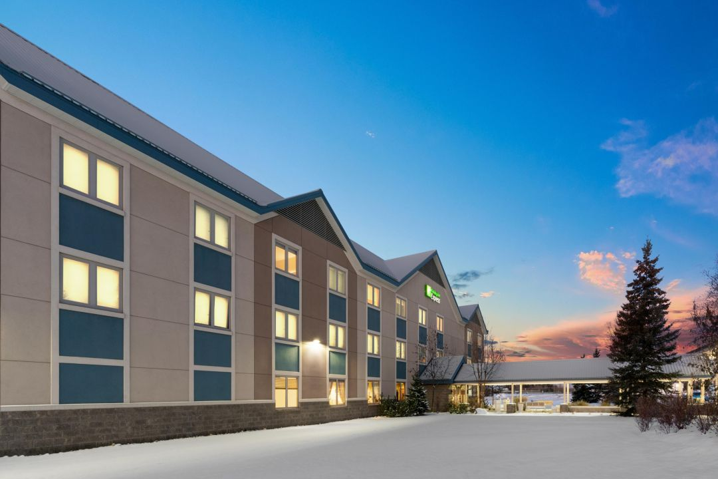

HOLIDAY INN EXPRESS (IHG HOTEL)
Bldg. 3402 Santiago Ave., Fort Wainwright, AK
(907) 370-0999 for General Questions and Reservations

Service Description:
The Holiday Inn Express is conveniently located on Fort Wainwright, AK. The hotel has a business center, fitness center, laundry rooms, a playground, picnic areas, and complimentary daily breakfast.

For more information about the Holiday Inn Express visit: https://www.ihg.com/armyhotels/hotels/us/en/fort-wainwright/mfwak/hoteldetail

ALASKA VA SERVICES
Frequently Used Numbers
 | Service | Phone Number
* | Veteran Crisis Hotline | 1-800-273-8255 - option 1
1 | Rural Veteran Coordinator | 1-888-353-7574 then 0 ask for Rural Veteran Coordinator
2 | Dental | 1-888-353-7574 ext. 4940
3 | Eligibility | 1-907-328-1750 - option 3
4 | Fairbanks VA CBOC appointments | 1-907-328-1750 - option 2
5 | Integrated Care (ICS) Questions about Authorizations from ICS | 1-888-353-7574 ext. 6904
6 | Medication refill of VA prescribed (no refills left or refills expired) | 1-907-328-1750 - option 1
7 | Medication refill of VA prescribed (which have refills left) | 1-907-328-1750 - option 1
8 | National Benefits Hotline | 1-800-827-1000
9 | Travel Questions | 1-855-574-7292
10 | Triage Nurse* after 1630 Weekdays, weekends, & Holidays | 1-800-874-2273 - option 3
11 | Billing | 1-907-328-1750 - option 4
12 | Veterans Center-Fairbanks | 1-907-456-4238
13 | Vocational Rehabilitation | 1-800-827-1000 - option 6
14 | Veteran Service Officer (DAV) | 1-907-353-2203
15 | Veteran Service Officer (VFW) | 1-907-651-9337

MILITARY ONESOURCE



“What can Army OneSource do for you?”

Toll Free: 1-800-342-9647
En espanol llame al: 1-800-342-9647
TTY/TDD accessible: 1-800-342-9647

Service Description:
Connecting with confidential help is simple with Military OneSource. Available 24/7 using the phone numbers listed or tools found at: https://www.militaryonesource.mil/.

CONSULTATION, RESEARCH and REFERRALS: Need child care, spouse employment, help with home repairs, or have a special needs issue? Call or email a Master’s-level consultant anytime! No question is too small. No issue too big.

INTERPRETATION AND TRANSLATION: In more than 140 languages. Written documents can be translated and interpreters can facilitate three-way phone calls to ensure communication between and a third party.

COUNSELING: You have access to six in-person nonmedical counseling sessions right in your own community at no cost to you. Licensed counselors can help with issue such as:
- Coping with deployment and return
- Adjusting to your new location
- Marital and couples concerns
- Parenting and family matters
- Grief and Loss
- Combat stress and more…

EDUCATIONAL MATERIALS: Whether you’re a new parent, dealing with relationship issues, or buying your first car, Military OneSource has booklets, CDs, and audiotapes to help. Order your free copies online or by phone.

INTERACTIVE WEB SITE: You’ll find locators for education, child care, and elder care, informative articles; referrals to military and community resources; financial calculators; Webinars; relocation tools; audio podcasts, access to consultants; and much more!

Serving Active Duty, Guard, Reserve and Their Families

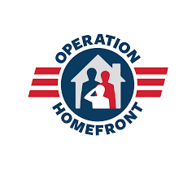
OPERATION HOMEFRONT
“Supporting our troops and helping
the families they leave behind”

Website: https://www.operationhomefront.org

Service Description:
Operation Homefront provides emergency assistance and morale to our troops, to the Families they leave behind and to wounded warriors when they return home. A nonprofit 501(c)(3), Operation Home front leads more than 4,500 volunteers in 30 chapters nationwide and has provided critical assistance to more than 45,000 military Families in need. Some of the support services provided by Operation Home front include assistance with vehicle repair, food and financial assistance, moving assistance and other not for profit support. For more information, visit the Operation Homefront webpage.

SCOUTING PROGRAMS

Boy Scouts Girl Scouts
1400 Gilliam Way 431 Old Steese Highway, Suite 100
(907) 452-1976 (907) 456-4782
https://www.midnightsunbsa.org/contact.html https://www.fairbanksgirlscouts.org

US SOCIAL SECURITY ADMINISTRATION OFFICE

101 12th Ave, Fairbanks, Alaska
1- 800-478-0391
Website: https://www.ssa.gov/

Service Description:
The Fairbanks Social Security Office determines eligibility and pays benefits to those entitled to survivor benefits. Determines eligibility and pays benefits to the entitled legally blind. Determines and pays retirement benefits to those aged 62 and older.

dmvVAILABLE TRAVEL

Eielson AFB Passenger Terminal Information

732d AMC OL-A

2939 Flight Line Ave

Eielson AFB, AK 99702

24 Hour Flight Recording: (907) 377-1623

Service Counter: (907) 377-1854/1250

E-mail: 354LRS.EielsonSpaceA.SpaceA@us.af.mil

EDUCATION CENTER

FORT WAINWRIGHT FORT GREELY
4391 Neely Rd, Fort Wainwright, AK Bldg. 661, Fort Greely, AK
(907) 361-7486 (907) 873-4369

Service Description:
Education centers provide academic and vocational programs and services for the total Army family. Services offered include professional counseling, testing and instructional support. Programs and services include graduate and undergraduate college classes, basic skills programs, tuition assistance, MOS (Military Occupational Specialty) libraries, computer labs and apprenticeship programs. The Education Center on Fort Wainwright offers college programs from three colleges and universities that serve the Armed Forces nationwide and overseas.
The institutions that offer classes on post are:
Central Texas College POC: (907) 428-1317
University of Alaska Fairbanks POC: (907) 356-3826
Wayland Baptist University POC: (907) 356-2403

Eligibility:
Active duty military and Family members. Services are provided to active duty, reservists, retirees, family members and DOD civilians

POST EXCHANGE

Location: Bldg-3703B, Fort Wainwright
Phone: 907-356-1357 (for all the food concessions below unless otherwise noted)

COMMISSARIES

Fort Wainwright Fort Greely
3703 Oak Ave, Fort Wainwright, AK Bldg. 601, 1st St, Fort Greely, AK
(907) 353-6218 (907) 873-3114
Daily: 1000-1900 Mon & Sat: 11:00 am-7:00 pm
Tues-Thurs: 10:30 am-7:00 pm
Sunday: CLOSED
Service Description:
Commissaries provide a wide-range of grocery and sundry items at a reduced cost to military personnel and families. There is a 5% surcharge on all prices.
http://www.commissaries.com/

Eligibility:
Commissary services are offered to all active duty military, reservists, retirees, and their Family member

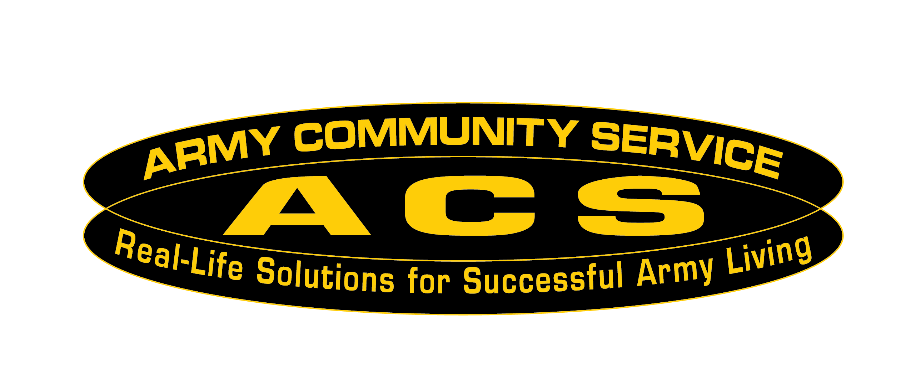

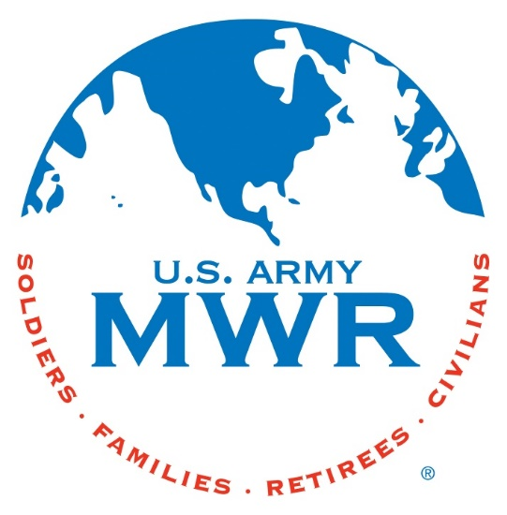

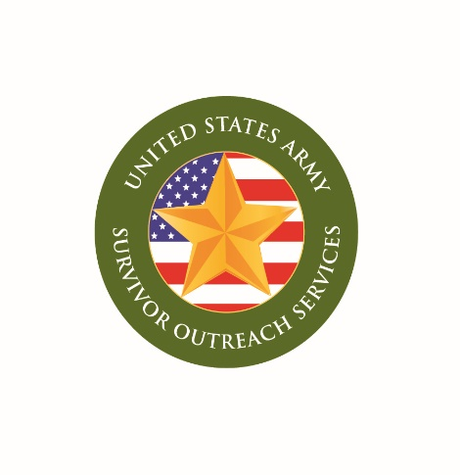
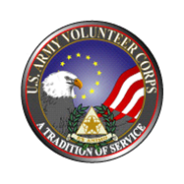

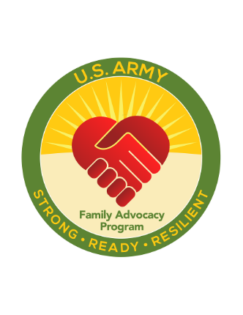
FORT WAINWRIGHT ACS
Bldg. 3401 Santiago Ave.
Phone: 907-353-4227
Monday-Friday 0800-1600
US Holiday…….….Closed
Training Holiday… Closed

