

HAAF Army Community Service

Financial Readiness Program

Jul-Dec 2025 Class Calendar

Promoting Financial

Readiness & Fitness

Class Calendar updated 6/24/2025

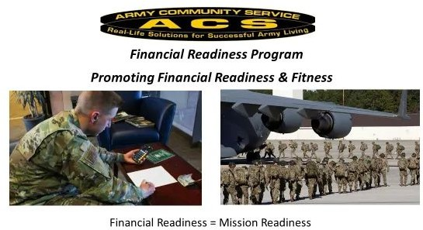

Money Management and

Financial Planning Classes

# Milestone (Touch Point)

# Trainings1

Financial Planning for PCS

First Tuesday Every Month

1030 -1130

Vesting in TSP

Jul 15, Dec 16

1030 -1100

Continuation Pay

Jul 15, Dec 16

1100 -1130

Marriage

Aug 19

1030 -1130

Divorce

Sep 16

1030 -1130

Welcoming a New Child

Oct 21

1030 -1130

Money Management2

First and Third

Tuesday Every Month

0830 -0930

Creating a Budget2

First and Third

Tuesday Every Month

0930 -1030

Credit Scoring & Debt Elimination3

Second and Fourth

Tuesday Every Month

0830 -1000

Saving, Investing and TSP

Jul 8, Sep 9, Nov 13

1000 -1130

Planning for Major Purchases

(Home and Vehicle)

Aug 12, Oct 14, Dec 9

1000 -1130

1. These trainings may be tracked by unit in DTMS and Vantage

Milestone trainings can be taken on line at <https://olms.armyfamilywebportal.com/course/index.php?categoryid=5>

1. This training is required prior to an individual budget appointment
2. This training is required prior to an individual credit appointment

Classes available by request for unit training

For more information or to register, visit

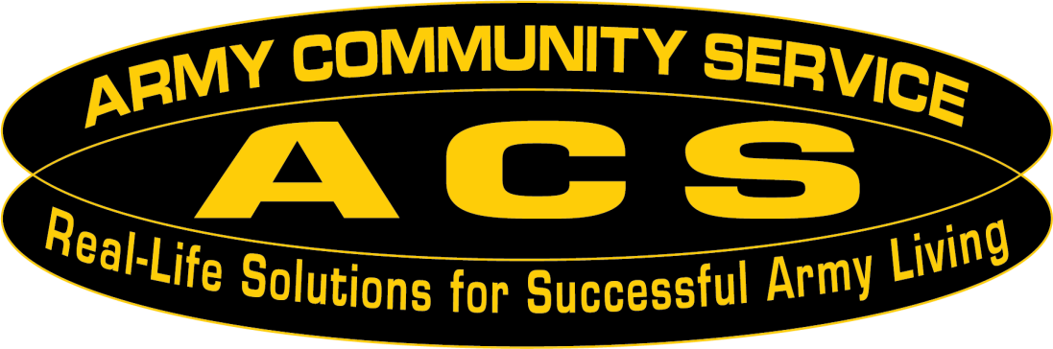ACS Financial Readiness Program HAAF Bldg. 1286

(571) 801 - 7494

# Financial Readiness = Mission Readiness

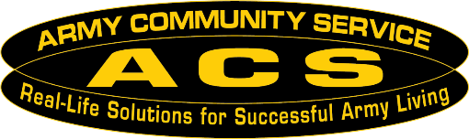

Money Management

Do your finances stress you out? Does it feel like you have no control over your money? Learn how to create a financial plan for your money and your life. This class will help you identify what you can spend to keep your finances on track and develop a plan to achieve your goals and financial freedom.

Creating a Budget

Have you ever felt like your money isn’t working for you? Does it always feel like you have more month than money? This class will walk you through creating a budget so that you can make your money work for you! Bring your end of month LES and you’ll walk out with a completed budget.

Credit Scoring & Debt Elimination

Have you ever wondered what your credit score really means? Did you know there is a difference between a credit score and a credit report? Do you feel overwhelmed by your debt? This class will help you understand how credit scoring works, what you can do to improve your score, and help you develop a plan for paying off your debt.

Major Purchase Planning (Home and Vehicle)

Are you thinking about making one of the biggest purchases of your life? Did you know without proper planning you could pay $1,000s to $100,000s more than you need to over the course of your loan? This class will help you evaluate if you are ready to make a major purchase and what you can do to lower the up front and lifetime costs of your purchase.

Saving, Investing and TSP

Should you be saving or investing and what is the difference? Have you ever wanted to start investing but didn’t know where to start? Does all the information you hear about investing leave you feeling confused? This class covers the basics of saving and investing, including helping you understand the different terms and how to identify your risk tolerance. Learn how to build wealth for the future.

**Milestone (Touch Point) Trainings**

Touch points are major military life-cycle-events that require financial training, counseling and planning to assist Soldiers in making key financial decisions throughout their career.

Financial Planning for PCS (E1-E6, O1-O3, W1)

This class covers financially planning for a PCS and includes information on entitlements, how to cover expenses, and planning for the inevitable PCS surprises.

Vesting in TSP (Soldiers investing in TSP)

Did you know that if you are contributing to TSP you are investing? Did you know that you may be receiving a match? That match is free money. Come and learn about this important retirement benefit and how it works.

Continuation Pay (Soldiers in Blended retirement between 7-12 years of service)

Did you know that you may be eligible for a bonus? If you are between years 7-12 of your enlistment, come to this class to learn about this one-time mid-career bonus.

Marriage (Soldiers getting married)

Are you getting or have recently gotten married? There are lots of things to consider with your finances in a marriage, should you combine your finances or keep them separate? Do you have enough insurance? This class will help you learn to navigate the ins and outs of finances in marriage.

Divorce (Soldiers getting divorced)

Are you getting or have recently gotten divorced? How do you separate your information? There are lots of things to navigate with finances in a divorce. This class will help you learn to navigate the ins and outs of finances during divorce.

Welcoming a New Child (Soldiers adding a minor child to DEERS)

Are you having a baby or adopting a child? There are lots of things to plan with finances as you expand your family. This class will help you learn to navigate the ins and outs of finances when growing your family.

Financial Readiness

Class Descriptions