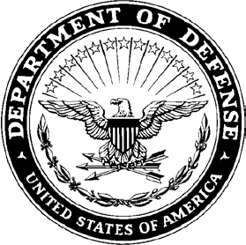**DEPARTMENT OF THE ARMY**

**UNIT LETTERHEAD**

Office Symbol 5 July 2024

MEMORANDUM FOR Accountable Officer, Ammunition Supply Point (W45NQJ), JBSA Fort Sam Houston, Texas 78234

SUBJECT: Failure to Properly Reschedule and/or Cancel an Issue Request or Receive

1. 4th SUST CMD HHC failed to receive and/or reschedule a pickup from the ASP on 15 July 2024. Doc # W45NQJ-XXXX-XXXX (**TAMIS Doc #**)
2. **The reason for this failure is……...**
3. **The corrective action is to rectify/prevent this failure is the future is……**
4. The POC for this memo is SFC Hulka, Bill at 210-625-3687 or via email at [bill.hulka.mil@army.mil](mailto:bill.hulka.mil@army.mil) .

TOM KAZANSKY

LTC, AV

Commanding