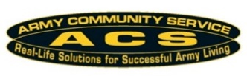
ACS REGISTRATON FORM
FOR SOLDIER AND FAMILY READINESS GROUPS

- Request registration of _________________ (unit) in Fort Riley, Kansas as a Soldier and Family Readiness Group.
The activities of the organization and its fund will be conducted IAW the provisions of AR 600-20, Chapter 5-10, The Army Command Policy; AR 608-1, Appendix J, Army Family Readiness Group Operations; and the Joint Ethics Regulation.
The purpose of the organization is to help Family Members meet the challenges of military life by providing a communication link for information, referrals, planning special events and programs, and generating small amounts of funds to support these activities.
- The SFRG’s Volunteer Leadership are as follows:
  - Advisor Phone E-mail

  - Coordinator ______ Phone E-mail

  - Funds Custodian Phone E-mail

  - Alternate Funds Custodian Phone E-mail
- SFRL/CFRR _______________________________________Phone
E-mail __________________________
- Commander’s Name_ Phone E-mail
- 1SG or CSM’s Name_ Phone E-mail

