

**Soldier for Life - Transition Assistance Program**

**Advanced Resume Writing Handout**

Resume Template, Resume Content Information, and

DOLEW (Army) Resume Examples

September 2018

Contents

RESUME TEMPLATE 3

SUGGESTED SENTENCE STARTERS: 4

SUPPORTING DOCUMENTS 6

SOME COMMON MILITARY TERMS AND ABBREVIATIONS 7

IDENTIFICATION OF JOB SKILLS BY OCCUPATION 10

ACTION VERBS - TO DESCRIBE ACCOMPLISHMENTS 12

GENERAL SUMMARY OF QUALIFICATIONS BULLETS - SOFT SKILLS 13

BULLETED STATEMENTS 14

ANALYSIS TOOL – WORD CLOUDS 16

EVALUATION USAGE 18

EVALUATION USAGE 19

DOLEW Master Resume Example 22

DOLEW Targeted Resume Example for Army Infantryman separating 25

REFERENCES WORKSHEET 31

JOB APPLICATION WORKSHEET 35

### RESUME TEMPLATE

**NAME (First and last name, no nicknames)**

Mailing Address with no abbreviations (except states)

City, State Zip

Contact Phone Number **\*** ProfessionalEmail Address

(Tell the employer your name and how to reach you. *NOTE: Mailing address is optional. If you leave off, ensure you include phone and email*)

**OBJECTIVE**

(Tell the employer what you want or what you bring)

Usually 1 sentence.Obtain a position as listed in advertisement with position identifying number if applicable **OR** combine objective statement with summary of qualifications introduction statement.

**SUMMARY OF QUALIFICATIONS**

(Tell the employer about yourself as related to the position using the four-part formula below. If you mention it in the summary, then it should be mentioned in the resume.)

1. Introduction sentence.
   1. Length of employment with what organization doing what.
2. Hard Skills
   1. Proficient in…..
   2. Experienced in…..
   3. Knowledgeable in…..
3. Soft Skills
   1. Use two to three skills that would fit well with the position applying for (and fits your skills)
   2. Communication, team player, loyal, decision-maker…
4. Other
   1. Add other relevant information such as TOP SECRET Clearance, Bi-lingual, excellent driving record, *top physical condition,* flexible and available for travel, etc. *NOTE:* you would not include physical condition unless it related to or was required for the position. Otherwise omit.
   2. This added information should be relevant to the position.

Tell the employer about your strengths and abilities using one-word descriptors below the summary of qualifications. This section is referred to as competencies, skills or a hot zone.

Use the table below to enter three, six or nine words.

|  |  |  |
| --- | --- | --- |
|  |  |  |
|  |  |  |
|  |  |  |

**FIRST AND LAST NAME 2**

(Always include heading and page number on additional pages)

**WORK EXPERIENCE**

(Tell the employer what knowledge, skills, and abilities you have as related to

the advertised position.)

**Position Title Beginning Month and Year – Ending Month Year**

**Location Enter in “Present” if still employed**

Give an overview of the department or organization in which you work and your responsibilities in approximately four lines. You should make this document a third person tense and spell everything out the first time such as United States Disciplinary Barracks (USDB) and use *acronyms* thereafter. *NOTE:* It is recommended to use civilian language and omit acronyms unless directly related to the position. Example: instead of using the acronym USDB, you could use military correctional facility. Tell the reader how large the organization, amount of customers, value of as well as the amount of local, regional, or remote sites it may be comprised. Include your knowledge, skills, and abilities. Sentences starters - Proficient in…Plan and implemented…Comprehensive experience in…Extensive knowledge of…Train and supervised staff in…Planned and conducted…etc.

**Duties**

* Add statements of your duties listing highest skill level first
* Start with an active verb such as monitored, documented, supervised
* Do not repeat yourself

**Accomplishments or responsibilities**

* Add statements of your accomplishments and how you helped the organization using percentages and numbers
* Accomplishment
* Accomplishment

**Repeat block above based on amount of jobs as far *back* as 10 years.** *NOTE*: Tailor those jobs to the applicable position, i.e., you might only need to go back six years if the first four years aren’t applicable to the position.

### SUGGESTED SENTENCE STARTERS:

|  |  |  |
| --- | --- | --- |
| Comprehensive experience in… | Extensive knowledge of… | Familiar with… |
| Knowledge of… | Plan and conduct… | Plan and implement… |
| Proficient in… | Proven abilities in… | Skilled in… |
| Train and supervise staff in… | Utilize… |  |

**TIP:** End sentence with the “Which resulted in…” technique. Example: Managed complex 750K logistics project, completing project 10 weeks early. *Which resulted in…*Managed complex 750K logistics project, completing project 10 weeks early with a cost savings of $52K.

**FIRST AND LAST NAME 3**

(Always include heading and page number on additional pages)

**EDUCATION and TRAINING**

(Tell the employer about your civilian education level; include certifications relevant to the position)

**Continuing Education** or Pursuing Degree, Name of Institution, State (hrs. completed) YYYY

**Degree Earne**d, Name of institution, State YYYY

**Bachelor of Arts**, Business, Logan College, Loganville, IA YYYY

(Next, tell the employer about any military, on-the-job training, or certifications)

**Graduate**, Name of Course, US Army, City, ST YYYY

**Certificate**, Name of Course, US Army, City, ST YYYY

**Certificate**, Name of Course, US Army, City, ST YYYY

**OPTIONAL SECTION HEADINGS**

(Tell the employer anything else they should know as **related to the position**)

**AWARDS**

**Name of the award grantor**, name of the award, purpose of the award. **YYYY**

**LANGUAGE SKILLS**

**Language:** competency level

Enter the language followed by a proficiency level such as native, conversational, fluent, written, spoken, speaking and reading, basic writing, listening, business speaking, etc.

**MEMBERSHIPS / VOLUNTEER WORK**

**Name of the Association,** Office Title/Member/Volunteer **YYYY-YYYY**

Membership in professional associations, clubs or community groups, or volunteer organizations; include name of the association, any offices held and the dates.

### SUPPORTING DOCUMENTS

|  |  |  |
| --- | --- | --- |
| Birth Certificate / Proof of Citizenship (if applicable) / Passport / Personal ID / Social Security Card | DD 2586 (VMET), Verification of Military Experience and Training | DA1059 Service School Academic Evaluation Report (describes Army courses) |
| Army / American Council On Education (ACE) Registry Transcript System -Joint Services Transcript (JST), https://jst.doded.mil/smart/ | GAP Analysis / Course Certificates, Diplomas, and Licenses | College Transcripts / Licenses / Certifications |
| Certificates of Achievement, Commendations & Awards | DA 348 Equipment Operator’s Qualification Record (list of vehicles and equipment licensed to operate) | DA 4856 Developmental Counseling Form (for enlisted job descriptions) |
| Enlisted Records Brief (ERB) / Officer Records Brief (ORB) | DA 67-9 Officer Evaluation Report (OER) (for lieutenants, captains, majors, colonels) | DA 2166-8 NCO Evaluation Report (NCOER) (for sergeants, first sergeants, and sergeant majors) |
| DA 638 Recommendation for Award (contains bullets similar to resumes) | Security Clearance Letter or beginning and ending dates of clearance | DA 300 Language Proficiency Questionnaire (for foreign language proficiency) |
| VA Disability Rating Letter (and medical records) | DD 214, Certificate of Release or Discharge from Active Duty (or Statement of Service letter from Commander may substitute until actual DD 214 is available) | References: Co-Workers / Supervisors / Teachers / Mentors |
| NOTE: Some of this information should be listed on your ITP. For example, Block 2 (Employment), has areas for professional and personal references | | |

### SOME COMMON MILITARY TERMS AND ABBREVIATIONS

| MILITARY TERMS AND ABBREVIATIONS | POSSIBLE TRANSLATION / COMMENTS |
| --- | --- |
| AAM, ARCOM, MSM (Achievements) | Recognized for…(give specific example of why award was given) |
| Adjutant General | HR Assistant, HR Generalist |
| Aid Station | Medical section, medical clinic, medical center |
| AIT | Advanced Individual Training.Include name of course, if applicable to job objective |
| ANCOC | Advanced Leadership and Management Course |
| Assigned | Employed, worked, responsible for, attached |
| Battalion (BN), Brigade (BDE), Company (CO) & Garrison | Unit, organization, staff sections, widely dispersed organizations, agency |
| BNCOC | Leadership and Management Development Course |
| Briefings | Presentations, Meetings |
| CASSS (Military Training) | Corporate Level Staff and Resource Management School |
| CGSC (Military Training) | Chief Executive Officer and Senior Corporate Level Resource Management School |
| Chain of Command | Executive levels, management, upper-level management. Also called line of command. |
| CMDR / Commander | Commander / Officer, Manager, Mid-Level; Manager, Senior Manager (but not CEO level); Supervisor, head of, leader, director, executive, officer, upper-level management |
| CO / Company | Company, A tactical and administrative army grouping of three or more platoons. Units, organizations, staff elements, activities, work centers |
| Combat | Conflict, emergency situations, crisis, crisis intervention |
| Combat Training | Survival skills, emergency training/instruction |
| Deactivation | Closure, terminated operations |
| Deployed | Assigned, Traveled (usually family/dependent restricted) |
| Detachment NCO | Operations manager/officer, supervisor, executive responsible for, chief of |
| Drill sergeant | Personnel trainer, training manager, personnel manager, supervisor, instructor, teacher |
| Drivers Badge (Achievements) | Recognized (commended) for driving over miles with no accidents or safety violations |
| Field Exercises | Dispersed operations, training |
| Field Offices | Large, diverse, or dispersed organization |
| First Sergeant | Operations manager/officer, supervisor, chief of |
| Hand receipt holder | Logistics manager, supply manager, equipment manager |
| Leader | Supervisor, executive, management, trainer, official manager, chief, director, authority |
| Maintenance | # Vehicle Fleet or kinds of |
| Mission | Functions, tasks, obligations, objectives, requirements, priorities, initiatives, operations |
| Mobilization and Selection Officer | HR Manager, HR Specialist |
| NCO | Non-Commissioned Officer. Enlisted, Supervisor, Management, middle management, senior personnel supervisor's), employee(s), leader, administrator |
| NCO Academy | Leadership course, government training course |
| OER/NCOER | Employee evaluation report, efficiency reports, performance rating |
| Officer(s) | Management, middle management, senior personnel supervisor(s), employee(s), leader, administrator, Rank structure ranges from O1 - O10. |
| OIC/NCOIC | Supervisor, director, executive, manager |
| Operational Readiness | Equipment Availability |
| Operations, NCO/Officer | Operation officer, operations manager, manager, oversaw operations, manager |
| Orderly | Training room Personnel office |
| Personnel Officer | HR Manager, Trainer, Labor Relations Manager, Military Personnel Officer |
| Platoon SGT | Personnel trainer, training manager, troop leader, personnel manager/supervisor, instructor, chief trainer |
| Platoon(s) | Personnel, individuals, people, positions, elements, team members, staff, clients, employees. A tactical and administrative infantry grouping of three or more sections or squads (i.e. about 30 men) |
| PLDC (Military Training) | Primary Leadership Course or First Line Supervisors Course, Leadership course, government training course |
| Reconnaissance | Data collection, survey, field supervision, terrain analyst, topography, geographic analyst, data collector skills |
| Scattered Units | Outlying organizations, affiliated organizations, field sections |
| SGM/CSM | Sergeant Major/Command Sergeant Major. Operations manager/ officer, supervisor, executive, management, trainer, model, guide, director, authority |
| Soldier / Subordinate | Position Title – Co-worker, Clerk, personnel, employee, individuals, people, positions, elements, team members, staff, clients, employees |
| Superior(s) | Supervisor, management, executive management, officials |
| Suspense (Suspense Date) | Deadline |
| TAC NCO | Trainer, advisor, counselor |
| Tasking / Detail | Assignment, job |
| Troops | Personnel, passengers, individuals, people, positions, elements, staff, clients, employees |
| Unit | Army grouping of three or more platoons. |
| Resources: Staff files; us.army.mil; http://www.armystudyguide.com/; http://www.acronymfinder.com/; http://www.1stiocmd.army.mil/; http://www.goarmy.com/jag/jobs.html | |

### IDENTIFICATION OF JOB SKILLS BY OCCUPATION

**AVIATION**

|  |  |  |
| --- | --- | --- |
| Pilot Certification | Flight Operations | Flight Instructing |
| Avionics | Safety / QC / Inspections | Calibrations |
| Installation | Air Traffic Control | Aerial Maps |
| Route Planning | Airframe | Power plant |

**COMBAT ARMS, TRANSPORTATION, FUEL HANDLING, SUPPLY**

|  |  |  |
| --- | --- | --- |
| Security / Guarding | Instruction | Driving |
| Transportation | Customer Service | Inspection |
| Record Management | Environmental Safety | Automation |
| Receiving / Shipping | Recycling | Communications |

**COMMUNICATIONS, INFORMATION MANAGEMENT**

|  |  |  |
| --- | --- | --- |
| Satellite Ops | Customer Service | Software |
| Data Collection | Oral Communications | Antennae Systems |
| Monitoring | System Administration | Data Entry |
| Telecommunications | Equipment Maintenance | Correspondence |

**FOOD SERVICE, HOSPITALITY**

|  |  |  |
| --- | --- | --- |
| Reservations | Staffing | Lodging |
| Marketing | Business Development | Forum Scheduling |
| Organization | Contract Assessment | Food Design/Displays |
| Budgeting / Ordering | Supply Allocations | Food Storage |

**INSTRUCTION, TRAINING**

|  |  |  |
| --- | --- | --- |
| Public Speaking | Evaluate / Critique | Material Preparation |
| Student Relations | Training Analysis | Assessment |
| Coach/Mentor | Training Standards | Curriculum |

**LAW ENFORCEMENT, PUBLIC SERVICES**

|  |  |  |
| --- | --- | --- |
| Security | Patrolling | Weapons |
| Communication | Gate Guard | Access Control Point |
| Records Check | Investigations | Vehicle Ops |

**MANAGEMENT, SUPERVISION, ADMINISTRATION**

|  |  |  |
| --- | --- | --- |
| Program Direction | Communicative Skills | Budget Formulation |
| Contracting / Outsourcing | Statistics / Analysis | Interviewing / Screening |
| Facilities Management | Financial Planning | Quality Assurance |

**MEDICAL, SOCIAL SERVICES**

|  |  |  |
| --- | --- | --- |
| Documentation | Health Plan Coordinator | Department Coordinator |
| Certifications | Licensures | Scheduling |
| Customer Service | Patient Care | Speech Therapy |

**OFFICE ADMINISTRATION, FINANCE**

|  |  |  |
| --- | --- | --- |
| Reception | Coordination | Reports / Suspense |
| Data Entry / Typing | File Management | Internal Control |
| Customer Service | Statistics | Bookkeeping |

**SALES, MARKETING**

|  |  |  |
| --- | --- | --- |
| Presentations | Briefings | Evaluations |
| Coordination | Product Knowledge | Purchasing |
| Advertising | Product Testing | Area Canvassing |

**TECHNICAL, MECHANICAL, AND CONSTRUCTION**

|  |  |  |
| --- | --- | --- |
| Diagnostics | Assembly | Airframe |
| Parts | Maintenance | Codes |
| Installation | Transmissions | Shop Operations |

Additional Resource: DA Pam 611-21 or Directory of Occupational Titles (O’NET)

### ACTION VERBS - TO DESCRIBE ACCOMPLISHMENTS

**PEOPLE THINGS IDEAS**

Accomplished Built Adapted

Activated Calculated Analyzed

Adapted Changed Coordinated

Adjusted Compiled Created

Administered Completed Defined

Advertised Constructed Devised

Advised Created Educated

Analyzed Designed Established

Arranged Drafted Executed

Assembled Edited Explained

Assisted Enlarged Illustrated

Calculated Established Implemented

Catalogued Evaluated Initiated

Chaired Examined Innovated

Coached Expanded Integrated

Conceptualized Expedited Interviewed

Conciliated Facilitated Investigated

Conducted Familiarized Maintained

Consulted Formulated Marketed

Contracted Generated Modified

Coordinated Governed Monitored

Delegated Guided Negotiated

Demonstrated Hired Obtained

Devised Identified Organized

Directed Improved Presented

Distributed Increased Presided

Effected Indexed Processed

Explained Informed Proposed

Indoctrinated Inspected Publicized

Managed Installed Recommended

Motivated Invented Recorded

Organized Prepared Recruited

Programmed Programmed Related

Promoted Revised Surveyed

Stimulated Specified Synthesized

Supervised Used Transmitted

Taught Wrote

### GENERAL SUMMARY OF QUALIFICATIONS BULLETS - SOFT SKILLS

**PRODUCTIVITY SKILLS**

* Highly organized; accomplished assigned tasks in an efficient manner.
* Well-qualified professional accustomed to competently managing multiple assignments in fast-paced environments that depend on efficiency and accuracy.
* Supervise and promote teamwork while accomplishing tasks and deadlines.

**COMMUNICATION SKILLS**

* Possess strong communication skills, proven leadership and excellent interpersonal skills.
* Able to make difficult decisions and communicate effectively in stressful situations.
* Possess excellent briefing skills and poise; highly experienced in and comfortable with presentations to senior staff.
* Ability to make important decisions and communicate effectively in stressful situations.

**LEARNING SKILLS**

* Ability to comprehend new procedures quickly and adapt to a fast-changing environment.
* Adaptive and able to comprehend new operations and procedures with minimal training and supervision
* Ability to quickly master new operations.

**SPECIFIC SKILLS**

* Exceptionally competent self-starter with a strong background in Human Resources.
* Ability to assess operations involving major organizations and develop cost-saving measures while maximizing productivity.
* Able to motivate personnel and ensure compliance with standard operating procedures.
* Skilled in producing higher performance standards and enhancing productivity.
* Skilled in cross-functional team building, organizational performance movement, and productivity gain.
* Enforced federal and state safety rules and standards.

**JUDGMENT SKILLS**

* Capable of exercising independent judgment within defined procedures and processes to determine appropriate approach.
* Possess effective and innovative problem solving skills.

**TEAM PLAYER**

* Strong ability to work as a contributing team member or team leader.
* Team player with exceptional interpersonal communication skills.

**DEPENDABILITY**

* Structured individual who is self-motivated to achieve results.
* Disciplined, honest, and dependable with a strong work ethic.
* Reliable and ready to accept any challenge.

### BULLETED STATEMENTS

**Maintenance**

* Researched, obtained approval for purchase, and managed the installation of upgraded on-board video equipment, increasing the video recording capability by ##% and image quality by ##%.
* Observer for two Army Attack Helicopter units consisting of approximately ## personnel, as well as ## Apache Helicopters and over ## wheeled vehicles.
* Initiated, coordinated and supervised # personnel in the installation of equipment modifications on ## radio transmitters and receivers, saving over $##.

**Finance**

* Managed a $## million Cash Holding Authority for a major US government agency.
* Analyzed monthly department budgeting and accounting reports for the purpose of maintaining expenditure controls.
* Supervised operations associated with the disbursement and collection of over $# million annually, affecting government payments to employees in # foreign currencies worldwide.

**Human Resources Management**

* Applied a true hands-on approach, as well as strong knowledge of non-union distribution / manufacturing environments, systems theory, organizational communications, consultation skills, and analytical thinking in addition, effective presentation and persuasion skills.
* Administered compensation programs for hourly and salaried personnel
* Ensured effective management of the Global Performance System that provided policy, process, and tools for performance plans, career development, reviews and upward supervisory feedback.

**Instructor / Training**

* Qualified ## classroom instructors.
* Recognized by senior level management for management and training excellence in training proficiency and adaptation of training protocols during annual readiness exercises.
* Developed and implemented ## lesson plans with handouts that resulted in a ##% increase in student learning and comprehension.

**Logistics**

* Established and managed a 23,000 sq. ft. government storage facility in accordance with federal regulations.
* Supervised and coordinated activities of ## workers involved in the ordering, receiving, storing, inventorying, issuing, and distribution of supplies, tools, equipment, and parts.
* Researched the history of items lost, damaged, or misplaced to determine reasons for discrepancies. Conducted 100% inventories and the distribution of supplies.

**Management**

* Conduct quarterly safety inspections, ensuring installed safety equipment is within inspection cycles and all safety equipment is within inspection standards.
* Directed all preventative and corrective maintenance action of over 35 assorted shipboard systems, valued in excess of $5 million.
* Initiated a comprehensive training program. Cross-trained eight technicians on using radar and communications systems and troubleshooting procedures which reduced trouble call response time by 65%. Maintained 100% operational capability for over three years.

**Operations**

* Coordinated and organized effective instructional programs with various organizations resulting in being recognized by senior management for obtaining a 100% training proficiency rating in all evaluated areas.
* Adapted Total Quality Management training to meet the needs of the Kentucky Army National Guard. Conducted individual and team training to over ## individuals.
* Established long-range training objectives and provided guidance for both individual and organizational training requirements to over ### employees in located within six states.

**Personnel**

* Planned and conducted new employee orientations to foster positive attitudes toward company goals, while ensuring full comprehension of all products and services offered to the public.
* Accountable for ## staff sales and recruiting representatives, ## government vehichles, and ## computer networks, with a regional responsibility of ## square miles.
* Directly supervised over 17 equipment technicians in the daily performance of maintenance applications, training missions, and quality control.

**Sales**

* Conducted over 158 exhibit shows to 35,000 potential job applicants, providing a quality lead source for local recruiters.
* Accurately managed a $130,000 operations budget to assist in the recruiting of highly qualified individuals and coordinated a worldwide training program for sales technicians.
* Earned to highest achievement award given by the U.S. Army Recruiting Command, the Glenn E. Morrell Award of Recruiting Excellence.

**Security / Law Enforcement / Corrections**

* Secured tactical equipment inventory valued in access of $40 million.
* Accurately accounted for, maintained, and secured three HMMWV’s, six Secure Radio Systems, nine M9 Pistols, three M203 Grenade Launchers, six M4 Rifles, three M239 Squad Automatic Weapons, three MK 19 Grenade launchers and peripheral equipment valued in excess of $750,000.
* Recognized for training skills. Certified 100% of the Military Working Dog teams on most recent certifications and exceeded the Department of Defense standard of 90%.

### ANALYSIS TOOL – WORD CLOUDS

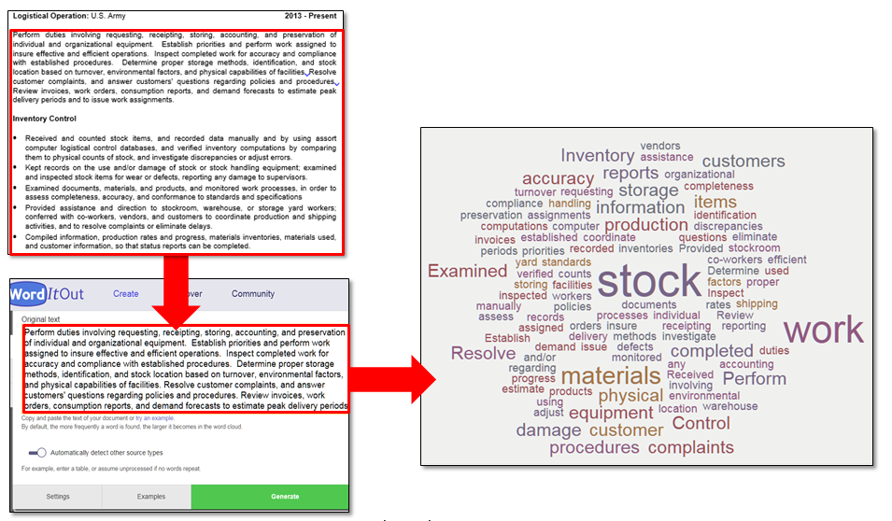

Three common online Word Cloud programs are Wordle, <http://www.wordle.net/>, Tag cloud®, <http://tagcrowd.com/>, and WordItOut, <http://worditout.com/>.

Word Clouds assemble words into patterns. The greater the size of the word in the display; the greater the use of the word in the source text.

For most sites, you will paste the job position and/or your resume information into the Word Cloud application and select generate. The program automatically formats the words into a pattern.If you have difficulty viewing any of the text, select regenerate or manually change the display settings.

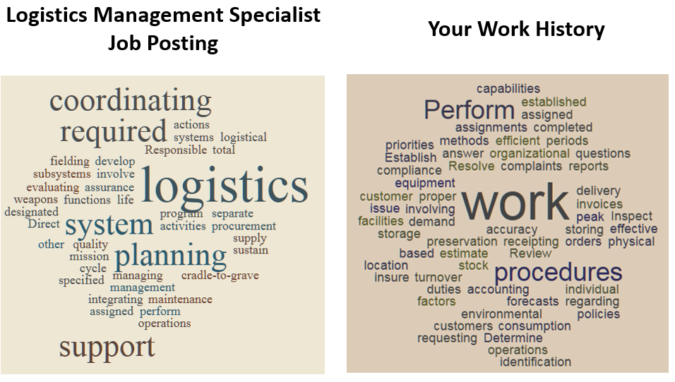

Notice which words match and which are missing. Often, agencies aren’t looking for just a single word, but a combination of words or key phrases, however, using a Word Cloud can assist in identifying some words.

In order to more closely match the job posting, one might consider incorporating “logistics”, “coordinating”, “planning”, and then reevaluating their resume.

### EVALUATION USAGE

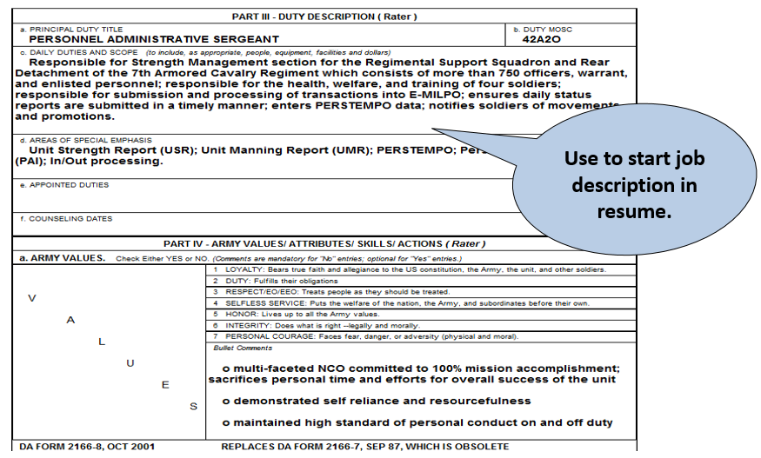

Some of the areas on the front of the OER or NCOER may provide relevant information. Remember to change the word “responsible” to an active verb, such as “Maintained”, “Supervised”, and “Allocated”.

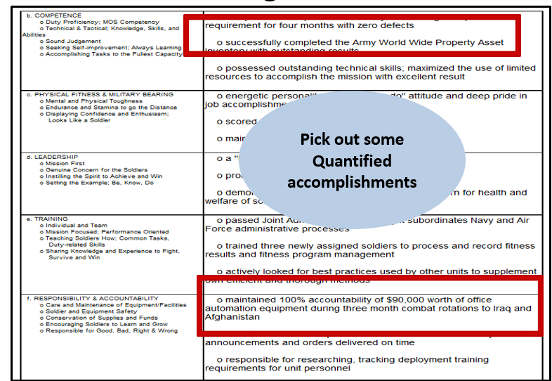

The back of the OER or NCOER may provide relevant accomplishments and quantifiable achievements during your time in the job. Include in your resume competencies. Competencies include; but, are not limited to:

* Interpersonal abilities (works well with others; team work)
* Customer service (understand how to provide good customer service)
* Flexibility (works well in fluid and changing situations)
* Creativity (can develop unique solutions to problems, situations; appreciates and implements new ideas)
* Analytic skills (analyses problems and situations and suggests solutions)
* Technical skills (have the skills required to perform the duties of the jobs).

### EVALUATION USAGE

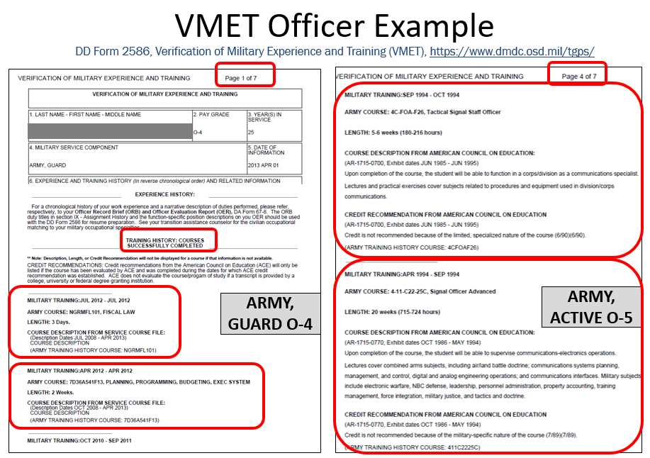

Utilize your VMET as a resource to gain some of the skill sets you were trained to do in the military. Commissioned Officers do not have an occupation description on their VMET. They are referred to their Military Personnel File for that information.

Additionally, military training classes with the number of hours and core curriculum will be on everyone’s VMET.

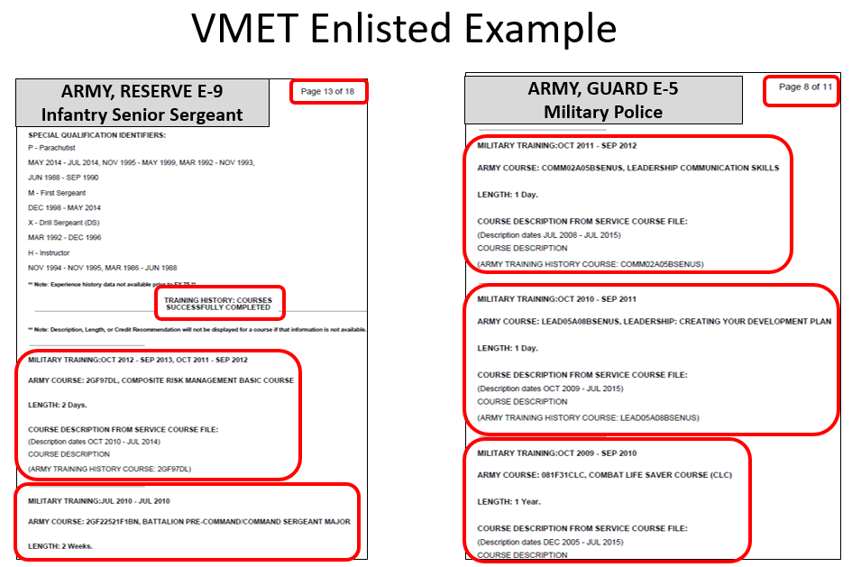

Notice that the military training is placed towards the end of the document, which for some may be on page eight or later.

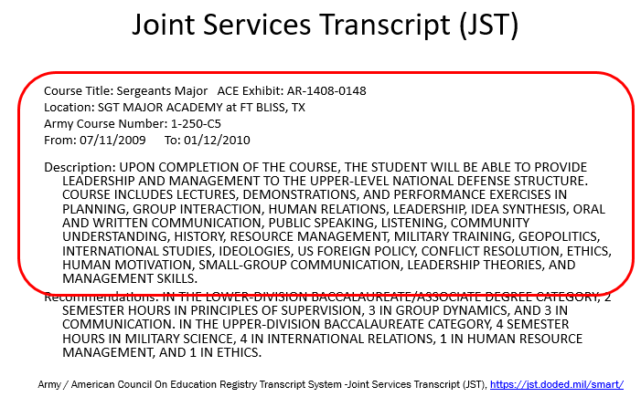

In addition to your VMET, the Joint Services Transcript also provides military education, along with a description. CCAF for Air Force.

### DOLEW Master Resume Example

*Note:* Document has not been civilianized and includes military jargon and acronyms. This would be not be included in a civilian resume unless applicable. For example, if applying to a government contractor position, the military jargon might be understood and desired. Always know your audience!

**Michael Cook**

135 Oak Street, Eastport, MD 21111

(301) 555-5555 michael.n.cook@gmail.com

**Summary of Qualifications**

Astute military professional with eight years comprehensive ground combat experience that includes extensive training and simulation participation to ensure maximum readiness. Extensive knowledge of ground surveillance protocol, mine detection techniques and explosives removal procedures. Proven ability to adapt to new surroundings while remaining continuously observant, physically capable and mentally alert under pressure.

* Active secret security clearance
* Experienced with patrols, security, and conducting safety investigations
* Expert weapons qualifications on automatic and semi-automatic weapons
* Able to operate, troubleshoot and repair radios and other electronic equipment
* Effective manager and team player
* Instructor and test evaluator for numerous Soldiers on a variety of subjects
* Three years’ experience in the U.S. Army serving at stations in the US and overseas
* Fluent in Spanish and English

**Work Experience**

**Infantryman, Fort Campbell, KY, U.S. Army, March 20XX-Present**

Served as team leader for four-person team. Duties included:

* Supervised, trained and ensured the safety and welfare of a four-person team, maintaining a 100% safety record.
* Ensured work areas were safe and hazardous materials were stored according to OSHA, EPA and DOD regulations, resulting in zero workplace accidents.
* Consistently scored in the top 10% of a 100-person organization during the semi-annual physical fitness training. Received an Ironman designation. Performed daily regimen of physical fitness to include running, push-ups, sit-ups, road marches and lightweight training.
* Trained with 5th Special Forces Group in conventional warfare.

Served as Expert Infantryman instructor for unit and test evaluator for adjacent units. Skills taught and tested included:

* Protection from chemical and biological contamination.
* Preparation of a light anti-tank weapon for safe operation.
* Performance of corrective misfire procedures.

**Infantryman, 12 month deployment to Afghanistan, March 20XX - March 20XX**

Served as Team Leader for six-person team. Duties included:

* Inspecting team members’ weapons and equipment for proper operation and 100% serviceability prior to deployment.
* Supervised, trained and ensured the safety and welfare of all assigned personnel and sustained a 100% safety record.
* Conducted more than 80 foot patrols in Afghanistan, and ensured safety of Soldiers and civilians; resulted in the identification and confiscation of over 700 pounds of explosive devices.
* Selected above 150 personnel in the unit and appointed to the distinguished position of Company Sniper.
* Successfully completed more than 15 sniper missions, enhanced overall safety of military patrol missions.
* Recognized by supervisors for excellent performance and awarded an Army Commendation medal during Operation Enduring Freedom.

Served as Expert Infantryman instructor for unit and test evaluator for adjacent units. Skills taught and tested included:

* Protection from chemical and biological contamination.
* Decontaminate personal individual equipment using chemical decontamination kits.
* Apply pneumatic splints to casualties with fractures.
* Insert Nasopharyngeal and Oropharyngeal Airways.
* Preparation of a light anti-tank weapon for safe operation.

Assigned to Post Ammunition Supply Point for 2 months. Duties included:

* Loaded, secured, and unloaded high explosive artillery rounds in vehicles.
* Conducted daily safety inspections throughout the facility.
* Implemented access control measures to ensure only authorized personnel entered the facility.
* Conducted hundreds of searches of vehicles and personnel entering the facility with zero breaches of security.
* Conducted weekly inventories of ammunition.

**Infantryman, Ft. Drum, NY, March 20XX - April 20XX**

* Operated and maintained 100% accountability for over $100,000 of equipment, including night vision goggles, multiband radios, laser target locator, and mine detection equipment.
* Certified to operate wheeled and tracked vehicles.
* Performed preventive maintenance checks and services before and after each trip.
* Logged over 400 hours and 8,000 accident-free hours as an operator.
* Inspected, issued and maintained 100% accountability for unit’s chemical, biological, radiological and nuclear defense equipment, including personal protective gear and hazard detection devices.
* Earned Expert Infantry Badge

**Basic and Infantry Training, Fort Benning, GA, December 20XX - February 20XX**

Key skills acquired:

* Safe operation and maintenance of weapons
* Teamwork
* Safe handling of explosives
* Land navigation
* Operation of radios and other electronic equipment
* Emergency medical aid

**Retail Associate, 6-12 Convenience Store, Eastport, MD, August 20XX - December 20XX**

* Oversaw a team of four, ensuring full schedule coverage for weekend daytime shifts.
* Trained new employees on computers including point of sale system.
* Stocked display shelves and conducted weekly inventory reviews, ensured adequate stock and resupply.
* Fostered customer loyalty by providing friendly and efficient service.

**Education**

12 credit hours, University of Maryland University College, ongoing

5 credits, Columbia Community College, Baltimore, MD, 20XX

High School Diploma, Columbia High School, Columbia, MD 20XX

**Military Training**

Basic Combat Training, Infantry School, Fort Benning, GA 20XX

Advanced Individual Training: Infantry School, Fort Benning, GA 20XX

Combat Sniper Course, US Army 20XX

Combat Lifesaver Course, US Army 20XX

Infantry Drivers’ Academy Course, US Army 20XX

Management Development Course

Equal Employment Opportunity (EEO) Training (yearly)

Sexual Harassment Training (yearly)

### DOLEW Targeted Resume Example for Army Infantryman separating

*NOTE:* Not all words have been civilianized, but again, know your audience. Also, note that the resume could be more targeted towards marketing to include highlighting social media; writing skills; sales skills; graphic skills; and especially public speaking.

**Michael Cook**

135 Oak Street, Eastport, MD 21111

Phone: (301) 555-5555 Email: michael.n.cook@gmail.com

**Objective**: Marketing Representative on the future-focused team at SUPER Home Remodeling

**Summary of Qualifications:**

Astute, results-oriented, self-motived professional, with a passion for excellence. Proven ability to adapt to new surroundings while remaining observant and accurately assessing what needs to be done in order to close a deal. Able to employ creative approaches and meet or exceed all designated objectives. Ability to distill complicated information into clear and concise messages for diverse audiences, and ensure that all parties reach mutually desired goals. Bilingual in Spanish and English. Relevant skills include:

|  |  |
| --- | --- |
| * Troubleshooting | * Organizational and communication skills |
| * Training and mentoring | * Scheduling meetings |
| * Inspecting and maintaining equipment | * Interfacing with customers |

**Work Experience**

**Mentoring and Training**

* Conducted training for 25+ members of the military on a variety of subjects. Ensured that all military members met training standards.
* Oversaw small groups of military members, ensuring each person was prepared and trained for the mission.
* Conducted inspections and patrols in the U.S. and overseas, ensuring safety and security. Maintained 100% accountability of all professional equipment.
* Trained newly hired employees at a retail store on shift responsibilities and point of sale system. Ensured 100% schedule coverage of weekend shifts.

**Communication Skills and Customer-Facing Experience**

* Conducted searches on hundreds of individuals and vehicles entering controlled space. Ensured zero security breaches and 100% understanding of and compliance with the government security regulations.
* Fostered customer loyalty by providing friendly and efficient service to hundreds of customers each week.
* Troubleshot electrical equipment which required speedy diagnosis through visual assessment and verbal reports. Correctly identified issues with electronics and repaired equipment ensuring that any non-operational equipment was back in service within 24 hours.
* Utilize computers, communication equipment and personal navigation devices to complete tasks quickly and accurately.
* Communicated weekly status reports of ongoing projects and problem resolution through verbal and written presentations to leadership and stake holders.

**Continuous Professional Development and Dedication to Quality**

* Selected above 150 peers to serve in a distinguished role in the U.S. Army. Recognized by supervisors for excellent performance and awarded a commendation medal.
* Maintained 100% accountability over a 3-year period for over $25,000 of sensitive government equipment.
* Served as an instructor and test evaluator in five different subject areas. Provided instruction, testing and certification for more than 20 military members preparing for work in a war zone. Recognized by leadership for resourceful problem solving techniques.
* Scored in the top 10% of a 100 person organization during physical fitness training, resulting in a designation as Ironman.

**Work History**

December 20XX – Present, Infantryman, U.S. Army, various locations in the US and overseas

August 20XX –December 20XX – Retail Associate, 6-12 Convenience Store, Eastport, MD

**Education & Training**

Associate Degree, Business Administration, University of Maryland University College, anticipated completion June 20XX

**DOLEW Resume Example** for Army E-7 retiring after 20 years

*NOTE:* Individual is seeking a supervisory position. Not all training may be applicable, but as a supervisor, always review your training and keep in mind the company. Eliminate training which doesn’t directly relate to the position.

**Bradley Patel**

1222 Javelin Court Fort Drum, NY 13602

(123) 456-7890 bradley.patel@email.com

**Objective** Supervisor position with Advanced Manufacturing Corporation

**Professional Summary**

Over 20 years of experience supervising, training, and motivating team members in the most challenging work environments.

**Experience**

**Senior Manager *(U.S. Army Platoon Sergeant)*, Fort Drum, NY**  **Sep 20XX– Present**

* Supervised 40 team members in 150+ operational missions; identified vulnerabilities and overcame shortfalls with specialized training–success confirmed with Meritorious Unit Commendation Award
* By-name request to support compliance inspection preparation team; devised program review strategy for 58 inspection areas–achieved “Outstanding” rating during major command evaluation
* Led unit’s inventory control and preventative maintenance processes for $250K vehicle fleet equipped with classified communication gear–eliminated downtime; sustained 100% accountability

**Mid-level Manager *(U.S. Army Squad Leader)*, Fort Lewis, WA Jun 20XX –Aug 20XX**

* Conducted 72 team-focused quality assurance inspections; validated standards compliance with a 97% pass rate–maximized operational readiness and elevated team competency in key processes
* Managed supply/equipment distribution of $1.2M high-value inventory; devised new re-utilization program underpinned with in-house vice contract repair–accelerated re-issue; saved $70K annually
* Developed revised curriculum for satellite communications system upgrade training; simplified complex vendor guidance with scaffold modules; raised end-of-course evaluation scores by 15%
* Expedited integration; improved multi-functional interoperability with end-users in the field

**Front-line Supervisor *(U.S. Army Team Leader, Sergeant)*, Jul 20XX – May 20XX**

**Fort Carson, CO**

* Prepared 123 unit personnel for overseas deployment; validated passport/visa documentation, confirmed medical status, evaluated training records–eliminated processing readiness errors
* Established fitness competition with associate units; measured weight, strength, agility and speed factors–inspired teamwork; unit won 10 of 12 competitions; raised morale and physical readiness

**Education**

* A.S., Management, University of Massachusetts-Lowell 20XX
* Leadership and Management School ((Senior Leader Course), 12 Weeks 20XX
* Team Leadership Training (Advanced Leader Course), 8 Weeks 20XX
* First-line Supervisor Training (Basic Leader Course) 3 Weeks 19XX

**Training**

* Equal Employment and Opportunity Training 20XX
* Sexual Harassment Prevention Training 20XX
* Advanced First Aid/CPR Training 20XX
* Suicide Prevention Training 20XX
* Operational Risk Management Training 20XX
* Occupational Safety and Health Standards Training 20XX
* Information Security Training 20XX
* Disaster Preparedness Training 20XX

**DOLEW Resume Example** for Army Major (04) separating after 14 years

*NOTE:* Always evaluate the use of additional borders or headings. Does the information use space wisely or can it be eliminated?

**Jessica MacFarlane**

5268A Wolff Avenue, Fort Bliss, TX 79906

jessica.macfarlane@email.com

915-555-1212

www.linkedin.com/in/jessicamacfarlane

**Experienced Information Technology & Support Professional**

**Objective:** Director, Technology & Support, Paragon Manufacturing Systems

**Summary**

Computer scientist with established people skills and project management experience. Ensures complicated technology projects are completed on time and under budget. Able to quickly understand user priorities and operating constraints and adapt systems to meet their unique needs. Recognized leader providing mentorship, strategic planning, and personnel development. Distinct areas of expertise include:

|  |  |  |
| --- | --- | --- |
| * Cyber Security | * Project Management | * Cost-Benefit Analysis |
| * End-user Analysis | * Network Design | * Contingency Planning |
| * Compliance | * Recovery Techniques | * Traffic Management |

**Relevant Experience**

**Information Management Officer, U.S. Army Jan 20XX – Present**

**Fort Benning, GA**

* Create, update, and monitor system compliance for 700 users with policies governing communications security, Internet and email usage, access controls, and incident response.
* Prepare, and implement departmental IT plans, including needs assessment, work plans, and resource management. Monitor processes to ensure progress and consistently meet timeline milestones and budget goals.
* Lead a team of more than 50 communications specialists, programmers, and network technicians who provide technical support to eight organizations across five states.
* Generate technical reports and formal briefings to executive leaders on developing technologies, providing the data they needed to forecast departmental IT needs.
* Collaborate with four department leads to design, plan and implement proprietary database to manage inventory control of 2,500 computer components across multiple platforms.
* Direct daily operations of information management office with $1.2 million annual budget.

**Special Projects Officer, U.S. Army Oct 20XX – Dec 20XX**

**Fort Hood, TX**

* Led study group that evaluated and selected hardware and software to upgrade communication networks at three military bases serving 65,000 users.
* Designed and supervised the implementation of a program that combined customized software, computer networks, and new processes that were adopted by 120 operating departments.
* Conducted monthly training inspections with geographically-dispersed units, leading to 98% mastery rate for students learning new computer systems.
* Planned and coordinated replacement of 1,300 obsolete computers with upgraded systems increasing efficiency over 75%. Created procedure to ensure continuity of upgrades.

**Education & Training**

U.S. Army Information Systems Manager Course, Fort Gordon, GA

Signal Officer Basic Course, Fort Gordon, GA

Bachelor of Science, Computer Science, California State University, Bakersfield, CA

REFERENCES WORKSHEET

**NOTE:** Information is also identified on ITP Block 2. Worksheet allows for more details and extra references. Use identifier for unisex names, i.e., Ms. Jordan Smith or Mr. Jordan Smith. Suggest having numerous references to prevent burnout from using same individuals over and over.

**PROFESSIONAL REFERENCES** (Address work qualifications and work experience; consider managers, supervisors, co-workers, colleagues, etc.)

**Professional Reference 1**

First/Last Name __________________________________________

Title: ________________________________________________________________________

Company: ________________________________________________________________________

Street Address: ______________________________________________________________________

City, State, Zip Code: __________________________________________________________________

Daytime Phone; Email: ________________________________________________________________

*Optional: Relationship with reference, i.e., Richard Smith was my direct supervisor (SSG) at Fort Hood from June 2013 to December 2015: ______________________________________________________________*

**Professional Reference 2**

First/Last Name: __________________________________________

Title: ________________________________________________________________________

Company: ________________________________________________________________________

Street Address: ______________________________________________________________________

City, State, Zip Code: __________________________________________________________________

Daytime Phone; Email: ________________________________________________________________

*Optional: Relationship with reference, i.e., Richard Smith was my direct supervisor (SSG) at Fort Hood from June 2013 to December 2015: ______________________________________________________________*

**Professional Reference 3**

First/Last Name: __________________________________________

Title: ________________________________________________________________________

Company: ________________________________________________________________________

Street Address: ______________________________________________________________________

City, State, Zip Code: __________________________________________________________________

Daytime Phone; Email: ________________________________________________________________

*Optional: Relationship with reference, i.e., Richard Smith was my direct supervisor (SSG) at Fort Hood from June 2013 to December 2015: ______________________________________________________________*

**Professional Reference 4**

First/Last Name: __________________________________________

Title: ________________________________________________________________________

Company: ________________________________________________________________________

Street Address: ______________________________________________________________________

City, State, Zip Code: __________________________________________________________________

Daytime Phone; Email: ________________________________________________________________

*Optional: Relationship with reference, i.e., Richard Smith was my direct supervisor (SSG) at Fort Hood from June 2013 to December 2015: ______________________________________________________________*

**PERSONAL REFERENCES** (Address my character; consider members of volunteer organizations, coach, former teacher, etc.)

**Personal Reference 1**

First/Last Name (Use identifier if needed, such as nickname, i.e., Margaret Smith is known as Peggy Smith or Bob Smith is Robert Smith): ________________________________________

Title if applicable: ____________________________________________________________________

Organization: _______________________________________________________________________

Street Address: ______________________________________________________________________

City, State, Zip Code: __________________________________________________________________

Daytime Phone; Email: ________________________________________________________________

*Optional: Relationship with reference, i.e., Peggy was my mentor from June 2011 to December 2013:* _________________________________________________________________________

**Personal Reference 2**

First/Last Name: __________________________________________

Title: ________________________________________________________________________

Company: __________________________________________________________________________

Street Address: ______________________________________________________________________

City, State, Zip Code: __________________________________________________________________

Daytime Phone; Email: ________________________________________________________________

*Optional: Relationship with reference, i.e., Peggy was my mentor from June 2011 to December 2013:* _________________________________________________________________________

**Personal Reference 3**

First/Last Name: __________________________________________

Title: _________________________________________________________________________

Company: __________________________________________________________________________

Street Address: ______________________________________________________________________

City, State, Zip Code: __________________________________________________________________

Daytime Phone; Email: ________________________________________________________________

*Optional: Relationship with reference, i.e., Peggy was my mentor from June 2011 to December 2013:* _________________________________________________________________________

### JOB APPLICATION WORKSHEET

**NOTE:** Information is also identified on ITP Block 2. Worksheet allows for more details.

**Job Application 1**

(Optional: print and attach job announcement)

Website accessed (username/password): __________________________________________________

Announcement # or Position Title: ______________________________________________________

Industry/Company Name: _____________________________________________________________

Location of Position: _________________________________________________________________

Date applied / Date position closes: ______________________________________________________

Name of Resume Used: _______________________________________________________________

Documents submitted: (Circle all that apply)

|  |  |  |
| --- | --- | --- |
| Cover Letter | DD 214 | Transcripts |
| Licenses / Certificates | Resume | References |
| Diplomas |  |  |

Other documents: ___________________________________________________________

Keywords:

1. ________________________________________________
2. ________________________________________________
3. ________________________________________________

Notify these three individuals, who have granted permission to be used as a reference, and provide a copy of this resume along with position title:

|  |  |
| --- | --- |
| **Name** | **Received a copy of my resume (Y/N)** |
|  |  |
|  |  |
|  |  |

Comments (Environmental concerns, transportation costs/commute distance, company benefits, relocation assistance, etc.): __________________________________________________________________________

__________________________________________________________________________

**Job Application 2**

(Optional: print and attach job announcement)

Website accessed (username/password): __________________________________________________

Announcement # or Position Title: ______________________________________________________

Industry/Company Name: _____________________________________________________________

Location of Position: _________________________________________________________________

Date applied / Date position closes: ______________________________________________________

Name of Resume Used: _______________________________________________________________

Documents submitted: (Circle all that apply)

|  |  |  |
| --- | --- | --- |
| Cover Letter | DD 214 | Transcripts |
| Licenses / Certificates | Resume | References |
| Diplomas |  |  |

Other documents: ___________________________________________________________

Keywords:

1. ________________________________________________
2. ________________________________________________
3. ________________________________________________

Notify these three individuals, who have granted permission to be used as a reference, and provide a copy of this resume along with position title:

|  |  |
| --- | --- |
| **Name** | **Received a copy of my resume (Y/N)** |
|  |  |
|  |  |
|  |  |

Comments (Environmental concerns, transportation costs/commute distance, company benefits, relocation assistance, etc.): __________________________________________________________________________

__________________________________________________________________________