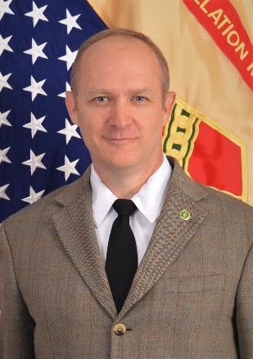
David J. Fullmer
Interim Deputy to the Garrison Commander
Parks Reserve Forces Training Area

Email Address: david.j.fullmer4.civ@mail.mil

David Fullmer assumed position as the Interim Deputy to the Garrison Commander (DGC) at Parks Reserve Forces Training Area (PRFTA) in October 2018. As the DGC, Mr. Fullmer is the Garrison Commander’s primary advisor on base operations support and installation service delivery.
.
Career Chronology:
- Oct 18 – Present GS13, Interim Deputy to the Garrison Commander, PRFTA
- Jul 14 – Sep 18 GS13, Chief, Plans Analysis & Integration, USAG Fort Hunter
Liggett (FHL)
- Oct 17 – Feb 18 GS13, Director, Emergency Services USAG FHL
- Nov 14 – Jul 17 GS13, Interim Director, Human Resources, USAG FHL
- Mar 12 – Jul 14 GS14, Chief, Force Protection Division, U.S. Army Africa
- Aug 09 – Mar 12 GS13, Director, Emergency Services, USAG FHL
- Oct 08 – Aug 09 YC02, Chief, Physical Security, NAS Patuxent River
- Apr 07 – Oct 08 GS11, Deputy Director, DPTMS, USAG Okinawa

Significant Training:
- Certified Public Manager Program (CP29), 2016
- Graduate, Amy Community of Excellence Examiner Course, 2015
- Graduate, Advance Course, 2011

Certifications:
- Certified Public Manager, 2016

Education:
- Masters of Science in Administration, Central Michigan University, 2004

Awards and Honors:
- Commanders Award for Civilian Service, 2012
- Multiple Performance and on the spot awards

