FORT MCCOY

INTEGRATED NATURAL RESOURCES MANAGEMENT PLAN
2021

Prepared by

Directorate of Public Works

Environmental Division

Natural Resources Branch

Fort McCoy, Wisconsin

Effective
2021 until revised

FORT MCCOY
INTEGRATED NATURAL RESOURCES MANAGEMENT PLAN

2021

Prepared By:

Charles Mentzel Forester

David Beckmann Wildlife Biologist

John Noble Fisheries Biologist

Jessup Weichelt Endangered Species Biologist

Kevin Luepke Natural Resources Specialist

Aaron Yaeger Environmental Assessment Preparer

Tim Wilder Chief, Natural Resources Branch

Ryan Howell Cultural Resources Program Manager

FORT MCCOY
INTEGRATED NATURAL RESOURCES MANAGEMENT PLAN (INRMP)

2021

Approved By:

_____________________________________________________

Fort McCoy Director of Plans, Training, Mobilization and Security

______________________________________________________

Fort McCoy Director of Public Works

_______________________________________________________

Fort McCoy Garrison Commander

In Agreement with the INRMP

__________________________________________________________

US Fish and Wildlife Service

_____________________________________________________________

Wisconsin Department of Natural Resources

CONTENTS

LIST OF FIGURES AND TABLES vi

EXECUTIVE SUMMARY vii

1.0 OVERVIEW 1
1.1 Authority 1
1.2 Purpose 1
1.2.1 Compliance Requirements 1
1.2.2 Stewardship Requirements 2
1.3 Scope 2
1.4 Goals 3
1.5 Responsibilities 4
1.5.1 Directorate of Public Works (DPW) 4
1.5.2 Directorate of Plans, Training, Mobilization, and Security (DPTMS) 5
1.5.3 Directorate of Emergency Services (DES) 7
1.5.4 Directorate of Family and Morale, Welfare and Recreation (DFMWR) 7
1.5.5 Other Defense Organizations 7
1.5.6 Other Federal Agencies 8
1.5.7 State Agencies 9
1.5.8 Universities 9
1.5.9 Contractors 10
1.5.10 Monroe County Land Conservation Department (LCD) 10
1.5.11 Other Interested Parties 10
1.6 Review and Revision Process 10
1.6.1 Annual Review 10
1.6.2 Major Revision 10
1.7 Management Strategies 11
1.7.1 Ecosystem Management 11
1.7.2 Biodiversity 11
1.7.3 Landscape 11
1.7.4 Multiple-use 11
1.7.5 Science and Data Collection 11
1.8 Other Plan Integration 11

2.0 CURRENT CONDITIONS AND USE 12
2.1 Installation Information 12
2.1.1 Description 12
2.1.2 Area Information 12
2.1.3 Land Use History 12
2.1.4 Fort McCoy History 14
2.2 Facilities 14
2.2.1 Overview 14
2.2.2 Cantonment 14
2.2.3 Housing 16
2.2.4 Recreation Areas 16
2.2.5 Transportation Systems 16
2.2.6 Water 17
2.2.7 Projected Changes in Facilities 18
2.3 Military Mission 18
2.3.1 Overview 18
2.3.2 Natural Resources Needed to Support the Military Mission 19
2.3.3 Effects of the Military Mission on Natural Resources 20
2.3.4 Effects of Natural Resources Management on the Mission 21
2.3.5 Future Military Mission Impacts on Natural Resources 22
2.4 Physical Environment 22
2.4.1 Topography and Geology 22
2.4.2 Glacial Influence 23
2.4.3 Climate 23
2.4.4 Air Quality 23
2.4.5 Soils 23
2.5 Ecosystems 26
2.5.1 Fort McCoy Ecosystem 26
2.5.2 Tension Zone 26
2.6 General Biotic Environment 26
2.6.1 Water Resources 26
2.6.2 Flora 33
2.6.3 Floral Inventories 40
2.6.4 Fauna 41
2.6.5 Threatened and Endangered Species 41

3.0 ENVIRONMENTAL MANAGEMENT STRATEGY AND MISSION SUSTAINABILITY 42
3.1 Land Uses 42
3.1.1 Standard Training Areas 42
3.1.2 Special Training Areas 42
3.1.3 North Impact Area (NIA) 42
3.1.4 Developed Areas 46
3.1.5 Wetlands and Fort McCoy Natural Areas 47
3.1.6 Experimental Plots and Study Areas 47
3.1.7 Recreation Areas 48
3.1.8 Wellhead Protection Area 49
3.1.9 Outleases and Easements 49
3.1.10 Shale Quarries and Sand Pits 50
3.1.11 Stump Disposal Areas 50
3.2 Management Units 51
3.2.1 Training Areas 51
3.2.2 Forestry Compartments 51
3.2.3 Special Management Areas 52
3.3 Natural Resources Consultation Requirements 52
3.4 National Environmental Policy Act (NEPA) Review 52
3.4.1 NEPA Goals 52
3.4.2 NEPA Categories 52
3.5 Partnerships and Collaborative Resource Planning 53
3.6 Public Access and Outreach 53
3.6.1 Outreach Objectives 53
3.6.2 Military Personnel Awareness 54
3.6.3 Public Awareness 54
3.6.4 Volunteer Programs 54
3.6.5 Environmental Education 54
3.6.6 Research Opportunities 54
3.7 Encroachment Partnering 55
3.7.1 Army Compatible Use Buffers (ACUB) 55
3.8 State Comprehensive Wildlife Plan 55
3.8.1 Additional Documents Citing Fort McCoy’s Ecological Significance 56
3.9 Climate Change Vulnerability Assessment 56
3.9.1 Wisconsin Climate Trends 56
3.9.2 Wisconsin Climate Projections 56
3.9.3 Affected Resources on Fort McCoy 57
3.9.4 Fort McCoy Management Actions 57
3.9.5 DoD Report on Effects of a Changing Climate 58

4.0 PROGRAM ELEMENTS 60
4.1 Threatened and Endangered Species Management 60
4.1.1 Management Activities 60
4.1.2 Karner Blue Butterfly Surveys and Management 60
4.1.3 Gray Wolf Surveys and Management 61
4.1.4 Northern Long-Eared Bat Surveys and Management 62
4.1.5 Rusty Patched Bumble Bee Surveys and Management 62
4.1.6 Blanding’s and Wood Turtle Surveys and Management 63
4.1.7 Monarch Butterfly Surveys and Management 63
4.1.8 Regal Fritillary Butterfly Surveys and Management 64
4.1.9 Frosted Elfin Butterfly Surveys and Management 64
4.1.10 Golden-Winged Warbler Surveys and Management 64
4.1.11 Little Brown Bat Surveys and Management 65
4.1.12 Tri-Colored Bat Surveys and Management 65
4.1.13 Ottoe Skipper Butterfly Surveys and Management 65
4.1.14 Phlox Moth Survey and Management 66
4.1.15 Bald Eagle Surveys and Management 66
4.1.16 Cerulean Warbler Surveys and Management 66
4.1.17 Henslow’s Sparrow Surveys and Management 66
4.1.18 Red-tailed Prairie Leafhopper Survey and Management 66
4.1.19 Rough White Lettuce Surveys and Management 67
4.1.20 Eastern Massasauga Rattlesnake Surveys and Management 67
4.1.21 Bullsnake Surveys and Management 67
4.2 Law Enforcement of Natural Resources Laws and Regulations 67
4.2.1 History and Authority 67
4.2.2 Jurisdiction 68
4.2.3 Enforcement Activities 68
4.2.4 Training 68
4.2.5 CLEP Responsibilities 69
4.3 Wetlands Management 69
4.3.1 Management Activities 70
4.4 Fisheries Program – Watershed Management 70
4.4.1 Management Activities 70
4.4.2 Watershed Management - Lake Resources 71
4.4.3 Watershed Management – Stream Resources 71
4.5 Wildlife Management 75
4.5.1 White-tailed Deer Management 76
4.5.2 Hunting and Trapping Seasons 76
4.5.3 Habitat Management 77
4.5.4 Grassland (Prairie) Management 77
4.5.5 Game Species Surveys 78
4.6 Forestry 78
4.6.1 Forest Inventory 78
4.6.2 Timber Harvest 79
4.6.3 Forest Health 80
4.6.4 Timber Stand Improvement 81
4.6.5 Reforestation 81
4.7 Vegetative Management 82
4.7.1 Vegetative Inventories 82
4.7.2 ITAM Vegetation Management 83
4.7.3 Grounds Vegetation Management 84
4.8 Migratory Bird Management 84
4.8.1 Unintentional Take of Migratory Birds for Actions Other than Military Readiness Activities 85
4.8.2 Management Activities 85
4.9 Invasive Plant Control 86
4.9.1 Management Activities 86
4.9.2 Invasive Plant Species Monitoring 87
4.10 Pest Management 87
4.10.1 Management Activities 87
4.11 Integrated Training Area Management 87
4.11.1 Range and Training Land Assessment 87
4.11.2 Land Rehabilitation and Maintenance 89
4.11.3 Geographic Information System 91
4.11.4 Training Requirements Integration 92
4.11.5 Sustainable Range Awareness 92
4.12 Agriculture/Grazing Outleases 92
4.12.1 Management Activities 92
4.13 Geographic Information Systems (GIS) Management 92
4.14 Outdoor Recreation 92
4.14.1 Military Mission Considerations 92
4.14.2 Public Access 93
4.14.3 Hunting, Fishing, and Trapping Programs 93
4.14.4 Other Natural Resources Oriented Outdoor Recreation 94
4.14.5 Safety and Security 94
4.15 Wildlife Aircraft Strike Hazard (WASH) Program 94
4.16 Wildland Fire Management 94
4.16.1 Wildland fire Partnerships 95
4.16.2 Priority Actions 95
4.16.3 Reducing Wildland fire Potential 95
4.16.4 Management Activities 95
4.16.5 Wildland Fire Training 96
4.16.6 Prescribed Burns 96
4.17 NRB Training 97
4.18 Coastal/Marine Management 99
4.19 Floodplains Management 99
4.20 Other Leases 99
4.20.1 Management Activities 99
4.21 Fort McCoy Natural Areas Management (FMNA) 99
4.21.1 Management Activities 99
4.22 Military Land Use Areas Management 99
4.22.1 North Impact Area (NIA) 100
4.22.2 Drop Zones (DZ), Air Assault Strip and Landing Zones (LZ) 100
4.22.3 Improved Ranges 100
4.23 Developed Areas Management 101
4.23.1 Cantonment and Housing Area Management 101
4.23.2 Airport Management 101
4.23.3 Roads and Railroads 101
4.24 Cultural Resources Management (CRM) 102
4.24.1 Cultural and Historic Resources 102
4.25 RTLA Bird and Small Mammal Surveys 103
4.26 Soil Resources 103
4.26.1 Inventory 103
4.26.2 Monitoring 104
4.26.3 Erosion 104
4.26.4 Management Activities 104
4.27 Data Storage, Retrieval and Analysis 104

5.0 IMPLEMENTATION OF THE PLAN 105
5.1 Project Development 105
5.1.1 Determine Project Need 105
5.1.2 Project Details 105
5.1.3 Project Approvals 105
5.1.4 Project Completion 105
5.2 Achieving No Net Loss 105
5.2.1 Internal Constraints 106
5.2.2 External Constraints 108
5.3 Use of Cooperative Agreements (CAs) 108
5.4 Funding 109
5.4.1 Budget Requirements Worksheet 109
5.4.2 Reimbursable Funds 109
5.4.3 Un-Resourced Requirements 110
5.5 NRB Staffing 110
5.5.1 Volunteers 110
5.6 Monitoring Progress 110
5.6.1 INRMP Implementation Assessment 111

6.0 ENVIRONMENTAL ASSESSEMENT 112
6.1 Introduction 112
6.2 Purpose and Need for the Proposed Action 112
6.3 Description of the Proposed Action 112
6.4 Alternatives Considered 112
6.5 Affected Environment 112
6.6 Environmental Consequences 112
6.7 Cumulative Effects 113
6.8 Conclusions Regarding Significance of Impacts 113
6.8.1 Context 113
6.8.2 Intensity 113
6.9 List of Preparers and Agencies and Persons Consulted 114
6.9.1 Preparers 114
6.9.2 Persons Consulted 114

Bibliography 115

APPENDIX A Acronyms

APPENDIX B Implementation Schedule

APPENDIX C Training Restrictions

APPENDIX D Streams, Lakes and Impoundments

APPENDIX E Species Lists

APPENDIX F Mound Prairie Sacred Area Management Plan

APPENDIX G Sample Prescribe Burn Management Plan

APPENDIX H Finding of No Significant Impact

APPENDIX I Public Review Comments and NRB Replies

LIST OF FIGURES AND TABLES

Figure 1. Fort McCoy regional location….…………………….…….……….….….12
Figure 2. Public land near Fort McCoy……….……………………….….…….…...13
Figure 3. Facilities.......................................................................................................15
Table 1. Fort McCoy construction projects................................................................18
Figure 4. Soil types on Fort McCoy............................................................................25
Figure 5. Major watersheds on Fort McCoy...............................................................27
Figure 6. Reduction in time required for Eurasian Watermilfoil removal..................28
Figure 7. Dredging operations on Hazel Dell Lake ...................................................29
Figure 8. Streams, lakes, impoundments, wetlands and natural areas........................32
Figure 9. Fort McCoy trout trends...............................................................................33
Figure 10. Land Cover Types......................................................................................35
Figure 11. Succession model for dry upland plant communities................................37
Figure 12. Oak savanna...............................................................................................38
Figure 13. Goat prairie................................................................................................38
Figure 14. Northern red oak forest..............................................................................39
Figure 15. Succession model for dry mesic upland plant communities......................40
Figure 16a. Land Uses on North Post of Fort McCoy................................................43
Figure 16b. Land Uses on South Post of Fort McCoy................................................44
Table 2. Range Complex Master Plan projects...........................................................45
Figure 17. Flooding at the parade field in 2017..........................................................58
Figure 18. Female Karner blue butterfly.....................................................................60
Figure 19. Remote Water Sampling Devices..............................................................73
Figure 20. Streambank restoration and habitat improvement project.........................75
Figure 21. Prescribed burning.....................................................................................77
Table 3. Grass mowing requirements..........................................................................84
Table 4. Permit sales information................................................................................94
Figure 22. Prescribe burn locations.............................................................................98

EXECUTIVE SUMMARY

PURPOSE

The purpose of the Integrated Natural Resources Management Plan (INRMP) is to support the military mission at Fort McCoy from 2021 until revised by prescribing natural resources conservation measures that are integrated and consistent with federal and state stewardship requirements with minimal impact and encroachment on the training areas, live fire ranges, and impact area within the Range Complex. It provides goals to guide natural resource programs and serves as a reference manual for understanding the management of Fort McCoy natural resources. It is also a support tool for the Fort McCoy Integrated Training Area Management (ITAM) program. Embedded within the INRMP is the Environmental Assessment for natural resources management on Fort McCoy.

ENVIRONMENTAL COMPLIANCE

Installations are required to prepare and implement an INRMP according to Army Regulation (AR) 200-1, the Sikes Act (16 U.S.C. 670a et. Seq.), Office of the Deputy Under Secretary of Defense (DUSD), Updated Guidance for the Implementation of the Sikes Act, 5 November 2004, Department of Defense (DoD) Instruction 4715.03 (Natural Resources Conservation Program), 5 October 2017 and Department of Defense Manual 4715.03 (Integrated Natural Resources Management Plan Implementation Manual), 31 August 2018.
This INRMP has the signatory agreement of the US Fish and Wildlife Service (USFWS) and the Wisconsin Department of Natural Resources (WDNR). This agreement signifies that the INRMP complies with the Endangered Species Act. Review of the INRMP is considered informal consultation with regard to the Endangered Species Act.
The Sikes Act, as amended in November 1997, requires that INRMPs include:
- • fish and wildlife management, land management, forest management, and wildlife-oriented recreation;
- • fish and wildlife habitat enhancement or modifications;
- • wetland protection, enhancement, and restoration where necessary for support of fish, wildlife, or plants;
- • integration of, and consistency among, the various activities conducted under the Plan;
• establishment of specific natural resource management goals and objectives and time frames for proposed action;
• sustainable use by the public of natural resources to the extent that the use is not inconsistent with the needs of fish and wildlife resources;
• public access to the military installation that is necessary or appropriate for sustainable use by the public of natural resources to the extent that the use is not inconsistent with the needs of fish and wildlife resources, subject to requirements necessary to ensure safety and military security;
• enforcement of applicable natural resource laws;
• no net loss in the capability of military installation lands to support the military mission of the installation;
• regular review of this INRMP and its effects, not less often than every five years;
• provisions for spending hunting and fishing permit fees exclusively for the protection, conservation, and management of fish and wildlife, including habitat improvement, and related activities in accordance with the INRMP;
• exemption from procurement of services under Office of Management and Budget Circular A-76 and any of its successor circulars; and
• priority for contracts involving implementation of this INRMP to state and federal agencies having responsibility for conservation of fish and wildlife.
This INRMP includes these items if they are applicable to natural resources management and land use at Fort McCoy.

SCOPE

The INRMP will provide the basis and criteria for protecting and enhancing natural resources using ecosystem management principles that are consistent with the military mission. The publication “Our Strategy For Success” (Fort McCoy 2021) defines the Fort McCoy Strategic Plan for 2021-2025. Requirements in the INRMP apply to all activities, whether they are under the Fort McCoy command or a tenant organization, as well as units training or mobilizing on the installation. This INRMP is integrated with the Fort McCoy Master Plan, the Range Complex Master Plan, the Integrated Cultural Resources Plan, and other plans that address the land on Fort McCoy. Implementation of the INRMP is subject to the availability of funding and manpower and to the mission requirements. The Natural Resources Branch (NRB) will request the required funding through appropriate channels. When INRMP projects are not completed due to inadequate funding, manpower, a change in mission requirements, or other circumstances, NRB will review the INRMP’s goals to determine where adjustments are necessary.

RELATIONSHIP TO THE MILITARY MISSION

Fort McCoy serves as a Total Force Training Center that annually supports the year-round training of over 150,000 reserve and active component US military personnel from all branches of the armed services. Fort McCoy’s Mission Statement is “Strengthen total force readiness by serving as a training center, mobilization force generation installation and strategic support area.” Fort McCoy supports power projection missions responsible for deploying military forces in support of contingency operations for war and overseas operational missions in support of Combatant Commanders. To accomplish this mission, realistic and quality training opportunities are necessary. The mosaic of natural communities found on Fort McCoy and climate extremes ranging from warm summers to cold winters provides the military with a variety of realistic training scenarios.
This INRMP supports the military mission by outlining management objectives protecting and enhancing training lands upon which the mission is critically dependent. The INRMP also describes recreational opportunities associated with natural resources that are available to the Fort McCoy, local, and regional communities.
The INRMP describes the impacts of the military mission upon natural resources and means to mitigate these impacts. However, this INRMP does not evaluate Fort McCoy’s military mission, nor does it replace any requirement for environmental documentation of the military mission. Nothing in this INRMP will result in any net loss of land available for military training. The implementation of the INRMP will ultimately achieve mission support of the Fort McCoy Strategic Objectives (2021-2025) and overall installation mission and motto as a “Total Force Training Center”.

PARTNERSHIPS

This document was prepared in partnership and cooperation with the US Fish and Wildlife Service and the Wisconsin Department of Natural Resources, representing the federal and state Sikes Act cooperating agencies, respectively. Other partners in this effort include universities, in addition to other federal, state, and local agencies. The INRMP Partnerships are essential for successful natural resource management and will help fulfill the Fort McCoy Strategic Plan Command Imperative to “Foster stewardship of Fort McCoy’s fiscal and natural resources, energy and the environment.”

PLANNED MAJOR INITIATIVES

This INRMP includes a description of ongoing and planned natural resource programs and projects at Fort McCoy. These major initiatives support two of the Strategic Plan Objectives: 4) Expand land and airspace access to accommodate military technology modernization; and 6) Enhance and expand quality of life programs. Most of these will either be continued or completed. The most significant projects within this INRMP include:
a. Maintain existing areas of the oak savanna vegetation community and increase the acreage where compatible with military training.
b. Control and eliminate (when possible) invasive/exotic plants and animals that threaten native ecosystems, rare species, and training lands.
c. Conduct hunting and trapping seasons to maintain wildlife populations within the carrying capacity of the land.
d. Maintain and improve aquatic ecosystem integrity.
e. Manage the forest resource according to ecosystem management principles while providing a sustained yield of forest products.
f. Manage and protect all state and federal Threatened and Endangered (T&E) species using ecosystem management techniques while allowing the successful completion of the military mission.
g. Support Land Rehabilitation and Maintenance (LRAM) Program to rehabilitate, reconfigure, and sustain realistic and relevant training land resources.
h. Partner with Range and Training Land Assessment (RTLA) to monitor short- and long-term vegetation trends and responses to military training and natural resources management activities.
i. Manage and protect Fort McCoy natural areas and wetlands and create initiatives to enhance their natural value.
j. Coordinate and cooperate with other federal agencies, state agencies, and private environmental organizations to manage Fort McCoy’s natural resources.
k. Support the development of an Army Compatible Use Buffer (ACUB) program.
l. Support the implementation of a Joint Land Use Study (JLUS).
m. Identify restrictions to the military training mission resulting from environmental/natural resource program management or policy, develop proposals to reduce these restrictions, and initiate action plans to implement those proposals with senior leadership for those agencies involved.

INRMP ORGANIZATION

This INRMP is organized in distinct categories.
- Chapter 1 introduces the purpose, scope, goals, and objectives of the INRMP and includes responsible parties and their roles in implementation of this INRMP. It lists compliance requirements, describes the review and revision process, management strategies, and integration with other plans.
- Chapter 2 focuses on the current conditions and use. It describes the regional land uses, the history and military use of Fort McCoy, and the physical environment and ecosystems.
- Chapter 3 addresses the environmental management strategy and mission sustainability portion of the INRMP. This includes consultation requirements with outside agencies, National Environmental Policy Act (NEPA) compliance, public access and outreach, and encroachment partnering.
- Chapter 4 describes the natural resource programs, including program goals and objectives.
- Chapter 5 covers how the INRMP will be implemented, including the funding process.
- Chapter 6 includes the embedded Environmental Assessment for the INRMP.

MONITORING INRMP IMPLEMENTATION

The INRMP will be evaluated through monitoring programs including the Environmental Program Assessment System, Army Environmental Database-Environmental Quality, and reviews by the Installation Management Command and the Army Environmental Command. The implementation schedule at Appendix B can provide a basis for evaluating plan implementation.
The success of individual programs included in the INRMP will be evaluated by the effectiveness of programs in question. For example, white-tailed deer management will be evaluated by the estimated deer per square mile and lack of an obvious browse line in the forest.

FUNDING AND BENEFITS

Funding is primarily supplied by environmental funds secured through annual program budget submissions. However, the Department of Defense is reviewing current and future cost avoidance initiatives to reduce overhead, and realize cost reductions through efficiencies. Because of this, future budget submissions will be reviewed to incorporate as many cost savings efficiencies into our current business practices as possible. Forestry, fisheries and wildlife bring in revenue from timber sales and permit sales to supplement and support those programs. There are significant socio-economic benefits from hunting and fishing to the local community and Fort McCoy recreation and housing programs. Timber harvests also benefit Monroe County by providing a payment of 40% of timber sale profits to the county for roads and school use.
Implementation of this INRMP will improve the quality of training land. It will enhance mission realism through more realistic training lands. It will reduce maintenance costs and improve health and safety and the ability for long range planning at Fort McCoy. Nothing in this INRMP will result in any net loss of land available for military training.
The INRMP provides the basis for the conservation and protection of natural resources. It will help reduce vegetation loss and soil erosion due to military activities. It will reduce the potential for environmental pollution. It will provide biodiversity conservation. Plan implementation will increase overall knowledge of the operation of Fort McCoy ecosystems through surveys and research.
Both community relations and Fort McCoy’s environmental image, internal and external to the Department of Defense, will be enhanced. Quality of life for the Fort McCoy community and its neighbors will be improved. INRMP implementation will decrease long-term environmental costs and reduce personal and installation liabilities from environmental noncompliance.

SUMMARY

The INRMP outlines steps required to meet Department of Defense, US Army, and Fort McCoy legal obligations to provide for the stewardship of the natural resources on Fort McCoy, while enabling the accomplishment of the military mission. The INRMP has been developed through cooperation with appropriate regulatory agencies. This plan will not resolve all existing and/or future environmental issues. It does, however, provide the guiding strategy, personnel requirements, and means to minimize and work toward resolution of such issues. Implementation of this INRMP is subject to the availability of annual funding, availability of manpower and subject to mission requirements. Fort McCoy will make best efforts to request funding through appropriate channels. Fort McCoy will review the plan’s goals and objectives to determine whether adjustments are necessary when projects identified in the plan are not implemented due to lack of funding, availability of manpower, mission requirements or other compelling circumstances.

1.0 OVERVIEW

1.1 Authority
Installations are required to have an Integrated Natural Resources Management Plan (INRMP) according to the following directives:
- Army Regulation (AR) 200-1, Environmental Protection and Enhancement.
- The Sikes Act (16 USC §670a et seq), as amended.
- Office of the Deputy Under Secretary of Defense (DUSD), Updated Guidance for the Implementation of the Sikes Act, 5 November 2004.
- Department of Defense Instruction 4715.03, Natural Resources Conservation Program.
- Department of Defense Manual 4715.03, INRMP Implementation Manual
- Environmental Effects of Army Actions, 32 Code of Federal Regulations (CFR) 651.
- 32 CFR 190, Appendix-Integrated Natural Resources Management.
- Memorandum, Deputy Assistant Secretary of the Army for Environment, Safety and Occupational Health (DASA-ESOH), 18 Sep 2006, INRMP Template.

1.2 Purpose
The purpose of the INRMP is to support the military mission at Fort McCoy from 2021 until revised by prescribing natural resource conservation measures that are integrated and consistent with federal stewardship requirements. It provides goals to guide programs and serves as a reference manual for understanding the management of Fort McCoy natural resources. It also serves as a support tool for the Fort McCoy Integrated Training Area Management (ITAM) program. With the encouragement of the Department of Defense (DoD) to adopt ecosystem management principles on all DoD lands, the NRB has developed this plan to integrate ecosystem management concerns into all natural resource management decisions. Embedded within the INRMP is the Environmental Assessment for natural resources management on Fort McCoy by containing the required documentation.

1.2.1 Compliance Requirements
Fort McCoy is Federally-owned property and must comply with all laws, mandates, and regulations concerning land management. In most cases it is necessary to document compliance. The NRB, along with other organizations from the Environmental Division of the Directorate of Public Works, oversee compliance with the following laws and regulations:
- The Clean Water Act
- Migratory Bird Treaty Act
- The National Environmental Policy Act
- The Endangered Species Act
- Energy Independence and Security Act (EISA) 42 U.S.C. § 17094
- Federal Noxious Weed Act as amended, 1990
- Clean Air Act
- DoD Directives 4700.4 and 4150.7
- Department of Army (DA) regulations such as AR 200-1
- Fort McCoy regulations
- National Historic Preservation Act of 1966
- Archaeological Resources Protection Act
- Native American Graves Protection and Repatriation Act
- American Indian Religious Freedom Act
- Fish and Wildlife Conservation Act
- Hunting, Fishing, and Trapping on Military Lands (Public Law 86-337)
- Wisconsin Best Management Practices for Water Quality
- Wisconsin Administrative Rule; NR27, NR102, NR104 and NR105
- Executive Order (EO) 12962, 7 June 1995, concerning recreational fisheries
- EO 13007 concerning cultural resources
- EO 13112 Invasive Species
- EO 13352 Facilitation of Cooperative Conservation
- EO 11988 and 11990 concerning wetlands and floodplains
- Noise Control Act of 1972
- Quiet Communities Act of 1978
- Department of Defense (DoD) Guidance of 1977
- 32 Code of Federal Regulations (CFR) Part 651 – Environmental Analysis of Army Actions
- 36 CFR 800 concerning historic resources
- 36 CFR 79 concerning curation of historic artifacts
- Sikes Act (Sikes Improvement Act of 1997- Public Law 105-85)

The Sikes Act, as amended by the Sikes Act Improvement Act (SAIA) of 1997 requires the Secretary of Defense to carry out a program to provide for the conservation and rehabilitation of natural resources on lands used for military mission activities, consistent with the use of those lands to ensure the preparedness of the Armed Forces. For Fort McCoy, an INRMP, prepared in cooperation with the USFWS and Wisconsin Department of Natural Resources (WDNR), serves as the means of implementing this program. Section 4(a)(3) of the Endangered Species Act (ESA) added the following: "The Secretary [of the Interior] shall not designate as critical habitat any lands or other geographical areas owned or controlled by the Department of Defense (DoD), or designated for its use, that are subject to an integrated natural resources management plan prepared under Section 101 of the Sikes Act (16 U.S.C. 670a(B)(i)), if the Secretary determines in writing that such plan provides a benefit to the species for which critical habitat is proposed for designation." This INRMP serves this purpose for listed species and for candidate and rare species that may become listed in the future."

1.2.2 Stewardship Requirements
The INRMP directs natural resources management on Fort McCoy to assure sound stewardship of the public lands and resources entrusted to the Army. Stewardship goes beyond the compliance requirements by committing Fort McCoy to protect, conserve, and enhance native flora and fauna. Specific examples of stewardship activities include:
- Monitor and manage the biotic and abiotic resources on Fort McCoy for the long-term sustainability of the military mission and ecosystem functions.
- Provide opportunities for extracting products of renewable resources in a sustainable fashion without significant impacts to the military mission or the environment. Examples include firewood, timber harvests, fishing, hunting, and trapping.
- Provide guidelines to support professional enforcement of natural resource laws.
- Involve the surrounding community in Fort McCoy’s natural resources program.
- Ensure that Fort McCoy natural resources management is coordinated with other agencies and conservation organizations.

1.3 Scope
The INRMP will provide the basis and criteria for protecting and enhancing natural resources using ecosystem management principles that are consistent with the military mission and maximizing training acreage for maneuver. Requirements in the INRMP apply to all activities, whether they are under the Fort McCoy command or a tenant organization, as well as units training or mobilizing on the installation. This INRMP is integrated with the Fort McCoy Master Plan, the Range Complex Master Plan (RCMP), the Integrated Cultural Resources Management Plan, the Integrated Wildland Fire Plan, and other plans that address the land on Fort McCoy. Implementation of the INRMP is subject to the availability of funding and manpower and to the mission requirements. NRB will request the required funding through appropriate channels. When INRMP projects are not completed due to inadequate funding, manpower, a change in mission requirements, or other circumstances, NRB will review the INRMP’s goals to determine where adjustments are necessary.

1.3.1 INRMP Background
Natural resources management plans on Fort McCoy (then Camp McCoy) started with a forest fire agreement with the State of Wisconsin Conservation Department in 1948. In 1953 the US Forest Service prepared a timber management plan and in 1963 a Cooperative Agreement for managing fish and wildlife was signed by the State of Wisconsin, US Fish and Wildlife Service and Camp McCoy. Various fish and wildlife management plans and forest management plans were written and approved to guide natural resource management on the installation. The first INRMP was approved in 2000 with a first major revision in 2005 and a second major revision in 2012. This document is the third major revision and will guide natural resources management from 2021 with annual revisions until the next major revision is required.

1.3.2 Determination for Major Revision
A major revision is needed when there are significant changes to the installation’s mission requirements, its natural resources, or goals and objectives of the present INRMP. It was determined to undergo a major revision based on a few key changes in the past five years.

1.3.2.1 Strategic Objectives and Military Mission
In the past five years the mission focus was directed towards counter-insurgency operations. This centered on the use of forward operating bases and convoy defense and reaction training with very little overland maneuvering. It is anticipated that future training scenarios will involve more large-scale maneuver elements involved in more conventional force-on-force, multi-domain operations against a near-peer threat, while continuing to include training against a hybrid threat. This means Fort McCoy most likely will see more mounted (wheeled and tracked vehicle) and dismounted (soldiers on foot) training and maneuvering across the landscape. It is expected there will be more brigade level exercises annually in the next few years with increased numbers of Soldiers training at Fort McCoy. These exercises may keep Soldiers in the field for up to three weeks at a time with increased soil disturbance, vehicle traffic and all-season training.

1.3.2.2 Reduction of Training Restrictions
Internal training restrictions have reduced the amount of acres available for military training exercises, see paragraph 5.2.1 and Appendix “C” for more information on encroachment factors. Reducing the amount and type of restriction will effect a change in natural resource management activities. Some changes under consideration include removing Karner blue butterfly core areas (these were removed in 2012); review completed phase II archaeological area surveys to determine potential sites for capping or phase III work; mitigating lupine on properties off the installation (initiated in 2013); continue unexploded ordnance clearing on designated sites by DPTMS and reducing/removing training limitations within Fort McCoy Natural Areas. Any of these changes may require more monitoring or mitigation measures to reduce negative effects to the natural resources.

1.3.2.3 Expected Funding Cuts
Funding cuts for all government programs are expected for the next five years. To prepare for less funding, this INRMP identifies the projects that are critical to maintain a high quality military training environment as well as the natural resources that make Fort McCoy a valuable asset to the military, local community, state of Wisconsin and the region.

1.3.2.4 Maintaining Oak Savanna
One of the major initiatives in the previous two INRMPs was to create and maintain oak savanna habitat. It has been determined that 16,730 acres of Fort McCoy (including the North Impact Area) are considered under savanna management with 13,675 acres (including the North Impact Area) can be considered high quality savanna. Investigations are on-going to determine the appropriate amount of savanna habitat for Fort McCoy. For the present time the goal is to maintain the amount of savanna present (approximately 27% of the installation).

1.3.2.5 Other
Other factors that led to the decision to complete a major revision of the INRMP include:
- In former INRMP’s, it was required to update the Cooperative Plan with the US Fish and Wildlife Service and the Wisconsin Department of Natural Resources. The Cooperative Plan is no longer required whereas partner responsibilities are now identified in sections 1.5.6.1.1 and 1.5.7.1.
- The number of federally listed threatened and endangered species has increased.
- Updated guidance from the Office of the Deputy of Staff, G-3/5/7 (3 June 2019) to integrate ITAM into INRMP development or major revision.

1.4 Goals
The primary goals of the INRMP are:
- To remain scalable, flexible and adaptable to accommodate expansion of the training mission and customer base over the next several years while ensuring the operational mission will continue on a sustainable basis.
- To ensure that Army activities and natural resource conservation measures on Fort McCoy are integrated and meet or exceed Federal stewardship requirements.
- To address state and local concerns with regards to actions and management of Fort McCoy natural resources.
- To explain the background for natural resource management decisions, provide goals to guide programs, and serve as a reference manual for understanding the management of Fort McCoy natural resources.
- To provide natural resources support to the ITAM program.
- To serve as a basis for measuring the success or accomplishment of ecosystem management practices implemented on Fort McCoy.
- To serve as the Environmental Assessment for natural resources management on Fort McCoy.
- To enhance the quality of life for Fort McCoy personnel and the public in general.
- To provide an outline of management objectives to other internal and external programs associated with Fort McCoy to reduce multiple-use and long-term planning conflicts.

1.5 Responsibilities
The Garrison Commander of Fort McCoy is ultimately responsible for implementation of the INRMP. The proponent for developing and implementing the INRMP is NRB, Environmental Division, Directorate of Public Works (DPW). Other organizations that have a large interest in the INRMP include: Training Division within the DPTMS; Fire Prevention and Protection Division and Fort McCoy Police Department within the Directorate of Emergency Services (DES); Public Affairs Office; and Community Recreation within the Directorate of Family and Morale, Welfare and Recreation (DFMWR).

1.5.1 Directorate of Public Works (DPW)
The DPW is responsible for providing and managing Fort McCoy’s facilities and real property. It includes six divisions; Business Operations and Integration, Housing, Operations and Maintenance, Environmental, Master Planning, and Engineering. Services such as facility maintenance, snow removal, grass cutting, tree care, and custodial have been contracted. Since DPW oversees the contracted services, all references to the services will be termed as DPW.
DPW lists two “Aligned Performance Goals” that tier off the Fort McCoy Strategic Business Plan 2021-2025:
- Enhance Fort McCoy’s military value through improved training area utilization, land use agreements, and land purchase initiatives by protecting the existing operational training areas from future external encroachments and restrictions and expanding our maneuver training footprint.
- Promote outdoor recreational opportunities (i.e. hunting, fishing, etc.) and environmental outreach activities to improve Quality of Life programs and services in partnership with, including but not limited to DPTMS, DFMWR and PAO.

1.5.1.1 Environmental Division (ED)
The Environmental Division is comprised of two branches (Compliance and NRB) and is responsible for the NEPA, natural resources, cultural resources, hazardous waste, recycling, asbestos, air emissions, storm water pollution protection, oil/water separators, ozone depleting chemicals, radon gas monitoring, lead hazard reduction, site cleanup and closure, storage tank management, landfill inspection, environmental noise management, pest management, Emergency Planning and Community Right-To-Know Act (EPCRA), military munitions, range response and others. This organization obtains all state and Federal environmental permits.

1.5.1.1.1 NRB
The NRB manages Fort McCoy’s natural and cultural resources and is comprised of Fisheries, Wildlife, Forestry, Threatened and Endangered Species (T&E), Invasive Species, Cultural Resources, Permit Sales and Pest Management. The NRB operates under the team concept to facilitate integrated land management. Decisions are reviewed by the NRB to ensure that management practices will fully benefit all resources and land uses. Recommendations are then provided to the Chief of the NRB for review. As needed, recommendations and decisions are sent forward to the Chief, ED for review and approval. Recent guidance has shifted the responsibility of the Integrated Wildland Fire Management Plan (IWFMP) back to NRB.

1.5.1.1.1.1 NRB Mission
The mission of the NRB is to foster the wise stewardship of natural resources which will support and sustain:
- A realistic and relevant training environment.
- Biological diversity.
- The integrity of sensitive or unique sites.
- Commercial and recreational opportunities.

1.5.1.1.1.2 NRB Goals
All NRB actions support or enhance the military mission by:
- Complying with all federal and state laws, mandates, and regulations that apply to Fort McCoy.
- Promoting sustainability of a realistic and productive operational training installation.
- Ensuring ecosystem management is the basis for land management decisions.
- Optimizing the use of renewable resources while generating revenue for land management practices.
- Leveraging project execution through engaging federal, state and local entities.
- Fostering and maintaining positive community relations.

1.5.1.2 Facilities and Grounds
The DPW has contracts in place to complete the maintenance of grounds in developed areas (to include ranges and real property assets in the training areas, natural occurring erosion, fire breaks, etc.) and along right-of-ways. This includes, but not limited to, mowing, urban tree care, gardening and other miscellaneous grounds work.

1.5.1.3 Pest Control
Pest control operations on Fort McCoy are conducted by the DPW contractor and guided by the Integrated Pest Management Plan (IPMP), (last review and approval 2012) as required in AR 200-1. All pesticides used by the DPW contractor, DPW-ED, and DPTMS-ITAM are reported to the Integrated Pest Management Coordinator (IPMC) in monthly reports. All pesticides used by all organizations on Fort McCoy are reported to Pest Control for inclusion in the annual report on the pounds of active ingredients used installation-wide. Pest Control support is primarily within the cantonment area, family housing, and other areas of infrastructure to control nuisance plants (e.g. weeds), insects (e.g. wasps, ants), and animals (e.g. raccoons, mice). The NRB provides oversight of the IPMP implementation by serving as the IPMC for the installation.

1.5.2 Directorate of Plans, Training, Mobilization, and Security (DPTMS)
The DPTMS oversees four divisions: Plans, Operations and Security; Airfield; Operations Support; Logistics, and Training.

1.5.2.1 Training Division
Functions of the Training Division include Range Branch, Training Support Branch, and Training Coordination Branch.

1.5.2.1.1 Range Branch
The Range Branch is comprised of the Range Officer, Range Safety, Range Operations Section, the Range Maintenance Section, and Integrated Training Area Management Section.

1.5.2.1.1.1 Range Officer
The Range Officer is responsible for the overall safe and efficient utilization of the Range Complex and for the maintenance and range management program; supervises internal operations of Range Branch which includes Range Operations, Range Safety, Range Maintenance, and the ITAM program.

1.5.2.1.1.2 Range Operations
Coordinates and supervises the overall operation of the Range Complex to include Range scheduling and Range Inspection Sections. Operates and maintains Range Facility Management Support System (RFMSS) for scheduling training facilities. Operates the Range Branch Fire Desk during all scheduled range complex activities. Inspects, in-processes, and clears all ranges and training facilities within the Range Complex. Manages Restricted Air Space R6901A/B, in Accordance With (IAW) this regulation, AR 95-2, and Federal Aviation Administration (FAA) guidance. Maintains the Officer in Charge and Range Safety Officer Range Safety Certification and Training Program. Provides hunting area closures for posting on the Fort McCoy game line/i-Sportsman IAW conflicts list and locks and unlocks access gates, as indicated on the game line/i-Sportsman IAW Range Gate Standard Operating Procedures (SOP). Maintains the Range Branch sharepoint site. Processes all unit special site and non-standard training requests. Ensures the Range Officer is fully briefed on Range Complex and Training Facility operational status, incidents and accidents.

1.5.2.1.1.3 Range Maintenance Section
Operates automated ranges and supervises the maintenance and upkeep of ranges and training facilities within the Range Complex. Maintains range target systems, urban areas, battlefield effect devices and communications equipment.

1.5.2.1.1.4 Integrated Training Area Management (ITAM) Section
The ITAM Section is responsible for the Army’s ITAM Program at Fort McCoy and is comprised of Range and Training Land Assessment (RTLA), Land Rehabilitation and Maintenance (LRAM), Training Requirements Integration (TRI) and Sustainable Range Awareness (SRA) teams. The Geographic Information System (GIS) is a supporting component to Range Branch, ITAM, and DPTMS as a whole. The ITAM coordinator is the major player in keeping INRMP activities compatible with military training needs. The ITAM Program provides a management and decision making process to integrate Army training and other mission requirements for land use with sound natural resources management. It integrates elements of operational, environmental, master planning and other programs that identify and assess land use alternatives. The intent is to manage the lands in a sound manner to ensure no net loss of training capabilities and support current and future training and mission requirements. The ITAM program supports sound natural and cultural resources management practices and stewardship of land assets to support training, testing, and other installation missions. The program is explained more in paragraph 4.11

1.5.2.1.1.4.1 RTLA
The RTLA component gives managers a standard method of collecting and analyzing land condition and trend data to make good land management decisions that promote sustained training and multiple-use of military lands. It incorporates relational database and GIS technologies to spatially maintain training load information, land conditions, and natural resources inventories. Such technology and data is then made as available as possible to all decision-making authorities related to Fort McCoy and to military units as needed for training events and environmental compliance.

1.5.2.1.1.4.2 LRAM

The LRAM component provides a preventive and corrective land rehabilitation and maintenance procedure to reduce the long-term impacts of training on Fort McCoy. It also focuses on the redesign or reconfiguration of existing training areas as needed to meet current and anticipated future training needs. These efforts help installations maintain quality lands and reduce costs associated with land rehabilitation, additional land purchases or environmental litigation issues. The LRAM Program includes programming, planning, designing, and executing land rehabilitation, maintenance, and reconfiguration projects based on requirements and priorities identified in the TRI and RTLA components of the ITAM. Usual maintenance work is done with chainsaws, severe-duty shredder, bulldozers, tractor and disk. The NRB reviews the annual and emergency work-plans to make sure environmental laws are being followed and natural resources are protected or enhanced.

1.5.2.1.1.4.3 TRI
The TRI component provides a decision support procedure that integrates training requirements with land management, training management, and natural and cultural resources management processes and data derived from RTLA and NRB programs. The integration of all requirements occurs through continuous consultation between the NRB and other components of DPTMS and the environmental staff. This INRMP is an implementing document and requires TRI input. The TRI also involves coordination with external agencies and Federal departments. The “Training-Environmental” interface ensures wise land-use planning and management decisions that meet regulatory compliance and training activity requirements. Information provided by TRI will help quantify training land carrying capacity.

1.5.2.1.1.4.4 SRA
The SRA component educates land managers on the military mission requirements for an installation as well as educating land users on environmental limitations and sensitivity of the land resources. Land users include military units, personnel within installation directorates, recreationalists, adjacent landowners, and any other agencies or persons that can impact installation activities associated with training or the land resources. Education focuses on identifying potential impacts to the land and ways that users can avoid or minimize the effects. The SRA can help to improve public relations by communicating the successes at sustaining mission activities while preserving Army land. This is done with help from the Public Affairs Office (PAO). Formats for SRA includes; Soldier field cards, leader handbooks, posters/photos, news articles, briefings, pamphlets/brochures, Fort McCoy website, maps, overlays and other media.

1.5.2.1.1.4.5 GIS
The GIS component is a supporting element of ITAM and the Range Branch overall. It provides spatial and tabular representation of training land and range assets both digitally and in hard copy. The GIS is a key element in all land management and planning activities. It provides a readily available analytical tool and is a major resource to archive actions taken within the training areas. The component also provides support projects to using units in the form of maps, photo imagery, and layouts of available ranges / training sites.

1.5.3 Directorate of Emergency Services (DES)
The DES oversees two divisions: Fire and Emergency Services (FES) Division and Police Division. Both divisions are involved with INRMP issues.

1.5.3.1 Fire Prevention and Protection
The FPP oversees all fire protection and prescribed burning on Fort McCoy. Any prescribed burns planned by NRB require the review and approval of the Fire Chief. The IWFMP was completed in 2015 and ties in closely with the INRMP. Reduction of fuel loads on or near ranges and fire hazards within the training areas of Fort McCoy is a key concern of FPP. The FPP and NRB work together to identify these sites and implement prescribed burns specifically for this purpose.

1.5.3.2 Fort McCoy Police Department
The Fort McCoy Police Department provides support and enforcement of firewood, fishing, hunting and trapping regulations. They provide input and recommendations for the yearly update and review of the Fort McCoy hunting, fishing, and trapping laws and regulations (FM Regulation 420-29) and are also responsible for controlling access to Fort McCoy. Close coordination between NRB program managers and the Fort McCoy Police Department is essential in achieving INRMP goals.

1.5.4 Directorate of Family and Morale, Welfare and Recreation (DFMWR)
The DFMWR oversees two divisions: Business and Recreation and NAF Support Services. The Business and Recreation Division includes Whitetail Ridge Ski Area, Pine View Recreation Area (PVRA), Fort McCoy Community Club, The Recreation Center, Rumple Fitness Center and other activities. The PVRA store also provides customer service to anglers and hunters purchasing Wisconsin and Fort McCoy hunting and fishing permits by providing access and assistance to the WDNR’s Go Wild and Fort McCoy iSportsman systems.

1.5.5 Other Defense Organizations

1.5.5.1 US Army Corps of Engineers (USACE)
The USACE is responsible for any transactions involving real estate. Standing trees are considered real estate so the Omaha District-USACE administers the commercial timber sales that occur on Fort McCoy. The NRB forestry staff does the planning and fieldwork for timber sales and submits maps and information to the USACE. The USACE creates and sends an invitation for bid to interested logging and pulpwood contractors. The bid opening, depositing sale income, and closing out the sale are some of the USACE responsibilities. A Memorandum of Understanding (MOU) between Fort McCoy and the Omaha District was approved in July 2021 (MOU # IM-W91ESJ-21-039/DACA-9-20-6031) to detail the responsibilities, authorities, support services, and procedures of each organization.
The Minneapolis District-USACE issues permits involving wetlands and navigable waters projects through the local office in La Crescent, Minnesota. The Waterways Experimental Station provides research support for projects related to fish and wildlife management and military training.
Various USACE districts have provided administrative and contracting officer services for NRB service contracts. The Fort Worth District – USACE assists Fort McCoy with administering the majority of on-site support of natural and cultural resource management thru the Cooperative Ecosystems Studies Unit (CESU). CESU allows a wide variety of universities, agencies and organizations the ability to collaborate with DoD; presently Fort McCoy partners with USACE and Colorado State University.
The U.S Army Engineer Research and Development Center’s (ERDC) Construction Engineering Research Laboratory (CERL) facility is located in Champaign, Illinois that provides products, services and expertise to military installations for sustainability worldwide. CERL’s Installation Division has three branches, which are, Ecological Processes, Environmental Processes and Lands and Heritage Conservation. CERL provides research support for natural and cultural resources programs for TES, water resources, invasive species, historic structures and land sustainability.

1.5.5.2 Installation Management Command (IMCOM)
Fort McCoy is under the command and control of the Installation Management Command (IMCOM) – Central Region. IMCOM is a major subordinate command of Army Material Command.

1.5.5.2.1 Army Environmental Command (AEC)
The AEC is a subordinate command of IMCOM and is responsible for administering the reimbursable programs covered by the INRMP. They include timber sales, permit sales, and agricultural/grazing outlease income and disbursements. The AEC uses a web-based program called Headquarters Army Environmental System (HQAES) to keep track of the income and requirements for each installation. Installations annually submit their funding requirements for commercial forestry, agricultural/grazing and permit sales to HQAES. Each quarter the installations update income and obligations from the reimbursable programs. HQAES is intended to closely monitor the income and spending to avoid obligating more funds than received. The AEC also serves as the Pest Management Consultant and provides guidance related to integrated pest management issues.

1.5.5.3 Army Reserve Installation Management Directorate (ARIMD)
Fort McCoy submits its annual budget requirements to ARIMD who in turn determines the amount of funding that Fort McCoy will receive for the year. The Army Reserve Installation Management Directorate distributes the environmental funds to Fort McCoy.

1.5.5.4 United States Army Public Health Command (Provisional)

US Army Public Health Command completes Fort McCoy’s Environmental Noise Management Plan and assists Fort McCoy pest management program and zoonotic disease issues (Lyme’s Disease, West Nile Virus, etc.).

1.5.6 Other Federal Agencies

1.5.6.1 United States Department of Interior (USDOI)

The USDOI manages America’s Federally-owned natural and cultural resources. Two of its eight bureaus are involved with the Fort McCoy INRMP implementation; The United States Fish and Wildlife Service and the United States Geological Survey.

1.5.6.1.1 United States Fish and Wildlife Service (USFWS)
The USFWS is a signatory partner of this INRMP. They review and provide input to the management of T&E species and have the opportunity to provide input on management of game and nongame species, fish management, fish health and certifications, fish propagation, barrier removals and stream restoration, fish stocking, and water quality monitoring. Fort McCoy routinely consults with the USFWS, in accordance with section 7 of the Endangered Species Act (as amended in 1973) on military and non-military activities that may adversely affect federally listed threatened and endangered species. More specific information is provided in the section on T&E species. Fort McCoy will continue to collaborate with the USFWS for specialized services like fish health certifications, stocking (rainbow trout, walleye, etc.), and promoting common watershed management interests for brook trout, streambank restoration, habitat enhancement, fish passage and barrier removals.

1.5.6.1.2 United States Geological Survey (USGS)
The USGS provides scientific information for the management of water resources worldwide. The USGS conducts water quantity and water quality studies of surface waters, ground waters, and lakes throughout Wisconsin. They are available to conduct specific studies on Fort McCoy if there is a need.

1.5.6.2 United States Department of Agriculture (USDA)

The USDA focuses on the nation’s food, agriculture, natural resources and rural development. Three of its agencies assist with the Fort McCoy INRMP implementation; the United States Forest Service, Natural Resources Conservation Service, and Animal and Plant Health Inspection Service.

1.5.6.2.1 United States Forest Service (USFS)
The USFS provides assistance with forest health issues. Funding for forest pest control is authorized through a Memorandum of Understanding (MOU) between the Department of Agriculture and the DoD. Since 1993, $125,000 has been provided to Fort McCoy to control oak wilt (Ceratocystis fagaceareum) disease.

1.5.6.2.2 Natural Resources Conservation Service (NRCS)
The NCRS is an active partner in plant and water management in the La Crosse and Black River Basins.

1.5.6.2.3 Animal and Plant Health Inspection Service (APHIS)
The APHIS assists Fort McCoy with questions and concerns involving Federal quarantines on plant or animal species. A permit from APHIS is required before biological controls can be introduced on Fort McCoy for use in the invasive species control program. This has been done to release insects for spotted knapweed and leafy spurge control. APHIS-Wildlife Services trapped and collared gray wolves on Fort McCoy.

1.5.6.3 US Environmental Protection Agency (EPA)
The EPA has been a partner for initiatives to correct waters listed on the US Impaired Water List (303d List). These efforts are specific to Suukjak Sep and Stillwell Creek. The EPA also teams with Fort McCoy to manage stormwater runoff for the implementation of Federal requirements under Section 438 of the Energy Independence and Security Act (EISA).

1.5.7 State Agencies

1.5.7.1 Wisconsin Department of Natural Resources (WDNR)
The WDNR oversees all natural resources management and compliance issues in Wisconsin. The State of Wisconsin maintains ownership of the fish and wildlife and relies on Fort McCoy to manage natural resources in accordance with the INRMP. Fort McCoy is included within the Wisconsin Basin Plans for water resource management and implementation. The WDNR is a signatory partner of this INRMP and have reviewed and provided input to the management of T&E species, isolated wetlands, game and nongame wildlife species, fish management, barrier removal and stream restoration, and water quality testing. Any issues involving state environmental laws are administered by the WDNR. More specific information is provided in the section on T&E species (Para. 4.1). Fort McCoy will continue to collaborate with the WDNR for specialized services to promote common watershed management interests for brook trout reserves, biomonitoring, water quality, fish consumption advisories, streambank restoration, habitat enhancement, fish passage and barrier removals, as well as to promote and support recreational angling.

1.5.7.2 Wisconsin Department of Agriculture, Trade and Consumer Protection (WDATCP)
The WDATCP is the state agency responsible for food safety, animal and plant health, protecting water and soil, and monitoring fair and safe business practices. The WDATCP oversees the Wisconsin portion of the nationwide “Slow the Spread” gypsy moth control program. They focus on slowing the westward advance of the moth and use trapping to identify areas of high populations and aerial spraying to reduce populations in those areas. The WDATCP annually placed 100 traps on Fort McCoy in past years (this was discontinued in 2013). In 2007 one of the spray areas included a portion of the installation (the spray program used pheromone flakes and a biological control, Nucleopolyhedrosis Virus (NPV), that does not affect other butterflies or moths). The agency established and enforces quarantine areas for gypsy moths and emerald ash borers. They also license and certify the NRB contractors to apply pesticides on the installation. WDATCP also coordinated the development a Fort McCoy Pesticide Management Plan for the KBB and continues to assist in updating this plan when the need arises.

1.5.7.3 State Historic Preservation Officer (SHPO)
The SHPO provides views and consultation on issues pertaining to Section 106 of the National Historic Preservation Act (NHPA) and 36 CFR 800.

1.5.8 Universities

1.5.8.1 University of Wisconsin-La Crosse (UWL)
The UWL’s curation facility houses all of the curated archaeological materials from Fort McCoy. A Memorandum of Understanding is in place between UWL and Fort McCoy regarding the treatment of these artifacts.

1.5.8.2 University of Wisconsin-Madison (UWM)
Cooperative efforts with UWM include: graduate student projects, field trips, studies on invasive plants, and other research projects conducted on the installation.

1.5.8.3 Michigan State University (MSU)
The MSU has conducted several graduate research projects related to Lyme disease. A 3-year multi-university study started in 2010 to examine Lyme disease variations in the eastern US. The field work was completed in 2013 and the universities are analyzing the data.

1.5.9 Contractors
Contractors accomplish most of the technician level work in NRB. The NRB relies on DPW to direct their contractor to accomplish tasks such as grass and vegetation mowing, and facilities maintenance.

1.5.10 Monroe County Land Conservation Department (LCD)
Fort McCoy is the largest landowner within Monroe County; therefore the installation is included as an entity for resource management within the Monroe Co. Land and Water Plan. The LCD partners with Fort McCoy to resolve land and water issues to improve portions of the La Crosse and Black River Basins.

1.5.11 Other Interested Parties

1.5.11.1 Ho-Chunk Nation
The Ho-Chunk Nation is a Federally-recognized Native American Indian tribe whose aboriginal homeland is part of the land occupied by Fort McCoy. EO 13007 requires agencies to do two things: accommodate Indian tribe’s requirements for access to and ceremonial use of sacred sites on public lands and avoid damaging the physical integrity of such sites.

1.5.11.2 The Nature Conservancy (TNC)
A two-year Cooperative Agreement was approved between the Wisconsin TNC and Fort McCoy in 2002 to allow cooperation in a Central Wisconsin Fire Partnership. The partnership also included the Black River State Forest. Its goal was to address fire management issues in the project area that covers about 1,000,000 acres, including Fort McCoy. Some priority actions identified during that project are still in place, see paragraph 4.16.2. The TNC was instrumental in helping NRB start prescribed fire and savanna restoration programs in the early 1990’s.

1.5.11.3 Trout Unlimited (TU)
The TU provides annual support improving stream habitat and also serves as a financial partner for projects within the La Crosse and Black River Basins.

1.5.11.4 Wild Turkey Federation
The local chapter, Monroe County Longspurs, have provided funding to enhance turkey habitat.

1.5.11.5 Ruffed Grouse Society (RGS)
The RGS has provided funding for aspen management to improve ruffed grouse habitat.

1.5.11.6 Whitetails Unlimited (WU)
The WU has provided funding for deer habitat management.

1.6 Review and Revision Process
The INRMP undergoes an annual review and may be revised every five years if needed.

1.6.1 Annual Review
The NRB is required to complete an annual review of the INRMP and include the USFWS and WDNR in the review process. The review is intended to demonstrate to the Army and outside agencies that the INRMP is effectively implemented. The review will identify that projects are funded, future projects are identified, and significant changes to the mission are identified. It gives the agencies a chance to provide feedback on an annual basis. Appendix B summarizes the annual projects and is used to determine the degree to which the INRMP is implemented.

1.6.2 Major Revision
The INRMP may require a major revision if the current INRMP has been in effect for five or more years or if there has been any major changes in the Fort McCoy mission or natural resources management activities. If the INRMP has been in effect for five years and all signatory parties agree there are no major changes, the current INRMP will stay in effect until an annual review determines the need for a major review.

1.7 Management Strategies
The NRB bases its management of Fort McCoy’s natural resources on the concepts of ecosystem management, biodiversity, landscape scale management, and multiple-use management. It is also recognized that science and data collection are important to realize these management concepts.

1.7.1 Ecosystem Management
“Ecosystem management is a goal-driven approach to environmental management that is at a scale compatible with natural processes; is cognizant of nature’s time frames; recognizes social and economic viability within functioning ecosystems; and is realized through effective partnerships among private, local, state, tribal, and federal interests. Ecosystem management is a process that considers the environment as a complex system functioning as a whole, not as a collection of parts, and recognizes that people and their social and economic needs are a part of the whole” (DoD Ecosystem Management Principles).
“There are two inherent features of natural ecosystems which must be understood before ecosystem management can be successfully attempted: 1) ecosystems are incredibly complex and 2) our understanding of them involves a great deal of uncertainty” (Leslie et al, 1996).

1.7.2 Biodiversity
“Ecosystem management dictates managing the land for a high level of natural biodiversity. Biodiversity includes the variety of genetic combinations, species functions, and associations occurring in an area, and the degree representative of the indigenous flora and fauna. It is a dynamic principle that contains highly interdependent components at many organizational levels” (DA 1994).

1.7.3 Landscape
“To fully understand the importance of an ecosystem’s response to any influence, the spatial and temporal context of the event must be considered at the landscape level. Many processes occur across a landscape, which can be regional in scope. A landscape contains many ecosystems, and many spatially distinct occurrences of those ecosystems. The landscape perspective is essential since events that impact particular ecosystems may originate in part or in whole outside their boundaries” (Trame et al, 1995).

1.7.4 Multiple-use
Multiple-use was and still is the focus of natural resources management on Fort McCoy. Multiple-use is an obvious management philosophy for military installations, offering military training plus wildlife, fisheries, forestry and recreation values. Multiple-use land values are consistent with ecosystem management principles as they incorporate people and their needs. The general philosophy of ecosystem management is if the health of the ecosystem or landscape is maintained, the land will be in the best condition to support a diversity of species, products, and uses.

1.7.5 Science and Data Collection
“Science and the information it generates are integral to ecosystem management and must be fully incorporated into decision making. Wise decisions are supported by credible, objective, unbiased, relevant, and timely information that is widely available, easily accessible, and usable. Ecosystem management uses data from many sources, including inventories, surveys, assessments, classifications, and research. This information is required for baseline determinations, monitoring, evaluations, and adaptive management approaches. Ecosystem management integrates scientific and experiential knowledge across a spectrum of ecological, economic, and social values and opportunities. Successful ecosystem management depends upon a clear role for science and scientists in the decision-making process as well as a clear path for scientific information to flow to and from all participants. Comprehensive monitoring is essential to a successful “feedback loop,” and thus to adaptive management” (Keystone Center, 1996).

1.8 Other Plan Integration
The INRMP is fully integrated with other plans developed for Fort McCoy. These plans include the; Integrated Pest Management Plan, Installation Master Plan, Integrated Cultural Resources Management Plan, Range Complex Master Plan, Integrated Training Area Management Work Plan, Installation Design Guide, Integrated Wildland Fire Management Plan, Wildlife Aircraft Strike Hazard Plan, and other planning processes that may occur.

2.0 CURRENT CONDITIONS AND USE

2.1 Installation Information

2.1.1 Description
Fort McCoy is located in west central Wisconsin, approximately 30 miles east of the Mississippi River (Figure 1). Fort McCoy encompasses almost 60,000 acres of land, of which approximately 4,619 acres of land are considered nonoperational and 55,072 acres are considered operational area for military training. Nonoperational lands are zoned for most of the consolidated infrastructure, support, and developed administrative, billeting, warehousing, and support buildings, recreation facilities, as well as a family housing area, an ammunition supply point, and the interstate corridor which runs through the south end of Fort McCoy. Operational lands generally provide for a wide range of training opportunities and a full spectrum of facilities such as; ranges, maneuverable training areas, artillery firing points, land navigation courses, an air-to-ground impact area, five airborne drop zones, an airport and a tactical landing site. Many of the operational areas have some level of training limitation due to internal constraints outlined in section 5.2.1. and Appendix C.

2.1.2 Area Information
Fort McCoy is in Monroe County and borders Jackson County. The population density of this region is low, and predominantly rural. The closest major population center is La Crosse, with a population of about 50,000, and is located 30 miles west of Fort McCoy. The towns of Sparta and Tomah, with a population of approximately 9,000 each are approximately 3 miles to the west and east of Fort McCoy, respectively. The Black River State Forest, Necedah National Wildlife Refuge, Meadow Valley and Sandhill State Wildlife Areas, and various county forests, along with Fort McCoy, comprise about 460,000 acres of public lands within a 30-mile radius of Fort McCoy (Figure 2).

2.1.3 Land Use History

2.1.3.1 Pre-Settlement
Native American activity in the Fort McCoy area dates back 10,000 years. Influences on vegetation were likely limited to setting fires and small areas of plant cultivation. Native Americans burned the land to aid hunting and gathering (Higgins 1986) in the northern Great Plains. It is likely that the fire dependent ecotype of this area was greatly influenced by this practice. More information on presettlement history is available in the draft Fort McCoy Integrated Cultural Resources Management Plan, 2003.
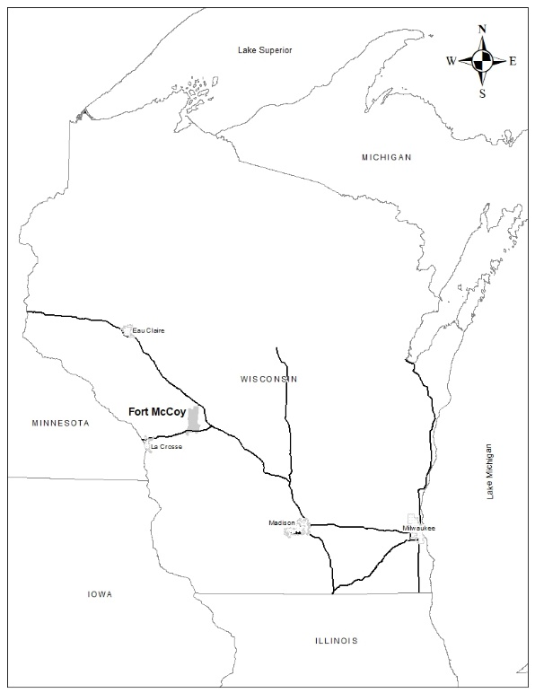

Figure 1. Fort McCoy regional location.

2.1.3.2 Logging
Fort McCoy lies just south of the historic northern Wisconsin pineries. The lumber period was relatively short lived but intense in Wisconsin. Fort McCoy most likely saw some of this lumbering activity. There were sawmills located on the La Crosse River on land that is now Fort McCoy. Since the pine harvesting operations generally floated their logs down river to large sawmills, the small mills located on the La Crosse River were probably set up to accommodate the pioneer need for timber to build houses, farm buildings, and businesses. A variety of tree species were probably harvested for the small mills, including quality oak. Trees were also harvested during pioneer times for firewood. Trees cleared from new farm fields were probably used for heating and cooking fuel. During the period 1942 to 1946, a sawmill was in operation that cut local oak and pine into railroad ties, blocking for vehicle shipping and utility lumber. All logs were cut on the installation with some of the labor being provided by prisoners of war. While there is no record of which areas were harvested or the volume removed, it is estimated that over 100,000 board feet a year were processed and used during each of the five years.
The first record of the Army taking action to manage the forest was a forest fire control agreement with the Wisconsin Conservation Department (WCD) in 1948. In the early 1950’s, the United States Forest Service conducted a timber survey and prepared a timber management plan. Commercial harvests started on Fort McCoy in 1954 with the WCD setting up the sales. In 1966, Fort McCoy hired its first professional forester to manage the resource. Forest management and commercial harvests of jack pine, red pine, white pine, oak and aspen continue to the present.

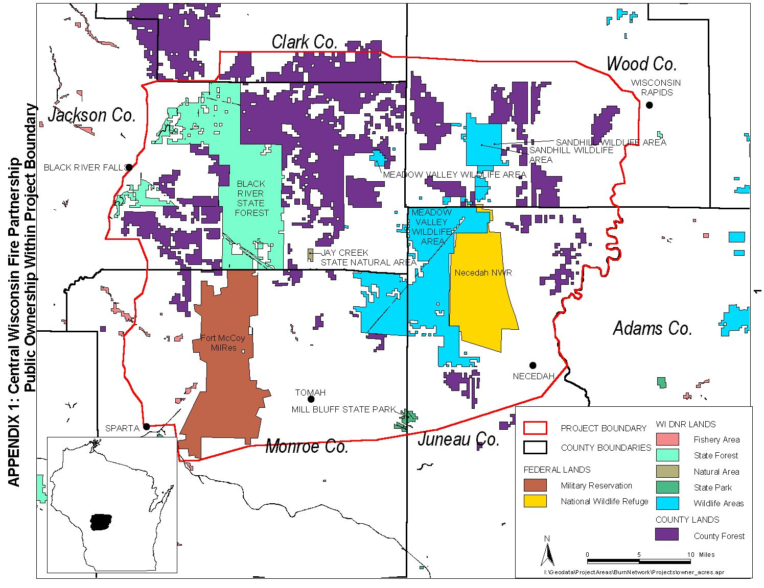

Figure 2. Public lands near Fort McCoy.

Courtesy of The Nature Conservancy.

2.1.3.3 Farming
The first settlers of the area cleared fields to grow wheat. As the wheat farms of the west became connected to the railroad lines, farming in Wisconsin turned to dairying, especially in the Driftless Area. The lush herbaceous cover type of the barrens and the steep terrain were ideal for cattle. Historic south-post was originally a ranch owned by Robert Bruce McCoy. McCoy had amassed 4,000 acres by 1909 when his property was purchased by the government for military training.
The intense property-line to property-line farming that is standard in most of the Midwest is not possible in the Driftless region because of the steep terrain. Some farmlands surrounding Fort McCoy are less than fifty percent plowed fields. The remaining land is woodlot and pasture. Several hardscrabble farms existed on north post prior to being purchased for military use in 1941. Fort McCoy is unique within the Driftless Area because the nearly level to gently sloping areas of the landscape have been left with the original vegetative communities relatively intact.

2.1.4 Fort McCoy History
Colonel Robert Bruce McCoy, the installation’s namesake, started buying land in the Sparta area for the purpose of eventually becoming an Army installation. By 1905, he had acquired approximately 4,000 acres of land that was sold as part of a 14,000 acre purchase by the Army in 1909 and made into two camps, Camp Emory Upton and Camp Robinson. Field artillery and some infantry units were trained there during World War I through 1918. In 1926, the name was changed to Camp McCoy. In the 1930’s, the camp served as a Quartermaster Supply Base for the Civilian Conservation Corps.
Between 1938 and 1942, Camp McCoy added 46,900 acres in preparation for World War II (WWII). Construction for the new cantonment area began in 1942 and was completed in the same year. The first unit to train at “new” Camp McCoy was the 100th Infantry Battalion, composed of Hawaiian National Guardsmen. The 100th Infantry Battalion fought with distinction up the “boot” of Italy while suffering extremely high casualties. Both Japanese and European prisoners of war were interred at Camp McCoy during WWII. At the end of the war, 247,779 Soldiers were processed through the Reception and Separation Center at Camp McCoy.
From 1951 to 1953, Camp McCoy was activated to train Soldiers for the Korean conflict. In 1974, the installation was redesignated as Fort McCoy. During the 1980’s the Reserve and National Guard mission of Fort McCoy continued to grow, reaching a milestone of training 100,000 Soldiers. In 1985, increases in the number of units and Soldiers scheduled to mobilize at Fort McCoy gave the post the distinction of being the largest single reserve component center in the US Army.
In 1990, Operation Desert Storm, supporting Saudi Arabia’s response to Iraq aggression became Fort McCoy’s primary mission. Mobilization started in August 1990 and continued until March 1991. In total, 74 units from nine states, accounting for nearly 9,000 Soldiers processed through Fort McCoy.
Fort McCoy served as one of the Army’s 15 Power Projection Platforms. The installation supported mobilization missions for eight operations around the globe. From 11 September 2001 through June 2010, Fort McCoy’s role as a Power Projection Platform involved supporting the mobilization/demobilization needs of approximately 116,168 military personnel from 2,100 units. More recently, Fort McCoy is designated as a Mobilization Force Generation Installation to mobilize Soldiers in support of the Army’s worldwide operational demands or a large scale contingency operation.

2.2 Facilities

2.2.1 Overview
The developed areas on post include the cantonment area, transportation corridors, airport, recreation areas, housing, and water systems (Figure 3). These areas, with the exception of some transportation corridors are considered “Non-Operational Areas” by the military trainers. The Real Property Planning Board decides upon land uses within these areas. The Fort McCoy Master Plan has divided the cantonment area into zones where like activities will be grouped. Activities identified include; classroom training, operations and maintenance, supply and storage, hospital, administration, family housing, troop housing, community facilities, and recreation.

2.2.2 Cantonment
The cantonment area is the main developed area of post and includes the administrative center of Fort McCoy along with clusters of barracks and support buildings. The original WWII design for post featured a low-density arrangement that allowed large open spaces between clusters of buildings. For this reason there is a significant amount of undeveloped land within the cantonment area. There are tracts of land, which have forestry and wildlife potential, and waterways with significant fishery potential within the cantonment area. The past fifteen years have seen an increase in construction on Fort McCoy along with an initiative to demolish or renovate WWII-era wooden buildings. Approximately 50% of new construction is occurring on previously undeveloped areas with subsequent acreage losses in forest, wildlife habitat and

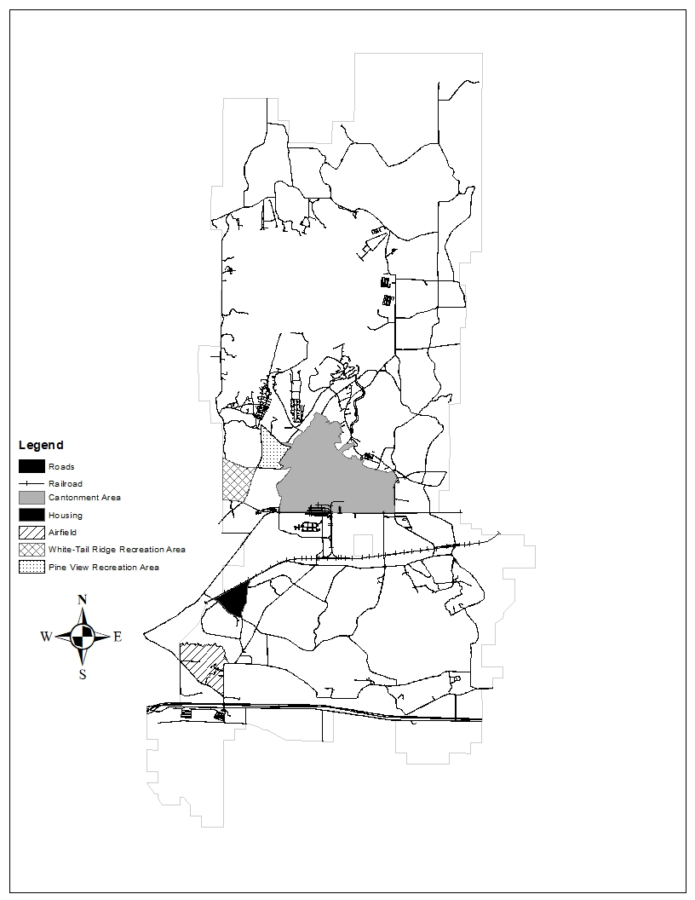

Figure 3. Facilities.
training land. To reduce mowing costs, there are designated no-mow areas. These no-mow areas are in low use areas and allowing the vegetation to grow has not adversely affected Fort McCoy’s mission.

2.2.3 Housing
Housing is located in old Camp McCoy which served as the administrative center and barracks area from 1916 to 1942. After that time, the buildings that existed in the housing area were converted into housing units and mobile homes were placed on cement tent pads for additional units.
In 1998, 12 single-family units were completed and open for occupancy. Prior to 2012, the majority of housing was available via a long-term contract for 80 units within the Woodridge subdivision in Tomah. Before that contract ended in 2012, Fort McCoy implemented a policy to build new units within the Fort McCoy Housing area. In 2008, 12 more single-family units were added. Twelve old apartments, housing units, and mobile home pads were demolished as part of that project. An additional 23 single-family units were added in 2011, and 10 more single family units were added in 2012. In 2017 an additional 56 homes were completed plus seven more homes completed in 2020 and added to the inventory making a total of 120 housing single-family units available.
The housing area has recreational facilities including a playground, walking path, basketball court, tennis courts, and a skate park.

2.2.4 Recreation Areas
Recreation areas include the Pine View and White-Tail Ridge Recreation areas. More information about these areas is located in section 3.1.7.

2.2.5 Transportation Systems

2.2.5.1 Airfields
The Sparta/Fort McCoy Airfield includes two military hangars and 22 civilian hangers, control tower, crash station, military and civilian fuel depot and administrative facility. The Sparta municipal airport merged with Fort McCoy in 1987 to reduce the danger of having two airfields within one mile of each other. The airfield has two runways, one orientated north-south and one east-west. Expansion of the runways to accommodate larger aircraft is hampered by a high ridge to the north, Silver creek with associated wetlands on the north, west and east, a railroad to the west, and a county highway, interstate highway and wetland to the south. The Med-Flight for Life was permanently stationed at the airfield, winter of 2019.
The Young Air Assault Strip includes one semi-prepared (unpaved) runway orientated east-west, with a partial parallel taxiway and ramp. The airstrip, although tactical, still has certain approach/departure, and clear zone safety requirements as does a normal airport/airfield.
The Unmanned Aerial System (UAS) strip has one small paved runway orientated east-west, with associated ramps for the establishment of approach landing aids and arresting cables/netting. This airstrip, although tactical, still has certain approach/departure, and clear zone safety requirements as does a normal airport/airfield.
The La Crosse Municipal Airport is the only commercial airport in the region. It is located off Interstate Highway 90 (I-90), about 30 miles west of Fort McCoy. The Volk Field Air National Guard Base is located about 26 miles southeast of Fort McCoy off I-90. All above listed airfields provide the infrastructure to support air assets for training, Emergency Deployment Readiness Exercises, and mobilization as required.

2.2.5.2 Road System
Fort McCoy is served by many state and local roads. State Highway 21 bisects Fort McCoy into roughly equal portions, termed south post and north post. The main gate is located off Highway 21. Fort McCoy is bisected at the southern edge of south post by I-90 with the closest off ramp at the west side of the installation onto State Highway 16 that runs parallel to I-90. A historic gated entrance to Fort McCoy is located off Highway 16. Both Highway 16 and 21 connect Fort McCoy with the nearest towns of Sparta and Tomah.
Fort McCoy has an extensive network of roads. The cantonment area has a dense network of paved roads while the range and training areas are served by main supply routes. Many of the main supply routes have been “chip sealed” to reduce maintenance costs associated with gravel roads and to decrease the amount of dust caused by vehicles. Since 1994, two north-south access roads were constructed to increase convoy movement between north and south post, avoiding the cantonment and housing areas. The training areas are also served by a network of tank trails and unimproved maneuver trails. There are approximately 254 miles of improved roads and tank trails maintained by DPW and over 300 miles of unimproved trails maintained by DPTMS.

2.2.5.3 Railway System
Fort McCoy is served by the Canadian Pacific Railroad with tracks running east-west through south post. Fort McCoy has its own switching engine to move rail cars within the installation. The Fort McCoy rail line accesses the Canadian Pacific Railroad and provides service to the industrial and warehouse areas near State Highway 21. Fort McCoy has an engine house for storing and servicing the switch engine.

2.2.5.4 Waterway System
Fort McCoy has the ability to utilize U.S. Army Corps of Engineer property located near Brownsville, MN as a Logistics Over-the-Shore (LOTS) training area. The site is located at mile 688.7R on the Mississippi Rivers right bank. The Corps of Engineers utilize the location as a dredge spoil site and maintain a depth of 10ft to allow barge access. The Brownsville site has direct access to the Mississippi River channel. Channel width at the site is over 1500 feet providing ample area for LOTS or barge operations without interfering with recreational or commercial navigation. In November of 2014 the Surface Deployment and Distribution Command Transportation Engineering Agency conducted a study of the Brownsville Site to determine its LOTS and commercial Barge capabilities. The site has an unimproved barge access point that is capable of out loading 400 military vehicles per day.

2.2.6 Water

2.2.6.1 Water System
Fort McCoy’s drinking water is derived from the Cambrian Sandstone aquifer. The installation operates three water systems: North Post (cantonment area), South Post (family housing area), and the airfield. Eleven additional wells provide water to the ranges and training areas. The installation lies within three principal surface water drainage basins including the Lower Wisconsin River, Bad-Axe La Crosse River and the Black River Basin.
The unconsolidated deposits beneath the installation consist mainly of sand, with some silt and gravel, with clay present in isolated locations. Thickness of the unconsolidated deposits ranges from 0 to 120 feet. The unconsolidated materials are underlain by Ordovician dolomite on ridge tops, and Cambrian sandstone, siltstone, and shale in the valley areas.
The two main aquifers are present beneath the installation: the unconsolidated alluvial aquifer, and the Cambrian sandstone aquifer. The upper portion of the Cambrian sandstone aquifer is interconnected with the unconsolidated aquifer. Depth to groundwater beneath the post ranges from zero in the marshy areas to as much as 20 feet in the valleys, and may be greater at some locations on ridge tops. Regional groundwater flow in the upper sandstone and unconsolidated material is generally to the southwest, toward the La Crosse River, with shallow flow toward local streams and rivers.
Fort McCoy receives its drinking water from nine wells in three general locations. Water use ranges from 0.5 to 1.5 million gallons per day (MGD). This amount of water is adequate to meet present and future needs. The Upper La Crosse River basin has good groundwater quality with no evidence of contamination or potential health problems. The water is pumped from the wells, treated to adjust the pH, disinfected, and sent to a reservoir.
There are two locations on Fort McCoy where groundwater has been contaminated with Per- and Polyfluoroalkyl Substances (PFAS) at levels above the United States Environmental Protection Agency’s Life Time Health Advisory level of 70 nanograms per liter. These locations are at the Airfield located in the southwestern portion of the installation and just north of the Cantonment Area. In addition, the PFAS contamination at the Airfield is discharging into Silver Creek, and is present at elevated levels within the fish in the creek. Investigation work is underway to define the nature and extent of contamination and to identify remedial options, if needed.

2.2.6.2 Wastewater System
The installation operates a Wastewater Treatment Plant (WWTP) located north of Wisconsin Highway 21 and southwest of the cantonment area. The WWTP consists of a laboratory, influent channel, primary and secondary treatment, trickling filters, sludge digesters, and drying beds. The WWTP treats 0.25 to 1.5 MGD and maintains a Wisconsin Pollutant Discharge Elimination System (WPDES) permit. The WPDES permit authorizes the WWTP to discharge its effluent to the La Crosse River. The effluent is analyzed to ensure biochemical oxygen demand, suspended solids, pH, dissolved oxygen, fecal coliform, and total phosphorous adhere to permit limitations. The majority of ranges and field training sites have vaulted latrines or septic systems. Tactical Training Base (TTB) Justice and TTB Independence (previously known as Multi-Purpose Field Training Sites) have septic systems to handle field shower and bath units. There are plans on creating additional leach field systems for TTB Patriot and EPW2 locations. The remaining training areas utilize porta-potties as needed.
The DPW implemented an adaptive management plan that meets the new phosphorus limits that were lowered for the WWTP discharge permit (WPDES Permit No. WI-0022420-08-0, effective 1 Jan 2019). Generally speaking, the adaptive management process will rely on reducing non-point source pollutants, sediment and phosphorus from entering the upper La Crosse River watershed. An example of qualifying projects may include streambank erosion controls. These streambank controls enhance instream habitat that decreases sediment input. Additionally, best management practices are used in ditches and basins to improve containment of sediment from cantonment area stormwater runoff. Surface water monitoring samples are collected from May to October at multiple locations; upstream from the WWTP and where water is leaving the installation in the La Crosse River at County Highway BB downstream of the WWTP.

2.2.7 Projected Changes in Facilities
In the next five years there are projects planned for a total cost of $70,600,000. The environmental assessment that has been completed for those projects determined that there would be no serious impacts to the environment.

 | Project Description | Cost ($000)
2022 | AT/MOB Barracks – 400 PAX | 25,000
2022 | Range 402 Ammo Bunker Installation | 3,300
2023 | C17 Load Trainer Construction | 4,600
2023 | Battalion Headquarters - Transient Training | 9,800
2024 | Garrison Operations Support Area Buildings | 18,500
2025 | Guard Shacks at Gate(s) 5, 15, South Post Housing, Main Gate | 9,400

Table 1. Fort McCoy construction projects.

2.3 Military Mission

2.3.1 Overview
The mission of Fort McCoy is: “Strengthen total force readiness by serving as a training center, mobilization force generation installation, and strategic support area.” The Fort McCoy motto is “Total Force Training Center.” Fort McCoy is known as the Total Force Training Center because this installation supports the training of reserve and active component military personnel from all branches of America’s armed forces. Fort McCoy has become the training site of choice for satisfying both individual and collective training requirements. The installation’s varied terrain, state-of-the-art ranges, new and renovated facilities, and extensive support infrastructure combine to afford our military personnel with an excellent environment in which to develop and sustain the skills necessary for their mission success. Fort McCoy annually supports the year round training of over 150,000 Reserve, National Guard, and active component US military personnel from all branches of the armed services. It is the only US Army installation in Wisconsin, as well as the only Army facility in the upper Midwest that is capable of providing the full spectrum of individual and collective training for combat, combat service, and combat service support personnel. It serves as a support installation which involves supporting the needs of all units training here, the other activities on the installation, and various government agencies located off-post.

2.3.1.1 Tenant Organizations
Tenant organizations are located on Fort McCoy but are not within the Fort McCoy organizational structure. They might support the Fort McCoy mission such as the Army/Air Force Exchange Services and the Defense Military Pay Office, or be completely independent of Fort McCoy such as the Wisconsin State Patrol Academy. These organizations include:
- 11th Bn. (MI)/100th Training Div.
- 13th/100th Ordnance (OD) Bn.
- 426th Regiment (Regional Training Institute) & Wisconsin Military Academy
- 871st Engineer Det
- 86th Training Division
- 88th Readiness Division
- 181st Infantry Brigade
- AIB Express
- C Co., 3rd, 399th, 800th Logistics Support Brigade, 80th Training Command
- CWT/Sato Travel
- Criminal Investigation Unit
- Detachment 1, 1152nd Trans Co.
- American Federation of Government Employees Union
- Army/Air Force Exchange Services
- Army Corps of Engineers Resident Office
- Army Reserve Civilian Personnel Advisory Center
- Army Reserve Equal Employment Opportunity Office
- Defense Commissary Agency
- Defense Military Pay Office
- Defense Logistics Agency Disposition Services Sparta
- Defense Logistics Agency, Document Services
- Equipment Concentration Site 67
- Fort McCoy Army Occupational Health Clinic
- Fort McCoy Army Reserve Careers Div.
- IHG Army Hotels
- Logistics Readiness Center
- Maneuver Area Training Equipment Site
- Mission & Installation Contracting Command McCoy
- Network Enterprise Center
- Non-Commissioned Officers Academy
- Public Health Cmd., Food Inspection Section
- Recruiting Company
- Regional Training Site-Maintenance
- Regional Training Site-Medical
- RIA Federal Credit Union
- TMDE Support Center
- United States Army Reserve Command Pay Center
- Wisconsin National Guard Challenge Academy
- Wisconsin State Patrol Academy

2.3.2 Natural Resources Needed to Support the Military Mission
The natural resources on Fort McCoy which support the military mission are:
- Trees and vegetation for concealment, cover, and rough construction timbers.
- Native plant species and communities adapted to soil conditions to maintain soil stability and reduce maneuver damage.
- Lakes for water purification, water points, air-to-lake rescues, bambi bucket/fire suppression training and bridge crossings.
- Streams for fording sites.
- Project sites for troop surveyor and engineer design projects involving wetland mitigation and creation, and dam renovation designs.
- Open areas for parachute drop zones, landing zones, engineer training sites, and maneuver areas.
- Stable soil for maneuvers.
- Steep terrain for wheeled and tracked vehicle difficult driving courses.
- Natural topography and various vegetative cover types for land navigation training and strategic tactical mounted and dismounted maneuver training.
- Recreational opportunities for temporarily stationed or permanent party members.
- Low occurrence of natural safety hazards such as poisonous plants or venomous animals.
- Wildlife populations within carrying capacity of native habitats to minimize impacts to native vegetation and the occurrence of wildlife and zoonotic diseases.

2.3.3 Effects of the Military Mission on Natural Resources
With a proactive natural resource management approach, the military mission at Fort McCoy has had a minor negative impact on the natural resources. Some areas that experience continual high use are losing tree cover through oak wilt and oak decline. Unimproved trails and scarified firebreaks in the steep terrain are the largest erosion threat that may impact surface water resources. Many of these sites are located far from surface water and have excessively drained sandy soils which allow water to quickly seep into the soil, preventing large amounts of sediment from washing into streams, lakes, and wetlands. LRAM and the previous Training Area Rehabilitation Program have been fixing eroded areas since 1989, minimizing the erosion threat. Invasive, exotic plant species are having an increasing impact on the native plant communities and are spread by foot traffic, vehicle movement and soil disturbance. Funding is insufficient to treat all invasive species everywhere they are found on the installation. In coordination with DPTMS and other NRB program managers, priority treatment areas were identified. In addition, each invasive species was prioritized with the highest priority assigned to those species not well established on Fort McCoy. Identifying priority areas and species helps to guide treatment efforts.
Bivouac sites are located throughout Fort McCoy. The amount of ground vegetation in these areas may be significantly reduced due to trampling by foot traffic and vehicle use. For low frequency use areas, the course sandy soils are not as susceptible to compaction as heavier loamy or clay soils, therefore much of the impacts are temporary. Bivouac and support activities may also produce litter. Waste materials must be recycled or properly disposed of in accordance with FM Pam 200-1. The use of portable latrines is strongly encouraged to prevent contamination of the environment. If they are unavailable, a special site request is required to establish field latrines in accordance with the environmental overlay map. Portable latrines are required during all winter field operations.
Oak wilt infestation is unnaturally high at Fort McCoy because the highest levels of military training coincide with the oak wilt infection period. Any break in the bark of oak trees from 1 April to 30 July can result in the tree contracting oak wilt through an insect vector that is attracted to the sap flow. Once infected, the tree can spread oak wilt to its neighbors via underground root grafts. This results in a pocket of dead trees. In some areas the oak wilt pockets have grown together, causing a significant loss of overhead concealment.
Military training has had some beneficial effects on natural resources at Fort McCoy. Wild lupine, the only host plant for the Federally-endangered Karner blue butterfly (KBB), thrives from many of the disturbances created by military training. Fort McCoy is believed to have one of the largest remaining populations of KBBs. Fort McCoy also has one of Wisconsin’s largest remaining populations of regal fritillary butterflies and frosted elfin butterflies and harbors the only known population of the ottoe skipper butterfly in the state. These species still occur, at least in part, as a result of the military training activities that occur on the landscape. It is believed that military training activities mimic former natural disturbances, such as herds of bison moving across the landscape. Understanding exactly what benefits military training activities provide these species is critical to ensure their successful management. Wildland fires are often caused by training activities when dry conditions exist. The highest incidence of fire is during the spring before plant growth. These fires may damage commercial timber or may benefit natural resources by setting back succession. The need to maintain open areas for firing points, drop zones, etc. has helped to maintain large complexes of barrens plant communities as well as native grassland bird species which depend on these characteristics for suitable habitat. Relatively limited access and maintenance of contiguous natural vegetation have enabled rare or endangered species to survive or repopulate the area.
Since 2005, the Fort McCoy mission focused on training for counter-insurgency operations. This relied heavily on exercises involving Improved Tactical Training Bases (ITTB), convoy training, and urban fighting. To provide this type of training, more ITTBs/Tactical Training Bases, mock villages, Mounted Operation Urban Training (MOUT) sites, and Logistical Support Areas (LSA) have been constructed or are in the planning stages for construction. This resulted in less natural habitat and outdoor recreation opportunities in the immediate areas around those facilities. The mission focus has since been expanded to incorporate more field bivouac and maneuver scenarios, affecting larger areas on a more infrequent basis.
To ensure installations can support military training requirements and balance environmental stewardship responsibilities, staffing and program funding often provide greater support to sustain the natural resources components than on other federal, state, and county or municipal lands without military training activities. This provides for a greater intensive monitoring, inventory and management of public entrusted lands.

2.3.4 Effects of Natural Resources Management on the Mission
Natural and cultural resources programs provide specific requirements for military units to consider when training at Fort McCoy. These requirements may appear as a training distracter or viewed as training encroachment, or quantified as physically limiting to the amount of land available to support the training mission (see Appendix C for list and explanation of training distracters). However, by avoiding sensitive resources, no training days have been lost due to special constraints to include natural and cultural resources requirements into their training mission. To date, the Endangered Species Act has not had a large impact on the mission. Fort McCoy consulted with the USFWS concerning the KBB and was granted an annual allowable take that has allowed most training activities to continue as usual or required only minor adjustments in planning. A Biological Assessment concerning activities affecting bald eagles and gray wolves was submitted to the USFWS in 2003. In January 2016, Fort McCoy provided a determination to the USFWS concerning the northern long-eared bat (NLEB). The determination stated that all activities described within previous biological assessments submitted to the USFWS would not result in prohibited incidental take as defined within the final 4(d) rule and accompanying Programmatic Biological Opinion for the NLEB. The USFWS concurred with this determination. Fort McCoy consulted with the USFWS concerning the rusty patched bumble bee (RPBB) and received an installation wide Biological Opinion (BO) that includes an approved level of annual incidental take that allows most training activities to continue as usual or with only minor adjustments in planning. Any land use changes, such as new ranges, or permanent construction require coordination with the NRB to eliminate or minimize impacts to endangered species.
The effect of cultural resources protection on the mission is seen in two primary ways: 1) Prior to any undertaking the installation must consult with the State Historic Preservation Office (SHPO). Additionally, more time and consultation is needed if an undertaking will adversely affect a historic property, which can result in delays to that proposed project; and 2) Projects located near protected cultural resources, such as National Registered Historic Places (NRHP)-eligible archaeological sites, NRHP-eligible historic architectural sites and Native American sacred sites, will be restricted to activities that will not adversely affect those resources. In FY13, the majority of Phase I archaeological resources identification surveys were completed on the installation with over 45,000 acres being surveyed. As of FY21, nearly 50,000 acres of the installations approximately 60,000 acres have been comprehensively surveyed for archaeological and historical resources. Most of the remaining acreage not surveyed consists of off-limits areas such as the artillery impact area and other Unexploded Ordinance safety areas or areas of extreme hill-slope unlikely to contain cultural resources. Over 1300 individual archaeological surveys have been conducted on the installation since 1985. Cultural resources on the installation consist of over 700 archaeological sites ranging in age from Native American sites dating from 12,000 years ago (10,000 B.C) to Euro-American homesteads dating to the mid-20th century. Over 830 buildings on the installation are considered of historical significance (greater than 50 years of age). The installation also contains four historic cemeteries and one prehistoric Native American burial mound group. Additional mitigation (capping/protection) may be necessary for NRHP-eligible sites. Archaeological sites identified as eligible for the NRHP should be avoided. Cultural resources determined not NRHP-eligible will also be reviewed when activities or undertakings occur in their vicinity because there is the possibility for inadvertent discoveries that can change the eligibility status for a resource and because Army guidance states, “The goal of the CRM should be to preserve a valid representative sample of all site types (2016:34).”
Timber harvests and other forestry activities can have a temporary negative impact on the mission by restricting vehicle maneuvers with logging debris (slash) and stumps. Timber sale contract requirements that require low stump heights along with LRAM shredding of woody debris remaining within the area after the sale are designed to minimize this problem in designated areas. Timber harvest also helps to transition high tree density sites into more accessible lands for vehicles maneuvers.
Buffer zones surrounding lakes, streams and other wetland areas reduce the amount of maneuver space available. Fort McCoy Regulation 350-1 prohibits vehicular movement within 25 meters of streams, lakes and wetlands, unless a special request is made and approved. Steep terrain can also limit vehicular movement. Two natural areas on Fort McCoy are limited to foot training scenarios. Other training scenarios are authorized upon special request.
Wellhead protection areas and restrictions within areas of shallow ground water limit certain training activities that could affect Fort McCoy’s drinking water supply and aquatic environments. Some of the prohibited activities include; vehicle storage and staging areas, liquid motor fuel dispensing areas, vehicle maintenance activities, petroleum product storage tanks, field sanitation activities, release of grey water, and vehicle painting activities.
The LRAM areas are sometimes off-limits to training to allow specific areas time to rehabilitate. Limitations are often set to allow for vegetation to reestablish before training is allowed to resume. In some cases, specific areas may be manipulated to reduce or limit future access where rehabilitation will not ensure long-term sustainability of training loads (i.e. log or earthen berms/dams along eroding trails located on steep terrain).
Invasive plants degrade land conditions and vegetative cover vital for realistic training and can directly limit training activities. Invasive species management assists the training mission by minimizing human health concerns, limiting erosion that increases maneuver sustainability, and preventing dense stands of species, such as exotic honeysuckle from becoming established that can limit troop use of the landscape. In addition, impacts to T&E species are reduced. Healthy populations of rare species require fewer restrictions to military training activities. Invasive species management is accomplished using an integrated approach that includes mechanical means (i.e. mowing and shredding), hand pulling, herbicide application and biological control agents.
T&E management can impact the training mission in several ways. Activities that result in land-use change or potential mortality/removal of a given T&E species from a specific site, such as building or range construction projects, and unit special site requests, have the highest likelihood of being impacted. If proposed construction projects or special site requests will negatively impact protected species, justification concerning project need, location, and timing are required. Alternate siting and timing of projects/requests will be looked at in an attempt to avoid impacts. If alternate siting is not possible, additional ways to minimize the impacts will be explored.
Appendix C shows the areas where restrictions on mission or training may occur and the areas where there are little to no training and mission restrictions.

2.3.5 Future Military Mission Impacts on Natural Resources
The Range Complex Master Plan for Fort McCoy has identified the need to modernize existing ranges and develop new ranges. Modernizing existing ranges should not have a significant impact on natural resources when compared with constructing new ranges that will likely clear forests and native vegetation, reduce wildlife habitat and temporarily erode the soil during construction. Predicting future impacts is difficult as the mission is dynamic. However, as the research and development continue, DPTMS expects a need to expand the northern impact area to accommodate the next generation of weapons and their increased firing distance. To reduce future impacts to the training mission; Fort McCoy established an agreement with the USFWS to allow mitigating the impacts to KBBs from projects occurring on the installation, off of the installation. Additionally, Fort McCoy could implement an Army Compatible Use Buffer (ACUB) program to help mitigate other internal encroachments to off post lands or minimize increasing restraints as unique nearby resources face greater losses to development and urbanization.
The Fort McCoy/Sparta Airfield may be expanded in the next five years to accommodate increased air traffic and provide the necessary runway lengths and safety areas required for modern aircraft. An Environmental Impact Statement would likely be required prior to project approval.
The DPTMS expects to support large scale contingency multi-domain operations and continue counter-insurgency training into the future and include a return to training for fighting conventional forces and unified land operations with joint services. The amount of training will continue to increase, both in length of time, frequency of coordinated exercises, and numbers of Soldiers in the field, and this will impact the amount of time an area has to rest between training exercises. The NRB programs will see a reduction in the time available to complete field projects such as timber sales, prescribed burns or invasive species control.
Proactive natural resource management should look at means to minimize expansion of ranges and cantonment area into wetlands and other sensitive areas. Using GIS as a tool to do queries to find the most suitable location for development will ultimately minimize the threat of expansion on specific cultural resources or threatened and endangered species. The Army might investigate acquiring lands or options to utilize non-DoD lands to ensure responsible installation development and growth as the military mission changes and expands. Many communities are looking at comprehensive plans for expansion such as “smart-growth”.
A Joint Land Use Study (JLUS) is a way to reduce potential conflicts between military installations and stakeholders while sustaining economic growth and development, protecting public health and safety, and protecting military missions. A JLUS study was completed and more information is located in paragraph 3.7.2.

2.4 Physical Environment

2.4.1 Topography and Geology
Ancient seas laid the geologic material of Fort McCoy down 500 million years ago. Layers of sandstone and limestone formed and experienced a geologic uplift. This uplift formed the Western Upland of Wisconsin. The Western Upland is a thoroughly dissected cuesta plateau with its major slope to the south-southwest. A cuesta is a geographical formation that has a long gentle slope on one side and a short steep slope on the backside. The thorough dissection is a result of millions of years of slow erosion creating long valleys or “coulees” as they are known locally. It is a rugged landscape with several hundred feet of elevation change from stream bottom to ridge top. Fort McCoy is located on the eastern edge of the Western Upland. The ridge that defines the highest point of the cuesta (1450 feet elevation) lies just east of Fort McCoy and is associated with the ridge system that runs throughout post. The upper geologic stratas of the area consist of harder limestones that are found in small deposits in the vicinities of Greenfield tower and Pikes Peak, both of these areas are located on the eastern boundary of post. The upland deposits of limestone have eroded away, leaving softer sandstone and shale deposits, the alluvium of which is the parent material for most soils on post. Windblown loess, a material derived from the glacial period, also has an influence on much of the soil on post.

2.4.2 Glacial Influence
A major portion of the Western Upland of Wisconsin has the unique distinction of never having been glaciated during the most recent glacial periods in the Pleistocene Epoch. There is some evidence of glacial coverage during the earlier glacial periods. Most of the Midwestern landscape received large deposits of glacial material, or drift. The Driftless Area escaped direct influence from the series of glaciers that scoured the Midwestern landscape. While the Driftless Area is surrounded by glacial deposits, it was never completely surrounded by glaciers at any one time. Separate glaciers from different periods influenced the surrounding landscape at different times. The Driftless Area is considered an ancient landscape and has been eroding into an intricate system of ridges and coulees for millions of years.

2.4.3 Climate
“The climate of Fort McCoy is continental. Frequent pressure systems that move across the continent from west to east are a major influence on the area’s weather. A variety of weather can be expected in all seasons. Spring is often late in coming and is a mixture of warm and cold periods. As spring advances, precipitation increases, reaching a peak in June. Summers are warm, with several hot and humid spells. Cool periods generally occur during any summer month. Fall arrives suddenly in mid-September and often lingers on into November. The change from fall to winter is often abrupt. Winters are long, cold, and snowy. In many years, a thaw lasting one to two weeks occurs in February” (Monroe County Soil Survey, 1984:2).
The growing season averages 139 days, beginning around 11 May and ending around 27 September. The total mean annual precipitation is 28.04 inches. The average seasonal snowfall is 39.3 inches with extremes recorded of 83 inches and 14 inches. In winter the average daily temperature is 19.9 degrees F and in the summer the average daily temperature is 68.4 degrees F. Recorded extremes are –48 degrees F and 109 degrees F. The prevailing westerly winds have an average wind speed ranging from a high of 12 mph in April to a low of 7 mph in August (Monroe County Soil Survey, 1984).

2.4.4 Air Quality
Regional air quality within the study area is good. This is primarily due to climatic characteristics conductive to dispersion and an absence of major industry. Fort McCoy is within an "attainment" area, indicating that the concentrations of air contaminants in the atmosphere do not exceed Federal and state ambient air quality standards. Air quality at Fort McCoy is good. The initial State Clean Air Act, Title V permit was obtained in July 1996, renewed in 2003 and was renewed again in 2020. Fort McCoy continues to complete process improvements to maintain a high air quality standard.

2.4.5 Soils
Fort McCoy soils are divided into six main categories based on their texture. These categories are peat, sand, loamy sand, sandy loams, silt loams and varied loams (Figure 4). Minor amounts of fine sandy loam and loam are present.
Dawson peat and Newson loamy sand soil series are deep, nearly level, poorly drained soils subject to flooding and ponding. The soils have a seasonal high water table above the surface or within one foot of the surface. A few other soils that have hydric inclusions in their mapping units are CeA (Ceresco), Cfa (Coffeen), CuA (Curran), DdA (Dells), Ka (Kato), Kpa (Kickapoo), MaA (Meehan and Au Gres sands). They support native wetland vegetation. The total acreage for poorly drained soils on Fort McCoy is 5,558 acres (source for all soils information: NRCS SSURGO 2004). Over 80% of Fort McCoy soils are classified as sand. The soil series include the Boone, Impact, Meehan, Au Gres and Tarr sands. They are deep, excessively drained soils with very little organic matter. When the vegetation layer is removed, wind erosion occurs in sandy soils. Slopes range from level to 45%. The total acreage for sand on Fort McCoy is 49,837 acres.
The sandy loams are mostly Billett sandy loam and Urne fine sandy loam. Very small amounts (less than 120 acres total) of Ceresco fine sandy loam, Eleva sandy loam, Kickapoo fine sandy loam and Meridian loam are present. They are deep, well drained soils with low organic matter content. Slopes range from level to 45%. The total acreage for sandy loams on Fort McCoy is 776 acres.
The silt loams are mostly Council silt loam and La Farge silt loam. Small amounts (ranging from 10 to 82 acres for each series) of the following soil series are present; Coffeen silt loam, Curran silt loam, Dells silt loam, Downs silt loam, Kato silt loam, Norden silt loam, and Wildale silt loam. The slopes range from 0 to 30%. The total acreage for silt loams on Fort McCoy is 914 acres.
Varied loams are Norden, Urne, and Dorerton soils. They are deep, steep and well-drained soils on ridge tops and back slopes. Organic matter content is moderately low in these soils. Slopes range from 20% to 45% and there is a very severe hazard of erosion. The total acreage for varied loams on Fort McCoy is 2,238 acres. With the exception of hilly areas, Fort McCoy is located in an area with relatively low inherent erodibility from water movement. The more level areas can tolerate high levels of soil disturbance, allowing for soil disturbing activities such as vehicular traffic to be more concentrated in those areas. Potential wind erosion, T&E species and cultural resources sites require some constraint in using these areas. Very sandy or very wet soils may also limit the accessibility and trafficability of some areas” (Warren et al., 2002).

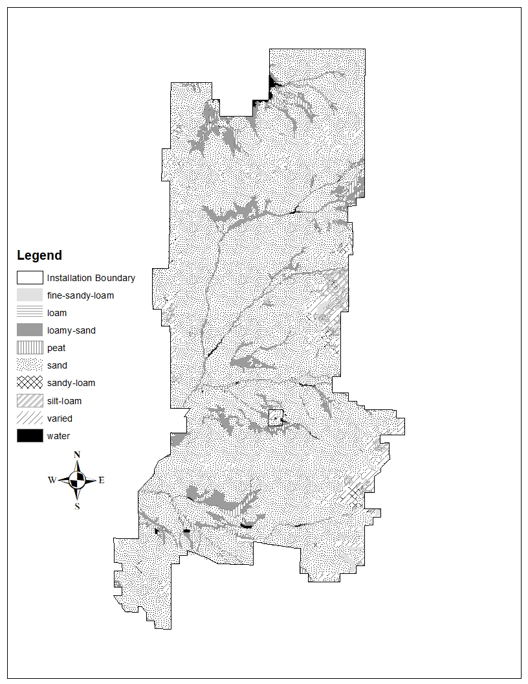

Figure 4. Soil Types on Fort McCoy.
(Natural Resources Conservation Service)

2.5 Ecosystems

2.5.1 Fort McCoy Ecosystem
The USFS has classified and mapped the ecosystems in the Upper Great Lakes region of Minnesota, Wisconsin and Michigan (Albert, 1995). This system places most of Fort McCoy in the Driftless Area under the Eau Claire subsection. The drier soils and greater frequency of fires results in more oak dominance in forest, savanna and brush lands than the other
Driftless Area subsections. The northwest corner of Fort McCoy is included in the Southeastern Wisconsin Savanna Ecosystem, under the Central Wisconsin Sand Plain subsection (Black River Falls sub-subsection). Glacial Lake Wisconsin occupied much of this subsection, depositing glacial lacustrine sediments. Droughty outwash and sand lake plain support jack pine-northern pin oak barrens.
The NRB used “A Guide to Forest Communities and Habitat Types of Central and Southern Wisconsin” (Kotar and Burger, 1996) to divide the ecosystem into management units. The system uses forest habitat type classification based on vegetation communities and soil properties.

2.5.2 Tension Zone
Fort McCoy lies at the intersection of two major ecotones, the zone of transition between two ecosystem types. On the east to west continuum, the transition from eastern forests to western prairies influence the vegetation types of Fort McCoy. This mix of forest and prairie results in the savanna ecosystem that dominates on post. On the north to south continuum Fort McCoy lies just south of the band, which has been termed the tension zone. The tension zone is identified in The Vegetation of Wisconsin (Curtis, 1959), as a relatively narrow band that separates the northern coniferous forests from the central deciduous forests. Within the tension zone there is gradation between these two plant provinces. Many plants reach their northern or southern limits within this zone. Fort McCoy lies within this zone and the mix of vegetation on post is indicative of both the northern and southern forests.

2.6 General Biotic Environment

2.6.1 Water Resources
Fort McCoy has 10 installation lakes and impoundments, totaling 184 surface acres that provide habitat for warm and cold-water fish species and approximately 71 miles of coldwater streams and tributaries (Appendix D). The majority of the streams are Class I trout water, maintaining naturally reproducing brook and brown trout. The Driftless Region of Wisconsin lacks natural lakes derived from glaciation. Fort McCoy lakes and impoundments are created by either damming rivers or streams or through excavating soil to create "man-made" lakes. The impoundments on Fort McCoy coldwater streams provide a variety of uses for recreation, military training, and habitat for fish and wildlife.

2.6.1.1 Watersheds
The La Crosse River begins in the northeast portion of Fort McCoy. Much of the installation is in the La Crosse River watershed (Figure 5). The northern ¼ of Fort McCoy drains into Robinson (Clear) Creek, which is part of the Black River watershed. Land to the east of post, including a very small portion of Fort McCoy, is the Lemonwier River portion of the Wisconsin River watershed. The La Crosse River is one of the minor Mississippi drainages. The Black River and Wisconsin River are considered major Mississippi drainages. Fort McCoy is the largest landholder in the upper La Crosse River watershed and is instrumental in maintaining good water quality in the La Crosse River.

2.6.1.2 Lakes
The three Sandy Lakes (Big Sandy, Sandy, and West Sandy) range in size from 10 to 19 acres. They were excavated in 1968 as borrow pits, providing construction sub-base material for the construction of Interstate 90. Their primary use is for military training but they provide excellent recreational angling opportunities. These closed system lakes are spring fed, support two-story fisheries and have mesotrophic characteristics. Generally, lake water is characterized by very soft water, typically neutral to slightly acidic pH, and infertile.

2.6.1.2.1 Management Considerations

Sandy and Big Sandy Lakes are managed for largemouth bass and bluegill. Rainbow trout stocking has played an important role to supplement angler’s creel where approximately 80 percent of the lake fishermen target rainbow trout. The recreational rainbow trout fishery reduces the angling demand on the naturally reproducing centrarchid (panfish) fishery. Trout stamps are required by anglers fishing for stocked trout. These fish are purchased through the Genoa National Fish Hatchery. The West Sandy panfish bag limit was modified in 2003 to reduce harvest, changing the Fort McCoy fishing regulation to allow 10- panfish of a minimum length of 8-inches kept per licensed angler. The regulation has had a positive effect to the panfish structure and will remain in place to sustain fish quality.

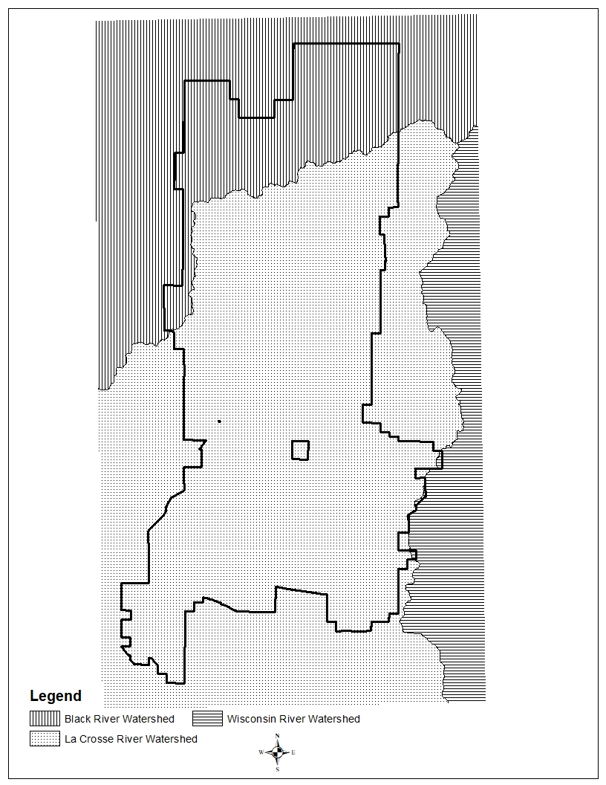

Figure 5. Major watersheds on Fort McCoy.

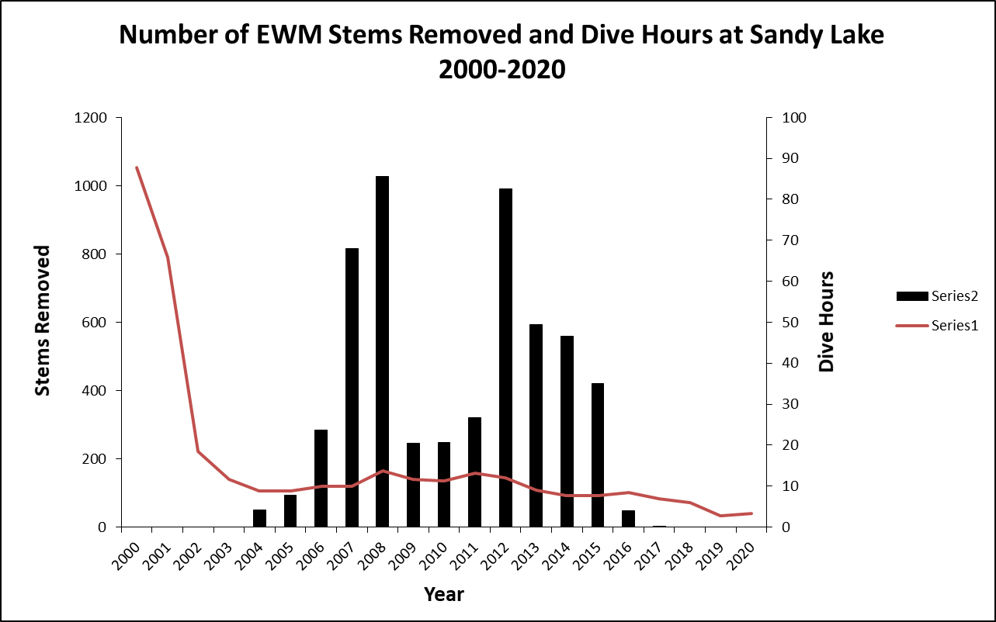
Figure 6. Eurasian watermilfoil (EWM), a prevalent invasive aquatic submergent plant was first observed in Sandy Lake in 1999. From 2000-2003, EWM densities were too numerous to count. The removal method of SCUBA diving and hand-pulling required extensive effort early in this project has reduced to 3-dive hours in 2019-2020. Zero EWM plants have been observed since 2018.

Military training use at Big Sandy Lake has increased since replacing Alderwood Lake as the site for water training and bridging. The Sandy lakes could be enlarged as an alternate means to developing another sand “borrow” site to provide fill for construction.
The fisheries program will continue diver surveillance and Eurasian watermilfoil (EWM) hand pulling effort to minimize occurrence in Fort McCoy waters. Figure 6 shows the historic effort from 2000-2010 – dive time required for Sandy Lake EWM removal. EWM plant numbers have been significantly reduced, with the plants virtually eliminated with zero EWM plants observed or found to be removed from dive efforts in 2018-2020. Monitoring aquatic vegetation will determine program success and monitor the status of other installation waters to keep aquatic invasive EWM from spreading. In utilizing the aquatic plant inventory process, EWM was identified in 2012 at West Sandy Lake. EWM plants were hand pulled from West Sandy late summer 2012. EWM had outpaced hand pulling efforts at West Sandy Lake in 2013 and 2014. Aquacide® was applied to West Sandy Lake in 2015 to quickly curtail the EWM dominance and spread. EWM management consideration should include chemical and/or hand pulling methods as a means for EWM eradication at Sandy and West Sandy Lake or wherever found in the future. Reference “Annual Fort McCoy Watershed Report –2020” (Rood et al. 2021) for updated West Sandy Lake EWM results.

2.6.1.3 Impoundments
There are primarily seven impoundments available for Fort McCoy recreational anglers, ranging in size from 2 to 93 acres (Appendix D). The oldest impoundment, East Silver, was created in the 1920’s and the most recent, Suukjak Sep Lake, was created in 1962. Kraft (2003) dam inventory showed that many impoundment dams were failing or in need of maintenance. Two impoundments, WAC (1991) and Lower Sparta Pond (1994) were reclaimed back to free flowing streams. The residual WAC dam structure was removed by the WDNR improving fish passage. Alderwood and Hazel Dell were drawn down and the water control structure removed from Hazel Dell in 2011 and the Alderwood structure removed in 2015. Sparta (new boards 2018), Swamp, East Silver (renovated 2018) and Stillwell (renovated 2018) have bottom draw outlets; the other impoundments, Lost Lake and North Flowage still have overflow or top-draw dams. All impoundments are subject to sand and silt deposition from stream bedload. Suukjak Sep Lake dam renovation was completed in 2011 allowing waters to be released from near the middle of the lake (see paragraph 4.4.3). Algal blooms and macrophyte growth during the summer can be problematic and result in lower angling and training quality.
Impoundment water quality characteristics and the fish community are monitored to identify trends and condition. Fort McCoy surface water quality is primarily characterized as soft water, typically neutral to slightly acidic pH, and infertile. The waters are low in nutrients, with low hardness and alkalinity. Impoundments associated with Silver and Tarr Creek watersheds are the exception with medium-hard water, medium-high productivity and fertile.

2.6.1.3.1 Management Considerations
A primary watershed management program goal is to manage sediment within streams and impoundments. Stream impoundments fill from sediment transport at accelerated rates. Aquatic succession from lake to wetland can happen within the course of decades. One impoundment, West Silver Wetlands (WSW), was created in 1952 and quickly filled in with sediment. The WSW dam was removed in 2017 with stream restoration completed 2018-2019. The former WSW or Silver Creek impoundment area is managed as a wetland and provides greatest benefit to waterfowl, reptiles, amphibians, and other wildlife. WSW ponds and floodway enhancement plans were established to enhance rare turtle habitat and flood resiliency designed by CSU (2019). Future work pending project funding availability. Hydraulic dredging was completed from 2002-2006 for Hazel Dell, Sparta, Swamp and East Silver Lakes helping to reclaim lake water storage, water releases and improved fisheries (figure 7). Suukjak Sep Lake has sediment deposition following stream barrier removals and successive years of high rainfall. The upper lake basin and lower stream will require removal of sediments by excavation or hydraulic dredging to maintain lake quality. Reference “Annual Fort McCoy Watershed Report –2020” (Rood et al. 2021)
Warmer water temperatures are a potential negative impact created by impoundments on trout streams. Since 1997, stream temperatures were monitored with thermograph data loggers. Temperature data along with stream biomonitoring using an index of biotic integrity (IBI) have indicated when Fort McCoy impoundments were significantly affecting aquatic integrity. Future management will continue to assess thermal impacts resulting from impoundments with alternatives to improve water quality to receiving waters. Alternatives include: 1) removing the dam structure to manage as a natural stream; 2) install a middle or bottom-draw dam/outlet to reduce the thermal impact to the receiving water; or 3) sediment
management, pond reclamation, excavating or dredging the impoundment sediments to reduce shallow areas that contribute to higher water temperatures. These options will be assessed on a case-by-case basis to determine the most cost-effective approach that not only enhances the training mission, but also benefits the aquatic ecosystem and recreational angling. When implementing the first two alternatives, it is important to assess and manage sediment and the potential for sediment transport when removing or renovating the dam or water control structure. Sediment trap maintenance will aid in the longevity of these reclamation projects and/or benefit the stream condition. As outlets are modified and sediment removed, water-level will be managed to minimize thermal effects or macrophyte and plant production to maximize reservoir fish production. The NRB shall continue to evaluate Fort McCoy watersheds to determine areas contributing to stream sediment loads and implement Best Management Practices (BMPs). Aquatic macrophytes are inventoried to assess plant densities and avoid the introduction of exotic plant species like curly pond weed (Potemogeton crispus) and EWM.

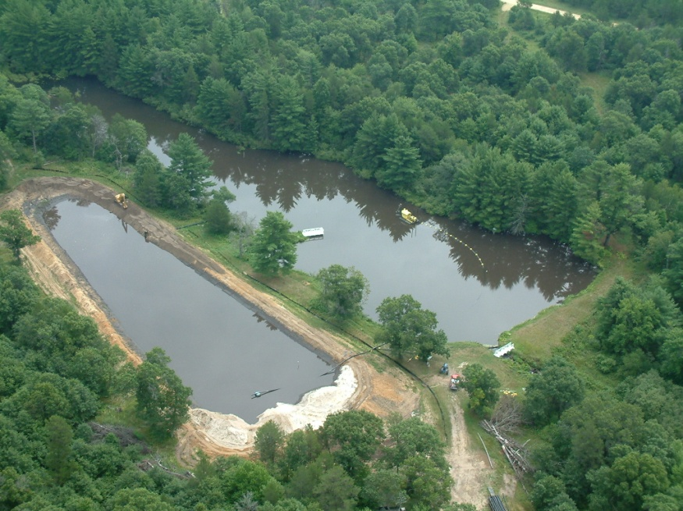
Figure 7. Dredging operations on Hazel Dell Lake.

2.6.1.4 Streams
Fort McCoy has approximately 71 miles of streams and tributaries (Figure 8). Almost all are recognized by the WDNR as trout streams with approximately 51 miles classified as Class I trout streams, 8 miles as Class II trout streams, and 5 miles as Class III trout streams (Appendix D). The North Impact Area (NIA) and Range 29 close 14.1 miles of trout stream to fishing access because of the risk from active training and unexploded ordnance. Two of the streams, Clear and Silver, have very unique and pristine habitats that could be considered as Outstanding or Exceptional Resource Waters as noted in NR207. Areas around these waters have been designated as Fort McCoy Natural Areas. Two streams, Creek 23-12 (Ash Run North Ditch) and Creek 11-8 (West Fork Ranch Creek) are characterized as non-trout waters.
Streams which have headwaters in the agricultural areas off Fort McCoy can be influenced by off-post land practices and typically have lower water quality when entering Fort McCoy. Brook trout and brown trout are naturally reproducing while an occasional rainbow trout enters the streams after being stocked in the impoundments. Trout anglers most commonly fish in the larger sections of the La Crosse River, Tarr and Silver Creek, however some find the smaller tributaries to be great fun, catching aggressive brook trout.
Aquatic vegetation and invertebrates are important to fish assemblages as well as indicators of water quality. Aquatic vegetation, like the exotic water cress (Nasturtium) is indicative of springs, groundwater or high water quality and grows in many of Fort McCoy’s streams. Vegetation like water crow’s foot (Ranuculus) and Elodea provides cover for fish and areas of attachment for aquatic insects. Aquatic vegetation provides diversity similar to braided channels within the channel, creating additional niches for young fish and forage. Woody debris provides additional habitat for fish and aquatic insects. Drake (1996) conducted the latest macroinvertebrate study, using insects to show water quality to be very good. Similar results were obtained from macroinvertebrate samples collected during sampling in 2007 and 2016/2017. Some insects found on Fort McCoy that are indicators of high water quality are: Plecopterans, Taeniopteryx spp., Isoperla spp., and Nemoura spp.; Ephermopterans, Baetis spp.; and Tricopterans, Platycentropus, Lepidostoma, and Glossosom.

2.6.1.4.1 Management Considerations
The watershed management program is focused on sediment management within streams and impoundments. Many tools and policies have been developed to reduce the effects from sedimentation and erosion within Fort McCoy watersheds. Many of the unimproved roads have been converted to asphalt, seal coat or concrete surface which reduces costs for maintenance and results in less sediment delivery to watersheds. Riparian habitat is typically well protected. Forest management practices overlook harvestable timber within a variable width buffer zone along stream habitat. Fort McCoy restricts vehicle maneuvering within 25 meters of streams and wetlands (Fort McCoy Reg 350-1). The LRAM program is actively restoring vegetation to minimize soil loss. The RTLA program has conducted monitoring associated with wetland buffers to determine the level of policy compliance and impacts to the resources. Two separate survey years have shown no significant breaches in policy or impacts from training within the designated buffers. Lanes training requires larger chunks of contiguous training area to perform military exercises. Stream crossings for tracked and wheeled vehicles are established, with unlimited restrictions to foot training within the wetlands and streams. Shallow water crossings will be built in the near future, one currently exists on Silver Creek near the natural area with the second at the former Alderwood Dam site. There are potentially three other training locations being considered.
The two natural areas located within Fort McCoy are along Clear and Silver Creeks. These areas are also protected from intrusive land uses like timber harvest and vehicle maneuver training. The stream bottoms are predominantly sand. Shifting sand substrate can limit the amount of natural reproduction, instream cover, and food available to the fish. Since 1995, Fort McCoy has used prefabricated wood structures (LUNKERS) armored with riprap, and brush bundling in streambank stabilization projects to increase overhead cover. These stream enhancement and erosion control methods have played a very important role in reproductive success and overall trout densities. Streambank restoration as well as sediment trap maintenance interrupt or minimize sediment loads and transport process. Sediment management has become an important tool to increase Fort McCoy trout numbers and stream biomass (Figure 9). Since 2018, removal of shrubs and tree canopy cover have proven successful in establishing riparian vegetation along with brush bundling to reducing bank erosion and minimize streambed loads for Sparta Creek. Similar success has been achieved from work in Mound Prairie in 2020-2021.
Continued growth and development will increase impervious surface and surface water runoff and have a potential affect to high quality trout waters. Wetlands and recharge areas are critical in times of droughts to replenish the aquifers. Watershed development and avoiding wetland impacts are going to be the greatest challenges in maintaining high quality aquatic resources. Codified (protected by Wisconsin State Statute) streams like Ash Run and associated ditches are susceptible to degradation if cantonment area development impinges on the riparian area and does not plan to manage stormwater runoff resulting in higher stream temperatures and sediment delivery. Low Impact Development (LID) concepts are going to be more common with DoD compliance of the Energy Independence and Security Act (EISA). The resultant of this smart growth concept should aid the installation to make continued improvements regarding surface water quality and sediment management. Generally, stormwater should be allowed to percolate and seep into settling areas, ditches or basins and select to have less stormwater piped or channeled directly into cantonment area streams. Vertical growth (taller buildings) in lieu of expanding horizontally, thus reducing the amount of impervious surfaces within the cantonment area, should also be examined.

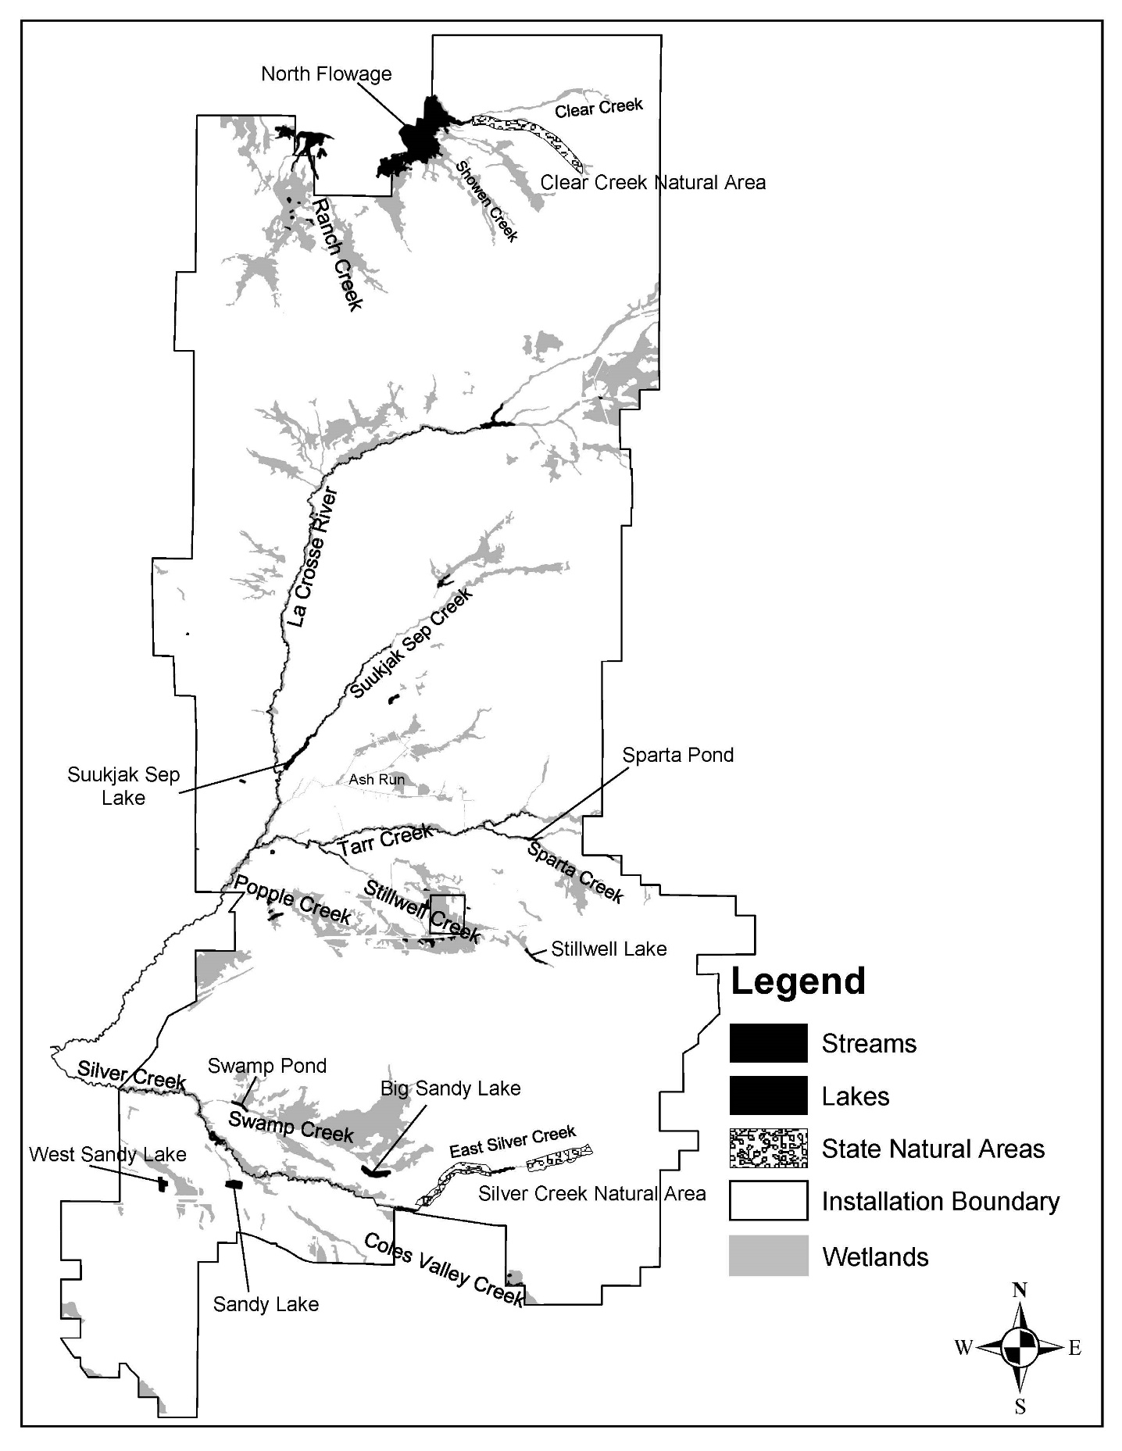

Figure 8. Streams, impoundments and lakes.

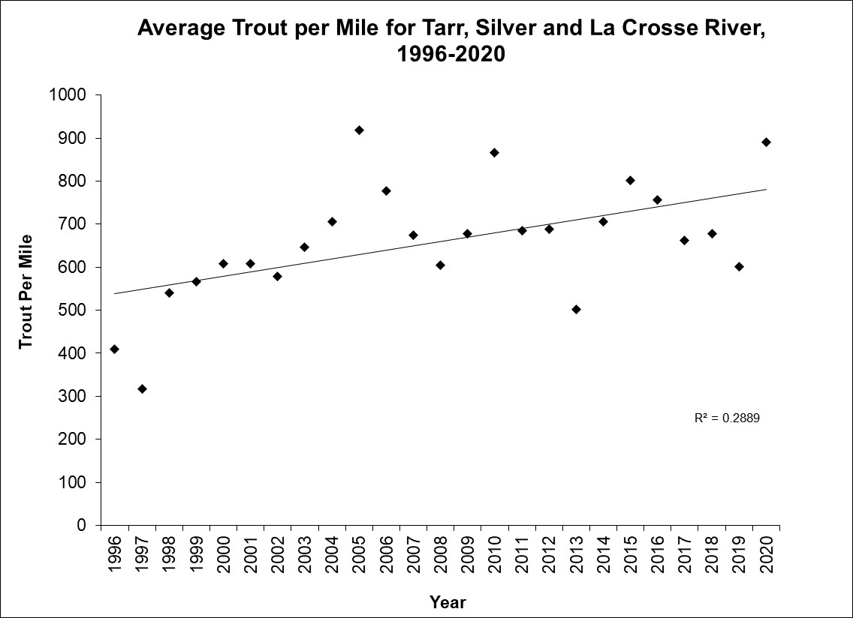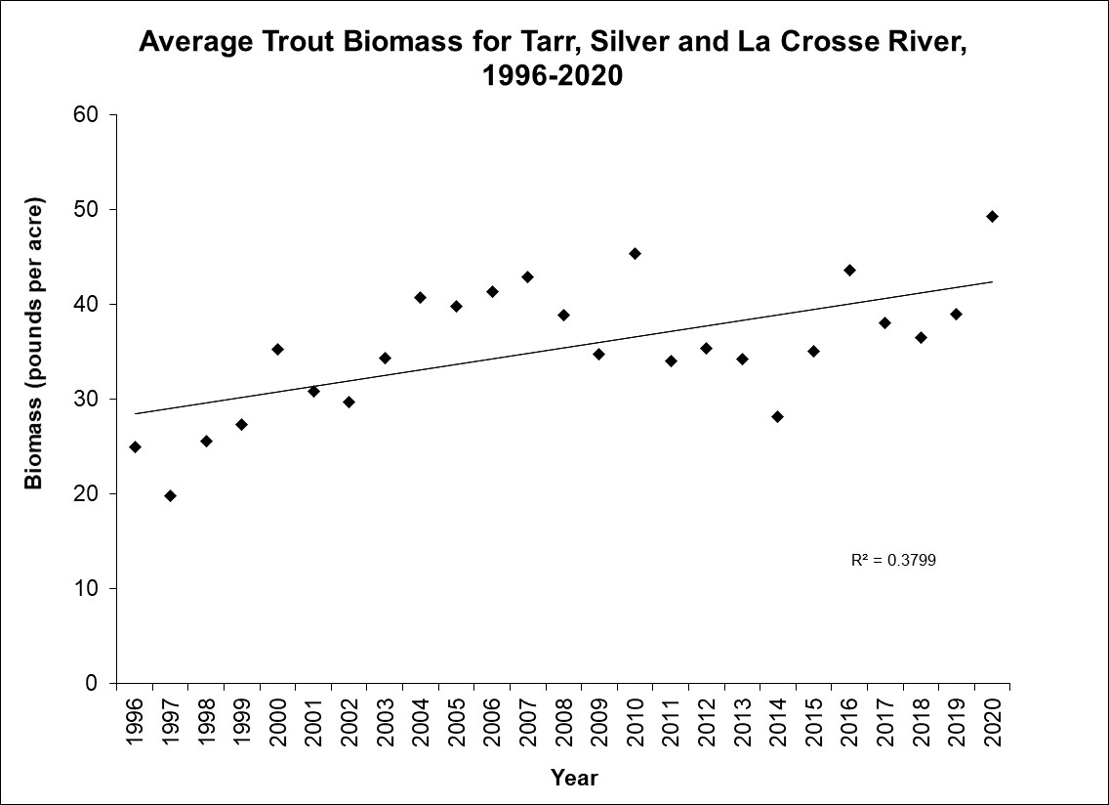
Figure 9. Fort McCoy trout trends, biomass (pounds per acre) in the upper panel and trout density (CPUE - trout per mile), for the La Crosse River, Tarr and Silver Creek. Since 1997, both young and adult brook and brown trout have responded positively to Fort McCoy watershed management, reducing sediment and enhancing stream habitat.

2.6.2 Flora
There are three broad categories of land cover type (communities) at Fort McCoy; wetlands, dry upland communities, and dry-mesic upland communities (Figure 10). These communities are based on The Forest Habitat Type Classification of Southern Wisconsin (Kotar, 1996).

2.6.2.1 Wetlands
Fort McCoy has approximately 4,400 acres of wetlands based on Wisconsin Wetland Inventory (Figure 10). Roads, railroads and other sources of fill material are believed to have caused the water table to rise in some lower areas, creating wetlands and modifying the boundaries of previously existing wetlands. The wetlands along streams were created by stream meandering and are believed to be less influenced by anthropogenic features. Wetlands provide an important function in recharging aquifers and buffering streams by filtering sediment and nutrients. Associated vegetation includes: white pine, red maple, quaking aspen, white oak, poison sumac, speckled alder, star flower, winterberry, dewberry, cinnamon fern, skunk cabbage, bunchberry, bluejoint grass, sedges, sphagnum moss, meadowsweet, cattails, and dogwood.
Animal species associated with these wetlands are: white-tailed deer, mink, otter, white-footed deer mouse, muskrat, beaver, sandhill crane, great blue heron, least bittern, wood ducks, northern harrier, sora rail, marsh wren, swamp sparrow, red-winged blackbird, wood turtle, Blanding’s turtle, green frog, northern water snake, and spring peeper.

2.6.2.1.1 Wetland types
The Forest Habitat Type Classification for Southern Wisconsin indicates the wetlands on Fort McCoy as PVRh (White Pine/Blueberry-Dewberry) habitat type. The vegetation reflects a dry mesic rather than a mesic or wet-mesic environment. This is probably related to the sandy soils above the saturation zone not holding sufficient moisture to support mesic vegetation during dry seasons or drier than average years. White pine is considered the climax successional stage in this community type. Non-forested wetland types documented on Fort McCoy are; pond, stream, marsh, sphagnum bog, coastal-plain bog, sedge meadow, wet meadow, alder thicket, shrub carr, and swamp (Freckmann 1992).
Ephemeral ponds are wetlands that fill with water in the spring and generally dry out later in the year. Some ephemeral ponds may only dry out under drought conditions. Ephemeral ponds are generally small and surrounded by terrestrial habitat. These ponds contain no fish, thus providing safe habitat for amphibians, insects, and crustacean species. The importance of ephemeral ponds to biodiversity and fully functioning ecosystems has only recently been recognized on a national scale. A Blanding’s turtle survey and monitoring project documented the importance of Fort McCoy’s ephemeral ponds to Blanding’s turtles. Blanding’s turtles travel long distances across the landscape and move from one ephemeral pond to the next.

2.6.2.1.2 Management Considerations
In accordance with EO 11990, avoidance of all aspects of long-term and short-term impacts to wetlands on federal lands is a very high priority, as well as initiatives to enhance their natural value. Disturbance associated with troop training activities or land maintenance and new construction activities present a high potential for damaging wetlands. Timber harvest, if conducted at the wrong time of year, can also adversely impact wetlands. Disturbance to wetlands, while necessary to set back succession, may result in the introduction or spread of exotic species which may degrade wildlife habitat quality. Historically, wetlands were kept in a dynamic state through periodic droughts and fires, which help to set back plant succession and remove organic matter deposited within the wetlands over many years. Due to over a century of fire suppression and changes in attitudes and policies about fire, many wetlands are now in, or approaching, a climax stage through the course of natural succession and the spread of exotic/invasive plants.
The 2017 WSW dam removal has changed the slope of Silver Creek, allowing the stream to headcut upstream and is expected to change the wetland hydrology. Following 2017-2019 Silver Creek dam removal and stream enhancements, the streambed and floodplain will require an assessment of wetland habitat that will require further enhancement to maintain the existing wetland hydrology and footprint. The wetland enhancement plan will be developed to maintain proper hydrology for the wetland community including floodwater inputs, enhanced vegetation diversity, and open water marsh and pools for seasonal habitat utilization required for animals, birds, turtles and other reptiles and amphibians.
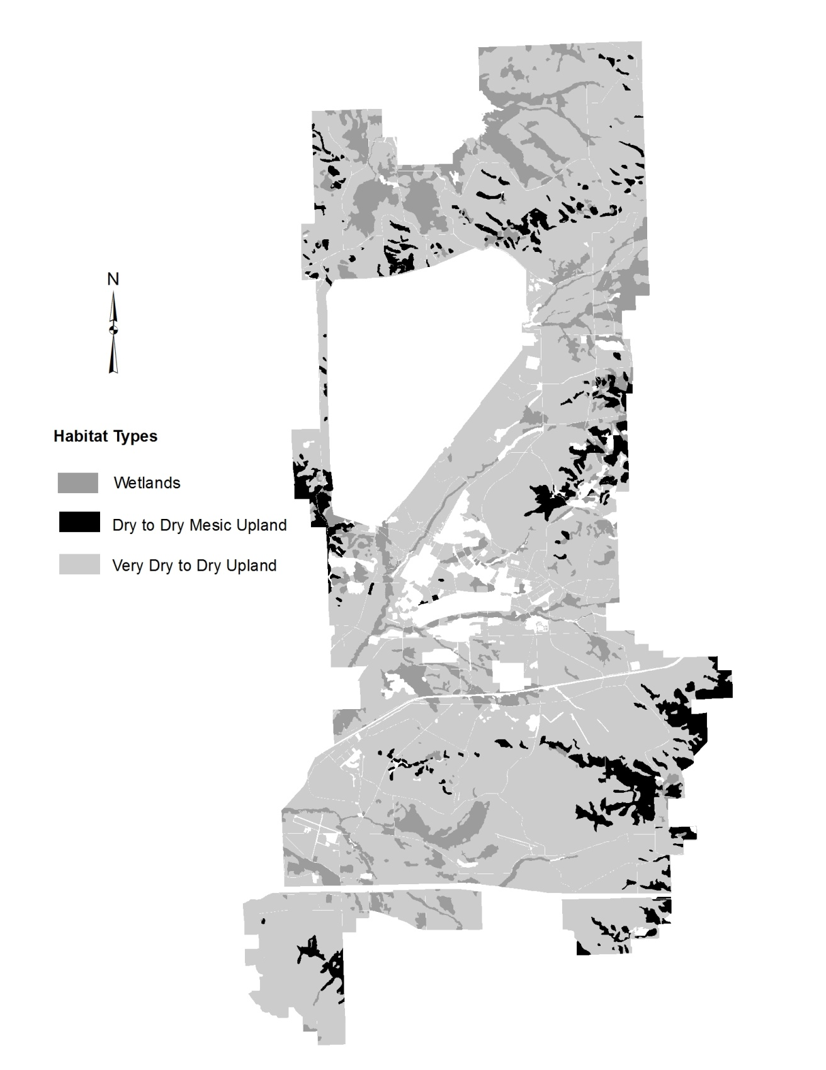

Figure 10. Land Cover Types.

Wetland loss should be avoided. The NEPA process will identify projects that affect wetlands and require mitigation. In areas where wetland “take” is unavoidable, mitigation will need to be considered and negotiated. Wetland mitigation and banking program will be considered with the WDNR, USACE and EPA to aid in Fort McCoy developments. Formal group discussions should be established with our basin partners for devising plans to best protect wetlands, the public trust, and mission needs. As an alternative to on-site wetland bank or mitigation, Fort McCoy may need to consider purchasing adjacent land to or acquiring land within the region that can be developed into wetlands to protect the training interests in regards to military mission expansion. Wetland mitigation is becoming more apparent with the need to upgrade training facilities and ranges to best prepare troops for future missions. A wetland delineation contract was completed in 2009 to assess large land parcels that are expected to have future developments. Wetland delineations will be completed as required for specific site developments to further reduce wetland loss. Wetland mitigation banking should also become a higher priority to best protect the training interest and off-set wetland loss when it cannot be avoided. Selecting locations where the natural resource conditions are suited or designs that will aid the treatment to convert the landscape to wetland is important.
Creating wetland–ephemeral pond habitat that adds critical habitat value to organisms like the Blanding’s turtle should also be emphasized. Mitigation will require Fort McCoy to manage the mitigated wetland to ensure that it meets and maintains wetland criteria specifications. Fort McCoy has successfully mitigated three separate wetlands for various projects over the past fifteen years, all were monitored for five years certifying establishment.

2.6.2.2 Very Dry to Dry Upland Communities
This is the predominant community type on Fort McCoy. It is described by the Forest Habitat Type Classification (Kotar) as PVGy (White pine/Blueberry-Huckleberry) community type. The USFS (Albert) describes this community as oak forest, savanna and brushlands. Excessively drained deep sands and sandy loams over sandstone in a rolling to steep landscape allow plants adapted to this xeric condition to thrive. Frequent fires maintain the oak forest and prevent natural succession to white pine, which is considered the climax forest (Figure 11). In areas where fire has been suppressed there is a considerable amount of red maple, black cherry and white pine in the understory.
Savanna plant communities are dependent on fire and disturbance to maintain the typical open structure. With fire suppression, the vegetation in the savanna communities quickly succeeded to a more closed forest condition. Oak grubs existed for decades in the presence of fire, slowly growing deep, established root systems, while the vegetation would be repeatedly burned. These oak grubs took advantage of the fire suppression and grew profusely for several seasons. In presettlement times a few oaks would attain a thick, corky bark during periods without fire and then be able to survive later fires. This process established the open structure of the savanna communities. With twenty years of fire suppression the canopy of the former oak barrens closed and caused a change in the ground layer. The typical mix of prairie and woodland plants slowly degraded to a low diversity woodland ground layer. The seed bank will exist for many decades in a degraded ecosystem. Prescribed fire and thinning the oaks can release this remnant seed bank. Savanna and barren communities are very similar so the term may be used interchangeably in this document.
Fires resulting from military training, disturbance associated with vehicle maneuvers, and the lack of intensive agricultural disturbance have kept areas of Fort McCoy in a quality savanna/barrens complex. The North Impact Area (NIA), Drop Zone-Badger, Range 29 and the former Fort McCoy Barrens Natural Area are good examples of an oak savanna. Jack pine stands are present and are managed for pulpwood. Red pine plantations have been planted in open areas and under a sparse oak overstory since the Wisconsin Conservation Corps days of the 1930’s.
Associated vegetation includes; black oak, white oak, bur oak, northern pin oak, jack pine, white pine, red pine, red maple, black cherry, American hazel, blueberry, huckleberry, big bluestem, little bluestem, wild lupine, hoary puccoon, bird’s foot violet, wild rye, downy phlox, prairie dropseed, blazing star and Indian grass.
Associated animals include; white-tailed deer, badger, red and gray fox, coyote, gray wolf, gray and fox squirrel, thirteen-lined ground squirrel, meadow vole, red-tailed hawk, kestrel, wild turkey, killdeer, upland sandpiper, eastern kingbird, eastern bluebird, tree swallow, grasshopper sparrow, savanna sparrow, KBB, western slender glass lizard, phlox moth, regal fritillary butterfly, red-tailed prairie leafhopper, blue racer, eastern hognose snake, bullsnake and five-lined skink.

2.6.2.2.1 Management Considerations
The oak savanna/barrens community (Figure 12) is considered one of the rarest plant communities in Wisconsin. The Wisconsin Natural Heritage Inventory lists oak barrens as a G2 rating (imperiled globally because of rarity). In pre-settlement times it is estimated there was between 7 and 10 million acres of Wisconsin savanna; presently the WDNR estimates that only about 2,000 acres of high quality barrens remains in the state outside of Fort McCoy. The NRB estimates that Fort McCoy has approximately 13,700 acres of quality barrens with 6,600 acres within the NIA. The KBB, a Federally-
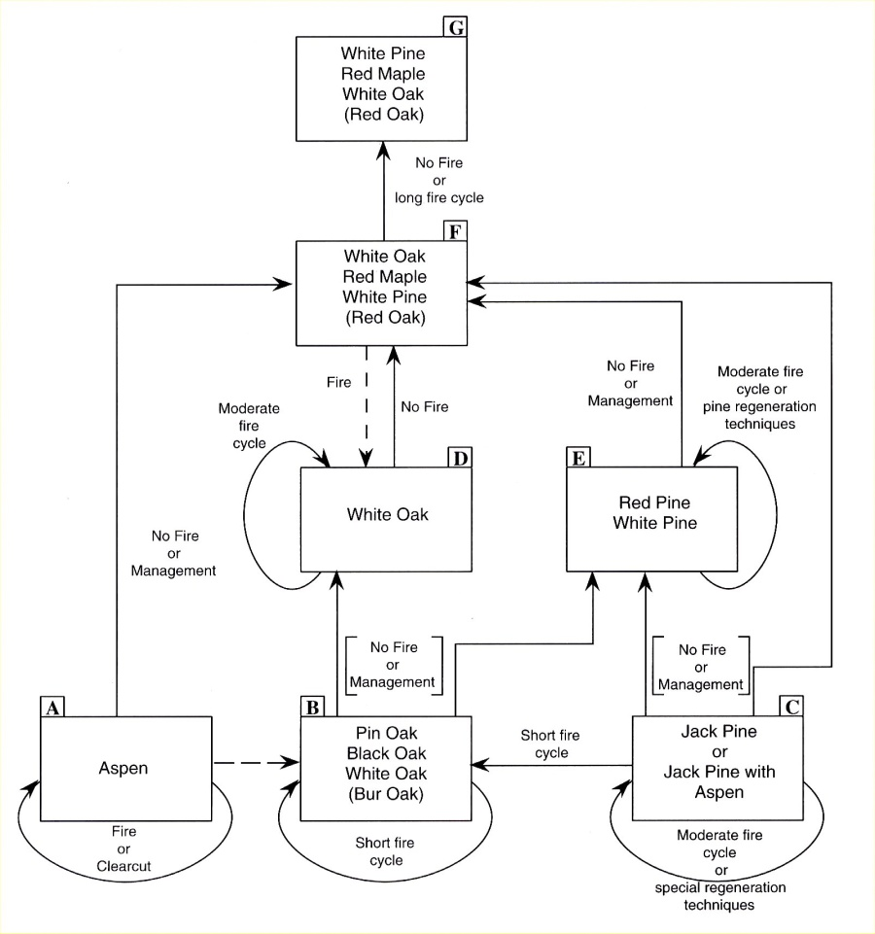

Figure 11. Succession model for dry upland plant communities.
(Reprinted with permission, Kotar and Burger, 1996)

listed T&E species, along with a whole host of Federal and state concern species are savanna dependent. Savannas are excellent areas for military training and maneuvers; the structure tends to allow available vehicle maneuverability, with random pockets of more dense trees or forest edges available for cover and concealment resources. With up to 20,000 acres of low quality oak forest on Fort McCoy, there is great potential for oak savanna restoration activities. Prescribed fires and timber cuts have been implemented to help restore these areas.
Invasive plants such as leafy spurge, spotted knapweed, cow vetch, crown vetch and St. John’s wort have been mapped within many of the savanna remnants and along the peripheries of low quality oak forests. Exotic invasive plant species have a very strong impact on native plant communities and may replace the majority of native species if left unchecked. One consideration with restoring low quality oak forest to savanna is the potential to increase such invasive plant species populations. Many of the savanna associated invasives cannot survive in more closed canopy forests, but if the forest canopies are thinned out or removed, it will create suitable environment for these species.

Open grassy areas on steep slopes and ridge tops are known as goat prairies and contain many unique and rare prairie plant and insect species. The extreme topography of goat prairies has prevented most uses or development that would have impacted them. The greatest threat to these areas is the steady encroachment of trees, shrubs and exotic species that shade or out-compete the prairie species. Conversion of low quality oak forest to red pine plantation has occurred frequently in the past. Based on the value of savanna to the military, wildlife and ecosystem management, red pines will not be planted in designated savanna areas.

The sandy soils have a thin A horizon that contains organic material overlaying thick sand. If the vegetation layer and the A horizon are lost, the sand is susceptible to wind erosion. This has occurred on some of the past and present ranges and other high use areas. Hundreds of dollars per acre were spent to restore sand blowout areas. It is now realized that these areas support uncommon insect species. Depending on military training requirements, some of these sand blowout areas will remain to provide habitat for these species.

Oak wilt is a fungal disease of oak trees which enters a tree through a wound in the bark and spreads to adjacent trees through root grafts. Activities such as pruning, timber harvesting, shredding, and firewood cutting are prohibited in oak stands during April through July, when oak wilt can be transmitted to healthy oaks via insect

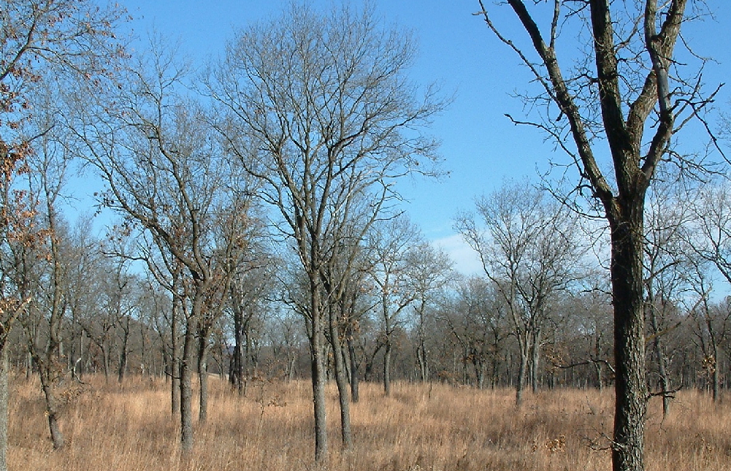

Figure 12. Oak savanna.

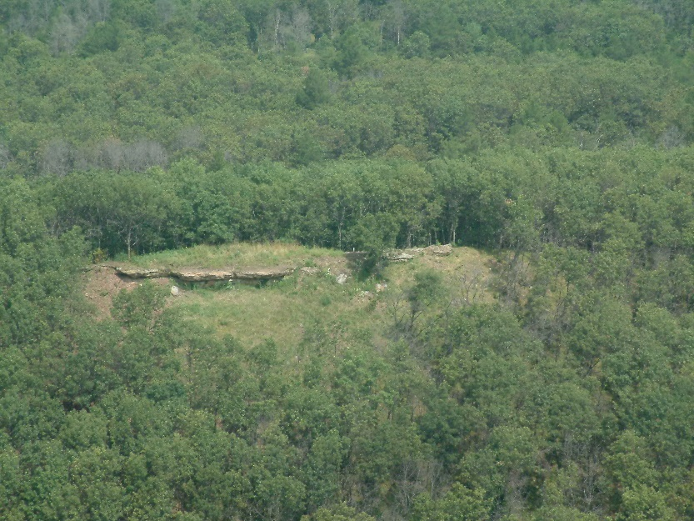

Figure 13. Goat prairie.

vectors feeding on sap flowing from a break in the bark. Oak wilt can kill red, black and northern pin oak trees within a couple of months of infection. Trees in the white oak family (white, bur) are more resistant to the disease. Fort McCoy has a significantly higher occurrence of oak wilt than surrounding areas because training maneuvers occur during the May-July infection period. Use of tree wound dressing is utilized to help reduce the possible spread of the disease. ITAM distributes tree wound dressing to military units and maintenance shops for activities that are considered high potential for tree damage during the May through July oak wilt season. The dressing does not treat the disease, it only seals off or covers exposure of tree wounds to reduce transmission of the fungus to new areas by insects. Additionally, management to limit root graft dispersal of the disease has been implemented on a limited basis via root plowing to sever infected areas from healthy trees. LRAM typically completes control on approximately 25 centers annually using this method.

2.6.2.3 Dry to Dry-Mesic Upland Communities
This community occurs on the north and northeast facing slopes on Fort McCoy. The Forest Habitat Type Classification (Kotar) calls this the ArDe-V (red maple/pointed-leaf tick trefoil, blueberry variant) community type. This type is found on loams and silt loams and represents a transition between the dry and dry-mesic communities. Northern red oak (Figure 14) is the dominant tree species in this community but it is not regenerating. Red maple, basswood and white pine are taking over these sites since they are more shade tolerant than oak (Figure 15).

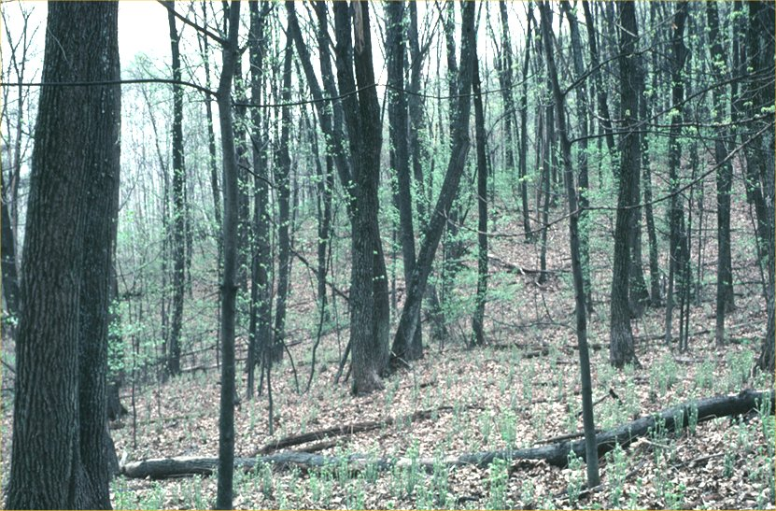

Figure 14. Northern red oak forest.

Associated fauna present are: white-tailed deer, gray and fox squirrel, flying squirrel, red and gray fox, white-footed deer mouse, red-backed vole, raccoon, porcupine, wild turkey, sharp-shinned hawk, ruffed grouse, barred owl, whip-poor-will, eastern wood peewee, eastern phoebe, black-capped chickadee, wood thrush, red-eyed vireo, scarlet tanager, wood frog, red-backed salamander, and northern red-bellied snake.

2.6.2.3.1 Management Considerations
The steep slopes associated with this community are less favorable for many military training activities and vehicle access. Because of the rugged terrain, water erosion is a concern. Large gullies from roads and shale pits have formed from unchecked water flow in some areas.
The natural conversion of oak stands to red maple, basswood and other species is a concern to both forestry and wildlife. Mast-producing oak trees are important to many different wildlife species for food and cover. Northern red oak sawtimber is the most valuable wood on Fort McCoy. Encroaching species are not as valuable to wildlife and produce lower quality lumber.
Oak wilt is a major factor in these community types (see Para. 2.6.2.2.1).
These communities also tend to be located where richer loam and silt soils are found. These soils are much more vulnerable to sheet and rill erosion due to soil structure/textures and the steep slopes they are associated with, than the coarse sands that comprise most other areas on post. Maintaining good tree and vegetative cover in these areas is crucial to limit natural erosion and to reduce access of activities that could increase soil erosion potential, such as off-road driving.
Exotic invasive plant species including garlic mustard have become established within this habitat type. The invasives are responsible for reducing native plant diversities and are likely to have a strong negative impact on valuable red oak and other timber species regeneration within these areas. Management strategies need to target these species for control/elimination and ensure management practices take these species into consideration during the planning phases.

2.6.2.4 Fort McCoy Natural Areas
There are two Fort McCoy Natural Areas (FMNA) established because of their uniqueness, high natural integrity and rare status (Figure 10). Clear Creek and Silver Creek FMNA’s are pristine wetlands associated with floodplains along
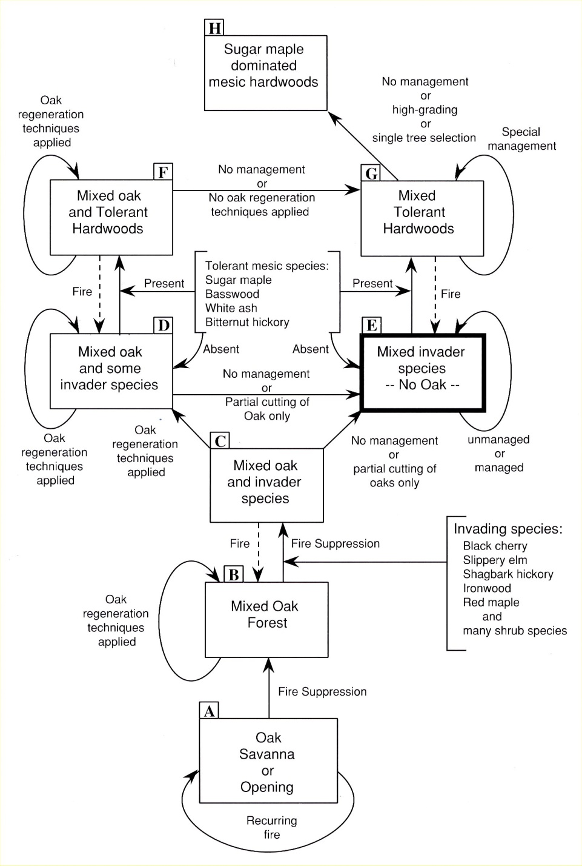

Figure 15. Succession model for dry-mesic upland plant communities.
(Reprinted with permission, Kotar and Burger, 1996.)

stream headwaters. These riparian communities have rare vegetation and excellent water quality. Memorandums of Understanding (MOU) and management plans have been developed between Fort McCoy and the WDNR for these FMNAs. In November 2020 the Oak Barrens FMNA was removed from the program. Fort McCoy is developing a management plan with training restrictions and will study, repair, and manage impacts from training in the Oak Barrens.

2.6.2.4.1 Fort McCoy Natural Areas Management Considerations
Management of FMNAs is guided by MOUs and management plans that have been approved by the WDNR. Vehicle use is restricted in the FMNAs except on established trails or by special request; foot training is allowed at any time. The goal for FMNAs is to maintain and enhance natural community interactions, aquatic integrity and rare populations.
The Fort McCoy Natural Areas (see figure 8) allows foot training only.

2.6.3 Floral Inventories
The earliest recorded instance of plant collecting on Fort McCoy was in 1931 when Emil Krushke collected a specimen of prairie parsley (Polytaenia nuttallii) for the Milwaukee Public Museum. Surveys were done for specific areas in 1972, 1979, 1988 and 1989. In 1975, a general survey of all areas on Fort McCoy was completed. In 1981 and 1982, a herbarium collection was started, additional plants were added in 1990-91 by RTLA. The RTLA program has continued to add more plants to the plant list and collection on a nearly annual basis. All of the plants documented (approximately 1000 species) on Fort McCoy are listed in Appendix E, Table 8. More information on flora inventories and monitoring is at Para. 4.11.1.

2.6.4 Fauna
As of March 2012, over 230 bird, 53 mammal, 19 reptile, 12 amphibian and 30 fish species have been identified on Fort McCoy (Appendix E, Tables 1, 2, 3 and 4). An initial insect survey was conducted by Judy Maxwell in 1992 and additional butterfly and moth surveys were conducted by Kyle Johnson in 2017, 2018, and 2019. (Appendix E, Tables 5 and 6).

2.6.5 Threatened and Endangered Species
As of February 2021, two federal endangered species, one federal threatened species, 15 state endangered species, and 18 state threatened species have been documented on the installation. The KBB was listed as a federally endangered species in 1992. Per a court decision, the gray wolf was removed from the federal endangered species list in January 2021 while the northern long-eared bat (NLEB) was listed as a threatened species in May 2015. In March 2017, the rusty patched bumble bee (RPBB) was listed as a federal endangered species. Formal consultation is currently underway concerning potential impacts to RPBB from military and non-military activities occurring on the installation. Seven species found on Fort McCoy will be or are currently undergoing a status review to determine if they should receive protection under the ESA. These species are the golden-winged warbler, regal fritillary butterfly, frosted elfin butterfly, little brown bat, tri-colored bat, Blanding’s turtle and wood turtle. In addition, three species (red-tailed prairie leafhopper, regal fritillary butterfly, and Henslow’s sparrow) that have been documented on the installation are now classified as Army Species at Risk (Appendix E, Table 7). Fort McCoy shall provide for the protection and conservation of state protected species when practicable. That is, similar conservation measures will be provided for state-listed species as are provided for species listed under the ESA, as long as such measures are not in direct conflict with the military training mission.

3.0 ENVIRONMENTAL MANAGEMENT STRATEGY AND MISSION SUSTAINABILITY

3.1 Land Uses
The main use for Fort McCoy lands is to support military training and one of the primary goals of this INRMP is to ensure the operational mission will continue on a sustainable basis. There are areas where training is highly limited (natural areas and wetlands), areas where training is prohibited (family housing), and places where non-military use is restricted (NIA). Most locations on post are open to both training and other uses such as recreation and natural resources management. There are many areas within the boundaries of the post that are dedicated to specific uses (Figures 16a & 16b). These areas are based on use, or use restrictions. Within each area there are a variety of ecological associations.

3.1.1 Standard Training Areas
The majority of the land on Fort McCoy is divided into 82 training areas totaling 45,633 acres. These training areas are assigned to troop units as requested for specific training purposes. Maneuvers, bivouac, and dismounted training are allowed in these training areas. Included in the training areas is the large network of improved roads, tank trails and unimproved (woods) trails.

3.1.1.1 Management Considerations
Military training takes priority in training areas and all other uses are allowed when they will not hinder the training mission. In general, natural resource management activities are designed to enhance the training capabilities of the land. The goal of the NRB is to use ecosystem management principles to manage training areas for unrestricted military training while encouraging biodiversity and preserving the integrity of ecosystems. All NRB activities that might impact training are coordinated with the DPTMS Range Officer and the Scheduling Section prior to work being conducted.

3.1.2 Special Training Areas
Special training areas are primarily dedicated to training Soldiers on specific tasks. Other uses of the land such as timber production, outdoor recreation and ecosystem management are secondary or nonexistent. These areas include ranges (multi-purpose, small arms, ambush, tank, grenade, machine gun and demolition), firing points (artillery and mortar), an assault airstrip, landing zones (LZ), drop zones (DZ), enemy prisoner of war camps, tactical training bases, a rock crusher site, entry control points, forward arming and fueling points, collective training facilities, a Combined Arms Collective Training Facility (CACTF), an unmanned aerial system airstrip, and Improved Tactical Training Bases (ITTB). Approximately 2600 acres of Fort McCoy are dedicated to special training areas (some but not all of these areas are shown in figures 16a & b). For more specific information on special training areas, reference Fort McCoy’s Range Complex Master Plan (RCMP).

3.1.2.1 Management Considerations
Care and maintenance of the range areas is under the jurisdiction of the Training Division and the direction of the Training Division Chief and Range Officer in DPTMS. The DPW provides mowing and pest control support on the ranges. The NRB coordinates any activity that may impact the training areas or ranges (timber harvests, hunting, or data collection) with Range Scheduling. Some ranges and special use areas are burned each spring to reduce woody vegetation and decrease fuel loads to prevent uncontrolled wildland fires during active use. The DZs, firing points, and LZs are maintained as open grasslands and managed, secondarily, for prairie flora and fauna. Integrated pest management strategies are used to control weeds at ranges that may impede mechanical target functionality or pose additional fire risks to structures.
The RCMP recommends specific actions to meet the training needs in the near future. Projects that are programmed to occur in the next five years are listed in table 2.

3.1.3 North Impact Area (NIA)
The NIA is 7,773 acres and serves as the target area for artillery and aircraft weapons firing and has a safety fan for the ranges that surround it. The NIA began use around 1944 to support anti-aircraft and artillery usage and by 1959 had expanded to its current size.
The majority of the NIA is treeless and is comprised of low rolling hills. This terrain allows targets to be seen for long distances providing excellent training for gunners and forward observers. The NIA is the only impact area where high explosive ammunition is fired at Fort McCoy. The majority of the NIA is strictly off limits because of the danger of unexploded ordnance. When live fire activities are not occurring, access is allowed on established trails that have been

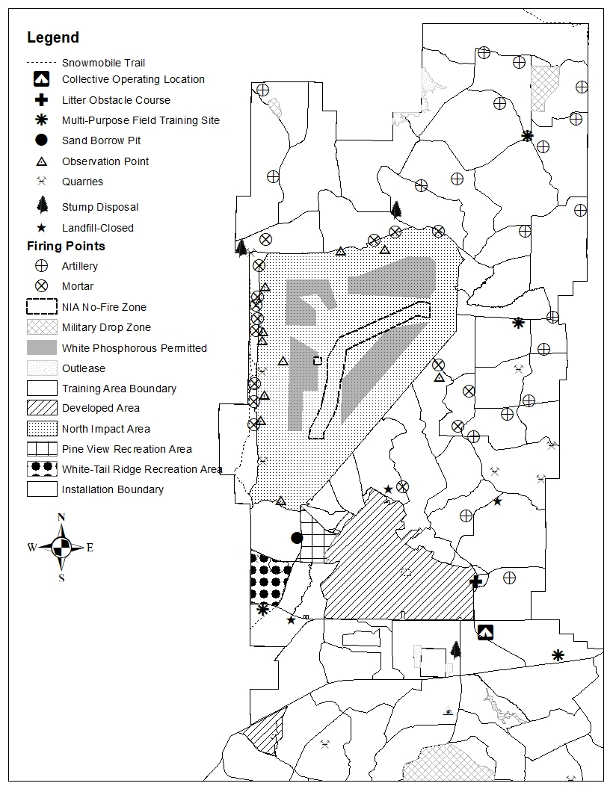

Figure 16a. Land Uses on North Post of Fort McCoy.

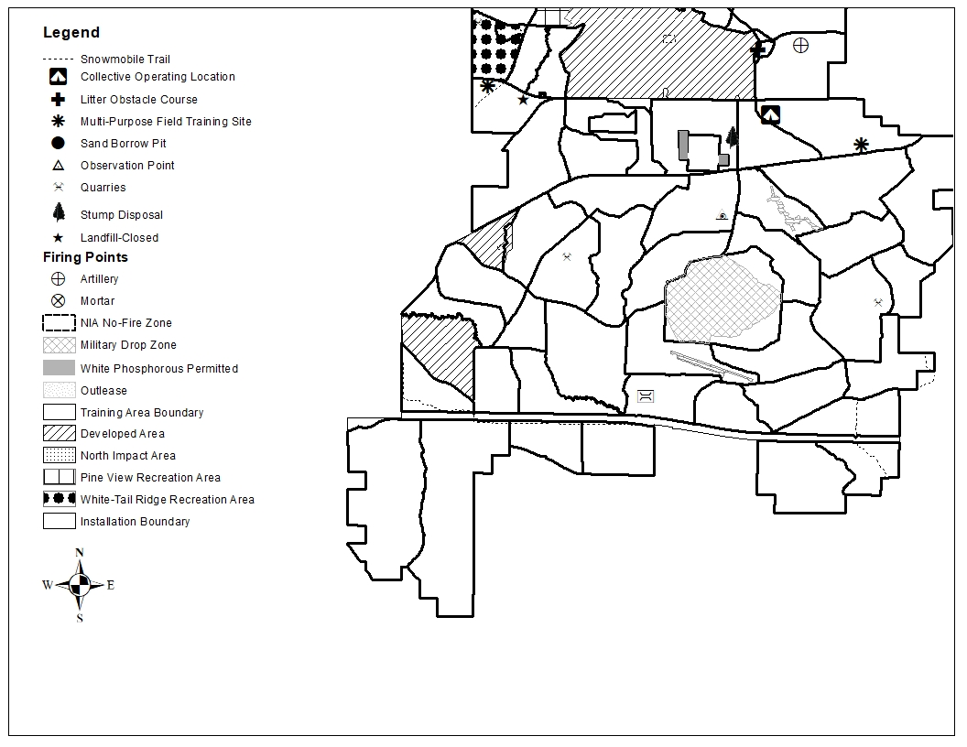

Figure 16b. Land Uses on South Post of Fort McCoy.

cleared of UXO for the treatment of invasive species and to conduct rare species surveys. The La Crosse River flows through the center of the NIA with a broad expanse of level to rolling ground on either side. Steep ridges surround much of the perimeter and provide some noise abatement. A scarified firebreak and berm serves to prevent wildland fires from escaping and identifies the perimeter boundary.

3.1.3.1 Management Considerations
Concern over the NIA and its possible impacts to the La Crosse River resulted in WDNR, USFWS, DPTMS and DPW forming a team that met periodically in the 1990’s to review data collected on water quality and training activities. One outcome of this team was the designation of a 547 acre Restricted Fire Zone around the LaCrosse River. This group no longer meets, however information and data is shared with state and federal agencies on an as needed basis.
White phosphorous (WP) firing is restricted to four areas within the NIA to avoid depositing WP into wetlands. When burning WP lands in a water body or wetland the burning is extinguished and the oxidation process slows. Waterfowl can ingest the particles while searching for food and be poisoned. A small family cemetery is located in the NIA and is designated as a no-fire zone.
While military use is the exclusive use of the NIA, this area is believed to closely resemble the presettlement prairie/savanna landscape (Simmers et al. 1995). Wild lupine thrives from the fire and surface disturbance that is common in the NIA. There is also a significant wetland complex associated with the La Crosse River. Live fire ranges using the impact area as a safety fan may have electronic target systems that can be damaged by uncontrolled fires. Using prescribed burning and firebreaks is important to keep target system damage to a minimum and it is a crucial tool to minimize lost training time.
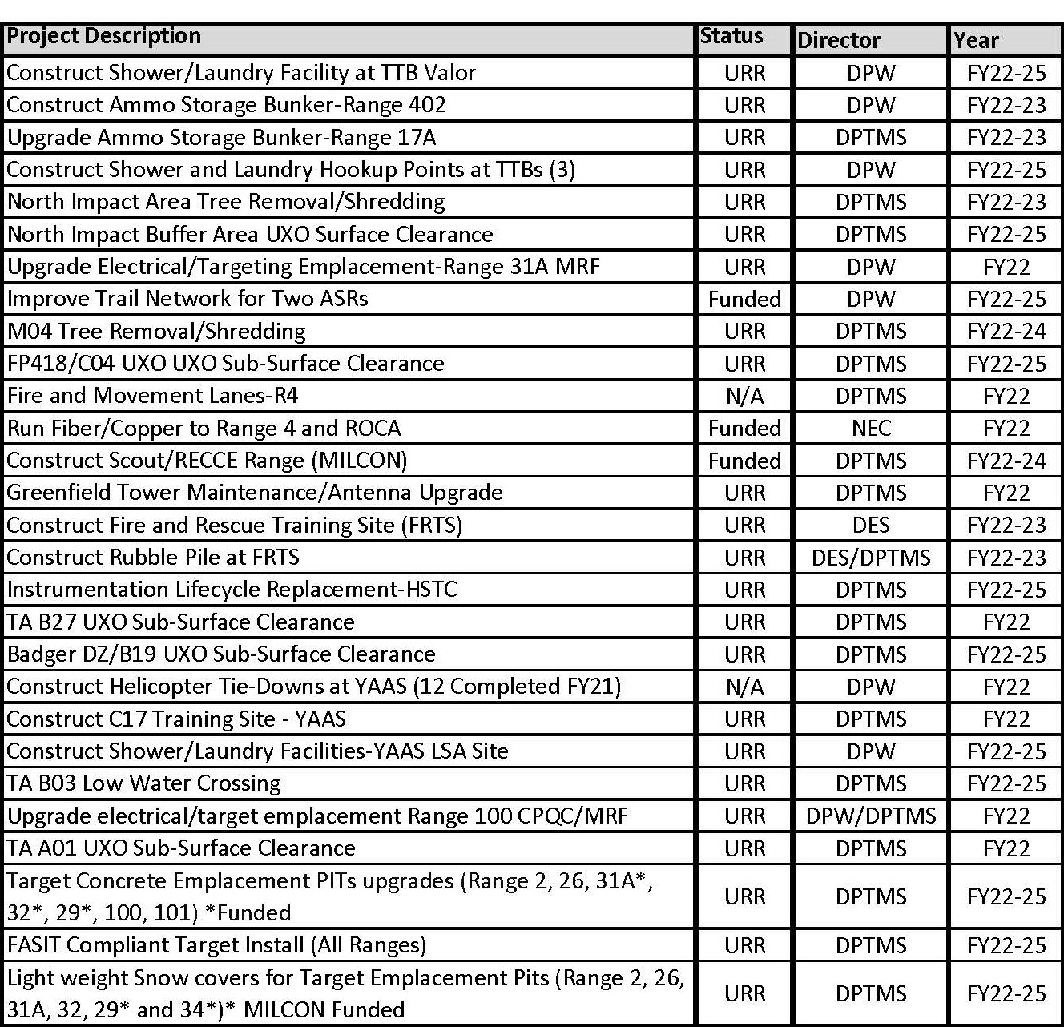

Table 2. Range Complex Master Plan projects.

Ranges which have been prescribed burned are less likely to stop training due to safety concerns and limited visibility from smoke and fire. The goal is to maintain the NIA as a viable training resource and to maintain high water quality on the La Crosse River. There are approximately 550 acres of KBB habitat in the NIA. The frequent wildland fires are thought to be beneficial to KBB habitat even though large areas may be burned at one time. Annual prescribed burning of the NIA is also implemented to reduce fuel loads and minimize wildland fire burns from escaping the area. In 2018, both regal fritillary and ottoe skipper butterflies were documented within the NIA. There are two active bald eagle nests near the boundary of the NIA, one near the southeast corner and the other near the NE corner where the La Crosse River enters the NIA. The NIA provides a large refuge to deer during gun-deer season. Leafy spurge and spotted knapweed have been discovered growing in the NIA.
In 2008, an Operational Range Assessment Program (ORAP) Phase I Qualitative Assessment was conducted for the Fort McCoy operational range complex. The purpose of the ORAP Phase I Assessment is to evaluate operational range areas using readily available data to determine whether or not a potential existed for a release or a substantial threat of a release of Munitions Constituents of Concern (MCOC) to an off-range area at levels that may pose an unacceptable risk to human health or the environment. The MCOC are defined as those munitions constituents that have the potential to migrate from a source area to an off-range receptor (human or ecological) in sufficient quantities to pose an unacceptable risk to human health or the environment (Department of Defense Instruction (DODI) 4715.14, 2005).
The ORAP Phase I Qualitative Assessment (Malcolm Pirnie, 2008) evaluated the 226 operational ranges at Fort McCoy based on three components: (1) sources of potential MCOC, (2) migration pathways from ranges, and (3) potential off-range human and/or ecological receptors. Ranges with at least one component absent were categorized as unlikely to have MCOC migrate off-range and pose an unacceptable risk to human or ecological receptors: 161 of Fort McCoy’s operational ranges were categorized as ‟unlikely.” Ranges with the potential for MCOC migrating off-range and affect human or ecological receptors were categorized as ‟inconclusive.” Sixty-five of Fort McCoy’s operational ranges were categorized as ‟inconclusive” and recommended for inclusion in this Phase II Assessment.
The project goal for the ORAP Phase II Assessment at Fort McCoy is to determine whether concentrations of MCOC in surface water systems and/or groundwater are migrating from the 65 operational ranges at concentrations that present an unacceptable risk to human health and/or the environment. The Phase II Assessment will analyze media which may include surface water, sediment, benthic macroinvertebrate, and groundwater samples collected at Fort McCoy. During the ORAP Phase II Assessment, MCOC will be identified for each medium in the La Crosse-Bad Axe River Basin based on an evaluation of munitions types and environmental media. Surface water samples will be analyzed for potential MCOC including metals, explosives, and perchlorate, sediment will be analyzed for metals and explosives, and groundwater will be analyzed for metals, explosives, and perchlorate. The final round of sampling took place in June 2011 and included the collection of surface water and sediment from four separate locations on Fort McCoy. Groundwater samples from the wells at Ski Hill and Range 2 were also collected. The ORAP Phase II Assessment was completed in October 2012 and found that the operational ranges are not migrating MCOC at levels that pose an unacceptable risk to off-range human and or ecological receptors. The inconclusive ranges identified in the phase I Assessment should be re-categorized as unlikely.

3.1.4 Developed Areas

3.1.4.1 Cantonment
See paragraph 2.2.2 for more information.

3.1.4.2 Housing
See paragraph 2.2.3 for more information.

3.1.4.3 Transportation
See paragraph 2.2.5 for more information.

3.1.4.4 Management Considerations
The infrastructure of developed areas is a factor that must be taken into account when managing the land. Management activities such as deer hunts and timber sales are more visible to the public in developed areas. Several security fences were placed around the cantonment and family housing areas. The fencing is restricting deer movement and made accessibility to some training areas more difficult for recreational use and training use. Some of the gravel parking lots and their edges are infested with exotic, invasive plants and serve as a seed source to infest new areas when vehicles drive into the training areas after parking in the cantonment area. In the next five years, there are new construction projects planned in the cantonment area and the airfield. Many of the projects are upgrades or later phases of existing facilities and are sited within the cantonment area. See Para. 2.2.7 for more details on future construction.
An increase of paving and parking lots in the cantonment area is increasing the amount of storm water runoff. In 2010, Fort McCoy collaborated with EPA and Purdue University to use Purdue’s Long Term Hydrological Impact Analysis to delineate the watersheds. The EPA’s Guidance for complying with Section 438 was used to identify preliminary low impact development (LID) practices for the 3 subwatersheds. An additional 16 developing subwatersheds were identified in which LID management practices may provide benefits in reducing runoff and non-point source (NPS) pollution. We look to utilize EPA “Smart Growth” objectives for future developments to negate storm water concerns and perhaps even resolving existing surface water quality threats. Stormwater treatment areas have been designed and developed for the cantonment area utilizing LID concepts starting in FY14. Recently, DPW Master Planning has completed several stormwater studies and established stormwater plan. Stormwater initiatives are on-going and will continue into the future. Quantifying these treatment sites will be beneficial for the Adaptive Management Plan (2017) that is expected to reduce sediment and phosphorus from being discharged into the upper La Crosse River watershed.
Movement of deer in/around the Fort McCoy/Sparta Airport runway was identified as a safety problem until the airfield was enclosed by a fence in 2009 to exclude deer and provide security.
Roadsides in the training areas provide habitat for the KBB so a system of identifying KBB areas along roads has been implemented. The areas were marked using painted fence posts, and from the mid-1990s until 2018, these areas were not mowed until September or October, after the KBB flight periods were over. To reduce the potential of spreading invasive weed seeds, beginning in 2018 these areas are mowed between June 1 and July 15.
The DPW completes tree removal along roads thru timber sales, cutting non-merchantable trees and shredding that are impacting travel or road maintenance. Erosion is a main concern in areas of steep slopes or in the vicinity of stream crossings. Coordination between DPW and NRB is vital to minimizing impacts to water resources.

3.1.5 Wetlands and Fort McCoy Natural Areas
See paragraphs 2.6.2.1 and 2.6.2.4 and Figure 10 for information on wetlands and FMNAs.

3.1.5.1 Management Considerations
See paragraphs 2.6.2.1.2 and 2.6.2.4.1 for information on management considerations.

3.1.6 Experimental Plots and Study Areas
Experimental plots have been established on Fort McCoy to provide scientific information needed to conduct ecosystem management. Research partnerships are established with universities and other agencies. Experimental plots, like wetlands and natural areas, can pose some restrictions to training. Unlike wetlands and natural areas, these restrictions normally result in minimal impacts to training and are usually temporary in nature. Plot locations are coordinated with Range Scheduling to ensure impacts on military training are minimized.
Studies done in the past and partners involved include:
- Study of ticks and zoonotic diseases with Michigan State University and other researchers.
- Erosion control with the Construction and Engineering Research Laboratory (CERL).
- Chunkwood road construction with Cold Regions Research and Engineering Laboratory, USFS and Wisconsin National Guard.
- Oak wilt control with University of Minnesota.
- Response of lupine to disturbance with the UWM.
- Mark-recapture of KBB with the University of Wisconsin-Stevens Point.
- Flea beetle predation on leafy spurge with the U. S. Department of Agriculture.
- The KBB population modeling with the Oak Ridge National Laboratory.
- Control of leafy spurge with UWM.
- Grassland bird monitoring with UWM.
- Diplodia shoot blight research in red pine plantations with UWM.
- Developing western slender glass lizard survey techniques with the University of Wisconsin-Stevens Point.
- Characteristics of habitat utilized by phlox moths with Iowa State University.
- Bird Surveys in conjunction with image texturing as a predictor of bird occurrence and abundance - UWM.
- Grassland bird geo-locator study designed to determine migration routes and over-wintering locations.
- Western slender glass lizard research for understanding chemical signaling and divergence among isolated populations.
- Conspecific attraction as a management tool for endangered and at-risk species.
- Snake fungal disease.
- Frosted elfin habitat study with CERL.
- Acoustic bat recording and NAB at mobile routes with CERL.
- eDNA assessments of streams, ponds and wetlands for aquatic invasives, fish, rare species and brook trout gill lice with CERL
- NIA stream attenuation study with CERL
- Tick Research to identifying species present; determine tick densities by habitat area, determine small mammal interactions, and identify diseases carried by ticks on the installation with CERL.

3.1.6.1 Management Considerations
The use of experimental plots that exclude military use from that area must be located to prevent hampering the military mission. Many of the studies do not require exclusion of training, but merely intermittent access to the sites and possible placement of data collection devices. After the study is completed the area is returned to normal use as quickly as possible. These types of studies are important for properly managing the natural resources on Fort McCoy as many of the ecological and natural community processes are not well understood at this time. “In reality there are large gaps in our knowledge of the ecology and population biology of these species (rare plants)… Fort McCoy is a laboratory well suited for research that addresses both practical problems faced by conservationists (e.g., habitat restoration) and theoretical questions yet unanswered by science” (Leach, 2001:12).

3.1.7 Recreation Areas
Outdoor recreation areas are divided into two classes. Class I areas are primarily managed for intensive recreational use and include the Pine View Recreation Area and Whitetail Ridge Recreation Area. Class II areas are natural environment areas that support dispersed recreational activities in conjunction with other uses to include hunting, fishing, and trapping. Class II generally fall within the training areas with some of the Whitetail Ridge area undeveloped and used as Class II recreation. See Figure 16a & b for locations of Class I recreational areas.

3.1.7.1 Pine View Recreation Area (PVRA)
The PVRA is the only authorized campground and swimming area on Fort McCoy. It is a complete facility containing 148 paved camping pads, 30 tenting pads, 16 lakeside cabins and other types of rentals for overnight stays. Most are equipped with full (electric, water, sewer) or electric hook-up, picnic table and grill. All types and sizes of camping units are accommodated. Located within walking distance of the campground is a five-acre picnic site with two comfort stations, two large shelter houses, grills, playground equipment, swimming beach and ample parking. A marked hiking trail of about 1.5 miles begins at the picnic area and meanders along the La Crosse River.

3.1.7.2 Whitetail Ridge Recreation Area (WRRA)
The WRRA has the only marked and groomed cross-country ski trail on Fort McCoy. It also contains a downhill skiing facility with 185-foot vertical drop, four lighted slopes (the longest two are 1300 feet in length), and a T-bar lift. A water storage pond is located within WRRA to provide water for the snowmaking machine. Other amenities include snow tubing that was upgraded in 2018 with a new lift called the “Magic Carpet”, ski equipment rental, chalet with snack bar, lounge, restrooms, paintball course, and laser tag course.

3.1.7.3 Sportsman’s Range
The Fort McCoy Sportsman’s Range opened in fall 2010 with a small clubhouse, rifle range, pistol range, a 3-D archery range, and a trap and skeet range. The range is open to active duty military, retired military, DoD appropriated fund and non-appropriated fund employees, retired civilian employees, DoD contractor employees working full-time at Fort McCoy and their immediate family members and guests late afternoons during the fall months or by calling ahead.

3.1.7.4 Snowmobile Trail
There are approximately 18 miles of authorized snowmobile trails on Fort McCoy; the northeast corner, along the west boundary, and south of US 16 (see Figures 16a & b). The trail surface is groomed by the Monroe County Snowmobile Alliance (MCSA) as needed. The Fort McCoy trail is a portion of a regional trail operated by MCSA stretching over 75 miles from Tomah to Neillsville.

3.1.7.5 Natural Environment Areas (Class II Recreation Areas)
Natural environment areas make up the majority of Fort McCoy’s land and are locations that support dispersed recreational activities to include firewood collecting, hunting, fishing, and trapping. These activities require the purchase of a Fort McCoy permit and appropriate WDNR license. Access to hunting areas may be limited due to training requirements. Other recreational activities such as hiking, photography, berry picking, bird watching, dog walking, mushroom foraging and bicycling are allowed in training areas not closed due to military training requirements. Specific training areas/sites may be closed due to scheduled training taking place. All personnel not involved with scheduled training or authorized work duties are required to have an active Fort McCoy iSportsman account and must consult their activities map and the Game Line area closure listing in iSportsman before entering any of the 82 training areas.

3.1.7.6 Management Considerations
The NRB manages that portion of Outdoor Recreation that is related to the natural resources. The Community Recreation Division of the DFMWR is responsible for managing and maintaining the recreational activities, facilities and programs. The DPW provides mowing and other grounds maintenance support. The maintenance and use of the snowmobile trail is responsible for spreading invasive plants along its path, so more resources have to be dedicated to invasive species control and containment. Additional coordination with the snowmobile clubs is planned to develop strategies to limit impacts of invasive species (i.e. timing of mowing). The Sportsman’s Range has the potential to negatively impact training in the adjacent training areas and ranges.

3.1.8 Wellhead Protection Area
The WDNR has required Fort McCoy to establish a Wellhead Protection Area (WHPA) in accordance with WDNR regulation NR811. The WHPA must encompass an area that has a minimum of a five-year travel time for groundwater supplying Fort McCoy’s drinking wells. It is desirable to protect a fifteen-year time of travel if possible. More information on Fort McCoy’s wells is located in Para. 2.2.6.1. Fort McCoy created a Wellhead Protection Plan (WPP) to establish responsibilities and procedures for protecting Fort McCoy’s water resource from contamination. The WPP lists prohibited activities and minimum setbacks required from water supply wells to various activities. In addition to the drinking wells, there is also a 100 foot buffer around all wells on ranges and within training areas.

3.1.8.1 Management Considerations
The rapid permeability of the sandy soils and sandstone bedrock on Fort McCoy that allows a quick groundwater recharge rate also increases the possibility of groundwater contamination. The predominant soils, Tarr, Impact and Boone sands have poor filtering capacity for substances that could contaminate the groundwater. Some activities that could pollute ground water are restricted within the WHPA with tighter restrictions within 1200 feet of the wells. These restrictions have direct impacts on training events associated with activities such as refueling operations, maintenance operations, grey water disposal, field latrines, or other activities that have a potential to pollute ground water resources. Management activities such as the use of herbicide for invasive plant species is also impacted by these restrictions, and therefore other control measures such as biologic or mechanical control may have to be used.

3.1.9 Outleases and Easements
Fort McCoy has one agriculture outlease involving two locations totaling 90 acres (Figures 16a & b) for cranberry bogs, drainage and reservoir. One of the lease areas is called the North Flowage and is a popular fishing area. The outlease brings in $1,492 per year that pays part of the administrative cost of operating the leases. These parcels are renewed every five years and the lessee is charged a one-time administrative fee of $3,700 for each renewal with the most recent renewal occurring in 2019.
Easements present on Fort McCoy involve utilities corridors (fiber optic cable, natural gas, and electricity), roads, administrative facilities and communications towers. The Omaha District, USACE administers the outleases and easements.

3.1.9.1 Management Considerations
Each lease has its own agreement that spells out limitations of use by Fort McCoy for training and recreation as well as limitations for the leasee. Fort McCoy’s largest body of water, the North Flowage, is flooded as a result of the water storage lease. The lease allows access to the flowage from military land for recreational purposes. The cranberry agriculture outlease area on south post has no provisions allowing recreational use of the leased land. The water storage lease and cranberry lease have little impact on military training as the majority of these areas are classified as wetlands. Pesticide use must be reported to the installation pest controller each month they are used. Easements for utilities and roads bisect training areas and have some negative impacts on the training mission and wildlife habitat.

3.1.10 Shale Quarries and Sand Pits
Fort McCoy has nine shale quarries and one active sand pit on the installation (Figures 16a & b). Locally excavated shale or purchased gravel was the main road surface on Fort McCoy for many years until 2001 when black top or “chip seal” became the preferred surfacing material. Shale is now mainly used to improve range roads and tank trails. Sand from the sandpit is used for fill material in construction projects. All but two of the shale quarries have been abandoned. One abandoned shale quarry is used to stockpile, and then crush cement chunks resulting from demolition projects. Another abandoned quarry was reclaimed in 1985 with dredge material hauled out of Upper Sparta Pond. Part of the dredge material was spread to a six-inch layer and the remainder was left as piles. Cottonwood trees quickly seeded in and stabilized the soil. Dredge spoils from Hazel Dell Lake were used to rehabilitate a former borrow site, this made the abandoned pit a more productive landscape.

3.1.10.1 Management Considerations
Shale and sand that is excavated close to the site where it is used can be a cost-effective material. The material is free for use on Fort McCoy and hauling costs are relatively low. Shale pits are typically located on ridge tops and are a leading cause of gully erosion on Fort McCoy. The vegetation and topsoil are removed and the area is compacted from excavation. During rain, the water cannot percolate downward and is directed out of the quarry area by opening channels on the quarries’ side. A large amount of water runs out from these openings and creates massive gullies, depositing the soil down-slope where it covers and kills vegetation. Water that does not run off the quarry sites collects and creates small wetlands. These wetlands are important sources of water for wildlife and ephemeral ponds for amphibian breeding. Roads leading to the quarries are usually steep and wash out frequently. Shale material becomes slippery from precipitation and therefore is not the best road material to use from a safety standpoint. It also has a tendency to breakdown over time, creating sediment runoff and the need to continually reapply material. Sand and other borrow pits that are left “open” for several years have a high probability of becoming infested with invasive plants, therefore efforts should be made to limit or properly site these pits to reduce impacts of invasive species.
Sandpits are highly susceptible to wind erosion. Once the topsoil and vegetation are removed it is very difficult to reestablish vegetative cover on the low fertility and droughty, course sandy soils. Once abandoned, the sandpit becomes a sand blowout and requires effort to stabilize it. All new sandpits require a reclamation plan to restore the site so it will benefit the training mission. Sand pits with steep, cliff-like edges may attract nesting birds such as bank swallows, cliff swallows, or kingfishers. Disturbing active nests by extracting sand is in violation of the Migratory Bird Treaty Act. All banks should be kept at a gentle slope to avoid fines or temporary closure of the sand pit.

3.1.11 Stump Disposal Areas
Fort McCoy has three authorized stump disposal areas for trees and stumps that are removed from construction projects or other removal needs such as hazard tree removal. The first stump disposal area was established in 1991 to deal with the increasing amount of debris from construction projects within and near the cantonment area. Two other stump disposal sites were established to handle material from range upgrades on North Post. A temporary stump disposal site may be created when necessary and will go through the NEPA review process before it is used.

3.1.11.1 Management Considerations
The debris is chipped once a year (more often if it is needed) and the chips are used as landscape mulch, erosion control, or to improve accessibility along sand trails within the training and maneuver area. The public is able to gather chips for personal use if they purchase a firewood permit. In February 2005 a pile of wood chips started on fire through spontaneous combustion. Subsequent wood grinding contracts limited the size of chip piles to prevent future fires and required enough space between the piles to allow access to firefighting vehicles. NRB inspects the areas where mulch is used to find new populations of invasive species spread through the use of the mulch. Wood chips that are infested with invasive plant material have the potential to spread invasive plants to new areas.

3.1.12 Mound Prairie Cultural Site
The Mound Prairie Cultural Site encompasses approximately 12.7 acres, and lies along the installation boundary south of State Highway 16. There are 12 low mounds in the area that were first reported as Native American mounds by Stephen Peet in 1883. Recent investigations have concluded the mounds are of natural origin but the area is still considered a sacred site by the Ho-Chunk Nation. Most of the area was covered by red pine that was planted in 1966 and 1968. In the mid-1990’s the pine was harvested from the mounds without using heavy equipment. In 2010 most of the plantation was salvage harvested after a severe hail storm in July 2009 caused widespread mortality. Smaller portions of the site were planted with black walnut in 1967 and 1968, or are covered by a natural stand of jack pine. In 2018, both jack pine and black walnut trees were removed from on top of, and from within 15 feet of, the mounds to prevent inadvertent disturbance from windfall trees. Additionally, as a management strategy, woody brush was removed, walnut trees thinned, and native grasses planted on and adjacent to the mounds. This area is not shown on the map at figure 16b to respect the privacy of the Ho-Chunk Nation.

3.1.12.1 Management Considerations
Any continued management activities considered for the site must be coordinated with the Ho-Chunk IAW “The Mound Prairie Sacred Area Management Plan.” When the storm damage was discovered, NRB consulted with the Ho-Chunk to determine the proper course of action. The trees were harvested off most of the site but a small section along Coles Creek remained unharvested to avoid damaging part of the cultural site. The management plan (Appendix F) was developed with Ho-Chunk approval that encompassed the site and surrounding area damaged by the hail storm. The actual sacred site will be managed as a savanna with the outlying area allowed to naturally regenerate back to pine forest with hand planting to augment the existing seedlings. The site is limited to dismounted military training (no vehicles) only.

3.1.13 Closed Landfills
Fort McCoy has ten properly closed landfills within its boundaries. Two of the largest landfills dated back to the 1940’s and 1960’s. The demolition landfill was in operation for approximately 20 years in the 1990’s and 2000’s. All three have been closed in conformance with the WDNR rules governing landfill closures.

3.1.13.1 Management Considerations
Three of the closed landfills are off limits to vehicle traffic and soil or cap disturbance, to prevent damage to their caps. This is accomplished with fences and signs. The landfill adjacent to the LaCrosse River is managed as a sand prairie and may be placed into a prescribed burn schedule to help maintain the plant community. This area is being considered for use as a solar panel farm in the future. The closed landfill next to Range 29 is at risk of wildland fires from the range. The Fire Department is not allowed to use the fire plow to control fires on the landfill cap. Fires are discouraged by keeping the grass mowed and with a series of firebreaks between the range and the landfill.

3.2 Management Units

3.2.1 Training Areas
Fort McCoy has 82 training areas with the capacity for military maneuvers totaling 45,633 acres. Boundaries are typically natural or cultural features that are generally easy to identify, such as, streams, ridgelines, roads or firebreaks. The installation is divided into five main areas; A, B, C, D and M. Those areas are further divided numerically. The average training area size is 557 acres and ranges from 112 to 1477 acres.
Units training at Fort McCoy have to request specific training areas and then stay within those areas while conducting exercises. This allows Range Scheduling to disperse the training across Fort McCoy throughout the year and to ensure safety, while minimizing training conflicts. The ITAM Program uses the training area designations to analyze the impacts associated with training loads, to provide the Range Scheduler and Range Officer with the conditions of the various training areas and suggestions for carrying capacity of each training area, as well as the cost of rehabilitation and repair associated with varying training loads or specific events. Starting in mid-2021, Range Scheduling will provide NRB with a training area schedule weekly to update the iSportsman Game Line and alert recreational users of scheduled training areas to prevent conflicts with training, especially during the hunting season. Hunters, trappers, fishermen, and firewood collectors are required to call the Game Line (866) 277-1597 or check online at www.mccoy.isportsman.net prior to accessing Fort McCoy to get a listing of the closed areas.

3.2.2 Forestry Compartments
The Forestry Program has divided the installation into 94 forest compartments ranging in size from 144 to 1183 acres, with the average size being 683 acres. The boundaries originally corresponded with training area boundaries when the first inventory was completed in 1967-1968. Over time, the training area boundaries have changed but the compartment boundaries have remained constant. In 1970, various impact areas were consolidated into the present day NIA. The result was 8 compartments removed from management (51, 52, 62, 63, 66, 67, 68, and 69).
Each compartment is further divided into stands. These are areas of similar vegetation or land use with forested stands grouped by species, age, size and stocking density. The minimum size for a stand is typically 10 acres although stands may be delineated to a smaller size if there are special management needs (high timber value, wildlife or T&E habitat).

3.2.3 Special Management Areas
Areas with cultural or significant natural resources are considered under special management to provide the required degree of protection. One cemetery, five individual burials, and three Native American Sacred Sites (Mound Prairie and two water springs) have been identified and protected. One other cemetery, LaFayette Cemetery, lies within the cantonment, but is not owned by Fort McCoy. Known buried cultural resources sites are protected but not identified in maps or on the ground to prevent looting. Consistent with the military mission and Executive Order 13007, federally recognized Indian tribes that have a cultural or historical affiliation with the lands encompassed by the installation may have access to sites and
resources that are of religious importance, or that are important to the continuance of their cultures. This includes non-commercial gathering of botanical and mineral resources for traditional cultural use.
To obtain access to the installation, the Nation's Tribal Historic Preservation Officer (THPO) will contact the installation Native American Coordinator. The Native American Coordinator will obtain all necessary information regarding the access request, such as, purpose of visit, specific location to be visited, date/time/extent of visit, etc. The Native American Coordinator will then complete all internal coordination concerning access to the installation by tribal members. Access may not always be able to be granted on the date, time and/or location requested due to military mission and/or safety requirements.

3.3 Natural Resources Consultation Requirements
Fort McCoy has completed formal consultation with the USFWS on activities that have the potential to impact the federally endangered KBB, NLEB, and RPBB. Section 7 consultation with the USFWS now occurs when Fort McCoy anticipates exceeding the amount of incidental take currently authorized, or new activities will be conducted that have not yet been assessed.

3.4 National Environmental Policy Act (NEPA) Review
The NEPA review coordinates environmental reviews for projects planned on Fort McCoy in accordance with 32 CFR Part 651, Environmental Analysis of Army Actions. The NEPA process includes the systematic examination of possible and probable environmental consequences of implementing a proposed action. The NEPA review is managed by the ED.

3.4.1 NEPA Goals
The goal of NEPA review is to integrate the NEPA process into Army project planning at the earliest possible time. All construction, repair, remodeling activities, repair and maintenance of all range roads, the South Post family housing area, the airfield, range and training area modifications and upgrades are reviewed for environmental impact. The project proponent completes an internal work review information sheet and submits that along with pertinent project data to the environmental coordinator to initiate the environmental review.
“Informed decision-making using the NEPA process must be an integral part of natural resources management on installations. By following the NEPA process, damages to natural resources on Army lands can be minimized or mitigated”(Williamson, 1997:3).
The NEPA establishes policies and goals for the protection of the environment. Section 102(2) of NEPA contains certain procedural requirements directed toward the attainment of such goals. The NEPA process includes the systematic examination of possible and probable environmental consequences of implementing a proposed action. To be effective, integration of the NEPA process with other Army project planning will occur at the earliest possible time.

3.4.2 NEPA Categories
The following are the five broad categories into which proposed actions on Fort McCoy may fall into for environmental review:
- Exemption by law. The law must apply to DoD and/or Army and must prohibit, exempt, or make impossible full compliance with NEPA (40 CFR 1500.6).
- Emergencies. In the event of an emergency, the Army may need to take immediate actions that have environmental impacts, such as those to promote national defense or security or to protect life or property, without the specific documentation and procedural requirements of other sections of this part. In such cases, at the earliest practical time, the Headquarters, Department of Army proponent will notify the Office of Director of Environmental Programs.
- Categorical Exclusions (CATEX). These actions normally do not require an Environmental Assessment (EA) or an Environmental Impact Statement (EIS). The Army has determined that they do not individually or cumulatively have a significant effect on the human environment.
- Environmental Assessment (EA). An EA is a public document and is required when the proposed action has the potential for:
- Cumulative impact on environmental quality when combining effects of other actions or when the proposed action is of lengthy duration.
- Release of harmful radiation or hazardous/toxic chemicals into the environment.
- Violation of pollution abatement standards.
- Some harm to culturally or ecologically sensitive area.
5. Environmental Impact Statement (EIS). An EIS is a public document with a primary purpose of ensuring that NEPA policies and goals are incorporated early into the programs and actions of Federal agencies. An EIS is required to provide a full and fair discussion of significant environmental impacts. Along with other project documentation, the EIS provides a basis for informed decision making. Further, it allows a public review and comment on the proposal.
The following are actions normally requiring an EIS:
- Significant expansion of a military facility, such as a depot, munitions plant, or major training installation.
- Construction of facilities that have a significant effect on wetlands, coastal zones, or other areas of critical environmental concern.
- The disposal of nuclear materials, munitions, explosives, industrial and military chemicals, and other hazardous or toxic substances that have the potential to cause significant environmental impact.
- Major changes in the mission of facilities either affecting areas of critical environmental concern or causing significant environmental impact.
- Land acquisition, leasing or other actions that may lead to significant changes in land use.
- Training exercises conducted outside the boundaries of an existing military reservation where significant environmental damage may occur.

3.5 Partnerships and Collaborative Resource Planning
The NRB actively participates in partnerships and resource planning to enhance awareness and work collectively to manage resources for the following projects or organizations:
- Clear Creek and Stillwell Creek stream monitoring trends with the USGS, WDNR, Monroe Co., NRCS, and EPA
- The KBB Recovery Groups
- Trout stream habitat restoration (Trout Stamp & Trout Unlimited)
- Lake Restoration (Lake Tomah, Angelo, and Perch Lake)
- American Fisheries Society (WI Chapter)
- Monroe County Climate Change Task Force
- Wildlife Society (WI Chapter)
- Monroe County Invasive Species Working Group
- Monroe County Chronic Wasting Disease Task Force
- Adaptive Management and Water Quality Trading with Monroe Co Land Conservation and City of Sparta.

3.6 Public Access and Outreach
Public access for outdoor recreation activities dates back to 1962 when the Camp McCoy Fish and Wildlife Advisory Council approved small game, gun deer and archer seasons. In 1963, the first cooperative agreement was signed by the Wisconsin Conservation Department, USFWS and Camp McCoy that allowed the Army to manage the wildlife on the installation. The Sikes Act and AR 200-1 state that Army installations that are suitable for recreational use are open to public access for hunting, fishing, and trapping. This access is subject to requirements necessary to ensure safety and military and installation security. More information about recreational access is found in paragraph 4.14.2.

3.6.1 Outreach Objectives
The NRB conducts natural resources awareness activities within the Fort McCoy community in accordance with DPW and mission priorities. If the mission dictates, awareness activities are also considered for implementation on a case by case basis within the surrounding area. The objectives of these activities are to:
- Showcase the natural resources present on Fort McCoy.
- Highlight the work done to protect and enhance the resources.
- Educate the workforce and trainers on compliance requirements for natural resource laws and regulations.
- Inform outdoor users about hunting and fishing opportunities and management.
- Explain program goals and activities.
- Encourage support for management activities and projects.

3.6.2 Military Personnel Awareness
The SRA program under ITAM takes the lead on educating the military about the environment (Para. 1.5.2.1.1.4.4). The NRB provides T&E information to Range Branch, DES-FES, Facilities and Grounds and LRAM to avoid unnecessary take. This may be either presentations by the T&E biologist or an information packet sent for review and signature.

3.6.3 Public Awareness
Any request for public awareness activities are requested through the Fort McCoy Public Affairs Office then routed to DPW and ED. The activity can be supported if it is determined to be a benefit for
Fort McCoy and the NRB staff is available. Some past activities include the following:
- Presentations at meetings of professional societies.
- Field trips for universities, local schools, nongovernmental environmental organizations and state and local government agencies.
- Annual Arbor Day Ceremony to highlight the importance of trees in everyday life.
- Informational booths at Armed Forces Day.

3.6.4 Volunteer Programs
Volunteer work is greatly encouraged and appreciated. Each year numerous volunteers participate in a wide variety of projects. These projects help to meet the management goals and provide beneficial experiences for the volunteer participants. Some past volunteer projects included:
- Invasive plant species surveys and control.
- Maintaining artificial nesting structures for several bird species.
- Assistance with spotlight deer surveys.
- Assist disabled hunt participants.
- Apple tree surveys and brush clearing.
- Rough white lettuce planting and surveys.
- Conducting phlox moth surveys and surveys for rare butterflies.
- Assist with whitetail deer harvest registration.
- American chestnut introduction and monitoring.
- Forest inventory data collection.
- Providing volunteer opportunities to military and civilian personnel.
- Prescribed burning (if the individual has credentials).
- Bluebird nest box monitoring.

3.6.5 Environmental Education
The NRB has supported and lead numerous environmental education and outreach programs both on and off the installation. The NRB has been involved with the following programs:
- Badger Challenge Academy.
- Fort McCoy Child Development and Youth Services programs.
- Sparta Area Independent Learning School.
- High School science and environmental groups extra-curricular field trips.
- West Salem School District 7th Grade Outdoor Education Program.
- West Salem School District 3rd Grade Environmental Day
- Brookwood Elementary School 5th Grade Environmental Day.
- Eagle and Boy Scout projects provide a chance for scouts to participate in wildlife projects.
- Teacher environmental workshops.
- Conducting conference field trips.
- Hosted a two day session for area teachers as part of the Science Technology, Engineering, and Math (STEM) grant program.

3.6.6 Research Opportunities
Research projects prove beneficial to the NRB by providing insight into species diversity and management goals and strategies. Where appropriate, NRB will continue to support graduate student research projects and collaboration efforts with federal, state, and local agencies and universities on natural resources issues.

3.7 Encroachment Partnering
Encroachment is the cumulative result of internal and external activities/events that inhibit military training, testing, and operations. It is the result of any activity, law, or pressure that affects the ability of military forces to train to doctrinal standards or to perform the mission assigned to the installation.

3.7.1 Army Compatible Use Buffers (ACUB)
The Army program to address encroachment is called Army Compatible Use Buffers (ACUB). The ACUB program establishes buffers around Army installations to limit effects of encroachment and to maximize the amount of land inside the installation that can support the mission. An ACUB proposal is under development with completion expected in 2021, and approval likely in 2022.

3.7.2 Joint Land Use Study (JLUS)
A Joint Land Use Study (JLUS) is a way to reduce potential conflicts between military installations and stakeholders while sustaining economic growth and development, protecting public health and safety, and protecting military missions. The Fort McCoy/Monroe County JLUS was completed in February 2013 and involved elected officials from the local communities of Sparta, Tomah, Monroe County, Jackson County, and the towns of Adrian, Angelo, Grant, Greenfield, LaFayette, and New Lyme in Monroe County. The study was prepared by The Mississippi River Regional Planning Commission, with financial support from the DoD Office of Economic Adjustment. A copy of the report is found on the internet at http://www.mrrpc.com/JLUS.html
The report offered five recommendations to improve compatibility and avoid land use conflicts in the future:
- Maintain the agricultural character of Monroe County and the towns surrounding Fort McCoy by supporting farm-friendly policies and educating new residents and businesses about the nature of rural life and life near a military reservation.
- Maintain the rural character of Monroe County and the towns surrounding Fort McCoy by supporting environmentally friendly policies toward forests and waterways.
- Maintain positive relationships between Fort McCoy and the surrounding civilian communities through formal partnerships, joint planning efforts, and increased communication.
- The towns, Monroe County, and Fort McCoy should investigate what payment options might be necessary in the future to offset property tax revenue that the towns will not receive simply because there is a military reservation in their territory.
- Encourage unzoned towns surrounding Fort McCoy to adopt land use controls.

3.8 State Comprehensive Wildlife Plan
The Wisconsin Wildlife Action Plan focuses on efforts to conserve species of greatest conservation need. The plan identifies native wildlife species with low or declining populations, the habitats associated with these species, and conservation actions that are needed to ensure these species do not become listed as threatened or endangered.
Sixteen ecological landscapes have been identified in Wisconsin based on their ecological attributes and management opportunities. Fort McCoy is included under the Western Coulee and Ridges Ecological Landscape. The Wisconsin Wildlife Action Plan includes Fort McCoy as part of a larger Conservation Opportunity Area (COA) called the Fort McCoy Barrens and Oak Savanna COA and is of continental significance because of the rare natural communities and species it contains. The INRMP management efforts that tie into the Wisconsin Wildlife Action plan include:
- Oak savanna restoration.
- Sand prairie and oak barrens restoration and maintenance.
- Goat prairie restoration and maintenance.
- Grassland wildlife management.
- Management of floodplain forests and large southern upland forest tracts.
- Restoration and maintenance of red and white oak as a cover type.
- Protection of rare features found only in the Driftless Area.
- Preservation of cliff communities, along with cave and bat hibernacula.
- Restoration and protection of spring-fed cold water streams.
- Big river protection and maintenance. Some of these streams support especially rich or otherwise significant assemblages of fish, reptiles and aquatic invertebrates.

3.8.1 Additional Documents Citing Fort McCoy’s Ecological Significance
In addition to its listing in the Wisconsin Wildlife Action Plan, Fort McCoy is listed as a Land Legacy Place in Wisconsin by the WDNR. The WDNR gives Fort McCoy five stars out of a possible five stars for its conservation significance, specifically noting the coldwater streams, grasslands, and rich reptile and insect communities.
The Wisconsin Bird Conservation Initiative lists the Fort McCoy-Robinson Creek Barrens as a Wisconsin Important Bird Area citing the area as the largest and best-maintained barrens and savanna in the entire upper Midwest.
In May 2009, Wisconsin Wetland Association launched the Wetland Gems™ program with the intent to “increase public awareness of and appreciation for all of the state's wetlands and to generate community pride in and commitment to stewardship of local wetlands”. Fort McCoy was the recipient of Wetland Gem™ designation on 29 August 2009 that featured Fort McCoy’s high quality riverine wetlands associated with Clear Creek and Silver Creek. Fort McCoy represented two of the 93 WMA Wetland Gem™ community sites http://wisconsinwetlands.org/gemslist.htm.

3.9 Climate Change Vulnerability Assessment
The Wisconsin Department of Natural Resources, along with the University of Wisconsin are working together in a partnership titled the “Wisconsin Initiative on Climate Change Impacts (WICCI)”. This partnership assessed past data to determine how Wisconsin’s climate has changed and to make predictions on future climate conditions. WICCI has released its first comprehensive report, Wisconsin’s Changing Climate: Impacts and Adaptation (2011). As stated in the WICCI website: “The report will serve as a resource for business executives, government, natural resource managers, public health officials and other decision makers as they take strategic steps to preserve jobs, invest resources wisely, build resiliency and protect our built and natural environment in the face of a changing climate.” The goals of WICCI are to:
- Assess and anticipate climate change impacts upon Wisconsin’s natural and built environments.
- Evaluate risks and vulnerabilities within our ecosystems, infrastructure, industries, agriculture, tourism and other human and natural systems.
- Recommend practical adaption strategies and solutions that businesses, farmers, public health officials, municipalities, resource managers and other stakeholders can implement.
In 2021, WICCI published the Climate Science Update. New analyses of historical climate changes over the past 10-years, especially seasonal warming, precipitation changes, and more extreme climatic trends are consistent with the weather predictions from the WICCI 2011 Assessment Report. New climate projections under a low-end emissions (of greenhouse gas) scenario suggest Wisconsin will continue to warm into the mid-21st Century, tripling in frequency the number of extreme heat days. Also, Wisconsin is expected to be wetter in the coming century with likely increases in frequency and magnitude of winter, spring and fall precipitation events. Under larger greenhouse gas emissions conditions, the high-end models for emissions predict more significant climate change impacts - higher temperature and greater precipitation. Wisconsin also published the Governors’ Task Force on Climate Change Report in 2020. These reports have helped the Monroe Co Land Conservation Department to formalize the Climate Change Task Force (CCTF) working collaboratively with agencies and landowners to improve public safety and flood resiliency. NRB will use these reports to help guide adaptive management strategies within the INRMP as well as glean other landscape management techniques from participation in the Monroe Co CCTF - Green Fire demonstration projects. We anticipate more cooperation with WDNR for the Brook Trout Reserve initiative to embrace climate challenges and sustain coldwater resources throughout Fort McCoy’s forested watersheds. Culmination of these landscape efforts may be productive in uniting local, state and federal entities into a sanctioned Sentinel Landscape coalition.

3.9.1 Wisconsin Climate Trends
The following is a summary of Wisconsin’s climate trends from 1950-2006.
- Statewide average temperature increased 1.1⁰F.
- The greatest amount of warming is occurring in winter and spring, especially in northwest Wisconsin.
- Nighttime low temperatures are warming faster than daytime highs, especially in summer.
- There has been a decline in extremely cold winter nights, especially in northwest Wisconsin.
- The date of the last spring freeze is occurring 6-20 days earlier.
- The date of the first fall freeze is occurring 3-18 days later.
- The growing season has increased up to 4 weeks.
- Statewide annual average precipitation has increased 15% although areas of northern Wisconsin became drier.

3.9.2 Wisconsin Climate Projections
The following is a summary of future climate projections for Wisconsin.
- Average temperatures will increase 4-9℉.
- The winter time period will see the most pronounced warming at 5-11℉.
- There will be fewer extremely cold winter nights and more hot summer days.
- The likelihood of 3-inch or more rainstorms will increase during the spring and fall.
- A four week increase in the growing season.
- More rainfall, less snow during winter and spring.
- Wisconsin’s tension zone is projected to move north due to a warming climate.

3.9.3 Affected Resources on Fort McCoy
How will climate change impact the fish and wildlife species found on Fort McCoy. It is projected that the following will occur:
- Tree species, such as, jack pine, red pine, paper birch and aspen will retreat northward and will become a much smaller component of the forest landscape.
- There will be a decline in tree species diversity.
- New forest pests and diseases will occur.
- Though annual precipitation will increase, warmer temperatures will result in increased evapo-transpiration resulting in drier soils.
- The likelihood of summer wildland fires will increase.
- Some wildlife species will see either range expansions or contractions.
- Migration patterns will change with earlier arrivals and later departures while some species may not migrate at all.
- Plant and insect phenology could change rapidly resulting in insect emergence at times when host plants are not available.
- Cold water fish species, such as brook trout, may disappear from streams due to warm water temperatures.
- Cause increased mortality for KBB larva and adults.
- Oak savannas may persist as climate conditions favor prairie conditions may help maintain or increase these areas.
- Extended summer droughts could increase incidence of red pine pocket decline and other pathogens.
- Warmer winters are decreasing the duration of frozen ground conditions, reducing the window for winter harvest operations.
- Longer growing seasons and warmer growing season temperatures are increasing the window of opportunity for dry-ground harvest operations, particularly in late summer and fall.
- Red maple is adapted to warmer conditions and may increase on the landscape.
- Forests may grow faster and use water more efficiently with additional CO₂ in the atmosphere.

3.9.4 Fort McCoy Management Actions
Fort McCoy is in the initial stages of modifying land management activities in an attempt to minimize these impacts. A few examples of these modifications are:
- With increasing air temperatures and the severity of storms, it will become more critical to maintain KBB habitat in shaded areas that offer refuge areas for the butterfly. Instead of using herbicides to kill the sapling and shrub component, mechanical alteration of the habitat will be utilized allowing for re-growth of these species. Completing this management on a rotational basis will ensure habitat both within open and partially shaded areas.
- Maintaining tree and shrub species along streams will buffer temperature increases. In some instances, this may require the planting of trees within the riparian areas that will offer future shade to the stream.
- Investigate the source of tree seedlings for planting and avoid seedlings from seed stock located or grown more than 100 miles north of Fort McCoy.
- Use timber sales to maintain and enhance species and structural diversity by promoting diverse age classes, maintaining the diversity of native species and retaining biological legacies.
- Reduce the impact of biological stresses on the forest to help the trees resist pests and pathogens. This can be accomplished with intermediate timber harvests to prevent overstocked forests, preventing the introduction and controlling existing populations of invasive species and managing deer to promote the regeneration of desired species.
- Participate in county-wide and regional landscape initiatives to improve flood resiliency and sustain coldwater resources as future climate changes challenge natural resources, military training and sustainability.

3.9.5 DoD Report on Effects of a Changing Climate
In 2019, the DoD released a report that provides an assessment of the significant vulnerabilities from climate-related events in order to identify high risks to mission effectiveness on installations and to operations (DoD, 2019). The climate-related events that were assessed were recurrent flooding, drought, desertification, wildland fires, and thawing permafrost. The report provides guidance on appropriate changes to installation master planning, design and construction standards to minimize the impacts of the changing climate. The climate-related events most likely to occur at Fort McCoy are flooding, drought and wildland fires.

3.9.5.1 Flooding
Fort McCoy streams and rivers have experience significant flooding in the past 30 years. In 1990 a flood destroyed the dam at WAC Pond and washed out culverts on some of the installation roads. Floods on Tarr Creek and Silver Creek have the greatest potential to damage infrastructure on the installation. The cantonment was constructed in a wetland using drainage ditches to lower the ground water table. In places the water table is still high enough to cause ponding in many areas. A recent example happened in 2017 when a significant rain event flooded the parade field and other locations (Figure 17). Fort McCoy Airfield experienced flooding in 2017 in an area that was being used for a unit bivouac. Monroe County flooding had high flood frequencies from 2016-2020 Stream base flows for the Driftless Area stream were at record high levels throughout 2020 resulting in record high water levels for the Mississippi River.

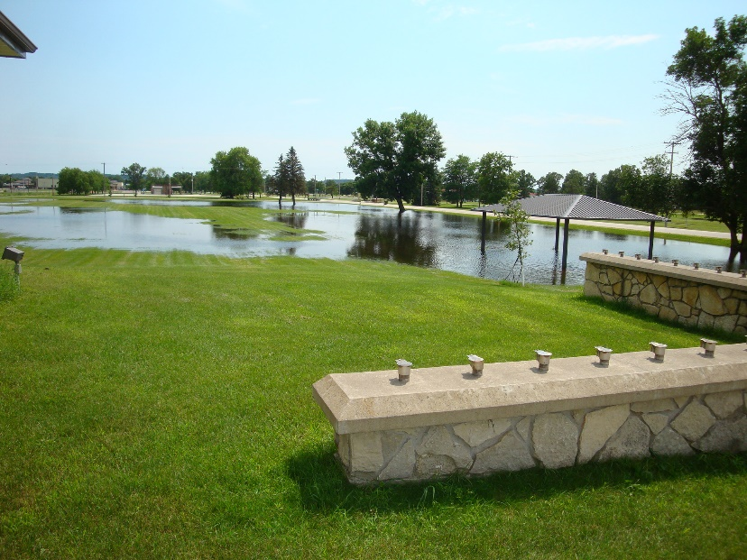

Figure 17. Flooding at the parade field in 2017.

3.9.5.2 Droughts
Over 80% (49,837 acres) of Fort McCoy soils are classified as sand. They are deep, excessively drained soils with very little organic matter and low available water capacity making them susceptible to droughts. Historical data shows that Wisconsin experiences a drought every 10 years. In 1976-77 the United States experienced a major drought with some areas in Wisconsin getting only 50% of the average annual precipitation. In 1988 one of the most severe droughts occurred since records were kept in Wisconsin with Fort McCoy receiving six to eight inches less annual precipitation than average. Fort McCoy stream flows were down significantly and many trees were stressed or died, especially in low areas when the high water table dropped out of the reach of tree roots. Another significant drought occurred in 2012 with a record heat wave.

3.9.5.3 Wildland Fires
Droughts and heatwaves combine to increase the chances of extreme wildland fire events. Forest fire conditions in the drought of 1977 were the most severe the state had seen since 1936. In 1977 the number of reported fires was 3,923 that burned 65,806 acres. Two fires between Fort McCoy and Black River Falls burned 20,627 acres with 14 homes lost and $1,400,000 in damages. The wildland fire records on Fort McCoy during 1976-77 show 20 reported fires that burned 643 acres. In 1988 a fire burned 911 acres along Interstate 90 approximately 50 miles from Fort McCoy. That year the installation had 16 wildland fires that burned 776 acres. 1988 also saw the historic wildland fire in Yellowstone National Park. While the drought of 2012 did not have a notable large wildland fire in Wisconsin, Colorado had it worst year for wildland fires with 244,000 acres burned, over 600 homes destroyed and six deaths. During the same year New Mexico had its largest wildland fire in history, burning 297,845 acres in the Gila National Forest. Fort McCoy reported 8 wildland fires that burned 218 acres in 1988. Since 2014, the western United States have set annual records of acres burned, largest acreage wildfires and monetary losses just about every year.

3.9.5.4 Management Activities
See paragraph 4.16.4 for actions identified to reduce the number and size of wildland fires.

4.0 PROGRAM ELEMENTS

4.1 Threatened and Endangered Species Management
Fort McCoy has taken a proactive approach in managing T&E species on the installation. This has greatly reduced any negative impacts to the military training mission. The focus of T&E management is savanna habitat management to enhance populations of the federally endangered KBB (Figure 18). Fort McCoy also manages/conserves state listed species as long these measures do not directly impact the military mission. A list of T&E species present is in Appendix E, Table 7.
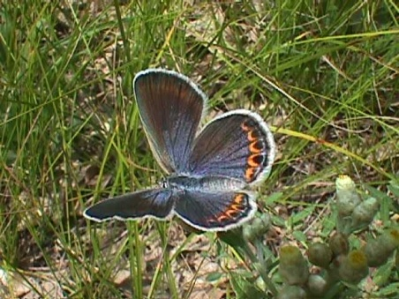
The goals for the program are:
a. Support the continuance of the military training mission while at the same time maintaining compliance with all applicable federal and state laws and regulations, such as the Endangered Species Act of 1973.
b. Continue to protect/manage state and federal T&E species found on Fort McCoy while allowing the successful completion of the military mission.
c. Adopt, to the maximum extent possible, the KBB Federal Recovery Goals established for Fort McCoy in order to assist with the conservation of this species.
d. Educate Soldiers, civilian employees and individuals in the surrounding communities on the importance of managing/conserving T&E species. Figure 18. Female Karner blue butterfly.

4.1.1 Management Activities
- Have an open line of communication with all persons and agencies interested in or who may impact T&E species.
- Review projects through the NEPA review process to eliminate or minimize negative impacts to T&E species. Coordinate all management and research activities with DPTMS as well as other NRB programs to ensure compatibility.
- Submit reports to the compliance agencies.
- Conduct annual briefings to the segment of the workforce that might impact T&E species.
- Document occurrence records for listed species.
- This INRMP will serve as the conservation plan for all State listed species occurring on the installation. Specific monitoring to document incidental take of individual State listed species will not be conducted but incidental take will be documented when observed (i.e., dead specimen found/reported) and reported to the WDNR in a timely manner.
- Proactively survey, monitor, and conduct management activities for rare species in order to prepare for possible future federal listing. When surveys and management activities are conducted for State listed species, a summary of these activities, to include impacts to State listed species when known, will be forwarded to the WDNR in a timely manner.

4.1.2 Karner Blue Butterfly Surveys and Management
The KBB was listed as federally endangered in 1992. The Fort McCoy KBB Management Plan was revised in 2012. The main management objective of this plan is to assist in the conservation of the KBB while accomplishing the military mission. The goals of the current plan are to:
a. Maintain two Large Viable Metapopulations (LP) of KBBs.
b. Continue to conserve the population of KBBs found within Training Areas A1 and A2.
c. Maintain connectivity between the North Post LP and the KBB population located on Black River State Forest (BRSF) lands south of Interstate 94.
The major actions required to meet the management objectives and conservation goals are:
a. Maintain a positive disturbance regime through military training, silviculture, wildlife, and
specific KBB habitat management practices.
b. Control or eradicate invasive plant species that have the ability to displace lupine and nectar species.
c. Implement a monitoring plan that will: provide population estimates on a biannual rotation; initiate a new rotation of presence and/or absence surveys every 10 years; and commence a new rotation of mapping the installation and leased/permitted properties for KBB habitat every 10 years.
d. Continue to review projects through the NEPA review process to eliminate or minimize negative impacts to KBBs.
e. Continue to enhance KBB habitats in training area C21 to facilitate the movement of KBBs between Fort McCoy and BRSF lands.
f. Continue to provide KBB awareness information to Soldiers and those civilian employees whose activities may impact KBBs or their habitat.
g. Habitat management is completed as outlined in the KBB management plan and the Biological Opinion for the species.

4.1.2.1 Management Activities
- Utilize distance sampling using straight-line transects to estimate KBB populations. Surveys are conducted at 23 sites every other year during both the spring and summer flights. The survey protocol states that each site will be surveyed on a seven-day interval. This is not always possible due to inclement weather conditions and conflicts with military training.
- Monitor KBB habitat at selected sites to determine changes in nectar availability and canopy cover. Vegetation data is collected at ten KBB survey sites every other year. The goal of KBB habitat monitoring is to detect changes in vegetation that is believed to be important to KBBs. Data collected will be used to assist in determining the cause of KBB population trends, either long term declines or increases. A secondary use of data is to assist in determining when to conduct management activities within a site. KBB habitat was first monitored on Fort McCoy using this protocol in 2006.
- Re-map KBB habitat every 10 years. Wild lupine is the sole host plant for larvae of the KBB. The first survey to identify the location and density of all wild lupine patches on Fort McCoy was conducted in 1991 through 1994. A re-inventory of wild lupine was initiated in 2001 and completed in 2006. A third survey was completed between 2011 and 2014. Beginning in 2018, wild lupine will be mapped annually on 10% of the installation and lands leased by Fort McCoy with lupine mapping being completed every 10 years. The goal of previous mapping efforts was to complete all mapping within a four-year period every 10 years. All incidental take calculations are completed using acres of wild lupine disturbed.
- Conduct presence/absence surveys within all KBB habitat patches to determine percentage of habitat being used by the butterfly. The KBB presence/absence surveys were conducted from 1991-1994, from 1996-2002, from 2006-2008, and from 2015-2017. In all four instances, survey results indicated that over 90% of lupine patches on Fort McCoy are used by KBBs. Presence of KBBs is confirmed by observing adult KBBs, larvae, or eggs. In general, the 1995 Wisconsin Habitat Conservation Plan protocol for conducting presence/absence surveys is followed. The areas most likely to contain KBBs within and/or around each lupine patch are searched three times before determining that KBBs are absent. Beginning in 2019, presence/absence surveys will be conducted within wild lupine patches mapped the year prior. This will result in presence/absence surveys being conducted within approximately 10% of the wild lupine patches annually, and all wild lupine patches being surveyed every 10 years.
- Complete habitat management activities as specified within the KBB Management Plan. This generally includes the control of undesirable vegetation through mowing, shredding, prescribed fire, removal by chainsaw and brush cutters, and herbicide application.
- Complete mitigation actions (re-planting of wild lupine and nectar species) required due to permanent loss of habitat resulting from construction projects. Mitigation actions are either completed on Fort McCoy or by providing funding to the USFWS who partners with the WDNR to complete mitigation actions off of the installation.

4.1.3 Gray Wolf Surveys and Management
The first resident gray wolf was documented on Fort McCoy in 1999. Since that time wolves have occupied a territory that encompassed most of North Post and adjacent private land. During the winter of 2009/2010, a pair of wolves established a territory on South Post. Wolves occupied this territory through November 2014. Currently as of January 4th, 2021 the gray wolf has been removed from the ESA. Fort McCoy has a valid Gray Wolf Management Plan and plans to continue to manage wolves despite this delisting. The objective of the management plan is to assist in the conservation of the gray wolf while accomplishing the military mission. This will be accomplished by protecting known den and rendezvous sites, maintaining habitat, and maintaining an adequate prey base for wolf survival.
The conservation goal is to maintain habitat suitable to support a minimum of one wolf pack on the installation. Actions required to meet the management objectives and conservation goal are:
a. Continue with a Wolf Awareness Training Program to educate soldiers, civilian employees,
recreational users of Fort McCoy, and surrounding landowners.
b. Protect known wolf den and rendezvous sites.
c. Maintain an adequate prey base.

4.1.3.1 Management Activities
- Conduct track surveys during winter months to estimate populations.
- Conduct howling surveys during summer months to determine if pups are present within the pack(s).
- Utilize remote cameras to assist in determining wolf numbers on the installation.
- Maintain over-winter white-tailed deer populations at 20-25 deer per square mile through hunting seasons.
- Limit disturbances to known den and rendezvous sites by maintaining a 100 meter buffer around them.
- Continue the ban on coyote hunting during the gun-deer season to prevent accidental shooting of gray wolves.
- Continue with ban on coyote hunting with dogs on North Post.
- Continue to limit coyote trappers to using #2 offset coil spring traps or smaller to increase the likelihood that wolves can pull out of traps if captured.
- Provide all survey results to the WDNR for inclusion in statewide data summaries.
- If a wolf harvest is authorized, Fort McCoy will coordinate wolf harvest activities with the WDNR. If conducted, it is likely that not all harvest methods approved in Wisconsin will be allowed on Fort McCoy. For instance, the use of hounds to hunt wolves will not be allowed on the installation. Since Fort McCoy wolf pack territories extend off the installation, Fort McCoy intends to be conservative if/when setting harvest levels since it is possible wolves from these packs could be killed off the installation.
- Fort McCoy will authorize USDA-Animal and Plant Health Inspection Service (APHIS)-Wildlife Services to trap and euthanize up to one mile within the installation borders any wolves that depredate on livestock or pets near residential areas adjacent to the installation, as the military mission allows.
- Continue to work with the WDNR and with USDA-APHIS-Wildlife Services in an attempt to capture and place telemetry collars on additional wolves. The WDNR aircraft used for monitoring wolves will be allowed access to Fort McCoy airspace when the military training mission allows.

4.1.4 Northern Long-Eared Bat Surveys and Management
The NLEB was added to the federal list of threatened species in May 2015. The NLEB is in decline due to the effects of white-nosed syndrome, a fungal disease affecting several cave dwelling bat species. In 2011 and 2012, in coordination with the WDNR, acoustic surveys were conducted on Fort McCoy. All seven species of bats known to inhabit Wisconsin were documented during these surveys. NLEBs were documented on three occasions, twice near Big Sandy Lake and once near the La Crosse River near the Pine View Campground. In January 2016 Fort McCoy provided a determination to the USFWS concerning the northern long-eared bat (NLEB). The determination stated that all activities described within previous biological assessments submitted to the USFWS would not result in prohibited incidental take as defined within the final 4(d) rule and accompanying Programmatic Biological Opinion for the NLEB. There are no known hibernacula on Fort McCoy with the nearest being located over 0.5 miles from the installation boundary. The USFWS concurred with this determination.

4.1.4.1 Management Activities
- Develop management guidelines specific to this species.
- When feasible, cut/remove trees during the NLEB inactive season (October 1 – March 31).
- Do not cut/remove any known NLEB maternity roost trees during the maternity season (June 1 – July 31).
- When feasible, conduct prescribed burns during the NLEB inactive season.
- When feasible, demolish buildings during the NLEB inactive season.
- Avoid clearcuts within 0.25 miles of known, occupied roost trees during the pup season.
- Avoid the use of smokes and obscurants within 50 meters of any known NLEB roost tree with the exception of areas identified within Appendix 1 of the Smokes & Obscurants Biological Assessment.
- Consider NLEB conservation studies to determine the location of maternity roost trees.

4.1.5 Rusty Patched Bumble Bee Surveys and Management
The rusty patched bumble bee (RPBB) was listed as federally endangered on March 21, 2017. Prior to listing, there were no records of the RPBB occurring on Fort McCoy or in Monroe or Jackson Counties. Planning level surveys completed in the mid-1990s did not focus on bumble bee diversity, so little information was known about the bumble bee diversity occurring on the installation. In 2017, surveys documented 11 species of bumble bees on the installation to include the RPBB. Fort McCoy received a BO from the USFWS that includes an incidental take statement for activities that impact the RPBB and which need to be tracked and reported on annually.

4.1.5.1 Management Activities
- The USFWS has developed High Potential Zones related to the six confirmed RPBB sightings on Fort McCoy. These are areas on the installation where RPBBs should be assumed present until further surveys are completed or the habitat is evaluated and determined not suitable.
- Follow the management guidelines as they are laid out in the installation wide BO received through the USFWS.
- Continue surveys to determine the distribution of the RPBB on the installation.
- At a landscape scale, maintain diversity of flowering plants used by the RPBB and other pollinator species.
- Units are required to submit a Special Site Request to Range Control prior to any digging activity. These actions are then reviewed by Range Control to ensure the digging is not occurring within a known UXO area, or other environmentally sensitive areas. If the location of a RPBB nest is identified in the future, the review of Special Site Requests for digging will be used as a way of minimizing impacts to nest sites.
- When the location of a RPBB nest is known, all reasonable attempts will be made to protect the nest from digging activities. If the nest area must be disturbed, consultation will occur with the USFWS before any digging is conducted.
- Will use the maximum length fire return interval that is adequate to maintain or restore barrens and prairie habitats, or meet other management objectives.
- Will allow fires to burn in a patchy pattern (i.e. will leave fire skips unburned) when this meets management objectives.
- Fires will be mapped to ensure future fire planning is based on an accurate understanding of prior fire history.
- Will avoid high intensity fires when not needed to meet management objectives.
- When burning during the RPBB active season, no more than one-third of suitable foraging habitat in an area will be burned annually.
- Habitat for over-wintering queens (clump grasses, leaf litter, rock piles) will be maintained on the landscape.

4.1.6 Blanding’s and Wood Turtle Surveys and Management
The Blanding’s turtle is a Federal species of concern and wood turtle is a state threatened species. A 12 month status review of both the Blanding’s and wood turtle will be completed by the USFWS to determine if protection under the ESA is warranted. Prior to the 12 month finding a Special Status Assessment (SSA) will be developed. The SSA is planned for completion in 2022. The primary intent of Blanding’s and wood turtle surveys and management is to gather baseline information on the distribution and habitat utilization of Blanding’s and wood turtles on Fort McCoy. Information gathered during the project will be used when drafting a Biological Assessment should these turtles become federally listed. In addition, the information is used to assess impacts of construction and maintenance projects, military training activities, and fish habitat improvement projects on the turtles. Specific objectives of the surveys and telemetry monitoring are to: 1) identify hibernating areas; 2) identify nesting areas; 3) identify habitat utilization preferences; and, 4) obtain home range estimates.

4.1.6.1 Management Activities
- Continue telemetry monitoring project as funding resources allow. Transmitters are attached to turtles and they are located numerous times throughout the year in order to obtain home range estimates, identify hibernating areas, identify nesting areas, and to identify habitat utilization preferences. Information gathered is used to assess impacts of construction and maintenance projects, military training activities, and fish habitat improvement projects on the turtles.
- Continue surveys to determine distribution of Blanding’s and wood turtles on Fort McCoy as funding resources allow. Observations of both species have been maintained since the late 1970’s, however, surveys specifically targeting these species were not conducted on Fort McCoy from 1982 through 1999. Surveys are now conducted annually as resources allow. Surveys are conducted by walking marsh and stream edges searching for turtles that have recently emerged from hibernation or that are basking in open areas.

4.1.7 Monarch Butterfly Surveys and Management
A 12 month status review was completed on December 17, 2020 that determined the monarch warranted protection under the ESA but listing was precluded due to higher priority species. Monarch populations have declined by up to 80% in the last 10 years. The main reason for this decline is believed to be a reduction in milkweed plants throughout the mid-west. Historically, monarch butterflies have been observed throughout Fort McCoy, but little data has been collected to assist in determining abundance.

4.1.7.1 Management Activities
- Milkweed populations along roads, trails, and selected open areas were mapped in 2017. Mapping milkweed populations in additional areas will occur as funding allows.
- Include various milkweed seeds in future LRAM plantings.
- Consideration will be given to planting milkweed in areas where milkweed density has been reduced as a result of invasive species herbicide treatments. The majority of invasive species treatments are spot applications and care is taken to minimize impacts to non-target species. .
- Record monarch observations while conducting surveys for KBBs, regal fritillary and ottoe skipper butterflies.
- Tag monarchs for annual migration as time allows each year.

4.1.8 Regal Fritillary Butterfly Surveys and Management
The regal fritillary is an Army species at risk, a state endangered species, as well as a federal species of concern. A 12 month status review of the regal fritillary will be completed by the USFWS to determine if protection under the ESA is warranted. Prior to the completion of the 12 month finding, a SSA will be developed that will be used to inform the 12 month finding. This species was first documented on Fort McCoy in 2010. Current survey results indicate that Fort McCoy is now home to the largest population of this butterfly in the upper mid-west.

4.1.8.1 Management Activities
- Conduct surveys to determine current distribution and relative abundance of this species on the installation.
- Determine appropriate methods for managing the habitat within Drop Zone Badger to support the military mission and the regal fritillary butterfly population. Surveys indicate that Drop Zone Badger and the NIA support the largest populations of this butterfly on the installation.
- Map bird’s foot violet (Viola pedata) populations within appropriate habitat areas as resources allow. Bird’s foot violet is the host plant of the regal fritillary butterfly larvae. Mapping was completed within Drop Zone Badger in 2017 and 2018.
- Develop management guidelines specific to this species.

4.1.9 Frosted Elfin Butterfly Surveys and Management
The frosted elfin butterfly is a state threatened species that was first documented on Fort McCoy in the mid-1990s. A 12 month status review of the frosted elfin butterfly is being conducted by the USFWS to determine if protection under the ESA is warranted. An interim SSA has been completed that will be used to inform the 12 month finding. Annual surveys to document their distribution and relative abundance on the installation began in 2009. From 2009 – 2014, 1-5 individuals were observed annually. In 2015, the number of frosted elfin butterflies observed began to increase dramatically with 121 observed in 2017, and a record 267 observed in 2018. This survey data indicates that Fort McCoy now contains one of the largest remaining populations in Wisconsin.

4.1.9.1 Management Activities
- Increase survey effort to better determine the distribution and relative abundance of this species on the installation.
- Support research as funding allows to determine: key components of frosted elfin butterfly habitat; what is controlling its current distribution (i.e. it is not found in all apparent appropriate habitat); appropriate habitat management activities, etc.
- Develop management guidelines specific to this species.
- Participate in the on-gong status review for this species by providing the USFWS with summaries of all survey and management activities conducted on Fort McCoy, and by reviewing USFWS draft documents that result from the status review.

4.1.10 Golden-Winged Warbler Surveys and Management
A status review is currently underway to determine if protection under the ESA is warranted. Surveys to determine the distribution and relative abundance of the golden-winged warbler (GWW) on the installation were completed in 2013 and 2014. Research on conspecific attraction as a management tool for endangered and at-risk species on military lands was initiated on Fort McCoy in 2016. This was a three-year research project conducted through the US Army Engineering Research and Development Center, Construction Engineering Research Laboratory, along with the University of Illinois. Conspecific attraction uses the tendency for individuals of the same species to settle near one another, and provides an alternative tool that can be a cost-effective means of attracting animals to newly created or restored habitats. The GWW was one of the species selected to test this technology. As part of this research, surveys to locate GWWs on the installation were conducted. Mist nets were used to capture and band individual GWWs.

4.1.10.1 Management Activities
- Maintain early successional habitat that is used by GWWs for nesting.
- Continue to conduct surveys to determine the distribution and relative abundance of the GWW as resources allow.

4.1.11 Little Brown Bat Surveys and Management
A 12 month status review will be conducted by the USFWS to determine if protection under the ESA is warranted. There is currently a SSA underway for the little brown bat to inform the 12 month finding. In 2011 and 2012, in coordination with the WDNR, acoustic surveys were conducted on Fort McCoy. All seven species of bats known to inhabit Wisconsin at that time were documented during these surveys. During the majority of these surveys, the little brown bat was the most abundant species documented. As with the NLEB and tri-colored bat, white-nosed syndrome is believed to be the main cause in the population decline of this species. Beginning in 2021, Fort McCoy will conduct acoustic mobile route surveys as well as stationary acoustic surveys annually to assess the bat population within the installation.

4.1.11.1 Management Activities
- When feasible, cut/remove trees during the little brown bat inactive season (November – March).
- Do not cut/remove any known little brown bat maternity roost trees during the maternity season (June – mid August).
- When feasible, conduct prescribed burns during the little brown bat inactive season.
- When feasible, demolish buildings during the little brown bat inactive season.
- Consider the adoption of other little brown bat management guidance as it becomes available.

4.1.12 Tri-Colored Bat Surveys and Management
A 12 month status review will be conducted by the USFWS to determine if protection under the ESA is warranted. There is currently a SSA underway for the tri-colored bat to inform the 12 month finding. In 2011 and 2012, in coordination with the WDNR, acoustic surveys were conducted on Fort McCoy. All seven species of bats known to inhabit Wisconsin at that time were documented during these surveys. Tri-colored bats were only documented during one acoustic survey that occurred in September of 2011. This may indicate that this bat only occurs on Fort McCoy during the fall when the species is moving back towards its hibernation sites or it may be present throughout its active period but in low numbers. As with the NLEB and little brown bat, white-nosed syndrome is believed to be the main cause in the population decline of this species. Beginning in 2021, Fort McCoy will conduct acoustic mobile route surveys as well as stationary acoustic surveys annually to assess the bat population within the installation.

4.1.12.1 Management Activities
- When feasible, cut/remove trees during the tri-colored bat inactive season (October 15 – April 15).
- Do not cut/remove any known tri-colored bat maternity roost trees during the maternity season (June – mid August).
- When feasible, conduct prescribed burns during the tri-colored bat inactive season.
- Consider the adoption of other tri-colored bat management guidance as it becomes available.

4.1.13 Ottoe Skipper Butterfly Surveys and Management
The ottoe skipper butterfly is a state endangered species that was first documented on Fort McCoy in the mid-1990s. No additional surveys for this species were conducted until 2012. Surveys have been conducted annually since 2012. Since 2016, Fort McCoy is the only location in Wisconsin where this species has been observed. In 2018, ottoe skipper butterflies were observed for the first time within the southern portion of the NIA and within Training Area D9, which is located adjacent to the NIA.

4.1.13.1 Management Activities
- Conduct surveys as resources allow to better determine the distribution and relative abundance of this species on the installation.
- Determine appropriate methods for managing the habitat within Drop Zone Badger to support the military mission and ottoe skipper butterflies.
- Conduct habitat management to increase the available habitat for this species on the installation.

4.1.14 Phlox Moth Survey and Management
The phlox moth is a federal species of concern and a Wisconsin state endangered species. This species was first documented on Fort McCoy in 1993. When resources allow, surveys for this species are conducted annually. To date, this species has been documented in approximately 140 separate habitat patches.

4.1.14.1 Management Activities
- Conduct surveys in known habitat areas.
- Map the habitat of phlox moths on the installation and update as resources allow.

4.1.15 Bald Eagle Surveys and Management
The bald eagle was removed from federal listing in 2007 but is still a federally protected species. There are currently five active eagle nests on the installation. Surveys will be conducted annually to determine nest use and nesting success.

4.1.15.1 Management Activities
- Periodic visits will be made to previous nest locations to determine eagle presence within these territories.
- Periodic checks of nest sites will be made to determine nesting success. Results of these surveys will be provided to the USFWS annually.
- Maintain buffers around active nests to limit the types of activities that can occur within these areas (i.e. timber sales, construction activities, etc.). See Appendix C for more specific information on buffer areas.

4.1.16 Cerulean Warbler Surveys and Management
The cerulean warbler is a state threatened species and a federal species of concern. A singing male was first documented on the installation in 2009. Additional surveys conducted since have documented up to five singing males annually.

4.1.16.1 Management Activities
- Conduct surveys annually in areas where cerulean warblers were previously found.
- As resources allow, expand surveys to other areas of suitable habitat in an attempt to document additional warblers on the installation.
- Attempt to verify nesting activity (i.e. female warblers).

4.1.17 Henslow’s Sparrow Surveys and Management
The Henslow’s sparrow is an Army Species at Risk, a state threatened species, and a federal species of concern. Observations of this species on Fort McCoy occurred during the 1990s. In 2007 and 2008 Henslow’s sparrow surveys were conducted on the installation but no observations were recorded. In 2018, bird researcher Stephen Tyndel documented a minimum of three singing males within Drop Zone Badger. These males were documented at numerous locations over a 6 week period in June and July indicating breeding activity. Henslow’s sparrows were documented again in 2019 -2021 during point count surveys within Drop Zone Badger. Fort McCoy lies on the northern edge of the Henslow’s sparrow range. Little preferred habitat, large areas of tall dense grasses, occur on the installation.

4.1.17.1 Management Activities
- Conduct surveys periodically as funding allows.

4.1.18 Red-tailed Prairie Leafhopper Survey and Management
The red-tailed leafhopper is an Army species at risk, a federal species of concern and a Wisconsin state endangered species. Initial surveys for this species were conducted in 1997 when they were found in 12 locations on the installation. Additional surveys were completed from 2008-2014, 2016 and 2018-2020 documenting the leafhopper in over 80 locations. Surveys are currently being conducted annually throughout the installation where suitable habitat occurs. Some of the leafhoppers were located in prairie remnants found on steep slopes. These areas are referred to as goat prairies. Since 1997, many of these goat prairies have been expanded by removing trees and brush.

4.1.18.1 Management Activities
- Conduct surveys in sites known to contain the red-tailed prairie leafhopper and in other suitable habitat areas.
- Control the encroachment of woody vegetation in areas known to support the red-tailed prairie leafhopper.

4.1.19 Rough White Lettuce Surveys and Management
In the early 1980’s, rough white lettuce, a state endangered species, was documented in one location on Fort McCoy. Subsequent surveys conducted in the early 1990’s were unsuccessful in locating this plant. In 1998, a new population was discovered in an area that was prescribed burned in 1997 and 1998. Seeds from these plants were collected and planted in additional locations on the installation. In 2002, a second population was discovered in an area that had recently been prescribed burned and a third population was found adjacent to the second. Subsequent surveys have documented several additional populations with all populations being monitored periodically to determine their status.

4.1.19.1 Management Activities
- Periodically prescribe burn rough white lettuce areas to stimulate growth.
- Conduct surveys as resources allow for documenting the location and number of rough white lettuce plants.

4.1.20 Eastern Massasauga Rattlesnake Surveys and Management
The eastern massasauga rattlesnake was added to the federal list of threatened species on October 31, 2016. Historic populations of this snake occurred within three miles of the installation boundary but there have been no confirmed observations of this snake on the installation.

4.1.20.1 Management Activities
- As resources allow, coordinate with the USFWS to determine if suitable habitat exists on the installation and if surveys for this species would be appropriate.

4.1.21 Bullsnake Surveys and Management
Bullsnakes are a state of Wisconsin species of concern. Occurrence records for this species have been documented since the mid-1980s. A telemetry monitoring project was initiated in 2005. The goals of this monitoring project are to determine the distribution on the installation; identify habitat utilization preferences; obtain home range estimates; identify hibernation/denning sites; and to gather information on growth rates. Information gathered is also being used to assess and minimize impacts of construction and maintenance projects, military training activities, and natural resource management activities on bullsnakes and their habitat.

4.1.21.1 Management Activities
- Conduct surveys in early April to identify denning sites and to capture new individuals.
- Place passive information transponders (PIT) under the skin of bullsnakes to identify individual snakes if recaptured. From 2005-2021, 195 bullsnakes had PITs implanted. Of the 195 bullsnakes, 31 have been recaptured at least once some point after the PIT was implanted. One bullsnake has been recaptured four times since the PIT was implanted in 2010 while numerous bullsnakes have been recaptured three times.
- Surgically implant telemetry transmitters in selected snakes and continue to monitor these snakes as resources allow. From 2005-2020, transmitters were implanted within 19 bullsnakes.
- Continue to educate Soldiers, civilian employees and other interested individuals concerning this species.

4.2 Law Enforcement of Natural Resources Laws and Regulations
Enforcement of natural and cultural resources laws are a vital aspect of management. Rules and regulations are developed (see para. 4.2.1 and 4.14.3) to protect rare or unique species, protect sensitive areas and keep sportsmanship an active part of hunting and fishing.

4.2.1 History and Authority
The Police Division under the Fort McCoy Police Department of the Directorate of Emergency Services (DES) enforces all laws on Fort McCoy including conservation law enforcement. They also provide road and range patrols, military police investigations, crime prevention, and physical security. DES and NRB have developed a Conservation Law Enforcement Program (CLEP) in accordance with DODI 5525.17 Conservation Law Enforcement Program.
Since hunting and fishing was allowed on post starting in the late 1950’s, game warden responsibilities have gone through many changes. In the early 1960’s, additional military police were brought in from other bases and federal agents were on base to process violators. In 1973, the first conservation warden was hired. In 2013 DODI 5525.17 required the creation of a DOD CLEP and integration into the INRMP. At the present time, there are three Conservation Law Enforcement Officers (CLEO) positions within the DES.
The NRB is the proponent organization for hunting, fishing, trapping and firewood regulations and initiates the yearly review, update and approval of all natural resource regulations. The regulations are coordinated with the installation directorates and staffed for Command approval far enough in advance of the specific season for the process to be completed in a timely manner.
The Garrison Commander has the authority and responsibility to enforce natural resource laws under 16 USC § 670a (b) (3) (A), 10 U.S.C. § 2671(c), and AR 200-1, paragraph 1-24 (b)(af)(ag). Federal civilian law enforcement authorities may be granted to designated CLEOs pursuant to Section 2672 of Title 10, U.S.C., in accordance with DoD Directive 5525.21, to enforce civilian laws on federal property.

4.2.2 Jurisdiction
Fort McCoy has areas of concurrent and exclusive federal jurisdiction. Enforcement can be performed by state and federal officers in areas of concurrent jurisdiction. Department of the Army police enforce laws in areas of federal exclusive jurisdiction. Fort McCoy uses the Federal Magistrate Court to adjudicate violators who are issued natural resource violations.
Section 2671 of Title 10, U.S.C. requires that all hunting, fishing, and trapping on an installation be in accordance with the laws of the State in which it is located. It also states that offenders are guilty of a like offense and subject to a like punishment for an act or omission on the installation that would be punishable if committed within the jurisdiction of the State.

4.2.3 Enforcement Activities
Natural resources enforcement on Fort McCoy occurs year-round, with particular emphasis during the various hunting, fishing, and trapping seasons. With the adoption of early trout season and spring turkey hunts, the hunting and fishing season is essentially year-round. The gun-deer season has a greater influx of sportsman and the DES responds by increasing the number of officers available to support game enforcement.
The United States District Court Violation Notice is used as the charging document to notify the magistrate court of misdemeanor offenses that occur within its jurisdiction; however, felonies committed on military lands are referred to the local United States Attorney’s Office. Felony violations on the installation are within the investigative purview of the appropriate military criminal investigative organization (MCIO). Coordination will be conducted with both the supporting MCIO and the USFWS before proceeding beyond the preliminary stages of a felony investigation so that appropriate coordination can be made with the responsible assigned Assistant United States Attorney.
CLEOs are expected to make every effort to cooperate with and assist officials of State fish and game agencies and law enforcement officials of other federal, State, tribal, and local agencies located in their geographic area of responsibility for the purpose of enforcing natural and cultural resource laws on the installation.
The DES provides recommendations to the hunting, fishing, and trapping regulation including updates to the violations list. Installation violations can range from warnings and monetary fines to permanent revocation of recreational activities. A revocation appeals committee comprised of the wildlife biologist, installation legal office attorney, and police chief reviews all revocation appeals requests and provide recommendations to the Deputy to the Garrison Commander and Garrison Commander for final decision. Revocation appeals must be completed within 30 days of receipt of the request.

4.2.4 Training
The Sikes Act mandates that DoD installations employ adequate numbers of professionally trained natural resources personnel, including law enforcement personnel, to implement the INRMP. The Act authorizes DoD to enforce all federal environmental laws. The DODI 4715.03 (31 Aug 2018) (page 20) states, “DoD Components shall ensure that sufficient numbers of professionally trained natural resources management personnel and natural resources law enforcement personnel are available and assigned responsibility to manage their installations’ natural resources”.
In accordance with DODI 5525.17 all conservation officers (regardless of previous law enforcement training) must successfully complete LMPT at the FLETC or US Army Military Police School (USAMPS) Conservation Law Enforcement Officer equivalent natural resource training as required by the DoD Peace Officers Standards and Training Commission within 1 year of being hired.
Military police, DACP, or other law enforcement personnel who are temporarily or seasonally assigned to CLEPs are not required to complete LMPT or USAMPS CLEO training but should be supervised by a fully certified conservation officer and receive on-the-job training specific to conservation law enforcement. Personnel augmenting CLEPs are only to be used for temporary or seasonal assignment and are not to be used to fulfill the full-time CLEO requirement.
DoD CLEOs should complete a minimum of 40 hours of annual refresher training, specialized to conservation law enforcement.

4.2.5 CLEP Responsibilities
The CLEP has specific goals and objectives to ensure compliance with laws and regulations; to support the overarching goals of the INRMP and to integrate with other installation security and emergency services plans. These objectives include:
a. To provide education and training to the installation populace, workforce, and general public to prevent inadvertent violation of natural resource and cultural resource laws. CLEOs provide and assist with programs such as: Hunter’s Safety Education, DOD ATV/UTV safety training, Unit Conservation Briefings, coordination with PAO to educate the public through press releases, and other education and outreach activities as required.
b. Define areas clearly to prevent hunting, fishing, and other outdoor recreational activities in unauthorized areas. The North Impact Area is closed to all for hunting, fishing, and other outdoor recreational activities. This area is defined and identified in issued regulations and recreation maps available to the public. There are other restricted hunting and fishing areas that are determine by the NRB through their evaluation process and are updated in the Fort McCoy Hunting, Fishing, and Trapping Regulation.
c. Report non-compliance with laws and regulations in accordance with Military Service criminal data reporting procedures. Law enforcement reports are completed and reported in accordance with Army Regulation 190-45, Law Enforcement Reporting. The Army Law Enforcement Reporting and Tracking System (DA Form 190–45–SG) is used to record all Conservation Law Enforcement activity and violations.
d. DES has established coordination with the United States Fish and Wildlife Service (USFWS) for large scale investigations which may cross jurisdictional lines, or, may be of such great scope where the resources of USFWS may be needed to conduct a successful investigation.

4.3 Wetlands Management
The NRB manages wetlands to maintain or improve the wetland quality. Wetlands are important features for watershed management as they filter storm and flood water and recharge groundwater aquifers. Wetlands and associated floodplains provide important buffering capacity for streams to ultimately maintain fishery and water quality to negate any potential impacts as a result of military maneuvers and watershed developments. The Environmental Compliance Branch plays a role in wetland management whenever wetlands are impacted, requiring regulatory compliance specific to wetland losses. There are over 4,000 acres of wetlands on Fort McCoy. A description of Fort McCoy wetlands is detailed in para. 2.6.2.1. The NRB will actively manage between 100-300 acres annually.
Timber harvesting activities in wetlands are done during winter months or when areas are dry to ensure harvesting equipment does not cause damage or excessive rutting. Swamp hardwoods and aspen in the wetlands will be harvested based on recommendations from the wildlife biologist to increase ruffed grouse habitat. White pine will be thinned to increase the diameter of remaining trees. Precautions such as higher residual basal areas and leaving dominant trees will be taken into account to ensure crop trees are windfirm since root systems tend to be shallow on these sites. The use of vehicles and heavy equipment for timber harvesting in wetlands is restricted to frozen or unusually dry conditions. Beyond this exception for timber harvests, and for travel on established roads/trails, there is a 25-meter buffer zone of no vehicle travel around wetlands and waterways.
Federal facilities are to maintain “no net loss of wetlands.” Construction and building expansion on Fort McCoy has significantly increased without direct impact to wetland habitat. Wetland banking and mitigation concepts are being pursued with the expectation there may be wetland impacts that are unavoidable with future growth. In 2002, the first wetland mitigation project was initiated that was required for completing the eastern maneuver road project. The mitigation involved creating a 1.4-acre wetland to buffer Suukjak Sep Creek from stormwater runoff originating at Anderson Shale Pit and associated roadways. The wetland has been re-shaped and lined with soil clay amendments. In addition, a solar powered well was installed to assure proper plant hydration throughout the growing season. Non-native plant species are controlled to enhance the native wetland plants. Additional monitoring and prescribed burning are also conducted there to ensure quality and compliance. Wetland mitigation requires annual monitoring and reporting to the USACE for a period of five years.
Two additional wetland mitigation projects were initiated to mitigate wetland loss from the Commemorative Area Expansion and Alderwood Dam Removal projects. Monitoring of these two mitigation were completed in 2019 and 2021, respectively.
In 2008, a wetland delineation contract was implemented to help DPW and DPTMS avoid construction and watershed development conflicts with wetlands. The contractor surveyed Fort McCoy lands to identify wetland area boundaries by investigating three factors; hydric soils, hydrology, and hydrophytic plants. Master planning is using this information to plan future facility and infrastructure projects. The NEPA process is also used to avoid negative wetland impacts.
In 2009, the Wisconsin Wetland Association (WWA) established a new outreach program that highlights some of the best wetlands in Wisconsin. Fort McCoy was a participant of the WWA Wetland Gems program which recognized two wetlands on Fort McCoy that were characterized as a lowland hardwood and coniferous swamp area. The program goal is to increase public awareness and appreciation of the state’s wetlands. This recognition demonstrates the ability of Fort McCoy to train Soldiers and maintain stewardship of high quality natural resource habitat.

4.3.1 Management Activities
- Control beaver populations through trapping to prevent degrading trout habitat, flooding roads or drowning large areas of timber.
- Maintain diverse wetland communities through prescribed burning, open water creation, and the control of woody vegetation.
- Survey, monitor, and control invasive plant species such as reed canary grass, purple loosestrife, glossy buckthorn, and other species.
- Manage and maintain natural integrity of rare bog communities.
- Survey and evaluate potholes that were made in the early 1980s for the presence of invasive plants.
- Identify and treat any pristine wetland sites that have small populations of reed canary grass.
- Use the NEPA review process to avoid or minimize impacts to wetlands, including ephemeral ponds, from construction and maintenance projects.
- As funding allows, continue to delineate wetlands on the installation and update that information in the GIS database.
- If needed, establish a wetland bank or wetland partnership. One option is to purchase lands to allow wetland banking off the installation.
- If needed, develop an opportunity to purchase wetland credits for smaller wetland impacts.
- Map ephemeral ponds when observed.

4.4 Fisheries Program – Watershed Management
The Fort McCoy fisheries program manages for healthy and viable aquatic resources on a watershed scale. Having high quality aquatic resources is important for the military mission and supports the public trust. See chapter 2.6.1 for more water resource information. Other paragraphs in this INRMP address initiatives to promote water quality; these include 2.6.1, 3.1.8, 4.3, 4.11, and 4.22.1.1. Program goals are:
a. Promote the successful completion of military training missions by maintaining high quality aquatic resources.
b. Maintain and improve aquatic ecosystem integrity.
c. Provide recreational opportunities. Fort McCoy supports EO 12962 on recreational fisheries by providing access to the general public.

4.4.1 Management Activities
- Develop and manage contracts for watershed and water quality management. Prepare the annual ‟State of Fort McCoy Waters Report”.
- Develop annual work plans and management plans. As required update 5-year plan. Provide comments and data to the Monroe County Land and Water Plan, and WDNR Basin Plan (State of the Bad-Axe LaCrosse River Basin) or similar WI water resource and fishery action plan.
- Support Monroe Co Land and Water Plan as a technical advisor and collaborator (i.e. CCTF, Green Fire, etc).
- Establish and maintain partnerships and Inter Agency Agreements. Work towards improving status of 303d impaired waters. Continue partnership support of the Stillwell and Clear Creek projects.
- Enhance recreational angling and obtain disease free fish from the USFWS for stocking the lakes.
- Coordinate military training opportunities with troop units for water related mission essential tasks.
- Use the NEPA review process to minimize impacts to aquatic resources while benefiting training sustainability.
- Develop monitoring strategies to support Section 438 Energy Independence & Security Act.
- Integrate stormwater management into DPTMS, DPW, and DFMWR construction projects to include wetland mitigation benefits.
- As resources allow, apply sediment management strategies to maintain surface water quality (dredge lakes, stream sediment basins, fix erosion, use best management practices, or apply low impact developments).
- Promote fisheries by educating the public and military about the fisheries program and mission initiatives.
- Utilize a collaborative effort in obtaining grant funding and support to aggressively manage sediment loads in the upper La Crosse River watershed (Tarr and Silver Creek). As applicable, use erosion control and stream restoration projects to support the DPW WWTP Discharge Permit compliance or for water quality trading.
- Manage and maintain fishing regulations to support recreational angling quality.

4.4.2 Watershed Management - Lake Resources
Lake resources provide a realistic training platform for water purification training, water supplies for construction, and adjacent land space for bivouac sites. Specific to military training and safety, Big Sandy Lake has been upgraded to fully support bridging and rafting exercises affording the opportunity to remove the Alderwood Lake dam to return this former training lake to a free flowing stream. The lakes and reservoirs are also managed for fishery quality to provide Soldiers, families, and the public recreational angling opportunities.
Watershed management for lake resources also focuses on: 1) assessment, treatment and eradication of exotic species in Fort McCoy’s aquatic habitat, and 2) evaluating aquatic vegetation and the fish community to maintain high quality training and recreational facilities. Eurasian watermilfoil (EWM), a macrophyte, is the primary exotic species targeted for control. Educational signs have been installed at boat ramps. The EWM is spreading rapidly through Minnesota and Wisconsin waters. Lake Associations, local, state and federal agencies have been working to control the spread of this species. Nuisance plants like curly pondweed and EWM dominate lake littoral zones, overtake native macrophytes, reduce fish habitat, and impact recreational activities.

4.4.2.1 Management Activities
- Assess lake morphology and sediment inputs.
- Plan and implement mechanical or hydraulic removal of lake and stream sediments.
- Survey, control, and/or eradicate EWM and curly pondweed in Fort McCoy waters.
- Monitor fish populations using approved Wisconsin or American Fishery Society methods.
- Provide public education materials on EWM at the boat landings.
- Establish and sustain a high quality bass fishery at the North Flowage, and validate the bass population using fish age structures and tag techniques
- Maintain lake predator-prey population balance to improve and sustain a quality panfish population at the North Flowage and other lakes.
- Determine fish populations, determine harvest goals, remove excess or undesirable fish, and when appropriate support local restoration projects. Assure fish are certified disease-free prior to restocking.
- Analyze and monitor water quality characteristics to determine conditions and trophic trends for management recommendations.
- Utilize water level management as a productive means for lake and stream water quality, aquatic macrophyte, and algal management.
- Modify water control structures and as resources allow, repair or renovate.
- Determine lake requirements for dissolved oxygen then manage, modify, and/or maintain dissolved oxygen levels using aeration and water circulation devices.
- Improve lake habitat: fix AquaCrib fasteners, add woody debris, and tree drops, etc.
- Conduct angler and creel surveys: interviews and questionnaires are used to enhance management strategies.
- Use anglers and regulations to sustain fishery balance.
- Stock disease free forage fish (minnow species) in designated waters.
- Stock disease free channel catfish in West Sandy.
- Stock disease free walleye in Stillwell Lake.
- Stock disease free rainbow trout in Stillwell, Sparta, Suukjak Sep, Swamp, Big Sandy, and Sandy Lake.
- As required, assess fish and aquatic biota for perfluorates, munitions, metal, and pesticide contaminants.
- Control furbearer (muskrat, beaver, otter, raccoons, mink) population through trapping to minimize impacts to shorelines, dams/dikes, fish populations, habitat, roads, or forest resources.

4.4.3 Watershed Management – Stream Resources
Fort McCoy water resources were significantly impacted by military training activities prior to 1980’s. Fort McCoy land practices not only affected local water quality but had an effect on water quality and fisheries downstream. Management practices like LRAM along with changes in military training minimized damages to land especially near waterways which helped to minimize water quality and wetland impacts. Fort McCoy baseline stream water quality characteristics were established during a study from 1993 to 1996. The study showed that the water quality to be good when leaving the installation (Noble 1996). Characteristics like fecal coliform, suspended solids, and turbidities were typically higher when entering the installation as compared to leaving the installation, especially during rain events. Noble (1998) reported that Coles Valley and Mound Prairie had significantly higher turbidity and total suspended solid levels than other Fort McCoy streams. These higher levels are likely attributed to off-post land uses. Fecal coliform was significantly higher at Mound Prairie than any other site sampled.
The US Army Corps of Engineers Waterways Experiment Station (WES) conducted an extensive study in the North Impact Area (NIA) looking at munitions and metals (Simmers et. al. 1995). The WES study provided Fort McCoy with baseline concentrations of munitions and metals found in aquatic sediment and waters. Biomonitoring assessments were also used to show that the aquatic biota was not affected by constituents found within water and aquatic sediments.
Since 1996, Fort McCoy has used the Wisconsin methodology for stream assessments related to stream habitat and the aquatic community (Hilsenhoff 1983, Lyons 1996, and Simonson et al. 1993). Biomonitoring processes use the aquatic organisms, like aquatic invertebrates or the “fish community” to establish an Index of Biotic Integrity (IBI) or water quality rating. Biomonitoring can be effective in identifying locations impairing stream water quality and affecting the biotic index. The health of aquatic ecosystems as determined by IBI helps classify or rate the quality of each fishery that was derived from the number and type of fish collected from the stream. Fort McCoy biomonitoring results along with water quality characteristics are used for developing management plans, basin plans, and classifying trout waters. The WDNR includes this information in the Clean Water Act (CWA) 305b EPA report. The IBI data supports the water quality-monitoring program, serves as baseline information for some streams, and provides fishery information prior to habitat improvement, construction, unknown phenomena or natural events (Figure 19).
Fort McCoy collaborated with USGS to install stream gages on three streams (Stillwell, Silver Creek and the La Crosse River). Silver Creek and La Crosse River serve as reference sites. Water characteristics for each site are determined for water flow, sediment loads, temperature, and oxygen. Increased precipitation in the area coincided with the establishment of the stream gages. Local aquifers and streams have been impacted by a multi-decade drought, but precipitation amounts have increased similar to having flood events comparable to a 100 and 500-year events. These high flow and flood events have impacts on stream bank and substrate erosion as well as increasing channel size impacting habitat. Our goal is to monitor stream water released from upstream water reservoirs (lakes) and monitor conditions as to establish new action steps if necessary to improve water quality and quantity to sustain a coldwater trout fishery. As a result of increased rain events, stream flows have increased significantly. Meteorologists report that 2010 was one of the warmest and wettest years on record. Fort McCoy has two streams that qualify as EPA 303d impaired waters, Stillwell Creek and Suukjak Sep Creek. This designation requires the use of monitoring results to formulate the Total Maximum Daily Loads (TMDLs) of pollution (i.e. sediment and water temperature). The TMDL aids in the process for determining potential alternatives for stream rehabilitation and a Suukjak Sep implementation plan when feasible.
Both Stillwell and Suukjak Sep Creek were listed as a "303d impaired waters" in 2002 as a result of Fort McCoy's water and biomonitoring programs. Suukjak Sep Creek impairments result from warmer lake surface water that is released from the water control device, a pipe used to discharge water from the Suukjak Sep Lake at Pine View Campground. These warmer surface waters when discharged into Suukjak Sep Creek regularly impact aquatic life dependent on coldwater, especially brook trout and mottled sculpin. In 2011, the dam at Suukjak Sep Creek was renovated with a design to release waters from a depth of 8' below the lake’s surface. This will release colder water into Suukjak Sep Creek to improve the water quality. Stillwell Creek impairments are somewhat different and appear to be related to sediment and water releases from a cranberry operation that is isolated within the installation. Water management from the agricultural operation artificially creates poor stream habitat and water quality conditions. The primary impacts are from their water use practice having wide flow regimes, where we see them hold water, releasing too little water or conversely when they need to release large quantities, they release water quickly. Releasing large quantities of water may benefit coldwater species within the stream. For Stillwell Creek, the program goal is to assess watershed trends; determine water quality and quantity; and determine action steps or solutions to sustain a trout fishery downstream from an agriculture operation.
Minimum and maximum stream flow, sediment, and water quality characteristics are monitored and used to establish management strategies. These management strategies must be suitable for the agricultural operation as well as to
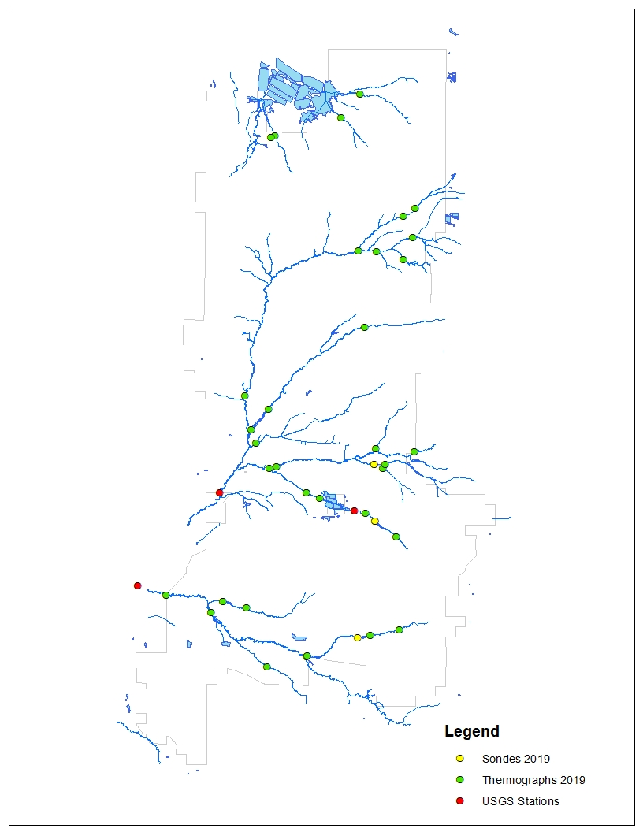
Figure 19. Remote water sampling devices that continuously collect water characteristics are displayed with colored dots for stream sites tested (2019-2021) Water quality characteristics correlates significantly to the fish and invertebrate community. The YSI Sondes (yellow dots) were used below lakes to collect temperature, oxygen, pH and turbidity for anticipated dam removal or renovation projects. Thermographs (green dots) were used to monitor summer temperatures for fish index of biotic integrity sampling stations. The USGS gage stations (red dots) continuously monitor flows and temperature. Water sample collections are triggered remotely with select samples provided to a certified laboratory for sediment and nutrients assessments.

support a trout fishery downstream. If unsuccessful, the lease terms may need to be modified to address water quality problems. The WDNR and EPA evaluate stream conditions and the ability to sustain the trout fishery, both are requirements used to classify Wisconsin's streams status as trout water. The Suukjak Sep Creek Summary Report (Noble et al. 2014) was submitted to the WDNR to begin the process to remove Suukjak Sep Creek from the impaired waters list. Stream habitat restoration was completed by the WDNR in 2014, improving approximately 1100 feet of the stream. In 2016, the WDNR confirmed that Suukjak Sep Creek is no longer listed as impaired waters of the U.S.
In the summer of 2012 a low water stream crossing was constructed in B05/B07 training areas allowing for military vehicle maneuver across Silver Creek. The crossing was engineered and installed utilizing cabled concrete and various aggregate to harden the site. Training use of the low water crossing site has not shown any significant or negative impacts to the stream resource. The Fort McCoy Training Division is looking to continue this practice in wetlands and creeks to support additional maneuver training corridors, while preventing/minimizing watershed sediment disturbance on downstream aquatic life. The NEPA review process will be used to assess the entire project in determining the best method for crossing wetlands and streams to assure natural resource and training concerns are not limited. A program goal is to refine the water monitoring project for the La Crosse River and Silver Creek as water leaves the installation. It is valuable to monitor spring-summer rain events and use quarterly monitoring to determine land use and training effects on Fort McCoy surface waters. Adaptive Management samples have been collected in 2016-2021 to support the WWTP discharge permit requirements to reduce phosphorus in water. Monitoring results demonstrates to the public that Fort McCoy water quality is within compliance of the CWA and to use as an indicator for identifying and repairing land uses that may impact surface waters. Continuous monitors are also used in select locations to determine thermal and dissolved oxygen effects from environmental (seasonal) and water development projects. Biomonitoring projects will continue as an important and reliable requirement to support the military mission, demonstrate fishery trends for recreational quality and as indicators of water quality. The results of water monitoring show that the military training mission can be accomplished without negatively impacting the aquatic resource. USGS gage stations are triggered remotely to collect water throughout larger rain events with select samples provided to a certified laboratory for sediment and nutrients assessments.

4.4.3.1 Management Activities
- Update GIS stream data layers for land use planning opportunities.
- Coordinate with on- and off-post organizations to minimize watershed sediment loading.
- Identify dams and culverts for removal or reclamation.
- Secure funding to either remove or reclaim dams.
- Integrate water resource tools applicable for design of water crossings and control structures.
- Determine lake and stream water quality trends.
- Monitor Ammunition Supply Point for white phosphorus usage within the NIA.
- As resources allow, coordinate and use sediment removal devices to best manage sediment loading in the upper La Crosse River Basin.
- Require Best Management Practices (BMP) in all aspects of construction, forestry and range projects following guidance in Wisconsin Construction Site Handbook (WDNR 1993) and Forestry BMPs for Water Quality in Wisconsin (WDNR 1995). Fix watershed erosion and sedimentation using BMPs on disturbed sites, to include borrow sites, boundary firebreaks and road crossings.
- Implement biomonitoring assessments annually.
- Complete streambank restoration and habitat improvement projects as resources allow (Figure 20).
- Establish management strategies to enhance waters with impaired integrity. Monitor treatments like BMPs and streambank restoration to demonstrate cost-effectiveness and to achieve continuous process improvements.
- Integrate survey results with WDNR datasets to update the Fish Distribution Study, Master Fish File, and stream classifications updates referenced in Wisconsin Trout Streams (WDNR 2002).
- Work with DPW and DPTMS to improve culvert style, size, and installation.
- Work with local partners to improve stream conditions in the La Crosse and Black River Basins.
- Conduct angler and creel surveys to determine economic impact and angler satisfaction.
- Control furbearer population through trapping to minimize impacts to shorelines, fish populations, habitat, roads or forest resources.
- Remove beaver dams affecting trout waters.
- Assess low water crossing impacts to the stream resource.
- Support ACUB efforts and the development of an Adaptive Management Plan to improve the upper La Crosse River watershed on and off the installation.
- Support local and regional watershed management initiatives for climate changes, brook trout and flood resiliency.

4.4.4 Watershed Management Sampling Methods
The NRB utilizes a suite of sampling methods to monitor lake and stream fish communities. These methods are approved by the American Fisheries Society and consistent with state and federal sampling and monitoring protocols. Stream electrofishing units (backpack, towed-barge), boom shocker (lakes), nets, visual, creel-angler interviews, or hook-and-line surveys are used to assess fish populations and to arrive at management inferences. Lake and stream fish communities are also used as indicators of aquatic biotic integrity to establish a water quality rating. Water quality samples are typically collected by remote or continuous monitoring devices (Sondes, thermographs, and USGS gage stations). Water samples are also collected by contractors sending water samples to certified laboratories or by using portable devices for flow, turbidity, temperature, oxygen, pH, salinity, and conductivity.

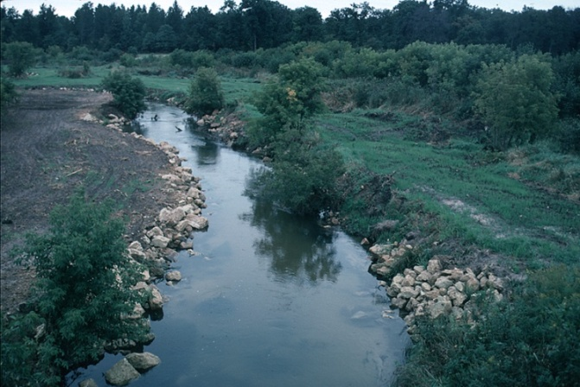

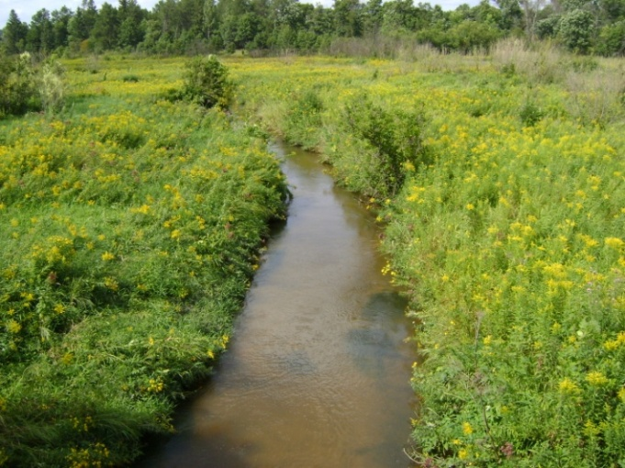

Figure 20. Streambank restoration and habitat improvement project.
Top photo is project in 1995; bottom photo is project in 2010.

4.5 Wildlife Management
The Wildlife Program is tasked with maintaining and improving the wildlife resource on
Fort McCoy. Management techniques such as hunting/trapping programs, prescribed burning, habitat management, and invasive plant control are important tools in maintaining the biological diversity and integrity of Fort McCoy's wildlife and military training resources. Program goals are:
a. Support the military mission while maintaining compliance with all applicable federal and state laws and regulations.
b. Maintain healthy, viable wildlife populations.
c. Improve, maintain and restore habitat quality.
d. Provide hunting and trapping opportunities.
e. Provide guidance and management to minimize wildlife/human/military training conflicts.

4.5.1 White-tailed Deer Management
Deer population management is essential to the military mission. The overwinter population goal is 20-25 deer per square mile of deer range. Populations in excess of goals can result in degraded military training lands due to vegetation changes; loss of habitat quality and biological diversity; impacts to endangered, threatened, and species of concern; agricultural depredation; public relations problems; increase in motor vehicle accidents; spread of zoonotic disease (i.e., Lyme, Anaplasmosis, Babesia, and Ehrlichia); and potential wildlife health problems such as chronic wasting disease (CWD). Fort McCoy was established as a separate deer management unit in Wisconsin in 1985. Population management is achieved through regulated hunting programs that also provide recreational opportunities and generate funds for the Wildlife Program.

4.5.1.1 Management Activities
- Conduct annual archery and gun hunting seasons (see para.4.5.2).
- Collect and analyze deer population data.
- Maintain a deer population database.
- Conduct cantonment area dusk and spotlight surveys from September through November annually to monitor urban deer population trends.
- Conduct doe/fawn surveys throughout the installation annually from July through September to determine population recruitment.
- Conduct habitat management projects that benefit deer populations (see para.4.5.3).
- Support CWD testing requests from the WDNR.
- Conduct Training Area dusk and spotlight surveys from September through November annually to monitor deer population and trends.

4.5.2 Hunting and Trapping Seasons
Some wildlife species (game species) are managed to prevent their populations from exceeding the carrying capacity of the habitat or conflicting with human activities or interests. Zoonotic disease problems such as rabies (some furbearers) and Lyme disease (deer) can result from populations that are too high. Population management is primarily directed at white-tailed deer and furbearing species such as beaver, fox, raccoon, otter, and muskrat. Although beaver create valuable wetlands, they can also cause damage to roads and culverts, flood upland habitat, and degrade coldwater trout streams. Black bear reports have increased since 2005 and are indicative of a growing local bear population that is expanding southward as the population increases. Population management strategies, including hunting, will need to be developed to avert potential problems in the future. Hunting and trapping seasons are conducted annually to maintain wildlife populations at levels that reflect management goals. All hunting and trapping seasons are held in conjunction with Wisconsin State seasons except the disabled and muzzle loader seasons. Hunting seasons include: archery, spring and fall turkey, small game, gun-deer, youth deer hunt, and a deer hunt for people with disabilities. Special archery seasons are held within the cantonment area as part of an urban deer management program.

4.5.2.1 Management Activities
- Prepare a Fort McCoy Hunting, Fishing, and Trapping Regulation 420-29 annually.
- Establish permit quotas for the permit sales program for gun-deer, disabled hunt, cantonment archery, and fall and spring turkey seasons.
- Collect harvest and biological data and maintain databases.
- Coordinate with DFMWR on hunting and fishing activities information.
- Collect biological data from deer harvested during the 9-day gun-deer, youth deer, and the disabled season.
- Coordinate trapping activities in areas with large furbearer populations when needed.
- Issue a limited number of trapping permits each year.
- Coordinate annually with the WDNR on matters pertaining to hunting and trapping seasons, including extensive CWD sampling on the installation.
- Coordinate and support military preventive medicine or veterinary units and/or researchers involved with zoonotic disease projects.
- Conduct hunter surveys through email or on-line.
- Establish strategies and procedures, including hunting and/or trapping options, to manage bear populations.
- Manage the iSportsman automated system to issue annual access passes (recreational), sell hunting, fishing, and trapping permits, provide hunting area closures listing, outline outdoor opportunities and share useful information such as hazardous plants and tick brochures, fish health updates, deer population statistic, and general NRB program area information.

4.5.3 Habitat Management
The goal is to improve, maintain and restore habitat quality to support ecologically diverse and resilient training lands that can withstand various training activities. Coordination is done with ITAM and DPTMS to ensure habitat management strategies coincide with current and future training land requirements. A wide range of vegetative communities are found within Fort McCoy, including dry sand prairies, oak savanna-barren associations, upland forests, wetlands, and riparian corridors. These diverse communities provide important habitats for many game and nongame wildlife species, including species of special concern. Prescribed burning (Figure 21) plays a large part in habitat improvement. Other program areas involve coordination with forestry on upland habitat projects and ITAM on restoration projects involving native plant species. Native seed often takes multiple years to become firmly established and to dominate a planted site, therefore nurse crops such as annual rye or oats, etc. should be planted with the native plant species in order to ensure there is sufficient vegetative cover to limit encroachment of invasive plant species.

4.5.3.1 Actions
- Conduct spring and fall prescribed burns. Improve habitats for grassland birds.
- Coordinate aspen management with the forestry program.
- Identify areas of degraded oak savanna and use timber sales, prescribed fire, mechanical clearing and troop projects to restore the savanna/barrens communities.
- Keep prairie/barrens tracts on a rotational 7-10 year burn basis to complement training activities and resource needs.
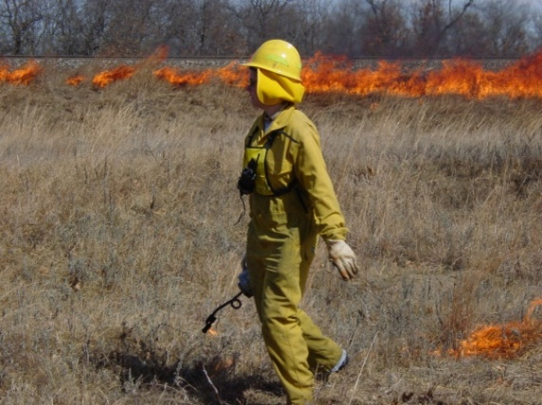
- Continue to work and communicate with other government agencies and private organizations to manage savanna communities.
- Manage apple trees by pruning trees and removing competing species.
- Improve white-tailed deer browse by selectively cutting and shredding woody plant species such as aspen, oaks, staghorn sumac, and other shrub or tree species to provide food and cover for game and nongame species. When feasible, work with the forestry program and military trainers to keep logging slash on site to provide winter browse.
- Use volunteers when available to accomplish annual cleaning and maintenance of artificial nest boxes and other structures for wood ducks, eastern bluebirds, and bats. Figure 21. Prescribed burning
- Collect native plant seed on Fort McCoy for revegetation or use
Wisconsin highway native seed mixtures (70, 70A, 75, or 80) where appropriate. Use Wisconsin highway mix # 3 in areas that need quick stabilization. Maxwell’s (1996) field investigation showed that the highway mix does not invade into the surrounding native vegetation, instead the native vegetation is slowly establishing into areas seeded with highway mix.
- Monitor American chestnut plantings.
- Develop habitat specific seed mixtures where needed for rehabilitation/restoration.

4.5.4 Grassland (Prairie) Management
Grasslands are an important component of Fort McCoy providing large open areas to meet military training requirements. They also are a declining habitat type nationwide which support a wealth of wildlife species. Fort McCoy currently has 3,475 acres of grassland that is actively managed through prescribed burns, invasive plant control, and LRAM rehabilitation. The WDNR report “Managing Habitat for Grassland Birds; A Guide for Wisconsin” lists Fort McCoy as a top 10 priority grassland management areas in the state (Sample and Mossman, 1997). Fort McCoy is the only large-scale management area south of the Tension Zone, increasing the importance for birds and other species that are near the northern edge of their range. Research has provided baseline data on the distribution and productivity of grassland birds on Fort McCoy which is being used to develop and implement management strategies to avoid potential conflicts if grassland birds are federally listed in the future.

4.5.4.1 Management Activities
- Maintain the current grassland resources and increase the size of specified sites, if feasible, by using rotational prescribed burning, exotic plant control, mowing, native plant restoration, timber harvests, and brush removal.
- The NIA, Warrens DZ, Cranberry DZ, Range 29, Badger DZ, and the oak savanna FMNA will serve as “core” grassland bird population areas and will be managed spatially to maintain a balance of grassland successional stages while maintaining military mission requirements within those specified areas.
- Maintain specified open areas within the cantonment area as unmowed grassland sites.
- Breeding and visiting bird species will be monitored to evaluate management practices and training impacts, and to identify areas of population sinks.
- Identify lowland areas of potential grassland for management.
- Support research projects that provide further understanding of grassland communities.

4.5.5 Game Species Surveys
Deer population levels and trends are calculated through harvest data and road surveys. Cantonment deer surveys are conducted from September through November to monitor urban deer populations. Harvest data are used in the Sex-Age-Kill formula developed by the WDNR. This information is used to set harvest goals and tag quotas. Harvest figures are also collected during the spring and fall turkey seasons to monitor turkey populations.
Surveys include ruffed grouse drumming surveys, turkey gobble surveys, and brood surveys for woodcock, waterfowl, grouse and turkey.
Winter track surveys are conducted, primarily for wolf detection, but also provides as indices for other furbearers present on the installation.

4.6 Forestry
The purpose of the forestry program is to provide a scientific basis for managing the forest resources. The major forest types present are scrub oak (low quality oak), jack pine, oak, red pine and white pine. Lesser amounts of aspen, red maple, and paper birch are present. Program goals are:
a. To support Fort McCoy’s military training and mobilization requirements.
b. To manage the forest resource according to ecosystem management principles while providing a sustained yield of forest products.
c. To manage for forest health. Specific pests that are monitored or actively managed against include jack pine budworm, oak wilt, gypsy moth, emerald ash borer, white pine tip weevil, heterobasidion (annosus) root disease, and pine bark beetle.
d. To provide for other multiple uses of the forest resources like outdoor recreation, wildlife habitat, soil erosion protection, watershed protection, clean air and noise abatement.

4.6.1 Forest Inventory
Army Regulation 200-1, section 4-3, para. d.7 requires responsible stewardship of forested lands. Army Regulatory Guidance for Reimbursable Agriculture/Grazing and Forestry programs (DAIM-ED-N, 17 Aug 1999) requires that volume inventories of forest stands be made and kept current (not older than ten years). Fort McCoy has 52,000 acres of land in the inventory system so a reinventory of 5,200 acres each year will keep the inventory current and provide accurate information for determining management goals. Areas which received a treatment such as a timber sale, planting, or TSI, or have had a land use change have highest priority. The data and inventory maps are entered into a GIS mapping system and database. The annual allowable harvest is recalculated every five years based on forest inventory updates.
The forest acreage by major cover type is: scrub oak (low quality oak)-22,000 acres, jack pine-4,700 acres, northern red oak-4,200 acres, red pine-2,500 acres, aspen-1,200 acres, white pine-3,300 acres, swamp hardwoods-700 acres. Minor cover types occupy 1,100 acres and include bottomland hardwoods, central hardwoods, northern hardwoods, spruce, and tamarack. The remainder of the acreage is comprised of non-forest such as grasslands, brush and marsh at 7,000 acres, and other areas such as developed areas, right of ways, roads, water and rock outcrops.

4.6.1.1 Management Activities
- Re-inventory 4,000 to 5,500 acres annually.
- Recalculate annual allowable harvest for the major commercial tree species.

4.6.2 Timber Harvest
Timber harvests are completed for a variety of reasons but are usually in one of four categories:
1) Training improvement harvest to reduce tree density or create openings to benefit military training; 2) Intermediate harvest to remove some of the trees in the forest to give the remaining trees more growing space; 3) Salvage harvest to remove dead and dying trees or to remove trees for a land-use change; 4) Regeneration harvest to remove trees in order to regenerate the forest. Timber harvests may occur in any forested area of the installation except where they are not allowed such as the NIA, riparian areas, and cultural resources determined eligible for inclusion in the NRHP.
Fort McCoy has two processes for harvesting timber, it may be administered by the Omaha District, USACE, (governed by AR 405-90) or it may be completed by the installation using the Small Lot Timber Sale (SLTS) Regulation FMR 200-5. Sales completed through the SLTS program are limited to an appraised value of $5,000 per sale and a total income of $30,000 per year and funds are deposited into the forestry account IAW DFAS-IN Manual 37-100. The USACE sales consist of the larger valued sales.
Proposed timber sales are submitted for review in January and bids are usually opened the following December. Proposed sales are reviewed utilizing the installations NEPA process to accept, reject, or modify individual sales on the list. Once an area is approved, the forestry staff will establish boundaries, estimate the volume, determine the harvest regulations, create a map and bid sheet for the USACE to use in soliciting bids.
A timber sale may allow biomass harvesting in the form of removing timber slash or unmerchantable trees in accordance with “Wisconsin’s Forestland Woody Biomass Harvesting Guidelines”. Fort McCoy might deviate from the guidelines, especially guideline 4.B: “Do not harvest fine wood material on dry nutrient-poor sites” where it is necessary to clear the land for a land use change (range construction, etc.), remove slash to avoid short-term negative impacts to the training mission, or reduce fuel loads near sensitive areas (installation boundary and ranges, etc.).
Timber harvesting operations are coordinated with range scheduling to avoid conflicts or negative impacts on the military training mission. When timber sales occur within training areas, the NRB schedules these areas in RFMSS and they are placed in a “hold” status. This status does not close the training area to other users, i.e. hunting. In the event a military unit is scheduled for the same training area, the range scheduler may determine that timber harvesting can co-exist without impacting training or NRB may be required to contact the unit POC for a decision. If it is determined that harvest operations cannot co-exist with training, the training area is closed to harvest operations and scheduled for another time. It is understood that military training will have precedence over other activities conducted on post, to include timber harvesting.

4.6.2.1 Regeneration Harvest
Harvesting methods such as clearcutting, strip clearcutting, seed tree, shelterwood and group selection are used to secure the necessary light, moisture and seedbed requirements for each tree species to regenerate. Aspen are always regenerated using clearcuts. The roots send up a thick growth of sprouts when the soil is exposed to sunlight. Jack pine seeds require mineral soil to effectively germinate and the seedlings need full sunlight. Jack pine is best regenerated by clearcutting, strip clearcutting and seed tree harvests. Northern red oak may sprout from stumps or regenerate by acorns; the seedlings need moderate to full sunlight to survive. Shelterwood and group selection are the harvest systems most often used to regenerate oak. Post-sale treatments, seedbed scarification, and herbicides may be used to enhance the regeneration conditions. If natural regeneration is inadequate five years after harvest, then artificial reforestation is considered.

4.6.2.2 Intermediate Harvest
The intermediate harvest removes trees that are poor quality, suppressed, declining in health, or are an undesirable species. The remaining trees have more growing space and will respond by increasing their diameter growth. Red pine harvests will be limited to thinnings, salvage cuts or removals for land use changes. Northern red oak, scrub oak, red pine and white pine are thinned periodically. Red pine is thinned every eight to ten years with the removals limited to 1/3 or less of the volume. This prevents wind damage that may occur if too many trees are removed and the remaining trees are exposed to the wind.

4.6.2.3 Salvage Harvest
Salvage harvests remove dead or dying timber quickly before the timber decays to the point that it cannot be used by the forest industry. Harvesting prior to land use changes such as new construction or creating fuel breaks can also be categorized as a salvage harvest. The land use change takes the area out of timber management so the timber value is salvaged by the Army. Reasons that salvage harvests have been completed on Fort McCoy include wind damage, bark beetle infestation, hail damage, flood damage, pine pocket mortality, range construction, building construction, fuel breaks, and impact area expansion. Timber harvested for enhancing training or reducing fuels for wildland fires may be followed by shredding or prescribed burning.

4.6.2.4 Management Activities
- Timely removal of timber in areas designated for a land use change.
- Harvest timber to secure natural regeneration of tree species, restore oak savanna, or enhance training missions. Approximately 600 acres a year will be harvested. The rotation ages and annual allowable harvest for each tree species are: jack pine, 45 years, 160 acres; red pine, 120 years, 28 acres; red oak, 90 years, 28 acres; swamp hardwood, 50 years, 23 acres; aspen, 40 years, 30 acres.
- Manage red pine plantations for pulpwood and sawtimber production.
- Manage jack pine stands for pulpwood on a 45-year rotation.
- Clear-cut aspen to regenerate aspen stands and provide a variety of age classes within a close spatial arrangement.
- Use timber sales and firewood permits to remove dead trees that pose a safety hazard to training.

4.6.3 Forest Health
Ecosystem management recognizes that endemic levels of insects and disease play a vital role in maintaining a healthy forest. Epidemic outbreaks of pests are prevented through the use of silvicultural practices and monitoring. Specific pests that are monitored or actively managed against include; jack pine budworm, oak wilt, heterobasidion (annosus) root disease, gypsy moth, white pine tip weevil, emerald ash borer and pine bark beetle. Wildland fire management is an important component of forest health management, more information can be found in para. 4.16.
In May 2007, Fort McCoy completed a gypsy moth management plan (Kerkman, 2007) to give military leaders and natural resource managers the information necessary to make decisions and take actions to prepare for a gypsy moth outbreak. High priority treatment areas are identified in the plan to protect areas that are heavily used by military training. Areas considered most vulnerable are bivouac areas and the wooded edges along multipurpose field training sites, firing points, mortar points, platoon/squad ranges, and drop zones. In 2009, Monroe County was added to the gypsy moth quarantine area. This requires timber harvesters to provide documentation they are certified to conduct inspections and certify that the wood products are gypsy moth free. The quarantine affected firewood cutters by prohibiting firewood movement out of the quarantine areas.
Monroe County was included in the forest products quarantine in summer 2014 when EAB were found in Oakdale, approximately 15 miles from Fort McCoy. The Fort McCoy EAB plan was approved in May, 2014 and advises treating high value ash trees when the EAB is found within 15 miles of the installation. Treatment of urban ash trees in the cantonment area and Pine View Campground began in 2015 with trees located in high priority areas along “J” Street receiving an injected pesticide. As of 2021 NRB has treated 64 ash trees with all having been treated a second time three years after the first treatment and 27 trees treated a third time in 2021. A cost analysis of the treatments showed it is less expensive to treat the trees than to remove them so the program will continue to treat ash trees until replacements with other species are established. In 2018, the EAB had spread to enough counties that quarantine was expanded to include the entire state.

4.6.3.1 Forest Health Surveys

4.6.3.1.1 Oak Wilt Survey
Since 1990, Fort McCoy has been actively surveying and controlling oak wilt. The occurrence of oak wilt is unnaturally high at Fort McCoy because the highest levels of military training coincide with the oak wilt infection period. During early to mid-July when the oak wilt symptoms are most visible (leaves turning brown and falling off), the forestry staff conducts either a windshield survey or helicopter survey of the oak forests to identify new oak wilt centers or to determine if established centers are still active. This information is added to a GIS database.

4.6.3.1.2 Gypsy Moth Trapping
The Wisconsin Department of Trade, Agriculture and Consumer Protection (WDATCP) completed surveys on Fort McCoy using 100 gypsy moth traps each year as part of the USFS program “Slow the Spread”. The traps are baited with female gypsy moth pheromones and placed on a grid of about one per square mile. This is done to survey the moth population to determine if more aggressive control measures are needed. In 1996, four gypsy moths were captured and the number steadily increasing each year until 2017 when the trapping on Fort McCoy ended because the gypsy moth was considered established in the area. Before 2009, the trapping program was completed with forestry staff using WDATCP supplied traps. Starting in 2009 the trapping on Fort McCoy was taken over by the Monroe County gypsy moth trapper funded by WDATCP until they stopped trapping Fort McCoy in 2017.

4.6.3.1.3 Emerald Ash Borer Trapping
An EAB detection survey was conducted in 2014 before it was known that an EAB infestation was 15 miles away from the installation. A total of four sticky traps baited with chemical attractants were place in four locations in May; Silver Creek, PineView campground, cantonment area, and Alderwood Lake. The traps were removed in September and no EABs were found. Trapping was discontinued with the discovery of the nearby infestation and the discovery of EAB on Fort McCoy in 2017.

4.6.3.2 Management Activities
- Assist the Fire Department with wildland fire protection, to include prescribed burning.
- Coordinate oak wilt control treatments with ITAM.
- Monitor oak wilt centers that have been treated with a vibratory root plow to check the spread of oak wilt between healthy and diseased trees. Identify new oak wilt centers. Educate Soldiers, civilian employees and visitors about oak wilt.
- Coordinate gypsy moth control with the WDATCP, WDNR and USFS as required. This may involve aerial spraying of pheromone flakes, biological agents such as Gypcheck or Bt, or pesticides.
- Use timber sales to thin overstocked oak forests to increase the health and vigor of the residual trees to prepare them for gypsy moth defoliation.
- Survey for forest damage with a helicopter overflight once each year if support is available.
- Prevent heterobasidion (annosus) root disease from becoming established on Fort McCoy by treating red pine stumps with fungicide approved for heterobasidion in accordance with the WDNR guidelines. Logging contractors will be required to apply fungicides to the stumps when the harvested stand is within 25 miles of a stand with confirmed heterobasidion and the pines are harvested from April 1 to November 30.
- Treat high priority ash trees with an injected pesticide to protect the trees until replacement trees are established.

4.6.4 Timber Stand Improvement
Timber stand improvement (TSI) uses mechanical or chemical means to increase growth on higher value tree species. Northern red oak, red pine, and white pine are the trees species most commonly targeted for improvement with TSI. Trees removed are usually cut down so they are resting on the ground. This prevents large numbers of dead trees standing within the training areas and presenting a falling hazard to Soldiers training in the area. Types of TSI activities that are suitable on the installation include:
- Weeding-removing undesirable tree species from direct competition with the desirable trees. Trees
removed may be within a set radius or overtopping the “leave” tree. This is typically done in younger stands to increase the proportion of the target species within the forest.
- Crop tree release-removing trees from direct competition with high quality or “crop” trees. The
removed trees may be the same species as the crop trees but of poorer form. This is typically done in young to mid-aged stands where tree form and quality are evident.

4.6.4.1 Management Activities
- Manage the high value oak stands for quality sawlogs.
- Maintain stands of northern red oak.
- Release white or red pine from competition.

4.6.5 Reforestation
Fort McCoy places an emphasis on natural reforestation by using timber sales to create proper seedbed and light conditions for the targeted tree species. Northern red oak and jack pine seedlings are shade intolerant and are typically regenerated using seed tree, shelterwood, or clear cuts. Vegetation control may be needed before or soon after the timber sale to remove competing plants.
Artificial regeneration may be accomplished by hand planting or machine planting, depending on the size of the area, advance regeneration present, and access restrictions. Large areas of red pine have been planted in the past but are seldom planted at this time; open areas are more valuable as grassland or barrens habitat than pine plantations. Hand planting is often accomplished by school groups, Challenge Academy cadets or Boy Scout organizations as part of classroom learning or to complete community service requirements.

4.6.5.1 Management Activities
- Perform seedbed preparation for jack pine regeneration using the severe duty shredder or anchor chains on about 20 acres per year as the budget allows.
- Mature oak is harvested using the shelterwood method in conjunction with understory removal by herbicides or fire. In areas where oak regeneration has failed, oak seedlings may be hand planted to restore the oak component.
- Hand or machine plant red or white pine to serve as visual screens or noise buffers near the installation boundary, highway corridors, or range areas.
- Hand plant a variety of tree species along stream corridors to provide stream-side shade to buffer stream temperatures.

4.7 Vegetative Management
This section discusses the vegetation management activities completed by ITAM and the DPW grounds contractor. Other types of vegetation management are addressed in different sections of this INRMP: management of forests and trees is addressed in section 4.6; and management of invasive species is addressed in section 4.9. The ITAM section has the responsibility for management of vegetation other than trees and invasive plants in the training areas and DPW manages vegetation within improved grounds areas to include ranges, cantonment, airfield, roads, natural erosion/non-maneuver erosion locations, and railroads.

4.7.1 Vegetative Inventories

4.7.1.1 Range and Training Land Assessment (RTLA) Inventory

A major goal of the Army’s ITAM program is to achieve optimum sustainable use of training lands. The RTLA component of ITAM supports this goal by providing scientifically valid land condition data that is used to determine how training may impact long term sustainability of training lands. The RTLA program was authorized Army-wide in 1987, and was established on Fort McCoy in 1991. From 1991 -1994, all core plots were surveyed on an annual basis to develop baseline data and to determine trends in soil erosion and training disturbance. Base line data was also used to establish knowledge of plant and animal communities throughout the installation. During this period, data collection followed an Army wide protocol (Tazik et al., 1992). Data collection and reporting was uniform for all installations, but lacked specific details necessary for yearly management needs. In 1995, DA authorized installations to deviate from the initial methodology in order to tailor programs more suitable to individual installation training scenarios and needs. The new protocols were dubbed LCTA II methodology. The LCTA II methodologies for Fort McCoy were formed from 1995 through 2000. Collecting baseline data using the new techniques took place from 1995-1997. Short-term monitoring for LCTA II protocol took place in 1997 and 2000. There were no LCTA data collected in 1998 due to lack of funding. Two special projects were conducted in 2000 and 2001; a study on the impacts of wind-storm damage and forest regeneration and a study of oak savanna restoration for the INRMP. From the end of 2002 until the spring of 2005 the RTLA program on Fort McCoy was not staffed. This was due to budgetary shortfalls within ITAM, as well as reorganization of Fort McCoy’s Directorate of Plans, Training, Mobilization, and Security. During this hiatus, in 2004, the LCTA program was officially renamed as the Range and Training Land Assessment (RTLA) program to better reflect its role in range and training land management and training support. The program focused on installation specific training and land requirements and provided a uniform RTLA Plan outline to be completed by all installations. In 2008 a revised RTLA Plan was finalized. That plan is the current protocol used on Fort McCoy with methodologies modified as needed based on lessons learned in the field and through analysis of data or to support new training requirements.
The current RTLA plan can be divided into three main categories: Long Term monitoring (vegetation assessments), Short Term monitoring (mapping of disturbance features in high use areas for example) which assesses current condition of high use areas, and validation assessments which determine the effectiveness of LRAM management. Long term monitoring assessments conducted once every 3 – 5 years are designed to collect trend information on plant community shifts and changes on ground cover attributes (for example amount of bare soil versus litter and vegetation cover). Short term monitoring consists of photo monitoring, mapping of disturbance features, and in some cases is an abbreviated version of long term monitoring protocol where important parameters are assessed using a more qualitative approach. Other long term monitoring assessments have been conducted in Firing Points, drop zones (Drop Zone-Badger), and special management sites (C-12 Hazel Dell). Short term monitoring (annual assessments) are also conducted in Firing Points as well as throughout the installation (Training Disturbance Mapping and Reconnaissance Assessment). Training Disturbance Mapping Assessment tracks medium to high levels of soil disturbance in an effort to track different levels of training pressures across the installation. Long term monitoring techniques can be used in high use areas as defined by the mapping exercise to define the plant community and ground cover attributes. This is done in an effort to develop management recommendations as needed.
Drop Zone-Badger Assessments of LRAM management areas comprise the remaining RTLA survey efforts. RTLA conducts validation surveys to give direct feedback on the efficacy of management techniques utilized by LRAM. LRAM utilizes a series of techniques to control woody encroachment within open maneuver areas and to rehabilitate moderate to severely degraded areas. The RTLA program supports the LRAM program by assessing the effectiveness of the different techniques used to reach the management goal. The assessments used to validate LRAM management can vary in technique depending on the specific management goal.

4.7.1.2 Special Vegetation Inventories
Special vegetation surveys are done to document natural processes or management actions. In 2000, a survey was completed to document vegetation changes resulting from a severe windstorm that damaged over 3,000 acres of forest. Another survey was conducted in 2001 and updated in 2007 to check the results of the oak savanna restoration project north of Hazel Dell Lake. Additional surveys may occur at Hazel Dell to validate management techniques used to manage the area. The Drop Zone-Badger (DZB) was surveyed in 2001 and again in 2008-2009 to document the vegetation trends following extensive engineering dig operations that took place in 2000.
In 2014 to present, RTLA has conducted vegetation surveys in B23 to facilitate the removal of B23 from the Wisconsin State Natural Area program and to establish a long term management goal for B23. The removal of B23 from the State Natural area program allows Fort McCoy to have a more active hand in management and allows a regulated amount of vehicle use within the training area.
In 2015 to present, surveys were established along a 400m grid system across Drop Zone-Badger – in B19 to track changes in vegetation after unexploded ordinance (UXO) were extracted from the drop zone area. This is an ongoing project that investigates vegetation re-establishment rates after variable degrees of soil disturbances (determining long term response of vegetation cover). In 2020, survey methods in Drop Zone-Badger (DZB) UXO vegetation study were also used to determine the effect wildland and prescribed fire have on ground cover in DZB (more specifically biological soil crusts) and vegetation community. The purpose of work conducted in DZB and other special vegetation surveys is to determine a timeline of vegetation recovery and to determine if there is a different response in vegetation cover when different planting strategies and land management techniques such as prescribed fire are used.

4.7.1.3 Urban Forest Survey
An initial survey was conducted in 1991 with subsequent updates in 1995, 1999 and 2008-2009. Survey information collected before 2008 was lost during directorate reorganization. The 2008-2009 survey covered the cantonment area, family housing, and the Pine View Recreation Area and included GIS files showing the tree/shrub location and attributes. The survey should be maintained annually by updating plantings and removals. A full inventory update is planned to be completed by end of 2023.

4.7.1.4 Forest Inventory Analysis Plots
The USFS established about 20 permanent forest inventory plots on Fort McCoy as part of the USFS Forest Inventory and Analysis (FIA) Program. Plot locations are visited on a five year rotation with 20% of the plots surveyed in a given year. The research mission is to inventory and evaluate past trends, current status, and potential supply, use, condition and productivity of the renewable natural resources of forest lands. The FIA Program combines the information with related data on insects, diseases and other types of forest damages and stressors to assess the health, condition and potential future risks to forests. Information on the plot locations is not given out to land owners or managers to avoid intentional disturbance or preservation.

4.7.2 ITAM Vegetation Management
The LRAM program under ITAM completes actions to sustain the extensive training lands that are available to off road military maneuvers, which include maneuver trails. Most of these actions are directed toward controlling the woody vegetation encroaching into open spaces, creating open areas by removing existing small trees and brush, maintaining maneuver trails, repairing maneuver damage, and planting vegetation to control erosion associated with military maneuvers.

4.7.2.1 LRAM Vegetation Control
The LRAM controls woody vegetation encroachment and removes existing small trees and brush using a severe-duty shredder to cut and chip the plants. This can be done at any time of the year unless oak trees or wild lupine are present. Shredding is avoided from April through July when oaks are present to avoid injuring oaks and spreading oak wilt disease. Shredding is normally not completed from May through August to avoid adult KBB flight periods. Follow-up treatments with more shredding, prescribed burning, or herbicide application may be necessary if the vegetation sprouts back.

4.7.2.2 LRAM Vegetation Planting
Planting is done with seed mixtures free from invasive plant species and is done mainly along maneuver trails, cross country maneuver sites, and DPTMS training area reconfiguration projects to prevent erosion. Seed germination and seedling survival is increased when planted with a cover crop such as rye.

4.7.3 Grounds Vegetation Management
The grounds contract requires grass mowing and trimming IAW the performance work statement for the DPW Service Contract. Mowing is done between 1 April and 31 October in designated locations when the grass exceeds the maximum length for those locations. See table 3 for the allowable maximum length for each area. Area A includes the high visibility areas in the cantonment area (“J” Street, building 50, and Wisconsin Military Academy) and consists of 113 acres. Area A1 includes in and around curbs, mulch beds and shrubs and includes 13 acres. Clippings and other debris from mowing, edging, trimming and weeding will be removed and properly disposed. Area B includes the majority of the cantonment area, PVRA, range staging areas and firing lines, family housing, and the administrative portion of the airfield and consists of 887 acres. Area C includes roadsides, parade fields, Ammo Supply Point, ranges, and consists of 614 acres. Area D includes lake edges, FOBs, closed landfills, and consists of 368 acres. Area E includes drainage ditches and consists of 199 acres. The Airfield Runway Areas have a requirement to grow grass longer than the other areas to reduce the attraction to geese and other birds and consists of 229 acres. Area F includes the installation boundary accessible by DES brush truck. This mowing includes small diameter woody species, keeping these areas accessible for wildfire control.
All work that could impact threatened and endangered species/plants shall only be done in accordance with the INRMP. There are designated delayed mowing areas within Grass Cutting Areas C and E. These are areas along roadsides that support the federally endangered Karner blue butterfly and should only be mowed between June 1 and July 15 annually and should be mowed at a height no less than 8”. These areas are marked with fence posts that have the top one foot painted red/yellow. A map is provided from NRB by May 15th annually that denotes the locations of these delayed mowing areas.
Herbicides may be used to control vegetation along fence lines, within parking lots, for line of site and maintenance issues on ranges, and within the Fort McCoy railroad Right-Of-Way (ROW). NRB manages the invasive plant species that occur on the installation. Many invasive plant species occur within roadsides. Once the invasive species are sprayed with a herbicide, the roadside cannot be mowed for minimum of 10 days. Coordination with the contractor will occur concerning which areas are to be treated that will require a delay in mowing.

Grass Cutting Area | Maximum Allowable length | Cut to # of inches
A | When grass exceeds 4” | 3
A1 | When grass exceeds 4” with a bagger or raking | 3
B | When grass exceeds 6” | 3
C (Includes Roadsides) | When grass exceeds 9” | 3
D (Includes Lakesides) | When grass exceeds 12” | 3
E | Cut one time during June to Mid-July | 3
F | Cut one time between 15 May to 1 July | 3
Airfield Runway Areas | When grass exceeds 12” | 9

Table 3. Grass mowing requirements.

4.8 Migratory Bird Management
The Migratory Bird Treaty Act (MBTA) prohibits the taking, killing, or possessing of migratory birds unless permitted by regulations promulgated by the Secretary of the Interior. Conserving migratory birds is a key component to managing for biological diversity and ecosystem management. Conserving migratory birds starts with conserving, protecting, and managing the species habitats. This can be accomplished through consideration of migratory birds and their habitats when assessing the impacts of projects through the NEPA Review Process. In addition, surveys for these species will be accomplished as resources allow. Research projects targeting migratory birds will be encouraged to increase our knowledge of these species and their habitat utilization on the installation.

4.8.1 Unintentional Take of Migratory Birds for Actions Other than Military Readiness Activities
In accordance with Executive Order 13186 and the associated Memorandum of Understanding between the DoD and the US Fish and Wildlife Service to Promote the Conservation of Migratory Birds, Fort McCoy will, to the extent feasible and practical, conduct military non-readiness activities in a manner that will minimize or avoid their impacts on migratory birds, with special emphasis on migratory bird Species of Concern (SOC).
There are a number of non-readiness activities that provide direct and essential support for military readiness activities or other essential mission activities. Because of the criticality of these activities in establishing the necessary environmental conditions to provide the realistic military training, or maintaining the safety and security of the installation, efforts to minimize or avoid impacts on migratory birds may not always be feasible.
At Fort McCoy, Soldiers are trained in the use of individual and heavy weaponry, tracked and wheeled vehicles, and crew-served weapons systems, involving target practice/maneuver areas/mock battlefield, to develop and/or sustain their battle readiness skills. To meet the required “combat readiness” standards, Soldiers are scheduled to train on all installation land and range facilities multiple times a year. Given the number of Soldiers that will be training at Fort McCoy, firing ranges and maneuver areas must remain open and in ready condition throughout the year to meet readiness standards. To maintain such sites, prescribed burning, mowing, shredding selected areas, and select timber harvesting must occur even during periods when migratory birds are most active in the area. As such, migratory birds may be unintentionally taken as a result of these preparatory activities.
In maintaining a defined installation border, munitions storage area perimeter, impact area and training range firebreaks, and other like sites the installation must control vegetation in these areas. The installation must also remove trees and/or other vegetation that cause a direct safety hazard, such as dead tree(s) in and around residential or administrative areas or vegetation that poses an unacceptable fire danger within these areas. Roadsides are mowed to increase visibility. The impact area, training ranges and firing points, railroad right-of-ways, and other select sites are prescribed burned annually to reduce fuel loads, prevent wildland fires, maintain biological diversity, and improve wildlife habitat for numerous species to include migratory birds. Migratory birds may be unintentionally taken during implementation of these activities.
Military firing ranges and firing points (including firebreaks), drop zones, and impact area and other like locations provide foraging and breeding habitat for a number of migratory bird species. It is determined that the proposed maintenance and management activities that are likely to occur within these areas during the migratory bird nesting season will have immediate but minimal impact on these species including the SOC known to nest in the area (see Appendix F, Table 6). According to the Partners in Flight Landbird Population Estimates database, the populations of the migratory bird SOC within Bird Conservation Region 23, in which Fort McCoy occurs, are only a small percentage of the total population of these species. Additionally, Fort McCoy is located on the edge of the breeding range for many of these species. The potential loss or unintentional “take” of active nests would not significantly affect these SOC since a small percentage of the habitat for these species found on the installation would be impacted at any one time. The indirect impacts of habitat loss are also not to the level that would result in a significant impact to any migratory bird species. In this ecosystem, many vegetative communities have developed in a pyrophytic environment that requires growing (nesting) season prescribed fire. These communities will not develop or cannot be maintained when burning is only conducted during the dormant season. Since many of the maintenance and management activities are conducted during the migratory bird nesting season, the overall habitat quality will be improved, thus providing even more opportunities for successful nesting in the future.
Although effects of maintenance and management activities are considered to be minimal on migratory birds, the installation still employs management/conservation efforts, to the greatest extent feasible, which will lessen the impacts on and, in many circumstances, benefit the bird species. To reduce the probability of unintentional take, the installation will, to the greatest extent possible, conduct maintenance activities (mowing, tree and/or vegetation clearing) and management activities (prescribed burning, shredding of vegetation) outside of the migratory bird nesting season (i.e. 1 May – 30 August). Other minimization efforts, if and when possible, would be to avoid nests or remove inactive nests to discourage nesting in an area that will be impacted by readiness and non-readiness activities. For migratory bird SOC, some mitigation measures that could be considered, if feasible and practicable, are removing active nests before conducting the activity and giving the eggs and/or chicks to a licensed migratory bird rehabilitator. When maintenance and management activities will occur during the migratory bird nesting season, the reason why these activities are occurring during this time period will be documented within the NEPA review completed for the project.
The installation implements several management and conservation projects/efforts that benefit migratory birds, including those species that may be impacted by the military non-readiness activities discussed above. Further information and details on the installation’s migratory bird management efforts are included in 4.8.2.

4.8.2 Management Activities
The following management activities are conducted on Fort McCoy to benefit migratory birds.
- Manage habitats through a variety of methods to include timber sales, prescribed burning, mechanical shredding, and invasive species control. Prescribed burns are normally conducted on a 7-10 year rotation. An integrated pest management approach is taken to control invasive species to include the following treatments: chemical, mechanical, biological, and hand-pulling. Invasive species that invade grassland and savanna habitats, such as spotted knapweed and leafy spurge, are aggressively treated.
- Avoid large scale habitat manipulation such as prescribed burning during nesting seasons. The majority of prescribed burns occur during March and April. Timber sales and mechanical shredding normally occur outside the nesting season.
- Monitor borrow pits and prohibit removal of material if nesting activity is evident. Proper sloping of borrow pits are maintained to discourage nesting activity.
- Maintain artificial nesting structures for bluebirds, tree swallows, osprey, and wood ducks.
- Support research requests that provide greater insight on species.
- Monitor habitat needs and population trends.

4.9 Invasive Plant Control
Invasive plants degrade land conditions and vegetative cover vital for realistic training and can directly limit training activities; pose human health and safety concerns; act as one of the leading causes of habitat destruction and biodiversity loss (T&E species); require the diversion of funding from other natural resource or operation priorities; and threaten the economic value of surrounding agricultural and private lands. Fort McCoy currently works to control over 40 invasive species. An Invasive Weed Management Plan goes into further detail of early detection, prevention, control, and monitoring. Survey and treatment contracts and on-going partnerships are used to control invasive plants. These projects will provide continued implementation of management efforts that will ensure protection, preservation, and stability of training lands and native flora and fauna. The amount of funding received for invasive species management varies from year to year, but it is unlikely that there will ever be sufficient funding to treat each invasive species over the entire installation. Realizing this, the highest priority treatment areas were identified (i.e. key bivouac and compass course locations, high quality jack pine and red oak stands, high quality wetlands and barrens habitats, and habitat areas for rare species). The species receiving the highest priority for treatment are those generally not well established on the installation and where control efforts may be able to eradicate them at little cost (i.e. as compared to treatment costs of well-established populations). When developing an annual work plan for invasive species treatments, both the priority ranking of a species and whether it occurs within a priority area is considered.

4.9.1 Management Activities
- Survey for new populations of invasive plants during the time of year each target species is most visible.
- Identifying new species or undocumented populations before they become well established (i.e. early detection).
- Once identified, treat new species quickly before they become well established (i.e. rapid response). Treating invasive populations before they become well established greatly reduces treatment costs.
- Monitor the results of treatments and adjust as necessary to achieve optimal results. Continue the use of biological control agents for leafy spurge, spotted knapweed, and St. John’s-wort control.
- Coordinate with other programs and directorates to minimize spread and impacts associated with invasive plants.
- Identify alternative ways to control/treat invasive plants, such as coordination with DPW to grade old vegetated parking lots or mow populations of invasive plants prior to seed set.
- Recommend changes to the roadside mowing program to reduce the spread of invasive plants throughout the landscape. Beginning in 2018, roadsides mowed once annually are mowed between June 1 and July 15, prior to when most invasive species have produced mature seeds. Beginning in 2021, installation firebreaks mowed once annually are mowed between May 15 and July 1 for same reason.
- Collect field data associated with mapping and treatments of invasive plants.
- Consider reseeding the pollinator plant community in areas where herbicide applications significantly impact their availability.
- Submit monthly reports of herbicide amounts used, acres treated, and species treated.
- Maintain a database of all treatments and coordinate for GIS layers to be created or updated to graphically display treatment areas and data.
- Provide maps, consultation, and comments to NEPA review and project coordinators in reference to invasive populations.
- Maintain herbicide equipment and identify needed resources.
- Be an active member of the Monroe County Invasive Species Working Group. Work in partnership with federal, state, and local agencies to control invasive plants; provide biological control agents to these partners to aid in control off the installation.
- Conduct prescribed burns for integrated management strategies.
- Investigate new biocontrol options.
- Survey for potential new invasive species.

4.9.2 Invasive Plant Species Monitoring
Work with invasive plant species started in 1988. Since that time, populations of 40 different species have been mapped to include leafy spurge, spotted knapweed, glossy buckthorn, garlic mustard, and purple loosestrife. For some of these 40 species, the populations have not been mapped throughout the installation, but only in selected areas. New populations are continually mapped and entered in GIS. Treatments are monitored annually and entered in a database.

4.10 Pest Management
Pest Management Operations on Fort McCoy are guided by the IPMP (2009) as required in AR 200-1. The goals of Fort McCoy’s pest management operations are to:
a. Reduce pesticide use through Integrated Pest Management (IPM).
b. Operate in a safe and legal manner.
c. Manage pests that are of health, safety and infrastructure concern.

4.10.1 Management Activities
- Report pesticide use each month as required by AR 200-1.
- Report annual pesticide use to AEC.
- The NRB serves as the IPMC and coordinates with the pest control contractors on pest issues.
- Follow the procedures listed in FM Reg 420-30 (Wellhead Protection Plan) that places restrictions on mixing and storing pesticides to reduce the chances of contaminating potable water supplies.
- Coordinates with NRB on reported injured, sick, or dead fauna.
- Identify issues relating to natural resources in the draft IPMP.

4.11 Integrated Training Area Management
The Integrated Training Area Management (ITAM) Program resides in the Training Division/Range Branch of DPTMS. ITAM provides a management and decision making process to integrate Army training and other mission requirements for land use with sound natural resources management, with a focus on maximization of training capabilities on the available land. To support this effort, ITAM on Fort McCoy has five components: Range and Training Land Assessment (RTLA), Land Rehabilitation and Maintenance (LRAM), Geographic Information Systems (GIS), Training Requirements Integration (TRI), and SRA Sustainable Range Awareness (SRA).
Goal 1: Provide maneuver land capability to support Installation training mission requirements.
- Quantify training land capabilities and capacity to support maneuver training.
- Monitor training land conditions and training impacts to identify land maintenance and repair requirements.
- Improve training land capacity by conducting land maintenance and repair projects to support existing and future mission needs.
Goal 2: Decision support capability.
- Provide geospatial capability to support range operations, range modernization, and ITAM program.
- Promote awareness of mission land capabilities and management issues to avoid unnecessary maneuver damage and environmental impacts.
- Acquire and assess data about the impacts from land management activities, mission activities, and land conditions.
- Use data to support scheduling decisions and range modernization planning.
- Ensure mission needs are considered in environmental and facilities planning.
- Ensure training land capabilities constraints are considered in mission planning.

4.11.1 Range and Training Land Assessment
The RTLA component of the ITAM program focuses efforts in collecting land condition data and interprets data in an effort to maximize training capabilities long term (AR-350-19). RTLA data is collected and available to the LRAM program to plan future and existing projects and determine the efficacy of management techniques (AR-350-19). RTLA data is used to create products that depict availability, suitability, accessibility, and capacity of training lands to support current training loads. RTLA projects are divided into three distinct categories: 1) Annual Assessments which give immediate feedback on land condition, 2) Foundational Assessments which focus on long term trends in ground and vegetation cover, and 3) Validation Assessments designed to measure the efficacy of LRAM management techniques.
Voucher specimens in the Fort McCoy herbarium are heavily utilized to help key out unknown plants in current RTLA investigations. Plant vegetation assessments are done in the event that LRAM needs verification of the effectiveness of planting strategies. Plant vegetation assessments are also done to define the level of recovery of the plant vegetation community after intense training impacts or intense management.
Fort McCoy’s RTLA program is the component of the ITAM program responsible for the collection, management, and analysis of biological and land use data related to military training on the Installation. RTLA data is used to facilitate the training area management process and offers critical information to the LRAM program as land management decisions are made. RTLA is equipped with the proper tools to track and document major changes to installation training areas, document training damage, identify hazardous conditions, and validate the effectiveness of management projects.

4.11.1.1 Annual Assessments
The RTLA program utilizes the Training Disturbance Mapping and Reconnaissance Assessment to capture training related disturbance features and to capture road obstruction features such as dead fall over roads and heavy erosion events that compromise the accessibility of the trail. The RTLA program has been tracking locations of training use and training disturbance features since 2006. This data is used to define areas throughout the installation that are used on a continuous basis. Data is also analyzed to determine troop use after specific management is conducted. Learning how troops use certain habitats helps ITAM determine proper management to maintain ideal training conditions. In 2018, RTLA conducted the 5th iteration of the Unimproved Trails Assessment which is derived from the reconnaissance survey. This survey has proven useful for tracking problem areas for LRAM projects and to track long term effectiveness of trail rehabilitation techniques such as trail stability inputs and water diversion features.

4.11.1.2 Validation Surveys
Validation surveys to support the LRAM program include the evaluation of woody stem control in open maneuver areas and to evaluate the success of mechanical seeding techniques. Encroachment of shrubby vegetation that could inhibit training is a common theme in open maneuver areas; therefore, woody vegetation is managed for annually. A variety of techniques have been used to control woody vegetation encroachment including shredding, mowing, fire, and foliar treatments. The overall goal of studying re-vegetation rates for LRAM is to understand how to reclaim disturbed areas with a native plant community in a cost effective and timely manner. Plant vegetation data can help determine how successful the planting is and explore how the natural vegetation community is responding to the planting.

4.11.1.3 Foundational Assessments
Foundational Assessments are surveys that collect more detailed vegetation data over a longer period of time. This information is used to define the vegetation community to develop appropriate rehabilitation techniques. Foundational Assessment data is also used to help develop a timeline of recovery that can be applied across the installation. There are four Foundational Assessment projects that will have data collection and data analysis conducted in the next five years.

4.11.1.3.1 Training Area B23W/B23E
The Fort McCoy Oak Barrens Natural Area (B23) was removed from the Wisconsin State Natural Areas (SNA) Program in 2021 allowing for more access to military training opportunities. Although it has been removed from the SNA program, this oak barrens community, with its dune landscape, is unique and management strategies are being developed using land use thresholds to protect the landscape while still allowing additional military training opportunities. The area (B23) was split, creating B23W and B23E to allow greater access to portions of the area that can sustain various training activities. Until management thresholds are developed, B23W/B23E will support training such as orienteering and dismounted force on force training, but not support wheeled based training due to the delicate vegetation and biological crust composition. In an effort to define land condition of B23W/B23E, the RTLA program designed a study to determine if the area can withstand normal levels of training compared to other barrens savanna habitats that sustain average levels of training impacts. The goal for B23W/B23E is to maintain current healthy conditions while sustaining average training loads. Parameters measured in past RTLA assessments include percent cover of bare soil and cover (including dead vegetation litter and lichen/moss), and frequency of high quality indicator plant species (species that are indicators of a pre-settlement high quality vegetation community and therefore an indicator of a stable vegetation community). An evaluation of floristic quality and the presence and extent of biological soil crust can be used to evaluate the stage of growth and repair of the soils and vegetation cover throughout the natural area. This information will help determine the ability of the land to withstand training impacts.

4.11.1.3.2 Training Area B19
Training Area B19 had concentrations of metal and possible unexploded ordinance (UXO) identified in a recent survey designed to identify high concentrations of metal. In order for B19 to support training capabilities that include digging, contractors were hired to remove metal and possible UXO items from B19. To systematically search and remove UXO items, a 200 ft. by 200 ft. grid was created to cover the entire area of Drop Zone-Badger (DZB) in B19. The RTLA program took advantage of the grid system developed by the contractor and collected ground cover data and later plant species data ahead of the crews that initiated the UXO digs. The point intercept method was used along a 50m transect line that was placed in 4 different directions (45, 135, 225, and 315 degrees). Bare soil, litter/ live vegetation, and biological soil crusts (which are indicators of soil damage and are responsible for soil rehabilitation processes) were assessed every 5m along each transect line. Pre-dig and post-dig data have been collected and evaluation of vegetation and soil response to UXO digging will continue. In 2017, it was determined that live UXO items were being found lower than the 2 feet depth limit used to clear UXO items. This makes future training that requires digging beyond the 2 foot limit extremely hazardous. Because DPTMS did not want to limit training opportunities, it was determined that a series of small boxes (15 x 30m), larger boxes (50m², 100m², 200m²), and boxes of various acreages (3.67 acres and 2.7 acres) across B19/DZB are being completely excavated and sifted to clear areas of UXO items. Excavation depth will vary depending on how many UXO items are found. Excavation will continue until the soil is clean of UXO items (which is typically 4 – 6 feet down). The sifted soil is put back into the designated boxes. If a unit wants to dig defilades or tank ditches in the future, they would be directed to these prepared locations. The first year a full excavation and sifting of the soil was done in DZB to clear designated area of UXO items was 2018. Data will be heavily used to determine extent of damage and to determine vegetation recovery rates in areas that had UXO removal operations conducted. Data collected in DZB is considered foundational assessment data that will be used aid in reconstructing the vegetation of DZB through management (and BMP’s) after digging and shredding operations. The goal is to repair the vegetation community of DZB to match or improve the vegetation community that existed prior to the UXO extraction and shredding operations.

4.11.1.3.3 Training Area C20
Drop Zone Warrens (DZW) is considered a degraded open maneuver area due to excessive amounts of bare soil and thin vegetation cover. The Range and Training Lands Assessment Program planned a study of ground cover and vegetation to define the status of the land prior to and after scheduled training. Field investigations took place in 2016 and 2017 but follow up evaluations will be conducted to determine vegetation response to LRAM management conducted to improve cover from native dry sand prairie species.

4.11.1.3.4 Firing Points
Fort McCoy Firing Points have been assessed as part of the RTLA program monitoring since 2005. Firing points continue to be important for RTLA to monitor given the variety of training scenarios that firing points can support. Typical events include but are not limited to small element foot training maneuvers, battalion size bivouac sites, rotary wing aircraft operations, wheeled and tracked vehicle maneuvers, and firing operations. Foundational assessments entail more intense monitoring techniques to help capture change and detect trends in vegetation and ground cover over time. Ground cover, vegetation cover, vegetation community, woody stem encroachment, and presence of noxious and invasive species are collected as part of foundational assessments in firing points. Comparisons between data collected in 2006 and 2007 with current data will identify trends and define the effects training and management have on firing points. Knowing the balance of management with natural recovery processes can develop appropriate techniques to stabilize degraded training lands. The more intact a native vegetation community is the more resilient it is to training impacts.

4.11.2 Land Rehabilitation and Maintenance
LRAM provides preventive and corrective land rehabilitation and maintenance procedures to reduce negative long-term impacts of training on Fort McCoy training lands. It also focuses on reconfiguration through land management of existing training areas as needed to meet current and anticipated future training needs. These efforts help the installation maintain quality lands and reduce costs associated with land rehabilitation, additional land purchases or environmental litigation issues. LRAM rehabilitates heavily damaged areas to increase training realism, reduce long term damage to the environment, and improve safe training land conditions for soldiers. LRAM includes programming, planning, designing, and execution of rehabilitation, maintenance, and reconfiguration projects based on requirements and priorities identified in the TRI and RTLA components of ITAM.

4.11.2.1 LRAM Program Parameters
LRAM projects are rigorously identified, planned, programmed, and tracked. The following guidelines are utilized when planning and executing LRAM projects:
- Annually identify land maintenance requirements.
- Coordinate for submission of storm water permits as needed per LRAM project greater than one acre in size. Create storm water protection plans per LRAM project as needed.
- Annually develop a scope of work for the projects that includes a site description, maps, design, resources required, and an expected outcome. Input those projects into the RCMP tool under the ITAM section to track progress, requirements, and project totals.
- Execute projects as resources become available.
- Provide completed projects with adequate preventative maintenance.
- Coordinate closely with Range Section and Troop Projects as land disturbing projects are implemented to ensure erosion controls are in place and scope of work is adhered to minimize impacts to non-project associated lands/resources.
- Work to provide a no net loss in the capability of Fort McCoy training lands that support the military mission.
- Provide detailed data on work completed and materials utilized for projects to ITAM Coordinator for input into the Range Complex Master Plan and GIS database layers for archival and follow-up purposes.
- LRAM will attempt to use the following warm season native grasses when repairing damaged or project areas: little bluestem, side oats gramma, June grass, Canada wild rye, prairie drop seed and sand drop seed when applicable to maintain the native component to our training lands. LRAM will also use native forbs such as: lead plant, button blazing star, silky aster, prairie coreopsis, western sunflower, roundhead bush clover, flowering spurge, gray goldenrod, common milkweed, whorled milkweed, butterfly weed, and black eye susan. Seed will be purchased from a vendor that will provide seed that is from local eco-types.

4.11.2.2 Current Management
- Utilize tracked forestry shredders and other equipment to reduce slash and troop maneuver obstacles in timber harvest areas, semi-open areas, bivouac sites, and as directed by ITAM Coordinator/Range Officer and coordinated with DPW Foresters.
- Maintain firing points, mortar points, declination stations, and observation points in an open state, with minimal woody encroachment and comprised of native grasses and forbs when feasible for long term viability.
- Recover UXO clearance areas in Drop Zone-Badger as the boxes are cleared, plant these areas with native warm season grasses and forbs where applicable. Cover crops maybe used to reduce erosion concerns and reduce soil movement.
- Maintain and stabilize maneuver trails to improve and sustain access to all training areas and training sites situated in the training areas.
- Shred annually 300-400 acres of maneuver space to reduce fire hazards, down and dead material that restricts troop movement, and unwanted species of shrubs and small trees to improve access via foot and vehicle traffic.
- Shred annually 40-60 miles of trail edges to reduce woody encroachment and possible tree damage from vehicles that spreads oak wilt and other tree diseases.
- Reduce the loss of overhead canopy cover annually in high use bivouac and TOC locations, utilize oak wilt treatments and coordinate these sites with DPW-Forestry.
- Repair annually 100-150 acres of maneuver damage from troop training efforts during annual training events.
- Install/repair/replace culverts where necessary to improve water flow and reduce long term damage and erosion to maneuver lands and trails.
- Install rubber belting strips on trails to reduce sheet flow and erosion issues on trails where steep terrain and water flow create issues.
- Utilize rock, gravel, recycled concrete fines, and asphalt chunks where necessary to stabilize, harden, and compact trail segments that are eroding, damaged, or impacted from overuse.
- Maintain rotary wing aircraft training by annually maintaining Landing Zone/Pick-Up Zones (LZ/PZ), Forward Arming and Refueling Points (FARP), and pinnacle sites. This work can include mowing, herbicide treatments of woody encroachment, maneuver damage repair, and trail maintenance.
- Establish and maintain travel corridors to increase trail networks between and among training areas.
- Use Seibert stakes to mark areas that are sensitive or hazardous. Seibert stakes are red and yellow in color and mark the perimeter of these areas. A vertical black stripe on the Seibert stake indicates you are within the boundary of the sensitive or hazardous area. Seibert Stakes are used at some, but not all, sensitive sites; see Maneuver Restrictions map for comprehensive guide on land usage limitations. Avoid activities that cause ground disturbance within the Seibert staked areas. Examples of such activities include digging, mechanical removal of vegetation, ATV use, vehicle or equipment staging, construction, and vandalism. These human activities cause ground disturbance that can alter or destroy endangered plant species and/or cultural resources, or cause inadvertent detonation of unexploded ordnance.

4.11.2.3 Proposed Management
In addition to the current management activities, the following are added:
- Continue utilizing outside contractor to support woody tree and shrub removal via foliar applications in key areas up to 100 acres annually.
- Provide herbicide applicator training to LRAM heavy equipment operators to support vegetation management for long-term results.
- Continue to protect cover and concealment using oak wilt center treatments usually treating 20-30 centers annually, continue to look for dollars in supporting this effort from the USFS and coordinate these activities with DPW-Forestry.
- Protect significant cultural resources sites by utilizing signage, berms, trail closures, and capping where appropriate.
- Support maneuver lane development in TA-B03 to support the stream crossing project that DPW is installing.
- Install low water stream crossings on two intermittent streams in TA-C11, and C08 using cable concrete.
- Support development/hardening of trails leading to stream crossing locations in TA-C11 and C12.
- Reclaim and close TA-D08 borrow pit to stabilize the site and reduce long term erosion concerns.
- Work to resolve state natural areas boundary sign discrepancies, support brush and small tree removal to help delineate these boundaries to accurately reflect acreages listed with the WDNR.

4.11.3 Geographic Information System
The GIS component is a supporting element of both ITAM and the Range Branch as a whole. GIS data produced and maintained within ITAM provides spatial and tabular representation of training land and range assets both digitally and in hard copy. GIS products are used as training aids, decision-making support tools, and provide framework for analysis in support of planning of training facility construction and enhancement. This data is often analyzed in conjunction with DPW proponent data to assist the decision making process with regards to training facility placement, non-standard training event approval/disapproval, and other issues where both training and environmental considerations need to be addressed. GIS is a key element in all land management and planning activities that integrates training and environmental related data in order to make information available to facilitate informed decision-making. This component also provides support projects to using units in the form of maps, photo imagery, and layouts of available ranges / training sites.
The ITAM GIS section maintains both static and interactive, digital products. Static products include range maps, training site maps, the Military Installation Map, and others totaling over 100 cartographic products available as PDF documents. The section also maintains a centralized GIS database in a SQL/ArcSDE format to provide up to date, authoritative data to all GIS users on the installation. This data store houses both DPW and DPTMS proponent data. In 2017, a web mapping platform was instituted that allows visualization and some analysis of this GIS data to all Fort McCoy users via web browser. This capability increases the utility of GIS data to serve its main functions by not requiring direct input from personnel with knowledge and experience with specialized software to view and utilize the data.

4.11.3.1 ITAM GIS Products Related to Natural Resources
There are several GIS products that are notably consequential to Natural Resources management:
- The 1:25,000 hard copy/PDF “Maneuver Restrictions Map” is produced and annually updated by modelling go/no-go areas for certain training activities utilizing natural resources, unexploded ordnance, and other pertinent data as inputs.
- A version of the 86 page PDF format “Training Area Map Book” is produced with an aerial photo background overlaid with maneuver restriction features, in order to view maneuver restrictions at a larger scale.
- A digital, interactive version of the maneuver restrictions map products called the “Special Site Request Application” is also available via web mapping application to support the approval of special site requests. The application allows spatial searches, visualization at multiple scales, customization of visible layers, addition of graphics, and visualization of Lupine areas in addition to the other maneuver restriction polygons.
- Custom maps are routinely produced to depict construction projects and nearby natural resource potential impediments. These maps are typically included with project NEPA applications.

4.11.4 Training Requirements Integration
TRI facilitates the meeting of installation training mission goals through decision support and coordination of training mission needs with other installation plans and work plans. Information and analysis are utilized to assist with range and training land planning, scheduling, and modernization and maintenance. All other components of the ITAM program as well as plans from and coordination with other installation offices are integrated into the TRI process. Likewise, TRI involves ensuring training mission needs are incorporated into work plans of other installation offices involved with management of land and natural, cultural, and environmental resources.

4.11.5 Sustainable Range Awareness
The goal of SRA is to educate land users on the military mission requirements for an installation as well as the environmental limitations and sensitivity of the land resources. Land users include military units, personnel within installation directorates, recreationalists, adjacent landowners, and any other agencies or persons that can impact installation activities associated with training or the land resources. Education focuses on identifying potential impacts to the land and ways that users can avoid, minimize, and/or mitigate the effects. SRA can help to improve public relations by communicating the successes at sustaining mission activities while preserving Army land. This is done with help from the Public Affairs Office. SRA products include soldier field cards, leader handbooks, posters/photos, news articles, briefings, pamphlets/brochures, Fort McCoy website, maps, overlays and other media.

4.12 Agriculture/Grazing Outleases
For more information on agricultural outleases see para. 3.1.9.

4.12.1 Management Activities
- Update agricultural outlease agreements to include measures allowing recreational angling in accordance with initial lease agreement (Stillwell Creek watershed).
- Establish uniform flow regimes within Stillwell Creek.

4.13 Geographic Information Systems (GIS) Management
At the close of each fiscal year, major accomplishments, events and activities are summarized and archived by the GIS lab for use in reports within and outside Fort McCoy. Some of the activities archived include: prescribed burns, wildland fires, urban tree removals, timber sales and invasive plant control. The GIS is used to document many of the surveys and management activities conducted within the NRB. The majority of this data is available for use by all managers within the NRB, and selected data is available for use by individuals within other organizations on Fort McCoy. Examples of data layers created and maintained include: prescribed burn areas; wildland fire areas; watershed areas; wetlands; timber sales; areas treated for invasive plant control; endangered species habitats; and occurrence records for listed and rare species. These data layers are routinely used to assess impacts of proposed projects on installation natural resources as well as in reports summarizing surveys and management actions completed.

4.14 Outdoor Recreation
See section 3.1.7 for a description of outdoor recreation (OR) areas. The contracted grounds crew maintains the turf and trees in high-use areas such as Pine View Recreation Area (PVRA) and Whitetail Ridge Recreation Area (WRRA). Management of fish and wildlife species and their habitats provides for hunting, fishing, trapping and wildlife viewing. Forest management uses the multiple-use concept to provide for OR considerations. Pest Control is responsible for controlling undesirable animal and plant species that pose a health and safety threat to users and are not compatible with OR programs. The NRB goals for OR are to:
a. Protect and maintain the natural resources upon which OR depend.
b. Assist with specific OR program and project expansions.

4.14.1 Military Mission Considerations
To avoid conflicts with the military mission, PVRA and WRRA are located on 660 acres that do not allow tactical military training (Figures 16a &b). Training areas open to hunting and fishing are announced using the Game Line (866) 277-1497 or online at www.mccoy.isportsman.net. Permit holders are not allowed in training areas while they are used for military training.

4.14.2 Public Access
The public is allowed access on Fort McCoy to pursue recreational opportunities. The PVRA and WRRA are unrestricted to the public. Access to the training areas is limited to individuals with an access pass obtained through iSportsman, an access pass allows the holder to be aware of the closed areas to avoid losing their privileges. Access to the cantonment area is restricted to gates guarded by Fort McCoy police. Visitor passes require the driver of the vehicle to present a valid driver’s license, and to have the vehicle registration and proof of insurance in the vehicle as required by Wisconsin Law. Additionally, all adult occupants of the vehicle must have a valid photo ID, undergo and pass a criminal history check (NCIC III), and are subject to inspection while on the installation.

4.14.3 Hunting, Fishing, and Trapping Programs
Hunting, fishing, and trapping are valuable recreational uses of the resources on Fort McCoy and will be conducted in accordance with State and Federal laws and in accordance with additional regulations established as needed for the protection of any given species.
Hunting, fishing and trapping are allowed by the public through the purchase of permits. There are no preferences given to military in purchasing non-quota permits (i.e., small game, archery, and fishing). For seasons that have a limited number of permits available (i.e., gun-deer, cantonment archery, turkey hunting and trapping) permit allotments have been established for 4 separate categories: Category A (Active and Retired Military and their dependents) 25%; Category A-1 (Veteran) no allotment, but added to Category B and C drawings; Category B (Current and Retired Fort McCoy, NAF, and Federal employees) 15%; Category C (General Public) 60%. Any permits not awarded under the Category A and B quotas are made available to Category C applicants until the maximum number of permits issued is reached. The seasons and general regulations typically follow the State of Wisconsin regulations, the exceptions included varied season dates for the disabled hunt, archery season and spring turkey season to meet management goals and reduce interference with military training requirements. Regulations that are unique to Fort McCoy have been added. Violating the regulations can result in revocation of all hunting, fishing, trapping firewood collection, and recreational privileges for one year to life, depending on the severity of the violation. The suspension of privileges is an additional administrative action in conjunction with any judicial and/or punitive actions related to violation of the regulation and/or state and federal laws.
All Fort McCoy hunting, fishing, and trapping permit holders must also possess the appropriate State of Wisconsin permit as outlined in Fort McCoy Regulation 420-29.

4.14.3.1 Permit Sales
Hunting, fishing, trapping and firewood permits are issued through NRB. All permitees require appropriate State of Wisconsin state licenses in addition to Fort McCoy permits before they are allowed to hunt, fish, or trap on Fort McCoy. Money generated is used to purchase fish for stocking, habitat improvement projects and fund up to 10% of permit sales administration. Permit information is summarized in table 4.
An automated user assistance system (iSportsman) is used to improve communication with users and provide real time updates including areas closures and hunter sign-in. The permit application process and sale of permits has been incorporated into i-Sportsman as of 2019. The sale of firewood cutting permits was added into iSportsman in 2020. Revenue is collected through Pay.gov (credit or debit card only) with minimal cash sales over the counter and deposited through OTCnet. No vendor or transaction fees are collected.

PERMIT FEE DATES
Small Game $13 Concurrent with state season
Waterfowl Included under small “ “
game permit “ “
Fall Turkey $13 “ “
Archery $17 “ “
Cantonment Archery (urban hunt) $13 “ “
Archery Bonus Tag $12 “ “
Gun-deer $21 “ “
Gun-deer Bonus Tag $12 “ “
Disabled Hunt (Deer) $10 Second full weekend in October
Youth Hunt (Deer) $10 Second full weekend in October
Spring Turkey $13 Six - five day seasons in April and
May
Trapping $20 Concurrent with state season
Fishing $13 1 April to 31 March of each year
Fishing $8 (over 65, disabled, 4 day resident/nonresident or children under 16)
Firewood $10/day, $50/month cantonment all year, training areas are open
from 1 Sept to 30 April yearly.

Table 4. Permit sales information.

All revenues generated from the sale of Fort McCoy hunting, fishing, or trapping permits will be expended solely for the implementation of fish and wildlife management activities identified in the INRMP. Expenditures will be authorized solely for the conservation and management of Fort McCoy’s fish and wildlife resources and for no other purposes. Permit fees will be deposited directly into the Installation’s Fish and Wildlife Receiving Account.

4.14.3.2 Management Activities
- Conduct permit sales process reviews annually for possible increases in efficiencies.
- Issue all permits by required dates.
- Provide customer service for questions concerning hunting, fishing, trapping, or firewood regulations.

4.14.4 Other Natural Resources Oriented Outdoor Recreation
Camping is allowed only at PVRA. Picnicking is available at the PVRA and the lakes where shelters have been erected for that use (Sandy, Big Sandy, West Sandy, Swamp, and Stillwell,). Swimming is only allowed at the PVRA beach in the marked swimming and wading area where lifeguards are on duty. Pleasure boating is allowed on all the lakes except Stillwell, Swamp and Sparta Pond. Gasoline motors are not allowed on Fort McCoy lakes, power boats must keep the propeller out of the water when in a lake. Hiking trails are located in PVRA and WRRA. Downhill skiing, cross-country skiing and downhill tubing are available at the WRRA. Dispersed recreational opportunities are allowed throughout the installation in areas open to hunting and fishing. These activities include; photography, berry picking, mushroom collecting, bird watching, bicycling and recreational driving. Recreationists must have an access pass and use iSportsman to verify if a specific area is open for use.

4.14.5 Safety and Security
The cantonment area, airfield, ammo storage area, and family housing have fences separating them from the training areas and public access. Fort McCoy Pamphlet 190-1 requires a clear zone of 20 feet on each side of the fence. NRB is using a combination of timber sales, tree removal contracts and shredding contracts to create the clear zone in forested areas that can be mowed. Access to the cantonment area is limited to gates manned by the Fort McCoy Police who check identification of individuals wanting entry or electronic gates that open with a common access card that has been authorized by DES. Requirements for access to the training areas for recreational purposes is described in Fort McCoy Regulations 420-29 and 420-34.

4.14.5.1 Management Activities
- Use timber sales and contracts to remove trees within the 20 foot clear zone and prepare the area for mowing.

4.15 Wildlife Aircraft Strike Hazard (WASH) Program
Fort McCoy airfield operations has an approved WASH program. A chain-link fence constructed around the perimeter of the airfield in 2009 has significantly reduced chances of aircraft collisions with deer and other large mammals.

4.16 Wildland Fire Management
Fire Protection and Prevention (FPP) is responsible for all fire suppression and prescribed burning that occurs on Fort McCoy. The NRB serves as technical advisors and proponents for ecosystem management burns. The NRB also assists by providing personnel and equipment to help with fuel reduction burns and occasional wildland fire suppression activities. The NRB maps the extent of wildland fires and appraises any damage caused to commercial timber or wildlife habitat. The damage appraisal is then forwarded to ITAM, Range Control, and FPP. The IWFMP was approved in July 2009 and addresses fire management issues in greater depth than the INRMP. Forest stands are protected from wildland fires by scarifying firebreaks around areas that are likely to burn (NIA and certain ranges) to prevent the fire from spreading. The NRB personnel assist the FPP with prescribed burning of the NIA and various ranges for fuel reduction. Prescribed burning of selected forest stands, prairie and savanna areas, and areas of high fuel accumulations are accomplished for silvicultural reasons and to prevent wildland fires.
FPP uses a fireplow attached to a tracked tractor to suppress a large portion of wildland fires each year. While this is an effective technique, it has the potential to increase soil erosion, spread invasive plants and hinder overland vehicle movement. Either FPP or LRAM should revegetate the plowline after the fire is completely extinguished.

4.16.1 Wildland fire Partnerships
Fort McCoy partnered with the Black River State Forest and TNC of Wisconsin in TNC’s Fire Learning Network (FLN) initiative. The FLN was part of a nationwide collaboration between TNC, the USFS and the US Dept. of Interior that promotes restoration of fire-adapted ecosystems across the US through fire use education, fire management training, and support for on-the-ground fire restoration efforts. This project was funded through the National Fire Plan whose 10-year comprehensive strategy is to; improve fire suppression and prevention, reduce hazardous fuels, restore fire adapted ecosystems and promote community assistance.
NRB and FES is partnering with the WDNR and the Wisconsin Army National Guard to provide aerial wildland fire suppression training to pilots with the 1st Battalion, 147th Aviation Regiment. The pilots receive training in dropping water from UH60 (Blackhawk) helicopters with suspended 600 gallon “Bambi-Buckets” on prescribed burns. This training certifies the pilots to assist the WDNR with wildland fire suppression and help with Fort McCoy wildland fire suppression if needed.

4.16.2 Priority Actions
Through a series of workshops and meetings the FLN has provided a means to allow large landowners a chance to collaborate toward landscape-scale ecosystem management. Each partner has identified priority actions that will fit into the National Fire Plan. Fort McCoy’s priority actions are:
- Reduce wildland fire potential in areas adjacent to NIA.
- Reduce wildland fire potential and enhance habitat in the northeast corner of Fort McCoy.
- Develop habitat and reduce wildland fire potential through mutually beneficial actions along the installation boundary with the Black River State Forest.
- Reduce wildland fire potential in the northwest corner of Fort McCoy by working with Monroe Co. and private landowners.
- Reduce wildland fire potential along eastern edge of Fort McCoy by working with WDNR.
- Conduct red card certification class (S-130, S-190, I-100 and pack test) for all burning crew members.
- Conduct crew boss academy training.
- Send select employees to fire behavior classes (S-290 and S-390).

4.16.3 Reducing Wildland fire Potential
Fort McCoy is a fire adapted ecosystem and hosts an assortment of military training activities that can easily ignite a wildland fire (artillery, pyrotechnics, tracer rounds, smoke grenades, etc.). This creates the possibility that Fort McCoy could cause a catastrophic wildland fire at some time. The town of Millston is 2.5 miles north of Fort McCoy and is considered a community at risk of wildland fire damage. There are also many houses that have been built near the boundary in recent years. Containing wildland fires on the installation and at a manageable size is a priority. Some of the actions to reduce the risk of catastrophic wildland fires include; breaking up continuous stands of pine that could sustain a running crown fire, keeping trails open and accessible for fire suppression vehicles, maintaining scarified firebreaks where environmentally appropriate, maintaining the installation boundary firebreak as an access lane and fuel break, grinding debris from range and training land maintenance activities with a tub grinder, and grinding timber sale slash in place with the severe duty shredder. Some new training requirements have created increase need for fire management. Firing of the Multiple Launch Rocket System (MLRS) has potential to create wildland fires and steps are now taken annually to identify firing areas and conduct prescribed burns or mowing to reduce fuels a short period of time before the unit comes to Fort McCoy to train.

4.16.4 Management Activities
- Conduct prescribed burns to remove pine regeneration and heavy fuel load build-up.
- Grind trees and stump debris from maintenance and construction projects using a tub grinder.
- Annually assist fire dept. with burning the NIA, ranges of potential risk, and MLRS or other special use sites with wildland fire potential.
- Conduct timber harvests to remove continuous pine cover.
- Establish bur oak, a fire resistant species, in areas of high fire incidence.
- Maintain scarified firebreaks around the NIA and select ranges.
- Maintain a vegetated fuel break around the installation boundary with emergency vehicle access where possible.

4.16.5 Wildland Fire Training The Integrated Army Wildland Fire Policy created the requirement for the IWFMP and incorporates the National Wildland fire Coordinating Group (NWCG) organizational standards into installation wildland fire organizations. This requires all military, civilian, contractor and emergency services personnel involved in wildland fire management to possess certifications appropriate for their expected level of involvement. The minimum requirement is the red card certification (S-130, S-190, I-100 and pack test) and all FPP and NRB personnel involved with wildland fire or prescribed burning were required to meet these qualifications by 2021. Higher levels of training, such as crew boss and fire boss require more classes for certification. The Chief, FPP will determine which individuals will be trained at those levels.

4.16.5.1 Management Activities
- Have all personnel involved with burning trained to the red card specifications.
- Have an adequate number of personnel trained to higher levels as directed by Chief, FPP.

4.16.6 Prescribed Burns
Prescribed burns are accomplished on Fort McCoy for five main reasons; reducing fuel loads, ecosystem management, enhancing training lands, controlling exotic species and as a training opportunity for military units with firefighting related mission essential tasks. The two main fire seasons are spring and fall. Occasional brush pile burns are done in summer or winter. There are two main types of prescribed burns: 1) Annual burns - these burns are associated with weapons ranges/firing for the purpose of avoiding wildland fires by reducing fuels. 2) Other - these burns are completed for any of the five reasons listed above and may be burned one time or repeatedly. Locations of these burn types are shown in Figure 22.

4.16.6.1 Planning Process
At least one month before the burn season, a list of potential burn areas is created by NRB and reviewed by FPP, ITAM, NEPA and Range Control. Priority areas are identified and detailed plans for each burn are prepared and reviewed. A copy of the plan is sent to Chief, FPP for his approval and files. Burns required for fuel reduction projects are given the highest priority and usually burned first.
On the day prior to burning, the Range Operations Section is contacted to ensure no military training is occurring and FPP is contacted to see if they can support a burn mission. On the burn day, the FPP notifies the following activities: Fort McCoy Public Affairs Office; Fort McCoy Range Operations/Fire Desk; Fort McCoy Police Desk; WDNR Fire Dispatch in Black River Falls; Monroe County Sheriff; neighbors who are close to the burn; the railroad company if the railroad right-of-way is burned; the area power company if burning under power lines; Fort McCoy rail line if burning by Fort McCoy tracks; DPW roads and grounds in case they are doing projects adjacent to sites; and the Fort McCoy Ammunition Supply Point if within their vicinity. When the required equipment and personnel are on site, the weather is verified to see if it is within the written prescription, the crew is briefed on the fire plan, and a small test burn is conducted. When the burn boss is satisfied that a burn can be safely accomplished, the burn is carried out as planned with all ignition being completed by 1400 hours. The FPP usually checks the burn site the night of burn to ensure no re-ignition occurs.

4.16.6.2 Site Specific Burn Plans
Each burn requires a specific plan and map developed so the interested parties can review and comment on the plan. Each burn has the potential to cause adverse effects to natural and cultural resources in the burn site, in the vicinity of the burn, and downwind from the burn. The adverse effects are listed on the burn plan along with planned actions to avoid or mitigate the effects. On the burn day the plan is briefed to all the burning participants and each one is given a map. A sample plan and map is located in Appendix G. Each plan must include the following components:
- Burn objectives
- Notification list
- Area description
- Burn objectives/justification
- Concerns from each NRB program manager
- Acceptable weather and fuel moisture parameters
- Smoke management plan
- Crew organization
- Equipment required
- Expected duration of the burn
- Managing the burn (preparation, firing, contingencies, mop-up, etc.)
- Post burn assessment
Upon completion of the burn and post burn assessments are complete, the plan with field notes, along with the map is archived by the wildlife office. A GIS shapefile of the actual burn area is created for archiving by the GIS laboratory. This may be done either by digitizing off an aerial photo or using global positioning systems (GPS).

4.16.6.1 Management Activities
- Annually plan and burn approximately 1,000 acres of prescribed burns outside of the NIA.
- Plan prescribed burns using the Fort McCoy prescribed burn form and route for approval.
- Place notification on Game-line during spring turkey and fall hunts about possibility of burns.
- Prepare and route burn plans electronically for approval and storage.

4.17 NRB Training
As the operational budget allows, typical training conferences and classes attended by the NRB staff on an annual basis may include the following:
- Attend annual National Military Fish and Wildlife Association Meeting.
- Attend annual Fisheries Society National Meeting.
- Attend annual WDNR Wildlife Management Meeting.
- Attend annual meeting of The Wisconsin Wildlife Society.
- Prescribed fire training.
- DoD/Army Forester training sessions.
- National and Wisconsin Society of American Foresters Meetings.
- Herbicide recertification.
- Any additional pertinent training offered.
- US Army Training Support System Conference

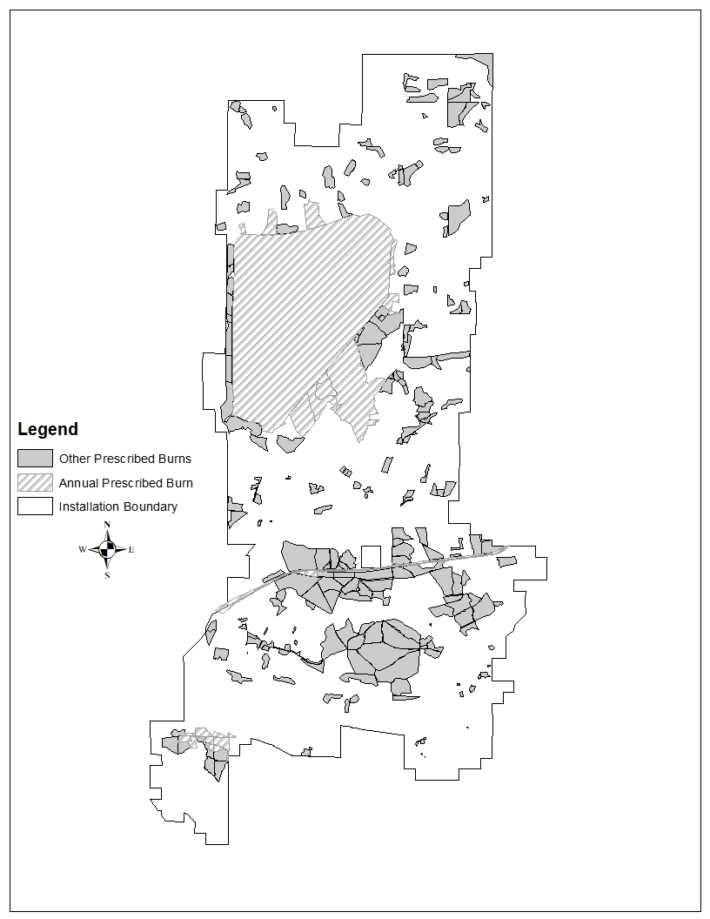

Figure 22. Prescribed burn locations.

4.18 Coastal/Marine Management
Not applicable.

4.19 Floodplains Management
Reference wetland paragraph 4.4.3.

4.20 Other Leases
Fort McCoy leases 67,815 acres from the Black River State Forest, 1,015 acres from Jackson County, 1,147 acres from Monroe County, and 406 acres from Habelman’s Cranberry Co. for use by Soldiers training on Fort McCoy. Training on all the areas except Habelman’s is limited to low impact uses such as dismounted military training and some bivouac. The agreement for Habelman’s requires Fort McCoy to fix impacts after use.
If the training on leased properties has the potential to affect threatened or endangered species, consultation with the USFWS is required. An assessment is submitted to the USFWS that describes the potential impacts of military training activities on listed species. An incidental take request is included within this assessment if it is likely that incidental take of listed species will occur. Surveys to map the location of wild lupine are completed on Jackson County, Monroe County, and Habelman’s leased properties every 10 years.
Military training on leased properties also has the potential to affect cultural resources. Consultation with the Wisconsin State Historical Preservation Office (SHPO), the Ho-Chunk Nation, and the interested public is required. A records search of previous cultural resources work that has been completed on the leased property will be required. This will provide further information as to the amount of additional survey work that is required prior to training.

4.20.1 Management Activities
- Investigate ways to increase training use of leased lands.

4.21 Fort McCoy Natural Areas Management (FMNA)
FMNAs are valuable for scientific research, teaching of conservation and natural history, the preservation of biological diversity, and for providing benchmarks for determining the impact of use on managed lands. As such, the FMNAs are limited to dismounted, non-mechanized military training. More information on FMNAs is located in para. 2.6.2.4. MOUs and management plans have been developed between Fort McCoy and the WDNR for these FMNAs. In 2020, the decision was made with the WIDNR and USFWS to remove the designation of Natural Area from the 220 acre site formally known as Oak Barrens Natural Area. A plan is in development that will become an appendix to this document outlining the special management that will/will not take place within this training area.

4.21.1 Management Activities
- Follow practices as outlined in the approved FMNA Management Plans.
- Conduct yearly inspections of FMNAs as outlined in the MOU with the WDNR.
- Monitor beaver activity/populations in FMNAs. Remove beaver and dams as needed.
- Ensure signage is posted per MOU and management plan.
- Maintain plant community integrity and conduct management as necessary.
- Conduct invasive species control and surveys.
- Provide education and outreach programs using these sites, if requested.
- Conduct prescribed burns in these sites.
- Submit yearly report to WDNR on status of FMNAs and management conducted.
- Continue to develop management plan for area formally known as Oak Barrens Natural Area and implement practices.

4.22 Military Land Use Areas Management
The DPTMS, Range and Training Division has the primary responsibility of managing operational areas, maintaining targetry and training aids on ranges/training sites, and maintaining training areas, maneuver trails, and associated sites like firing points, mortar points, landing and drop zones. DPW has a role in maintaining ranges, roads, tank trails and training sites that are considered real property assets.

4.22.1 North Impact Area (NIA)
See para 3.1.3 for background information on the NIA.

4.22.1.1 Management Activities
- Reduce erosion and stream sedimentation through BMPs within the La Crosse River watershed outside of the NIA and encourage private landowners to participate.
- Enhance and maintain the integrity of the fishery. Use the fish community as an indicator of aquatic integrity.
- Demonstrate that the NIA is managed in a responsible manner. Management includes but is not limited to sampling water quality, NIA crater studies, restricting white phosphorus indirect fire to designated areas and documenting the number of rounds fired annually, and periodic meetings with outside agencies to discuss issues as desired.
- Maintain the NIA and upper La Crosse River corridor in a plant community (oak savanna/barrens/prairie complex) that is tolerant of the land use activities.
- Allow the La Crosse River to maintain natural sinuosity and monitor the effects.
- Use prescribed burning to reduce the chance of wildland fires escaping from the NIA.
- Develop plan for the control of spotted knapweed and leafy spurge in the NIA. Control options will include chemical and biological agents. Some areas along the perimeter of the NIA can be chemically treated and arrangements can be made with an Explosive Ordnance Disposal unit and Range Control to access limited areas within the NIA.
- Continue to monitor regal fritillary and ottoe skipper butterfly populations within the NIA as access restrictions allow.

4.22.2 Drop Zones (DZ), Air Assault Strip and Landing Zones (LZ)
There are five DZs. Badger, Geriaco, and Warrens, are open grasslands that are managed primarily as open expanses for training and secondarily for prairie flora and fauna. The other two DZs include a fixed wing landing strip, Young DZ, and the Sparta/ McCoy Airport, Sparta/McCoy DZ. Although mowing has been used at Cranberry LZ and Warrens DZ, it should be avoided unless required for a specific mission because it can damage grassland bird nests and damage habitat for species such as the ottoe skipper butterfly, regal fritillary butterfly and red-tailed prairie leafhopper. In 2015, clearance of UXO within Badger was initiated with the intent of clearing UXO from an 800 acre area. This clearance had the potential to degrade the habitat in the area by spreading invasive species. In 2018, the decision was made to clear UXO from 35 acres within this 800 acre area. Digging will be allowed within these 35 acres supporting the military training requirement, while the remaining 765 acres will continue to receive non-intrusive training activities that will maintain the habitat for rare species. The Young Air Assault Strip is surrounded by a grassy area that is periodically mowed by DPW. In 2014 eleven LZs were established. Five are pinnacle landing zones located on high elevation hilltops and six were relatively flat/level terrain. One additional pinnacle site was created in 2015. Pinnacle sites are all less than one acre in size and landing zones range from three to eight acres. All are managed to limit woody species that would impede helicopter landings. Generally, designated firing points are also managed to make them usable for rotary wing landing zones. An unmanned aircraft airfield was constructed in 2013 creating 65 more acres of grassland/low brush habitat.

4.22.2.1 Management Activities
- Control invasive plant species and woody plant species encroachment.
- Use prescribed burning to keep the DZs open and enhance fire adapted plant communities.
- Use timber sales to clear trees from the airstrip runway approaches and DZ expanses.

4.22.3 Improved Ranges
Care and maintenance of the range areas is under the jurisdiction of Range and Training Division in DPTMS with support from DPW for maintenance on roads, grounds, and other real property assets. The DPW provides mowing, pest control support, and maintenance of buildings, parking lots, roads, etc. The ITAM and NRB coordinate any activity that may impact the range (timber harvests, hunting, or data collection) with the DPTMS Scheduling Section. Prescribed burns are conducted around certain ranges each spring to reduce woody vegetation and decrease fuel loads to prevent uncontrolled wildland fires during active use. The large open area (700 acres) of Range 29 has become an important area for grassland birds. Cease-fires are initiated whenever mega-fauna are identified on ranges to help reduce impacts to wildlife species.

4.22.3.1 Management Activities
- Annually burn Ranges 6, parts of 18, 26, and 29 in the spring to reduce wildland fire potential.
- Annually burn downrange of Range 101 and 31A in early spring to reduce wildland fire potential from night shooting of tracer rounds.
- Use contracts to complete fire break maintenance around selected ranges (26, 100, 101 and 102) to reduce wildland fire danger.
- Use timber sales to clear trees for new range requirements.
- Assist with vegetation management to ensure adequate line of site to designated targets or to sustain forested resources where cover/concealment is required to support tactical range requirements.
- Provide technical review of NEPA documents from DPTMS projects.

4.23 Developed Areas Management

4.23.1 Cantonment and Housing Area Management
The DPW operates the grounds maintenance program and is responsible for the grounds work in developed areas, along right-of-ways, and other areas. In 1982, Fort McCoy started withdrawing land from the mowing program until approximately 212 acres were put into the “No-Mow” program. These included areas that were a distance from buildings and mowing could not be justified. In addition to saving money by not mowing the land, other benefits were; increase of native vegetation, improved nongame wildlife habitat and additional stormwater retention.
The goals of the grounds maintenance program are:
a. Support present and future mission requirements.
b. Protect real estate investments from depreciation and damage.
c. Protect the natural beauty of the landscape.
Housing occupants maintain their yards. A contract is used to prune deadwood from the large trees in the area to prevent damage and injury to property and persons. The DFMWR personnel maintain a fenced garden plot for the occupants. Pest control services are provided as needed or supported through a self-help program for smaller problems.

4.23.1.1 Management Activities
- Coordinate mowing and pest control requirements to achieve natural resource objectives.
- Provide technical oversight relating to urban forest management to include identifying and marking hazardous trees for removal, determining tree planting locations and suitable species to plant, and planning pruning operations to improve tree structure or remove hazardous branches.
- Use special/urban hunts to manage deer populations.
- Minimize negative effects from stormwater run-off by using BMPs in construction designs and projects.
- Provide technical review of NEPA documents from DPW projects.
- Provide technical oversight related to water development projects.
- Control invasive plant species.
- Update urban forest inventory annually.

4.23.2 Airport Management
The NRB involvement is limited to managing the nearby forest to keep tree growth from impacting the facilities and managing animal populations to avoid interfering with aircraft. The DPW is responsible for mowing, urban tree care, clearing vegetation from the fence and removing individual trees that impact Federal Aviation Administration (FAA) rules for runway safety which include Lateral Clearance Zones, Accident Potential Zones and Clear Zones. The airfield was enclosed by a fence in 2009 to provide increased security and exclude deer from the runways.

4.23.2.1 Management Activities
- Control invasive species.
- Use timber sales to help keep runway flight paths in compliance with FAA, DoD, AR, CFR and other rules for runway and aircraft approach and landing safety.
- Provide pest control support to include the removal of nuisance wildlife.
- Assist with the implementation and updating of the Wildlife Aircraft Strike Hazard (WASH) plan.

4.23.3 Roads and Railroads
Herbicides are used along the railroad bed to keep vegetation in check while roadsides are mowed. Roadsides in the training areas provide habitat for the KBB so a system of identifying KBB areas along roads has been implemented. The T&E biologist marks KBB habitat with fence posts and for many years instructed the grounds crew not to mow those areas until September or October. Beginning in 2018, roadsides mowed once annually, to include KBB habitat areas, are mowed between June 1 and July 15, prior to when most invasive species have produced mature seeds. The road maintenance crew assists with tree removal along roads during winters when snowfall amounts are below normal. LRAM personnel also remove trees along road edges during the winter months. Erosion is a main concern in areas of steep slopes or in the vicinity of stream crossings. Coordination between the road maintenance crew and NRB is vital to minimizing impacts to water resources.

4.23.3.1 Management Activities
- Maintain markers identifying KBB habitat restricted-mow areas along the roads.
- Prescribed burn along the railroad ROW to reduce fuel loads and maintain prairie species to reduce railroad likelihood as corridor for long range spread of non-native and invasive plants.
- Use the work order process to alert the DPW contractor when culverts are obstructed.
- Coordinate with mowing crews to reduce spread of invasive plants, especially wild parsnip.
- Recommend and coordinate methods to minimize effects from stormwater runoff.
- Recommend BMPs to minimize sediment loading.

4.24 Cultural Resources Management (CRM)
Cultural Resources Management assists the Garrison Commander in making decisions regarding the cultural resources and historic properties under his/her control in compliance with public laws, in support of the military mission, and consistent with sound principles of cultural resources management. The successful balance of mission requirements and cultural resources compliance responsibilities requires long-term planning and coordination, and effective management to prevent conflicts between the mission and managed resources. More information concerning the CRM program is found in the Integrated Cultural Resources Management Plan (ICRMP).
Program goals are:
a. Accomplish necessary compliance actions for the management of cultural resources that may be affected by installation, tenant, or troop actions. This goal is the focus of the ICRMP that ties into the INRMP, the Range Complex Master Plan, and the Installation Master Plan.
b. To locate, identify, and evaluate the significance of cultural resources (such as historic buildings, archaeological sites, burial sites, and places of significance to Native Americans) located on Fort McCoy and to protect all those that meet the criteria for inclusion on the NRHP.
c. To contribute to the knowledge about the prehistory and history of West-Central Wisconsin through the analysis and synthesis of data collected in procedures designed to achieve compliance with Federal and state historic preservation laws.
d. To give priority to the evaluation and conservation of cultural resources and historic properties located in areas that are heavily used for training maneuvers, to devise protective strategies for National Register-eligible archaeological sites located in areas of high maneuver impact and to reduce the number of eligible archaeological sites or other historic properties that must be avoided by training activities.
e. To enforce Federal laws that prohibit willful vandalism and casual collection of antiquities from archaeological sites located on Fort McCoy through a program of selective surveillance and published notices.

4.24.1 Cultural and Historic Resources
Fort McCoy lands contain archaeological sites and other historic properties dating from the Paleo-Indian period through the modern military era (ca. 10,000 BP through present day). Numerous Native American archaeological sites are present in areas that are in close proximity to streams and wetlands. These sites are typically a palimpsest of small short term occupations resulting from resource procurement excursions and are marked by features, or artifacts such as projectile points, lithic debitage, or pottery from later woodland-era sites. Activity on the stream terraces appears to intensify during the Middle Archaic period (approximately 4500 years ago) and continues through late pre-contact and even early post-contact Native American periods. Occasionally pre-contact Native American lithic reduction workshops are present in areas where workable raw materials are located away from water sources.
EuroAmerican use of land overlooking waterways is indicated by homesteads, mill activity and, to a lesser extent, recreational lake clubs. These archaeological sites have been identified through a combination of historic records and locating surface remnants of buildings and/or structures, such as cabin foundations or mill dams. This Euro-American presence at Fort McCoy began in the late 19th Century and continued until the land was purchased by the US Government for the Army installation. Away from water sources, the archaeological sites at Fort McCoy tend to be primarily post-contact farmsteads and military-related sites.
In FY13, the majority of archaeological resources identification surveys (aka Phase I) were completed on the installation. Over 45,000 acres were surveyed for this effort. Since that time, archaeological evaluations (aka Phase II investigations) employing the criteria specified in the National Historic Preservation Act (NHPA), assessed 156 archaeological sites as eligible for listing in the NRHP and seven sites are currently unevaluated. As stated earlier, three archaeological sites and one cemetery site are located in UXO-intensive areas and will not be evaluated at this time because of safety concerns. Additional mitigation or protection strategies (i.e. site capping, berms, signage) may be necessary for NRHP-eligible sites. Archaeological sites identified as eligible for the NRHP should be avoided. Sites determined ineligible for the NRHP will be available for future maneuver training and construction without the need for additional archaeological evaluation. However, cultural resources determined not NRHP-eligible will also be reviewed when activities or undertakings occur in their vicinity because there is the possibility for inadvertent discoveries that can change the eligibility status for a resource and because Army guidance states, “The goal of the CRM should be to preserve a valid representative sample of all site types (2016:34).”
In 2018 and continuing in 2019, historic architectural identification survey (a modern Section 110 identification survey) identified 49 possible NRHP-eligible historic properties. Two buildings and two sets of stone gates have been determined eligible for listing in the NRHP. Like most of the constructed properties on the installation, these properties are associated with the Army’s use of the land. Additional identification of architectural properties and other structures is a continuous process as these types of properties age and have become, or will become, older than 50 years, a key criteria used to evaluate historic properties for listing in the NRHP.
The Ho-Chunk nation identified two sacred sites and one property of traditional, religious, and cultural significance located on Fort McCoy. With proper coordination and installation access procedures, the Ho-Chunk Nation will be allowed access for ceremonial and religious purposes. The installation currently has a Memorandum of Understanding (MOU) with the Ho-Chunk nation which provides for consultation about processes to address cultural resources, historic properties, acred sites, the property of traditional, religious, and cultural significance, and the use of natural resources.
More information and a summary of Fort McCoy’s mission and its effects on cultural and historic resources are located in the Fort McCoy Integrated Cultural Resources Management Plan.
Military training on leased properties also has the potential to affect cultural resources. Any lease or lease renewal will require compliance with 36CFR800 and the Section 106 process for cultural resource compliance. Which includes requirements for consultation with the Wisconsin State Historical Preservation Office (SHPO), the Ho-Chunk Nation, and the interested public.

4.25 RTLA Bird and Small Mammal Surveys
Bird surveys under LCTA were conducted during 1991, 1992, and 1994 field seasons. Surveys conducted during this period were to follow an Army-wide protocol (USACERL Tech Report N-92/03, Feb 1992). Current suggestions for avian surveys point to the need to conduct annual bird surveys using the Ralph et al (1995) point count methodology, which is the standard acceptable methodology for the Upper Midwest. Previous data collected by LCTA and by the wildlife program on presence/absence is useful background information, but in order to understand trends in bird populations at Fort McCoy annual surveys using a standard protocol will need to be conducted.
Small mammal surveys were also dictated as a part of the initial LCTA protocol. Small mammal surveys were to take place every 5 years. The initial small mammal survey was conducted June through July of 1991. To date no further small mammal survey using the original LCTA protocol has been accomplished due to changes in program guidance and focus. Other presence/absence surveys have however been conducted by the wildlife program on post. More information on LCTA monitoring is discussed under Section 4.7.1.
Guidance from the Sustainable Range Program as of 2004 had indicated avian and wildlife survey efforts, especially if there is a well-established Natural Resources Branch in place on the installation, are generally not a RTLA program responsibility. Therefore, the current RTLA program does not participate in avian and wildlife assessments as part of the normal monitoring program. See section 4.1, Threatened and Endangered Species Management, for details on current avian bird surveys.

4.26 Soil Resources

4.26.1 Inventory
Soils inventories on Fort McCoy are based on the NRCS Soil Survey Geographic (SSURGO) Soils database from 2004. Field validation of these mapping units has not been conducted on a comprehensive level. One important aspect to consider is identification of hydric soils or soils with hydric components. Field verifications should be conducted as needed such as when a proposed construction site overlaps possible hydric soils.

4.26.2 Monitoring
Currently, the RTLA program monitors erosion, soil disturbance, and exposed soils at vegetative survey plots as part of the long-term monitoring every five years. RTLA short-term monitoring, conducted annually, makes qualitative assessments of disturbed soils and potential erosion problem areas. Information obtained during surface water quality monitoring conducted during rainfall events will help identify watersheds impacted from erosion and sedimentation. Observations and soil erosion reports from other Fort McCoy personnel will also aid in correcting installation erosion areas. Problem areas will be addressed with appropriate Directorates to achieve water quality improvements.

4.26.3 Erosion
The LCTA Program contracted Center for Environmental Management of Military Lands (CEMML) to produce an erodibility index of Fort McCoy’s soil resources. The report, Soil Erosion Survey of Fort McCoy, Wisconsin (Warren et al., 2002), provides some general conclusions and suggestions for soil conservation on post. The report concluded, generally, that up to 90 % of the land area of Fort McCoy has soils with a high tolerance for soil disturbance, as long as vegetation loss is minimized. The RTLA program will utilize information derived from this report as well as field data collected to keep updated tabs on soil and disturbance related impacts.
The Fisheries program (see section 4.4) helps identify and resolve erosion problems. The LRAM program completes erosion control when the training mission is determined to be the cause or where needed to improve sites for training requirements. The RTLA Program assists in identifying training impacts via disturbance monitoring during each training season, maneuver trail surveys, and monitoring of high use areas such as firing points. The DPW is responsible for control work when the erosion is natural or resulting from improved roads, shale quarries or sand pits. If erosion poses an immediate threat to safety or surface water quality, it is given a higher priority in the work order process and control may occur quickly. More information about LRAM erosion control work can be found in the five year ITAM plan.

4.26.4 Management Activities
- Identify and prioritize erosion resulting from abandoned shale quarries and submit work orders for DPW.
- Annually inspect active shale quarries and sand pits to determine erosion control measures required. Emphasize project phasing to minimize the area of soil disturbance. Recommend project site solutions, offering best management practices (BMPs) to minimize soil loss.
- Ensure BMPs for erosion control are implemented in contracts that involve construction, timber harvests, or other operations disturbing vegetation that contribute to soil erosion.

4.27 Data Storage, Retrieval and Analysis
Each NRB program stores data in their individual filing cabinets and computer files. Computer files are stored in a central server that is backed up daily. At the close of each fiscal year (FY), major accomplishments, events and activities are summarized and archived by the GIS lab for use in reports within and outside Fort McCoy. Some of the activities archived include: prescribed burns, wildland fires, timber sales and invasive plant control.

5.0 IMPLEMENTATION OF THE PLAN

5.1 Project Development
This section describes how the NRB develops new projects and administers existing projects to complete implementation of the INRMP. There are two general types of projects; one-time and recurring. One-time projects are closed-out after project completion while recurring projects are typically planned for successive years. An example of one-time projects is lake dredging while an example of a recurring project is KBB habitat mapping which is completed annually. All projects are subject to the NEPA review process as defined in 32 CFR Part 651.9.

5.1.1 Determine Project Need
All projects begin when there is an identified need. The need may result from a change in the military mission, new law or regulation, research and education, new technology, professional judgment, customer request, or any other changes or new information that might surface. Recurring projects should be assessed annually to determine if the project is still required.

5.1.2 Project Details
The project proponent or program manager in charge of the project researches the details and cost before presenting it for initial approval by the Chief, NRB. The project proponent or program manager will need to provide the following information before a project will be reviewed:
a.) How much will the project cost?
b.) What is the estimated schedule for completion?
c.) When will the project start and end?
d.) Is it a one-time or recurring project?
e.) What are the benefits of the project?
f.) How will it benefit and support the military mission?
g.) How will the project be completed (project design that is most cost-effective or beneficial)?
h.) Who will complete the project?
i.) Has this been attempted by other installations or agencies?
j.) What equipment and supplies are required?
k.) Will additional funding sources be needed?
l.) Future requirements or potential impacts on military mission.
m.) What are the ramifications if we don’t do the project?

5.1.3 Project Approvals
After the project has been researched and a summary of the project is completed, the project is submitted to the Chief, NRB for review and approval. After review, the Chief, NRB will route the project to the Chief, ED for a final approval. After the project is approved, a NEPA review will be initiated. Small projects may be completed by installation staff or by the existing DPW contractor if the project is covered by the contract. If the project requires a new contract or a change to the existing contract then a “Request for Services Contract Approval” form is completed for approval. Funding for the project is requested through the appropriate source described in section 5.4.

5.1.4 Project Completion
Any activity that occurs within the training areas must be coordinated with Range Scheduling to prevent any impacts to the military training mission. Projects that involve excavating or digging need coordination with Digger’s Hotline. The project proponent visits the site frequently to inspect progress and make sure the project specifications are followed. A completed project is inspected to determine if the project goals were satisfied. If everything is satisfactorily completed, NRB records are updated.

5.2 Achieving No Net Loss
The most effective way to achieve “no net loss” of training capability at Fort McCoy is to be proactive in managing the natural resources. Anticipating a potential training constraint (or encroachment) and completing actions to minimize the impact on training prevents a “roadblock” from negatively impacting the military training mission. Some constraints are required by federal statute and cannot be avoided. Constraints may be internal or external. Internal constraints come from within the installation boundaries and result from actions done by the Army or Fort McCoy that inhibit some or all training missions. These constraints may be imposed through laws and regulations from other Federal agencies and include; cultural resources, threatened and endangered species, wetlands, surface water, steep topography, well/wellhead protection areas, natural area designations, above ground and underground utilities, family housing, development, landfills, and safety related precautions such as unexploded ordnance (UXO) areas or smoke and pyrotechnic use restrictions. External constraints result from actions that occur off the installation such as housing developments and roads. Paragraph 2.3.4 discusses the effects of natural resources management on the mission and Appendix C shows the areas where restrictions on mission or training may occur and outlines Internal Constraints or Encroachment Factor impacts on various types of training.

5.2.1 Internal Constraints

5.2.1.1 Cultural Resources
The presence of certain types of cultural resources may place constraints on the type of undertaking conducted, including training and other activities that result from the military mission. Constraints usually reflect the nature of the resource as well as that of the undertaking. The most prevalent type of protected cultural resource is archaeological sites or historic structures that are eligible for inclusion in the NRHP. Native American sacred sites and properties of traditional, religious, and cultural significance are also protected and training is restricted to foot traffic only. Other activities may be restricted to actions that will not adversely affect any NRHP-eligible historic property. After the final determination of all archaeological sites for NRHP-eligibility is completed remaining sites will be assessed for mitigation (excavation, cataloguing, removal, and preserving of site features) or protection strategies (i.e. site capping, berms, signage, Seibert stakes) to allow for military maneuvers to eliminate or reduce training limitations at these sites. Mitigation or protection actions will be considered on a case by case basis, limited to mission critical sites that are feasible for such work, and for sites as allowed through federal, state, and other applicable requirements. After the final determination of NRHP eligibility is completed for any unevaluated historic structures, the process to meet federal, state, and other applicable requirements will be integrated into the development of a Programmatic Agreement, which will eliminate or reduce the effect of mission activities to these types of historic properties.

5.2.1.2 Cemeteries
There are two cemeteries and five individual gravesites located on Fort McCoy. One of the cemeteries, LaFayette Cemetery, lies within the cantonment, but is not owned by Fort McCoy. These areas are protected from all disturbances and will remain that way into the future.

5.2.1.3 Threatened and Endangered Species
The KBB and gray wolf management plans were written with input from DPTMS in order to minimize impacts to the training mission at the planning stage. Actions conducted on Fort McCoy that will disturb vegetation and soil, to include many military training activities, are reviewed prior to completion in order to lessen impacts to resources. If endangered species habitats will be impacted, suggestions are made to either avoid or minimize these impacts. Building construction within KBB Management Areas is avoided whenever possible since these sites generally have the highest KBB populations and are the most important areas for Fort McCoy to reach its conservation goals. If impacts to KBB habitat are unavoidable, the biologist determines if the incidental take can be approved at the installation level or if approval from the FWS is needed. Endangered species habitat that is disturbed from a construction project normally must be mitigated. That is, the habitat lost must be replaced in an alternate location. Mitigation actions are either completed on Fort McCoy or by providing funding to the USFWS who partners with the WDNR to complete mitigation actions off of the installation. Off post mitigation is the preferred action when feasible and appropriate based on management goals and outside agency consultations.
In January 2016 Fort McCoy provided a determination to the USFWS concerning the northern long-eared bat (NLEB). The determination stated that all activities described within previous biological assessments submitted to the USFWS would not result in prohibited incidental take as defined within the final 4(d) rule and accompanying Programmatic Biological Opinion for the NLEB. The USFWS concurred with this determination. Other than initial restrictions for the use of smokes and obscurants, there have been no significant impacts to the military training mission that resulted from the listing of the NLEB.
The RPBB was listed as federally endangered on March 21, 2017. Prior to listing, there were no records of the RPBB occurring on Fort McCoy or in Monroe or Jackson Counties. Planning level surveys completed in the mid-1990s did not focus on bumble bee diversity, so little information was known about the bumble bee diversity occurring on the installation. In 2017, surveys documented 11 species of bumble bees on the installation to include the RPBB. Fort McCoy has received a BO from the USFWS that includes approved levels of incidental take for activities that impact the species. Fort McCoy must provide an annual take report to the USFWS that identifies the acres of RPBB habitat impacted the previous calendar year. Little to no impact to training is expected from this BO.

5.2.1.4 Surface Water and Wetlands
Wetland habitat accounts for less than one tenth of the installation land acreage, covering approximately 4,400 acres. Floodplains and riparian habitat are typically protected from vehicular travel. Fort McCoy restricts vehicle maneuvering within 25 meters of streams, lakes, and wetlands (Fort McCoy Reg 350-1) relating to approximately 7,340 acres of restrictions (see Appendix D). Restrictions are in place around bodies of surface water to minimize sources of pollution; however there are exceptions to the regulation given appropriate coordination or activity review to permit water related training like water removal, water purification, or float-type vehicle missions. Larger chunks of contiguous training land are needed to perform realistic military exercise. The DPTMS is in the planning process to establish stream crossings for tracked and wheeled vehicles. Foot training within the wetlands and streams are unrestricted.
The NEPA process identifies projects that may impact wetlands. Training and engineer personnel who apply good planning techniques can identify project alternatives to help avoid or minimize wetland losses. In areas where wetland losses or “take” is unavoidable, mitigation may need to be considered and negotiated. Wetland mitigation and banking programs will be considered with the WDNR, USACE and EPA to aid in Fort McCoy developments. Formal group discussions should be established with our basin partners for devising plans to best protect wetlands, the public trust, and mission needs. As an alternative to on-site wetland bank or mitigation, off-site wetland project should be considered to protect the military mission.
The 7,773-acre NIA is bisected by the La Crosse River and several smaller tributaries and wetland complexes. Efforts have been successful to minimize weapons fire into wetlands and waterways by moving targets outside a “no-fire” La Crosse River buffer area to reduce errant rounds impacting the stream. See the map of indirect fire restrictions in Appendix C. Ammunition containing white phosphorus is used in target areas designated to limit exposure to water and waterfowl. Monitoring efforts demonstrate that these practices as well as training activities are not having significant impacts to the aquatic resources.
The NRB helps to mitigate sediment impacts on water quality associated from training lands development and military operations by applying habitat restoration techniques in lakes and streams. Monitoring programs are in place to aid in identifying areas impacting aquatic resources and surface water quality to avoid environmental compliance concerns. Environmental non-compliance to the CWA or a notice of violation could possibly delay or impede the military mission. Proactive management is not only a benefit to the military’s natural resource, but a benefit to neighboring landowners within these major water basins.

5.2.1.5 Fort McCoy Natural Areas (FMNA)
The FMNAs offer limited access for troop training. Only dismounted field training exercises can take place within FMNA boundaries and digging/excavation is not allowed. Two designated natural areas, Clear Creek and Silver are being evaluated to adjust and correct the area boundaries which will encompass approximately 156 acres. Upon approval of the updated boundaries, a new MOU and area management plans will be developed with the WDNR. The Oak Barrens Natural Area, located in B23, was removed from the Natural Area Program in 2021. Fort McCoy RTLA surveys have determined that high quality oak barrens habitat is found throughout the installation from years of landscape management. An internal management plan with disturbance thresholds is being developed for the oak barrens in B23 to reduce habitat degradation and protect archeological and sensitive areas.

5.2.1.6 Steep Topography
Fort McCoy has 8,600 acres of land with slopes greater than 20%. These sloped areas are less conducive to mounted vehicle maneuvers and for sites such as tactical operations centers or assembly areas. The NRB can reduce the amount of T&E constraints on level ground by creating more KBB habitat on the steep hillsides. Thinning trees near the top of ridges can increase the quality of training by providing good lookout areas on high ground.

5.2.1.7 Wells and Wellhead Protection Area (WHPA)
Fort McCoy Regulation 420-30 prohibits activities from taking place within the WHPA that have the potential to contaminate Fort McCoy’s drinking water. Military training activities that are affected include; vehicle/equipment maintenance, motor fuel dispensing facilities/operations, petroleum product storage tanks, target/backstop areas, impact areas, firing of large munitions and burning powder charges. There are three wellhead protection areas; cantonment, family housing, and the Sparta/Fort McCoy Airport and restrictions apply to wellhead 90 day and 5 year recharge areas for each. Individual potable wells within the operational area also have a 100 foot restricted buffer zone around each well. Any future plans to develop new wells, or increase well restriction areas, will require thorough analysis and take into consideration potential impacts to current and future military training missions, via consultation with DPTMS.

5.2.1.8 Landfills
Out of ten closed landfills on Fort McCoy, four of them are off limits to vehicle traffic and soil or cap disturbance; three are located in the training areas and one in the NIA buffer zone. The first landfill, approximately six acres in size and located in Training Area C-2, was used as a demolition landfill for approximately 15 years from the early 1990’s until 2005. It contains primarily wood scraps from building demolition and is surrounded by a fence to prevent access. Landfill 5, the second landfill located in the training area, is approximately 30 acres in size and is located in Training Area M-3. Landfill 5 was in use from 1965 to 1989 and was used for a variety of wastes from animal carcasses to demolition material. Landfill 5 has a fence on the south and west sides to prevent access. The third landfill, landfill 2, is six acres in size and is located in Training Area D-11. Landfill 2 was used to dump coal ash, construction waste and other non-recyclable material from 1942 to 1950.
The landfill located in the NIA buffer zone was used from WWII until 1965 for disposing empty pesticide containers. It was excavated and capped in 1993 and the cap must be maintained. The pesticide landfill has an earthen berm around the perimeter and the road leading to it is gated at the NIA boundary to prevent access. It is approximately 0.7 acres in size.
A sediment disposal site covering three acres in training area B-24 has heavy metal contaminated soils from dredging Hazel Dell Lake. Vehicle use and digging is prohibited in this 3.3 acre site.
It is currently not considered economically feasible to remove these sites for the limited potential gain in maneuver training acreages.

5.2.1.8 UXO
Areas of known UXO (see Appendix C) to include the Fort McCoy NIA buffer area create training and management limitations based on safety considerations. As funding becomes available Fort McCoy DPTMS will continue to contract for UXO clearance support to reduce this constraint with an annual goal of 33 acres of sub-surface clearance.

5.2.1.9 Additional Internal Constraints
On an annual basis ITAM will review internal constraints as a part of the RCMP process to determine if new constraints have evolved or new conditions allow for removal of existing constraints. Constraints associated with the LaCrosse River buffer, white phosphorous restricted areas, and shallow water table restrictions (see Appendix D) will currently remain unchanged. Smoke and pyrotechnic use restrictions will remain in place, but may be altered on a case by case basis after review by the DPTMS Range Branch.

5.2.2 External Constraints
The area around Fort McCoy has historically been rural with low population densities. Within the past 20 years, more development has taken place in the area adjacent to the installation boundary and most external constraints result from this increased development.
The Army program to address external encroachment is called Army Compatible Use Buffers (ACUB). The ACUBs establish buffers around Army installations to limit effects of encroachment and maximize the amount of land inside the installation that can support the mission. Fort McCoy is completing an ACUB program proposal with the goal to have an approved ACUB established in 2022.
A Joint Land Use Study (JLUS) is a way to reduce potential conflicts between military installations and stakeholders while sustaining economic growth and development, protecting public health and safety, and protecting military missions. The JLUS for Fort McCoy was completed in February 2013 and involved the local communities of Sparta, Tomah, Monroe County and Jackson County. The Mississippi River Regional Planning Commission was a partner in this process.

5.3 Use of Cooperative Agreements (CAs)
A Cooperative Agreement (CA) is an acquisition tool that is less formal than a contract but gives the government more control than a grant. It is considered an effective way to implement INRMPs and requires substantial government involvement. The CAs have been used by the NRB in the past. There are no CAs in place at this time, but there are on-going discussions concerning how to enter into agreement CA with the WDNR. Department of Defense Instruction (DODI) 4517.03 references section 670c-1 of the Sikes Act to give priority for the procurement of INRMP implementation and enforcement services to Federal and State agencies with responsibility for fish and wildlife management. The DODI also states that DoD installations may enter into CAs with States, local governments, nongovernmental organizations, and individuals to provide for natural resources maintenance and improvement or conservation research on or off DoD installations. The DoD installations are allowed to enter into interagency agreements with other Federal agencies for INRMP implementation and enforcement services.

5.4 Funding
All requirements set forth in this INRMP requiring the expenditure of funds are expressly subject to the availability of appropriations and the requirements of the Anti-Deficiency Act (31 U.S.C. Section 1341). No obligation undertaken by Fort McCoy under the terms of this INRMP will require or be interpreted to require a commitment to expend funds not obligated for a particular purpose. This section describes the different types of fund sources available through DPW. The INRMP projects may be funded through a variety of funding mechanisms each with unique rules on what is allowed. The ITAM program is funded through DPTMS channels and is described in the draft ITAM plan.

5.4.1 Budget Requirements Worksheet
The majority of INRMP funding is acquired primarily through the Resource Management Office (RMO) on Budget Requirements Worksheet. The Budget Requirements Worksheets are submitted for funding in three broad categories: 1) Recurring Requirements, 2) Non-Recurring Requirements, and 3) Other Recurring and Non-Recurring Requirements.

5.4.1.1 Recurring Requirements
Recurring requirements are those that occur on a routine and predictable cycle. They include costs for civilian labor, contractor support, travel, training, equipment, and supplies. Recurring costs are associated with regularly or periodically occurring requirements and the requirement frequency may be annually, every three years, every five years or other.

5.4.1.2 Non-Recurring Requirements
Non-recurring requirements are needed to address environmental activities not performed on a recurring basis. These are one-time requirements to address new regulations, a change in mission, correct currently out of compliance situations, or prevent a situation that is currently in compliance but may soon be out of compliance due to upcoming deadlines or changes in regulations. They also include those requirements necessary for preparing, updating, and revising plans.

5.4.1.3 Other Recurring and Non-Recurring Requirements
These are requirements and activities that are not required or do not specifically have established deadlines by legally-mandated requirements or have conditions or deadlines contained in national laws but are needed to address overall environmental goals and objectives and to sustain environmental stewardship.

5.4.2 Reimbursable Funds
The wildlife and forestry programs bring in funds to the government through the sale of timber, firewood, fishing permits, hunting permits, and trapping permits. Agriculture outleases are another source of revenue. Funds brought in through these sources are returned to the installations by reimbursing costs charged to the individual accounts.

5.4.2.1 Forestry Reimbursable Account
Revenue generated through timber sales and firewood permits is deposited in the Army Forestry Automatic Reimbursable Authority (ARA). Each year the forestry program is required to estimate the amount of funds they will deposit into the account and request the amount needed to fund forestry activities on the installation. The Omaha District COE administers the timber sale program on Fort McCoy and they also estimate the amount of deposit and reimbursement they require for the FY. All this information is entered into the Headquarters Army Environmental System (HQAES). The HQAES is a web-based program that facilitates efficient data entry and analysis. The ARA is self-sustaining so the estimates from all the participating installations is used to calculate the total amount of estimated income and the total funding requirement of the program. Each installation is authorized no more than the amount of income they estimate, funding amount may be adjusted up or down through the year as income is deposited. If an installation makes more income than the combined expenses of the administering COE and their program, then 40% of the net proceeds (the amount not utilized by the installation and COE for operating expenses) are sent to a state entitlement fund created to compensate states for tax revenue not paid on federally owned land IAW 10 USC 2665. These revenues are intended to be used for roads and schools in the counties affected. The remaining 60% of the net proceeds are deposited into the DoD Forest Reserve Account.
Forestry reimbursable funds can only be used for expenses related to the production of lumber or timber products. This includes protection from fire, insects, and disease. Forestry reimbursable funds are used to fund one of the forestry technicians, forestry supplies, and forestry service contracts.

5.4.2.2 Forest Reserve Account (FRA)
Net revenues obtained by the ARA that are not deposited into the state entitlement fund are made available for natural resources projects through the FRA. The projects are not limited to commercial timber production and may include wildlife or other conservation projects that are related to forest management. Recent FRA projects on Fort McCoy funded invasive species surveys and suppression efforts in timber sale areas. The FRA projects are requested annually through RPTS and are prioritized with all installation submissions.

5.4.2.3 Fish and Wildlife Reimbursable Funds
Revenue obtained through the sale of Fort McCoy hunting, fishing and trapping permits is deposited into the 21X5095 account and is available to support wildlife and fisheries projects and annual stocking of fish into several impoundments. Recent projects supported by 21X funds include enhancement of winter deer browse, grassland management, wildlife surveys, hunting seasons, aquatic habitat enhancement and sediment removal. Up to 10% of the revenue can be used to support permit sales administration.

5.4.3 Un-Resourced Requirements
Installation Budget Requirements Worksheet funding shortfalls are immediately put on an Un-resourced Requirements List (URR). This list is forwarded to RMO to request additional funds to complete projects. The URR funds may come in at any time of the year but typically are released near the end of the FY.

5.5 NRB Staffing
The following staffing is identified to implement this INRMP:

Environmental Division Chief 1
Natural Resources Branch Chief 1
Forester 1
Forestry Technician 2
Wildlife Biologist 1
Natural Resource Specialist 1
Fisheries Biologist 1
Endangered Species Biologist 1

The staffing list does not include personnel within DFMWR, Office of the Staff Judge Advocate, and DPTMS who have roles in implementation of this INRMP. The list does not include any contract staff involved with the service contracts administered by NRB. Per DODI 4517.03, “the management and conservation of natural resources within DoD control, including planning, implementation, oversight, and enforcement functions are inherently governmental functions that shall not be contracted.” The scopes-of-work for services contracted for INRMP implementation clearly address contractor and Government functions relating to natural resources.

5.5.1 Volunteers
The NRB has used two volunteer programs to allow interested individuals to work under the direction of NRB government staff. The USFWS and the Army Family and Morale, Welfare and Recreation Command have volunteer programs. Volunteers are typically individuals from the local area who are high school or college-aged and are interested in pursuing a career in natural resources management. Other volunteers have been adults who enjoy the outdoors and are looking for ways to become involved during their spare time. Some projects using volunteer services have been forestry, fisheries and wildlife. Volunteers are required to complete forms that give them insurance coverage while performing volunteer services.

5.6 Monitoring Progress
Progress toward completing INRMP goals is measured in four ways:
  - Tracking funding of the Installation Budget Requirements Worksheet projects and the
obligation rate of the funds.
  - The implementation schedule (Appendix B). This schedule shows the planned actions
and their scheduled completion dates that will help complete INRMP goals. Each program will check off their accomplishments for the completed fiscal year on the implementation schedule.
  - The Army Environmental Database – Environmental Quality (AEDB-EQ) system provides for a quarterly submission of metrics related to the Army’s compliance, conservation and pollution protection programs.
  - Assessing whether NRB programs have successfully managed natural resources on the
installation without impacts to the military mission.

5.6.1 INRMP Implementation Assessment
In addition to the four subjects measured in para 5.6, INRMP implementation is further analyzed by reviewing the following seven topics:
a. INRMP Project Implementation
(1) Are INRMP projects, including follow-up inventorying and monitoring work,
properly identified, developed, and submitted for funding?
(2) Has project funding been received, obligated, and expended?
(3) Have projects been completed and do they meet expected objectives?
b. Listed Species and Critical Habitat
(1) Are conservation efforts effective?
(2) Does the INRMP provide conservation benefits necessary to preclude critical habitat
designation?
(3) Are species at risk identified and are steps being undertaken to preclude listing?
c. Partnerships Effectiveness
(1) Has the INRMP review team (USFWS and WDNR) been effective in ensuring
the INRMP's implementation?
(2) Are other partnerships needed to meet the INRMP goals?
(3) Have other partnerships been effectively used to meet INRMP goals?
d. Fish and Wildlife Management and Public Use
(1) Are public recreational opportunities such as hunting, fishing and wildlife viewing
available to base residents and employees?
(2) Are public recreational opportunities such as hunting, fishing and wildlife viewing
available to the public?
e. Team Adequacy
(1) Is the installation's natural resources team adequately resourced to fully implement
the INRMP?
(2) Is the installation's natural resources team adequately trained to fully implement the
INRMP?
(3) Does the installation encourage retaining existing natural resources personnel to
maintain corporate knowledge and manage resources with the most qualified professionals
to support the military mission?
f. Ecosystem Integrity
(1) To what extent are the installation's native ecological systems currently intact?
(2) In what ways are an installation's various habitats susceptible to change or damage
from different stressors?
(3) What stressors affect each habitat type?
g. INRMP Impact on the Installation Mission.
(1) To what degree (i.e., high, medium, or low) is the INRMP and its associated actions supporting the installation's ability to sustain the current and potential future military mission?

6.0 ENVIRONMENTAL ASSESSEMENT

6.1 Introduction
This Environmental Assessment (EA) is prepared in accordance with NEPA, its implementing regulations published by the Council on Environmental Quality (40 CFR 1500-1508), AR 200-1, Environmental Protection and Enhancement and 32 CFR 651, and Environmental Analysis of Army Actions. Under NEPA and its implementing regulations, federal agencies are required to consider the environmental impacts of major proposed actions in the form of an EA or Environmental Impact Statement (EIS). This NEPA analysis is in the form of an EA, which analyzes the potential consequences of implementing the INRMP for Fort McCoy.

6.2 Purpose and Need for the Proposed Action
a. Purpose: The purpose of the proposed action is to implement the INRMP at Fort McCoy. The INRMP is the installation’s plan for managing natural resources to support and be consistent with the military mission while protecting and enhancing those resources for multiple use, sustainable yield and biological integrity. The management of natural resources is a series of processes over an extended period of time. This updated INRMP begins in 2021 and extends until a review for operation and effect (conducted no less than every five years) determines the need for a major revision.
b. Need: The Sikes Act (16 USC 670) requires military installations to develop and implement an INRMP in cooperation with the US Fish and Wildlife Service (USFWS) and the state fish and wildlife agency, in this case, the Wisconsin Department of Natural Resources (WDNR). Army Regulation 200-1 requires installations to integrate natural resources stewardship and compliance responsibilities with operational requirements to help achieve sustainable ranges, training areas, and other land assets and develop, initiate and maintain programs for the conservation, utilization, and rehabilitation of natural resources on Army lands.

6.3 Description of the Proposed Action
The proposed action for this EA is to implement the Fort McCoy INRMP. Under the Sikes Act the elements of the INRMP must be consistent with the use of the military installation to ensure the preparedness of the Armed Forces. The elements of the plan are to provide for: 1) fish and wildlife management, land management, forest management and fish and wildlife-oriented recreation; 2) fish and wildlife habitat enhancement or modifications; 3) wetland protection, enhancement, and restoration, where necessary for support of fish or wildlife; 4) integration of, and consistency among, the various activities conducted under the plan; 5) the establishment of specific natural resource management objectives and time frames for proposed actions; 6) the sustained use by the public of natural resources to the extent such use is not inconsistent with the needs of fish and wildlife resources management; 7) public access to the military installation that is necessary or appropriate for the use described in number 6, above, subject to requirements necessary to ensure safety and military security; 8) for the enforcement of natural resource laws and regulations; and 9) no net loss in the capability of the installation land to support the military mission of the installation.

6.4 Alternatives Considered
The No Action Alternative and the Preferred Alternative are the only two alternatives considered for the proposed action.
a. The preferred alternative is to implement the revised INRMP at Fort McCoy: This alternative is required by statute (16 U.S.C. 670). It is also required by Army Regulation 200-1.
b. No Action: This alternative is not feasible. Fort McCoy would be in violation of 16 U.S.C. 670 and AR 200-1.

6.5 Affected Environment
The affected environment for Fort McCoy in general is covered in Section 2 of the INRMP itself and it is also thoroughly discussed in the Range Complex Master Plan that is updated annually by Fort McCoy personnel.

6.6 Environmental Consequences
This is a focused Environmental Assessment. The following valued environmental components (VECs) have been categorically excluded from this EA because no significant adverse effects are anticipated: Land Use; Air Space; Geology and Soils; Vegetation and Forestry; Invasive Species; Wildlife and Fisheries; Threatened and Endangered Species; Groundwater; Surface Water & Wetlands; Air Quality; Noise; Hazardous Materials & Hazardous Waste; Fire Management; Public Access and Recreation; Socioeconomics and Environmental Justice; Human Health and Safety; Cultural Resources; Visual Resources; Traffic and Transportation; and Infrastructure. The INRMP, by design, provides beneficial impacts to the natural resources of Fort McCoy and to the environment in general. These beneficial impacts are discussed in the INRMP. The Sikes Act requires the INRMP to provide for the integration of, and consistency among, the various activities conducted under the INRMP. The Fort McCoy INRMP has been prepared and reviewed by qualified, experienced natural resources professionals at Fort McCoy. No known adverse impacts were included in the plan. This Environmental Assessment, along with the INRMP itself, will go out for public review. Any significant comments will be addressed in the final documents.

6.7 Cumulative Effects
There will be no adverse cumulative effects as a result of this plan.

6.8 Conclusions Regarding Significance of Impacts
There are no significant adverse impacts expected from the implementation of the INRMP. The implementing regulation at 40 CFR Parts 1500-1508 (1508.27) of the NEPA requires consideration of whether a project would have significant effect on the quality of the human environment. Significance includes consideration of both the context and intensity.

6.8.1 Context
Per 40 CFR Parts 1500-1508 (1508.27) of the NEPA: “Context: This means that the significance of an action must be analyzed in several contexts such as society as a whole (human, national), the affected region, the affected interests, and the locality. Significance varies with the setting of the proposed action. For instance, in the case of a site-specific action, significance would usually depend upon the effects in the locale rather than in the world as a whole. Both short- and long-term effects are relevant.” The implementation of the INRMP would not create a significant adverse impact on society as a whole or on the affected region.

6.8.2 Intensity
Per 40 CFR Parts 1500-1508 (1508.27) of the NEPA: “Intensity: This refers to the severity of the impact. Responsible officials must bear in mind that more than one agency may make decisions about partial aspects of a major action. The following should be considered in evaluating intensity:”
- “Impacts that may be both beneficial and adverse. A significant effect may exist even if the Federal agency believes that on balance the effect will be beneficial.” The beneficial effects of implementing the INRMP are discussed throughout the INRMP with most of the discussion in Sections 2 and 4. This INRMP is intended to have beneficial effects on the natural resources of Fort McCoy and any known management procedures that could cause adverse effects have been removed.
- “The degree to which the proposed action affects health and safety.” There are no known adverse impacts on health and safety.
- “Unique characteristic of the geographical area such as proximity to historic or cultural resources, park lands, prime farm lands, wetlands, wild and scenic rivers, or ecologically critical areas.” The implementation of the INRMP will have no adverse effect on cultural resource sites located on the installation. There are no park lands, prime farm lands, wild and scenic rivers or ecologically critical areas on the installation. There will be no adverse effect on wetlands on the installation.
- “The degree to which the effects on the quality of the human environment are likely to be highly controversial.” This plan is not expected to be highly controversial.
- “The degree to which possible effects on the human environment are highly uncertain or involve unique or unknown risks.” The possible effects on the human environment are not highly uncertain and do not involve unique or unknown risks.
- “The degree to which the action may establish a precedent for future actions with significant effects or represents a decision in principle about a future consideration.” The implementation of the INRMP will not establish a precedent for future actions with significant effects or represent a decision in principle about a future consideration.
- “Whether the action is related to other actions with individually insignificant but cumulatively significant impacts. Significance exists if it is reasonable to anticipate a cumulatively significant impact on the environment. Significance cannot be avoided by terming an action temporary or by breaking it down into small component parts.” The implementation of the INRMP is not related to other actions that together will have significant adverse cumulative impacts. The intent of the implementation of the INRMP is to produce beneficial cumulative effects.
- “The degree to which the action may adversely affect districts, sites, highways, structures, or objects listed in or eligible for listing in the National Register of Historic Places or may cause loss or destruction of significant scientific, cultural, or historical resources.” The implementation of the INRMP will not have any significant impact on districts, sites, highways, structures, or objects listed in or eligible for listing in the National Register of Historic Places and will not cause loss or destruction of significant scientific, cultural or historical resources.
- “The degree to which the action may adversely affect an endangered or threatened species or its habitat that has been determined to be critical under the Endangered Species Act of 1973.” Separate Biological Assessments were prepared for the Gray Wolf Management Plan and for the Karner Blue Butterfly Management Plan. The KBB is a federally endangered species found on the installation while the gray wolf was recently removed from the federal list of endangered species as of January 2021.

6.9 List of Preparers and Agencies and Persons Consulted

6.9.1 Preparers
a. Mr. Aaron Yaeger, Lead Preparer, Compliance Branch, Environmental Division, DPW,
Fort McCoy, Wisconsin 54656
b. Mr. John Noble, Fishery Biologist, Natural Resources Branch, Environmental Division,
DPW, Fort McCoy, Wisconsin 54656
c. Mr. Timothy Wilder, Chief, Natural Resources Branch,
Environmental Division, DPW, Fort McCoy, Wisconsin 54656
d. Mr. David Beckmann, Wildlife Biologist, Natural Resources Branch, Environmental
Division, DPW, Fort McCoy, Wisconsin 54656
e. Mr. Charles Mentzel, Forester, Natural Resources Branch, Environmental Division, DPW,
Fort McCoy, Wisconsin 54656
f. Mr. Jessup Weichelt, Endangered Species Biologist, Natural Resources Branch, Environmental Division, DPW, Fort Mcoy, Wisconsin 54656
g. Mr. Ryan Howell, Archeologist, Natural Resources Branch, Environmental Division, DPW, Fort McCoy, Wisconsin 54656
h. Mr. Kevin Luepke, Natural Resources Specialist, Natural Resources Branch, Environmental Division, DPW, Fort McCoy, Wisconsin 54656

6.9.2 Persons Consulted
a. Mr. Nathan Tucker, Wildlife Management Coordinator (contractor), Natural Resources Branch, Environmental Division, DPW, Fort McCoy, Wisconsin 54656
b. Mr. David Texley, Pest Control Coordinator (contractor), Natural Resources Branch,
Environmental Division, DPW, Fort McCoy, Wisconsin 54656

Bibliography

Albert, D. A. 1995. Regional Landscape Ecosystems of Michigan, Minnesota, and Wisconsin: A
Working Map and Classification. North Central Forest Experiment Station, Forest Service-U.S.
Department of Agriculture. General Technical Report NC-178.

Caldwell, Karyn. 2003. U.S. Army Fort McCoy Integrated Cultural Resources Management Plan.
Colorado State University @ Fort McCoy Archaeology Laboratory, 110 East Headquarters Road,
Fort McCoy, Wisconsin 54656-5226.

Curtis, J.T. 1959. The Vegetation of Wisconsin. The University of Wisconsin Press, Madison,
Wisconsin.

Department of Defense - Office of the Under Secretary of Defense for Acquistion and Sustainment. 2019. Report on Effects of a Changing Climate to the Department of Defense.

Directorate of Public Works .2008.Real Property Master Plan, Fort McCoy, Wisconsin. 2008.
FCH2MHILL.

Directorate of Public Works. 2010. Fort McCoy Regulation 420-30. Wellhead Protection Plan.
Environmental Division. Fort McCoy, Wisconsin.

Drake, T.C. 1997. Rapid Bioassessment and Macroinvertebrate Survey of 11 Streams on the Fort McCoy
Military Reservation, Sparta, Wisconsin. M.S. Thesis. College of Natural Resources. University
Of Wisconsin-Stevens Point.

Earth Tech Corporation. 1996. Fort McCoy Installation Compatibility Use Zone Study (ICUZ). Project
Number HA 00107 4P.

Freckman, R. W. 1992. Final Report-Fort McCoy Wetland Survey. Unpublished.

Gade, J., P.Seman, Baker, B., (in progress) Climate Vulnerability Assessment Tool User Guide, U.S.
Army Corps of Engineers: Washington, DC.

Haney, A., and S. Apfelbaum. 1993. Oak Barrens in Central Wisconsin. College of Natural Resources,
University of Wisconsin-Stevens Point.

Herrick, S.K., J.A. Kovach, E.A. Padley, C.R. Wagner, and D.E. Zastrow. 2009
Wisconsin’s Forestland Woody Biomass Harvesting Guidelines. PUB-FR-435-2009
WI DNR Division of Forestry and Wisconsin Council on Forestry: Madison, WI. 51 pp.

Kerkman, James R. 2007. Fort McCoy Gypsy Moth Management Plan. Directorate of Plans, Training,
Mobilization, and Security. Range and Training Division, Biological and Cultural Resources Team.
Fort McCoy, Wisconsin.

Kerkman, James R. 2014. Fort McCoy Emerald Ash Borer Management Plan. Directorate of Public
Works. Environmental Division, Natural Resources Branch. Fort McCoy, Wisconsin.

Keystone Center, The. 1996. The Keystone National Policy Dialogue on Ecosystem Management-Final
Report. Colorado.

Kotar, J., and T. L. Burger. 1996. A Guide to Forest Communities and Habitat Types of Central and
Southern Wisconsin. The Department of Forestry, University of Wisconsin-Madison.

Kraft, Chris. 2003 Dam Inspection Report, 2003. Griffin Services, Inc., Directorate of Support Services,
Engineering Department, Fort McCoy, Wisconsin.

Leach, Mark K. 2001. The Rare Plants of Fort McCoy Military Reservation, Monroe Co., Wisconsin.
The Michigan Botanist 40:3-15.
Leslie, M., G.K. Meffe, J.L. Hardesty, and D.L. Adams. 1996. Conserving Biodiversity on Military
Lands: A Handbook for Natural Resources Managers. The Nature Conservancy, Arlington, VA.

Lyons, J., L. Wang, and T.D. Simonson. 1996. Development and Validation of an Index of Biotic
Integrity for Coldwater Streams in Wisconsin. N. Amer. J. Fish Mgmt. 16:241-256.

Martin, Lawrence. 1965. Physical Geography of Wisconsin. The University of Wisconsin Press,
Madison, Wisconsin.

Maxwell, J. 1996. Memo to the Biological Services Team. Succession of Plant Community on Tarp
Areas-Observations. Unpublished.

Noble, Jr., J.D. 1997. La Crosse River Aquatic Monitoring Summary Report, 1993-1996. Fort McCoy
in-house report.

Noble, Jr., J.D. 1998. Silver Creek Water Quality Summary Report for Monroe County Department of
Land Conservation. Fort McCoy in-house report.

Noble, Jr., J.D., S.J. Rood, and R.P. Ennis, 2014. Suukjak Sep Creek Summary Report 2014. Fort McCoy
in-house report.

Nuzzo, V. 1986. Extent and Status of Midwest Oak Savanna: Presettlement and 1985. Natural Areas
Journal. 6:6-36.

Pest Control Management Plan. 1995. Fort McCoy, Wisconsin.

Public Forest Resource Group. 1994. Final Report of The Ad Hoc Committee-Collaborative Planning
Opportunities for State Forests, National Forest System and County Forests Association. Wisconsin
Department of Natural Resources, USDA Forest Service, Wisconsin County Forests Association.

Rood, Steven J, Maki, Derek and J.D. Noble. 2021. Annual Fort McCoy Watershed Report 2020. Colorado State
University, Colorado

Running, Garry L., Sabin, Ty J., and Ripley, Jemuel L. 1998. Geomorphological Survey of Fort McCoy,
Wisconsin. Department of the Interior, U.S. Geological Survey, Middleton, Wisconsin.

Sample, David W., Mossman, Michael J. 1997. Managing Habitat for Grassland Birds, A Guide for
Wisconsin. Bureau of Integrated Science Services, Department of Natural Resources, P.O. Box 7921,
Madison, Wisconsin 53707.

Simmers, J.W., Price, R.A., Myers, K., Karn, R., Kress, R.D., Tatem, H.E., Jensen, K.C., Wilhelm, G.S.,
and Cherry, D.S., 1995. Impact Area Contaminant Inventory: Fort McCoy, Misc. Paper EL-97. U.S.
Army Engineer Waterways Experiment Station, Vicksburg, MS.

Soil Conservation Service. 1984. Soil Survey of Monroe County, Wisconsin. United States Department
of Agriculture.

Tazik, David J., Warren, Steven D., Diersing, Victor E., Shaw, Robert B., Brozka, Robert J., Bagley,
Calvin F., Whitworth, William R., 1992. U.S. Army Land Condition-Trend Analysis (LCTA) Plot
Inventory Field Methods. US Army Corps of Engineers, Construction Engineering Research
Laboratory (USACERL) Technical Report N-93/03. USACERL, Champaign, IL.

Todd, Michael A. 2016. Fort McCoy Range Complex Master Plan FY2017. Directorate of Plans,
Training, Mobilization, and Security. Training Division, Range Branch. Fort McCoy, Wisconsin.

US Army Corps of Engineers, Huntsville Division. 1996. Range and Training Land Program, Range
Development Plan, Fort McCoy, Wisconsin. Nakata Planning Group, LLC.

U.S. Army Corps of Engineers, Omaha District. 1994. Wellhead Protection Area Study, Fort McCoy,
Monroe County, Wisconsin. RUST Environment and Infrastructure.

Warren, Steven D., Ruzycki, Thomas S., Senseman, Gary M. 2002. Soil Erosion Survey of Fort McCoy,
Wisconsin. Center for Environmental Management of Military Lands, Colorado State University,
Fort Collins, Colorado.

Welsh, Jamison. 2012. Final Operational Range Assessment Program Phase II Quantitative Assessment
Report Fort McCoy, Wisconsin. EA Engineering, Science, and Technology, Inc., Hunt Valley, MD.

Williamson, J. D. 1997. Guidelines to Prepare Integrated Natural Resources Management Plans for Army
Installations and Activities. U.S. Army Environmental Center, Aberdeen Proving Ground, MD.

Wilder, Timothy T. 2006. Fort McCoy Karner Blue Butterfly Endangered Species Management Plan.
Directorate of Plans, Training, Mobilization, and Security. Range and Training Division, Biological
and Cultural Resources Team. Fort McCoy, Wisconsin.

Wisconsin’s Changing Climate: Impacts and Adaptation. 2011. Wisconsin Initiative on Climate Change
Impacts Nelson Institute for Environmental Studies, University of Wisconsin-Madison and the
Wisconsin Department of Natural Resources, Madison, Wisconsin.

Wisconsin Department of Natural Resources. 2002. Wisconsin Trout Streams. PUB-FH-806 2002.

Wisconsin Department of Natural Resources. 1992. Strategic Plan for Managing the Mississippi River
into the Next Century.

Wisconsin Department of Natural Resources. 1993. Wisconsin Construction Site Best Management
Handbook. Publication WR-222 93-REV.

Wisconsin Department of Natural Resources. 1994. Bad Axe-La Crosse Water Quality Management Plan.
Publication number WR329-94-REV

Wisconsin Department of Natural Resources. 1995. Wisconsin’s Forestry Best Management Practices for
Water Quality. Publication number FR093.

Wisconsin Department of Natural Resources. 1995. Wisconsin Lakes. Publication number PUB-FM-800-
95REV.

White, K.D., A Pinson, B. Baker, C. Hiemstra, P. Loechl, E. Ritchie, P. O’Brien, J. Arnold, H. Conners (in
Progress), Interim Report on Evaluation of Climate Change Effects on Army Locations, U.S. Army
Corps of Engineers: Washington, D.C.

APPENDIX A

LIST OF ACRONYMS

ACUB Army Compatible Use Buffers
AEC Army Environmental Center
AIRFA American Indian Religious Freedom Act
aka Also Known As
APHIS Animal and Plant Health Inspection Services
AR Army Regulations
ARA Automatic Reimbursable Authority
ARMID Army Reserve Installation Management Division
AT Annual Training
ATTACC Army Training and Testing Area Carrying Capacity
ATV All Terrain Vehicle

BMP Best Management Practices
BRSF Black River State Forest

CACTF Combined Arms Collective Training Facility
CATEX Categorical Exclusion
CEMML Center for Ecological Management of Military Lands
CESU Cooperative Ecosystems Studies Unit
CFR Code of Federal Regulations
CLEO Conservation Law Enforcement Officer
CLEP Conservation Law Enforcement Program
COA Conservation Opportunity Area
CPRS Commander’s Performance Review System
CR Community Recreation
CRD Commercial Recreation District
CRM Cultural Resources Management
CSU Colorado State University
CWA Clean Water Act
CWD Chronic Wasting Disease

DA Department of the Army
DACP Department of Army Civilian Police
DES Directorate of Emergency Services
DFMWR Directorate of Family and Moral, Welfare and Recreation
DoD Department of Defense
DODI Department of Defense Instruction
DPTMS Directorate of Plans, Training, Mobilization and Security
DOL Directorate of Logistics
DZ Drop Zones
DZB Drop Zone Badger

EA Environmental Assessment
EAB Emerald Ash Borer
EAW Environmental Awareness
EIS Environmental Impact Statement
EISA Energy Independence and Security Act
EO Executive Order
EPA Environmental Protection Agency
EPR Environmental Program Requirements
EPW Enemy Prisoner of War
ESA Endangered Species Act
EWM Eurasian Watermilfoil

FAA Federal Aviation Administration
FES Fire and Emergency Services
FPP Fire Prevention and Protection
FLETC Federal Law Enforcement Training Center
FLN Fire Learning Network
FMNA Fort McCoy Natural Area
FOB Forward Operating Base
FPP Fire Protection and Prevention
FRA Forestry Reserve Account
FY Fiscal Year

GIS Geographic Information Systems

IBI Index of Biotic Integrity
ID Identify
ICRMP Integrated Cultural Resources Management Plan
IFB Invitation for Bid
IMMA Installation Material Maintenance Activity
IMCOM Installation Management Command
INRMP Integrated Natural Resources Management Plan
IPM Integrated Pest Management
IPMC Installation Pest Management Coordinator
IPMP Integrated Pest Management Plan
ITAM Integrated Training Area Management
ITTB Improved Tactical Training Bases
IWA In Accordance With
IWFMP Integrated Wildland Fire Management Plan

JLUS Joint Land Use Study
JTC Joliet Training Center

KBB Karner Blue Butterfly
KD Known Distance

LCM Land Condition Module
LCTA Land Condition Trend Analysis
LID Low Impact Development
LMPT Land Management Police Training
LP Large Viable Metapopulation
LRAM Land Rehabilitation and Maintenance
LSA Logistical Support Area

MBTA Migratory Bird Treaty Act
MCIO Military Criminal Investigative Organization
MCSA Monroe County Snowmobile Alliance
MCOC Munitions Constituents of Concern
MGD Million Gallons per Day
MOB Mobilization
MOU Memorandum of Understanding
MOUT Military Operations on Urbanized Terrain
MPFTS Multi-Purpose Field Training Site
MSU Michigan State University

NAGPRA Native American Grave Protection and Repatriation Act
NCO Non-Commissioned Officer
NEPA National Environmental Policy Act
NGO Nongovernment Organization
NHPA National Historic Preservation Act
NIA North Impact Area
NPS National Park Service
NPV Nucleopolyhedrosis Virus
NRB Natural Resources Branch
NRCS Natural Resources Conservation Service
NRHP National Registered Historic Places
NWCG National Wildfire Coordinating Group

OR Outdoor Recreation
ORAP Operational Range Assessment Program
ORISE Oak Ridge Institute for Science and Education

PAO Public Affairs Office
PIB Process Improvement Board
PIT Passive Information Transponder
PLS Planning Level Survey
PMP Pest Management Plan
PPV Public Private Venture
PVRA Pine View Recreation Area

RCMP Range Complex Master Plan
RFMSS Range Facility Management Support System
RMO Resource Management Office
ROW Right of Way
ROWPU Reverse Osmosis Water Purification Unit
RPBB Rusty Patched Bumble Bee
RPTS Reimbursable Program Tracking Software
RR Rail road
RTLA Range and Training Land Assessment

SHPO State Historic Preservation Officer
SLTS Small Lot Timber Sales
SOC Species of Concern
SRA Sustainable Range Awareness
SSA Special Status Assessment
SSURGO Soil Survey Geographic Database

TA Training Area
TARP Training Area Recovery Plan
T&E Threatened and Endangered
THPO Tribal Historic Preservation Officer
TMDL Total Maximum Daily Load
TNC The Nature Conservancy
TRI Training Requirements Integration
TSI Timber Stand Improvement
TTB Tactical Training Base

UAS Unmanned Aerial System
URR Un-Resourced Requirements
USACHPPM US Army Center for Health Promotion and Preventive Medicine
USACE US Army Corps of Engineers
USAMPS US Army Military Police School
USARC United States Army Reserve Command
USDA United States Department of Agriculture
USFS United States Forest Service
USFWS United States Fish and Wildlife Service
USGS United States Geological Service
UTV Utility Terrain Vehicle
UW University of Wisconsin
UWL University of Wisconsin-La Crosse
UWM University of Wisconsin-Madison
UXO Unexploded Ordnance

WASH Wildlife Aircraft Strike Hazard
WCD Wisconsin Conservation Department
WDATCP Department of Agriculture, Trade and Consumer Protection
WDNR Wisconsin Department of Natural Resources
WES Waterways Experimental Station
WHPA Wellhead Protection Area
WP White Phosphorous
WPP Wellhead Protection Plan
WPDES Wisconsin Pollutant Discharge Elimination System
WRRA Whitetail Ridge Recreation Area
WWII World War Two
WWA Wisconsin Wetland Association
WWTP Wastewater Treatment Plant

APPENDIX B

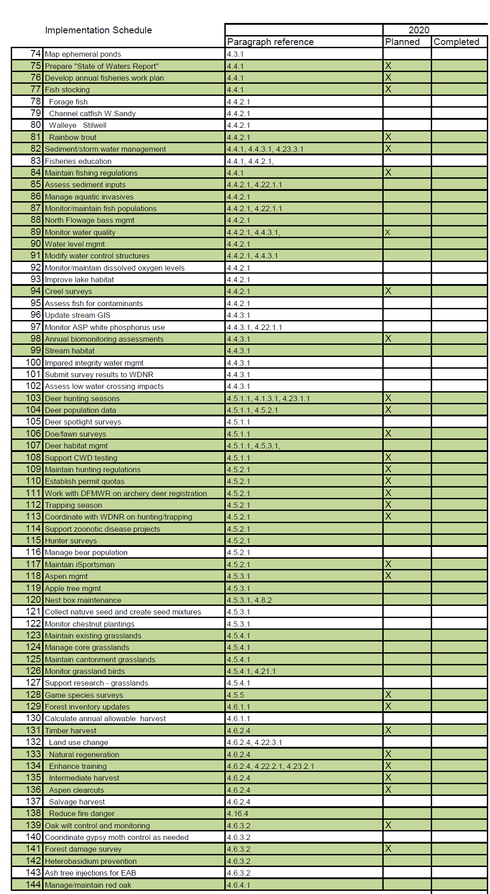

APPENDIX C

Training Restrictions
(Enclosed information and maps are from the 2015 RCMP, for updates refer to Todd, 2016.)
Landscape Conditions/Geographic Context: Overall Fort McCoy encompasses 59,660.5 acres of land. 4,609.4 acres of land are considered nonoperational area. These lands are zoned for most of the consolidated infrastructure, support, and developed administrative, billeting, warehousing, and support buildings, recreation facilities, as well as a family housing area, an ammunition supply point, and the interstate corridor which runs through the south end of Fort McCoy. The remaining 55,051.1 acres of land are considered available for operational training requirements, to include the north impact area ((NIA) 7,773.2 acres)) and the Fort McCoy airfield. Within Fort McCoy, there are various restrictions impacting training in a variety of ways. Some restrictions are dictated by federal and state regulations, such as restrictions associated with jurisdictional wetlands; some restrictions are based on human health and safety, such as areas suspected of buried unexploded ordnance (UXO); some restrictions are based on best management practices to limit impacts of specific types of training/training events, such as a 25 meter buffer restriction around wetlands and waterways applied to all heavy and light vehicle maneuvers; or limiting refueling operations in areas where ground water is near the soil surface; etc. Each encroachment factor can be referenced in Section 2.3 Safety, Environment, and Stewardship Considerations and the enclosed figure - Encroachment Factors and Training Impacts Matrix for Fort McCoy. Fort McCoy has additional acres available for maneuver training via one lease and three permits (See the enclosed figure, Off Post Training Areas). The permitted lands include: 1,447.8 acres of Monroe County land, 1,015.6 acres of Jackson County land, and 67,815.2 acres of Black River State Forest. Though available, these lands are severely restrictive to training. Any maneuver beyond dismounted training is restricted to established roads and designated trails and availability of these is severely restricted to very narrow windows of time. One way we will mitigate these maneuver restrictions is based on our objective to begin discussions with the BRSF Supervisor to remove select maneuver restrictions. The leased property available to Fort McCoy is a 602.6 acre parcel from a private owner, Habelman. This property is relatively free of restrictions, per the lease agreement; however encroachments, such as wetlands, still apply.

On Fort McCoy proper, maneuver space is limited in several ways. North and south post training lands are bisected by STH 21 and the placement of the cantonment area and general infrastructure support facilities. Additionally, Fort McCoy’s NIA exceeds 7,700 acres in size and though crucial for live fire training on the installation the location creates a bottle neck for maneuver along the western edge of north post. South post has several training areas isolated from the remainder of south post, as the installation is bisected by STH 16 and the U.S. Interstate Highway 90. Wetlands and streams have some impact on maneuverability as many of the streams run in an east-west direction. Local best management practices prohibit vehicle maneuvering, tactical encampments, and excavations within 25 meters of wetlands/waterways, except at established crossings. Fort McCoy currently has one low water crossing site on the installation, and future plans call for the construction of several new crossing sites. Topography has some impact on maneuver as there are several large ridge complexes running through the training areas, many of these ridges have very steep sides and narrow ridge tops (See the enclosed figure, The Fort McCoy topography depicted via 2006 shaded relief map). These same features however, are also important to the realism of training and play an important role in land navigation exercises, light infantry maneuvers, etc.

Fort McCoy is found within several unique geographic and biological zones. The region is both unglaciated from the last ice age, as well as falling along the “tension” zone between the prairie- forest and the northern hardwood provinces. This creates unique topography, soils, and diversity of flora and fauna. Most of Fort McCoy’s soils are very coarse sands, allowing for quick permeability of moisture, low nutrients, and often high acidity (pH) levels. These characteristics increase potential for droughty conditions, easy percolation of hazardous materials to groundwater resources, and difficulty in re-establishing vegetation once denuded or removed. These conditions are also favorable for, now rare, plant, and animal communities often referred to, or associated with, oak and pine barrens or savannas and short grass prairies. Barren/savanna communities often have both, forest and prairie species living within them, as well as species independent of each. Being on the tension zone, which runs southeast to northwest across Wisconsin, also means that Fort McCoy shares flora from both the northern and southern plant communities making for a more diverse and unique set of species than is found in the two individual floristic provinces themselves. These two unique features create a culmination of diversity that is very rare, especially given the fact that most areas of similar characteristics have been developed or used for agricultural purposes (Curtis 1959).

Oak wilt (Ceratocystis fagaceareum) is a fungal disease of oak trees which enters a tree through a wound in the bark and spreads to adjacent trees through root grafts. This results in a pocket of dead trees. In some areas, the oak wilt pockets have grown together, causing a significant loss of overhead concealment. Activities such as pruning, timber harvesting, shredding, and firewood cutting are prohibited in oak stands during April through July, when oak wilt can be transmitted to healthy oaks via insect vectors feeding on sap flowing from a break in the bark. Oak wilt can kill red, black and northern pin oak trees within a couple of months of infection. Trees in the white oak family (white, bur) are more resistant to the disease. Fort McCoy has a significantly higher occurrence of oak wilt than surrounding areas because training maneuvers occur during the May-July infection period. Use of tree wound dressing is utilized to help reduce the possible spread of the disease. ITAM distributes tree wound dressing to military units and maintenance shops for activities that are considered high potential for tree damage during the May through July oak wilt season. The dressing does not treat the disease, it only seals off or covers exposure of diseased tissues to reduce transmission of the fungus by insects to new areas (INRMP 2012).

2.3 Safety, Environmental, and Stewardship Considerations

The purpose of this chapter is to document the impacts and constraints various encroachment factors have on training. These impacts and constraints will be used in Chapter 7 when conducting an analysis of alternatives for the siting of both programmed and unprogrammed ranges to be constructed on the installation. In chapter 3 the impacts and constraints will be used to evaluate the installation’s ability to accommodate the maneuver training support requirements. In chapter 6, infrastructure projects required in the range complex will be compared against these impacts and constraints to ensure that the environment is taken into account during the planning and design phase of projects.

As previously stated in Section 2.2: There are 55,051.1 acres of land considered available for operational training requirements, to include the north impact area ((NIA) 7,773.2 acres)) and the Fort McCoy airfield. Within Fort McCoy, there are various restrictions impacting training in a variety of ways. Some restrictions are dictated by federal and state regulations, such as restrictions associated with jurisdictional wetlands; some restrictions are based on human health and safety, such as areas suspected of buried unexploded ordnance (UXO); some restrictions are based on best management practices to limit impacts of specific types of training/training events, such as a 25 meter buffer restriction around wetlands and permanent surface waters applied to all heavy and light vehicle maneuvers; or limiting refueling operations in areas where ground water is near the soil surface; etc. Each encroachment factor is discussed individually here and depicted in the associated enclosures. Restrictions listed/discussed are representative of Fort McCoy proper and do not relate directly to the permitted/leased lands.

ENVIRONMENTAL RESTRICTIONS

Air Quality: Regional air quality within the study area is good. This is primarily due to climatic characteristics conductive to dispersion and an absence of major industry. Fort McCoy is within an "attainment" area, indicating that the concentrations of air contaminants in the atmosphere do not exceed Federal and state ambient air quality standards (INRMP 2012). Fort McCoy does not have any air quality encroachment areas identified within the operational area.

Cultural Resources Sites: The majority of Fort McCoy’s 55,051.1 acres of operational training area have been surveyed for archaeological resources through completion of a Phase I archaeological survey. As a result, 557 archaeological sites on the installation were identified with 394 being considered not eligible for inclusion in the NRHP. Therefore there are 156 sites remaining throughout both operational and non-operational areas on Fort McCoy that are eligible, or have not yet been evaluated, for listing in the NRHP. These sites make up a variety of campsites, workshops, quarries, farmsteads, cemeteries, and burials that show how the land has been occupied and used over the past 12,000 years. These cultural resources sites encompass approximately 550 acres within the Fort McCoy operational land area. These resources will be evaluated for the feasibility of mitigation or protection strategies to then remove the maneuver restriction associated with those selected sites, thereby, increasing maneuver acreage. While there is always the chance for an archaeological site to be inadvertently discovered, it is expected that most of the sites on the installation have been identified. Any newly discovered site within an already surveyed area would be restricted to foot-traffic training until an archaeological evaluation can be completed. Under AR 200-1, in order to protect the integrity of unique and significant archaeological and cultural sites, the following training activities are not allowed on those NRHP-eligible or unevaluated sites: heavy and light vehicle maneuver (dismounted/foot training is allowed); digging; bivouac activities; indirect live fire activities; and activities which require construction or building; other special site request activities must be reviewed prior to approval.

Solid Waste Landfill Area: There are five historical /capped landfills, 53.6 acres, within Fort McCoy operational area that impact training, restricted 365 days a year. All of these locations are prohibited for digging operations, heavy and light mounted maneuvers, indirect live fire, and land conversion/construction projects due to possible health safety issues related to buried material. Additionally, two of these landfills (46.6 acres) are capped and vented systems which have additional prohibition for pyrotechnics and simulator use (due to possibility of release of gases from vents).

Contaminated Soils: There is one location within the Fort McCoy operational area that was used to bury material dredged from Fort McCoy impoundments; the site totals 3.3 acres in size, restricted 365 days a year. Due to possible health safety issues related to buried material this site is generally prohibited from digging, heavy and light mounted maneuver, indirect live fire, and land conversion/construction projects.

Fauna Critical Habitat: Fort McCoy does not have any critical habitat identified as defined in the Endangered Species Act. Fort McCoy does have two federally endangered species using Fort McCoy operational lands, the Karner Blue Butterfly (KBB) and the rusty patched bumble bee, and one federally threatened species, the northern long-eared bat (NLEB). Narratives reviewing the encroachment issues associated with these species have been identified in the next paragraph, “Fauna Federal and State Listed or Species of Concern”.

Fauna Federal and State Listed or Species of Concern:

Karner Blue Butterfly (KBB): The KBB is a federally endangered species found on the installation. Wild lupine is the sole host plant for the KBB larvae. There is currently 3,629.4 acres of wild lupine mapped throughout the operational area. Through consultation with the Fish and Wildlife Service (FWS), Fort McCoy has been given an “incidental take permit” allowance for various activities that may take place on Fort McCoy annually. In conjunction with this “take permit” Fort McCoy maintains an Endangered Species Management Plan (ESMP) for the KBB and works to ensure reasonable and prudent measures are implemented to avoid and minimize harm to the KBB and its habitat during the course of its activities. As part of the ESMP Fort McCoy established nine KBB Core Areas, all military training except for dismounted training was prohibited in these areas, which encompassed a total of 56 acres within Fort McCoy’s operational land area, restricted 365 days a year. As a result of consultation with the FWS, these KBB Core Areas were reopened to general maneuvers in June of 2012. Though not considered critical habitat by FWS definition, wild lupine has an impact on training when considering special site requests and land conversion/construction projects, such as building new ranges. Wild lupine is not considered an encroachment for most other training activities that occur on Fort McCoy. In addition, there are 17 KBB management areas on the installation. The sighting of building construction within KBB management areas will be avoided whenever possible since these sites generally have the highest KBB populations and are the most important areas for Fort McCoy to reach its conservation goals. In general, attempts are made to site construction projects in areas without lupine since these projects permanently remove lupine from the landscape. If impacts to lupine are unavoidable, mitigation actions to off-set the loss of lupine are required.

Rusty Patched Bumble Bee: The RPBB is a federally endangered species that is found on the installation. There have been six confirmed occurrences of RPBB as of February 2021 since they were first documented in 2017 on the installation. Fort McCoy is currently consulting with the USFWS on the impacts of this species from military activities. Once formal consultation has been completed Fort McCoy plans on developing a management plan to set reasonable and prudent measures to follow to reduce the impacts military activity has to the species. Fort McCoy is currently performing annual surveys to determine how widespread the RPBB is on the installation.

Northern Long-Eared Bat (NLEB): The NLEB was added to the list of federally threatened species on May 4, 2015. Fort McCoy submitted four Biological Assessments to the FWS covering activities occurring on the installation (i.e. Smokes and Obscurants, Forest Management and Hazardous Tree Removal, Construction, and Prescribed Burning) and their potential impact to NLEBs. Fort McCoy determined that all activities as described within these assessments would not result in prohibited incidental take as defined within the final 4(d) rule and the accompanying Programmatic Biological Opinion for the NLEB. The FWS concurred with this determination. In order to prevent a disruption to military training activities should the FWS be taken to court on the final 4(d) rule, Fort McCoy has requested the FWS provide a Biological Opinion covering the assessments that were provided to them. When received, Fort McCoy will abide by the Biological Opinion, not the final 4(d) rule. In order to reduce potential impacts to NLEBs, all reasonable attempts will be made to remove trees greater than 3 inches in diameter from September 1 through May 15.

Bald Eagle: There are currently four active bald eagle nests within the Fort McCoy operational area that have the potential to impact training. The bald eagle was removed from the federal threatened list in 2007, but still receives protection under the Bald and Golden Eagle Protection Act and the Migratory Bird Treaty Act. Protection of eagle nest is of primary importance. Generally a buffer zone around an active nest site would prohibit the following activities from March 1 to August 15th (168 days or 46% of the year): a 200 meter buffer for digging, heavy maneuver, indirect live fire, or new construction/land conversion activities which relates to 101.9 acres; 100 meter buffer for light maneuver, dismounted training, pyrotechnic use, indirect live fire/targeting, smoke and obscurant use, aviation overflight, and bivouac/camouflage net use which relates to 27.7 acres. These buffer zones will be maintained, unless it can be determined through consultation with the FWS that the eagles are tolerant of these activities in close proximity to their nesting locations (i.e. a mating pair selects and attends a nest site in close proximity to active events that would normally be prohibited).

Army Species at Risk; Federal Species of Concern & State Listed Species: Species that fall within these categories are currently an impact to training only in circumstances of construction and land conversion projects. Fort McCoy contains three Army species at risk (i.e. Henslow’s sparrow, red-tailed prairie leafhopper, and the regal fritillary butterfly) and numerous federal species of concern (Blanding’s turtle and phlox moth) and state listed species (wood turtle, Bate’s crescent butterfly, western slender glass lizard, frosted elfin, otto skipper (added January 2014), upland sandpiper (added January 2014), cerulean warbler, red shouldered hawk, hooded warbler, big brown bat, little brown bat, northern long-eared bat, and eastern pipistrelle bat) (See the enclosed Encroachment Factors and Training Impact Matrix for Fort McCoy for the number of sighted locations/acreages for each species). In general, there are no restrictions placed on military training activities from Army species at risk, federal species of concern, or state listed species. It is the Army’s policy to manage species at risk proactively in order to prevent Endangered Species Act listings that could severely degrade military readiness. Fort McCoy is committed to the wise stewardship of the natural resources found on the installation, to include rare and sensitive species. Attempts are made to minimize impacts to these species from training activities, construction, and maintenance activities whenever feasible. Impacts to these species from construction projects are considered under the National Environmental Policy Act Review process. If a construction project (i.e. building or range construction) will impact state listed species, the Wisconsin Department of Natural Resources requires alternatives be considered that do not impact these species or, if that is not possible, efforts to minimize impacts to these species are required.

Flora Critical Habitat: Fort McCoy does not have any critical habitat for flora species identified as defined in the Endangered Species Act.

Flora Federal and State Listed or Species of Concern: Army Species at Risk; Federal Species of Concern & State Listed Species: Species that fall within these categories are an impact to training only in circumstances of construction and land conversion projects currently. Fort McCoy contains no flora Army species at risk and numerous federal species of concern (prairie flame flower, bog bluegrass) and state listed species (rough white lettuce, dwarf milkweed, smooth sheathed sedge, prairie parsley, and brittle prickly pear cactus). As of January 2014 evening campion and creamy gentian have been removed from the state listed species and have therefore been eliminated from Fort McCoy list as of 2014 (See the enclosed Encroachment Factors and Training Impact Matrix for Fort McCoy for the number of sighted locations/acreages for each species; and the Fauna and Flora Listed Species Area/Point Restrictions map). In general, there are no restrictions placed on military training activities from Army species at risk, federal species of concern, or state listed species. Fort McCoy is committed to the wise stewardship of the natural resources found on the installation, to include
rare and sensitive species. Attempts are made to minimize impacts to these species from training activities, construction, and maintenance activities whenever feasible. Impacts to these species from construction projects are considered under the National Environmental Policy Act Review process. If a construction project (i.e. building or range construction) will impact state listed species, the Wisconsin Department of Natural Resources requires alternatives be considered that do not impact these species or, if that is not possible, efforts to minimize impacts to these
species are required.

Noise Pollution Areas: Fort McCoy does not currently have noise pollution areas within their operational training lands. Additional information on Noise Management can be found by referencing the Fort McCoy Operational Noise Management Plan (2008, with 2013 addendum).

Wetlands: Two wetland associated encroachment factors on Fort McCoy are: jurisdictional wetlands/permanent surface waters (4634.0 acres) and a 25 meter buffer around all wetlands and permanent surface waters (2691 acres of buffer area; 7325 acres combined), restricted 365 days a year (See the enclosed Encroachment Factors and Training Impact Matrix for Fort McCoy). Data utilized for wetlands relates to the Wisconsin Wetland Inventory as of 2011. Prior to that four GIS wetland data layers were utilized, greatly inflating the wetland acreages and buffer areas. Jurisdictional wetlands and permanent surface waters encompass 4634 acres
within Fort McCoy operational area. Jurisdictional wetlands have significant impact on sighting of ranges/construction projects, requiring special federal and sometimes state permits, as well as in many cases, a need to mitigate impacts. The maps also include all open water lakes, and permanent streams. Based on hydrology, plant, and soil changes over time, as well as methods utilized to interpret/create the boundaries for these wetlands the acreages and areas are an approximate tool. Ground verification per the United States Army Corp of Engineers wetlands survey methods are the only way to truly validate current wetlands boundaries. Even surveys conducted to these standards are only accepted as accurate if they have been conducted within 5 years of a project start date. Best management practices (BMP) at Fort McCoy also prohibit maneuver by wheeled and tracked vehicles within the jurisdictional wetlands and waterways; and within a 25 meter buffer around them. This BMP creates an additional 2691 acres of restrictions (7325 acres combined). This practice is to limit impacts to wetlands and waterways by maneuvering units, but does not limit dismounted training or bivouac operations (without vehicles). The 25 meter buffer also does not have a direct impact on sighting for range or other land conversion construction projects.

Shallow Water Table: Shallow water tables encroach upon 13,706.3 acres of training land and are restricted 365 days a year. This acreage estimate also excludes shallow water tables within the NIA, as vehicle refueling, grey water discharge, etc. will generally not be conducted within the NIA for safety reasons. Areas with a water table within 2.3 feet of the soil surface (6,415.4 acres) are generally prohibited for training associated with refueling operations. Areas with a water table generally within 4.5 feet of the soil surface (13,706.3 acres; 7,290.9 acres additional to 2.3 foot shallow water table area) are generally prohibited from training associated with discharge of water/field latrines that require sumps or similarly excavated discharge/percolation systems. Fort McCoy soils are dominated by very sandy soils that are highly leachable; therefore any spills or discharges that take place within shallow water table areas could potentially contaminate the groundwater resources of Fort McCoy.

Wellhead Protection: Impacts to training associated with wellhead recharge protection zones impact four sites totaling 2,170.3 acres; restricted 365 days a year. High capacity wells which support the Fort McCoy cantonment area, south family housing, and airfield have a restriction of no refueling, grey water, or unit maintenance activities within the five year water recharge area to protect the water resources from potential spills/discharges. Fort McCoy soils are
dominated by very sandy soils that are highly leachable; therefore any spills/discharges that take place within wellhead protection zones could potentially contaminate the groundwater and drinking water resources of Fort McCoy.

Well Buffer Zones: In addition to wellhead recharge restriction areas that supply water to the major infrastructure locations within Fort McCoy’s non-operational areas, there are individual wells located within the operational area that support individual ranges or training sites. Due to similar issues associated with the potential for contamination of these wells from spills/discharges, etc. there is a 100 foot buffer around each such well for no refueling operations or grey water discharge, etc. restricted 365 days a year. There are a total of 40 wells, covering 27.9 acres. It was determined in 2014 that 6 wells previously annotated as water wells were actually gas venting pipes and therefore the number of wells and acreages were reduced slightly from 2013 RCMP.

Military Air Restricted Sites: There are no encroachment factors on military air within the Fort McCoy operational areas, beyond issues covered for the Bald Eagle nesting sites (100 meter buffer 1 March – 15 August); four sites, 27.7 acres.

Natural Areas: Fort McCoy has four natural area sites (three natural areas), totaling 593.5 acres, within the operational area, per agreements with the Wisconsin Department of Natural Resources. Activities prohibited in these areas are heavy or light mounted (vehicle) training, digging, indirect live fire, and construction/land conversion projects, restricted 365 days a year. Fort McCoy is conducting a study of other non-established natural areas to demonstrate that maneuver has little to no impact on designated oak barren areas. Upon conclusion, Fort McCoy will work with Wisconsin DNR to lift remove the State Natural Area designation for the Oak Barren area.

La Crosse River NIA Buffer: The La Crosse River runs directly through the heart of Fort McCoy’s impact (NIA) area. To minimize impacts to this water resource and the biotic communities associated with it, there is a policy of no targeting for indirect fire weaponry or placement of small arms/direct fire weapons targets within 150 meters of the river edges (a
547.0 acre area), restricted 365 days a year.

White Phosphorous No Fire Zone: A no white phosphorous zone impacts 1,889.3 acres within the NIA indirect fire targeting zone, restricted 365 days a year. Due to concerns of white phosphorous residue on migratory waterfowl, the La Crosse River system and other biotic aspects of the river, indirect fire of white phosphorous ordnance has been restricted to four blocks within the NIA. These sites are more upland areas within the targeting zone thereby limiting residue that would directly reach the La Crosse River corridor.

SAFETY RESTRICTIONS

Unexploded Ordnance (UXO): There are three sites, restricted 365 days a year, with an overall area of 1,716.3 acres in size of potential subsurface UXO within Fort McCoy operational areas, to exclude the NIA itself (see NIA Paragraph). These were historical impact areas and an existing firing point. Areas include B19 (1199.5 acres, includes Drop Zone Badger area), B27 (133.3 acres; previously known as ECP1; a historic mortar impact area), Range 6 (134.8 acres), A01 (194.4 acres a historic mortar impact area) and FP418 (54.3 acres). In 2012 and 2013 five segmented areas (48.3 acres) within FP418 have been subsurface cleared to depth, there is an additional 54.3 acres that still need to be cleared/evaluated for UXO. Based on this, these areas are not available for digging (See the enclosed figure for Digging Restrictions), and must have UXO subsurface clearance conducted prior to any building or land conversions to take place. To minimize UXO impacts Fort McCoy will continue to aggressively pursue UXO clearance operations in accordance with DODI
3200.16, AR350-19, and AR385-63.

North Impact Area (NIA): The NIA on Fort McCoy is 7,773.2 acres in size (boundary limit/signed area). It includes the only dudded impact area on Fort McCoy. The NIA is generally off limits to entry for land maneuver/training use, except on maneuverable range footprints that have been surface/subsurface cleared. Beyond this limited training the NIA is off limits for training events such as digging, bivouac, and general entry or force on force maneuvering scenarios, restricted 365 days a year. Areas within the NIA that have been surface and subsurface cleared to depth total 333.8 acres in size an increase of 16.8 acres in 2013. These are associated with specific range footprints for access by troops training on these ranges and for Range Maintenance personnel to conduct maintenance as needed.

Indirect Live Fire Restrictions: There are several factors restricting indirect live fire activities on Fort McCoy (9172.5 acres total), restricted 365 days a year. Previously reported restrictions associated with firing indirect weapons from south post/south of STH 21 will no longer be tallied in the restrictive acres as of 2014. The Fort McCoy dudded impact area overlaps La Crosse River water way. McCoy is near the headwaters of this major river system which leaves Fort McCoy and travels to the Black and Mississippi River Systems. Based on concerns for water quality and the riparian ecosystem, Fort McCoy has in place two restrictions: a La Crosse River NIA Buffer and a White Phosphorous No Fire Zone; see the paragraphs above associated with each of these restrictions for more details. Additionally, as indirect firing systems can often create heavy disturbance in locations they are placed (firing from) these systems may not fire from wetlands/permanent surface waters or within the 25 meter buffer, cultural resources sites, 200 meter eagle nest buffer (restricted 46% of the time; nesting season), natural areas, the solid waste landfill areas, or the contaminated soil site (See the enclosed Encroachment Factor and Training Impact Matrix for Fort McCoy).

FAA Regulation Areas: There are currently no FAA Regulation Areas on Fort McCoy which are considered an encroachment factor on training.

Airfield: The Fort McCoy airfield restrictions (538.2 acres) for general heavy and light mounted maneuver by units, restricted 365 days a year was removed in 2014.

No Smoke Area: Smoke generation for training is not allowed within 100 meters of the installation boundary; and within 200 meters of: south family housing area; non-operational areas associated with the Fort McCoy Airfield, ski hill, campground, the ammunition supply point, the railhead, Interstate Highway 90, and State Highway 21; and anywhere within the cantonment. This entails 5,621.7 acres of encroachment, reduced from 14,533.2 acres in FY 11 by reducing the restriction from 500 meters to 100 meters along the installation boundary, restricted 365 days a year. See the enclosed Encroachment Factors and Training Impact Matrix for Fort McCoy and the figure for Smoke and Obscurant Restrictions) for a further listing of factors impacting the use of smoke.

Underground Utilities: There are underground utilities, sewer/septic systems, waterworks, etc. that run within the Fort McCoy operational area that could be damaged/create safety issues if digging were to occur. Overall there are 410.3 acres prohibiting digging within the operational area due to these resources, restricted 365 days a year. This acreage was figured utilizing the locations of the utilities as well as a 2.5 meter buffer to each side of the buried utility. Most of these areas run parallel to improved roads or are on improved sites such as range footprints, hardened training sites, etc.

Enclosed and associated maps depicted encroachments are as follows:

Fort McCoy Operational/Non-Operational Areas; Heavy Maneuver Restrictions; Light Maneuver Restrictions; Dismounted Training Restrictions; Digging Restrictions; Aviation Restrictions; Smoke and Obscurant Restrictions; Pyrotechnic and Simulator Restrictions; Indirect Live Fire Restrictions; Camouflage Net and Bivouac Restrictions; Water Quality Restrictions; Wetland and Permanent Surface Water w/25 Meter Buffer;. See the enclosed Encroachment Factors and Training Impact Matrix for Fort McCoy for factor encroachments associated with each training type/map listed below.
Fort McCoy Operational/Non-Operational Areas
There are no Off Limit Areas within the Fort McCoy Operational Area that are off limits to all facets of training/testing. The only area that might fall within this definition would be the non- operational area of 4,609.4 acres of land. These lands are zoned for most of the consolidated infrastructure, support, and developed administrative, billeting, warehousing, and support buildings, recreational areas, as well as a family housing area, an ammunition supply point, and the interstate corridor which through the south end of Fort McCoy. Even these areas however are often used for training of soldiers in various ways. The remaining 55,051.1 acres of land are considered available for operational training requirements, to include the NIA and the Fort McCoy airfield.
Heavy Maneuver Restrictions and Light Maneuver Restrictions
Fort McCoy has provided a Heavy Maneuver and Light Maneuver Restrictions Map. Heavy and light maneuver is limited on Fort McCoy by: cultural resources sites; eagle nest buffer (46% of year); wetlands and permanent surface waters with a 25 meter buffer; Fort McCoy NIA (except on UXO cleared range footprints); solid landfill sites; contaminated soil site; and the natural areas. See each encroachment factor paragraph for specific details. Overall Restrictions are 14,721.8 acres/ 27% Heavy and 14,691.5 acres/ 27% Light encroachment.

Dismounted Training Restrictions
Dismounted infantry maneuver training is generally allowed on all Fort McCoy operational areas, except for areas within the NIA, signed boundary, that have not been surface cleared due to hazards associated with UXO. This relates to an encroachment of 7439.3 acres/ 14% of the operational area.

Digging Restrictions
Digging restrictions are restricted due to: cultural resources sites; eagle nest buffer (46% of year); Fort McCoy NIA; UXO areas; solid waste landfill sites; contaminated soil site; natural areas; and underground utilities such as fiber, gas lines, electrical lines, water/sewer lines, etc. See each encroachment factor paragraph for specific detail. Overall encroachment due to these factors is: 10,903.6 acres/ 20% encroachment. For mechanical digging, digging beyond use of individual entrenching tool or shovel, requires a special site request and is also impacted by the wetlands and permanent surface waters with the 25 meter buffer.

Aviation Restrictions
Restrictions to aviation within the operational area of Fort McCoy are limited to eagle nest sites. There were three eagle nest locations in 2013; there are four in 2014. See each the encroachment factor paragraph for specific details. Overall encroachment due to this factor is: 27.7 acres, less than 1% encroachment on the operational area.

Smoke and Obscurant Restrictions
Restriction associated with the use/generation of smoke/obscurant is the No Smoke Use 100 and 200 meter buffer areas and the eagle nest buffer (100 meter). See each encroachment factor paragraph for specific details. Overall encroachment due to these factors is: 541.9 acres/ 10% encroachment acres.

Pyrotechnic and Simulator Restrictions
Restrictions to the use of pyrotechnics and simulators within the operational area are: eagle nest buffer location; and two of the five solid waste landfill sites. See each encroachment factor paragraph for specific details. Overall encroachment due to these factors is: 74.4 acres/ less than 1% encroachment.

Indirect Live Fire Restrictions
There are no restrictions for live or blank firing on Fort McCoy within the operational areas as defined, however Fort McCoy has provided an “Indirect Live Fire” restrictions map as there are some areas that have restrictions associated with the ability to fire artillery and other indirect firing systems. Restrictions are: eagle nest locations (200 meter buffer); cultural resource sites; wetlands and permanent surface waters with a 25 meter buffer (excluding those within the NIA not already restricted by the LaCrosse River Corridor buffer and the no white phosphorous fire zone area); natural areas; solid waste landfills; contaminated soils site; the La Crosse River corridor buffer; and the white phosphorous no fire zone. In 2013 all of south post south (Indirect Live Fire Restrictions) of State Hwy 21 (to include the airfield) were included in the indirect live fire restriction calculations (29,747.7 acres), but those restrictions were removed for the 2014 calculations. See each encroachment factor paragraph for specific details. Overall encroachment due to these factors is: 9,172.5 acres/17% encroachment.

Camouflage Net and Bivouac Restrictions
Restrictions impacting camouflage use, bivouac, or fixed locations are: cultural resources sites; eagle nest buffers (100 meter); NIA; two of the five solid waste landfill sites; and the contaminated soils site. See each encroachment factor paragraph for specific details. Overall encroachment due to these factors is: 8,322.5 acres/ 15% encroachment.

Water Quality Restrictions
This narrative does not directly discuss those issues already addressed under wetlands or indirect fire restrictions. Beyond jurisdictional wetlands, a 25 meter buffer around all wetlands and permanent surface waters, a no indirect fire targeting zone along the La Crosse River, and restriction zones for white phosphorous ordnance there are three major restrictions to protect groundwater resources. There are four wellhead (5 year, including the 90 day recharge area) recharge areas, 40 other wells within the training areas, and two shallow water table zones utilized to restrict refueling, maintenance operations, grey water discharge and similar activities. The shallow water tables within the NIA are excluded from these calculations as refueling, grey water operations, etc. are not likely to take place within the NIA. Overall encroachment due to these factors is: 18,293.7 acres/ 33%.

Wetland and Permanent Surface Waters
As a point of reference, a map showing the wetlands and waterways with a 25 meter buffer has been included in this chapter. This map is not a “Restriction to…” map, but simply added to show the overall area impacted by this factor. Acreage is 7,325 total (13% encroachment); the buffer accounts for 2691 (5% encroachment) acres of this area.

Fauna and Flora Listed Species Area/Point Restrictions
Due to the sensitive issue related to listed/rare flora and fauna species locations, all species been lumped into one map without reference to their individual identities. For details the acreages or number of occurrences of each species of impact on Fort McCoy, refer to the enclosed Encroachment Factors and Training Impact Matrix for Fort McCoy and each encroachment factor paragraph for specific details. Overall encroachment due to these factors is: 4,087.6 acres and 827 points (no acreage associated) identifying locations of observed species. This includes the mapped lupine locations within the operational area. Internal analysis at Fort McCoy through consultation with the Fort McCoy Endangered Species Biologist is conducted for each and every species as required for various projects. Species not federally listed do not impact general training events; they are more of an impact on land construction/conversion projects.

Maneuver Restrictions on Fort McCoy
This map depicts direct restrictions to some forms of training on one map. Overall acreage of encroachments to maneuver training is 31077.7 acres or 56% of the operational area. These areas are not generally off-limits to training, but have one or more constraints on what type of training can be conducted. The majority of restrictions are due to wetlands, waterways, high water table, NIA, and UXO areas that have been discussed previously and depicted in the wetlands, waterways, and digging restriction maps. This map helps soldiers training at Fort McCoy determine potential conflicts with training while in the field or as they are planning scenarios and operational area boundaries. This map should not be used for determining or planning new construction, range development, and or conversion of training acres into buildings, parking lots, etc. as other Flora and Fauna impacts may be significant and are not detailed in this map.

APPENDIX D

 |  |  | PORTION | BROOK | BROWN | RAINBOW |  |  |  |  |  |  | PUBLIC LANDS
STREAM |  |  | TROUT | BROOK | BROWN | RAINBOW | CLASS I |  | CLASS II |  | CLASS III |  | PUBLIC LANDS
NAME |  |  | WATERS | BROOK | BROWN | RAINBOW | PORTION | MI. | PORTION | MI. | PORTION | MI. | PUBLIC LANDS
 | Clear Cr (S Br Robinson Cr) |  | All  (Ft. McCoy) | n |  |  | W line S7, T19N, R2W, upstream | 2.0 |  |  | Jct of Ranch Cr downstream | 1.0 | x
 | Farmers Valley Cr |  | All | n | n |  | Interstate 90 upstream | 10.4 | Interstate 90 downstream | 1.0 |  |  | x | Mileage extends beyond Fort McCoy boundary
 | La Crosse R |  | All Perch L upstream (Ft. McCoy) | n | n | x | Trout Falls upstream | 12.7 | Between Perch L and Trout Falls | 7.7 |  |  | x | Mileage extends beyond Fort McCoy boundary
 | Ranch Cr |  | All  (Ft. McCoy) | x |  |  |  |  |  | 2.3 |  |  | x
 | Showen Cr |  | All | x |  |  |  |  |  | 0.7
 | Silver Cr |  | All  (Ft. McCoy) | n | n | x |  | 10.4 |  |  |  |  | x
 | Sparta Cr |  | All  (Ft. McCoy) | n | n | x |  | 1.7 |  |  |  |  | x
 | Suukjak Sep Cr |  | All  (Ft. McCoy) | n | x | x | Suukjak Sep L upstream | 5.6 |  |  | Suukjak Sep L downstream | 0.2 | x
 | Stillwell Cr |  | All  (Ft. McCoy) | x | x |  |  |  | Cranberry impoundment upstream | 1.9 | Cranberry impoundment downstream | 2.8 | x
 | Swamp Cr |  | All  (Ft. McCoy) | n |  |  |  |  |  | 1.9 |  |  | x
 | Tarr Cr |  | All  (Ft. McCoy) | n | n |  |  | 7.1 |  |  |  |  | x
UNNAMED STREAMS
 |  | Creek 15-13 | T17N, R3W CTH AA downstream (Ft. McCoy) | x |  |  |  |  |  |  |  | 1.5 | x
 |  | Creek 24-5 (Coles Valley Cr) | All T17N, R3W | n |  |  |  | 5.3 |  |  |  |  | x | Mileage extends beyond Fort McCoy boundary
 |  | Creek 20-11 | All T18N, R2W  (Ft. McCoy) |  | x |  |  | 1.1 |  |  |  |  | x
 |  | Creek 29-8 | All T18N, R2W  (Ft. McCoy) | n |  |  |  | 0.8 |  |  |  |  | x
 |  | Creek 12-4 | All T18N, R3W  (Ft. McCoy) | x |  |  |  |  |  | 0.4 |  |  | x
 |  | Creek 23-12 | All T18N, R3W  (Ft. McCoy) | n |  |  |  | 1.2 |  |  |  |  | x
 |  | Creek 23-11 | All T18N, R3W  (Ft. McCoy) | n |  |  |  | 3.1 |  |  |  |  | x
 |  | Creek 34-5 | All T18N, R3W  (Ft. McCoy) |  | x |  |  |  |  | 0.8 |  |  | x
 |  | Creek 29-11 | All T19N, R2W  (Ft. McCoy) | n |  |  |  | 2.1 |  |  |  |  | x
 |  | Creek 29-12 | All T19N, R2W  (Ft. McCoy) | n |  |  |  | 0.6 |  |  |  |  | x
 |  | Creek 29-15 | All T19N, R2W  (Ft. McCoy) | n |  |  |  | 0.7 |  |  |  |  | x
 |  | Stream | Totals |  |  |  | Class I | 64.8 | Class II | 16.7 | Class III | 5.5

Fort McCoy Streams

Fort McCoy Lakes

Dams on Fort McCoy. Rated by priority of servicing.

APPENDIX E

Appendix E, Table 1. Fish Species Documented on Fort McCoy.1

Family Species Name Common Name

Catostomidae
Catostomus commersoni White sucker
Centrarchidae
Lepomis cyanellus Green sunfish
Lepomis gibbosus Pumpkinseed
Lepomis gulosus Warmouth
Lepomis macrochirus Bluegill
Micropterus salmoides Largemouth bass
Pomoxis nigromaculatus Black crappie
Cottidae
Cottus bairdi Mottled sculpin
Cyprinidae
Notemigonus crysoleucas Golden shiner
Pimephales notatus Bluntnose minnow
Pimephales promelas Fathead minnow
Rhinichthys atratulus Blacknose dace
Semotilus atromaculatus Creek chub
Esocidae
Esox lucius Northern pike
Esox americanus vermiculatus Grass pickerel
Gasterosteidae
Culaea inconstans Brook stickleback
Ictaluridae
Ameiurus melas Black bullhead
Ameiurus natalis Yellow bullhead
Ameiurus nebulosus Brown bullhead
Icatlurus punctatus Channel catfish
Percidae
Etheostoma exile Iowa darter
Etheostoma nigrum Johnny darter
Perca flaverscens Yellow perch
Percina maculata Blackside darter
Sander vitreus Walleye
Petromyzontidae
Lampetra appendix American brook lamprey
Salmonidae
Oncorhynchus mykiss Rainbow trout
Salmo trutta Brown trout
Savelinus fontinalis Brook trout
Umbridae
Umbra limi Central mudminnow
______________________________________________________________________________________

1Family, common and scientific names were cited from the following publication:
Becker, George C. 1983. Fishes of Wisconsin. 1052 pp. Changes in scientific names are noted as found from the American Fisheries Society 1991 list.

Appendix E, Table 2. Amphibians and Reptiles Documented on Fort McCoy.1 Other species listed could occur on Fort McCoy.2

Family Species Name Common Name

Ambystomatidae
Ambystoma laterale Blue-spotted Salamander
Anguidue
Ophisaurus attenuatus attenuatus Western Slender Glass Lizard
Bufonidae
Bufo americanus americanus American Toad
Chelydridae
Chelydra serpentina serpentina Common Snapping Turtle
Colubridae
Coluber constrictor foxi Blue racer
Diadophis punctatus edwardsi Northern Ringneck Snake
Elaphe vulpina vulpina Western Fox Snake
Heterodon platyrhinos Eastern Hognose Snake
Lampropeltis triangulum triangulum Eastern Milk Snake
Nerodia sipedon sipedon Northern Water Snake
Opheodrys vernalis blanchardi Western Smooth Green Snake
Pituophis melanoleucus sayi Bullsnake
Storeria dekayi wrightorum Midland Brown Snake
Storeria occipitomaculata occipitomaculata Northern Red-bellied Snake
Thamnophis radix radix Eastern Plains Garter Snake2
Thamnophis sirtalis sirtalis Eastern Garter Snake
Emydidae
Emydoidea blandingi Blanding's Turtle
Chrysemys picta belli Western Painted Turtle
Chrysemys picta marginata Midland Painted Turtle
Clemmys insculpta Wood Turtle
Graptemys spp. Map Turtles2
Hylidae
Acris crepitans blanchardi Blanchards Cricket Frog
Hyla chrysoscelis Cope's Gray Tree Frog
Hyla crucifer crucifer Northern Spring Peeper
Hyla versicolor Eastern Gray Tree Frog
Pseudacris triseriata triseriata Western Chorus Frog
Kinosternidae
Sternotherus odoratus Stinkpot2
Plethodintidae
Hemidactylium scutatum Four-toed Salamander
Plethodon cinereus cinereus Red-backed Salamander
Ranidae
Rana clamitans melanota Green Frog
Rana palustris Pickerel Frog
Rana pipiens Leopard Frog
Rana sylvatica Wood Frog
Salamandridae
Notophthalmus viridescens louisianensis Central Newt2
Scincidae
Eumeces fasciatus Five-lined Skink
Teiidae
Cnemidophorus sexlineatus Six-lined Racerunner
Trionychidae
Trionyx spiniferus spiniferus Eastern Spiny Softshell Turtle2
Family Species Name Common Name

Viperidae
Crotalus horridus Timber Rattlesnake2
Sistrurus catenatus catenatus Eastern Massasauga2,3

_____________________________________________________________________________________

1Family names were cited from Conant (1958); common and scientific names were cited from Vogt (1981):
Conant, R. 1958. A field guide to reptiles and amphibians of eastern and central North American.
2nd. ed., Houghton Mifflin Co., Boston, Mass. 429 pp.
Vogt, R.C. 1981. Natural history of amphibians and reptiles in Wisconsin. Milwaukee Public
Museum, Milw., WI. 205 pp.

2Amphibian and reptile species that have not been documented on Fort McCoy as of April, 1992 are also listed; however, they reasonably could be expected to occur within the area because of certain habitat types found on the fort (personal communication, Daniel Nedrelo, Route 3, Viroqua, Wisconsin 54665).

3Species have been observed within 12 miles of Fort McCoy.
Appendix E, Table 3. Mammals Documented on Fort McCoy.1

Family
Sp.Code Species Name Common Name

Canidae (Dogs and Allies)
CALU Canis lupus Gray Wolf
CALA2 Canis latrans Coyote
Canis latrans x Canis familiaris Coyote-dog Hybrid (Coydog)
URCI Urocyon cinereoargenteus Gray Fox
VUVU Vulpes vulpes Red Fox
Castoridae (Beavers)
CACA8 Castor canadensis Beaver
Cervidae (Deer and Allies)
ODVI Odocoileus virginianus White-tailed Deer
Didelphidae (Oppossums)
DIVI Didelphis virginiana Opossum
Dipodidae (Jumping Mice)
ZAHU Zapus hudsonius Meadow Jumping Mouse
Erethizontidae (Porcupines)
ERDO Erethizon dorsatum Porcupine
Felidae (Cats and Allies)
LYRU Lynx rufus Bobcat
FESI Felis sylvestris House Cat
Geomyidae (Pocket Gophers)
GEBU Geomys bursarius Pocket Gopher
Leporidae (Hares and Rabbits)
LEAM Lepus americanus Snowshoe Hare
SYFL Sylvilagus floridanus Eastern Cottontail
Muridae (Old World Rats and Mice)
CLGA Clethrionomys gapperi Red-backed Vole
MIOC Microtus ochrogaster Prairie Vole
MIPE Microtus pennsylvanicus Meadow Vole
MUMU Mus musculus House Mouse
ONZI Ondatra zibethicus Muskrat
PELE1 Peromyscus leucopus White-footed Mouse
PEMA1 Peromyscus maniculatus bairdii Praire Deer Mouse
RANO Rattus norvegicus Norway Rat
REMO Reithrodontomys montanus Plains Harvest Mouse
SYCO Synaptomys cooperi Southern bog lemming
Mustelidae (Weasels and Allies)
LUCA1 Lutra canadensis Otter
MAPE Martes pennanti Fisher
MEME1 Mephitis mephitis Striped Skunk
MUER Mustela erminea Short-tailed Weasel
MUFR Mustela frenata Long-tailed Weasel
MUNI1 Mustela nivalis Least Weasel
MUVI Mustela vison Mink
TATA Taxidea taxus Badger
Procyonidae (Raccoons)
PRLO Procyon lotor Raccoon
Sciuridae (Squirrels)
GLSA Glaucomys sabrinus Northern Flying Squirrel
GLVO Glaucomys volans Southern Flying Squirrel
MAMO Marmota monax Woodchuck
SCNI Sciurus niger Fox Squirrel
SCCA Sciurus carolinensis Gray Squirrel

Family
Sp.Code Species Name Common Name
Sciuridae (Squirrels) - Continued

SPTR Spermophilus tridecemlineatus Thirteen-lined Ground Squirrel
TAST Tamias striatus Eastern Chipmunk
TAMI Tamias minimus Least Chipmunk
TAHU Tamiasciurus hudsonicus Red Squirrel
Soricidae (Shrews)
BLBR Blarina brevicauda Short-tailed Shrew
SOCI Sorex cinereus Cinerius Shrew
SOHO Sorex hoyi Pygmy Shrew
Talpidae (Moles)
COCR Condylura cristata Star-nosed Mole
SCAQ Scalopus aquaticus Eastern Garden Mole
Ursidae (Bears)
URAM Ursus americanus Black Bear
Vespertilionidae (Common Bats)
EPFU Eptesicus fuscus Big Brown Bat
LABO Lasiurus borealis Red Bat
LACI Lasiurus cinereus Hoary Bat
MYLU1 Myotis lucifugus Little Brown Bat
Myotis septentrionalis Northern Long-eared Bat
Perimyotis subflavus Eastern Pipistrelle
Lasionycteris noctivagans Silver-haired Bat
_____________________________________________________________________________________

1Family, common and scientific names were cited from:

Jackson, H.H.T. 1961. Mammals of Wisconsin. Univ. of Wisconsin Press. 504 pp.
Appendix E, Table 4. Birds Documented to Occur on or Near Fort McCoy.1

Family
Sp.Code Scientific Name Common Name Statusbcde
Gaviidae (Loons)
GAIM Gavia immer Common Loon B
Podicipedidae (Grebes)
POAU Podiceps auritus Horned Grebe M1
POGR Podiceps grisegena Red-necked Grebe
POPO Podilymbus podiceps Pied-billed Grebe B
Phalacrocoradidae (Cormorants)
PHAU Phalacrocorax aurtitus Double-crested Cormorant M
Ardeidae (Bitterns, Herons and Egrets)
ARHE Ardea herodias Great Blue Heron B
BOLE Botaurus lentiginosus American Bittern V3
BUIB Bubulcus ibis Cattle Egret M3
BUST Butorides striatus Green-backed Heron B
CAAL2 Casmerodius albus Common Great Egret V2
EGCA Egretta caerulea Little Blue Heron V1 3
IXEX Ixobrychus exilis Least Bittern B1
NYNY Nycticorax nycticorax Black-crowned Night-Heron B2
NYVI Nycticorax violaceus Yellow-crowned Night-Heron
Gruidae (Cranes)
GRCA1 Grus canadensis Sandhill Crane B
Anatidae (Swans, Geese and Ducks)
AISP Aix sponsa Wood Duck B
ANAC Anas acuta Northern Pintail M
ANAM Anas americana American Wigeon M
ANCL Anas clypeata Northern Shoveler M
ANCR Anas crecca Green-winged Teal M
ANCY Anas cyanoptera Cinnamon Teal
ANDI Anas discors Blue-winged Teal B
ANPL Anas platyrhynchos Mallard B
ANRU Anas rubripes American Black Duck M
ANST Anas strepera Gadwall M
ANAL Anser albifrons Greater White-fronted Goose M1 3
AYAF Aythya affinis Lesser Scaup M
AYAM Aythya americana Redhead M
AYCO Aythya collaris Ring-necked Duck M B1
AYMA Aythya marila Greater Scaup M
AYVA Aythya valisineria Canvasback M
BRCA1 Branta canadensis Canada Goose B1
BUAL Bucephala albeola Bufflehead M
BUCL Bucephala clangula Common Goldeneye M
CHCA Chen caerulescens Snow Goose M
CYBU Cygnus buccinator Trumpeter Swan M1 3
CYCO1 Cygnus columbianus Tundra Swan M
CYOL Cygnus olor Mute Swan M1 3
LOCU1 Lophodytes culcullatus Hooded Merganser B
MEME2 Mergus merganser Common Merganser M
MESE Mergus serrator Red-breasted Merganser M
OXJA Oxyura jamaicensis Ruddy Duck M
Rallidae (Rails)
CONO Coturnicops noveboracensis Yellow Rail
FUAM Fulica americana American Coot M
GACH Gallinula chloropus Common Moorhen M1 3
POCA1 Porzana carolina Sora B
Family
Sp.Code Scientific Name Common Name Statusbcde
RAEL Rallus elegans King Rail M1 3
RALI Rallus limicola Virginia Rail M1
Recurvirostridae (Stilts)
REAM Recurvirostra americana Avocet M1 2
Charadriidae (Plovers)
CHSE Charadrius semipalmatus Semipalmated Plover M
CHVO Charadrius vociferus Killdeer B
PLDO1 Pluvialis dominica Lesser Golden-Plover M1
PLSQ Pluvialis squatarola Black-bellied Plover M
Scolopacidae (Shorebirds)
ACMA Actitis macularia Spotted Sandpiper B
ARIN Arenaria interpres Ruddy Turnstone M1 2
BALO Bartramia longicauda Upland Sandpiper B
CAAL Calidris alba Sanderling M1
CAPU Calidris pusilla Semipalmated Sandpiper M
CAMA1 Calidris mauri Western Sandpiper M1 2
CAMI1 Calidris minutilla Least Sandpiper M
CAFU Calidris fuscicollis White-rumped Sandpiper M1
CABA Calidris bairdii Baird's Sandpiper M
CAME1 Calidris melanotos Pectoral Sandpiper M
CAAL1 Calidris alpina Dunlin M1
CAHI Calidris himantopus Stilt Sandpiper M1
CASE Catoptrophorus semipalmatus Willet M1 3
GAGA Gallinago gallinago Common Snipe B
LIGR Limnodromus griseus Short-billed Dowitcher M
LISC Limnodromus scolopaccus Long-billed Dowitcher M1
LIFE Limosa fedoa Marbled Godwit M1 2
LIHA Limosa haemastica Hudsonian Godwit M1
NUPH Numenius phaeopus Whimbrel
PHLO Phalaropus lobatus Red-necked Phalarope
PHTR Phalaropus tricolor Wilson's Phalarope M1 2
SCMI Scolopax minor American Woodcock B
TRFL Tringa flavipes Lesser Yellowlegs M
TRME Tringa melanoleuca Greater Yellowlegs M
TRSO Tringa solitaria Solitary Sandpiper M
Laridae (Gulls and Terns)
CHNI Chlidonias niger Black Tern M V
LAAR Larus argentatus Herring Gull M V
LADE Larus delawarensis Ring-billed Gull M V
LAPH Larus philadelphia Bonaparte's Gull M V
LAPI Larus pipixcan Franklin's Gull M1 3
STCA1 Sterna caspia Caspian Tern M V
STFO Sterna forsteri Forester's Tern M V
STHI Sterna hirundo Common Tern M V
Cathartidae (Vultures)
CAAU Cathartes aura Turkey Vulture B
Accipitridae (Hawks and Eagles)
ACCO Accipiter cooperii Cooper's Hawk B
ACGE Accipiter gentilis Northern Goshawk B3
ACST Accipiter striatus Sharp-shinned Hawk M
AQCH Aquila chrysaetos Golden Eagle M
BUJA Buteo jamaicensis Red-tailed Hawk B
BULA Buteo lagopus Rough-legged Hawk M
BULI Buteo lineatus Red-shouldered Hawk B
BUPL Buteo platypterus Broad-winged Hawk B
CICY Circus cyaneus Northern Harrier B
Family
Sp.Code Scientific Name Common Name Statusbcde
HALE Haliaeetus leucocephalus Bald Eagle B
Pandiondae (Osprey)
PAHA Pandion haliaetus Osprey B
Falconidae (Falcons)
FACO Falco columbarius Merlin M2
FAPE Falco peregrinus Peregrine Falcon M
FARU Falco rusticolus Gyrfalcon M1 3
FASP Falco sparverius American Kestrel B
Phasianidae (Pheasants, Grouse and Turkeys)
BOUM Bonasa umbellus Ruffed Grouse B
COVI Colinus virginianus Northern Bobwhite B
MEGA Meleagris gallopavo Wild Turkey B
PEPE Perdix perdix Gray Partridge B1
PHCO Phasianus colchicus Ring-necked Pheasant B2
Columbidae (Pigeons and Doves)
COLI Columba livia Rock Dove B
ZEMZ Zenaida macroura Mourning Dove B
Cuculidae (Cuckoos)
COAM Coccyzus americanus Yellow-billed Cuckoo B
COER Coccyzus erythropthalmus Black-billed Cuckoo B
Strigidae (Owls)
AEAC Aegolius acadicus Northern Saw-whet Owl B2
ASFL Asio flammeus Short-eared Owl V2
ASOT Asio otus Long-eared Owl V3
BUVI Bubo virginianus Great Horned Owl B
NYSC Nyctea scandiaca Snowy Owl M3
OTAS Otus asio Eastern Screech-Owl B
STVA Strix varia Barred Owl B
Tytonidae (Owls)
TYAL Tyto alba Common Barn Owl
Caprimulgidae (Nightjars)
CAVO Caprimulgus vociferus Whip-poor-will B
CHMI Chordeiles minor Common Nighthawk B
Apodidae (Swifts)
CHPE Chaetura pelagica Chimney Swift B
Trochilidae (Hummingbirds)
ARCO Archilochus colubris Ruby-throated Hummingbird B
Alcedinidae (Kingfishers)
CEAL Ceryle alcyon Belted Kingfisher B
Picidae (Woodpeckers)
COAU Colaptes auratus Northern Flicker B
DRPI Dryocopus pileatus Pileated Woodpecker B
MECA Melanerpes carolinus Red-bellied Woodpecker B
MEER Melanerpes erythrocephalus Red-headed Woodpecker B
PIPU Picoides pubescens Downy Woodpecker B
PIVI Picoides villosus Hairy Woodpecker B
SPVA1 Sphyrapicus varius Yellow-bellied Sapsucker M

Tyrannidae (Flycatchers)
COBO Contopus borealis Olive-sided Flycatcher M
COVI1 Contopus virens Eastern Wood-Pewee B
EMAL Empidonax alnorum Alder Flycatcher M1
EMFL Empidonax flaviventris Yellow-bellied Flycatcher M
EMMI1 Empidonax minimus Least Flycatcher B
ENTR Empidonax traillii Willow Flycatcher B
ENVI Empidonax virescens Acadian Flycatcher M1
MYCR Myiarchus crinitus Great Crested Flycatcher B
Family
Sp.Code Scientific Name Common Name Statusbcde
SAPH Sayornis phoebe Eastern Phoebe B
TYTY Tyrannus tyrannus Eastern Kingbird B
TYVE Tyrannus verticalis Western Kingbird
Alaudidae (Larks)
ERAL Eremophila alpestris Horned Lark B
Hirundinidae (Swallows)
HIPY Hirundo pyrrhonota Cliff Swallow B
HIRU Hirundo rustica Barn Swallow B
PRSU Progne subis Purple Martin B
Hirundinidae (Continued)
RIRI Riparia riparia Bank Swallow B
STSE Stelgidopteryx serripennis Northern Rough-winged Swallow B
TABI Tachycineta bicolor Tree Swallow B
Corvidae (Jays, Crows and Ravens)
COBR1 Corvus brachyrhynchos American Crow B
COCO2 Corvus corax Common Raven B1
CYCR Cyanocitta cristata Blue Jay B
Paridae (Tits)
PAAT Parus atricapillus Black-capped Chickadee B
PABI Parus bicolor Tufted Titmouse M3
Certhiidae (Creepers)
CEAM Certhia americana Brown Creeper M
Sittidae (Nuthatches)
SICA1 Sitta canadensis Red-breasted Nuthatch M2
SICA2 Sitta carolinensis White-breasted Nuthatch B
Troglodytidae (Wrens)
CIPA Cistothorus palustris Marsh Wren M1 B1
CIPL Cistothorus platensis Sedge Wren M1
THBE Thryomanes bewickii Bewick's Wren
THLU Thryothorus ludovicianus Carolina Wren
TRAE Troglodytes aedon House Wren B
TRTR Troglodytes troglodytes Winter Wren M
Muscicapidae (Kinglets, Gnatcatchers and Thrushes)
CAFU2 Catharus fuscescens Veery B
CAGU Catharus guttatus Hermit Thrush M
CAMI2 Catharus minimus Gray-cheeked Thrush M
CAUS Catharus ustulatus Swainson's Thrush M
HYMI Hylocichla mustelina Wood Thrush B
IXNA Ixoreus naevius Varied Thrush M3
POCA Poloptila caerulea Blue-gray Gnatcatcher B
RECA Regulus calendula Ruby-crowned Kinglet M
RESA Regulus satrapa Golden-crowned Kinglet M
SISI Sialia sialis Eastern Bluebird B
TUMI Turdus migratorius American Robin B
Laniidae (Shrikes)
LAEX Lanius excubitor Northern Shrike M
LALU Lanius ludovicianus Loggerhead Shrike M2
Mimidae (Mimics)
DUCA Dumetella carolinensis Gray Catbird B
MIPO Mimus polyglottos Northern Mockingbird
TORU Toxostoma rufum Brown Thrasher B
Motacillidae (Pipits)
ANSP Anthus spinoletta Water Pipit M1
Bombycillidae (Waxwings)
BOCE Bombycilla cedrorum Cedar Waxwing B
BOGA Bombycilla garrulus Bohemian Waxwing M1

Family
Sp.Code Scientific Name Common Name Statusbcde
Sturnidae (Starling)
STVU Sturnus vulgaris European Starling B
Vireonidae (Vireos)
VIBE Vireo bellii Bell's Vireo V
VIFL Vireo flavifrons Yellow-throated Vireo B
VIGI Vireo gilvus Warbling Vireo B
VIGR Vireo griseus White-eyed Vireo
VIOL Vireo oliviceus Red-eyed Vireo B
VIPH Vireo philadelphicus Philadelphia Vireo M
VISO Vireo solitarius Solitary Vireo M
Emberizidae (Warblers, Sparrows, Blackbirds, etc.)
AGPH Agelaius phoeniceus Red-winged Blackbird B
AMCA1 Ammodramus caudacutus Sharp-tailed Sparrow
AMHE Ammodramus henslowii Henslow's Sparrow V1
AMLE Ammodramus leconteii Le Conte's Sparrow M1
AMSA Ammodramus savannarum Grasshopper Sparrow B
CALA Calcarius lapponicus Lapland Longspur M
CACA4 Cardinalis cardinalis Northern Cardinal B
CHGR Chondestes grammacus Lark Sparrow B
DECA1 Dendroica caerulescens Black-throated Blue Warbler
DECA2 Dendroica castanea Bay-breasted Warbler M
DECE Dendroica cerulea Cerulean Warbler B1
DECO Dendroica coronata Yellow-rumped Warbler B
DEDI Dendroica discolor Prairie Warbler
DEFU Dendroica fusca Blackburnian Warbler M
DEKI Dendroica kirtlandii Kirtland's Warbler
DEMA Dendroica magnolia Magnolia Warbler M
DEPA Dendroica palmarum Palm Warbler M
DEPE Dendroica pensylvanica Chestnut-sided Warbler B
DEPE1 Dendroica petechia Yellow Warbler B
DEPI Dendroica pinus Pine Warbler M
DEST Dendroica striata Blackpoll Warbler M
DETI Dendroica tigrina Cape May Warbler M
DEVI Dendroica virens Black-throated Green Warbler M
DOOR Dolichonyx oryzivorus Bobolink B
EUCA1 Euphagus carolinus Rusty Blackbird M
EUCY Euphagus cyanocephalus Brewer's Blackbird B
GETR Geothlypis trichas Common Yellowthroat B
HEVE Helmitheros vermivorus Worm-eating Warbler
ICVI Icteria virens Yellow-breasted Chat V3
ICGA Icterus galbula Northern Oriole B
ICSP Icterus spurius Orchard Oriole M2
JUHY Junco hyemalis Dark-eyed Junco M
MEME Melospiza melodia Song Sparrow B
MELI Melospiza lincolnii Lincoln's Sparrow M
MEGE Melospiza georgiana Swamp Sparrow B
MNVA Mniotilta varia Black-and-white Warbler B
MOAT Molothrus ater Brown-headed Cowbird B
OPAG Oporornis agilis Connecticut Warbler M
OPFO Oporornis formosus Kentucky Warbler M1
OPPH Oporornis philadelphia Mourning Warbler B
PAAM Parula americana Northern Parula M1
PASA Passerculus sandwichensis Savannah Sparrow B
PAIL Passerella iliaca Fox Sparrow M
PACY Passerina cyanea Indigo Bunting B

Family
Sp.Code Scientific Name Common Name Statusbcde
Emberizidae (Continued)
PHLU Pheucticus ludovicianus Rose-breasted Grosbeak B
PIER Pipilo erythrophthalmus Rufous-sided Towhee B
PIOL Piranga olivacea Scarlet Tanager B
PLNI Plectrophenax nivalis Snow Bunting M
POGR1 Pooecetes gramineus Vesper Sparrow B
PRCI Protonotaria citrea Prothonotary Warbler M1
QUQU Quiscalus quiscula Common Grackle B
SEAU Seiurus aurocapillus Ovenbird B
SEMO Seiurus motacilla Louisiana Waterthrush
SENO Seiurus noveboracensis Northern Waterthrush M
SERU1 Setophaga ruticilla American Redstart B
SPAM Spiza americana Dickcissel B1
SPAR2 Spizella arborea American Tree Sparrow M
SPPA1 Spizella pallida Clay-colored Sparrow B
SPPA2 Spizella passerina Chipping Sparrow B
SPPU1 Spizella pusilla Field Sparrow B
STMA2 Sturnella magna Eastern Meadowlark B
STNE1 Sturnella neglecta Western Meadowlark B
VECE Vermivora celata Orange-crowned Warbler M
VECH Vermivora chrysoptera Golden-winged Warbler B
VEPE Vermivora peregrina Tennessee Warbler M
VEPI Vermivora pinus Blue-winged Warbler B
VERU Vermivora ruficapilla Nashville Warbler B
WICA Wilsonia canadensis Canada Warbler M
WICI Wilsonia citrina Hooded Warbler
WIPU Wilsonia pusilla Wilson's Warbler M
XAXA Xanthocephalus xanthocephalus Yellow-headed Blackbird M1
ZOAL Zonotrichia albicollis White-throated Sparrow M
ZOLE Zonotrichia leucophrys White-crowned Sparrow M
ZOQU Zonotrichia querula Harris' Sparrow M1
Brewster's Warbler (Hybrid) B3
Passeridae (Weaver Finches)
PADO1 Passer domesticus House Sparrow B
Fringillidae (Finches)
CAFL Carduelis flammea Common Redpoll M2
CAHO Carduelis hornemanni Hoary Redpoll M3
CAPI1 Carduelis pinus Pine Siskin M
CATR Carduelis tristis American Goldfinch B
CAME2 Carpodacus mexicanus House Finch B
CAPU1 Carpodacus purpureus Purple Finch M
COVE Coccothraustes vespertinus Evening Grosbeak M
LOCU2 Loxia curvirostra Red Crossbill M2
LOLE1 Loxia leucoptera White-winged Crossbill M2
PIEN Pinicola enucleator Pine Grosbeak M2

_____________________________________________________________________________________

1References used include:
(1) Kemper, C.A. 1982. New bird names - new checklist order. The Passenger
Pigeon, Vol. 44, No. 4, Pages 142-153.
(2) Supplement to the Auk 1982, Vol. 99, No. 3.
(3) American Ornithologist Union (AOU) North American check-list, 6th edition,
1983 and all supplements.

bB = known breeder (nester) on Ft. McCoy.
M = migrant to Ft. McCoy during fall, spring or winter.
V = visitor; not known to breed but has been observed during nesting season on Ft.
McCoy.

cSubscripts:
1 = records for the documentation were made within 10 miles of
Ft. McCoy by Eric Epstein, Dennis Kuecherer and/or by reports from
other verified sources. (i.e. M1 indicates that the species migrates
through within 10 miles of Fort McCoy.

2 = species activity within intervals of 2-5 years (i.e. M2 indicates that the
species does not migrate through every year. Examples would be
Pine Grosbeaks, Snowy Owls that migrate south very irregularly.

3 = species activity observed only once or twice throughout the record history
of Fort McCoy. (Accidental)

dBirds without a status letter indicate status for that species is unknown, but it could
reasonably be expected to occur in westcentral Wisconsin.

eRecords on Ft. McCoy are from (1) a bird survey conducted from 6-9 August 1979; (2)
observations made primarily by Ft. McCoy Fish and Wildlife personnel from
September 1978 to July 1992; (3) a breeding bird survey conducted from 23
May through 1 July 1983; and (4) migratory and breeding bird surveys conducted
by Dennis Kuecherer between July 1989 through June 1993.

Appendix E, Table 5. Insect Species Found on Fort McCoy.

Order Family Species Name
Collembola--Springtails
Entomobryidae (Slender Springtails)
Ephemeroptera--Mayflies
Baetidae (Small Minnow Mayflies)
Baetis sp.
Baetis brunneicolor
Baetis tricaudatus
Baetis cinctutus
Acerpenna sp.
Acerpenna macdunnoughi
Acerpenna pygmaea
Caenidae
Caenis sp.
Ephemerellidae (Spiney Crawlers)
Ephemerella sp.
Ephemerella excrucians
Ephemerella subvaria
Ephemerella catawba
Ephemerella inermis (sp. A)
Eurylophella funeralis
Euylophella temporalis
Heptageniidae (Flat-Headed Mayflies)
Stenonema sp.
Stenonema terminatum
Stenonema vicarium
Leptophlebiidae (Prong-Gill Mayflies)
Leptophlebia sp.
Paraleptophlebia sp.
Paraleptophlebia mollis
Isonychiidae
Isonychia sp.
Odonata--Dragonflies
Aeshnidae (Darners)
Aeshna sp.
Aeshna eremita
Aeshna umbrosa
Basiaeschna janata
Boyeria sp.
Boyeria vinosa
Calopterygidae (Broad-winged Damselflies)
Calopteryx aequabilis
Calopteryx maculata
Coenagrionidae (Narrow-winged Damselflies)

Cordulegastridae (Biddies)
Cordulegaster sp.
Cordulegaster maculata
Libellulidae (Common Skimmers)
Plathemis lydia

Order Family Species Name
Plecoptera--Stoneflies
Capniidae (Small Winter Stoneflies)
Paracapnia angulata
Leuctridae (Rolled-Wing Stoneflies)
Leuctra sp.
Nemouridae (Spring Stoneflies)
Amphinemura sp.
Amphinemura linda
Nemoura trispinosa
Perlidae (Common Stoneflies)
Acroneura sp.
Paragnetina media
Perlodidae (Predatory Stoneflies)
Isoperla sp.
Isoperla bilineata
Isoperla lata
Isoperla signata
Isoperla slossonae
Isoperla transmarina
Clioperla clio
Pteronarcyidae (Giant Stoneflies)
Pteronarcys sp.
Taeniopterydidae (Winter Stoneflies)
Taeniopteryx sp.
Taeniopteryx nivalis
Orthoptera--Grasshoppers, Crickets
Gryllacrididae (Camel and Cave Crickets)
Ceuthophilus sp.
Mallophaga--Biting Lice
Trichodectidae (Mammal Chewing Lice)
Geomydoecus geomydis (Osborn)
Hemiptera--True Bugs
Suborder Heteroptera
Gerridae (Water Striders)
Gerris sp.
Limnoporus sp.
Veliidae (Small Water Striders)
Microvelia sp.
Belostomatidae (Giant Water Bugs)
Belostoma sp.
Belostoma flumineum
Lethocerus sp.
Lethocerus americanus (Leidy)
Corixidae (Water Boatmen)
Hesperocorixa sp.
Sigara sp.
Nepidae (Water Scorpions)
Ranatra sp.
Notonectidae (Backswimmers)
Notonecta undulata Say
Notonecta sp.
Tingidae (Lace Bugs)
Acalypta lillianis
Corythuca sp.

Order Family Species Name

Miridae (Plant Bugs)
Coquilletia mimetica
Adelphocoris lineolatus
Nabidae (Damsel Bugs)
Nabicula subcoleoptera
Nabis sp.
Anthocordiae (Minute Pirate Bugs)
Xylocoris sp.
Berytidae (Stilt Bugs)
Neides muticus Say
Reduviidae (Assassin Bugs)
Empicoris sp.
Zelus luridus
Zelus tetrocanthus
Sinea diadema
Lygaeidae (Seed Bugs, Bigeyed Bugs, Milkweed Bugs)
Lygaeus kalmii
Slaterobius insignis
Pilophorus banksianae
Alydidae (Broad-Headed Bugs)
Alydus compersus
Alydus eurinus
Alydus sp.
Megalotomus quinquespinosus
Protenor belfragei
Coreidae (Leaf-footed Bugs)
Merocoris distinctus
Euthochtha galeator
Archimerus alternatus
Rhopalidae (Scentless Plant Bugs)
Arhyssus latevalis vs. nigristernum
Acanthosomatidae
Elasmostethus cruciatus
Cydnidae (Burrower or Negro Bugs)
Corimelaena sp.
Pentatomidae (Stink Bugs)
Stiretrus anchorago fimbriatus
Banasa dimidiata
Euschistus servus euschistoides
Euschistus tristigmius luridas
Euschistus polistus
Cosmopepla bimaculata
Brachymena arborea
Apateticus cynicus
Acrosternum hilare
Acrosternum pennsylvanicum
Mormidea lugens
Podisus placidus
Podisus modestus
Menecles incertus
Scutelleridae (Shield-back Bugs)
Homaemus aeneifrons
Homaemus bujugis

Order Family Species Name
Holcostethus sp.
Suborder Homoptera (Cicadas, Planthoppers, Aphids, Scales)
Cicadidae (Cicadas)
Tibicen canicularis
Membracidae (Treehoppers)
Stictocephala lutea
Ophiderma definita
Ophiderma pubescens
Pohiderma flavicephala
Cyrtolobus sp.
Campylenchia latipes
Enchenopa binotata
Glossonotus acuminatus
Telamona tiliae
Telamona sp.
Carynota mera
Smilia camelus
Ceresa lutea
Ceresa diceros
Ceresa inermis
Cercopidae (Spittlebugs and Froghoppers)
Prosapia ignipectus
Aphrophora cibrata
Lepyronia gibbosa
Clastoptera proteus
Clastoptera obtusa
Aphrophora saratogenisis
Philaenarcys killa hamilton
Philaenus spumarius
Caliscelidae
Bruchomorpha tristis
Cicadellidae (Leafhoppers)
Aflexia rubranura
Athysanus argenarius
Aphrodes sp.
Memnonia flavida
Draeculacephala paludosa
Draeculacephala antica
Draeculacephala zeae
Prairiana? kansana
Extrusanus oryssus
Empoasca sp.
Erythroneura sp.
Typhlocyva scripta
Kyboasca sp.
Paraphlepsius umbrosus
Paraphlepsius electus
Neokolla hieroglyphica
Gyponana salsa
Gyponana sp.
Panona scarlatina
Ponana pectoralis
Ponana rubidia
Penthimia americana

Order Family Species Name
Limnotettix (Scleroracus) dasidus
Texananus majestus
Dorycara platyrhynchus
Scaphytopius sp.
Menosoma cincta
Agalliopsis sp.
Osbornellus consors
Scaphoideus sp.
Hecalus viridis
Jikradia olitoria
Cedusa obscura
Derbidae
Scolops sulcipes
Fulgoridae (Fulgorid Planthoppers)
Catonia sp.
Epiptera fusca
Achilidae
Synecdoche sp.
Liburniella ornata
Delphacida (Delphacid Planthoppers)
Cixius basalis
Cixiidae (Cixiid Planthoppers)
Metcalfa pruinosa
Acanaloniidae (Acanaloniid Planthoppers)
Acanalonia bivittata
Megaloptera--Dobsonflies and Alderflies
Corydalidae (Dobsonflies and Fishflies)
Chauliodes sp.
Nigronia serricornis
Sialidae (Alderflies)
Sialis sp.
Coleoptera--Beetles
Cupedidae (Reticulated Beetles)
Cupes concolor
Dryopidae
Helichus sp.
Helichus lithophilus
Helichus striatus
Gyrinidae (Whirlygig Beetles)
Gyrinus maculiventris
Gyrinus sp.
Dineutus sp.
Dineutus hornii
Dineutus assimilis
Haliplidae (Crawling Water Beetles)
Haliplus immaculicollis
Haliplus sp.
Peltodytes sp.
Peltodytes edentutlus
Dytiscidae (Predaceous Diving Beetles)
Liodessus affinis
Agabus sp.
Agabus confusus
Rhantus

Order Family Species Name
Acilius
Hydroporus sp.
Hydroporus oblitus group
Hygrotus
Potamonectes sp.
Laccophilus sp.
Laccophilus maculosus
Lioporeus triangularis
Sanfilippodytes sp.
Carabidae (Tiger and Ground Beetles)
Megacephala virginica
Cicindela scutellaris
Cicindela repanda
Cicindela sexguttata
Cicindela lepida
Cicindela formosa generosa
Cicindela punctulata
Cicindela patruela
Cicindela repens
Omophron americanum
Omophron tessellatus
Carabus goryi
Carabus sylvosus
Carabus serratus
Calosoma calidum
Sphaeroderus stenostomus lecontei
Helluomorphoides praeustus bicolor*
Dyschirius truncatus
Dyschirius sextoni **
Dyschirius integer
Dyschirius montana
Clivina impressefrons
Pasimachus elongatus
Bembidion inaequale
Bembidion rapidum
Bembidion patruele
Bembidion bifossulatum
Elaphropus anceps
Badister neopulchellus.
Amara cupeolata
Amara rubrica
Geopinus incrassatus
Harpalus caliginosa
Harpalus eraticus
Harpalus indianus *
Harpalus herbivagus
Harpalus indigens *
Hartonymus hoodi
Stenolophus lineola
Stenolophus comma
Stenolophus ochropezus
Acupalus sp.
Selenophorus opalinus
Selenophorus planipennis *

Order Family Species Name
Euryderus grossus
Cratacanthus dubius
Anisodactylus rusticus
Anisodactylus sanctaecrucis
Amphasia sericea
Notiobia terminata
Chlaenius niger
Chlaeniuis pennsylvanicus
Cyclotrachelus sodalis
Cyclotrachelus seximpressus
Poecilus chalcites
Poecilus lucublandus
Pterostichus pensylvanicus
Pterostichus stygicus
Pterostichus mutus
Calathus gregarius
Platynus decentis
Agonum placidum
Agonum errans
Lebia atriventris
Lebia pumila
Lebia viridis
Lebia vittata
Lebia solea
Hydraenidae
Hydraena sp.
Hydrophilidae (Water Scavenger Beetles)
Anacaena sp.
Berosus sp.
Calleida purpurea
Crenitus digesta
Cymbiodyta sp.
Cymbiodyta chamerlaini
Cymindis planipennis LeConte*
Hydrobius sp.
Hydrobius melaenus
Paracymus sp.
Sperchopsis tesselata
Tropisternus sp.
Histeridae (Hister Beetles)
Geomysaprinus rugosifrons*
Atholus sp.*
Scydmaenidae (Antlike Stone Beetles)

Leiodidae (Round Fungus Beetles)

Ptiliidae (Feather Wing Beetles)

Silphidae (Carrion and Burying Beetles)
Nicrophorus orbicollis
Nicrophorus defodiens
Nicrophorus tomentosus
Nicrophorus pustulatus
Nicrophorus sayi

Order Family Species Name
Nicrophorus vespilloides
Nicrophorus marginatus fabricias
Necrophilia americana.
Oiceoptoma noveboracense
Heterosilpha ramosa
Thanatophilus lapponicus
Necrodes surinamensis
Staphylinidae (Rove Beetles)
Ontholestes cingulatus
Creophilius maxillosus
Philonthus cyanipennis
Lucanidae (Stag Beetles)
Ceruchus piceus
Lucanus capreolus
Lucanus placidus
Geotrupidae (Earth-boring Dung Beetles)
Geotrupes balyi
Geotrupes splendidus
Geotrupes hornii
Ochodaeidae
Ochodaeus musculus
Glaresidae
Glaresis inducta
Trogidae (Skin Beetles)
Trox aequalis
Trox hamatus
Trox unistriatus
Trox variolatus
Scarabaeidae (Scarab Beetles)
Aphodius campestris *
Aphodius concavus *
Aphodius distinctus
Aphodius erraticus
Aphodius fimetarius
Aphodius granarius
Aphodius insolitus *
Aphodius kirni *
Aphodius leopardus
Aphodius magnificens *
Aphodius peculiosus *
Aphodius prodromus
Aphodius rubripennis *
Aphodius rusicola
Aphodiuis stercorosus
Ataenius imbricatus
Ataenius punctifrons
Ataenius strigatus
Psammodius sp.*
Neopsammodius interruptus
Dialytes striatulus
Dialytes truncatus
Dialytes ulkei *
Copris fricator
Canthon chalictes*

Order Family Species Name
Melanocanthon nigricornis *
Phaneus vindex
Onthophagus hecate
Onthophagus nuchicornis
Onthophagus orpheus
Onthophagus pennsylvanicus
Onthophagus striatulus
Onthophagus sp.*
Serica georgiana lecontei
Serica intermixta
Serica parallela
Serica sericea
Diplotaxis sordida
Phyllophaga anxia
Phyllophaga balia
Phyllophaga crenulata
Phyllophaga drakei
Phyllophaga gracilis
Phyllophaga prunina
Phyllophaga tristis
Dichelonyx albicollis
Dichelonyx elongata
Macrodactylus subspinosus
Hoplia modesta
Hoplia trifasciata
Anomala binotata
Anomala ludoviciana
Anomala undulata
Strigoderma arboricola
Aphonus tridentatus
Ligyrus gibbosus
Euphoria fulgida
Euphoria inda
Cremastocheilus castanae
Gnorimella maculosa
Osmoderma eremicola
Osmoderma scabra
Trichiotinus assimilis
Trichiotinus piger
Trichiotinus viridans*
Scirtidae (Marsh Beetles)
Elodes sp.
Flavohelodes sp.
Prioncyphon sp.
Buprestidae (Metallic Wood-boring Beetles)
Buprestis salisburyensis
Buprestis maculipennis
Chalocophora liberta
Chrysobothris sexsignata
Chrysobothris quadriimpressa
Chrysobothris scabripennis
Chrysobothris rugosiceps
Chrysobothnis dentipes
Chrysobothnis cribraria

Order Family Species Name
Agrilus ruficollis
Agrilus obsoletoguttatus
Agrilus anxius
Agrilus acutipennis
Agrilus politus
Agrilus quadriimpressus
Agrilus bilineatus
Agrilus frosti
Agrilus geminatus
Agrilus criddlei
Anthaxia viridifrons
Anthaxia inornata
Anthaxia quercicola
Dicerca divaricata
Acmaeodera pulchella
Brachy ovatus
Sphenoptera jugoslavica
Byrrhidae (Pill Beetles)
Cytilus alternatus
Cytilus alternatus
Elmidae (Riffle Beetles)
Ancyronyx variegata
Dubiraphia sp.
Dubiraphia bivittata
Macronychus glabratus
Optioservus sp.
Optioservus fastiditus
Stenelmis sp.
Stenelmis crenata
Heteroceridae (Variegated Mud-loving Beetles)
Centuriatus auromicans
Lapsus tristus
Heterocerus undatus
Lanternarius brunneus
Ptilodacytlidae
Ptilodactyla serricollis
Eucnemidae (False Click Beetles)
Isorhipis obliqua
Rhagomicrus bonvouloiri
Microrhagus pectinatus
Microrhagus subsinuatus
Entomopthalmus ruficolis
Deltometopus amoenicornis
Dromaeolus cylindricollis
Elateridae (Click Beetles)
Ctenicera tarsalis
Ctenicera pyrrhos
Lacon discoides
Lacon avitus
Danosoma obtecta
Hemicrepidius memnonius
Cardiophorus cardisce*
Conoderus auritus
Dalopius vagus

Order Family Species Name
Negastrius arnetti
Agrioties stabilis
Agrioties isabellinus
Oxygonus obesus
Ampedus nigricans
Ampedus apicatus
Ampedus luctuosus
Ampedus melanotoides
Ampedus areolatus
Pseudanostirus hieroglyphicus
Athous cucullatus
Limonius basilaris
Dolerosomus silaceus
Melanotus hyslopi
Melanotus similis
Melanotus trapezoideus
Lycidae (Net-winged Beetles)
Calopteron terminale
Calopteron reticulatum
Phengodida (Glowworms)
Phengodes fusiceps
Lampyridae (Lightning Bugs or Fireflies)
Lucidota sp.
Pyractonema sp.
Pyropyga sp.
Ellychina sp.
Cantharidae (Soldier Beetles)
Chauliognathus pennsylvanicus
Polemius sp.
Cantharis sp.
Podarus lucidatus
Silis percomis
Dermestidae (Dermestid Beetles, Skin and Larder Beetles±)

Bostrichidae (Branch and Twig Borers, Horned, or False Powder-Post Beetles)
Lichnophanes bicornis
Lyctus planicollis
Anobiidae (Death-watch Beetles, Drugstore Beetles)

Trogossitidae (Bark-Gnawing Beetles)
Grynocharis quadrilineata
Thymalus marginicollis
Tenebroides sp.
Cleridae (Checkered Beetles)
Trichodes nutalli
Enclerus nigrifrans
Enclerus nigripes
Enclerus nigripes
Thanasimus dubius
Pyllaboenus pallipennis
Pyllaboenus verticalis
Pyllaboenus humeralis
Cymatodera bicolor
Isohydnocera tabida

Order Family Species Name
Chariessa pilosa
Placopterus thoracicus
Zenodosus sanguineus
Melyridae (Soft-winged Flower Beetles)
Collops quadrimaculatus
Attalus terminalis
Sphinidae
Odontosphindus denticollis
Spindus sp.
Nitidulidae (Sap Beetles)
Phenolia grossa
Glischrochilius sanguinolenius
Glischrochilius fasciatus
Glischrochilius
Glischrochilius siepmani
Glischrochilius obtusus
Omosita colon
Monotomidae

Silvanidae

Passandridae
Catogenus rufus
Laemophloeidae
Laemophlaeus biguttatus
Phalacridae (Shining Flower Beetles)

Cryptophagidae (Silken Fungus Beetles)
Antherophagus ochraceus
Languriidae (Lizard Beetles)
Acropteroxys gracilis
Erotylidae (Pleasing Fungus Beetles)
Triplax thoracica
Triplax flavicollis
Triplax dissimulator
Tritoma pulchra
Tritoma humeralis
Tritoma sanguinipennis
Cerylonidae
Philothermus glabriculusm
Cerylon sp.
Biphyllidae

Byturidae (Fruitworm Beetles)
Byturus unicolor
Endomychidae (Handsome Fungus Beetles)
Lycoperdina ferruginea
Aphorista vittata
Danae testacea
Endomycus biguttatus
Mycetina perpulchra
Coccinellidae (Ladybugs and Ladybird Beetles)
Brachiacantha ursina
Brumoides septentrionis

Order Family Species Name
Hyperaspis sp.
Coleomegilla maculata
Hippodamia parenthesis
Coccinella septempunctata L.
Coccinella novemnota
Anatis 15-punctata
Anatis mali
Corylophiidae (Minute Fungus Beetles)

Lathridiidae (Minute Brown Scavenger Beetles)

Mycetophagidae (Hairy Fungus Beetles)
Mycetophagus flexuosus
Mycetophagus punctata
Antherophaga ochraceus
Litargus sp.
Ciidae (Minute Tree-fungus Beetles)

Tetratomidae
Penthe obliquata
Tetratoma sp.
Melandryidae (False Darkling Beetles)
Eustrophus tomentosus
Melandrya striata
Eustrophinus bicolor
Dircaea liturata.
Mordellidae (Tumbling Flower Beetles)

Rhipiphoridae (Wedge-shaped Beetles)
Macrosiagon limbatum
Macrosiagon sayi
Colydiidae (Cylindrical Bark Beetles)
Bitoma quadriguttata
Synchita fulginosa
Microsicus parvulus
Tenebrionidae (Darkling Beetles)
Eleodes tricostata
Haplandrus fulvipes
Upis ceramboides
Meracantha contracta
Centronopus calcaratus
Neatus tenebriodes
Diaperis maculata
Bolitotherus cornutus
Synchroidae
Synchroa punctata
Meloidae (Blister Beetles)
Asclera puncticollis
Pyrochroidae (Fire-colored Beetles)
Pedilus terminalis
Pedilus impressus
Pedilus lugubris
Pedilus labiatus
Pedilus canaliculatus

Order Family Species Name
Neopyrochroa flabellata
Neopyrochroa femoralis
Dendroides concolor
Dendroides canadensis
Salpingidae
Rhinosimus viridiaeneus
Boridae
Boros unicolor
Anthicidae (Ant-Like Flower Beetles)
Notoxus desertus
Notoxus anchora
Aderidae
Elonus basalis
Elonus nebulosus
Zonantes fasciatus
Scraptiidae

Cerambycidae (Longhorn Beetles)
Orthosoma brunneum
Parandra b. brunnea
Strangalia luteicornis
Strangalia bicolor
Strangalia famelica
Strangalepta abbreviata
Strangalepta pubera
Typocerus octonata
Typocerus velutinus
Trycerus conflues
Analepta lineola
Leptura subhamata
Encyclops caerulae
Trigonarthis proxima
Xestoleptura octonata
Obera flavipes
Obera ulmicola
Oberea bimaculata
Oberea erythrocephala
Oberea tripunctata
Brachyleptura champlaini
Brachyleptura circumdata
Strophiona nitens
Callimoxys sanguinicollis
Molochrus bimaculatus
Batyla suturale
Trachysida mutabilis
Gaturotes cyanipennis
Clytus ruricola
Xylotrechus colonus
Xylotrechus sagittatus
Xylotrechus undulatus
Neoclytus acuminata
Neoclytus jouteli
Megacyllene robiniae
Megacyllene decora

Order Family Species Name
Rhagium inquisitor
Sarosesthes fulminans
Eutrichillus biguttatus
Monochamus scutellatus
Tetropes tetrophthalmus
Tetropes annulatus
Tetropes quinquemaculatus
Knulliana cinctus
Cyrtophorus verrucosus
Saperda vestita
Necydalis mellita
Eburia quadigeminata
Orsodacnidae
Orsodacne altra
Psyrassa unicolor
Chrysomelidae (Plant and Leaf Beetles)
Aphthona flava
Aphthona lacertosa
Aphthona nigriscutis
Diabrotica undecimpunctata howardi
Labidomera clivicollis
Chrysochus auratus
Anomoea laticlaya
Diabrotica barberi
Lema collaris
Anthribidae (Fungus Weevils)
Euparius marmereus
Attelabidae (Leaf-Rolling Weevils)
Merhynchites bicolor
Attelabus nigripes
Apion sp.
Brentidae (Straight-Snouted Weevils)
Arrhenoides minutus
Ithyceridae (New York Weevil)
Ithycerus noveboracensis
Curculionidae (Snout Beetles)
Pachyhinus elegans
Odontocorynus scultellum-album
Rhyssomatus lineaticollis (
Curculio sp.
Gymnetron tetrum
Phyllobius sp.
Ctiorhynchus ovatus
Hypera punctata
Pissodes strobi
Hylobiuis radicis
Larinus minutus
Larinus obtusus
Bangasternus fausti
Cyphocleonus achaetes
Magdalis gentilis
Magdalis barbita
Dryophtorus americanus
Anthonomus sp.

Order Family Species Name
Tychiuis picrostis
Diptera--True Flies
Athericidae
Atherix sp.
Atherix variegata
Cecidomyiidae (Gall Midges)
Spurgia esulae
Ceratopogonidae
Culicoides sp.
Probezzia sp.
Nilobezzia sp.
Dasyhelea sp.
Ceratopogon sp.
Ceratopogon culicoidithorax
Chironomidae (Midges)
Brillia sp.
Cardiocladius sp.
Chironomus sp.
Cladotanytarsus sp.
Corynoneura sp.
Cricotopus sp.
Cricotopus bicinctus
Cricotopus intersectus
Cricotopus sp.
Cryptochironomus sp.
Diamesa sp.
Dicrotendipes sp.
Diplocladius sp.
Eukiefferiella sp.
Glyptotendipes sp.
Larsia sp.
Limnophyes sp.
Micropsectra sp.
Microtendipes sp.
Nanocladius sp.
Natarsia sp.
Odontomesa sp.
Pagastia sp.
Paracladopelma sp.
Paratanytarsus sp.
Pentaneura sp.
Phaenopsectra sp.
Polypedilum sp.
Polypedilum convictum
Polypedilum fallax
Polypedilum halteralis
Polypedilum scalaenum
Potthastia sp.
Procladius sp.
Prodiamesa sp.
Psectrocladius sp.
Pseudochironomus sp.
Pseudorthocladius sp.
Rheocricotopus sp.

Order Family Species Name
Rheotanytarsus sp.
Stempellina sp.
Stempellinella sp.
Stictochironomus sp.
Tanytarsus sp.
Thienemanniella sp.
Tribelos sp.
Zavrelimyia sp.
Tvetenia sp.
Xylotopus sp.
Xylotopus par
Conchapelopia sp.
Tanypodinae sp.
Macropelopia sp.
Orthocladius sp.
Robackia sp.
Parachaetocladius sp.
Chironominae sp.
Empididae
Hemerodromia sp.
Chelifera sp.
Dolichocephala sp.
Ephydridae (Shore Flies)

Muscidae (House Flies)

Psychodidae (Moth Flies)
Pericoma sp.
Simuliidae (Black Flies)
Simulium sp.
Simulium euryadminiculum
Simulium corbis
Simulium tuberosum
Simulium venustum
Simulium verecundum
Simulium vittatum
Simulium pictipes
Simulium fibrinflatum
Prosimulium sp.
Prosimulium mysticum
Prosimulium mixtum
Prosimulium fuscum
Stegopterna mutata
Tabanidae (Horse and Deer Flies)
Chrysops sp.
Tabanus sp.
Asilidae (Robber Flies)
Asilus sericeus
Holopogon guttulus
Stichopogon trifasciatus
Proctacanthus hinei
Proctacanthus philadelphicus
Laphria aktis
Laphria posticata

Order Family Species Name
Diogmites neoternatus
Syrphidae (Flower Flies)
Eristalis tenax
Chrysotoxum radiosum
Tephritidae (Fruit Flies)
Urophora affinis
Urophora quadrifasciata
Tipulidae (Crane Flies)
Antocha sp.
Dicranota sp.
Erioptera sp.
Hesperoconopa sp.
Hexatoma sp.
Limonia sp.
Limnophila sp.
Pedicia sp.
Pilaria sp.
Pseudolimnophila sp.
Tipula sp.
Prionocera sp.
Dixidae
Dixa sp.
Ptychopteridae (Phantom Crane Flies)
Bittacomorpha sp.
Bittacomorpha clavipes
Ptychoptera sp.
Sciomyzidae (Marsh Flies)

Scathophagidae

Lepidoptera--Butterflies and Moths
Hesperiidae (Skippers)
Amblyscirtes vialis
Atrytone logan
Atrytonopsis hianna
Carterocephalus palaemon
Epargyreus clarus
Erynnis brizo
Erynnis icelus
Erynnis juvenalis
Erynnis persius
Euphyes conspicua
Euphyes vestris metacomet
Hesperia leonardus leonardus
Hesperia ottoe
Hesperia sassacus
Pholisora catullus
Poanes hobomok
Poanes massasoit
Polites coras
Polites mystic
Polites origenes.
Polites themistocles
Thorybes pylades
Thymelicus lineola
Order Family Species Name
Wallengrenia egeremet
Papilionidae (Swallowtail Butterflies)
Papilio polyxenes asterias
Papilio glaucus
Pieridae (Whites, Sulphurs, and Orangetips)
Colias eurytheme Bois.
Colias interior Scud.
Colias philodice Godart
Euchloe olympia
Colias eurytheme
Colias interior
Colias philodice
Lycaenidae (Hairstreaks, Coppers, and Blues)
Callophrys augustinus
Callophrys henrici
Callophrys irus
Callophrys niphon
Celastrina ladon
Glaucopsyche lygdamus
Cupido comyntas
Feniseca tarquinius
Lycaena phlaeas americana
Plebejus melissa samuelis
Satyrium calanus falacer
Satyrium liparops strigosum
Satyrium edwardii Grote &
Satyrium titus
Strymon melinus
Nymphalidae (Brush-footed Butterflies)
Asterocampa celtis
Limenitis arthemis arthemis
Limenitis arthemis astyanax
Charidryas harrisii
Charidryas nycteis
Chlosyne gorgone
Coenonympha tullia
Boloria bellona
Boloria selene myrina
Euptoieta claudia
Nymphalis antiopa
Nymphalis milberti
Nymphalis vau-album
Phyciodes batesii
Phyciodes cocyta
Phyciodes tharos
Polygonia comma
Speyeria cybele
Speyera aphrodite
Speyeria idalia
Vanessa atalanta
Vanessa cardui
Vanessa virginiensis
Satyridae (Nymphs and Satyrs)
Cercyonis pegala nephele
Enodia anthedon

Order Family Species Name
Megisto cymela
Satyrodes eurydice nr. fumom
Danaidae (Milkweed Butterflies)
Danaus plexippus
Amphisbatidae
Psilocorsis reflexella
Coleophoridae
Coleophora trifolii
Mompha circumscriptella
Cossidae
Prionoxystus robiniae
Crambidae
Anageshna primordialis
Argyria auratella
Argyria rufisignella
Chrysoteuchia topiarius
Crambus albellus
Crambus laqueatellus
Crambus saltuellus
Desmia funeralis
Diathrausta reconditalis
Elophila obliteralis
Eoreuma crawfordi
Loxostege cereralis
Microtheoris ophionalis
Nascia acutella
Nomophila nearctica
Palpita magniferalis
Parapoynx maculalis
Prionapteryx achatina
Pyrausta laticlavia
Pyrausta signatalis
Pyrausta unifascialis
Udea rubigalis
Xanthophysa psychialis
Depressariidae
Antaeotricha schlaegeri
Ethmia longimaculella
Drepanidae
Drepana arcuata
Drepana bilineata
Cochylidae
Agapeta zoegana
Euteliidae
Marathyssa inficita
Elachistidae
Elachista orestella
Erebidae
Apantesis nais
Apantesis phalerata
Bleptina caradrinalis
Caenurgina crassiuscula
Caenurgina erechtea
Catocala coccinata
Order Family Species Name
Dasychira pinicola
Hypena palparia
Hypena scabra
Hyphantria cunea
Idia americalis (Gn.)
Idia diminuendis
Idia lubricalis Gly.
Idia rotundalis Wlk.
Mocis texana
Palthis angulalis
Pangrapta decoralis Hbn.
Panopoda rufimargo (Hbn.)
Phalaenostola larentioides Grt.
Phalaenostola metonalis (Wlk.)
Phytometra ernestinana
Zale duplicata
Zale lunata
Zale metatoides
Zale minerea
Zale unilineata
Pyralidae (Snout and Meal Moths)
Aglossa cuprina
Ambesa laetella
Anerastia lotella
Bandera binotella
Coenochroa bipunctella
Dioryctria disclusa
Eulogia ochrifrontella
Hypsopygia costalis
Hypsopygia olinalis
Plutellidae (Diamondback Moths)
Plutella xylostella
Sesiidae (Clear-Winged Moths)
Synanthedon acerni
Synauthedou pictipes
Gelechiidae
Aristotelia rubidella
Aroga compositella
Deltophora sella
Dichomeris copa
Dichomeris isa
Dichomeris leuconotella
Dichomeris purpureofusca
Exoteleia pinifoliella
Pubitelphusa latifasciella
Ennomos subsignaria
Geometridae (Geometer Moths)
Anavitrinella pampinaria
Besma endropiaria
Besma quercivoraria
Biston betularia
Cabera erythemaria
Cabera variolaria
Campaea perlata
Chlorochlamys chloroleucaria

Digrammia denticulate
Digrammia eremiata
Ectropis crepuscularia
Ennomos magnaria
Erastria coloraria
Eubaphe mendica
Euchlaena amoenaria
Euchlaena johnsonaria
Euchlaena madusaria
Euchlaena serrata
Eufidonia convergaria
Eulithis explanata
Eulithis testate
Eumacaria madopata
Eusarca confusaria
Haematopsis grataria
Hethemia pistasciaria
Horisme intestinata
Hydriomena transfigurata
Idaea demissaria
Itame subcessaria
Lobocleta plemyraria
Macaria bisignata
Macaria masquerata
Macaria transitaria
Metarranthis duaria
Nematocampa resistaria
Nepytia canosaria
Orthonama obstipata
Pero honestaria
Pero morrisonaria
Plagodis alcoolaria
Probole alienaria
Scopula ancellata
Scopula inductata
Scopula limboundata
Semiothisa denticulata
Semiothisa maculifascia
Semiothisa transitaria
Xanthorhoe lacustrata
Lasiocampidae
Phyllodesma americana
Malacosoma disstria
Malacosoma americanum
Tolype velleda
Oecophoridae
Decantha boreasella
Epicallima argenticinctella

Saturniidae (Giant Silkworm and Royal Moths)
Actias luna
Antheraea polyphemus
Automeris io
Automeris sp.
Dryocampa cubicunda

Order Family Species Name
Sphingidae (Hawk Moths and Sphinx Moths)
Amorpha juglandis
Ceratomia amyntor
Darapsa myron
Darapsa choerilus
Hemaris diffinis
Hemaris thysbe
Hyles euphorbiae
Hyles lineata
Lapara bombycoides
Pachysphinx modesta
Paonias excaecatus
Paonias myops
Smerinthus cerisyi
Smerinthus jamaicensis
Sphecodina abbottii
Sphinx canadensis
Sphinx gordius
Sphinx poecila
Sphinx sp.
Tortricidae
Acleris albicomana
Acleris minuta
Acleris semipurpurana
Ancylis semiovana
Archips argyrospila
Archips cerasivorana
Archips semiferana
Argyrotaenia quercifoliana
Argyrotaenia velutinana
Catastega timidella
Cenopis directana
Cenopis pettitana
Choristoneura pinus
Choristoneura rosaceana
Clepsis clemensiana
Clepsis flavidana
Clepsis peritana
Cochylis aurorana
Cochylis ringsi
Epiblema tripartitana
Eucosma radiatana
Eucosma spiculana
Eucosma striatana
Gymnandrosoma punctidiscanum
Hedya cyanana
Hystrichophora taleana
Pandemis lamprosana
Pelochrista morrisoni
Pelochrista robinsonana
Pelochrista scintillana
Pelochrista zomonana
Sparganothis sulfureana
Sparganothis unifasciana
Order Family Species Name
Zomaria interruptolineana
Thyrididae
Thyris maculata
Notodontidae
Clostera albosigma
Clostera strigosa
Dasylophia anguina
Datana ministra
Datana perspicua
Furcula borealis
Furcula modesta
Gluphisia avimacula
Gluphisia septentrionis
Heterocampa guttivitta
Heterocampa obliqua
Heterocampa umbrata
Hyparpax aurora
Hyperaeschra georgica
Lochmaeus manteo
Macurocampa marthesia
Nadata gibbosa
Notodonta scitipennis
Oligocentria lignicolor
Oligocentria semirufescens
Peridea angulosa
Pheosia rimosa
Schizura ipomoeae
Schizura unicornis
Arctiidae (Tiger Moths)
Apantesis carlotta
Apantesis phalerata
Clemensia albata
Cisseps fulvicollis
Crambidia casta
Crambidia pallida
Crambidia pura
Ctenucha virginica
Cycnia inopinatus
Cycnia oregonensis
Cycnia tenera
Estigmene acrea
Euchaetes egle
Grammia arge
Grammia oithona
Grammia parthenice
Grammia phyllira
Grammia virguncula
Halysidota tessellaris
Hypanthis cunea
Hypoprepia fucosa
Phragmatobia fuliginosa
Protorthodes incincta
Pygarctia spraguei
Pyrrharctia isabella

Order Family Species Name

Spilosoma congrua
Spilosoma virginica
Virbia aurantiaca
Virbia ferruginosa
Nolidae
Baileya doubledayi
Nola cilicoides
Noctuidae (Owlet, Cutworm, and Underwing Moths)
Abagrotis alternata
Achatia distincta
Acronicta afflicta
Acronicta falcula
Acronicta funeralis
Acronicta hasta
Acronicta impressa
Acronicta innotata
Acronicta interrupta
Acronicta laetifica
Acronicta lithospila
Acronicta ovata
Acronicta sperata
Acronicta superans
Acronicta tritona
Agrotis gladiaria
Agrotis venerabilis
Agrotis vetusta
Agrotis volubilis
Aletia oxygala
Allagrapha aerea
Alypia octomaculata
Amphipoea velata
Amphipoea americana
Amphipyra pyramidoides
Amphipyra tragopoginis
Amolita fessa
Anagrapha falcifera
Anaplectoides prasina
Anepia capsularis
Anicla forbesi
Anicla illapsa
Anterastria teratophora
Apamea devastator
Apamea lignicolora
Apamea relicina
Apamea sordens
Apamea verbascoides
Athetis Miranda
Bleptina caradrinalis
Callopistria cordata
Callopistria mollissima
Capis curvata
Caradrina meralis
Catocala abbreviatella
Catocala amestris
Catocala antinympha
Catocala coccinata
Catocala concumbens
Catocala ilia
Catocala lineella
Catocala relicta
Catocala similus
Catocala whitneyi
Cerma cerintha
Chaetaglaea cerata
Charadra deridens
Chytonix palliatricula
Chytonix sensilis
Colocasia propinquilinea
Condica videns
Cosmia calami
Crymodes devastator
Crymodes relicina
Cryptocala acadiensis
Cucullia asteroides
Dargida diffusa
Deltote bellicula
Dypterygia rozmani
Elaphria alapallida
Elaphria festivoides
Eucoptocnemis fimbriaris
Eudryas grata
Eudryas unio
Eugraphe subrosea
Euxoa albipennis
Euxoa detersa personata
Euxoa niveilinea
Euxoa redimicula
Euxoa scandens
Euxoa servitus
Euxoa tessellata
Euxoa velleripennis
Faronta rubripennis
Feltia geniculata
Feltia herilis
Feltia jaculifera
Feltia subgothica
Feltia tricosa
Galgula partita
Graphiphora haruspica
Hadena capsularis
Heliothis acesias
Heliothus phloxiphagus
Heliothus zea
Heptagrotis phyllophora
Homorthodes furfurata
Hyperstrotia secta
Ipimorpha pleonetusa
Lacanobiea subjuncta
Lacinipolia anguina
Order Family Species Name
Lacinipolia lorea
Lacinipolia meditata
Lacinopolia olivacea
Lacinipolia renigera
Lacinipolia sareta
Lacinipolia vicina
Leucania commoides
Leucania inermis
Leucania insueta
Leucania linda
Leucania multilinea
Leucania phragmatidicola
Leucania pseudargyria
Lithacodia bellicula
Lithacodia albidula
Lithacodia carneola
Macrochilo absorptalis
Maliattha synochitis
Marathyssa inficita
Melanchra assimilis
Meropleon ambifuscum
Mythimna oxygala
Mythimna unipuncta
Nedra ramosula
Nephelodes minians
Ochropleura plecta
Ogdoconta cinereola
Oligia fractilinea
Oncocnemis riparia
Oncocnemis saundersiana
Orthodes crenulata
Orthodes detracta
Orthodes obscura
Panthea furcilla
Papaipema inquasita
Papaipema lysimachiae
Papaipema necopina
Papaipema pterisii
Parallelia bistriaris
Peridroma saucia
Phalaenophana pyramusalis
Phlogophora periculosa
Platyperigea meralis
Platysenta videns
Polia imbrifera
Polia purpurissata
Ponometia candefacta
Ponometia erastrioides
Ponometia tortricina
Protodeltote albidula
Protolampra brunneicollis
Protothordes incincta
Protothordes oviduca
Proxenus miranda
Pseudeustrotia carneola
Order Family Species Name
Pyrrhia cilisca
Renia flavipunctalis
Renia sobrialis
Schinia arcigera
Schinia florida
Schinia indiana
Schinia lucens
Schinia lynx
Schinia rivulosa
Scoliopteryx libatrix
Selicanis cinereola
Sideridis rosea
Spaelotis clandestine
Spirameter lutra
Sympistis riparia
Tarachidia tortricina
Tricholita signata
Trichordestra legitima
Trichosilia geniculata
Tricoplusia ni
Ulolonche culea
Ulolonche modesta
Xestia bugrai
Xestia c-nigrum adela
Xestia dolosa
Xestia normaniana
Xestia smithii
Zanclognatha laevigata
Zanclognatha literalis
Zanclognatha ochreipennis
Lymantriidae
Lymantria dispar
Limacodidae
Apoda biguttata
Euclea delphinii
Lithacodes fasciola
Yponomeutidae
Atteva aurea
Zelleria haimbachi
Ypsolophidae
Ypsolopha dentella
Trichoptera--Caddisflies
Brachycentridae
Brachycentrus sp.
Brachycentrus americanus
Brachycentrus numerosus
Brachycentrus occidentalis
Micrasema kluane
Glossosomatidae
Glossosoma sp.
Hydropsychidae (Common Net-Spinning Caddisflies)
Cheumatopsyche sp.
Hydropsyche sp.
Hydropsyche betteni
Diplectrona modesta
Order Family Species Name
Parapsyche apicalus
Ceratopsyche sp.
Ceratopsyche alhedra
Ceratopsyche morosa bifida
Ceratopsyche slossonae
Ceratopsyche sparna
Hydroptilidae (Purse Casemaker Caddisflies)
Hydroptila sp.
Oxyethira sp.
Lepidostomatidae
Lepidostoma sp.
Leptoceridae (Longhorned Caddisflies)
Ceraclea sp.
Oecetis sp.
Triaenodes sp.
Limnephilidae (Northern Casemaker Caddisflies)
Anabolia sp.
Hesperophylax sp.
Hesperophylax designatus
Hydatophylax argus
Limnephilus sp.
Oncosmoecus sp.
Oncosmoecus quadrinotatus
Platycentropus sp.
Pycnopsyche sp.
Molannidae
Molanna sp.
Philopotamidae (Finger-Net Caddisflies)
Chimarra obscura
Phryganeidae (Giant Casemaker Caddisflies)
Oligostomis ocelligera
Ptilostomis sp.
Fabria sp.
Polycentropodidae (Trumpet-Net Caddisflies)
Neureclipsis sp.
Polycentropus sp.
Psychomyiidae
Lype diversa
Psychomyia flavida
Rhyacophilidae (Free-Living Caddisflies)
Rhyacophila sp.
Rhyacophila vibox
Uenoidae
Neophylax sp.
Hymenoptera--Ants, Bees, and Wasps
Agrididae
Arge sp.
Pamphiliidae (Web-spinning and Leaf-rolling Sawflies)
Onycholyda sp.
Acantholyda sp.
Tenthredinidae (Common Sawflies)
Tethredo sp.
Tethida cordigera
Lycaota sodalis
Selandrini
Order Family Species Name
Braconidae (Braconid Wasps)
Zele mellea
Zemiotes maximus
Ichneumonidae (Ichneumonid Wasps)
Polyblastus pedalis
Pimpla pedalis
Pimpla aequalis
Liotryphon variatipes
Therion hilaris
Ichneumon laetus
Ichneumon subdolus
Ichneumon centrator
Ichneumon deliratorius cinctitarsis
Ichneumon annulatorius
Ichneumon feriens
Ichneumon canadicola
Ichneumon calcatorius
Diphyus. flebilis
Diphyus. ormenus
Phaeogenes sp.
Oxytorus antennatus
Barichneumon sorex
Melanichneumon flavocarina
Melanichneumon lissrufus
Cratichneumon scitulus
Cratichneumon anisotae
Cratichneumon singnatipes
Cratichneumon vescus
Cratichneumon paratus
Cratichneumon takomae
Cratichenumon sublatus
Gelis sp.
Homotherus townesi
Orgichneumon calcatorius
Coelichneumon leucographus
Coelichneumon histricus
Coelichneumon eximis
Coelichneumon magniscopa
Coelichneumon maurus
Spilicheumon bronteus
Tricholabus nortonii
Ctenichneumon ultus
Ephialtes spatulata
Ephialtes macra
Dicaelotus sp.
Vulgichneumon blandii
Tricyphus apicalis
Probolus expunctus
Platylabus metallicus
Phygadeuon sp.
Endasys auriculiferus
Endasys aurigena
Endasys rugitexanus
Dichrogaster crassa
Mastrus sp.
Order Family Species Name
Cubocephalus carnosus
Cubocephalus ardens
Cubocephalus impressus
Ceratophygadeuon sp.
Orthizema sp.
Gambrus canadensis
Cryptus albitarsis
Trychosis montivaga montivaga
Trychosis semirubra
Trychosis depilis
Trychosis sulcata
Diapetimorpha rufigaster
Ischnus inquisitorius atricollaris
Echthronomas lexiphaga
Sinophorus sp.
Campoplex sp.
Phobocampe sp.
Campoctonus carinatus
Campodoris sp.
Phobetes sp.
Hadrodactylus sp.
Alexeter sp.
Anoncus sp.
Chorinaeus aequalis
Trieces falvifrons
Spudaeus indigus
Exochus dorsalis
Banchus flavescens
Syzeuctus elegans
Lissonota coracina
Lissonota sp.
Cryptopimpla quadrilineata jocosa
Thyrateles lugubrator
Cremastus cressoni
Bassus annulipes
Syzeuctus elegans
Atanycolus ulmocola
Aleiodes burrus
Agathis longipalpus
Vespidae (Wasps, Yellowjackets, Hornets)
Parancistrocerus sp.
Pompilidae (Spider Wasps)
Anoplius illinoensis
Anoplius insolens
Anoplius cylindricus
Anoplius semirufus
Anoplius cylindricus
Arachnospila arctus
Poecilopompilus algidus algidus
Sphecidae (Sphecid Wasps, Digger, Sand-Loving, and Thread-Waisted Wasps)
Isodontia mexicana
Spex pennsylvanicus
Ectemnius continuus
Lestica producticollis
Tachysphex pompliformis
Order Family Species Name
Tachysphex semirufus
Tachysphex tarsatus
Tachysphex similis
Tachyspex antennatus
Microbembex monodonta
Mutillidae (Velvet Ants)
Timulla vagens vagens
Pseudomethoca simillina
Dasymutilla vesta vesta
Dasymutilla quadrigutata
Dasymutilla nigripes
Dasymutilla canella

*State Record
**County Record

Appendix E, Table 6. Federal and State Endangered, Threatened, and Special Concern Species that have been documented on Fort McCoy as of February 2019.

Endangered Threatened Federal Special Concern

BIRDS BIRDS BIRDS
Black Tern(FSC/SE)* Red-shouldered Hawk(ST)** Black Tern(SE/FSC)*
Caspian Tern(SE)* Great Egret(ST) Common Tern(SE)*
Forester's Tern(SE)* Cerulean Warbler(ST)** Loggerhead Shrike(SE)*
Common Tern(SE)* Bell's Vireo(ST)* Henslow’s Sparrow(ST)**
Loggerhead Shrike(SE)* Henslow’s Sparrow(ST)** Northern Goshawk**
Hooded Warbler(ST)** Cerulean Warbler(ST)**
Upland Sandpiper(ST)** Golden Winged Warbler (FSC)**

MAMMALS MAMMALS MAMMALS
Gray Wolf (FE) Northern Long-eared Little Brown Bat(ST/FSC)
Bat(FT/ST) Tri-Colored Bat (ST/FSC)
Big Brown Bat(ST)
Little Brown Bat(ST/FSC)
Tri-Colored Bat (ST/FSC)

REPTILES & AMPHIBIANS REPTILES REPTILES
Slender Glass Lizard(SE) Wood Turtle(ST/FSC) Blanding’s Turtle(ST/FSC)
Blanchard's Cricket Wood Turtle(ST/FSC)
Frog(SE)***

INSECTS INSECTS INSECTS
Karner Blue Butterfly(FE) Frosted Elfin(ST) Tawny Crescent Spot(FSC)
Rusty Patched Bumblebee Phlox Moth(SE/FSC)
Phlox Moth(SE/FSC) Red-Tailed Prairie
Red-Tailed Prairie Leafhopper(SE/FSC)
Leafhopper(SE/FSC) Regal Fritillary Butterfly(SE/FSC)
Regal Fritillary Butterfly(SE/FSC) Monarch Butterfly (FSC)
Ottoe Skipper Butterfly(SE)

PLANTS PLANTS PLANTS
Rough White Lettuce(SE) Large Water Starwort(ST) Prairie Fame Flower(FSC)
Smooth-Sheathed Sedge(SE) Brittle Prickly Pear(ST) Bog Bluegrass(FSC)
Blue-Stemmed Goldenrod(SE) Prairie Parsley(ST)
Prairie Bush-Clover(SE) Dwarf Milkweed(ST)
Midwestern White
Heart-Leaved Aster(ST)

FE = Federally Endangered Species
SE = State Endangered Species
FT = Federally Threatened Species
ST = State Threatened Species
FSC = Federal Species of Concern
* = Occasional/rare visitor, not known to breed on Fort McCoy, normally only
observed during spring and/or fall migrations
** = Known to breed on Fort McCoy
*** = Documented in historical records, not observed within the last 10 years

Appendix E, Table 7. Comprehensive List of Flora for Fort McCoy, WI

Nomenclature and codes follow the guidance of USDA, NRCS, 1999
National List of Scientific Plant Names, The Plants Database,
National Plant Data Center, (http://plants.usda.gov/plants), Baton Rouge, LA 70874-4490, USA.

PLANTS IN ALL CAPS ARE NON-NATIVE
Status plants are in bold.
Scientific names followed by "SC" are State Special Concern taxon.
Scientific names followed by "END" are State Endangered.
Scientific names followed by "THR" are State Threatened.
Scientific names followed by "FEDTHR" are Federally Threatened.

SCIENTIFIC NAME VARIATIONS COMMON NAME FAMILY
Acalypha virginica Three seeded mercury Euphorbiaceae
Acer negundo Box elder Aceraceae
Acer rubrum Red maple Aceraceae
Acer saccharinum Silver maple Aceraceae
Acer spicatum Mountain maple Aceraceae
ACHILLEA MILLIFOLIUM Yarrow Asteraceae
Actaea pachypoda White baneberry Ranunculaceae
Acteae rubra Baneberry Ranunculaceae
Adiantum pedatum Maidenhair fern Pteridaceae
Agalinis purpurea Pink gerardia Scrophulariaceae
Agalinis tenuifolia Slender gerardia Scrophulariaceae
Ageratina altissima White snakeroot Asteraceae
Ageratina altissima var. altissima White snakeroot Asteraceae
AGRIMONIA EUPATORIA Agrimony Rosaceae
Agrimonia gryposepala Agrimony Rosaceae
AGROSTIS GIGANTEA Redtop Poaceae
Agrostis perennans Upland bentgrass Poaceae
Agrostis scabra Bent grass Poaceae
Agrostis stolonifera Red top Poaceae
AJUGA REPTANS Bugleweed Lamiaceae
Aletris farinosa Colic root Liliaceae
Alisma subcordatum American water plantain Alismataceae
Alisma triviale Northern water plantain Alismataceae
Allium tricoccum Wild leek Liliaceae
Alnus incana ssp. rugosa Speckled alder Betulaceae
Amaranthus albus Tumbleweed Amaranthaceae
AMARANTHUS RETROFLEXUS Green amaranth Amaranthaceae
Ambrosia artemisiifolia Ragweed Asteraceae
Ambrosia psilostachya Ragweed Asteraceae
Ambrosia trifida Giant ragweed Asteraceae
Amelanchier arborea Serviceberry Rosaceae
Amelanchier bartramiana Bartrams Juneberry Rosaceae
Amelanchier interior Pacific serviceberry Rosaceae
Amelanchier sanguinea Juneberry Rosaceae
Amelanchier stolonifera Running serviceberry Rosaceae
Ammophila breviligulata Beach grass Poaceae
Amorpha canescens Lead plant Fabaceae
Amorpha fruticosa False indigo Fabaceae
Amphicarpaea bracteata Hog peanut Fabaceae
Anaphalis margaritacea Pearly everlasting Asteraceae
Andropogon gerardi Big bluestem Poaceae
Androsace occidentalis Western rockjasmine Primulaceae
Anemone canadensis Canada anemone Ranunculaceae
Anemone cylindrica Thimbleweed Ranunculaceae
Anemone quinquefolia Wood anenome Ranunculaceae
Anemone virginiana Thimbleweed Ranunculaceae
SCIENTIFIC NAME VARIATIONS COMMON NAME FAMILY
Angelica atropurpurea Purplestem angelica Apiaceae
Antennaria neglecta Pussy-toes Asteraceae
Antennaria plantaginifolia Plantain leaved pussy toes Asteraceae
ANTHEMIS COTULA Dog fennel Asteraceae
Apios americana Ground nut Fabaceae
Apocynum androsaemifolium Dogbane Apocynaceae
Apocynum cannabinum Indian hemp Apocynaceae
Apocynum X floribundum Intermediate dogbane Apocynaceae
Aquilegia canadensis Columbine Ranunculaceae
ARABIDOPSIS THALIANA Mouse eared cress Brassicaceae
Arabis canadensis Sickle pod Brassicaceae
Arabis glabra Tower rockcress Brassicaceae
Arabis hirsuta Hairy rockcress Brassicaceae
Arabis lyrata Rock cress Brassicaceae
Aralia hispida Bristly sarsasparilla Araliaceae
Aralia nudicaulis Wild sarsasparilla Araliaceae
Aralia racemosa Spikenard Araliaceae
ARCTIUM MINUS Burdock Asteraceae
Arctostaphylos uva-ursi Bearberry Ericaceae
ARENARIA SERPYLLIFOLIA Thyme leaved sandwort Caryophyllaceae
Arisaema triphyllum ssp. triphyllum Jack in the pulpit Araceae
Aristida basiramea Forked threeawn Poaceae
Aristida dichotoma "SC" Poverty grass Poaceae
Aristida longespica var. geniculata Slimspike threeawn Poaceae
Aristida oligantha Prairie threeawn Poaceae
Aristida purpupascens Arrowfeather threeawn Poaceae
Aristida tuberculosa Triple awn grass Poaceae
ARMORACIA RUSTICANA Horseradish Brassicaceae
ARRHENATHERUM ELATIUS Tall oats grass Poaceae
Artemisia campestris Wormwood Asteraceae
Artemisia campestris ssp. caudata Tall wormwood Asteraceae
Artemisia frigida "SC" Prairie sagewort Asteraceae
Artemisia ludoviciana White sage Asteraceae
Asarum canadense Wild ginger Aristolochiaceae
Asclepias amplexicaulis Blunt leaved milkweed Asclepiadaceae
Asclepias exaltata Poke milkweed Asclepiadaceae
Asclepias incarnata Swamp milkweed Asclepiadaceae
Asclepias ovalifolia "THR" Oval leaved milkweed Asclepiadaceae
Asclepias perennis Milkweed Asclepiadaceae
Asclepias purpurascens "END" Purple milkweed Asclepiadaceae
Asclepias syriaca Milkweed Asclepiadaceae
Asclepias tuberosa Butterfly weed Asclepiadaceae
Asclepias verticillata Whorled milkweed Asclepiadaceae
ASPARAGUS OFFICINALIS Asparagus Liliaceae
Asplenium platyneuron Ebony spleenwort Aspleniaceae
Athyrium filixfemina ssp. angustum Subarctic ladyfern Polypodiaceae
Athyrium filixfemina Lady fern Polypodiaceae
Aureolaria grandiflora False foxglove Scrophulariaceae
Aureolaria pedicularia Fern leaved false foxglove Scrophulariaceae
Aureolaria pedicularia var. ambigens Fern leaved false foxglove Scrophulariaceae
AVENA SATIVA Oats Poaceae
Baptisia alba var. macrophylla Wild white indigo Fabaceae
Baptisia bracteata Prairie wild indigo Fabaceae
Baptisia bracteata var. leucophaea Prairie wild indigo Fabaceae
Baptisia tinctoria "SC" Wild indigo Fabaceae
BARBAREA VULGARIS Winter cress Brassicaceae
Bartonia virginica "SC" Screwstem Gentianaceae
BERBERIS THUNBERGII Barberry Berberidaceae
BERTEROA INCANA Hoary alyssum Brassicaceae
SCIENTIFIC NAME VARIATIONS COMMON NAME FAMILY
Betula alleghaniensis Yellow birch Betulaceae
Betula papyrifera Paper birch Betulaceae
Betula pumila Swamp birch Betulaceae
Bidens bipinnata Spanish needles Asteraceae
Bidens cernua Beggar ticks Asteraceae
Bidens connata Beggar ticks Asteraceae
Bidens coronata Bur marigold Asteraceae
Bidens frondosa Beggar ticks Asteraceae
Bidens tripartita Beggar ticks Asteraceae
Boehmeria cylindrica False nettle Uriticaceae
Botrychium dissectum Grape fern Ophioglossaceae
Botrychium virginianum Rattlesnake fern Ophioglossaceae
Bouteloua curtipendula Side oats gramma Poaceae
Bouteloua hirsuta Gramma grass Poaceae
Brachyelytrum septentrionale Northern shorthusk Poaceae
Brasenia schreberi Water shield Cabombaceae
Bromus ciliatus Fringed brome Poaceae
BROMUS INERMIS ssp. inermis Awnless brome grass Poaceae
BROMUS JAPONICUS Japanese brome Poaceae
Bromus kalmii Artic brome Poaceae
Bromus latiglumis Earlyleaf brome Poaceae
BROMUS TECTORUM Cheatgrass Poaceae
BUGLOSSOIDES ARVENSIS Corn gromwell Boraginaceae
Calamagrostis canadensis Bluejoint Poaceae
Callitriche heterophylla "THR" Large water starwort Callitrichaceae
Calopogon tuberosis Grass pink Orchidaceae
Caltha palustris Marsh marigold Ranunculaceae
Calystegia sepium ssp. americana Hedge bindweed Convolvulaceae
Calystegia silvatica ssp. fraterniflora Hedge bindweed Convolvulaceae
Calystegia spithamaea ssp. spithamaea Erect bindweed Convolvulaceae
Camassia quamash Small camas Liliaceae
Campanula aparinoides Marsh bellflower Campanulaceae
Campanula rotundifolia Harebell Campanulaceae
CANNABIS SATIVA Marijuana Cannabaceae
CAPSELLA BURSAPASTORIS Pick pocket Brassicaceae
CARAGANA ARBORESCENS Siberian peashrub Fabaceae
Cardamine pennsylvanica Bitter cress Brassicaceae
CARDARIA DRABA Whitetop Brassicaceae
Carex aggregata Glomerate sedge Cyperaceae
Carex albicans var. emmonsii Emmon's sedge Cyperaceae
Carex annectens Yellowfruit sedge Cyperaceae
Carex aquatilis Water sedge Cyperaceae
Carex arctata Drooping sedge Cyperaceae
Carex bicknellii Bicknell's sedge Cyperaceae
Carex bromoides Bromelike sedge Cyperaceae
Carex brunnescens Brownish sedge Cyperaceae
Carex buxbaumii Buxbaumb's sedge Cyperaceae
Carex canescens Silvery sedge Cyperaceae
Carex crawfordii Crawford's sedge Cyperaceae
Carex crinita var. crinita Fringed sedge Cyperaceae
Carex cristatella Crested sedge Cyperaceae
Carex debilis White edge sedge Cyperaceae
Carex diandra Lesser panicled sedge Cyperaceae
Carex disperma Softleaf sedge Cyperaceae
Carex echinata Star sedge Cyperaceae
Carex festucacea Fescue sedge Cyperaceae
Carex filifolia Threadleaf sedge Cyperaceae
Carex foenea Dry spike sedge Cyperaceae
Carex folliculata "SC" Northern long sedge Cyperaceae
SCIENTIFIC NAME VARIATIONS COMMON NAME FAMILY
Carex frankii Frank's sedge Cyperaceae
Carex gracillima Graceful sedge Cyperaceae
Carex gynandra Nodding sedge Cyperaceae
Carex houghtoniana Houghton's sedge Cyperaceae
Carex hystericina Bottlebrush sedge Cyperaceae
Carex intumescens Greater bladder sedge Cyperaceae
Carex lacustris Hairy sedge Cyperaceae
Carex laxiflora Broad looseflower sedge Cyperaceae
Carex lenticularis "THR" Lakeshore sedge Cyperaceae
Carex leptonervia Nerveless woodland sedge Cyperaceae
Carex lurida Shallow sedge Cyperaceae
Carex muehlenbergii Muhlenberg's sedge Cyperaceae
Carex muskingumensis Muskingum sedge Cyperaceae
Carex normalis Greater straw sedge Cyperaceae
Carex oligosperma Fewseed sedge Cyperaceae
Carex pensylvanica Pennsylvania sedge Cyperaceae
Carex praegracilis Clustered field sedge Cyperaceae
Carex projecta Necklace sedge Cyperaceae
Carex rosea Rosy sedge Cyperaceae
Carex rostrata Beaked sedge Cyperaceae
Carex scoparia Broom sedge Cyperaceae
Carex sterilis Dioecious sedge Cyperaceae
Carex stipata Owlfruit sedge Cyperaceae
Carex stricta Upright sedge Cyperaceae
Carex suberecta "SC" Prairie straw sedge Cyperaceae
Carex tonsa Shaved sedge Cyperaceae
Carex tribuloides Blunt broom sedge Cyperaceae
Carex trisperma Three seeded sedge Cyperaceae
Carex vesicaria Blister sedge Cyperaceae
Carex vulpinoidea Fox sedge Cyperaceae
Carpinus caroliniana Blue beech Betulaceae
Carya cordiformis Bitternut hickory Juglandaceae
Carya ovata Shagbark hickory Juglandaceae
Castilleja coccinea Indian paintbrush Scrophulariaceae
Catalpa speciosa Northern catalpa Bignoniaceae
Caulophyllum thalictroides Blue cohosh Berberidaceae
Ceanothus americanus New Jersey tea Rhamnaceae
Ceanothus herbaceus New Jersey tea Rhamnaceae
Celastrus scandens American bittersweet Celastraceae
Cenchrus longispinus Sandbur Poaceae
CENTAUREA BIEBERSTEINII Spotted knapweed Asteraceae
CENTAUREA NIGRA Black knapweed Asteraceae
CERASTIUM FONTANUM Mouse eared chickweed Caryophyllaceae
CERASTIUM FONTANUM ssp. VULGARE Chickweed Caryophyllaceae
Cerastium nutans Mouse eared chickweed Caryophyllaceae
CHAENORHINUM MINUS Dwarf snapdragon Scrophulariaceae
Chamaedaphne calyculata Leather leaf Ericaceae
Chamaesyce glyptosperma Spurge Euphorbiaceae
Chamaesyce maculata Milk purslane Euphorbiaceae
Chamerion angustifolium Fireweed Onagraceae
Chelone glabra Turtle head Scrophulariaceae
Chenopodium album Lambs quarters Chenopodiaceae
Chenopodium leptophyllum Narrowleaf goosefoot Chenopodiaceae
Chenopodium simplex Maple leaved goosefoot Chenopodiaceae
Chimaphila umbellata Pipsissewa Pyrolaceae
Chrysoplenium americanum American golden saxifrage Saxifragaceae
CICHORIUM INTYBUS Chicory Asteraceae
Cicuta bulbifera Water hemlock Apiaceae
Cicuta maculata Water hemlock Apiaceae
SCIENTIFIC NAME VARIATIONS COMMON NAME FAMILY
Cinna arundinacea Sweet woodreed Poaceae
Cinna latifolia Drooping woodreed Poaceae
Circaea alpina Small enchanter's nightshade Onagraceae
Circaea lutetiana ssp. canadensis Enchanters nightshade Onagraceae
CIRSIUM ARVENSE Canada thistle Asteraceae
Cirsium discolor Field thistle Asteraceae
Cirsium muticum Swamp thistle Asteraceae
CIRSIUM VULGARE Bull thistle Asteraceae
Clematis virginiana Virgin's bower Ranunculaceae
Clinopodium vulgare Wild basil Lamiaceae
Clintonia borealis Corn lily Liliaceae
Comandra umbellata Toad flax Santalaceae
Comptonia peregrina Sweet fern Myricaceae
CONVOLVULUS ARVENSIS Field bindweed Convolvulaceae
Conyza canadensis Horseweed Asteraceae
Coptis trifolia Goldthread Ranunculaceae
Coreopsis palmata Stiff coreopsis Asteraceae
Cornus alternifolia Dogwood Cornaceae
Cornus amomum Silky dogwood Cornaceae
Cornus canadensis Bunchberry Cornaceae
Cornus racemosa Dogwood Cornaceae
Cornus rugosa Roundleaf dogwood Cornaceae
Cornus sericea ssp. sericea Red osier dogwood Cornaceae
CORONILLA VARIA Crown vetch Fabaceae
Corylus americana Hazelnut Betulaceae
Corylus cornuta Beaked hazelnut Betulaceae
Crataegus pruinosa Hawthorn Rosaceae
Crateagus chrysocarpa Hawthorn Rosaceae
Crateagus punctata Hawthorn Rosaceae
CREPIS CAPILLARIS Hawk's beard Asteraceae
CREPIS TECTORUM Hawk's beard Asteraceae
Crotalaria sagittalis "SC" Rattlebox Fabaceae
Cryptotaenia canadensis Honewort Apiaceae
Cuscuta gronovii Dodder Convolvulaceae
Cycloloma atriplicifolium Winged pigweed Chenopodiaceae
Cyperus bipartitus Slender flatsedge Cyperaceae
Cyperus filiformus Wiry flatsedge Cyperaceae
Cyperus houghtonii Houghton's flatsedge Cyperaceae
Cyperus lupulinus ssp. lupulinus Nut grass Cyperaceae
Cyperus odoratus Fragrant flatsedge Cyperaceae
Cyperus schweinitzii Schweinitz's flatsedge Cyperaceae
Cyperus strigosus Straw colored flatsedge Cyperaceae
Cypripedium acaule Pink lady slipper Orchidaceae
Cypripedium parviflorum "SC" Small yellow lady slipper Orchidaceae
Cypripedium pubescens var. pubescens Yellow lady slipper Orchidaceae
Cystopteris tenuis Fragile fern Dryopteridaceae
Dactylis glomerata ssp. glomerata Orchard grass Poaceae
Dalea candida White prairie clover Fabaceae
Dalea purpurea Purple prairie clover Fabaceae
Danthonia spicata Wild oats grass Poaceae
DAUCUS CAROTA Queen Anne's Lace Apiaceae
Delphinium carolinianum ssp. virescens Prairie larkspur Ranunculaceae
Deschampsia cespitosa "SC" Tufted hairgrass Poaceae
Deschampsia flexuosa "SC" Wavy hairgrass Poaceae
Desmodium canadense Canada tick trefoil Fabaceae
Desmodium glutinosum Tick trefoil Fabaceae
Desmodium nudiflorum Tick trefoil Fabaceae
DIANTHUS ARMERIA Deptford pink Caryophyllaceae
Dichanthelium boreale Northern panic grass Poaceae

SCIENTIFIC NAME VARIATIONS COMMON NAME FAMILY
Dichanthelium acuminatum var. fasciculatum Western panic grass Poaceae
Dichanthelium clandestinum Deer tongue grass Poaceae
Dichanthelium commutatum Variable panic grass Poaceae
Dichanthelium depauperatum Starved panic grass Poaceae
Dichanthelium dichotomum Cypress panic grass Poaceae
Dichanthelium latifolium Broadleaf rosette grass Poaceae
Dichanthelium leibergii Leiberg's panic grass Poaceae
Dichanthelium linearifolium Slimleaf panic grass Poaceae
Dichanthelium oligosanthes Heller's rosette grass Poaceae
Dichanthelium ovale Eggleaf rosette grass Poaceae
Dichanthelium sabulorum var. thinium Hemlock rosette grass Poaceae
Dichanthelium villosissimum var. villosissimum Whitehair rosette grass Poaceae
Dichanthelium xanthophysum Slender rosette grass Poaceae
Diervilla lonicera Bush honeysuckle Caprifoliaceae
Digitaria cognata var. cognata Fall witch grass Poaceae
DIGITARIA ISCHAEMUM Crab grass Poaceae
Digitaria sanguinalis Hairy crabgrass Poaceae
Digitaria texana Texas crabgrass Poaceae
Dioscorea villosa Wild yam Dioscoreaceae
Doellingeria umbellata var. umbellata Flat topped aster Asteraceae
Doellingeria umbellata var. pubens Parasol whitetop Asteraceae
Draba reptans Carolina draba Brassicaceae
Drosera intermedia Sundew Droseraceae
Drosera rotundifolia Sundew Droseraceae
Dryopteris carthusiana Spinulose woodfern Dryopteridaceae
Dryopteris clintoniana "SC" Clinton's woodfern Dryopteridaceae
Dryopteris cristata Crested shield fern Dryopteridaceae
Dryopteris expansa "SC" Spreading woodfern Dryopteridaceae
Dulichium arundinaceum Three way sedge Cyperaceae
ECHINOCHLOA CRUSGALLI Barnyard grass Poaceae
Echinochloa muricata Barnyard grass Poaceae
Echinocystis lobata Wild cucumber Cucurbitaceae
ELAEAGNUS ANGUSTIFOLIA Russian olive Elaeagnaceae
Elaeagnus commutata Silverberry Elaeagnaceae
ELAEAGNUS UMBELLATA Autumn olive Elaeagnaceae
Eleocharis acicularis Spike rush Cyperaceae
Eleocharis obtusa Blunt spike rush Cyperaceae
Eleocharis palustris Spikerush Cyperaceae
Elodea canadensis Waterweed Hydrocharitaceae
Elymus canadensis Wild rye Poaceae
Elymus hystrix var. hystrix Bottle brush grass Poaceae
ELYMUS REPENS Quackgrass Poaceae
Elymus riparius Riverbank rye Poaceae
Elymus trachycaulus ssp. trachycaulus Slender wheatgrass Poaceae
Elymus villosus Wild rye Poaceae
Epigaea repens Trailing arbutus Ericaceae
Epilobium ciliatum ssp. ciliatum Willow herb Onagraceae
Epilobium ciliatum ssp. glandulosum Fringed willow herb Onagraceae
Epilobium coloratum Purpleleaf willow herb Onagraceae
Epilobium leptophyllum Bob willow herb Onagraceae
Equisetum arvense Horsetail Equisitaceae
Equisetum fluviatile Water horsetail Equisitaceae
Equisetum hyemale var. affine Scouring rush Equisitaceae
Equisetum laevigatum Smooth scouring rush Equisitaceae
Equisetum pratense Meadow horsetail Equisitaceae
Equisetum sylvaticum Horsetail Equisitaceae
Eragrostis capillaris Lace grass Poaceae
ERAGROSTIS CILIANENSIS Stink grass Poaceae
SCIENTIFIC NAME VARIATIONS COMMON NAME FAMILY
ERAGROSTIS MINOR Little love grass Poaceae
Eragrostis pectinacea Love grass Poaceae
Eragrostis spectabilis Purple love grass Poaceae
Erechtites hieraciifolia Burnweed Asteraceae
Erigeron annuus Daisy fleabane Asteraceae
Erigeron pulchellus Fleabane Asteraceae
Erigeron strigosus Fleabane Asteraceae
Eriophorum angustifolium Cotton grass Cyperaceae
Eriophorum tenellum Fewnerved cotton grass Cyperaceae
Eriophorum virginicum Tawny cotton grass Cyperaceae
Erysimum inconspicuum Shy wallflower Brassicaceae
Eupatorium fistulosum Trumpetweed Asteraceae
Eupatorium maculatum var. maculatum Joe pye weed Asteraceae
Eupatorium perfoliatum Boneset Asteraceae
Eupatorium semiserratum Smallflower thoroughwort Asteraceae
Euphorbia corollata Flowering spurge Euphorbiaceae
EUPHORBIA CYPARISSIAS Cypress spurge Euphorbiaceae
Euphorbia dentata Toothed spurge Euphorbiaceae
EUPHORBIA ESULA Leafy spurge Euphorbiaceae
Euphorbia heterophylla Fire-on-the mountain Euphorbiaceae
Eurybia furcata Aster Asteraceae
Eurybia macrophylla Large leaf aster Asteraceae
Euthamia graminifolia Grass leaved goldenrod Asteraceae
Euthamia gymnospermoides Texas goldentop Asteraceae
FAGOPYRUM ESCULENTUM Buckwheat Polygonaceae
FAGOPYRUM TATORICUM Buckwheat Polygonaceae
FESTUCA OVINA Sheep's fescue Poaceae
Festuca rubra Red fescue Poaceae
Festuca subverticillata Nodding fescue Poaceae
Floerkea proserpinacoides False mermaid Limnanthaceae
Fragaria vesca ssp. americana Woodland strawberry Rosaceae
Fragaria virginiana Wild strawberry Rosaceae
FRANGULA ALNUS European buckthorn Rhamnaceae
Fraxinus nigra Black ash Oleaceae
Fraxinus pennsylvanica Green ash Oleaceae
Froelichia floridana Cottonweed Amaranthaceae
Galium aparine Bedstraw Rubiaceae
Galium asprellum Rough bedstraw Rubiaceae
Galium boreale Northern bedstraw Rubiaceae
Galium circaezans Licorice bedstraw Rubiaceae
Galium concinnum Bedstraw Rubiaceae
Galium obtusum ssp. filifolium Bluntleaf bedstraw Rubiaceae
Galium palustre "SC" Marsh bedstraw Rubiaceae
Galium triflorum Fragrant bedstraw Rubiaceae
Gaultheria procumbens Wintergreen Ericaceae
Gaylussacia baccata Huckleberry Ericaceae
Gentiana alba "THR" Cream gentian Gentianaceae
Gentiana andrewsii Closed gentian Gentianaceae
Gentianopsis crinita Fringed gentian Gentianaceae
Geranium bicknelii Cranesbill Geraniaceae
Geranium maculatum Wild geranium Geraniaceae
Geum canadense Avens Rosaceae
Geum lacinatum Rough avens Rosaceae
Geum macrophyllum Large leaved avens Rosaceae
Geum triflorum Prairie smoke Rosaceae
Geum virginianum Cream colored avens Rosaceae
GLECHOMA HEDERACEA Ground ivy Lamiaceae
Gleditsia triacanthos Honey locust Fabaceae
Glyceria canadensis Rattlesnake manna grass Poaceae
SCIENTIFIC NAME VARIATIONS COMMON NAME FAMILY
Glyceria grandis ssp. grandis Reed meadow grass Poaceae
Glyceria striata Fowl meadow grass Poaceae
GLYCINE MAX Soybean Fabaceae
GNAPHALIUM ULIGINOSUM Everlasting Asteraceae
Goodyera pubescens Rattlesnake plantain Orchidaceae
Gratiola neglecta Clammy hedge hyssop Scrophulariaceae
Grindelia squarrosa Gumweed Asteraceae
Hackelia virginiana Stickseed Boraginaceae
Hamamelis virginiana Witch hazel Hamamelidaceae
Hedeoma hispida Grass leaved pennyroyal Lamiaceae
Hedeoma pulegioides American pennyroyal Lamiaceae
Helenium autumnale Sneezeweed Asteraceae
Helianthemum bicknellii Frostweed Cistaceae
Helianthemum canadense Frostweed Cistaceae
Helianthus giganteus Tall sunflower Asteraceae
Helianthus grosseserratus Sawtooth sunflower Asteraceae
Helianthus hirsutus Sunflower Asteraceae
Helianthus mollis Ashy sunflower Asteraceae
Helianthus occidentalis Naked sunflower Asteraceae
Helianthus pauciflorus ssp. subrhomboideus Stiff sunflower Asteraceae
Helianthus strumosus Woodland sunflower Asteraceae
Helianthus X laetiflorus Showy sunflower Asteraceae
Heliopsis helianthoides Ox eye Asteraceae
HEMEROCALLIS FULVA Day lily Liliaceae
Hepatica nobilis Hepatica Ranunculaceae
Hesperostipa spartea Needle grass Poaceae
Heuchera americana Alum-root Saxifragaceae
Heuchera richardsonii Alum-root Saxifragaceae
HIERACIUM AURANTICUM Orange hawkweed Asteraceae
HIERACIUM CAESPITOSUM Field hawkweed Asteraceae
Hieracium canadense Hawkweed Asteraceae
Hieracium gronovii Queendevil Asteraceae
Hieracium longipilum Hairy hawkweed Asteraceae
Hieracium paniculatum Allegheny hawkweed Asteraceae
Hieracium scabrum Rough hawkweed Asteraceae
HIERACIUM X FLORIBUNDUM King devil Asteraceae
Hierochloe odorata Vanilla grass Poaceae
Hordeum jubatum ssp. jubatum Squirrel tail grass Poaceae
Houstonia longifolia Long leaf bluets Rubiaceae
Humulus lupulus Hops Moraceae
Huperzia lucidula Shining clubmoss Lycopodiaceae
Hydrocotyle americana Water pennywort Apiaceae
Hydrophyllum virginianum Shawnee salad Hydrophyllaceae
Hypericum ascyron Great St. John's wort Clusiaceae
Hypericum canadense Canadian St.John's wort Clusiaceae
Hypericum drummondii St. John's wort Clusiaceae
Hypericum kalmianum St. John's wort Clusiaceae
Hypericum majus St. John's wort Clusiaceae
Hypericum mutilum St. John's wort Clusiaceae
HYPERICUM PERFORATUM St. John's wort Clusiaceae
Hypericum prolificum Shrubby St. John's wort Clusiaceae
Hypericum punctatum St. John's wort Clusiaceae
Hypoxis hirsuta Stargrass Amaryillidaceae
Ilex decidua Possumhaw Aquifoliaceae
Ilex verticillata Winterberry Aquifoliaceae
Impatiens capensis Jewelweed Balsaminaceae
IRIS PSEUDACORUS Yellow iris Iridaceae
Iris versicolor Blue flag Iridaceae
Iris virginica Virginia iris Iridaceae

SCIENTIFIC NAME VARIATIONS COMMON NAME FAMILY
Iris virginica var. shrevei Shreve's iris Iridaceae
Isotria verticillata Whorled pogonia Orchidaceae
Juglans cinerea Butternut Juglandaceae
Juglans nigra Black walnut Juglandaceae
Juncus acuminatus Tapertip rush Juncaceae
Juncus alpinoarticulatus ssp. nodulosus Northern green rush Juncaceae
Juncus brachycephalis Smallhead rush Juncaceae
Juncus brevicaudatus Narrowpanicle rush Juncaceae
Juncus canadensis Canadian rush Juncaceae Juncus effusus var. solutus Soft rush Juncaceae
Juncus greenii Greene's rush Juncaceae
Juncus interior Path rush Juncaceae
Juncus nodosus Rush Juncaceae
Juncus tenuis Path rush Juncaceae
Juniperus communis Juniper Cupressaceae
Juniperus virginiana Red cedar Cupressaceae
Koeleria macrantha June grass Poaceae
Krigia biflora Two flowered Cynthia Asteraceae
Krigia caespitosa Weedy dwarf dandelion Asteraceae
Krigia virginica Virginia dwarf dandelion Asteraceae
Lactuca biennis Lettuce Asteraceae
Lactuca candensis Canada lettuce Asteraceae
Lactuca hirsuta Hairy lettuce Asteraceae
Lactuca ludoviciana Lettuce Asteraceae
LACTUCA SERRIOLA Prickly lettuce Asteraceae
LAMIUM PURPUREUM Purple dead nettle Lamiaceae
Laportea canadensis Stinging nettle Uriticaceae
LARIX DECIDUA European larch Pinaceae
Larix laricina Tamarack Pinaceae
Lathyrus ochroleucus Cream pea Fabaceae
Lathyrus palustris Vetchling Fabaceae
Layia carnosa Beach tidytips Asteraceae
Lechea mucronata Hairy pinweed Cistaceae
Lechea pulchella Pinweed Cistaceae
Lechia intermedia Pinweed Cistaceae
Lechia stricta Pinweed Cistaceae
Lechia tenuifolia Narrow leaved pinweed Cistaceae
Leersia oryzoides Rice cut grass Poaceae
Lemna minor Duckweed Lemnaceae
LEONURUS CARDIACA Motherwort Lamiaceae
Lepidium densiflorum Pepperweed Brassicaceae
LEPIDIUM RUDERALE Pepperweed Brassicaceae
Lepidium virginicum Pepperweed Brassicaceae
Lespedeza capitata Bush clover Fabaceae
Lespedeza leptostachya "FEDTHR" Bush clover Fabaceae
LEUCANTHEMUM VULGARE Ox eye daisy Asteraceae
Liatris aspera var. aspera Rough blazing star Asteraceae
Liatris aspera var. intermedia Rough blazing star Asteraceae
Liatris cylindracea Cylindric blazing star Asteraceae
Liatris pycnostachya Gayfeathers Asteraceae
Lilium michiganense Michigan lily Liliaceae
Lilium philidelphicum Wood lily Liliaceae
LINARIA VULGARIS Butter and eggs Scrophulariaceae
Linum striatum Flax Linaceae
Linum sulcatum Yellow flax Linaceae
Linum virginianum Wild yellow flax Linaceae
Liparis liliifolia Twayblade Orchidaceae
Lithospermum canescens Puccoon Boraginaceae
SCIENTIFIC NAME VARIATIONS COMMON NAME FAMILY
Lithospermum caroliniense Puccoon Boraginaceae
Lobelia inflata Indian tobacco Lobeliaceae
Lobelia siphilitica Great lobelia Lobeliaceae
Lobelia spicata Slender lobelia Lobeliaceae
Lobelia spicata var. spicata Highbelia Lobeliaceae
LOLIUM PERENNE English rye grass Poaceae
LOLIUM PRATENSE Meadow fescue Poaceae
Lonicera canadensis American fly honeysuckle Caprifoliaceae
Lonicera dioica Limber honeysuckle Caprifoliaceae
LONICERA MAACKII Amur honeysuckle Caprifoliaceae
LONICERA TATARICA Honeysuckle Caprifoliaceae
LONICERA XYLOSTEUM Fly honeysuckle Caprifoliaceae
LOTUS CORNICULATUS Bird's foot trefoil Fabaceae
Lupinus perennis Wild lupine Fabaceae
Luzula acuminata Hairy woodrush Juncaceae
Luzula multiflora Wood rush Juncaceae
Lycopodium annotinum Stiff clubmoss Lycopodiaceae
Lycopodium clavatum Running pine Lycopodiaceae
Lycopodium complanatum Ground cedar Lycopodiaceae
Lycopodium obscurum Ground pine Lycopodiaceae
Lycopus americanus Cut leaved water horehound Lamiaceae
Lycopus uniflorus Water horehound Lamiaceae
Lycopus virginicus Horehound Lamiaceae
Lysimachia ciliata Fringed loosestrife Primulaceae
Lysimachia hybrida Lance leaved loosestrife Primulaceae
Lysimachia lanceolata Lance leaved loosestrife Primulaceae
LYSIMACHIA NUMMULARIA Moneywort Primulaceae
Lysimachia quadrifolia Whorled loosestrife Primulaceae
Lysimachia terrestris Loosestrife Primulaceae
Lysimachia thrysifolia Tufted loosestrife Primulaceae
Maianthemum canadense Wild lily of the valley Liliaceae
Maianthemum racemosum ssp. racemosum False Solomon's seal Liliaceae
Maianthemum stellatum False Solomon's seal Liliaceae
Malus spp. Apple Rosaceae
MALVA NEGLECTA Cheeses Malvaceae
MEDICAGO LUPULINA Black medic Fabaceae
MEDICAGO SATIVA Alfalfa Fabaceae
Megalodonta beckii Water marigold Asteraceae
MELILOTUS ALBA White sweet clover Fabaceae
MELILOTUS OFFICINALIS Yellow sweet clover Fabaceae
Menispermum canadense Moon seed Menispermaceae
Mentha arvensis Wild mint Lamiaceae
MENTHA X PIPERATA Peppermint Lamiaceae
Milium effusum var. cisotlanticum Milletgrass Poaceae
Mimulus glabratus Monkey flower Scrophulariaceae
Mimulus ringens Monkey flower Scrophulariaceae
Mirabilis nyctaginea Wild four o'clock Nyctaginaceae
Mitchella repens Partridge berry Rubiaceae
Mollugo verticillata Carpet weed Molluginaceae
Monarda fistulosa Wild bergamot Lamiaceae
Monarda punctata var. villicaulis Dotted mint Lamiaceae
Monotropa uniflora Indian pipe Monotropaceae
Muhlenbergia bushii Nodding muhly Poaceae
Muhlenbergia frondosa Muhly grass Poaceae
Muhlenbergia mexicana Muhly grass Poaceae
Muhlenbergia racemosa Muhly grass Poaceae
Myriophyllum spp. Water milfoil Haloragaceae
Najas guadalupensis Southern water nymph Najadaceae
Nemopanthus mucronatas Mountain holly Aquifoliaceae
SCIENTIFIC NAME VARIATIONS COMMON NAME FAMILY
NEPETA CATARIA Catnip Lamiaceae
Nuttallanthus canadensis Canada toadflax Scrophulariaceae
Nymphaea odorata Fragrant water lily Nymphaeaceae
Oclemena nemoralis Bog aster Asteraceae
Oenothera biennis Evening primrose Onagraceae
Oenothera clelandii Evening primrose Onagraceae
Oenothera lacinata Cut leaved evening primrose Onagraceae
Oenothera perennis Evening primrose Onagraceae
Oenothera rhombipetala Evening primrose Onagraceae
Oligoneuron album Upland white aster Asteraceae
Oligoneuron album White aster Asteraceae
Oligoneuron ohiense Goldenrod Asteraceae
Oligoneuron rigidum var. rigidum Hard leaved goldenrod Asteraceae
Onoclea sensibilis Sensitive fern Dryopteridaceae
Opuntia fragilis "THR" Britle prickly pear Cactaceae
Opuntia humifusa var. humifusa Prickly pear Cactaceae
Orobanche uniflora "SC" One flowered cancer root Orobanchaceae
Oryzopsis asperifolia Roughleaf ricegrass Poaceae
Osmorhiza claytoni Sweet cicely Apiaceae
Osmunda cinnamomea Cinnamon fern Osmundaceae
Osmunda claytoniana Interrupted fern Osmundaceae
Osmunda regalis var. spectabilis Royal fern Osmundaceae
Ostrya virginiana Ironwood Betulaceae
Oxalis corniculata Wood sorrel Oxalidaceae
Oxalis stricta Yellow wood sorrel Oxalidaceae
Oxalis violacea Violet wood sorrel Oxalidaceae
Packera paupercula Golden ragwort Asteraceae
Panax quinquefolius Ginseng Araliaceae
Panax trifolius Dwarf ginseng Araliaceae
Panicum capillare Old witch grass Poaceae
Panicum verrocosum Warty panic grass Poaceae
Panicum virgatum Praire switch grass Poaceae
Parietaria pensylvanica Pellitory Uriticaceae
Parthenocissus quinquefolia Virginia creeper Vitaceae
Parthenocissus vitaceae Woodbine Vitaceae
Paspalum setaceum Thin paspalum Poaceae
PASTINACA SATIVA Meadow parsnip Apiaceae
Pedicularis canadensis Lousewort Scrophulariaceae
Pedicularis lanceolata Swamp lousewort Scrophulariaceae
Pellaea glabella Smooth cliff brake fern Pteridaceae
PENNISETUM GLAUCUM Yellow foxtail Poaceae
Penstemon gracilis Beardtongue Scrophulariaceae
Penstemon grandiflorus Large flowered beardtongue Scrophulariaceae
Penthorum sedoides Ditch stonecrop Crassulaceae
Phalaris arundinacea Reed canary grass Poaceae
Phegopteris connectilis Long beach fern Thelypteridaceae
PHLEUM PRATENSIS Timothy Poaceae
Phlox divaricata Wild blue phlox Polemoniaceae
Phlox paniculata Fall phlox Polemoniaceae
Phlox pilosa Downy phlox Polemoniaceae
Photinia melanocarpa Chokecherry Rosaceae
Phyrma leptostachya Lopseed Verbenaceae
Physalis heterophylla Clammy ground cherry Solanaceae
Physalis virginiana Virginia ground cherry Solanaceae
Physocarpus opulifolius Ninebark Rosaceae
Phytolocca americana American pokeweed Phytoloccaceae
PICEA ABIES Norway spruce Pinaceae
PICEA PUNGENS Colorado blue spruce Pinaceae
Pilea fontana Clearweed Uriticaceae
SCIENTIFIC NAME VARIATIONS COMMON NAME FAMILY
Pilea pumila Clearweed Uriticaceae
Pinus banksiana Jack pine Pinaceae
Pinus resinosa Red pine Pinaceae
Pinus strobus White pine Pinaceae
Piptatherum pungens Mountain ricegrass Poaceae
Piptatherum racemosum Blackseed ricegrass Poaceae
PLANTAGO LANCEOLATA Narrowleaf plantain Plantaginaceae
Plantago major Plantain Plantaginaceae
Plantago patagonica Sand plantain Plantaginaceae
Plantago rugelii Plantain Plantaginaceae
Plantago virginica Hoary seed plantago Plantaginaceae
Platanthera clavellata Club spur orchid Orchidaceae
Platanthera clavellata Club spur orchid Orchidaceae
Platanthera psycodes Purple fringed orchid Orchidaceae
POA ANNUA Annual bluegrass Poaceae
POA COMPRESSA Canada blue grass Poaceae
Poa paludigena "THR" Bog bluegrass Poaceae
Poa palustris Fowl meadow grass Poaceae
Poa pratensis Kentucky blue grass Poaceae
Poa secunda Sandberg bluegrass Poaceae
Podophyllum peltatum May apple Berberidaceae
Pogonia ophioglossoides Pagonia Orchidaceae
Polanisia dodecandra Clammy weed Capparaceae
Polemonium reptans Jacob's ladder Polemoniaceae
Polygala cruciata "SC" Milkwort Polygalaceae
Polygala polygama Racemed milkwort Polygalaceae
Polygala sanguinea Field milkwort Polygalaceae
Polygonatum biflorum Solomon's seal Liliaceae
Polygonatum biflorum var. commutatum Great Solomon's seal Liliaceae
Polygonatum pubescens Downy Solomon's seal Liliaceae
Polygonella articulata Jointweed Polygonaceae
Polygonum amphibium var. emersum Long root smartweed Polygonaceae
POLYGONUM ARENASTRUM Oval leaf knotweed Polygonaceae
Polygonum arifolium Tear thumb Polygonaceae
POLYGONUM AVICULARE Prostrate knotweed Polygonaceae
Polygonum careyi Carey's smartweed Polygonaceae
Polygonum cilinode False buckwheat Polygonaceae
Polygonum convolvulus Black bindweed Polygonaceae
POLYGONUM HYDROPIPER Marshpepper knotweed Polygonaceae
Polygonum pensylvanicum Smartweed Polygonaceae
Polygonum persicaria Spotted lady's thumb Polygonaceae
Polygonum punctatum Dotted smartweed Polygonaceae
Polygonum ramosissimum Bushy knotweed Polygonaceae
Polygonum sagittatum Tear thumb Polygonaceae
Polygonum scandens Climbing false buckwheat Polygonaceae
Polygonum tenue Knotweed Polygonaceae
Polytaenia nuttallii "THR" Prairie parsley Apiaceae
Populus deltoides Cottonwood Salicaceae
Populus grandidentata Bigtooth aspen Salicaceae
POPULUS NIGRA Lombardy poplar Salicaceae
Populus tremuloides Trembling aspen Salicaceae
POTAMOGETON CRISPUS Pondweed Potamogetonaceae
Potamogeton diversifolius Pondweed Potamogetonaceae
Potamogeton epihydrus Pondweed Potamogetonaceae
Potamogeton illinoensis Illinois pondweed Potamogetonaceae
Potamogeton nodosus Pondweed Najadaceae
POTENTILLA ARGENTEA Cinquefoil Rosaceae
Potentilla arguta Tall cinquefoil Rosaceae
Potentilla canadensis Dwarf cinquefoil Rosaceae

SCIENTIFIC NAME VARIATIONS COMMON NAME FAMILY
Potentilla norvegica Norwegian cinquefoil Rosaceae
POTENTILLA RECTA Sulphur cinquefoil Rosaceae
Potentilla rivalis Brook cinquefoil Rosaceae
Potentilla simplex Cinquefoil Rosaceae
Prenanthes alba White lettuce Asteraceae
Prenanthes aspera "END" Rough white lettuce Asteraceae
Prunella vulgaris ssp. lanceolata Heal all Lamiaceae
Prunus americana Wild plum Rosaceae
Prunus pensylvanica Pin cherry Rosaceae
Prunus pumila Sand cherry Rosaceae
PRUNUS SALICINA Japanese plum Rosaceae
Prunus serotina Black cherry Rosaceae
Prunus virginiana Chokecherry Rosaceae
Pseudognaphalium obtusifolium ssp. obtusifolium Sweet everlasting Asteraceae
Pteridium aquilinum Bracken fern Dennstaedtiaceae
Pulsatilla patens ssp. multifida Pasque flower Ranunculaceae
Pycnanthemum tenuifolium Narrowleaf mountain mint Lamiaceae
Pycnanthemum virginianum Mountain mint Lamiaceae
Pyrola asarifolia Liverleaf wintergreen Pyrolaceae
Pyrola elliptica Shinleaf Pyrolaceae
Quercus alba White oak Fagaceae
Quercus bicolor Swamp white oak Fagaceae
Quercus ellipsoidalis Northern pin oak Fagaceae
Quercus macrocarpa Bur oak Fagaceae
Quercus rubra Red oak Fagaceae
Quercus velutina Black oak Fagaceae
Ranunculus abortivus Buttercup Ranunculaceae
Ranunculus acris Tall buttercup Ranunculaceae
Ranunculus fascicularis Buttercup Ranunculaceae
Ranunculus hispidus Buttercup Ranunculaceae
Ranunculus hispidus var. nitidus Bristly buttercup Ranunculaceae
Ranunculus longirostris Long beak buttercup Ranunculaceae
Ranunculus micranthus Rock buttercup Ranunculaceae
Ranunculus pensylvanicus Bristly crowfoot Ranunculaceae
Ranunculus recurvatus Hooked buttercup Ranunculaceae
Ranunculus rhomboideus Labrador buttercup Ranunculaceae
Ranunculus trichophyllus var. trichophyllus White water crowfoot Ranunculaceae
RHAMNUS CATHARTICA Buckthorn Rhamnaceae
Rhexia virginica "SC" Meadow beauty Melastomataceae
Rhus copallinum Winged sumac Anacardiaceae
Rhus glabra Smooth sumac Anacardiaceae
Rhus hirta Staghorn sumac Anacardiaceae
Rhynchospora capitellata Brownish beak sedge Cyperaceae
Rhynchospora careyana Beak rush Cyperaceae
Rhynchospora recognita Beak sedge Cyperaceae
Ribes americanum American black currant Grossulariaceae
Ribes cynosbati Pasture gooseberry Grossulariaceae
Ribes lacustre Bristly black currant Grossulariaceae
Ribes missouriense Missouri gooseberry Grossulariaceae
Ribes rotundifolium Roundleaf gooseberry Grossulariaceae
Robinia hispida Bristly locust Fabaceae
Robinia pseudoacacia Black locust Fabaceae
Rorippa nasturtiumaquaticum Water cress Brassicaceae
Rorippa palustris ssp. fernaldiana Marsh cress Brassicaceae
Rorippa palustris ssp. palustris Marsh cress Brassicaceae
Rorippa sessiliflora Marsh cress Brassicaceae
Rosa blanda Smooth rose Rosaceae
Rosa carolina Wild rose Rosaceae
SCIENTIFIC NAME VARIATIONS COMMON NAME FAMILY
ROSA EGLANTERIA Rose Rosaceae
ROSA RUGOSA Rugosa rose Rosaceae
Rubus allegheniensis Blackberry Rosaceae
Rubus flagellaris Northern dewberry Rosaceae
Rubus hispidus Bristly dewberry Rosaceae
Rubus idaeus Raspberry Rosaceae
Rubus idaeus ssp. strigosus Red raspberry Rosaceae
Rubus occidentalis Black raspberry Rosaceae
Rubus pensylvanicus Pennsylvania blackberry Rosaceae
Rubus pubescens Dwarf red blackberry Rosaceae
Rudbeckia hirta Black-eyed Susan Asteraceae
Rudbeckia hirta var. pulcherrima Black-eyed Susan Asteraceae
Rudbeckia laciniata Tall coneflower Asteraceae
RUMEX ACETOSELLA Red sorrel Polygonaceae
Rumex altissimus Pale dock Polygonaceae
RUMEX CRISPUS Curled dock Polygonaceae
RUMEX OBTUSIFOLIUS Bitter dock Polygonaceae
RUMEX PATIENTIA Patience dock Polygonaceae
Rumex verticillatus Swamp dock Polygonaceae
Sagittaria latifolia Arrowhead Alismataceae
Salix amygdaloides Peachleaf willow Salicaceae
Salix bebbiana Bebb willow Salicaceae
Salix discolor Pussy willow Salicaceae
Salix eriocephala Cordate willow Salicaceae
Salix humilis Prairie willow Salicaceae
Salix interior Sandbar willow Salicaceae
Salix pedicellaris Bog willow Salicaceae
Salix petiolaris Meadow willow Salicaceae
Salix sericea "SC" Silky willow Salicaceae
Salix serissima Autumn willow Salicaceae
Sambucus nigra ssp. canadensis Elderberry Caprifoliaceae
Sanguinaria canadensis Bloodroot Papaveraceae
Sanicula marilandica Snakeroot Apiaceae
Sanicula odorata Blake snakeroot Apiaceae
SAPONARIA OFFICINALIS Bouncing bet Caryophyllaceae
Schizachne purpurascens Bluejoint Poaceae
Schizachyrium scoparium Little blue stem Poaceae
Schoenoplectus acutus var. acutus Hard stem bulrush Cyperaceae
S. tabernaemontani Great bul-rush Cyperaceae
Scirpus cyperinus Wool grass Cyperaceae
Scirpus microcarpus Bulrush Cyperaceae
Scirpus polyphyllus Leafy bulrush Cyperaceae
SCLERANTHUS ANNUUS German knotgrass Caryophyllaceae
Scleria triglomerata "SC" Whip nutrush Cyperaceae
Scrophularia lanceolata Figwort Scrophulariaceae
Scrophularia marilandica Figwort Scrophulariaceae
Scutellaria galericulata Marsh scullcap Lamiaceae
Scutellaria lateriflora Side flowered scullcap Lamiaceae
Scutellaria parvula var. missouriensis Scullcap Lamiaceae
SECALE CEREALE Rye Poaceae
Selaginella rupestris Northern selaginella Selaginellaceae
SETARIA VERTICILLATA Foxtail Poaceae
SETARIA VIRIDIS Green foxtail Poaceae
Shepherdia argentea Silver buffalo berry Elaeagnaceae
Silene antirrhina Sleepy catchfly Caryophyllaceae
SILENE LATIFOLIA ssp. alba White campion Caryophyllaceae
Silene nivea "THR" White campion Caryophyllaceae
SILENE VULGARIS Bladder campion Caryophyllaceae
Silphium perfoliatum Cup plant Asteraceae
SCIENTIFIC NAME VARIATIONS COMMON NAME FAMILY
SISYMBRIUM ALTISSIMUM Tumbling mustard Brassicaceae
Sisyrinchium albidum Blue-eyed Grass Iridaceae
Sisyrinchium campestre Blue-eyed Grass Iridaceae
Sisyrinchium montanum Blue eyed grass Iridaceae
Smilax glauca Sawbrier Smilacaceae
Smilax lasioneura Carrion flower Smilacaceae
Smilax rotundifolia Greenbrier Smilacaceae
Smilax tamnoides Greenbrier Smilacaceae
Solanum carolinense Horse nettle Solanaceae
SOLANUM DULCAMARA Bittersweet Solanaceae
SOLANUM NIGRUM Black nightshade Solanaceae
Solanum ptycanthum West Indian nightshade Solanaceae
Solidago caesia "END" Blue stemmed goldenrod Asteraceae
Solidago canadensis Canada goldenrod Asteraceae
Solidago canadensis var. scabra Tall goldenrod Asteraceae
Solidago flexicaulis Zig zag goldenrod Asteraceae
Solidago gigantea Goldenrod Asteraceae
Solidago hispida Hairy goldenrod Asteraceae
Solidago juncea Early goldenrod Asteraceae
Solidago missouriensis var. fasciculata Missouri goldenrod Asteraceae
Solidago nemoralis Field goldenrod Asteraceae
Solidago puberula Downy goldenrod Asteraceae
Solidago rugosa Rough stemmed goldenrod Asteraceae
Solidago sciaphila "SC" Cliff goldenrod Asteraceae
Solidago speciosa Goldenrod Asteraceae
Solidago speciosa var. erecta Slender goldenrod Asteraceae
Solidago uliginosa Bog goldenrod Asteraceae
Solidago ulmifolia Elm leaved goldenrod Asteraceae
SONCHUS ARVENSIS Field sow thistle Asteraceae
SONCHUS OLERACEUS Sow thistle Asteraceae
SORBARIA SORBIFOLIA False spiraea Rosaceae
SORBUS AUCUPARIA Mountain ash Rosaceae
Sorghastrum nutans Indian grass Poaceae
SORGHUM BICOLOR Sorghum Poaceae
Sparganium eurycarpum Burreed Sparganiaceae
Spartina gracilis Cord grass Poaceae
Spartina pectinata Cord grass Poaceae
Sphenopholis intermedia Wedge grass Poaceae
Spiraea alba var. latifolia Meadow sweet Rosaceae
Spiraea alba var. alba Meadow sweet Rosaceae
Spiraea alba White meadowsweet Rosaceae
Spiraea tomentosa Steeplebush Rosaceae
Spiranthes casei Ladies tresses Orchidaceae
Spiranthes cernua Ladies tresses Orchidaceae
Sporobolus cryptandrus Sand drop seed Poaceae
Sporobolus heterolepis Prairie drop seed Poaceae
Sporobolus vaginiflorus Poverty grass Poaceae
Stachys aspera Hyssopleaf hedge nettle Lamiaceae
Stachys palustris Rough hedge nettle Lamiaceae
Staphylea trifolia Bladdernut Staphyleaceae
Stellaria longifolia Starwort Caryophyllaceae
Stellaria media Chickweed Caryophyllaceae
Streptopus amplexifolius "SC" Twisted stalk Liliaceae
Streptopus lanceolatus var. roseus Twisted stalk Liliaceae
Symphoricarpos orbiculatus Coralberry Caprifoliaceae
Symphyotrichum boreale Bog aster Asteraceae
Symphyotrichum cordifolium Aster Asteraceae
Symphyotrichum cordifolium Arrow aster Asteraceae
Symphyotrichum ericoides var. ericoides Heath aster Asteraceae
SCIENTIFIC NAME VARIATIONS COMMON NAME FAMILY
Symphyotrichum laeve var. laeve Smooth aster Asteraceae
Symphyotrichum lanceolatum var. lanceolatum Marsh aster Asteraceae
Symphyotrichum novaeangliae New England aster Asteraceae
Symphyotrichum oolentangiense var. oolentangiense Aster Asteraceae
Symphyotrichum pilosum var. pilosum Heath aster Asteraceae
Symphyotrichum prenanthoides Zig zag aster Asteraceae
Symphyotrichum puniceum var. puniceum Red stemed aster Asteraceae
Symphyotrichum sericeum Western silvery aster Asteraceae
Symplocarpus foetidus Skunk cabbage Araceae
SYRINGA VULGARIS Lilac Oleaceae
Talinum rugospermum "SC" Fame flower Portulacaceae
TANACETUM VULGARE Tansy Asteraceae
Taraxacum officinale Dandelion Asteraceae
Tephrosia virginiana Devil's shoestrings Fabaceae
Teucrium canadense Germander Lamiaceae
Thalictrum dasycarpum Meadow rue Ranunculaceae
Thalictrum revolutum "SC" Wax leaved meadow rue Ranunculaceae
Thalictrum thalictroides Rue anenome Ranunculaceae
Thelypteris noveboracensis New York fern Thelypteridaceae
Thelypteris palustris Eastern marsh fern Thelypteridaceae
Thelypteris simulata "SC" Bog fern Thelypteridaceae
Tilia americana Basswood Tiliaceae
Torreyochloa pallida var. fernaldii Fernalds' false manna grass Poaceae
Toxicodendron radicans Poison ivy Anacardiaceae
Toxicodendron vernix Poison sumac Anacardiaceae
Tradescantia ohiensis Spiderwort Commelinaceae
Tradescantia virginiana Spiderwort Commelinaceae
TRAGOPOGON DUBIUS Meadow goatsbeard Asteraceae
TRAGOPOGON PRATENSIS Meadow goatsbeard Asteraceae
Triadenum fraseri Marsh St.John's wort Clusiaceae
Triadenum virginicum Marsh St.John's wort Clusiaceae
Trientalis borealis Starflower Primulaceae
Trifolium aureum Golden clover Fabaceae
TRIFOLIUM CAMPESTRE Hop clover Fabaceae
TRIFOLIUM HYBRIDUM Alsike clover Fabaceae
TRIFOLIUM PRATENSE Red clover Fabaceae
TRIFOLIUM REPENS White clover Fabaceae
Trillium cernuum Trillium Liliaceae
Trillium flexipes Trillium Liliaceae
Trillium grandiflorum Trillium Liliaceae
Triodanis perfoliata Venus looking glass Campanulaceae
Triplasis purpurea Purple sandgrass Poaceae
TYPHA ANGUSTIFOLIA Narrow leaved cattail Typhaceae
Typha latifolia Cattail Typhaceae
Ulmus americana American elm Ulmaceae
ULMUS PUMILA Dwarf elm Ulmaceae
Ulmus rubra Slippery elm Ulmaceae
Ulmus thomasi Rock elm Ulmaceae
Urtica dioica Stinging nettle Uriticaceae
Utricularia macrorhiza Bladderwort Lentibulariaceae
Uvularia grandiflora Bellwort Liliaceae
Uvularia sessilifolia Sessile bellwort Liliaceae
Vaccinium angustifolium Blueberry Ericaceae
Vaccinium macrocarpon Cranberry Ericaceae
Vaccinium myrtilloides Velvet leaf blueberry Ericaceae
Vaccinium pallidum Blue Ridge blueberry Ericaceae
Vallisneria americana Tape grass Hydrocharitaceae
VERBASCUM THAPSUS Mullein Scrophulariaceae
Verbena bracteata Bigbract verbena Verbenaceae
SCIENTIFIC NAME VARIATIONS COMMON NAME FAMILY
Verbena hastata Blue vervain Verbenaceae
Verbena stricta Hoary vervain Verbenaceae
Vernonia fasciculata New York ironweed Asteraceae
Veronica americana Brookline Scrophulariaceae
VERONICA ARVENSIS Corn speedwell Scrophulariaceae
Veronica officinalis Speedwell Scrophulariaceae
Veronica peregrina Speedwell Scrophulariaceae
Veronica scutellata Marsh speedwell Scrophulariaceae
Veronica serpyllifolia Thyme leaved speedwell Scrophulariaceae
Veronica verna Spring speedwell Scrophulariaceae
Veronicastrum virginicum Culver's root Scrophulariaceae
Viburnum acerifolium Maple leaved viburnum Caprifoliaceae
VIBURNUM LANTANA Wayfaring tree Caprifoliaceae
Viburnum lentago Sheepberry Caprifoliaceae
Viburnum rafinesquianum Downy arrowwood Caprifoliaceae
Vicia caroliniana Wood vetch Fabaceae
VICIA CRACCA Cow vetch Fabaceae
VICIA VILLOSA Hairy vetch Fabaceae
Viola affinis Sand violet Violaceae
Viola bicolor Field pansy Violaceae
Viola conspersa American dog violet Violaceae
Viola cucullata Blue marsh violet Violaceae
Viola lanceolata Lance leaf violet Violaceae
Viola macloskeyi ssp. pallens Wild white violet Violaceae
Viola pedata Bird's foot violet Violaceae
Viola pedatifida Prairie violet Violaceae
Viola pubescens Downy yellow violet Violaceae
Viola sagittata Arrow-leaf violet Violaceae
Viola sagittata var. ovata Ovate leaved violet Violaceae
Viola sororia Meadow violet Violaceae
VIOLA TRICOLOR Pansy Violaceae
Vitis aestivalis Summer grape Vitaceae
Vitis palmata Red grape Vitaceae
Vitis riparia Riverbank grape Vitaceae
Vitis vulpina Winter grape Vitaceae
Vulpia octoflora var. glauca Six weeks fescue Poaceae
Waldsteinia fragarioides Strawberry Rosaceae
Woodsia obtusa Blunt lobed woodsia Dryopteridaceae
Xyris torta Yellow eyed grass Xridaceae
Zanthoxylum americanum Northern prickly ash Rutaceae
ZEA MAYS Corn Poaceae
Zizania aquatica Wild rice Poaceae
Zizia aurea Golden Alexanders Apiaceae

APPENDIX F
MOUND PRAIRIE SACRED AREA
MANAGEMENT PLAN
2016-2020
FORT McCOY, WI

Prepared and Submitted By:

Fort McCoy Directorate of Public Works
Environmental Division
Natural Resources Branch

Purpose: The purpose of this plan is to guide management of Mound Prairie Sacred Area and the adjacent areas to comply with 25 USC 3001 et seq., 42 USC 1996, 54 USC 300101 et seq., 36 CFR Part 800, 43 CFR Part 7, 43 CFR Part 10, Executive Order 13007, and WS 157.70 while managing natural resources IAW the Fort McCoy Integrated Natural Resources Management Plan. The Ho-Chunk Nation Department of Heritage Preservation, Cultural Resources Division is a partner to this plan.

Background: On July 27, 2009 a hail storm caused substantial forest damage to a portion of Training Area A-4 of Fort McCoy. The pines damaged during this storm were eventually infected with Diplodia shoot blight. This infection could kill the majority of pine trees so it was necessary to salvage the trees quickly before timber value was lost due to fungus and insect attacks. Approximately 600 acres, including part of a red pine plantation within the Mound Prairie Sacred Area, was clear-cut from March 9 to May 14, 2010.

The contractor harvesting the trees had the equipment to remove and grind timber slash (tops and branches remaining after harvest) to use as biofuels. There was very little slash left on the site after the harvest was complete. The entire area had an invasive plant survey to identify the type and extent of invasive species. Table 1 shows the projects that were accomplished under the guidance of the Mound Prairie Sacred Area Management Plan 2010-2015 during the five years following the timber harvest.

Project | Start date | End date
Timber Sale | March 2010 | May 2010
Invasive plant survey | June 2010 | October 2010
Shredding | October 2010 | March 2012
Herbicide & assessments | November 2010 | August 2015
Prescribe burning (5) | June 2011 | Nov 2012
Plant seed gathering | August 2012 | September 2013
Plant seeding | April 2013 | October 2013
Tree Planting | April 2012 | April 2015
Mowing (2) | June 2014 | June 2015
Prescribe burning (2) | Nov 2012 | Nov 2012

Table 1. Schedule for completed projects.

A scheduled for accomplishing proposed projects spanning 2016-2021 is found at table 2 and a graphic timeline can be found in appendix A. Herbicides used in the plan are listed in appendix B

Project | Start date | End date
Site Monitoring | August 2016 | October 2020
Invasive plant survey | August 2016 | October 2020
Herbicide & assessments | July 2017 | October 2020
Prescribe burning | September 2016 | April 2020
Plant seed gathering | September 2016 | November 2020
Plant seeding | October 2016 | November 2020
Tree Planting | April 2017 | April 2020
Mowing | June 2017 | August 2020
Tree removal | December 2016 | February 2018

Table 2. Schedule for planned projects.

Management by Area: Figure 1 shows the Mound Prairie area divided into seven management areas. These areas were created based on the pre-existing vegetation, soil conditions, and cultural resources present. The numbered paragraphs correspond to the management areas identified in figure 1.

Map Deleted

Figure 1. Mound Prairie Management Areas.

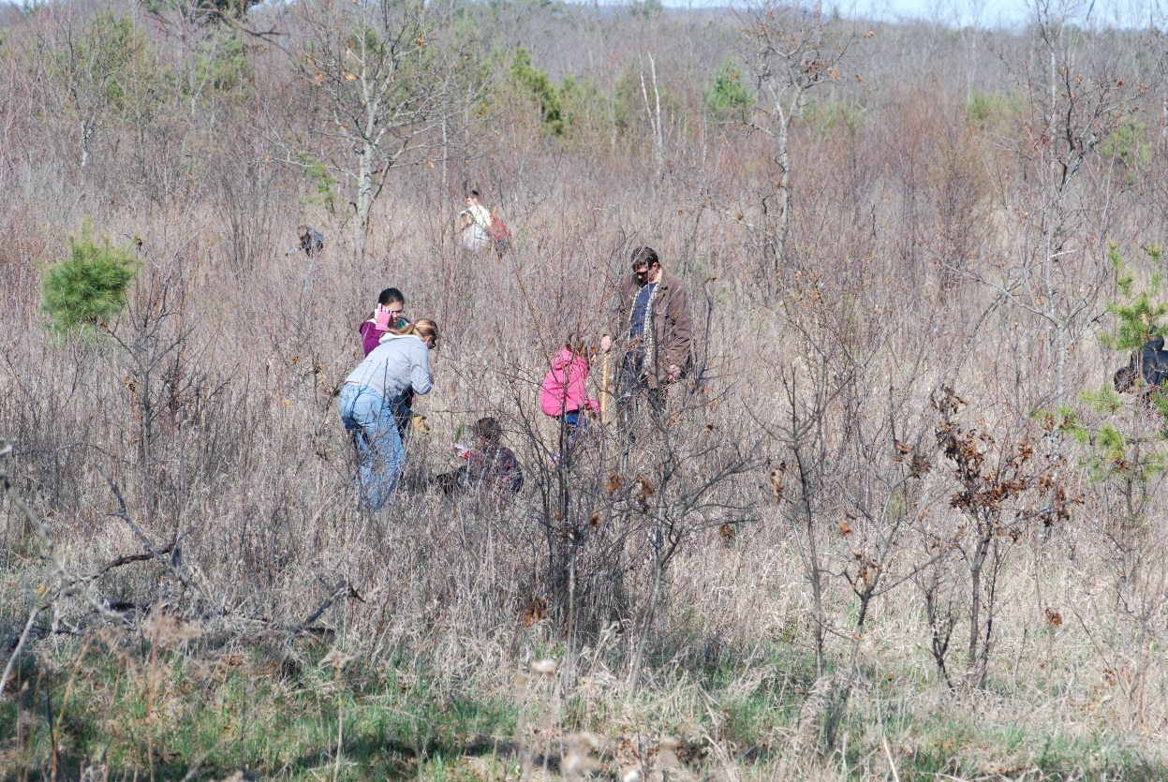

Figure 2. Planting trees in Area 1.

(1) Management Area 1.
- Size-16 acres.
- Description-Red maple and white pine saplings and some larger trees (fig. 2). Rubus spp. and exotic honeysuckle are present. The water table is within 3 feet of surface.
- Goal-Naturally regenerated forest of white pine, red maple, oak, and other associated tree species with some help from planted seedlings.
- Management Recommendations-Control exotic plants using the herbicides applied with basal stem treatment or foliar spot treatment. Allow naturally occurring tree seedlings and saplings to reforest the area.

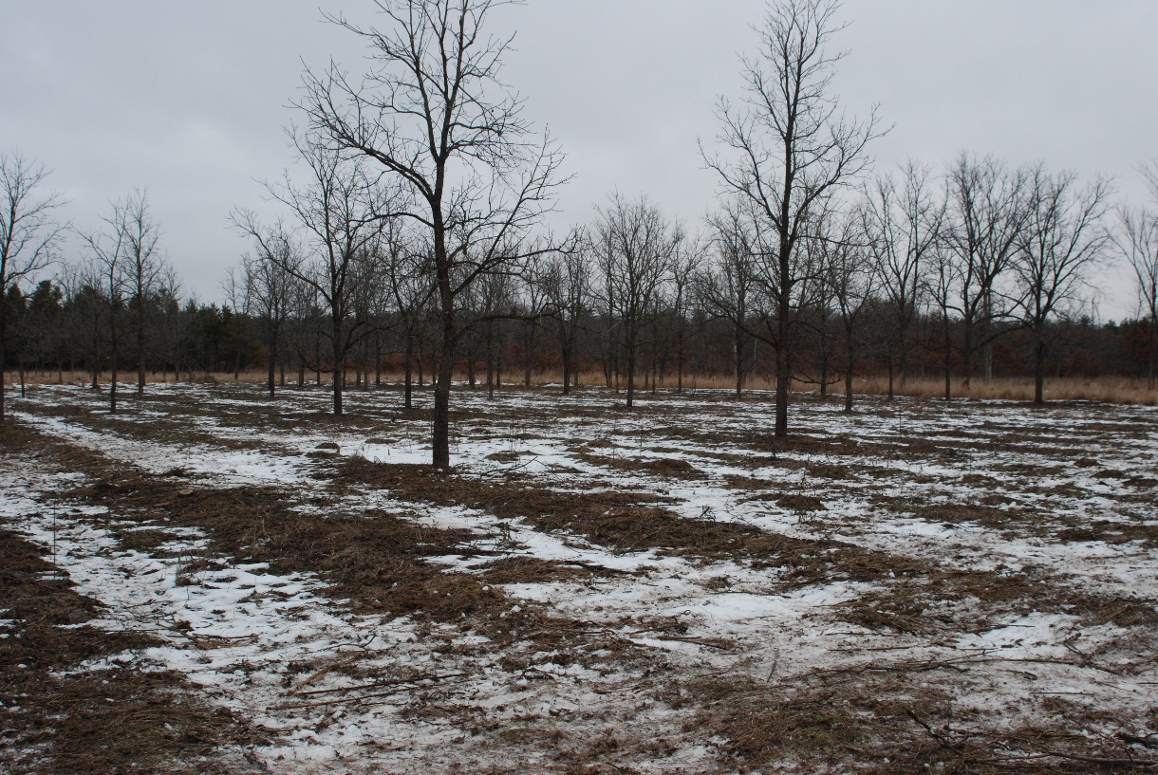

Figure 3. Recently Thinned Walnut in Management Area 2.

(2) Management Area 2.
- Size-3 acres.
- Description-Black walnut plantation within the Mound Prairie Sacred Area. Use is restricted to foot traffic only. Walnut trees have been thinned out in 2014 to create a more open savanna plant community. Prescribed burns and herbicides have been used to control invasive brome grass and prepare the area for seeding to native prairie plants (fig. 3).
- Goal-Create a savanna community with black walnut as the dominant tree species and manage the mounds following the guidelines detailed in the Wisconsin Department of Natural Resources (WDNR) Burial Site Maintenance Plan, Spring 2008.
  - Management Recommendations- After the brome has been controlled, native prairie grass and forb seed (see appendix C for a list of the plants by common name) will be hand seeded on the mounds and planted in the rest of the area, either by hand or using a Utility Task Vehicle (UTV) with a seeder to avoid impacts to the soil. The vegetation will be mowed for two consecutive years in order to encourage root growth of the native plants, add duff layer to return nutrients to the system, and prevent invasive plants from setting seed (mid-June). Mowing will be accomplished with a UTV off the mounds and by hand on the mounds (if the mounds need mowing). After mowing is completed, prescribed burning will be used to maintain the savanna by burning in April/May for two consecutive years. Burning in the out-years will be considered based on need. Trees growing on the mounds will be removed by hand cutting to the ground in frozen conditions, leaving the stump in place. After cutting the trees are moved a minimum of 15 feet from the mounds.
Monitor the site annually in accordance with the forthcoming Integrated Cultural Resources Management Plan (ICRMP).

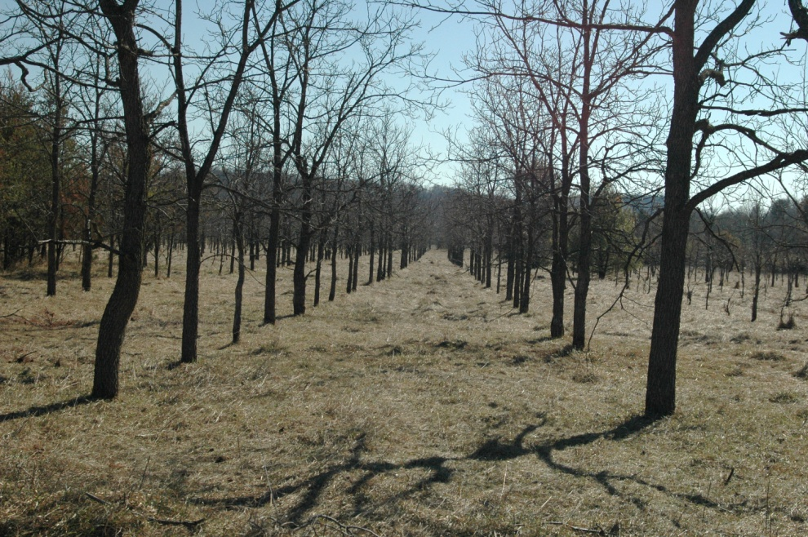
Figure 4. Black walnut plantation in Management Area 3.

(3) Management Area 3.
- Size-4 acres.
- Description-Black walnut plantation outside of the sacred area but within the cultural resource restricted area, allowing foot traffic only. Walnut trees are small, about 10 to 25 ft tall and in rows with a thick sod-layer of smooth brome (fig. 4).
- Goal-To avoid disturbing the site and prevent the smooth brome from spreading to area 2.
Management Recommendations-Prevent the brome from expanding out into other management areas by broadcast spraying herbicides as needed. Monitor the site annually in accordance with the current Integrated Cultural Resources Management Plan (ICRMP).

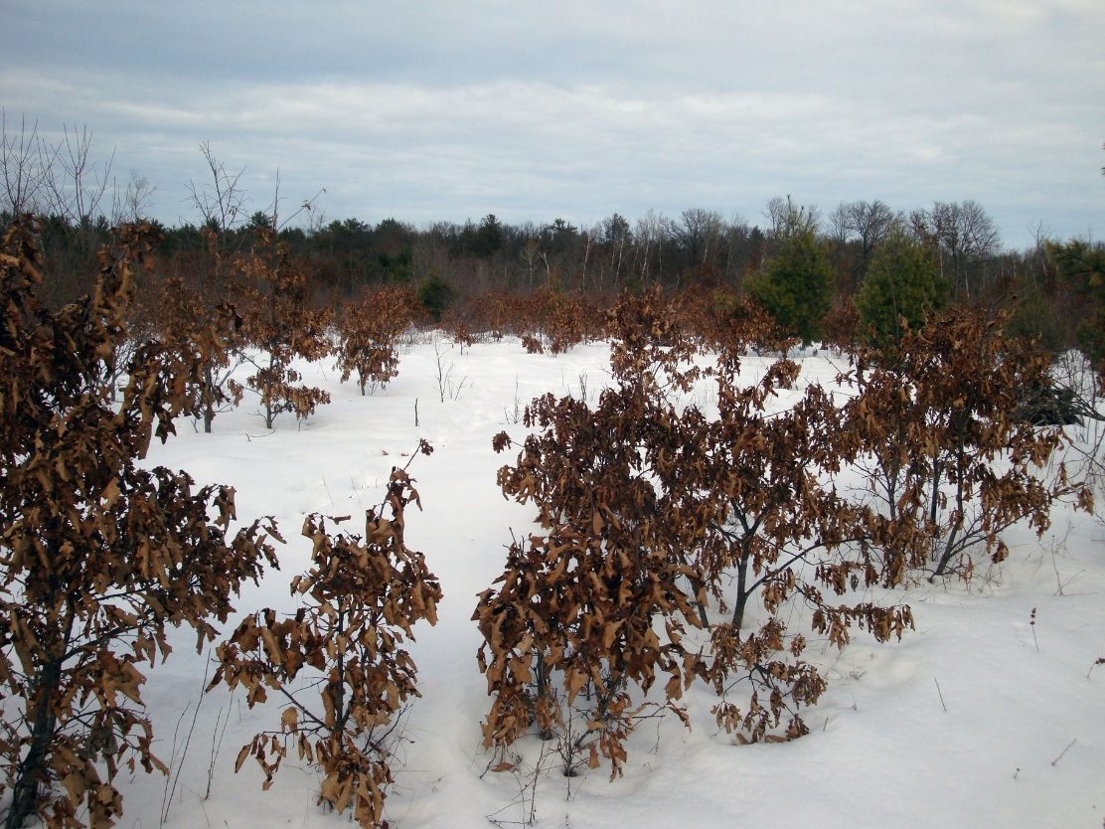

Figure 5. Limited tree regeneration in Management Area 4.

(4) Management Area 4.
- Size-13 acres.
- Description-Area also scattered white pine and oak seedlings and saplings (fig. 4). The amount of vegetation is less than in some of the other management areas and more bare soil was exposed during the harvest operation. Some exotic honeysuckle is present.
- Goal-Red and white pine forest.
- Management Recommendations-Use a dozer to scrape planting sites and hand plant red pine. Control honeysuckle using herbicides. Planting will be at least 15 meters from the boundary of management area 8.

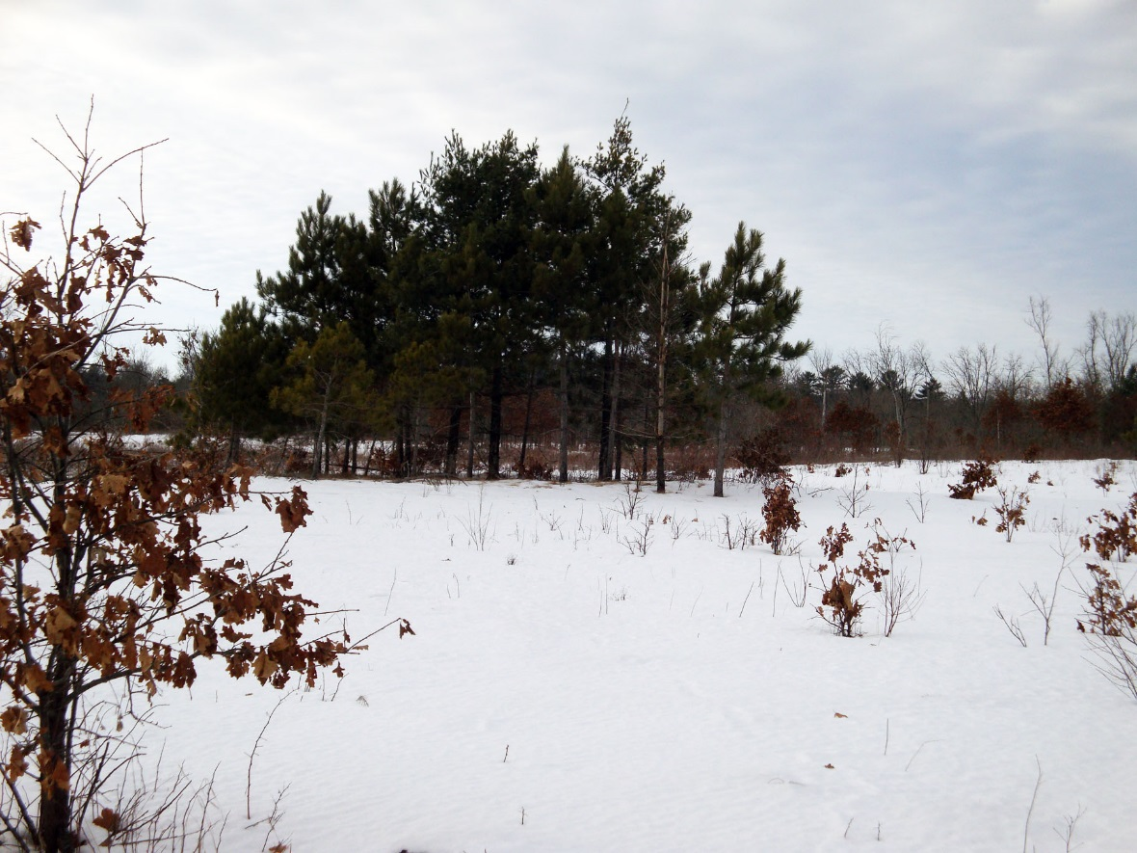

Figure 6. Background shows tree growth on a mound
in Management Area 5.

(5) Management Area 5.
- Size-14 acres.
- Description- This area encompasses a large portion of the Mound Prairie Sacred Site and is restricted to foot traffic only. Buckthorn and honeysuckle, two exotic plant species, are abundant and will be a problem if not controlled (fig. 5). Some of the area has white pine seedlings present.
- Goal-Restore an oak savanna plant community and manage with prescribe burning.
Management Recommendations- Control buckthorn and honeysuckle through cutting and herbicide treatments. Follow-up as needed to keep the invasive plants under control. Prescribe burns and a limited amount of native prairie plant seeding will follow the exotic plant treatments to establish a native prairie plant community. Seeding will be done by hand on the mounds and planted in the rest of the area, either by hand or using a Utility Task Vehicle (UTV) with a seeder to avoid impacts to the soil. The vegetation will be mowed for two consecutive years in order to encourage root growth of the native plants, add duff layer to return nutrients to the system, and prevent invasive plants from setting seed (mid-June). Mowing will be accomplished with a UTV off the mounds and by hand on the mounds (if the mounds need mowing). After mowing is completed, prescribed burning will be used to maintain the savanna by burning in April/May for two consecutive years. Trees growing on the mounds will be removed by hand cutting to the ground in frozen conditions, leaving the stump in place. After cutting the trees are moved a minimum of 15 feet from the mounds. Monitor the site annually in accordance with the forthcoming Integrated Cultural Resources Management Plan (ICRMP).

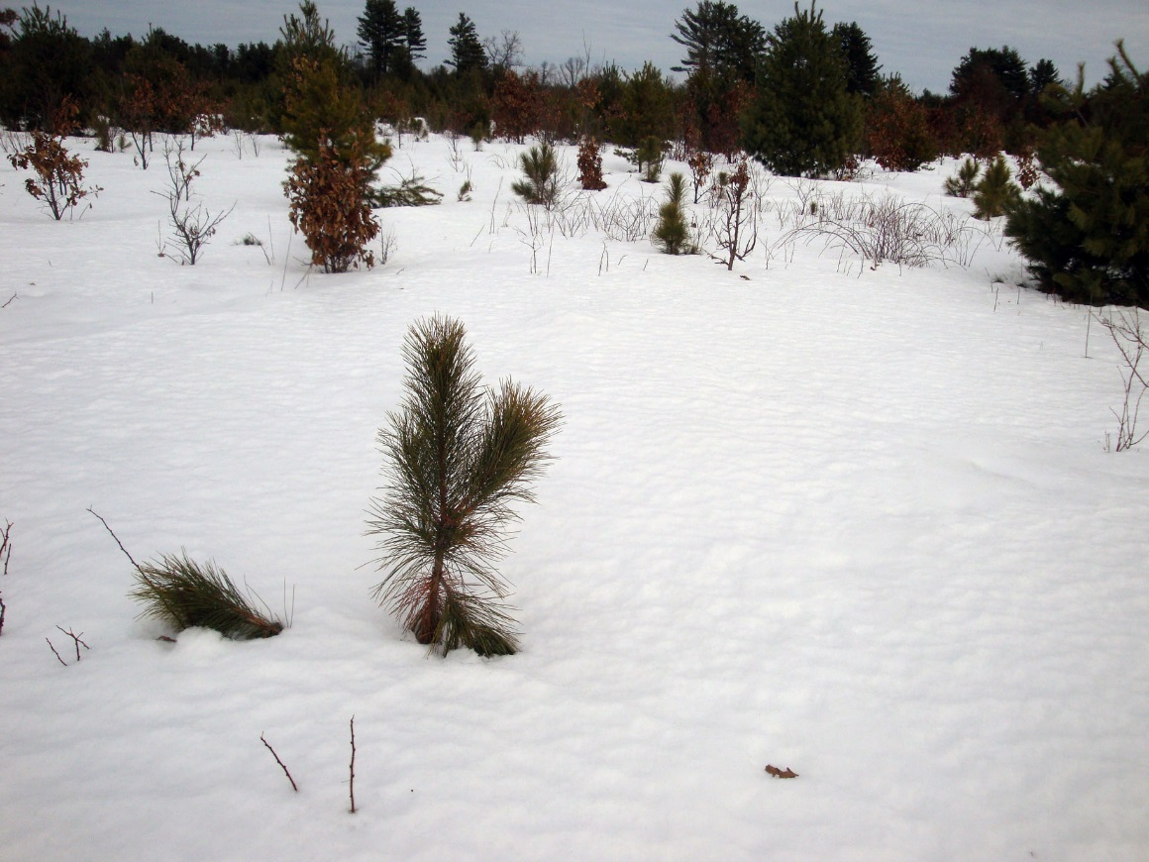

Figure 7. Planted tree seedlings in Management Area 6.

(6) Management Area 6.
- Size-28 acres.
- Description-The area has been hand planted with red pine seedlings to augment naturally occurring red and white pine seedlings (fig. 6). The ground cover has a dense growth of Pennsylvania sedge over much of the area making tree planting difficult. Exotic honeysuckle is present.
- Goal-Red, jack, and white pine forest.
- Management Recommendations -Hand plant red pine to augment the existing trees and control honeysuckle through mechanical/manual removal and herbicide applications.

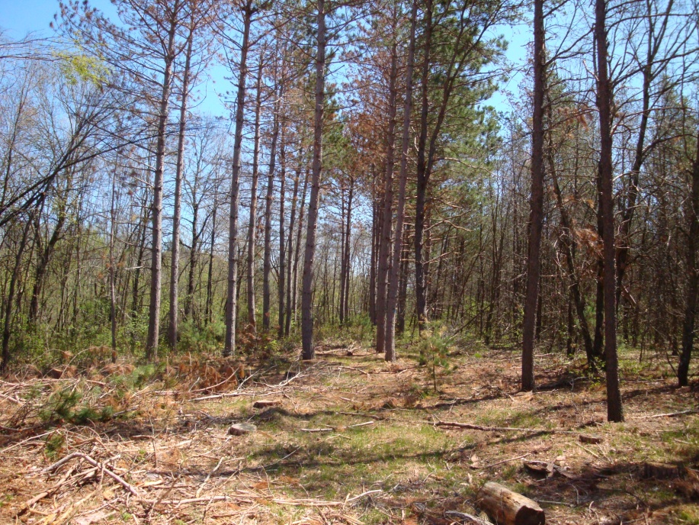

Figure 8. Storm damaged timber and seedlings in
Management Area 7 after the harvest.

(7) Management Area 7.
- Size-10 acres.
- Description-This management area contains the Mound Prairie Sacred Site and is restricted to foot traffic only. This area was not harvested due to potential damage to this site. Buckthorn and honeysuckle, two exotic plant species are abundant and will be a problem if not controlled. Some of the area has numerous white pine seedlings present (fig. 7). This section will remain as white, red and jack pine forest.
- Goal-Maintain as a pine forest and protect the cultural site.
Management Recommendations-Control the invasive plants by treating individual plants with herbicides using backpack sprayers or other manual application methods that can be accomplished as foot traffic only is allowed in the area. Monitor the site annually in accordance with the forthcoming Integrated Cultural Resources Management Plan (ICRMP).

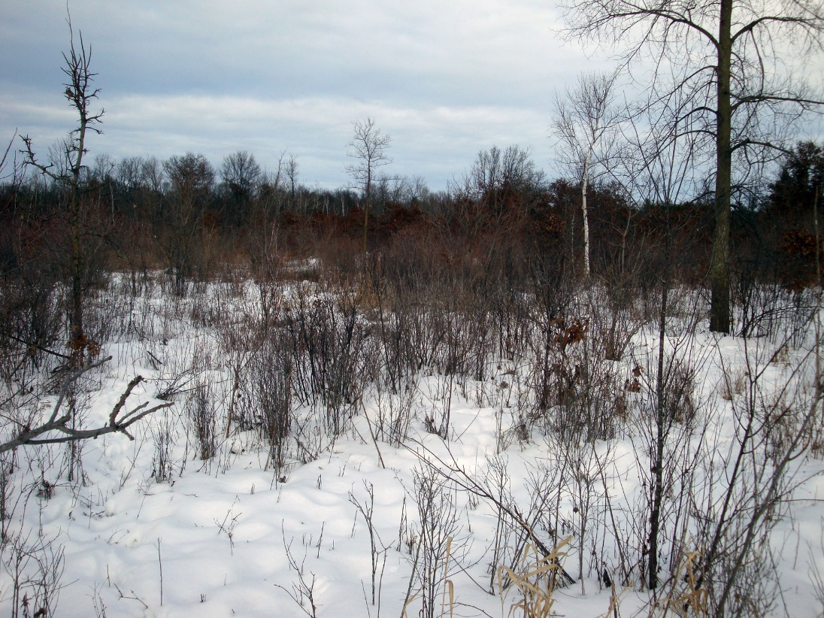

Figure 9. Dense growth in area 8.

(7) Management Area 8.
- Size-14 acres.
- Description-Much of this area is covered in thick brush and is within the cultural resource restricted area, allowing foot traffic only. This area was not harvested due to potential damage to this site. Buckthorn and honeysuckle, two exotic plant species are abundant and will be a problem if not controlled. Some of the area has numerous white pine seedlings present (fig. 7). This section will remain as white, red and jack pine forest.
- Goal-Allow the area to develop into a forest and protect the cultural site.
Management Recommendations-Control the invasive plants by treating individual plants with herbicides. Monitor the site annually in accordance with the forthcoming Integrated Cultural Resources Management Plan (ICRMP).

Estimated Project Costs: The estimated cost for all the projects suggested for the Mound Prairie area comes to $16,100. A breakdown of the cost by project, area, and year is located in appendix D. It should be noted that the ability to complete these projects will be subject to the availability of funding and a shortfall may necessitate a modification in the planned actions. In the event of funding shortfalls, Fort McCoy will consider alternative options including volunteer labor and partnering with interested stakeholders, including the Ho-Chunk Nation if interested, who might be able to provide assistance in meeting these management goals.

Conclusion: The U.S. Army and Fort McCoy are committed to the protection and proper management of all cultural resources as well as supporting the military mission by prescribing natural resource conservation measures that are integrated and consistent with Federal stewardship requirements. This management plan takes all of these responsibilities into account in order to sustain the military mission while protecting and preserving our natural and cultural resources for future generations.

Prepared by:

Mark W. McCarty, Chief, Natural & Cultural Resources Branch
James R. Kerkman CF, Forester
David J. Beckmann, Wildlife Biologist
Timothy T. Wilder, Endangered Species Biologist
Alexander D. Woods Ph.D., Cultural Resources Projects Manager, Colorado State University
Brent A. Friedl, Integrated Training Area Management Coordinator
APPENDIX A

Timeline for management activities at Mound Prairie

APPENDIX B

APPENDIX C

Native Plant Species

Rough blazing star
White and purple prairie clover
False indigo
Dotted mint
Prairie dropseed
Common milkweed
Black eye susan
Goats rue
Pasque flower
Lead plant
Rough godenrod
Asters
Thimbleweed
Rough white lettuce
Butterfly weed
Lupine
Downy phlox
Naked sunflower
Bergamot
Whorled milkweed
Big bluestem
Little bluestem
Coryopsis
Indian grass
Rattlesnake grass
Round headed bushclover
Stiff goldenrod
Showy goldenrod
Prairie blazing star

APPENDIX D

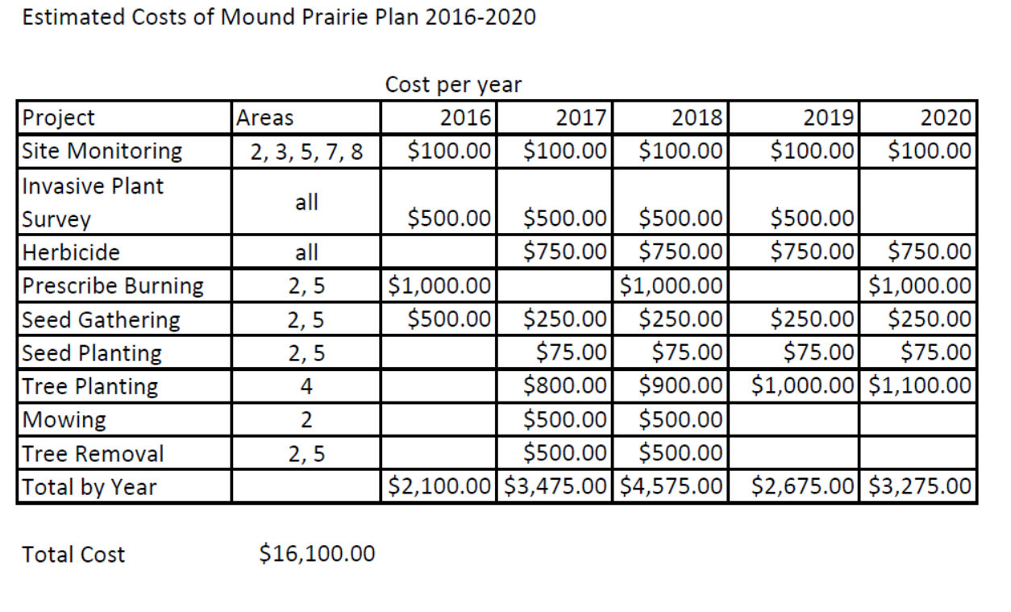

APPENDIX G

FORT MCCOY BURN PRESCRIPTION PLAN

1. LOCATION:
A-1, range 101
A1.3, A1.1
Training Area _________ Burn #__________________

2. EMERGENCY ASSISTANCE:

Phone Radio Channel

Fire 608-388-2508 _________________

PMO 608-388-2266 _________________

3. Notification: See attached phone list

4. AREA DESCRIPTION:
Vegetation Fuel Size of
Type Models Area % Slope Aspect
NE
N/A
N/A
3
0
0
24 ac
16 ac
17 ac
9
1
12
Oak forest
Mowed grass
Clearcut w/slash

Area Description: Maps Attached _X__
Downrange of range 101, oak forest with a couple pockets of jack pine and mowed range area. There is a steep, grass covered range berm. Far southern edge is the clearcut area with slash. Small portions have been shredded.

5. PRESCRIBED BURN JUSTIFICATION:

Reason for Burn (e.g. ecological management, forestry management, hazard reduction, training, research, etc.);
Fire hazard reduction by removing fuels as early as possible in the spring. The range will be firing tracers in the following weekends. The forested area will benefit for ecosystem burning

Specific Burn Objectives and Benefits To Military Training and/Or Ecosystem:
Burning the range will prevent the range being shut down while wildfires are suppressed by the Fire Department.

Forestry Concerns:
The forested areas have been repeatedly burned, may be contaminated with metal and are low quality oak. Suppress escapes to the east and west in the oak woods to prevent the fires from reaching pine plantations. Snow in woods will slow escape fires.

Endangered and Threatened Species Concerns:
A Karner Blue Butterfly core area is located immediately south of line B-C and west of line C-D. Must prevent escapes in that direction.

Wildlife Concerns:
None

Exotic Species Concerns:

ITAM/LCTA/Grounds:

Cultural Resources:

Poison Sumac Present? _____yes ___X__no
Munitions Found in the Past? ____X__yes ______no ______unknown
Fire Department Assistance Needed? ___X___yes ______no

6. ACCEPTABLE FIRE BEHAVIOR
Fuel Model
1
9
12

# ______ #______ #______
8 ft | 7 ft | 6 ft
1 ft | 1 ft | 1 ft
3 ft | 2 ft | 2 ft
0.5 ft | 1 ft | 1 ft
345 c/h | 40 c/h | 40 c/h
50 c/h | 5 c/h | 5 c/h
10 c/h | 5 c/h | 5 c/h
3 c/h | 0.9 c/h | .5 c/h
NA | 15 ft | 10 ft

Max. Headfire Flame Length
Min. Headfire Flame Length
Max. Backfire Flame Length
Min. Backfire Flame Length
Max. HF Rate of Spread
Min. HF Rate of Spread
Max. BF Rate of Spread
Min. BF Rate of Spread
Max. Scorch Height

7. FUEL AND WEATHER PRESCRIPTION DATE____________

Required Parameters: Conditions at Burn Time:
Hour 1 2 3 4 5
Wind Direction _____ _____ _____ _____ _____
NW
10
2
30
50
30

Effective Windspeed _____mph _____ _____ _____ _____
1-Hour Fuel Moist _____% _____ _____ _____ _____
10-Hour Fuel Moist _____% _____ _____ _____ _____
100-Hour Fuel Moist _____% _____ _____ _____ _____
Live Fuel Moisture _____% _____ _____ _____ _____

Guidance Parameters:

Air Temperature _55___ ______
Relative Humidity _30%__ ______
Days Since Rain _3____ ______
Other __________________ ____________________

8. SMOKE MANAGEMENT PLAN

List smoke sensitive areas:
I-90 and state highway 16 to the north. Private residences to the west of the burn.

Describe desirable smoke behavior:
Smoke rises and disperses high in the atmosphere in calm weather or there is a steady west/northwest breeze.

9. CREW ORGANIZATION
Charles Mentzel
Fire leader(s):

2
8
# Personnel Number of crews

Crew description
The crews consist of one ignitor using a drip torch, one 5-gallon backpack, and a swatter or firerake. An ATV with 10 gallon water tank and one or more brush trucks are stationed along line A-F to watch trouble areas and respond where needed.

10. EQUIPMENT

First aid kit _X___ Weather kit _X__ Protective clothing _X__

Number Number
Radios _8__ Fire rake _2__
Backpack sprayer _2__ Council rake _0__
4x4 ATV w/water tank _1__ Flappers _2__
Drip torch _4__ Fusee _0__
Jeeps __1_

11. BURN DURATION (preparation, spreading fire, and mop-up)
Coordinate with range scheduling to burn the area as early as possible in the spring. Burning usually starts about 1000 hrs when the fuel has been dried by the sun and can carry a fire. Ignition ends near 1330 hours.

12. MANAGING THE BURN:
Fire break preparation:
Line B-C must be inspected prior to the burn. A fire plow line was made on that line in spring 2003. This line is overgrown and must be wetlined. The rest of firebreaks are existing sand trails and have had the grass mowed recently. Snow is present on many of the firebreaks.

Fire techniques and ignition pattern:
Start firing in a downwind corner, “E” or “C” with two crews if the wind is from the NW or “A” if wind is from SE. Each crew light along lines in opposite directions from the start and run spot fires through the burn area, connecting the lines, to keep flame lengths low. Burn mowed area in a ring technique to keep fires as hot as possible.

Crew communication:
The radios are set to one of the Fire Dept frequencies.

Fire behavior and weather monitoring:
The fire boss or someone designated by him will frequently monitor the weather with the weather kit and monitor the weather channel. He will also monitor the fire behavior to make sure the burn is accomplishing the stated goals.

Holding:
If a fire escapes anywhere along the firebreak, all crews are ordered to stop firing until the escape is suppressed or the burn boss decides there is enough resources available to suppress without calling in another crew. PMO may be asked to control traffic if smoke obscures the highways.

Fire sensitive area or hazards:
Unfired rounds may be present. Jack pine may crown fire near corner I but should not carry far. Take care while firing on berm near corner F, tripping can cause dangerous falls. .

Contingencies:

Contingencies:
The 3,000 gallon water tanker and fire plow will be on site if needed or ready at the station. A secondary break is located south of the burn, the highways are north and firebreaks, sand trails are east and west of the burn.

Mop-up:
Put out any fires within 50 feet of the lines. Fell and extinguish any burning snags at any distance from the line since they can throw sparks a long way.

Public relations:
PAO is informed of the fire so they can handle questions from the public.

Follow-up assignments:
Reinspect the burn the morning after the burn is complete to make sure there are no escapes or smoldering fuel that can reignite.

13. Post Burn Assessment
Good________ Fair_________ Poor________
Why?

General Burn Description:

Areas of Interest in the Future?

Was the Crew and Equipment adequate for the burn?

Were the Burn Objectives and Concerns met?

APPENDIX H

FINDING OF NO SIGNIFICANT IMPACT
FOR THE
IMPLEMENTATION OF THE INTEGRATED NATURAL RESOURCES MANAGEMENT PLAN
AT FORT MCCOY, WISCONSIN

1. INTRODUCTION:

The Natural Resources Branch of the Directorate of Public Works (DPW) at Fort McCoy, Wisconsin has prepared an Environmental Assessment (EA) to identify and evaluate potential environmental impacts associated with the implementation of the Integrated Natural Resources Management Plan (INRMP) at
Fort McCoy. The EA was prepared in accordance with the National Environmental Policy Act (NEPA) and the Council on Environmental Quality Regulations for Implementing the Procedural Provision of NEPA (CEQ Regulations, 40 CFR Part 1500-1508), and Environmental Analysis of Army Actions (32 CFR 651). This INRMP is a revision and update of the existing Integrated Natural Resources Management Plan.

2. DESCRIPTION OF PROPOSED ACTIONS AND ALTERNATIVES:

The proposed action for this EA is to implement the Fort McCoy INRMP. Under the Sikes Act (16 U.S.C. 670) the elements of the INRMP must be consistent with the use of the military installation to ensure the preparedness of the Armed Forces. The elements of the plan are to provide for: 1)fish and wildlife management, land management, forest management and fish and wildlife-oriented recreation; 2)fish and wildlife habitat enhancement or modifications; 3)wetland protection, enhancement, and restoration, where necessary for support of fish or wildlife; 4)integration of, and consistency among, the various activities conducted under the plan; 5) the establishment of specific natural resource management objectives and time frames for proposed action; 6)the sustained use by the public of natural resources to the extent such use is not inconsistent with the needs of fish and wildlife resources management; 7) public access to the military installation that is necessary or appropriate for the use described in number 6, above, subject to requirements necessary to ensure safety and military security; 8) for the enforcement of natural resource laws and regulations; 9) no net loss in the capability of the installation land to support the military mission of the installation.

Alternatives Considered: The No Action Alternative and the Preferred Alternative are the only two alternatives considered for the proposed action.

a. The preferred alternative is to implement the revised Integrated Natural Resource Management Plan at Fort McCoy: This alternative is required by statute (16 U.S.C. 670). It is also required by Army Regulation 200-1.

b. No Action: This alternative is not feasible. Fort McCoy would be in violation of 16 U.S.C. 670 and AR 200-1.

3. SUMMARY OF ENVIRONMENTAL EFFECTS:
This is a focused Environmental Assessment. The following valued environmental components (VECs) have been categorically excluded from this EA because no significant adverse effects are anticipated: Land Use; Air Space; Geology and Soils; Vegetation and Forestry; Invasive Species; Wildlife and Fisheries; Threatened and Endangered Species; Groundwater; Surface Water & Wetlands; Air Quality; Noise; Hazardous Materials & Hazardous Waste; Fire Management; Public Access and Recreation; Socioeconomics and Environmental Justice; Human Health and Safety; Cultural Resources; Visual Resources; Traffic and Transportation; and Infrastructure. The Integrated Natural Resources Management Plan, by design, provides beneficial impacts to the Natural Resources of Fort McCoy and to the environment in general. These beneficial impacts are discussed in the INRMP. The Sikes Act requires the INRMP to provide for the integration of, and consistency among, the various activities conducted under the INRMP. The Fort McCoy INRMP has been prepared and peer reviewed by qualified, experienced natural resources professionals at Fort McCoy. No known adverse impacts were included in the plan. This Environmental Assessment, along with the INRMP itself, will go out for public review. Any significant comments will be addressed in the final documents.

4. CONCLUSION WHICH LED TO A FINDING OF NO SIGNIFICANT IMPACT:
No significant adverse impact is expected from the implementation of the Fort McCoy Integrated Natural Resource Management Plan because the plan is designed and intended to be beneficial to the natural resources and general environment at Fort McCoy.

5. PUBLIC REVIEW AND COMMENT. This Finding of No Significant Impact (FONSI) as well as the Environmental Assessment (EA) and the Integrated Natural Resources Management Plan will all go out for public review. Any Significant comments will be incorporated or included in the final INRMP, EA and FONSI.

6. FINDING OF NO SIGNIFICANT IMPACT. After careful review of the EA, I have concluded that implementation of the Proposed Action would not generate significant controversy or have a significant adverse impact on the quality of the human or natural environment. This analysis fulfills the requirement of NEPA and the CEQ Regulations. An Environmental Impact Statement will not be prepared, and the
Fort McCoy Garrison is issuing this Finding of No Significant Impact.

_______________________________________ _____________________
MICHAEL D. POSS Date
COL, CM
Commanding

APPENDIX I

