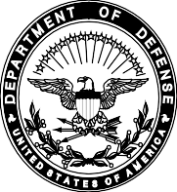
REPLY TO ATTENTION OF:
DEPARTMENT OF THE ARMY
HEADQUARTERS, 8TH ARMY UNIT #15316
APO AP 96271-5228

EAGA-HRSD 1 January 2023

MEMORANDUM FOR USAG-H, MPD Team CSP, APO AP 96205
SUBJECT: Soldier Declaration

- In accordance with Army Regulation 614-30 Para 3-5a(5), I make the following declaration:
The Family member(s) for whom I am requesting command sponsorship does not have any qualifying convictions for offenses listed under 42 USC 16911, or Army Regulation 27-10. I understand that if I am granted command sponsorship and my Family member(s) is convicted of a qualifying offense at anytime during the overseas tour, the command sponsorship will be revoked. Furthermore, I understand that the identified Family member(s) will be processed for early return from the overseas location.

- The point of contact for this action is the undersigned at DSN 757-**** or joe.snuffy@mail.mil.

JOSEPH SNUFFY SPC, USA

