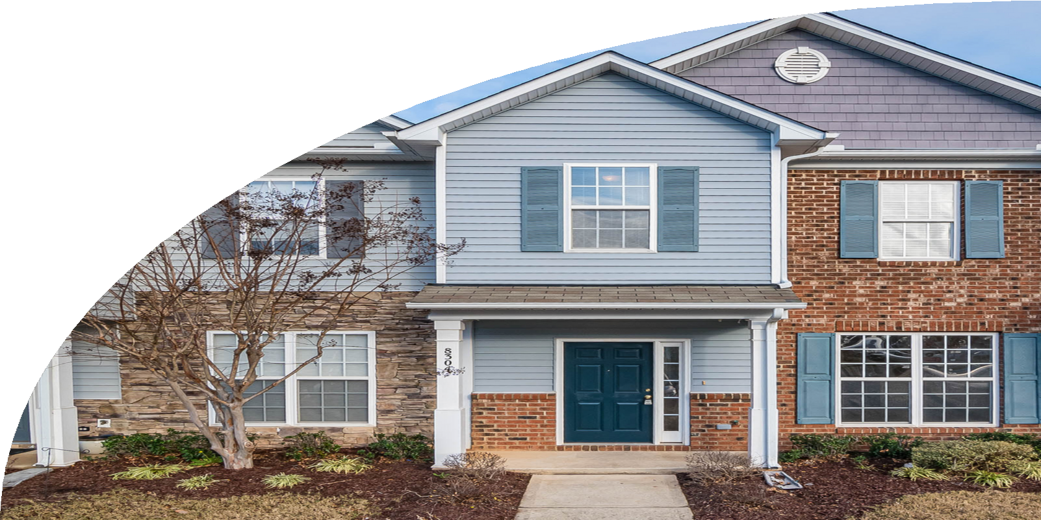

Army Housing Dispute Resolution

# WHAT IS DISPUTE RESOLUTION?

The Dispute Resolution process allows eligible tenants and their families who reside in Army Housing to obtain prompt and fair resolution of housing disputes. An **Informal Dispute** is intended to resolve disputes at the garrison level. A **Formal Dispute** is intended to resolve disputes regarding rights and responsibilities in their lease agreement, including maintenance and repairs, rental payments, displacement rights, lease termination, and more.

**DISPUTE BASICS**

* You must first attempt resolution of issues directly with your Privatized Army Housing Provider IAW the terms of the Universal Lease. If unsuccessful, you must attempt to reach a resolution using the Army Housing Office (AHO) Informal Dispute Resolution process.
* The Informal Dispute Resolution process is expected to take 10 days.
* If satisfactory resolution is not reached, you may complete the Formal Dispute Resolution form and submit it to the AHO to begin the process.
* To use the Formal Dispute Resolution Process, you must allow the Privatized Army Housing Provider, AHO, and an Independent Investigating Officer into your home for inspection(s). They will provide written recommendations for the resolution of the dispute.
* The Deciding Authority, generally the HQ IMCOM Commander, makes the final decision.
* The Formal Dispute Resolution process is expected to take 30-60 days.

# POLICY

AMC CPM 600-24 includes the processes, procedures, and available remedies for the Privatized Army Housing dispute resolution process. Visit <https://www.housing.army.mil> to view the policy and dispute resolution form.



**CONTACT ARMY HOUSING**

The AHO can assist with all your housing questions, including Informal and Formal Dispute Resolution questions. Contact your local AHO today!

(520) 692-6295/6390/6271/6266

USARMY Ft Leavenworth ID-Training Mailbox HSO <usarmy.leavenworth.id-training.mbx.hso@army.mil>

Learn More: www.housing.army.mil

