|  |  |  |
| --- | --- | --- |
|  | **The 3Rs of Explosives Safety** | ; <https://www.denix.osd.mil/uxo/>C:\Users\kclower\Desktop\3Rs KC\New 3Rs Logo\3Rs with Website Logo\3Rs_Stoplight w Website_Transparent.png |

The U.S. Armed Forces have conducted and continue to conduct live-fire training and maneuvers to be prepared to defend our Nation. This training involves the use of various types of munitions including bombs, artillery projectiles, grenades, mines, rockets, and simulators. Some munitions do not explode or function as intended. These are called unexploded ordnance or UXO.

For a number of reasons, these munitions and others (e.g., discarded souvenirs) may be encountered in areas where they are not expected. This has occurred at Fort Knox and other installations.

Over time, property, including property on an installation, the military once used for live-fire training or maneuvers has been put to different uses (e.g., parks, residential or industrial development). Erosion caused by natural phenomena, such as storms and frost heave, and construction often uncover munitions once buried in the ground. Additionally, some people discard munitions once kept as souvenirs in various areas (e.g., wooded areas, parks or the trash) without concern for the safety of others.

Munitions are designed to kill people and destroy equipment or buildings. Even practice munitions may have a small explosive charge that can be dangerous and cause serious injury. No matter the age, size, shape, or color, munitions are dangerous and should not be approached, disturbed or moved.

Military families are more likely to encounter munitions than the general public because they live on or near military installations. The Army and Fort Knox encourage you to visit 3Rs.mil to learn about the 3Rs of Explosives Safety with your family, and constantly reinforce the need for your family to follow the 3Rs of Explosives Safety:

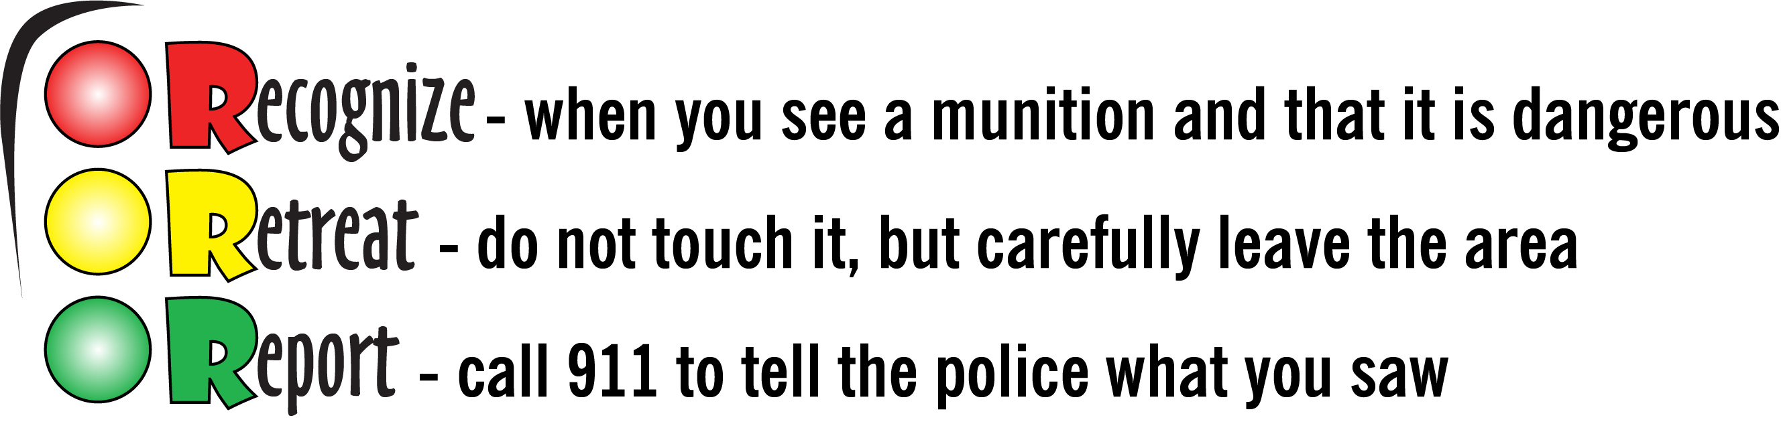

For more information on Fort Knox 3Rs Explosives Safety Program, contact the

Fort Knox Installation Safety office at (502) 624-3381.   
  
For more information about the 3Rs of Explosives Safety, visit ; <https://www.denix.osd.mil/uxo/>