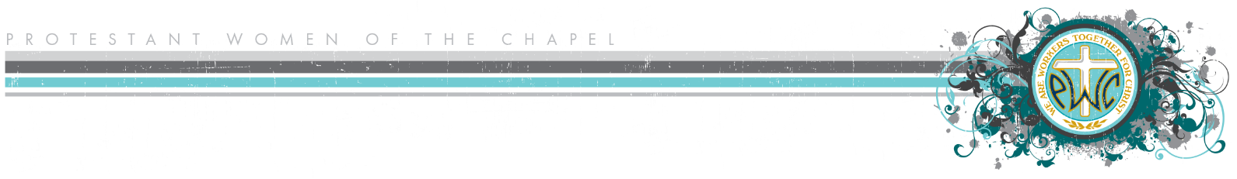

**Serving Our Sisters Signup and Checklist**

**Bible Study: __________________________________________________**

**SOS Date: _________________________**

**Greeters (***insert**time***)**

*Coordinate with Participation Team. Hold the door, help women with kids, help new ladies find watchcare and Bible study info, help those who are sitting alone in the sanctuary feel welcome.*

**1)**

**2)**

**Watchcare (***insert**time***)**

*Coordinate with Watchcare Coordinator. Must be background-checked.*

**1)**

**2)**

**3)**

**4)**

**Snacks for Fellowship**

*Coordinate with Hospitality.*

*Consider providing gluten-free options, protein, fruit/veggies, or breakfast foods.*

*Consider serving during Fellowship Time by getting drinks for mamas with their hands full, holding babies, taking empty plates/trash, connecting with someone that is alone or looking lost.*

**1)**

**2)**

**3)**

**4)**

**5)**

**6)**

**7)**

**8)**

**9)**

**10)**

**Food Handlers (***insert time***)**

*Help serve food during fellowship time. Must have completed Food Handlers Course.*

**1)**

**2)**

**Offering (***insert**time***)**

*Coordinate with Financial Liaison. Help collect the offering and count it.*

**1)**

**2)**

**Cleanup after Fellowship Time (***insert**time***)** *All Hands on Deck!*

* **Wipe down and disinfect tables; wipe down chairs**
* **Clear all food off tables; cover and refrigerate items that will spoil**
* **Wipe down tablecloths and fold them**
* **Wash and dry dishes**
* **Take trash out**
* **Sweep**
* **Mop (if required)**
* **Reset fellowship area to Chapel standard**
* **What else?**

**Cleanup after Class Time (***insert time***)** *All Hands on Deck! Pitch in if you can!*

* **Wipe down and disinfect surfaces**
* **Put away tables, chairs, and any other equipment used by PWOC**
* **Reset furniture in classrooms to Chapel standard** (individual classes should do this)
* **Remove trash in all classrooms and replace trash liners**
* **Check nursery and kids’ classrooms; reset to Chapel standard**
* **Disinfect toys**
* **Sweep**
* **Vacuum**
* **Mop (if required)**
* **Check bathrooms**
* **Walk through the sanctuary; make sure there is no trash or belongings left behind**
* **Walk through the building; make sure everything is in order**
* **What else?**