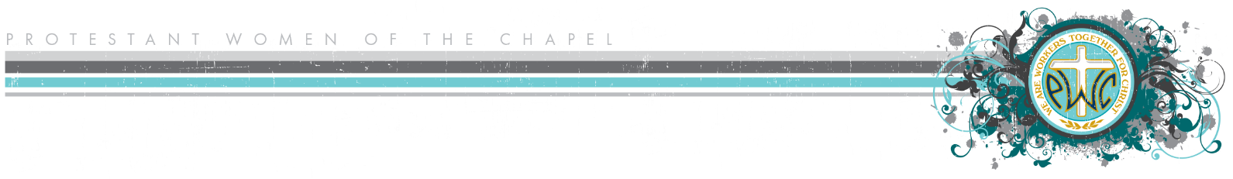
Bible Study Needs Assessment

What type(s) of Bible study would you be interested in? Check all that apply.
- A book of the Bible
- Basics of the Christian faith
- Prayer
- How to share your faith with others
- Deepening your relationship with Christ
- Marriage
- Parenting
- Bondage breaking
- Forgiveness
- Grief/loss
- Leadership
- Personal growth—What area? _________________________________
- Health and fitness
- Other _____________________________________________________

How much time are you able to commit to homework each week (5 days a week)?
- Light study (less than 15 minutes)
- Moderate study (15-45 minutes)
- In-depth study (more than 45 minutes)

Is there a specific study or author you would like to recommend? List as many as you would like.
- Authors: ____________________________________________________________________
__________________________________________________________________________

- Studies: ____________________________________________________________________
__________________________________________________________________________

Are you interested in leading a study? If so, please provide your contact information.
Name: ____________________________________________________________________
Email: ____________________________________________________________________
Phone: ___________________________________________________________________

