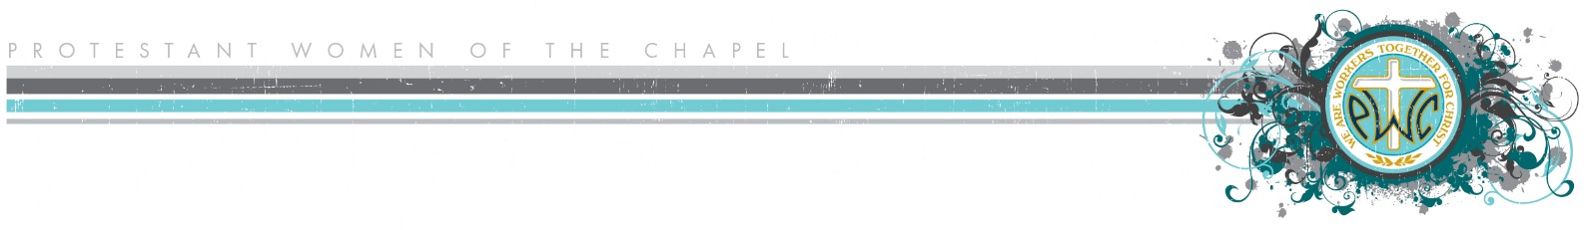
Healthy Priorities

Keeping “first things first” is essential as we step into leadership. If your family resents your role in PWOC leadership, it may be an indication that your priorities are out of order. Following is a suggested order of priorities; it is flexible, and the order should adjust to what is best for you and your family according to God’s guidance. At times, priorities may shift for a season—for example, if a Retreat is coming up, the Retreats & Events Board member may be putting in many more hours than usual—but priorities should eventually shift back into place. There is flexibility and grace.
Suggested Order of Priorities
- Relationship with God
This should be the number one priority in life. This is not necessarily church, PWOC, or ministry. It is abiding with Him in a continual love relationship nurtured through prayer, worship, the Word, and accountability among other things.

- Personal Health
Though it is easy to neglect our health, we are body, soul, and spirit (1 Thessalonians 5:23). Therefore, when we neglect our physical health, we are risking our spiritual and emotional well-being.

- Husband
This is both time with your husband and time to do the things he needs you to do. You are his partner. Your husband comes before your children because you are in covenant relationship with him and God, and because you will be with him after your children leave. The placement of this priority is not necessarily measured by time, but rather by heart attitude.

- Children
This can include time with your child(ren), homeschool, sports, time spend doing things for them, and time spent training them to do things for themselves. It includes investing in their spiritual, physical, and mental health and potential.

- Job (providing necessary income)
If you are the breadwinner for your family, your priority is here because it is necessary for you to keep your job. If you work full-time, other family members will likely be more involved in home management (#6).

- Home Management
This includes household cleanliness and maintenance. It may include other items such as meal-planning, managing finances, and taking care of pets.

- Job (supplemental income)
This type of work may be a matter of preference or fulfillment.

- Ministry & Community Volunteerism
This is where PWOC falls in the lineup, alongside any other ministry or organization in which God calls you to volunteer. When your other priorities are in order, your time in ministry will be more effective and rewarding for you and your family.

- Hobbies & Interests
This includes enjoyable, restorative activities. Although this item appears last on the list of priorities, it does not lessen its importance. Investing time in area of interest can recharge your batteries and infuse renewed energy into your other priorities. God will help you find wisdom and balance.

