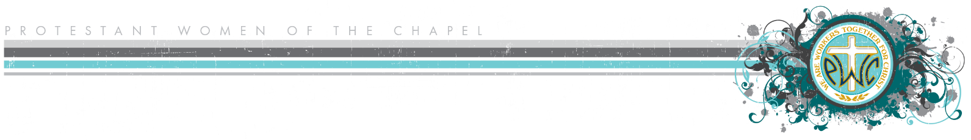

**Annual Board Position After Action Report**

**Dates of Service:**

**Name and Board Position:**

1. **Job description as written in the PWOC Ministry Manual:**
2. **Job description as you lived it (include average hours per week):**
3. **Key team members and other contacts:**
4. **What went well in your position this year?**
5. **What problems did you encounter this year?**
6. **What recommendations would you make to your successor?**
7. **What recommendations would you make to next year’s Board?**
8. **Share any spiritual lessons you learned from your service this year:**