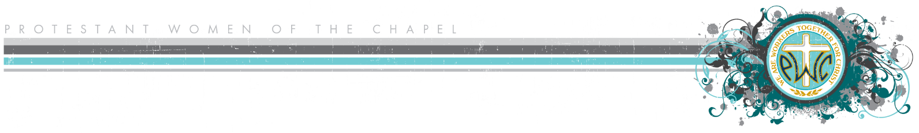

**Privacy Act Statement**

Include the following statement and note at the top of all rosters, directories, or other documents that include personal information such as addresses, phone numbers, email addresses, and other forms of contact. This includes rosters created through the Participation Board position, by class facilitators, or any other PWOC representative.

**Privacy Act Statement:** *This roster is to provide information for social and ministry functions within Protestant Women of the Chapel and the greater Military Chapel Community. Information furnished within this roster may not be disclosed to individuals not associated with PWOC. It may not be used to disseminate non-PWOC information, to promote a personal business, to recruit for another organization, to advertise for an event, or for any other non-PWOC-related purpose.*