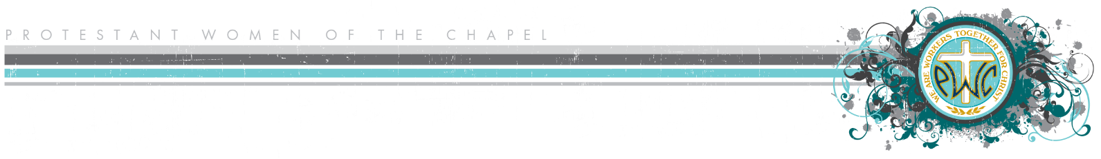
PWOC Leadership Interest Survey

EXECUTIVE BOARD POSITIONS
These five positions go through an application and leadership selection interview process

- President Interested in the Board position Have experience
Models servant leadership. Works directly with the PWOC Chaplain Sponsor. Leads the Board and the PWOC body to see and do the will of God, personally and corporately. Provides vision and guidance to create an environment that carries out the Aims of PWOC and the PWOC Chaplain Sponsor’s vision. Represents PWOC in the Chapel Community and broader Military Community.
- 1VP Spiritual Life Interested in the Board position Have experience Would like to be on the team
Prayerfully selects Bible studies in line with the Four Aims and the yearly theme or vision. Selects, trains, and equips Bible study Facilitators. Oversees weekly devotions for the PWOC body. Works with the President to support an environment for intentional spiritual growth.
- 2VP Programs Interested in the Board position Have experience Would like to be on the team
Plans and executes Programs in line with PWOC’s Four Aims and the yearly theme or vision, for the spiritual growth and enrichment of PWOC participants and their guests.
- Administrative Coordinator Interested in the Board position Have experience
Provides the communication structure to support spiritual growth within the PWOC community—first to the Board and then to the body. Coordinates all arrangements for Board Meetings and other Board events under the guidance and direction of the President. Cooperates with Publicity to manage social media outlets.
- Financial Liaison Interested in the Board position Have experience
Coordinates financial transactions for PWOC in accordance with local regulations under the guidance of the Resource Manager.
APPOINTED BOARD POSITIONS
These positions are appointed by the new President with the approval of the Executive Board

Hospitality Interested in the Board position Have experience Would like to be on the team
Fosters a friendly, welcoming environment at PWOC. Helps create meaningful fellowship time, typically with refreshments, for women to connect with God and with each other.
Inreach Interested in the Board position Have experience Would like to be on the team
Coordinates ministry projects or activities that meet practical needs within the PWOC body and that help women make meaningful social connections—both during and outside of a normal PWOC meeting.
Leadership Selection Interested in the Board position Have experience Would like to be on the team
Works with the PWOC Chaplain Sponsor and the Leadership Selection Team to prayerfully select the new Executive Board for the upcoming PWOC year, following the leadership selection process.
Leadership Trainer Interested in the Board position Have experience Would like to be on the team
Creates opportunities for leaders to grow in their leadership knowledge and skills—especially focusing on PWOC Board members, but also helping to identify potential leaders in the PWOC body.
Outreach Interested in the Board position Have experience Would like to be on the team
Coordinates ministry projects to meet physical and spiritual needs in the wider Military Community. May cooperate with the outreach efforts of a military chapel or other ministry.
Participation Interested in the Board position Have experience Would like to be on the team
Welcomes regular attendees and newcomers to PWOC each week. Fosters a sense of belonging. Keeps attendance records and participant information.
Praise & Worship Interested in the Board position Have experience Would like to be on the team
Leads her team and the PWOC body in corporate worship that exalts God and helps women connect meaningfully with Him. Selects music representing a variety of worship styles to honor the diversity in the PWOC body.
Prayer Interested in the Board position Have experience Would like to be on the team
Prays over the PWOC Board and body. Models how to pray using a variety of approaches. Offers opportunities for women to connect with God through prayer.
Publicity Interested in the Board position Have experience Would like to be on the team
Publicizes PWOC through all lines of communication in the Chapel Community and the greater Military Community. Cooperates with the Administrative Coordinator to manage social media outlets.
Retreats & Events Interested in the Board position Have experience Would like to be on the team
Plans and executes events as requested by the President—from smaller events lasting only a few hours, to large-scale, multiple-day retreats. Coordinates all aspects of the event from start to finish. Creates the space for women to break away from everyday life for intentional, spiritual development.
Titus 2 Interested in the Board position Have experience
Serves as an advisor to the President and Board—bringing spiritual insight, maturity, strength of character, sound judgment, wisdom, and a heart for the ministry of PWOC. Leads and teaches the women in the PWOC body as requested by the President. Prayerfully intervenes in sensitive situations, conflict resolution, and in addressing behavior inconsistent with biblical standards.
Watchcare Coordinator Interested in the Board position Have experience Would like to be on the team
Oversees the children’s program for PWOC, ensuring safety and spiritual care, in alignment with local and federal policy. Provides age-appropriate activities for children so they can enjoy their time at PWOC.

Name: ___________________________________________________________________________
Email: ___________________________________________________________________________
Phone: __________________________________________________________________________

