

Actions

&

Themes

Scripture

Needs

Issues

Our Vision

Phase 1: Executive Board Research

*President Meets with Chaplains*

Phase 2: Full Board Brainstorm

*First Vision Quest Meeting*

Phase 3: Full Board Application

*Second Vision Quest Meeting*

*What is the Senior Chaplain’s vision for PWOC?*

*What is the PWOC Chaplain Sponsor’s vision for PWOC?*

*What are the major issues facing our PWOC community? Group similar issues. (Aim for 3.)*

*How would each of these issues be answered or met? What do they need from Christ?*

*What Scriptures address these 3 needs AND the Chaplains’ vision? Which one does it best?*

*What actionable words and themes can be drawn out of the Scripture? Create a tagline.*

Chaplain

Sponsor

Vision

Senior

Chaplain

Vision

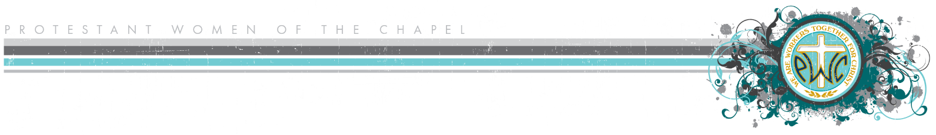

**Vision Quest (Theme Development) Worksheet**