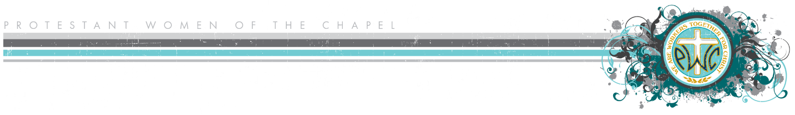

**Photo Release Form**

**Name of Local Military Installation: ___________________________________________**

**Ministry Years: 20______- 20______** (June 1-May 31)

I grant PWOC the right to take pictures/videos of me in connection with PWOC activities. I authorize PWOC to use and publish my picture in print and/or digitally, through social media or other online venues.

***Note:*** *If you do not want your picture taken or published, please make that clear to the Participation Board member so she can pass your preferences along to key Board members.*

**I have read the statement above and agree:**

|  |  |
| --- | --- |
| **Printed Name** | **Signature** |
|  |  |
|  |  |
|  |  |
|  |  |
|  |  |
|  |  |
|  |  |
|  |  |
|  |  |
|  |  |
|  |  |
|  |  |
|  |  |
|  |  |
|  |  |
|  |  |
|  |  |
|  |  |
|  |  |
|  |  |
|  |  |
|  |  |
|  |  |
|  |  |
|  |  |
|  |  |
|  |  |
|  |  |