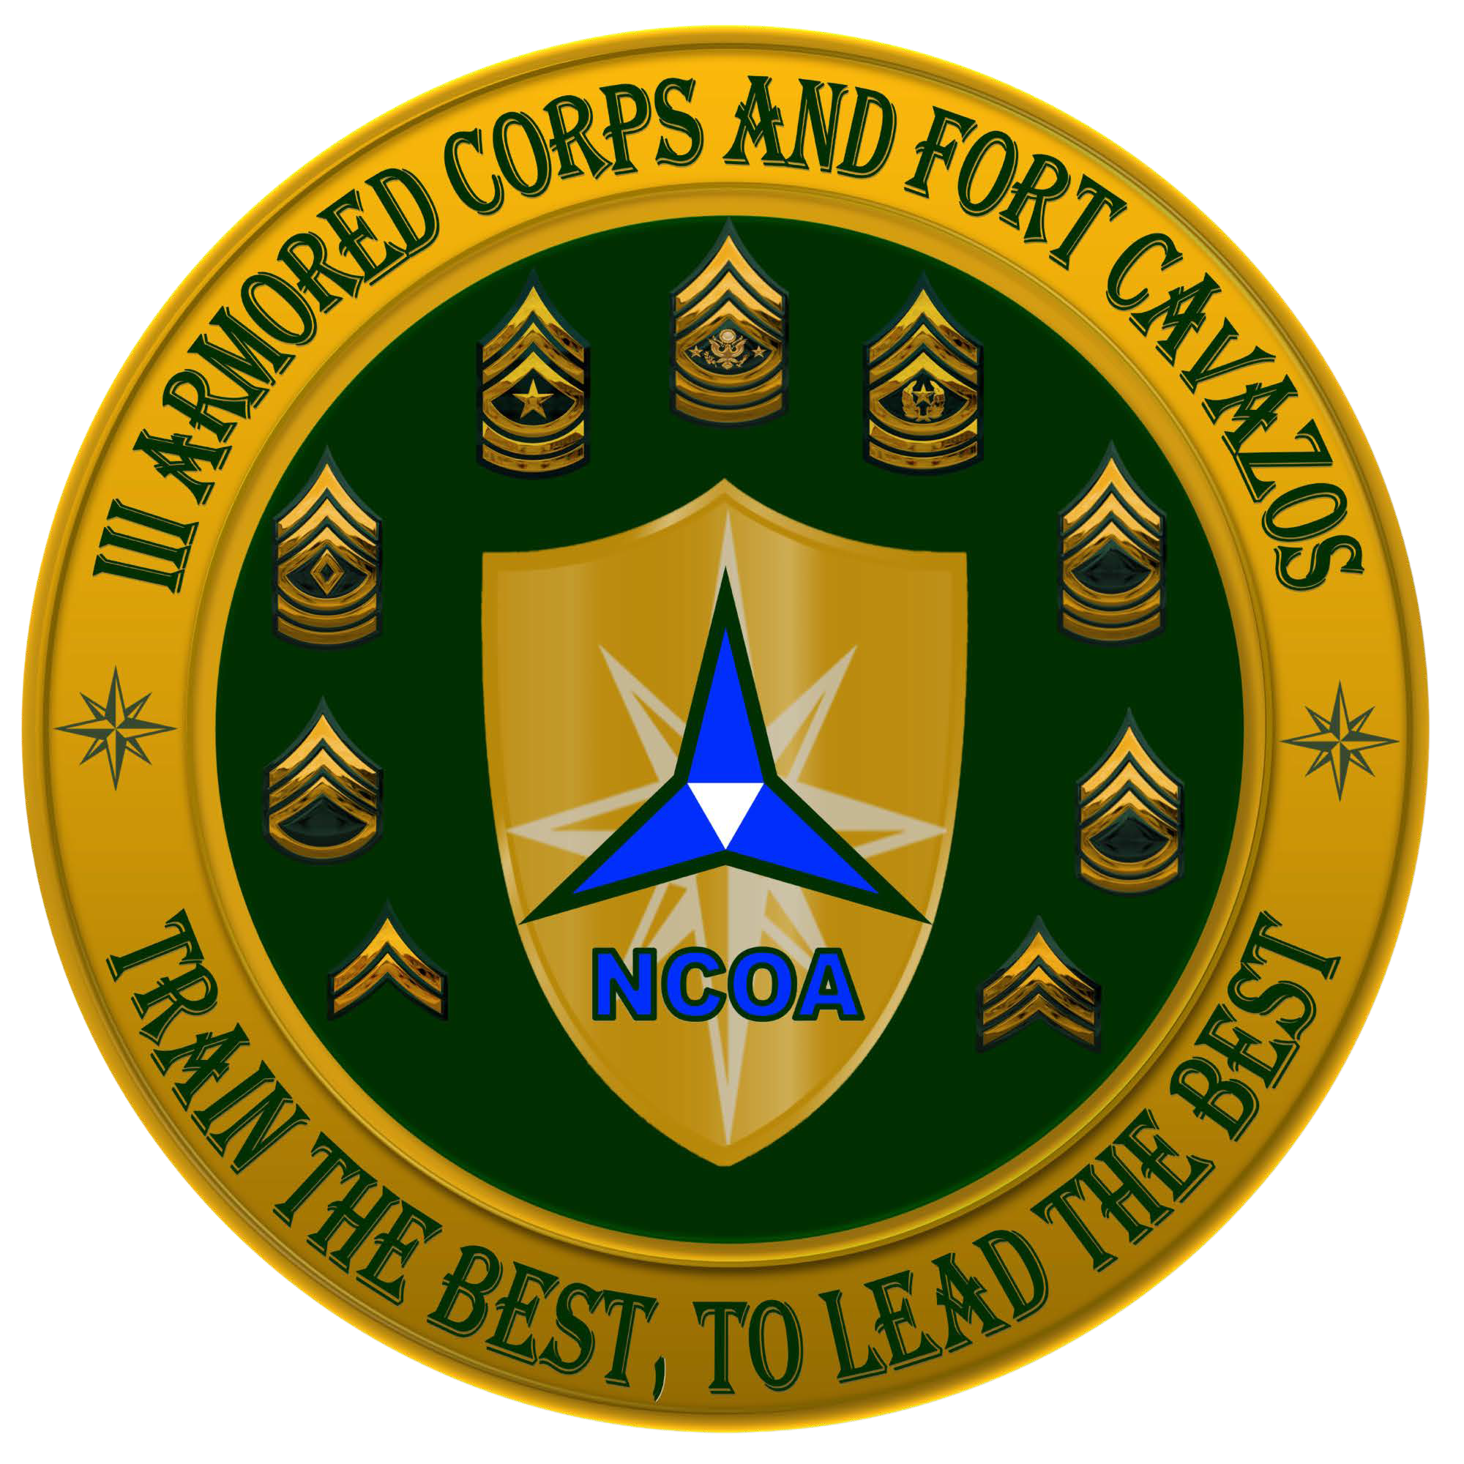IIIAC and FORT CAVAZOS NCO ACADEMY BLC PACKET

As of 12 November 2023

SOLDIER: RANK: NAME: SOLDIER AKO EMAIL: SPONSOR: RANK: NAME: 1SG PHONE #: SPONSORS PHONE #:

COMPANY: , BN: , BDE:

BLC Class #: SCHOOL START DATE: ATRRS

|  |  |  |  |  |
| --- | --- | --- | --- | --- |
|  |  | WALK-ON |  | (CHECK ONE) |

Fort Cavazos NCOA website: https://home.army.mil/cavazos/units-tenants/iii-corps/iii-armored-corps-nco-academy

**NOTE:** ATTRS PACKETS ARE SUBMITTED DIGITALLY

**THE FOLLOWING DOCUMENTS MUST BE COMPLETE AND DIGITALLY SIGNED:**

* UNIT PRE-EXECUTION CHECKLIST - Signed by Company CDR (TRADOC Form 350-18-2-R-E, APR 18)
* DA FORM 705 - ACFT CARD (within 60 Days of BLC report date)
* DA FORM 5500 / 5501 BODY FAT CONTENT SHEET (if applicable within 60 Days of BLC report date)
* BLC PACKING LIST with Chain of Command's signatures

**THE FOLLOWING DOCUMENTS MUST BE** [**INCLUDED IN THE DIGITAL PACKET AS AN**](https://home.army.mil/cavazos/units-tenants/iii-corps/iii-armored-corps-nco-academy) **ATT**[**ACHMENT:**](https://home.army.mil/cavazos/units-tenants/iii-corps/iii-armored-corps-nco-academy)

* STP (updated and within 30 days)
* SSD1 / DLC1 CERTIFICATE (DA Form 87)
* PERMANENT PROFILE / MEDICAL WAIVER (if applicable)
* COPY OF DD FORM 1610 (TDY only)

**I have reviewed the contents of this packet and all information is correct and true:**

|  |  |  |  |
| --- | --- | --- | --- |
| **POSITION** | **LAST NAME, FIRST** | **SIGNATURE** | **DATE** |
| **Soldiers Name** |  |  |  |
| **Sponsors Name** |  |  |  |
| **First Sergeants Name** |  |  |  |
| **BN Schools NCOIC** |  |  |  |
| **OPS SGM Name** |  |  |  |
| **CSM Name** |  |  |  |

**The Fort Cavazos NCOA receives all digital packets from IIIAC G-3 Schools. The NCOA will only accept digital packets from Corps G-3 Schools. It is the responsibility of the Soldiers' organization to conduct a follow up on their Soldiers digital packet.**