Press Release
Release Nr: 2305-01
May 4, 2023
Fort Drum Public Affairs

Rolling Power Outages Exercise Fort Drum Emergency Plans

Fort Drum, NY – Individuals who work and live on the installation will experience rolling power outages over the next two weeks as emergency planners and repair teams exercise responding to electrical issues.

Fort Drum leaders encourage those affected to use this installation event as an opportunity to ensure your home is well stocked ensuring life, health, and safety concerns during a power outage are recognized and mitigated in advance of an emergency. Visit www.ready.gov/power-outages for useful tips.

While most outages are only expected to last a short time, some will extend over several hours. The power disruptions will be advertised via installation communication platforms with as much notification as possible. If you could be affected by the outages, you are encouraged to connect with us via the following command-sponsored information resources for updates (NOTE - ALERT! Message sign-up is only available to DOD ID card holders):

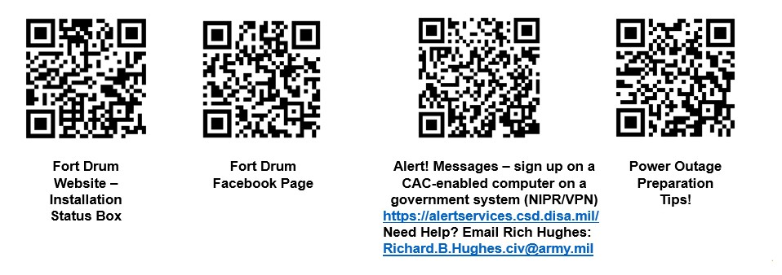

Media with inquiries regarding this press release should contact Fort Drum Public Affairs, Julie Halpin, julie.a.halpin2.civ@army.mi, 315-772-8286.

XXX

