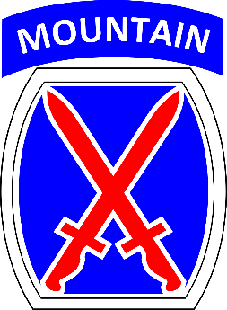10th Mountain Division   
Public Affairs  
315-804-0262  
August 5th, 2021

**MEDIA ADVISORY**

**10TH CAB INVITES THE PUBLIC TO VIEW TRAINING AT GRIFFISS AIRPORT**

**NEW YORK—**Members of the community will have the chance to view U.S. Army AH-64s and UH-60s, commonly referred to as Apache and Black Hawk helicopters. Aircraft from the U.S. Army’s 10th Mountain Division conduct summer training while based temporarily in Rome, NY. The exercise, known as *Falcon Peak,* will take place the week of August 8th through August 13th. During that time, the community can expect an increase in aircraft traveling from Rome, NY to the Adirondack mountain region.

“We’re incredibly lucky to live in this great North Country community,” said Col. Travis L. McIntosh, commander of the 10th Combat Aviation Brigade, 10th Mountain Division. “The diverse terrain of Northern New York provides ample opportunity for us to safely train our aircrews with minimal impact on the community.”

What: Members of the media and the public are invited to view U.S. Army AH-64s (Apaches) and U.S. Army UH-60s (Black Hawks) as 10th Combat Aviation Brigade, 10th Mountain Division conducts summer training.

When: Thursday, August 12th from 9 A.M. to 12 P.M.

Who: U.S. Army Colonel Travis L. McIntosh, 10th Combat Aviation Brigade, 10th Mountain Division, U.S. Army, will be available to take questions about the unit and its training.

Where: Griffiss International Airport in Rome, NY.

Why: 10th Combat Aviation Brigade will conduct flight operations and training in order to build proficiency as Army Aviators and prepare for future combat. The aviation brigade deploys all over the world, therefore its training must be tough, realistic, and adaptable for any environment.

How: Members of the media and the public interested in attending the viewing should register with 10th Combat Aviation Brigade Public Affairs Officer, U.S. Army Captain Veronica Bean at [veronica.bean2.mil@mail.mil](mailto:veronica.bean2.mil@mail.mil), 315-804-0262 no later than noon on Wednesday, August 11th. Registered parties should meet at the entrance of Million Air Rome (660 Hangar Rd, Rome, NY 13441) no later than 0845 on August 12th.

The U.S. Army’s 10th Mountain Division is one of the Army’s most heavily deployed divisions, and the 10th Combat Aviation Brigade is frequently one of the first aviation units into theater. Learn more about the men and women who serve in the U.S. Army’s 10th Combat Aviation Brigade, 10th Mountain Division here: <https://www.facebook.com/10thcab>.