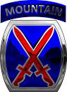**NEWS RELEASE**

Public Affairs Office

10th Mountain Division (LI)

FORT DRUM, NEW YORK 13602-5007

# Telephone: (315) 772-5924

After Hours: (315) 836-6594

Email: [harold.huff16..mil@mail.mil](mailto:harold.huff16..mil@mail.mil)

MEDIA RELEASE Release Number: 2005-04

May 21, 2020

10th Mountain Division’s 2nd Brigade Combat Team Changes Leaders

Fort Drum, N.Y. – The 10th Mountain Division held a modified change of command ceremony for 2nd Brigade Combat Team, May 21 at Memorial Park on Fort Drum, N.Y.

After two years in command, Col. Paul L. Larson, the brigade commander, relinquished command to Col. Damon K. Harris who joins the brigade from Forward Operating Base Fenty, Afghanistan.

“It’s a big day for the Commandos. Truly everyone knows what this great brigade has done over the past two years; continues to answers the call, continues to accomplish every designated mission that this country has asked of it and done so with honor,” said Brig. Gen. Brett Funck, 10th Mountain Division Senior Mission Commander.

Col. Harris commissioned as a second lieutenant into the infantry branch in May of 1997 from Alcorn State University.

Col. Harris’ deployments include Operation Iraqi Freedom (Iraq), Operation Enduring Freedom (Afghanistan), and Operation Resolute Support (Afghanistan). He has earned a Bachelor of Science degree in agronomy from Alcorn State University and Master's degree in Strategic Plans and Polices from the National War College.

Awards and decorations for Col. Harris include the Bronze Star Medal (with oak leaf), Defense Meritorious Service Medal, Meritorious Service Medal (with 4 oak leaf clusters), Joint Service Commendation Medal, Army Commendation Medal, Navy Commendation Medal, Joint Service Achievement Medal, Army Achievement Medal (with 2 oak leaf clusters), Expert Infantryman’s Badge, Combat Infantryman’s Badge, Senior Parachutist Badge, and Ranger Tab.

Media with inquiries regarding this press release should contact 10th Mountain Division Public Affairs Officer, MAJ Harold Huff at (315)772-5924 or email at Harold.huff16.mil@mail.mil.

-30-

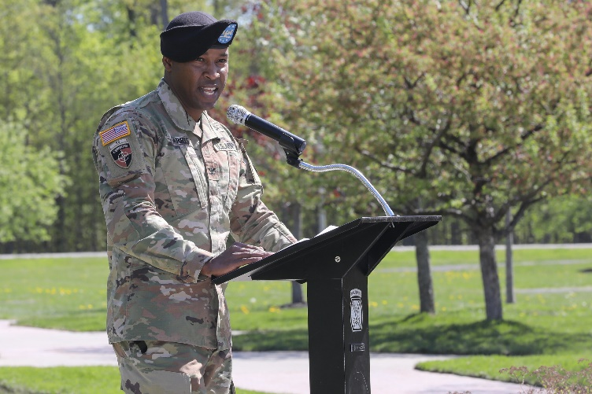

The 2nd Brigade Combat Team, 10th Mountain Division held a Change of Command Ceremony 21 May at Memorial Park on Fort Drum, N.Y. Brig. Gen. Brett Funck, Deputy Commanding General of the 10th Mountain Division and Fort Drum, presided over the ceremony where Col. Paul Larson relinquished command to Col. Damon Harris.

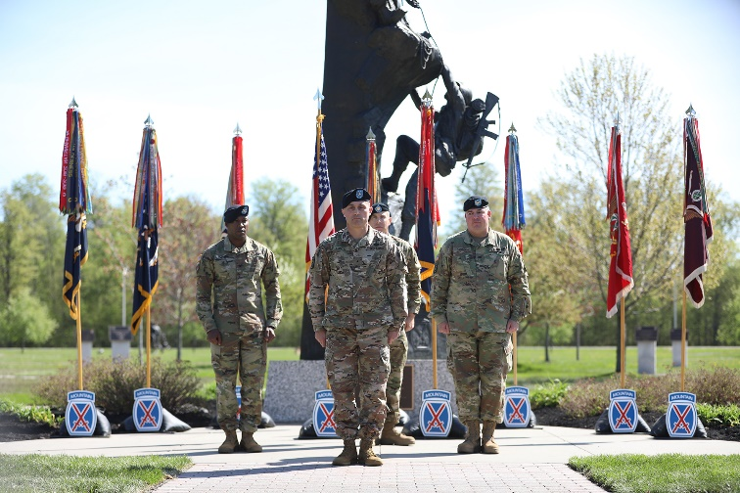

The 2nd Brigade Combat Team, 10th Mountain Division held a Change of Command Ceremony 21 May at Memorial Park on Fort Drum, N.Y. Brig. Gen. Brett Funck, Deputy Commanding General of the 10th Mountain Division and Fort Drum, presided over the ceremony where Col. Paul Larson relinquished command to Col. Damon Harris.

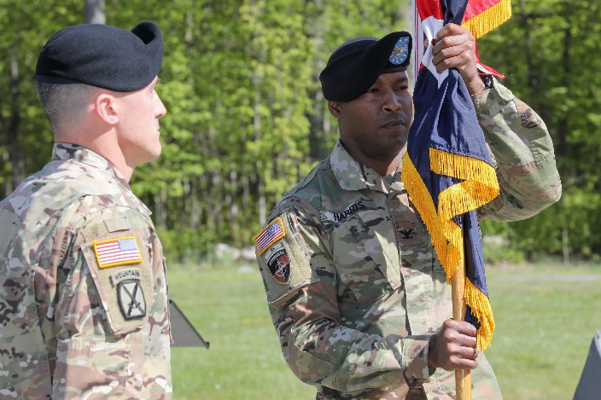

Col. Damon Harris (right), 2nd Brigade Combat Team Commander, holds the colors during the 2nd BCT Change of Command Ceremony 21 May at Memorial Park on Fort Drum, N.Y.