DEPARTMENT OF THE ARMY
US ARMY INSTALLATION MANAGEMENT COMMAND
(use your units letter head)

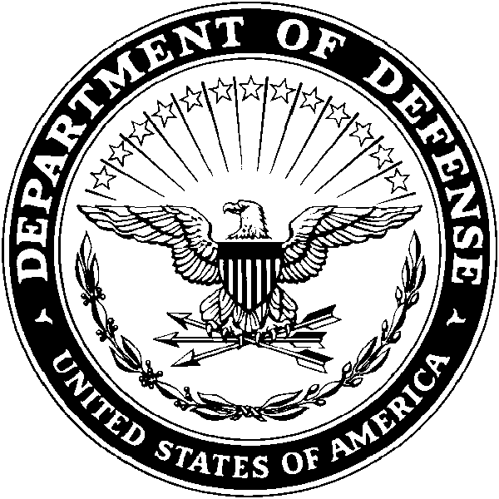
(Unit Office Symbol)

MEMORANDUM FOR USAG Daegu, DPW, ATTN: Environmental Division

SUBJECT: Environmental Officer Duty Appointment

1. Effective (enter Date), the below listed personnel received appropriate training and are assigned as Environmental Officer (EO) for (enter Unit, Installation and Building Number)

Primary: (enter Name and Rank)
DSN: (enter phone) E-Mail: (enter e-mail address) DEROS:

Alternate: (enter Name and Rank)
DSN: (enter phone) E-Mail: (enter e-mail address) DEROS:

2. Authority: AR 200-1,

3. Purpose: To assist the Unit Commander in meeting the environmental requirements of the assigned unit; including, but not limited to the implementation of the unit’s Environmental programs. The EO will be the point of contact within the assigned unit for environmental concerns and will distribute information and knowledge to all personnel within the unit concerning environmental issues.

4. Period: Until officially relieved or released from appointment.

5. POC for this memorandum is the undersigned at XXX-XXXX

(enter Commander’s or Supervisor’s Name)
(enter Rank or Grade)
(enter Unit)

What is an EO?
An EO is a person within a unit or organization appointed to ensure that environmental compliance requirements are met. The EO also coordinates with the DPW Environmental Division to clarify requirements or for assistance.

All organizations within the USAG - Daegu footprint must formally appoint an EO or Environmental POC using the EO Command Appointment Template within 90 days of being assigned environmental duties. This form must be returned to the DPW Environmental Division via e-mail or by hand.
EO Training
Appointed EO's must complete EO Training Course before or at the first opportunity after being appointed. To schedule attendance at this class, contact the Environmental Division. The course is offered several times a year. Specific dates and information are available from the Environmental Division. Until completion of the EO Course, the new EO contact the DPW Environmental Office to obtain basic guidance and reference materials.
EO Responsibilities

Reference:

- AR 200-1, Environmental Protection and Enhancement, 13 Dec 2007

- FM 3–34.500, Environmental Considerations, Feb 2010

- US Army Garrison (USAG) Daegu Policy Letter 18-31, Environmental Inspection and Assessment Policy
The environmental officer manages environmental issues within the unit and ensures environmental compliance. He or she also coordinates through the respective chain of command with the supporting installation environmental staff to clarify requirements and obtain assistance.

While this position of responsibility is not a formal staff position, the environmental officer is critical to the commander’s environmental program. The environmental officer—

- Advises the unit on environmental compliance during training, operations, and logistics functions.

- Ensure training for all unit personnel regarding installation environmental programs, policies and procedures, as well as any unit level procedures necessary to comply with installation policies.

- Advises and updates the commander on the unit’s environmental consideration integration and performance standards.

- Ensure compliance with Environmental requirements and conform to Garrison Environmental policies and procedures including Pollution Prevention, Recycling, Energy conservation, and Natural Resource Protection.

- Inform the commander, director or supervisor of any environmental problems, issues, potential violations, or legalities.

- Serve as a Cross-functional Team (CFT) member and attend special meetings or training sessions that may be coordinated during the year by DPW, Environmental Division.

- Updates and maintains the environmental portion of the SOP.

- Ensure proper management of hazardous materials, hazardous waste, and follow proper Standard Operating Procedures (SOP).

- Coordinates between the unit and higher/installation headquarters environmental staffs.

- Ensure any changes in policy, procedures and environmental information are disseminated to all levels within the organization.

- Manages information concerning unit environmental training and certification requirements.

- Conducts unit environmental self-assessments.

- Conducts environmental risk assessments.

- Submit a Unit Corrective Action Plan (UCAP) to the DPW Environmental Division within ten working days after receipt of inspection results and findings. UCAPs are maintained as part of the inspection record for three (3) years.

- Ensure required record and documentation is maintained.

- Serves as the SME to the commander on the integration of environmental considerations into OPLANs/OPORDs.

- Implement improvements Pollution Prevention (P2) Initiatives.

