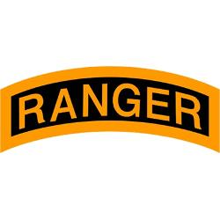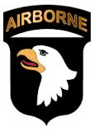**101st ABN DIV (AASLT)**

**Pre-Ranger Course**

**PRC Packet**

**NAME__________________ SSN____________**

**UNIT______________________________________**

**PRC Required Documents**

* **FC Form 4137 for PRC**
* **DA 4187 for PRC BAS Recoupment**
* **Ranger Physical (Signed DD 2807, 2808, Hearing Sheet, Copy of Labs)**
* **1610s (DTS travel orders)**
* **Commander’s Proficiency Memo**
* **Signed Ranger School Packing List**
* **SRB / ORB, IPPS-A Talent Profile (With in 6 Months)**
* **DD 93 and SGLV (With in 6 Months)**
* **Airborne Orders and Certificate (If Applicable**
* **Immunization Records**