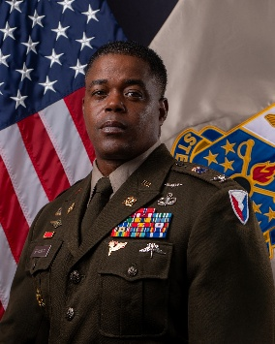
Colonel Ken Monroe was commissioned as a Quartermaster Officer and awarded a Bachelor of Science Degree in Biology from NC A&T State University. COL Monroe is a native of Elizabethtown, NC and holds a Master of Business Administration from Webster University, and a Master of Strategic Studies from the United States War College.
His command assignments include Commander of the 189th Division Sustainment Support Battalion, 82nd Sustainment Brigade, Fort Bragg, NC where he supported multiple operational objectives and efforts; Commander, C Company, 1st Special Warfare Training Center, Fort Bragg, NC; Additionally, COL Monroe has deployed twice to Afghanistan, twice to Iraq, Poland, and served in NATO with the NATO Rapid Deployable Corps-Turkey.
COL Monroe’s key staff assignments include Clothing and Textiles Supply Chain Director, DLA Troop Support in Philadelphia, PA; Aide-de-Camp to the Commanding General, United States Army Materiel Command at Redstone Arsenal, Alabama; Special Assistant to the Director of Army Staff in Washington, D.C.; Logistics Operations Officer, Deputy Chief of Staff, Army G-3 Operations Directorate; Executive Officer / Support Operations Officer / Group S-4, 3rd Special Forces Group Support Battalion at Fort Bragg, NC; Logistics Operations Officer in Special Activities and Programs, United States Army Special Operations Command at Fort Bragg, NC; Plans Officer in 3rd Infantry Division, Sustainment BDE at Fort Stewart, GA.
His military education includes the Quartermaster Officer Basic Course, the Combined Logistics Captains Career Course, United States Army Command and General Staff College, The Joint and Combined Warfighting School (JPME-II), and the United States Army War College.
COL Monroe’s awards and decorations include the Legion of Merit, Bronze Star Medal, the Defense Meritorious Service Medal with one Bronze Oak Leaf Cluster, the Meritorious Service Medal with three Bronze Oak Leaf Clusters, OIF and OEF Campaign Medals, Master Parachutist Wings, Military Freefall Wings, Pathfinder Badge, and Parachute Rigger Badge.
COL Monroe is married and has two sons.

