Ordnance Technical Data Sheet
U.S. LANDMINE, PRACTICE, M1 & M1B1

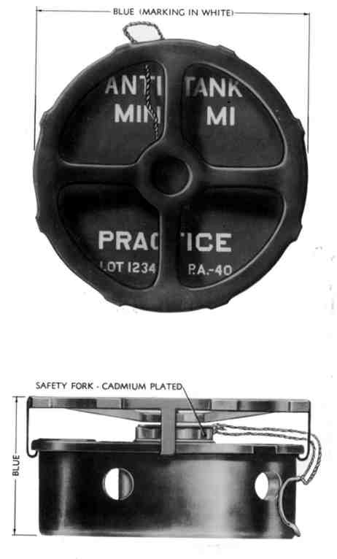 | 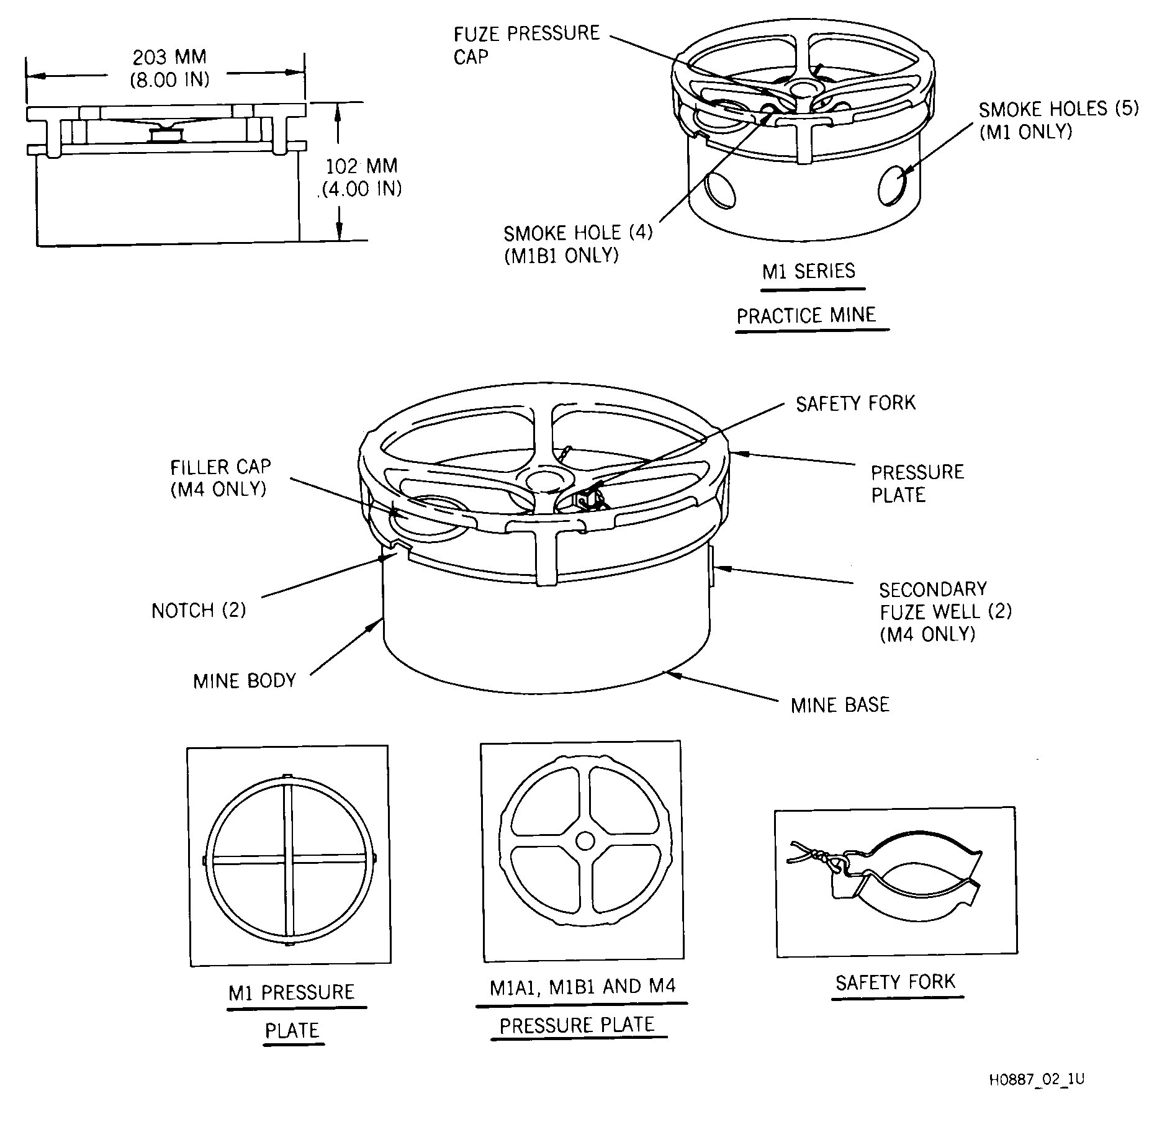
Nomenclature | PRACTICE, M1 & M1B1
Ordnance Family | Landmines
DODIC | Not Provided
Filler | Red Phosphorus
Filler Weight | 11.00 g
Item Weight | 4.80 kg
Diameter | 203.00 mm
Length | 102.00 mm
Maximum Range | Not Provided
Fuze | Manually armed, pressure-actuated
Usage | The M1 and M1B1 are practice landmines. All these mines have manually armed, pressure-actuated fuzes. The practice mines have smoke charges incorporated into the fuze.
Description | Tactical mines are painted olive drab (OD) with identifying markings stenciled in yellow on the top of the mine. Some older models have the base and a 19 mm (0.75 inch) band on the side painted yellow; the rest of the mine is painted olive drab. Practice mines are painted blue with identifying markings and the word PRACTICE stenciled in white on top of the mine.
Reference | ORDATA online

