Ordnance Technical Data Sheet
U.S. FLARE, TRIP, M48

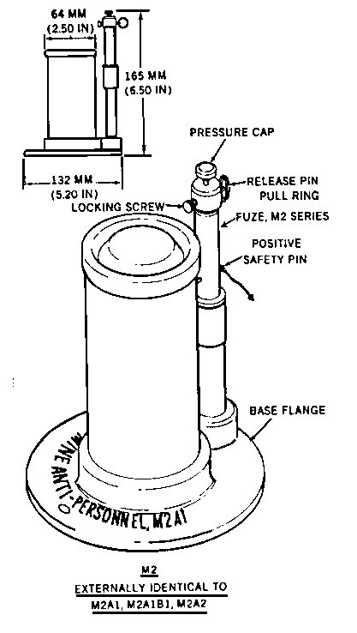 |  | 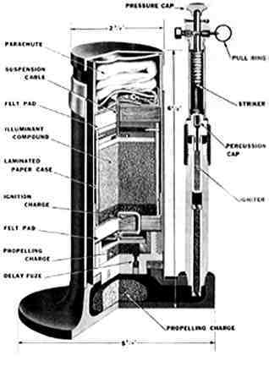
Nomenclature | TRIP, M48
Ordnance Family | Flares
DODIC | Not Provided
Filler | Single Composition, green
Filler Weight | 1.00 g
Item Weight | Not Provided
Diameter | 63.50 mm
Length | Not Provided
Maximum Range | Not Provided
Fuze | Not Provided
Usage | The flare is used to give warning of enemy marauders or infiltrating hostile troops; also for illuminating or signaling.
Description | The case is White to yellowish.
Reference | ORDATA online

