

US Army Corps of Engineers

Tulsa District

Draft Final

Work Plan:

Cleanout of Detention Basin and Associated Drainage Structures

Castner Range

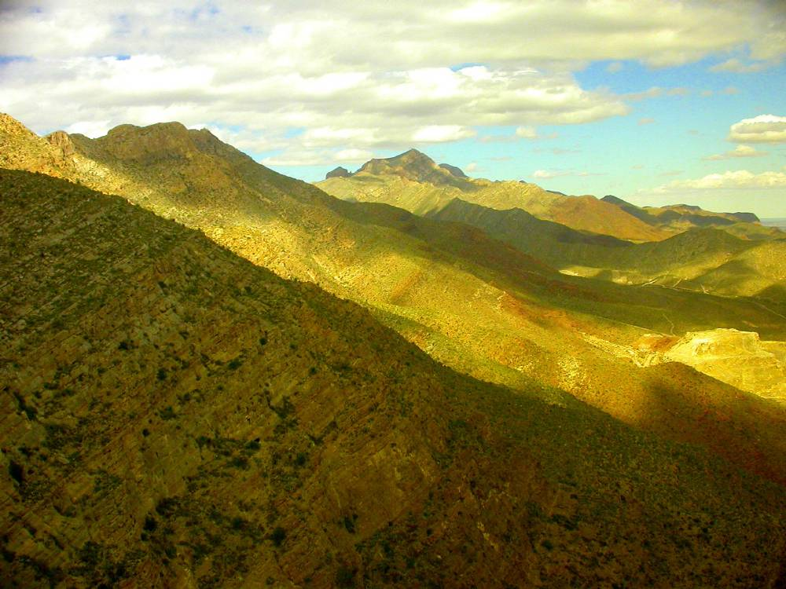
Fort Bliss Military Reservation

Prepared by the US Army Corps of Engineers Tulsa District
June 2008

Executive Summary

This work plan serves to provide a brief technical approach outlining the activities necessary to cleanout sediments and debris from an existing detention basin. This document also presents unexploded ordnance (UXO) construction safety support activities necessary to mitigate or reduce potential risk associated with munitions and explosives of concern (MEC) associated with sediments and stormwater runoff from a former military firing range, Castner Range, located upgradient of the detention pond. Castner Range occupies approximately 8000 acres and is located approximately 5 miles northwest of Fort Bliss Military Reservation, Texas

Castner Range is located within the northern limits of the city of El Paso, El Paso County, Texas. The range is bordered on three sides by residential and commercial development (North (North Hills Subdivision), East (US Highway 54), and South (Hondo Pass Road)) and on the west by the Franklin Mountains State Park, making unauthorized access to the range easy.

Table of Contents

1.0 Introduction 3
1.1 Overview 3
1.2 Project Scope and Objectives 3
1.3 Project Organization 3
2.0 Field Activities 3
2.1 Site Preparation and UXO Clearance 3
2.2 Sediment Removal and Relocation 3

List of Figures

Figure 1 – Castner Range Detention Basin, General Site Location 3
Figure 2 – Castner Range Detention Basin, Site Features 3

List of Appendices

Appendix A – UXO Support Safety Plan (USSP)

Acronyms and Abbreviations

MEC munitions and explosives of concern
PM project management
SOPs standard operating procedures
TM technical management
TXDOT Texas Department of Transportation
USACE U.S. Army Corps of Engineers
UXO unexploded ordnance

- Introduction

Overview
Recent storm events and associated stormwater runoff have deposited several cubic yards of sediments in a detention basin currently maintained by the State of Texas Department of Transportation (TXDOT). The detention basin is located in El Paso, Texas along the base of the Franklin Mountains. The basin lies downgradient of Castner Range, a former military firing range utilized by Fort Bliss Military Reservation and adjacent to North Hills Subdivision.

Due to the nature of the sediments and the possibility that MEC may have been washed off Castner Range and accumulated in the detention basin, the State of Texas has requested support to safely remove the sediments in order to maintain the effectiveness of the detention basin.

Project Scope and Objectives
The purpose of this work plan is to provide a brief technical approach outlining the activities necessary to cleanout sediments and debris from a detention basin and drainage structures.

The detention basin is actually composed of a sediment control pond and detention pond. The mouth of the detention basin appears to be constructed of gabions (filled with rocks) or covered with wire anchorings. A stone or concrete drainage structure has been constructed along the western edge of the basin and allows for stormwater to drain towards the basin. Figure 1 illustrates the general location of the detention basin.

This document presents UXO construction safety support activities necessary to mitigate or reduce potential risk associated with MEC associated with sediments and stormwater runoff from Castner Range.

TXDOT and their contractors will provide all construction support and supplies necessary to remove the sediments from the detention basin as well as conduct repairs to the associated structures as needed. The US Army has requested the assistance of the US Army Corps of Engineers (USACE) to provide UXO construction safety support throughout the duration of the construction activities. USACE, Huntsville District will provide personnel certified to serve as UXO team. USACE, Tulsa District will provide program management support as needed for the project.

Figure 1 – Castner Range Detention Basin, General Site Location

Project Organization
The project team consists of employees from TXDOT, US Army (Fort Bliss Military Reservation) and USACE. The project team consists of the following personnel:

TXDOT | James Stevenson | 915-790-4360
TXDOT | Roberto P Saenz | 915-757-5920
TXDOT Construction Contractor; Cleanserve Inc. | Ronnie Norwood | 713-725-2244
US Army Fort Bliss DPW | Kelly Blough | 915-568-0794
US Army Fort Bliss DPW Contractor; ASIS | Ron Baca | 915-568-7979
US Army Corps of Engineers;  Huntsville (UXO Support) | John Younghans | 256-895-1415
US Army Corps of Engineers;  Tulsa District (PM Support) | Rick Smith | 918-669-4956
US Army Corps of Engineers;  Tulsa District (TM Support) | Christopher Kennedy | 918-669-7072

- Field Activities

2.1 Site Preparation and UXO Clearance

All MEC project activities will conform to the requirements of the USACE EP 75-1-2 Munitions and Explosives of Concern Support During Hazardous, Toxic, and Radiological Waste and Construction Activities and with USACE EM 385-1-1 Safety and Health Requirements Manual

Prior to the execution of any construction activities, representatives of the US Army, USACE, and TXDOT will identify the perimeter of the work zone, the area where the sediments are to be removed from, the area where the sediments are to be placed and planned traffic routes/corridors. In accordance with the UXO Support Plan (USSP) addressed within this work plan, an OE Safety Specialist will be on site to observe the operation IAW EP 75-2-1, Chapter 6, paragraph 6-6 Standby Support.

Figure 2 outlines the approximate boundary of the work zone, the location of heavy sedimentation, the disposal area for the sediment, and the area where UXO clearance activities may be focused.

2.2 Sediment Removal and Relocation

Sediments will be removed from the drainage structures and sediment control pond of the basin by heavy equipment (backhoe, front end loader, bobcat) and/or by hand (shovel). Sediments will be removed in lifts not exceeding 12 inches in depth allowing the Safety Specialist to monitor the excavation activities. Care will be taken to not damage the gabion revetment and/or wire anchoring of the basin currently covered by the sediments. When applicable and practical, debris will be removed and set aside for offsite disposal. Construction activities will be conducted in accordance with current TXDOT standard operating procedures (SOPs). The UXO support personnel will observe excavation and hauling operations.

Sediments will be mechanically transported by truck or loader and returned to Castner Range to the approximate location identified within this document. All fills will be placed in lifts not exceeding 12 inches in depth and compacted in accordance with TXDOT SOPs. The slope of the fill surfaces will be no steeper than is safe for the intended use. Fill slopes shall be no steeper than one unit vertical in two units horizontal (50% slope).

Silt fences will be installed to prevent sedimentation in areas adjacent to grading and down gradients into drainage ways.

Figure 2 – Castner Range Detention Basin, Site Features

Appendices

Appendix A

(UXO Support Safety Plan (USSP)

Appendix A: UXO Support Safety Plan (USSP)

FOR THE

Standby Support for the Cleanout of Detention
Basin and Associated Drainage Structures
Castner Range
Fort Bliss Military Reservation
El Paso, Texas

Prepared by: John Younghans

June 2008

INTRODUCTION

The U.S. Army Corps of Engineers, Tulsa District has requested the support of the U.S. Army Corps of Engineering and Support Center, Huntsville (USAESCH) to provide Munitions and Explosives Constituents (MEC) Standby Support for The Cleanout of Detention Basin and Associated Drainage Structures associated with sediment and storm water runoff form a former military firing range, Castner Range, located up gradient of the detention pond.

USAESCH has prepared this appendix to support the Work Plan of US Army Corps of Engineers Tulsa District in support of Ft Bliss, TX.

All site personnel will read and sign this addendum prior to commencement of work and on a daily basis during the on site safety briefing conducted by the OE Safety Specialist.

  - PROJECT DESCRIPTION

The objective of this addendum is for USACE to provide Munitions and
Explosives of Concern (MEC) Standby Support to the Texas Department of Transportation and their contractor (CleanServe) during the removal of silt that has accumulated in the retention pond located on an easement at Ft Bliss (Castner Range)(see attached map).

  - SITE LOCATION

Fort Bliss is located in El Paso Texas. Castner Range is located within the northern limits of El Paso Texas. The range is bordered on three (3) sides by residential and commercial development. To the North is North Hills Subdivisions, to the East is US Highway 54, to the South is Hondo Pass Road, and to the West is Franklin Mountains State Park.

UXO SUPPORT MANAGEMENT PLAN

2.1 GENERAL INFORMATION
2.1.1 Background

This Technical Management Plan describes all the fieldwork steps from mobilization, to silt removal from the retention pond and sequent placement back on Castner Range. The management team will ensure that the objectives of the projects are achieved. The plan is written in a manner that establishes operational and regulatory guidance but allows the site management team to vary operational procedures and work sequences to best accommodate the field effort. Activities described herein are in accordance with the requirements of the U.S. Army Corps of Engineers (USACE). This Technical Management Plan applies only to activities performed by USAESH personnel, the prime contractor (Texas Department of Transportation (TxDOT), and the sub contractor (CleanServe) during the removal of the silt from the retention pond.

2.1.2 Chemical Warfare Materiel (CWM) Discovery

2.1.2.1 General Procedures
Fort Bliss is not suspected of containing CWM however, if suspect CWM is encountered during conventional MEC operations, all operations will be halted and all personnel will immediately withdraw upwind from the work area, contact the contracting officer, and call Fort Bliss emergency response. Personnel will secure the area and provide two personnel located upwind of the suspect CWM to secure the site until relieved by the onsite Technical Escort Unit (TEU). Emergency response personnel, e.g., construction of blast mitigation controls, may require additional support.

PROJECT ORGANIZATION

2.1.3

All equipment will be inspected upon arrival to ensure that it is in proper working order. Any equipment found damaged or defective will be repaired or returned to the point of origin, and a replacement will be obtained. All instruments and equipment that require routine maintenance and/or calibration will be checked initially upon arrival, and then checked again prior to use each day.

2.1.4 Coordination with Local Agencies and Other Contractors

During the course of this project, the USAESCH personnel will coordinate with local service providers and agencies to ensure the availability of resources that may be needed.

USAESCH OE Safety Specialist will conduct a daily safety briefing with the on-site contractors. The following items (not inclusive) are to be covered in the daily safety briefing: ensure communications, both internal and external, are adequate and functional; all personnel are made aware of the emergency route to hospital, hand signal for heavy equipment operators; weather conditions, confirmation of priorities and schedules.

2.1.5 Work Sequence

USAESCH personnel will inspect the proposed area where the soils will be placed prior to placement of silt (see attached map). This area will be inspected periodically during the project to ensure that no MEC was deposited.

In the event that MEC is discovered all operations will be halted, and all personnel will immediately withdraw to a safety area designated in the morning safety briefing. The OE Safety Specialist will determine if the item is acceptable to be moved to an area outside of the construction footprint. If the item is determined to be unacceptable to move then the UXO Safety Specialist will contact the local military EOD unit to respond.

USAESCH Safety Specialist will physically preview the actual construction footprint with the on-site management of the construction contractor and discuss visual observations and potential areas of concern.

Passage way for project vehicles (access and egress) will be inspected to ensure that the path is cleared of all surface debris.

Scrap

Scrap containers, such as 55-gallon drums, will be staged at each site or at a central processing location at the discretion of the USAESCH Safety Specialist and Ft. Bliss DPW-Environmental Division.

