HeliMag Survey Report

**Active Army Military Munitions Response Program**

**Field Demonstration of Wide Area Assessment Methods**

**at Closed Castner Firing Range**

**Fort Bliss, Texas**

**Prepared by:**

Sky Research, Inc.

**Prepared for:**

URS Group, Inc.

**DRAFT FINAL**

**EXECUTIVE SUMMARY**

This report describes the airborne geophysical survey conducted in support of the Active Army Military Munitions Response Program (MMRP) Field Demonstration of Wide Area Assessment (WAA) Methods at Closed Castner Firing Range, Fort Bliss, Texas. This work was performed by Sky Research, Inc. (SKY), under a subcontract from URS Group, Incorporated (URS). The objective of this subcontract was to demonstrate the costs and benefits of applying helicopter-borne magnetometry as a WAA method at an Active Army MMRP site. This project demonstrated helicopter-borne magnetometry as described in the *Wide Area Assessment Cost-Benefit Analysis: Active Army Military Munitions Response Program* conducted by the United States Army Environmental Command (USAEC) in 2007-2008. The goal was to provide the Army with efficient low-altitude digital geophysical mapping (DGM) for ferrous metal detection and feature discrimination to meet the requirements of a Comprehensive Environmental Response, Compensation, and Liability Act (CERCLA) Remedial Investigation (RI).

Sky Research personnel mobilized to El Paso, TX on January 9th and 10th, 2010. Data acquisition started on January 11th and finished, including re-flights, on January 14th, 2010. A total of 1,742 acres of survey data were collected at an average of 435.5 acres per survey day. Although the system performed within established specifications and met the survey data quality objectives, the local geology and vegetation degraded the utility of the final data set. The localized magnetic geologic response was significantly higher than optimal, effectively resulting in increased noise levels. Local vegetation forced the survey to be flown at the upper end of the system’s effective survey altitude envelope in some areas and outside its effective altitude in others. This decreased the received amplitude of the magnetic signal from ferrous material similar in size and shape to the targets of interest.

After data processing, a total of 52,751 anomalies were identified within the survey boundary. Although these anomalies were classified with respect to their apparent size and dipole orientation, separation of geologic anomalies from discrete ferrous objects was not reliably achieved. Anomaly density maps were produced to provide an image of the spatial anomaly distribution over the site. Based upon these results, seven areas of interest (AOIs) were identified by virtue of being indicative of some kind of anthropic activity such as clusters of large discrete dipoles that do not appear ‘natural’, linear features, or elevated anomaly density that is incongruent with the apparent local geologic response.

Much of the survey area was masked by the geologic response and/or contained vegetation that necessitated survey altitudes at greater than the effective altitude of the system. In these areas, the data do not support any conclusions with respect to the density and distribution of ferrous material at the site.

**TABLE OF CONTENTS**

[EXECUTIVE SUMMARY ii](#_Toc264830010)

[Acronyms and Abbreviations v](#_Toc264830011)

[1 Introduction 7](#_Toc264830012)

[1.1 Background and Objectives 7](#_Toc264830013)

[1.2 Scope of Work 7](#_Toc264830014)

[1.3 Site Location and Description 7](#_Toc264830015)

[1.3.1 Topography and Vegetation 8](#_Toc264830016)

[1.3.2 Geologic Conditions 8](#_Toc264830017)

[1.4 Known Ordnance History 8](#_Toc264830018)

[2 Equipment and Methodology Description 9](#_Toc264830019)

[2.1 System Components 10](#_Toc264830020)

[2.1.1 Helicopter Survey Platform 10](#_Toc264830021)

[2.1.2 Sensors and Boom 12](#_Toc264830022)

[2.1.3 Positioning Technologies 12](#_Toc264830023)

[2.1.4 Data Acquisition System 13](#_Toc264830024)

[2.2 AMS Survey Overview 13](#_Toc264830025)

[2.3 HeliMag System Quality Control 14](#_Toc264830026)

[2.3.1 Instrument Validation Survey Lane 14](#_Toc264830027)

[2.3.2 Instrument Standardization 14](#_Toc264830028)

[2.3.2.1 Validation Lane Test 14](#_Toc264830029)

[2.3.2.2 Equipment Warm-up 14](#_Toc264830030)

[2.3.2.3 Record Sensor Position 15](#_Toc264830031)

[2.3.3 Standard Logs 15](#_Toc264830032)

[2.4 Data Processing and Interpretation 15](#_Toc264830033)

[2.4.1 Data Transcription/Merge 15](#_Toc264830034)

[2.4.2 Initial Data Review/Processing 16](#_Toc264830035)

[2.4.2.1 Geophysical Data 16](#_Toc264830036)

[2.4.2.2 Positional Data 16](#_Toc264830037)

[2.4.3 Site-Specific Processing 16](#_Toc264830038)

[2.4.3.1 Sensor Data Filtering 16](#_Toc264830039)

[2.4.4 Gridding and Visualization 16](#_Toc264830040)

[2.4.5 Data Interpretation and Analysis 17](#_Toc264830041)

[2.4.6 Anomaly Selection 17](#_Toc264830042)

[2.4.7 Target Analysis/Classification 17](#_Toc264830043)

[2.4.8 Target Density Distribution Analysis 18](#_Toc264830044)

[3 Data Acquisition 19](#_Toc264830045)

[3.1 Mobilization 19](#_Toc264830046)

[3.2 Base of Operations 20](#_Toc264830047)

[The Helicopter was based out of El Paso International Airport, Julies Aviation. 20](#_Toc264830048)

[The main GPS base station was set up north of the URS project trailer. 20](#_Toc264830049)

[Base station coordinates in WGS84 Universal Transverse Mercator [UTM] Zone 13 are: 20](#_Toc264830050)

[Point Name: SkyCP1 20](#_Toc264830051)

[Northing: 363115.749 meters 20](#_Toc264830052)

[Easting: 3530716.175 meters 20](#_Toc264830053)

[Height above Ellipsoid: 1268.265 meters 20](#_Toc264830054)

[3.2.1 Instrument Validation Survey 20](#_Toc264830055)

[3.2.1.1 Instrument Validation Lane Description 20](#_Toc264830056)

[3.2.1.2 Initial Instrument Validation Survey Results 21](#_Toc264830057)

[3.3 Survey Data Acquisition 22](#_Toc264830058)

[3.3.1 Quality Control Results 22](#_Toc264830059)

[3.3.1.1 Instrument Validation Lane 23](#_Toc264830060)

[3.3.1.2 Lag Test 23](#_Toc264830061)

[3.3.1.3 High Altitude Magnetic Sensor Noise Test 23](#_Toc264830062)

[3.3.2 Data Quality 23](#_Toc264830063)

[4 Data Analysis 25](#_Toc264830064)

[4.1 Data Processing, Enhancements 25](#_Toc264830065)

[4.1.1 Data Pre-Processing 25](#_Toc264830066)

[4.1.2 Data Processing 25](#_Toc264830067)

[4.2 Anomaly Selection and Density Mapping 27](#_Toc264830068)

[4.2.1 Anomaly Selection 27](#_Toc264830069)

[4.2.2 Target Density Mapping 27](#_Toc264830070)

[4.3 Advanced Analysis and Results 29](#_Toc264830071)

[4.3.1 Target Classification 29](#_Toc264830072)

[4.3.2 Discussion of Results 29](#_Toc264830073)

[4.3.2.1 Areas of Interest 33](#_Toc264830074)

[5 Conclusions 38](#_Toc264830075)

[6 HeliMag Data Deliverables 38](#_Toc264830076)

[Appendix A – Data Acquisition Log 41](#_Toc264830077)

[Appendix B – Data Processing LOg 47](#_Toc264830079)

[Appendix C – Data Analysis log 53](#_Toc264830081)

[Appendix D – Validation Lane Survey Log 54](#_Toc264830083)

[Appendix E – daily HELIMAG PRODUCTION notes 55](#_Toc264830085)

[Appendix F – Aircraft Maneuver Noise Compensation 59](#_Toc264830086)

[Appendix G – Map Products 61](#_Toc264830087)

**LIST OF FIGURES**

[Figure 1 Closed Castner Range boundary and HeliMag survey extent. 8](#_Toc264830088)

[Figure 2. Theoretical magnetic response amplitudes for selected ordnance of interest. 9](#_Toc264830089)

[Figure 3. SKY HeliMag system in flight. 11](#_Toc264830090)

[Figure 4. HeliMag pilot steering display and mount. 12](file:///C:\Documents%20and%20Settings\victoria_kantsios\Desktop\Castner_Range_HeliMag_Survey_Report_Draft_Final_v1_clean.doc#_Toc264830091)

[Figure 5. Dipole response feasibility curves.. 19](file:///C:\Documents%20and%20Settings\victoria_kantsios\Desktop\Castner_Range_HeliMag_Survey_Report_Draft_Final_v1_clean.doc#_Toc264830092)

[Figure 6. Instrument Validation Survey (IVS) layout and gridded total magnetic field image.. 21](#_Toc264830093)

[Figure 7. HeliMag survey productivity graph. 22](#_Toc264830094)

[Figure 8. Target detection amplitudes relative to site geologic noise levels. 24](#_Toc264830095)

[Figure 9. Sensor survey altitude above ground level/water surface.. 25](#_Toc264830096)

[Figure 10. De-median filtered total magnetic field image. 26](#_Toc264830097)

[Figure 11. Full magnetic field, geology filtered magnetic field, and magnetic analytic signal 27](#_Toc264830098)

[Figure 12. HeliMag anomaly density 28](#_Toc264830099)

[Figure 13. Anomaly distribution percentage of anomalies with depth < 1 m (all angles and sizes).. 30](#_Toc264830100)

[Figure 14. Anomaly distribution percent of moment < 5 Am2 (all angles and depths). 31](#_Toc264830101)

[Figure 15. Anomaly distribution percentage dipole angle < 60° (all sizes and depths).. 32](#_Toc264830102)

[Figure 16. Seven AOIs within the HeliMag survey area.. 34](#_Toc264830103)

[Figure 17. AOI 1 - A mixture of large and small discrete anomalies not associated with apparent geology 35](#_Toc264830104)

[Figure 18. AOI 2 - A clustering of very large discrete anomalies.. 35](#_Toc264830105)

[Figure 19. AOI 3 - A series of medium and large anomalies arranged in linear N-S rows indicating possible anthropic activity. 36](#_Toc264830106)

[Figure 20. AOI 4 - A mixture of large and small discrete anomalies not associated with apparent geology, which may indicate anthropic activity 36](#_Toc264830107)

[Figure 21. AOI 5 - Three parallel, linear 50m long features running N-S, laterally separated by 90m indicating anthropic activity. 37](#_Toc264830108)

[Figure 22. AOI 6 - Linear zig-zag type feature possible indication of human activity. 37](#_Toc264830109)

[Figure 23. AOI 7 - Elevated anomaly density area. 38](#_Toc264830110)

[Figure 24. De-median filtered total magnetic field image.. 61](#_Toc264830111)

[Figure 25. HeliMag anomaly density 62](#_Toc264830112)

[Figure 26. Anomaly distribution percentage of anomalies with depth < 1 m (all angles and sizes).. 63](#_Toc264830113)

[Figure 27. Anomaly distribution percent of moment < 5 Am2 (all angles and depths). 64](#_Toc264830114)

[Figure 28. Anomaly distribution percentage dipole angle < 60° (all sizes and depths). 65](#_Toc264830115)

[Figure 29. Seven AOIs within the HeliMag survey area 66](#_Toc264830116)

**LIST OF TABLES**

[Table 1. Sky Research HeliMag Technology Components 10](#_Toc258919627)

[Table 2. Validation Lane Seed Items: 20](#_Toc258919628)

Acronyms and Abbreviations

3D 3-Dimensional

A/D Analog to Digital

AGL Above Ground Level

AMS Aerial Magnetometer Survey

AMSWP Aerial Magnetometer Survey Work Plan

AOI Area of Interest

CERCLA Comprehensive Environmental Response, Compensation, and Liability Act

cm centimeter(s)

Cs Cesium

DAS Data Acquisition System

DGM Digital Geophysical Mapping

DQO Data Quality Objective

FPGA Field Programmable Gate Array

GPS Global Positioning System

HeliMag Helicopter Magnetometry

Hz Hertz

IMU Inertial Measurement Unit

ISO Industry Standard Objects

IVS Instrument Validation Survey

m meter(s)

lb pound(s)

MEC Munitions and Explosives of Concern

mm millimeter

MMRP Military Munitions Response Program

MRA Munitions Response Area

m/s meter(s) per second

nT nanotesla

PPS Pulse Per Second

QC Quality Control

RI Remedial Investigation

RTK GPS Real Time Kinematic Global Positioning System

SKY Sky Research, Inc.

S/N Signal to Noise

SNR Signal to Noise Ratio

USAEC United States Army Environmental Command

UTM Universal Transverse Mercator

UXO Unexploded Ordnance

VLS Validation Lane Survey

WAA Wide Area Assessment

# Introduction

This report describes the airborne geophysical survey conducted in support of the Active Army Military Munitions Response Program (MMRP) Field Demonstration of Wide Area Assessment (WAA) Methods at Closed Castner Firing Range, Fort Bliss, Texas (Figure 1). Sky Research Inc (SKY) performed this work, under a subcontract from URS. The goal was to collect airborne Digital Geophysical Mapping (DGM) data to provide the Army with information to support the requirements of a Comprehensive Environmental Response, Compensation, and Liability Act (CERCLA) Remedial Investigation (RI).

This survey utilized helicopter magnetics (HeliMag), which provides efficient low-altitude DGM capabilities for ferrous metal detection and feature discrimination. This document summarizes the technology, data collection, processing, analysis, and quality control (QC) activities associated with the survey. The Aerial Magnetometer Survey Work Plan for Helicopter-borne Magnetometer Digital Geophysical Mapping in Support of Active Army Military Munitions Response Program Field Demonstration of Wide Area Assessment Methods at Closed Castner Firing Range, Fort Bliss, TX (AMSWP) (Sky Research, 2009) provided prior to deployment to the survey area describes the data collection procedures, QC specifications, data processing and target analysis processes used for the survey.

## Background and Objectives

The explicit purpose of this project is to detect ferrous metallic objects on the ground surface and/or subsurface and to provide an understanding of the relative densities and distribution of these objects at the Closed Castner Range. This information is used to identify areas of interest (AOI) that might contain munitions related metallic material, including munitions and explosives of concern (MEC). The survey did not differentiate metallic anomalies associated with munitions related material from other manmade ferrous metallic objects and geologic anomalies.

## Scope of Work

SKY performed 100% coverage surveys over accessible areas for the detection of surface and subsurface ferrous material consistent with possible MEC items of interest. These data were used to characterize the site with respect to the density and distribution of ferrous material across the site. Following completion of data collection activities, processing, analysis and target picking were performed to identify areas of interest. The results of the analysis and assessment are presented in this report. Geophysical maps have been prepared to visually represent the results and identify the areas that may require further investigation.

## Site Location and Description

The Closed Castner Range Munitions Response Area (MRA) is located within the northern limits of the city of El Paso, El Paso County, Texas. The range is bordered on three sides by residential and commercial development and on the west by the Franklin Mountains State Park. It is comprised of 7,007 acres, of which 1,593 were investigated during the aerial DGM survey.

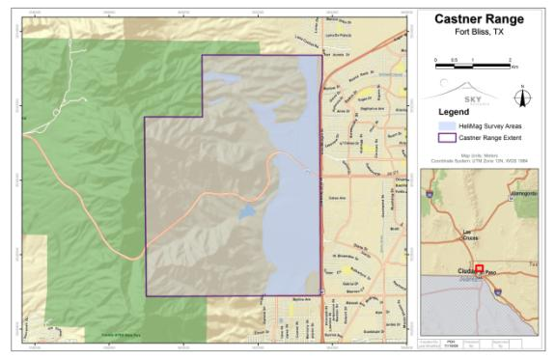

Figure 1 Closed Castner Range boundary and HeliMag survey extent.

### Topography and Vegetation

Topography and vegetation are the primary determinants of the HeliMag survey altitude. Prior to the survey a site suitability model of the topography was created and used to delineate regions in the Castner Range that are suitable for HeliMag deployment. Most of the planned survey area was gently sloping terrain interspersed with relatively steep drainage features. At first glance, the vegetation at Castner Range appears to be low and sparse enough to allow low-level HeliMag surveys. However the presence of some desert plants such as agave bushes (desert spoons) that had significant vertical extent up to 3 or 4 meters (m) would prove to be a limitation to low level surveys (see section 3.3.2 for survey altitude results).

### Geologic Conditions

Initial investigations suggested that the majority of the site consisted of geologic strata with low ferrous-mineral content. Geological maps of the survey area showed no geological formations typically associated with significant magnetic signatures. Unfortunately, survey data indicate that alluvial deposits across much of the survey area bore a significant magnetic signature (effects of the geologic signature are discussed in section 3.3.2).

## Known Ordnance History

Castner Range has been used for a wide variety of military training operations from the 1930s through the 1960s. Munitions suspected to be on the site include:

* 30 millimeter (mm) projectiles,
* 37mm projectiles,
* 2.36” rockets,
* 60mm mortars, and
* 120mm mortars.

The expected magnetic response for these targets will vary with target orientation relative to the Earth’s magnetic field as well as the target-sensor stand-off distance. Figure 2 presents the nominal magnetic response for selected ordnance types as a function of altitude.

Figure 2. Theoretical magnetic response amplitudes for selected ordnance of interest.

# Equipment and Methodology Description

The HeliMag system includes a helicopter-borne array of magnetometers, and system specific hardware and software designed to process data and perform physics-based analyses (Table 1). These technologies are described in greater detail in the following subsections.

## System Components

Table . Sky Research HeliMag Technology Components

|  |  |
| --- | --- |
| Technology Component | Specifications |
| Geophysical Sensors | 7 Geometrics 822 cesium (Cs) vapor magnetometers, 0.001 nanotesla (nT) resolution |
| GPS Equipment | 2 Trimble MS750 GPS receivers,  2-3 centimeter (cm) horizontal precision |
| Altimeters | 1 Optech laser altimeter and 4 acoustic altimeters, 1 cm resolution |
| Data Acquisition System | SKY Data Acquisition System |
| Aircraft | Hughes MD530F |

### Helicopter Survey Platform

SKY uses a Hughes MD530F helicopter (Figure 3) for data collection. The helicopter platform deploys the geophysical sensors, global positioning system (GPS) equipment, altimeters, inertial measurement unit (IMU), and data acquisition system (DAS) technologies listed in Table 1. The helicopter typically flies at survey altitudes of 1-3m Above Ground Level (AGL).

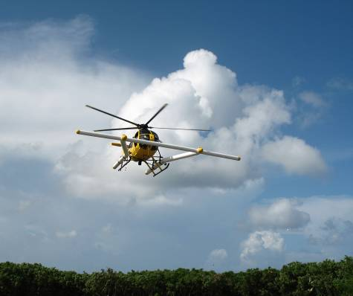Figure 3. SKY HeliMag system in flight. The lateral boom contains an array of 7 Cs magnetometers spaced at 1.5m increments. Positioning in 3 dimensions is performed using two GPS antennas mounted near each end of the boom.

An onboard navigation display (Figure 4) supported by a navigational computer provides pilot guidance. The computer delivers real-time kinematic global positioning system (RTK GPS) data streams to both the pilot display and the DAS. On the pilot display screen, the survey course is plotted in real time. The sensor operator monitors the DAS display presentation, which shows the data quality for the altimeter and GPS and the GPS navigation fix quality. Via limited communication between the pilot and sensor operator, the pilot is able to respond to both visual cues on the ground and to the survey guidance information.

### New PictureSensors and Boom

Figure 4. HeliMag pilot steering display and mount. The pilot is given position and altitude information updates at 10 Hertz (Hz).

The airborne HeliMag system hardware includes an array of seven DAS-interfaced Cs vapor total-field magnetometers (a variant of the Geometrics 822 sensor, designated as the Model 822A) mounted in a Kevlar boom affixed to the helicopter. The sensor boom is mounted forward of the helicopter to minimize interference from the aircraft rotor blades, engine components and avionics. This design puts the boom in clear view of the pilot allowing precise and safe low-level flying. The boom is 9 m long, and the sensors are mounted 1.5 m apart. Two GPS receivers (see next section) are mounted at either end of the boom and allow the magnetometer data to be precisely positioned.

### Positioning Technologies

Two Trimble MS750 RTK GPS receivers provide real-time position updates (at 20 Hz) and platform attitude updates (at 10 Hz) while four acoustic altimeters record platform altitude. The GPS receivers provide positions with a horizontal accuracy of ~2 cm and a vertical accuracy of ~ 4 cm. The GPS satellite clock time is used to time-stamp position and sensor data, allowing seamless merging of these asynchronous data streams.

In addition to serving as the platform velocity and positioning method, RTK GPS is also used to compute ground survey positions. Procedures for GPS measurements are overseen by an in-house professional land surveyor to ensure that geospatial data maintains accurate ties to the local coordinate system(s).

### Data Acquisition System

The DAS for the helicopter is made up of two primary components: 1) the Linux CerfCube and Field Programmable Gate Array (FPGA), which provide the timing and controlling procedures for the platform sensors, and 2) the magnetometer power distribution unit, which provides clean 28-volt power for the magnetometer Larmor frequency counters. A Panasonic Toughbook Tablet PC laptop operated by the sensor operator controls the CerfCube/FPGA and is used to start and stop surveys. In addition, it displays sensor data in graphical and numerical formats.

All data are time stamped to 10-microsecond accuracy, slaved to the pulse per second (PPS) input from the GPS, ensuring a rigorous master-slave relationship between the positioning and sensor subsystems. This precision results in constant, unambiguous synchronization of the GPS positions and sensor readings, which facilitates precise positioning of the sensor data. The system has eight serial ports, eight frequency counters, and seven 16-bit analog-to-digital (A/D) converters. The DAS supports fully-adjustable data collection parameters to optimize data resolution and sampling rates for various deployment needs.

The magnetometer data are acquired at 400 Hz and then decimated to 100 Hz, providing a nominal down-the-track sample interval of 0.15 m at a standard survey speed of 15 meters/second (m/s).

## AMS Survey Overview

Survey altitude is a critical parameter for this type of investigation as the ability to detect objects of a given size is dependent upon the survey altitude above the object. Therefore, the objective for any HeliMag data collection survey is to maintain a safe altitude while still supporting a significant level of detection. Under ideal topographic and vegetation conditions, survey data are collected at a sensor altitude of 1 to 3 m AGL. Rugged topography and tall vegetation cover can present significant challenges to the collection of low-level survey data. Flying at extremely low altitudes above the ground is much more challenging than conventional helicopter surveys. Although the helicopter can hover, the ‘lift’ available to a helicopter in a hover is significantly less than that available when the helicopter is traveling faster than its ‘translation’ speed (i.e., the speed at which the aircraft is gaining additional lift from its forward speed). During HeliMag survey operations a minimum speed must be maintained to ensure safety of the aircraft and crew. Maintaining this minimum speed entails that our ability to ‘drape’ the topography/vegetation is compromised in favor of maintaining a reasonable safety margin. Rugged terrain will also result in complex and dangerous wind conditions thus exacerbating the difficulties of maintaining survey altitudes and adding to the need for airspeed sufficient to maintain a prudent safety margin. The helicopter pilot makes the final decision of survey altitude/speed. Although the pilot is made aware of the technical importance of maintaining low survey altitudes, it is SKY’s policy to never request that a pilot fly at altitudes/speeds below his personal and professional comfort level. Violation of this policy elevates the inherent risk involved in HeliMag surveys to an unacceptable level. Because we are performing unexploded ordnance (UXO) remediation surveys to ultimately reduce risk, this policy is assumed to be in keeping with those of the client.

Theoretical survey lines are generated at 7 m line spacing. With the sensor array being 9 m wide, 7 m line spacing allows for significant (approximately 2 m) overlap between adjacent lines so that complete coverage is achieved with a minimal number of re-flights.

Initial data processing is completed daily. Daily processing of the data involves a series of standardized and quality controlled procedures to transform raw sensor data into a geo-referenced total magnetic field data set. SKY utilizes custom application software (SkyNet) to merge the position data with the magnetometer and altitude sensor data. During each day of the survey, the on-site Project Geophysicist conducts an initial review of the geophysical data to ensure that these data are within a reasonable range, free from excessive dropouts/spikes and timing errors and otherwise appear to be valid. The Project QC Geophysicist then reviews these data.

## HeliMag System Quality Control

The QC procedures typically used for the HeliMag system are described in the following subsections.

### Instrument Validation Survey Lane

An IVS test lane is used to validate the system response prior to the commencement of data acquisition as well as daily monitoring of system performance. The IVS test lane is comprised of a number of targets of interest or suitable surrogates emplaced along a line approximately 500 m long that may be conveniently flown at the start and end of each survey day. Precise ‘ground truth’ location measurements, made using established surveying techniques, are used to assess the performance of the system with respect to accuracy of detected target positions.

### Instrument Standardization

To document the proper operation of the sensors and data processing, the Project Geophysicist performs the following QC checks and procedures. These tests document the functionality of the airborne survey equipment and monitor the instruments for noise, stability, and repeatability.

#### Validation Lane Test

The IVS is surveyed twice daily for testing and verification of system performance. In addition, the IVS is surveyed after any sensor changes that are required during a day’s survey activities.

#### Equipment Warm-up

Most geophysical instrument readings drift for a couple of minutes after starting up. All sensors are allowed to warm up for at least 10 minutes prior to testing or data collection. Each time the instrument is started (e.g., at the start of the day, after breaks, refueling, etc.), this procedure is followed.

#### Record Sensor Position

Proper sensor geometry is important to the spatial registration of data during processing. The sensor positions relative to the helicopter and master GPS antenna are measured and recorded prior to the survey system installation. These spatial relationships remain fixed. At the beginning of the survey, the field crew performs a spike test under each sensor to ensure that the sensor’s cables are connected to the appropriate data input channel. This test is repeated every time the system is disassembled and reassembled.

### Standard Logs

All field and data processing activities are reported using web-enabled reports. The following reports are generated:

* Validation Lane Survey Log: This log documents the results from the Daily Validation Lane Flights and QC checks. Validation Lane Survey (VLS) logs were uploaded to a secure URS ftp folder upon completion of field work.
* Data Acquisition Log: This log documents information about each survey event and summarizes crew, equipment, filenames, and surveyed areas. It was updated on a daily basis.
* Data Processing Log: This log documents by sortie the data processing steps performed on each sortie as well as visual and statistical data quality checks. It was updated on a daily basis. The tracking sheet incorporated the sortie tracking information, as well as the processing steps and output.

## Data Processing and Interpretation

Data are downloaded from the airborne DAS via portable storage media disks and uploaded to a secure SKY ftp site via the Internet after each survey mission. SKY’s custom in-house software, SkyNet, is used to transcribe, filter, decimate, and position the airborne geophysical data. The output from SkyNet is an ASCII xyz file that is then imported into the Geosoft Oasis Montaj geophysical processing environment. Oasis is used to visualize the data and apply additional processing where required. The SkyNet/Montaj combination facilitates data review, merging, correction, filtering, interpolation, and target picking while also providing an industry-standard data management system. The advanced analysis of all detected HeliMag anomalies is conducted with the UXOLab software package, which is a validated, UXO discrimination package developed jointly by SKY and the University of British Columbia. The following sections describe the processing and QC steps that were used for data processing and analysis. The Data Processing Log (Appendix B) documents the parameters used and statistics from the review and processing steps.

### Data Transcription/Merge

The raw data are transcribed from their native data file formats into ASCII xyz files using SkyNet. At this point, the geophysical data are subjected to a lowpass/notch filter, decimated to a sample rate of 100 Hz, and assigned 3-dimensional (3D) positions based upon the GPS master antennae positions, aircraft attitude and the system geometry. Each magnetometer reading is positioned in three dimensions by interpolating and translating the master GPS antennae positions to a position for each sensor, based upon the system geometry and attitude. Because the geophysical and position data are collected asynchronously, they must be aligned with respect to their time of applicability. This is performed automatically during the merge process based upon highly precise time stamps associated with each data channel.

### Initial Data Review/Processing

The Data Processor performs the initial review of the geophysical data. If problems exist, the Data Processor notifies the Airborne Survey Geophysicist. The Airborne Survey Geophysicist assesses the problem(s) and adjusts the field operations or data processing as needed to ensure quality data collection. The sections below detail the initial review of each data type.

#### Geophysical Data

The initial review of geophysical (magnetometry) data ensures that the data are within a reasonable range (35,000 – 75,000 nT), are free from dropouts/spikes and timing errors, and otherwise appear to be valid. Invalid data are removed, and, where appropriate, requests for re-flights are passed to the acquisition team.

#### Positional Data

The initial review of positional data involves checking line profiles for position dropouts/spikes. A GPS fix quality indication is recorded as part of the GPS data string. Data tagged with a fix status that indicates the GPS was not operating in ‘RTK-fix’ mode (nominally 2 cm level accuracy) are rejected automatically.

### Site-Specific Processing

After the initial data review described above, the data follows a site-specific processing procedure, as discussed below.

#### Sensor Data Filtering

Spatial and/or time-based filters are used to remove long wavelength signal from the dataset. Some of the sources of this long wavelength response are diurnal variations, geologic response, sensor heading errors and aircraft maneuver noise. The specific parameters of the filters are determined by site conditions such as geologic response and survey altitude above ground.

### Gridding and Visualization

To convert the data into an image map, an interpolation algorithm converts xyz data into an evenly spaced grid image at 1 m intervals. The Data Processor reviews the grids to determine the completeness and accuracy of prior data manipulation steps. A color distribution range is selected to accentuate the areas/anomalies of interest. The same color scheme is used for each block in order to avoid confusion and to enhance the ability to easily compare the anomaly densities across the site.

### Data Interpretation and Analysis

HeliMag data are used in UXO investigations to characterize a site with respect to the distribution and character of detected ferrous material. Limits to the detection performance imposed by the sensor stand-off distance, physical obstacles and geologic responses limit the size and density of metallic items that can be detected. Anomaly density maps are used to augment existing knowledge about historical site usage to provide a preliminary assessment of the location and extent of large munitions related materials to guide future munitions response actions.

These maps can be simple density analyses of all of the ferrous material detected or they can be ‘refined’ density maps. Each target can be classified based upon inferred features (e.g., target size, depth, dipole orientation) derived through analysis of the magnetic response of each target. These classifications are used to create subsets of ‘targets of interest’ that are then used to create the refined density maps.

### Anomaly Selection

For each dataset, the Airborne Survey Geophysicist assesses each of the following factors prior to generating an anomaly list: (a) geophysical response (amplitude) of targets of interest, as measured in the validation lane; and (b) the local geologic/anthropogenic background conditions after filtering.

Based upon the site conditions, the Airborne Survey Geophysicist elects to select targets using automated or manual techniques. Under most conditions, automatic picking algorithms perform well; however, in areas with challenging background magnetic response or a great deal of anthropogenic clutter, manual selection techniques are required. The automated technique uses a ‘peak detection’ algorithm to select anomalies based upon the magnitude of the geophysical response. Because the total magnetic field response to ferrous material is dipolar in nature, the peak detection is performed on an ‘analytic signal’ grid derived from the gridded total magnetic field grid. The ‘analytic signal’ is the square root of the sum of the squares of the derivatives in the x, y, and z directions and thus is monopolar in nature. A manual review of the data and targets is used to locate additional anomalies or to delete anomalies. Anomalies are deleted if they are obviously due to cultural features or are well outside of the size/depth envelopes of the targets of interest.

### Target Analysis/Classification

Each selected anomaly is analyzed. The target analysis algorithms have been adapted to run within the University of British Columbia UXOLab software environment developed specifically to conduct target analysis and picking. Within the analysis environment, the processor selects mapped anomalies interpolated from the magnitude-corrected XYZ sensor data points. The software extracts sensor data points associated with the selected target. Each sensor reading is an input datum used in a seven-parameter, iterative calculation to derive the parameter values that describe a dipole model that best fits the observed data. These parameters include dipole position (3 dimensions), dipole angle (2 dimensions), dipole magnitude (size), and an offset parameter to account for any bias in the magnetometer data. These derived dipole parameters are then compared to training datasets developed from inert ordnance to perform target classification (discussed further in section 3). Final outputs from this step are XYZ points in ASCII format, which have associated dipole parameters and target classification declarations.

### Target Density Distribution Analysis

Target density distribution maps represent a final product of the HeliMag data processing. To aid in visualizing the distribution of metallic items across the site, a density raster is computed using a 100 m radius neighborhood kernel that assigns anomaly densities (in anomalies per hectare) to each cell in the raster. The target classification results are used to provide refined target lists and density distributions.

Although it is not possible to determine which specific anomalies are due to the targets of interest, it is possible to refine the list by excluding some anomalies based upon the character or ‘features’ of the anomaly. Each anomaly is characterized by performing a dipole fit analysis as per section . The dipole parameters are then used as ‘feature’ estimates for each target (e.g., the dipole model positions are accurate estimates of the object position and depth of each target). The target list can then be refined by excluding anomalies based upon one or more of these features. Dipole size and orientation with respect to the Earth’s field are the most useful features for refining target lists.

The utility of the dipole orientation relative to the Earth’s field is as follows: The magnetic response of ferrous material has two sources, ‘induced’ magnetism and ‘remanent’ magnetism. Objects that have undergone mechanical shock (such as ordnance that have been fired) will become demagnetized – i.e., the remanent magnetization is removed. In addition, ‘induced’ magnetic dipoles are aligned within 75° of the Earth’s magnetic field vector, while remanent dipole responses are not similarly constrained. Thus targets with dipole orientations greater than 75° from parallel with the Earth’s field can be assumed to have significant remanent magnetization and as such, are not likely to be associated with ordnance usage.

Dipole size is an obvious feature to use to refine the target list. Unfortunately the dipole fit size estimate for any given object will depend heavily on the orientation of the object in question. Figure 5 presents feasibility curves for a selection of ordnance items. These curves show how the dipole response for any given ordnance can vary depending upon its physical orientation with respect to the Earth’s field. The dipole response is non-unique for any shape other than a sphere. The maximum moment is achieved when the target is aligned with the Earth’s field and the minimum moment is achieved when the target is normal to the Earth’s field. (Note the image in Figure 5 depicts the dipole angle, not the physical angle of the object). It is also apparent from this image that multiple ordnance types occupy the same location on the graph, thus they may provide identical responses. Furthermore, there are an infinite number of non-ordnance ferrous objects whose responses may also overlap with responses of the objects of interest. For this reason total magnetic field techniques cannot be used to definitively declare an object as ordnance. However, to the extent that a given target response does not come close to the feasibility curves of the objects of interest, these features can be used to exclude these targets from the refined target list.

Feasibility_Curves2

Figure 5. Dipole response feasibility curves. The predicted dipole moment for given UXO types are plotted relative to the Earth's magnetic field vector. Dipole response angles greater than 75º indicate the presence of remanent magnetization. Note that the dipole angle presented here, although related, does not directly represent the physical angle of the object.

# Data Acquisition

The data collection effort was carried out in accordance with the AMSWP developed during the planning phase prior to mobilization to the site. The following sections describe in detail the data acquisition including mobilization, initial validation lane testing, survey data acquisition activities and challenges.

## Mobilization

SKY personnel mobilized to the site on January 8, 2010. The HeliMag system was installed into the helicopter on January 9-10 and high altitude calibration data were collected. The validation lane was established on January 10th and flown on January 11th through 14th. Survey data acquisition started on January 11th and finished, including re-flights, on January 14th.

## Base of Operations

### The Helicopter was based out of El Paso International Airport, Julies Aviation.

### The main GPS base station was set up north of the URS project trailer.

### Base station coordinates in WGS84 Universal Transverse Mercator [UTM] Zone 13 are:

### Point Name: SkyCP1

### Northing: 363115.749 meters

### Easting: 3530716.175 meters

### Height above Ellipsoid: 1268.265 meters

### Instrument Validation Survey

The initial IVS was conducted over the validation lane established by SKY personnel at the Closed Castner Range. Data collected over these lines were used for initial instrument validation as well as daily monitoring of the system performance.

#### Instrument Validation Lane Description

The IVS was seeded with inert ordnance and ordnance simulants as listed in Table 2. All targets were placed horizontally on the surface, and positioning measurements were taken from the center of the object.

Table . Validation Lane Seed Items:

| ID | Northing | Easting | Description/orientation |
| --- | --- | --- | --- |
| 1 | 363438.68 | 3530683.54 | 2.75” rocket E-W |
| 2 | 363443.72 | 3530682.22 | 155mm projectile E-W |
| 3 | 363449.40 | 3530681.04 | 155mm projectile N-S |
| 4 | 363454.51 | 3530680.26 | 100 pound (lb) bomb N-S |
| 5 | 363459.31 | 3530678.90 | ISO LARGE E-W |
| 6 | 363463.62 | 3530677.63 | ISO MEDIUM E-W |
| 7 | 363468.49 | 3530676.49 | ISO SMALL E-W |
| 8 | 363473.13 | 3530675.51 | 2.75” rocket N-S |
| 9 | 363478.01 | 3530674.18 | 100lb bomb N-S |
| 10 | 363482.80 | 3530673.46 | 155mm projectile N-S |
| 11 | 363487.18 | 3530672.49 | 2.75” rocket SW |

#### Initial Instrument Validation Survey Results

The initial IVS provides the opportunity to verify that the HeliMag system is functioning properly. Figure 6 shows the HeliMag response over the validation targets. The variations in amplitude of the magnetic field are represented by changes in the false color image. Adjacent local ‘highs’ (red) and ‘lows’ (blue) are indicative of a point source dipolar target. For example, the combined high and low above and below (respectively) target #3 is the response for this target. Depending upon the orientation of the dipole, only a high or low may be visible (e.g. target #4). The approximate spatial extent for each target anomaly is indicated by the dark grey polygons.

The responses for many of the targets are distorted by local geologic response and/or adjacent targets. For example, the target #5 (‘large ISO’) response is almost lost due to a large ‘low’ that is presumed to be of geologic origin. In the time series magnetic profile plotted in red the response due to this target is visible as a slight upward bulge on the side of the ‘low’. In other examples, the target #9 and, to a lesser extent, target #8 responses are severely distorted by another preexisting feature (labeled as feature B). The time series also shows how the responses for targets 10 and 11 merge. In general, the distance between seeded items was a little too small, and the vegetation limitation to low survey altitude exacerbated the signal overlap problem.

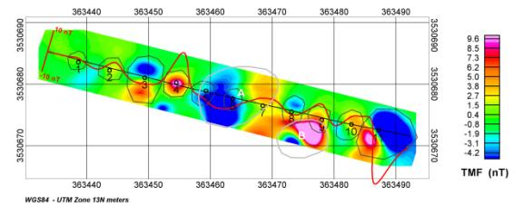

Figure 6. Instrument Validation Survey (IVS) layout and gridded total magnetic field image. The color represents the interpolated total magnetic field response as indicated by the scale bar on the right. The emplaced target locations are marked with small black circles and labeled using their ID number. The red trace represents a time-series profile of the measured magnetic field along a single sensor position line. This profile is plotted using the single line positions (black trace) as the zero base line. Approximate spatial extents for each target response are indicated by dark grey polygons, and approximate extents for two preexisting features identified as point A and point B are indicated by light grey polygons.

The response of the industry standard objects (ISOs) supplied by URS is mostly masked by adjacent geology and/or lost due to survey altitude, with the exception of the response the ‘Large’ ISO (target #5). The IVS target responses for the larger targets was sufficient to allow monitoring of data quality with respect to accuracy of target locations and repeatability of derived target parameters, thus meet the primary goals of the IVS.

## Survey Data Acquisition

After 2 days of set up and testing, data acquisition activities commenced on Jan 11th, 2010 and were completed, including reflights and extra fill-in areas, on Jan 14th, 2010. Daily acquisition logs for each data production day are provided in Appendix A. The SKY field team performed the data acquisition as prescribed in the AMSWP. The survey was flown at the lowest altitude possible, consistent with the safety of the aircraft and crew. The survey data quality was monitored on a daily basis in accordance with the QC procedures outlined in the AMSWP.

Figure 7 presents a chart used to track the daily production rate of the HeliMag team at the Closed Castner Range. The total area surveyed was estimated during production at 1,742 acres; the production rate at the site was just over 435 acres per survey day, excluding two days for set-up. Daily HeliMag production notes for each day are provided in Appendix E.

Figure 7. HeliMag survey productivity graph.

### Quality Control Results

At the beginning and end of each survey day, flight lines were flown over the validation lane in order to confirm that all system components were operating within required parameters. In addition, two daily high altitude sensor noise tests were performed to guarantee that all magnetic sensors were operating within pre-established noise threshold limits. The following subsections briefly describe the tests performed. There were two occasions where the end of day QC checks was not performed due to GPS availability. These omissions are beyond the team’s control and are deemed acceptable because evaluation of the day’s data and subsequent QC checks do not indicate problems with the system performance.

#### Instrument Validation Lane

The SKY Quality Control Geophysicist used the IVS data collected at the start and end of each day to monitor the performance of the system with respect to accuracy of target positioning and repeatability of dipole analysis derived target features. For each of the items with sufficient signal to noise (S/N) to support accurate dipole fit analyses, a model dipole was fit to the observed data. The parameters describing this model were used as estimates of the position, size, and orientation of the dipole response of each of these targets. These derived feature estimates were monitored for validity and consistency, and the results are provided in the Validation Lane Survey Log (Appendix D). The average position error was 0.41m – well under the 0.5m pass/fail threshold, although higher than typically achieved due to the local geologic response. The average target size variation was 14%, and the average dipole angle variation was 4°. These values were well under their respective pass/fail thresholds of 20% and 20 degrees, although again higher than typically achieved due to the local geologic noise.

#### Lag Test

Accurate positioning of the geophysical data requires that the time of applicability of the magnetometer sensor data be aligned with that of the positioning data. The architecture of the HeliMag data acquisition system is designed to automatically ensure that these data are aligned appropriately. Misalignment of these data results in a recognizable ‘herringbone’ pattern of distortion where reciprocal passes are flown over the same anomaly. The Validation Lane tests were performed at reciprocal headings, and images of the data were inspected to ensure that no apparent lag existed. The results of these tests are reported as part of the Validation Lane Survey Log (Appendix D). No tell tale herringbone signatures were evident in the test data.

#### High Altitude Magnetic Sensor Noise Test

Two daily high altitude magnetic sensor noise tests were performed; the first after the initial Validation Lane flight and the second before the final Validation Lane flight. These tests were conducted at altitudes where ground source response is negligible for a minimum duration of 20 seconds. The high altitude test results are presented in the Validation Lane Survey Log (Appendix D). The average standard deviation of the high altitude tests was 0.09nT, and all results were well under the 1nT pass/fail threshold.

### Data Quality

The quality of geophysical survey data as it relates to the survey objectives is determined by both the intrinsic quality of the instrumentation and methodologies used (as monitored by the QC program described above) as well as extrinsic site conditions that are beyond control of the survey team. While all of the Data Quality Objectives (DQOs) were met, indicating that the system was functioning properly, the site conditions severely limited the quality of the results. As alluded to in section 1.3.2, the geologic magnetic signature was not as benign as anticipated. Benign noise levels are typically about 1 to 5nT standard deviation. The geologic noise levels in the Castner Range survey site ranged from 35 to 100 nT standard deviation. Figure 8 shows ideal noise levels (5nT standard deviation) and the observed noise levels from two representative areas at Castner Range plotted relative to the anticipated signal levels for the targets of interest.

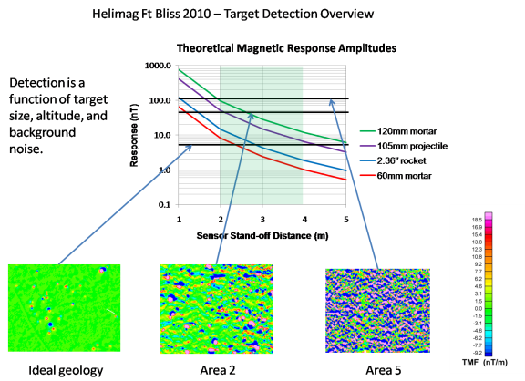

Figure 8. Target detection amplitudes relative to site geologic noise levels.

In addition, the vegetation at Castner Range, although sparse, was up to three meters high and was too dense to ‘fly around’. As a result, the survey altitude AGL was higher than optimal, exacerbating the problem due to geologic noise by reducing the expected signal from the objects of interest. Figure 9 presents the achieved sensor altitude performance as well as some images of the vegetation encountered on site.

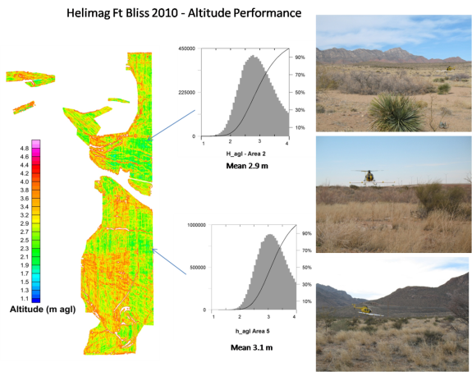

Figure 9. Sensor survey altitude above ground level/water surface. Data collected at altitudes higher than 4m AGL have been rejected.

# Data Analysis

## Data Processing, Enhancements

### Data Pre-Processing

As described previously, an initial processing stage was completed daily. During this stage, raw data were down-sampled to 100 Hz, reviewed as part of the initial QC, time-aligned, transcribed into a database, and mapped to X, Y, and Z UTM coordinates accurate to better than 5 cm. The data were positioned in UTM Zone 13 coordinates projected from the WGS84 ellipsoid. After processing, the along-track sample interval was nominally 0.15 – 0.25 m. The maximum across track interval is 1.5 m, but due to the overlap required to ensure complete coverage, the average cross track sample density was significantly higher.

### Data Processing

The raw magnetic data were corrected for aircraft orientation induced errors using an industry standard aeromagnetic compensation routine (described in Appendix F). A site-specific ‘de-median’ filter was applied to the magnetic data to remove unwanted, long wavelength signals (primarily due to geology and diurnal variations in the Earth’s magnetic field).

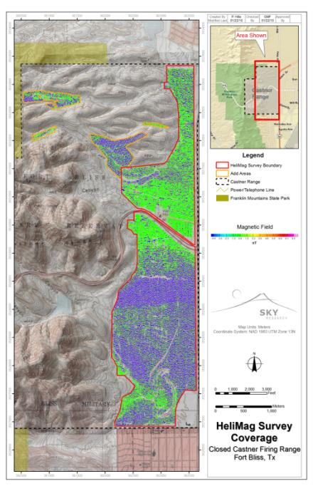

Figure 10. De-median filtered total magnetic field image. Areas where the helicopter was forced to fly higher than 4m AGL have been excluded from the final image.

## Anomaly Selection and Density Mapping

### Anomaly Selection

Due to the severe nature of the geologic response across most of the site, the anomalies were selected manually by an experienced analyst based upon the anomaly amplitude and spatial extent. Figure 11 presents the full magnetic field, geology filtered magnetic field, and magnetic analytic signal (i.e. total magnetic gradient). A total of 52,751 targets were selected. A list of the final selected targets and their locations is provided in the file ‘CCFR\_anomalies\_classified.csv’ delivered with the final deliverables described in Section 6, HeliMag Deliverables.

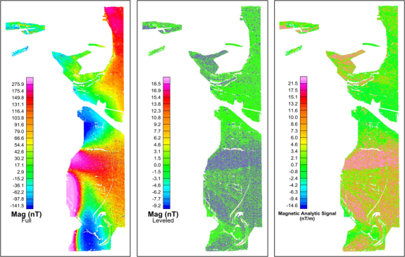

Figure 11. Full magnetic field, geology filtered magnetic field, and magnetic analytic signal

### Target Density Mapping

The initial set of anomalies consists of those anomalies potentially due to the targets of interest as well as anomalies caused by other metallic debris and localized geology. The spatial distribution of these targets is presented as density images in Figure 12. These maps are derived from a density raster computed using a 100 m radius neighborhood kernel that assigns anomaly densities in anomalies per hectare to each cell in the raster.

Conventionally, density images using all selected targets are useful for differentiating between areas of high use and areas that have only background levels of ferrous material distributions. The pervasive nature of the geology at this site limits the utility of the density image because anomaly density changes due to the geologic effects cannot be easily separated from actual changes in the density of ferrous material.

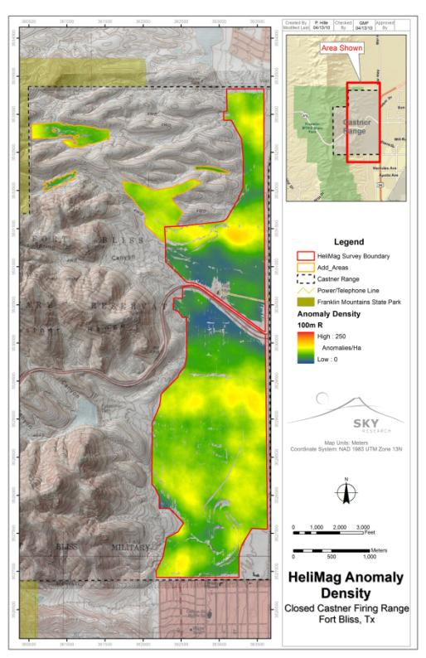

Figure 12. HeliMag anomaly density

## Advanced Analysis and Results

In an effort to extract as much information from the HeliMag survey as possible, we attempted to refine our density distribution maps using target features derived from the dipole fit analysis.

### Target Classification

As described in section 2.4.7, each detected anomaly is subjected to a dipole fit analysis. This analysis, through an iterative process, finds the model dipole that best fits the observed anomalous response. This model is described by seven parameters: position (x, y, and z), orientation (inclination and declination relative to the earth’s field), size, and quality of fit (a measure of how well the observed data fit the dipole model). The position results of this analysis are used to refine target position and depth estimates – generally localizing the target to within 0.25m. The size and orientation of the dipole model may be used to classify the anomalies with respect to their apparent size and magnetic remanence. The targets were sorted into Categories 1 through 7 as follows:

1 - Small (<1.5 Am^2), low remanence (dipole angle <60 degrees)

2 - Medium (>1.5 and <5.0 Am^2), low remanence

3 - Large (>5.0 Am^2), low remanence

4 - Small, high remanence (dipole angle >60 degrees)

5 - Medium, high remanence

6 - Large, high remanence

7 - Invalid fit (either due to poor signal to noise ratio (SNR) or overlapping signatures)

Small items are items similar in size to 2.75” rockets or smaller. Medium items are similar in size from 105mm to 155mm projectiles, and Large denotes anything larger than a 155mm projectile. Items identified as having high remanence (categories 4-6) are less likely to be ordnance.

### Discussion of Results

Often the density distribution maps can be refined by rejecting a subset of anomalies based upon the classification results. At this site, the spatial density distribution of the various classes did not differ significantly from that of the entire set. Efforts to identify spatial correlations based upon specific anomaly features such as dipole size, orientation, and depth were met with limited success. Assuming that the targets of interest would be small in size (<5 A-m2), shallow (<1m depth) and/or exhibit low magnetic remanence (dipole angle <60degrees) we can look for elevated percentages of these features in a spatial context. Figures 13, 14, and 15 show the results of these analyses respectively.

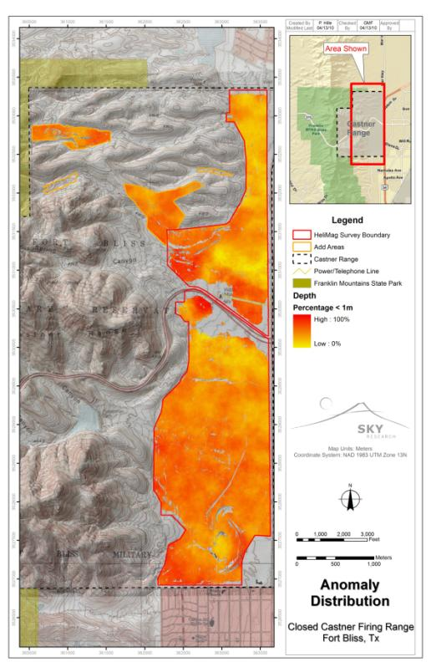

Figure 13. Anomaly distribution percentage of anomalies with depth < 1 m (all angles and sizes). Although these results are distorted by the presence of active geology, relative ‘highs’ may be indicative of anthropic activity, assuming that anthropic targets will on average have a shallow bias relative to geologic targets.

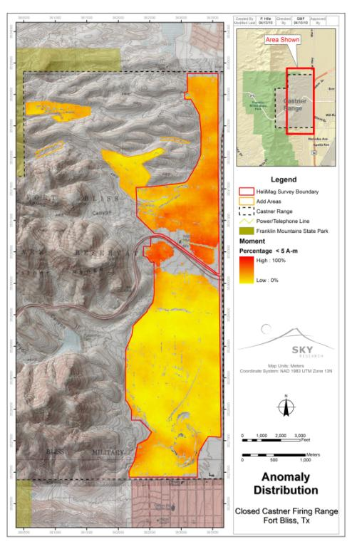

Figure 14. Anomaly distribution percent of moment < 5 Am2 (all angles and depths). Under the assumption that anthropic targets will in general provide smaller responses than geologic targets, a higher percentage of small targets might be indicative of anthropic activity. However, regions with extreme geologic activity may mask smaller targets, thus artificially lowering the percentage of small targets – this is likely the case for the southern half of the site.

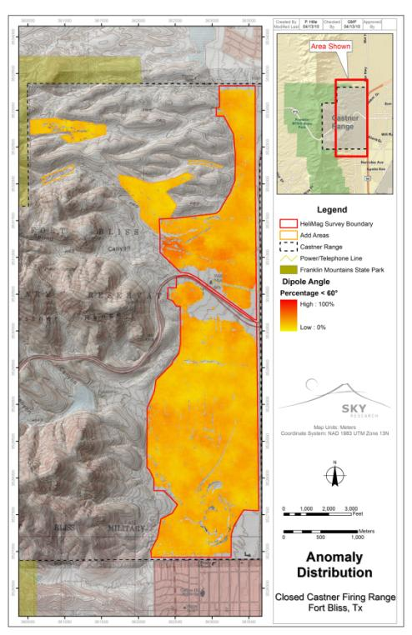

Figure 15. Anomaly distribution percentage dipole angle < 60° (all sizes and depths). A high percentage of dipole angles less than 60° indicate that many of the targets in the sample have little or no remanent magnetization. A lack of remanent magnetization is often consistent with MEC activity due to the phenomena of shock demagnetization.

#### Areas of Interest

Although the geologic response masked much of the site, there were a number of areas identified by the SKY analyst as AOIs. These were identified as such by virtue of being indicative of some kind of anthropic activity such as clusters of large discrete dipoles that do not appear ‘natural’, or linear features, or elevated anomaly density that is incongruent with the apparent local geologic response. These AOIs are illustrated in Figures 16 through 23. AOIs 1 through 6 (Figures 17 through 22) were identified because the character of the anomalies indicated anthropic activity, not because the anomalies were in any way UXO-like. AOI 7 presents a cluster of anomalies that differ in character from the surrounding geology. These anomalies and their distribution are consistent with MEC related activities. In addition to these AOIs a great many anomalies from individual ferrous targets are distributed throughout the site. These targets are difficult to discriminate from geologic anomalies, as are potential additional anthropic features that would otherwise be identified as AOIs. For this reason, the data collected in areas that exhibit high geologic activity do not support any conclusions with respect to the distribution of ferrous material across the site.

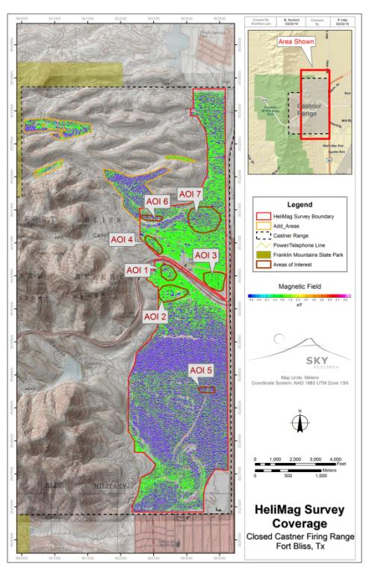

Figure 16. Seven AOIs within the HeliMag survey area. Note that areas with obvious high geologic response do not support any conclusions with the spatial distribution of ferrous material.

*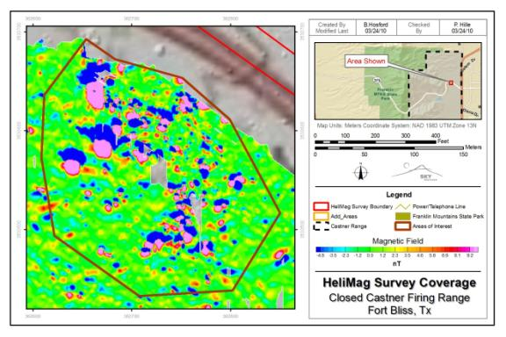* Figure 17. AOI 1 - A mixture of large and small discrete anomalies not associated with apparent geology

*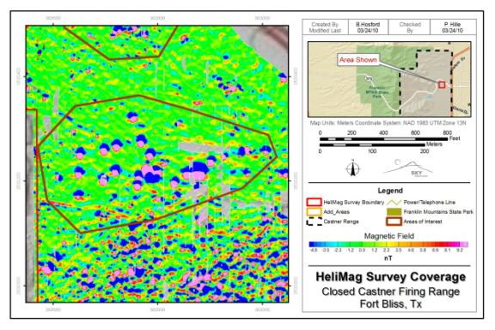* Figure 18. AOI 2 - A clustering of very large discrete anomalies. These anomalies are much larger than typical UXO response, but are indicative of anthropic activity.

*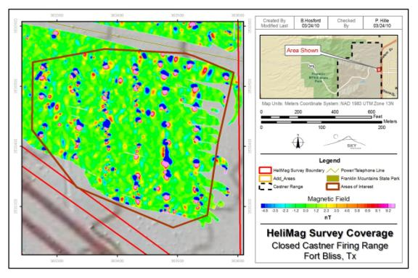* Figure 19. AOI 3 - A series of medium and large anomalies arranged in linear N-S rows indicating possible anthropic activity.

*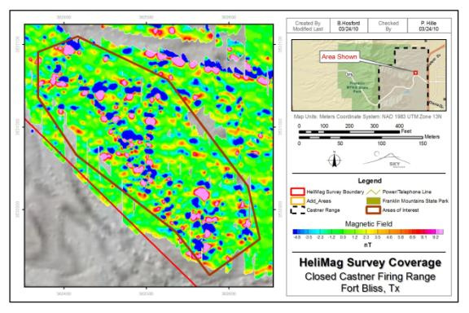* Figure 20. AOI 4 - A mixture of large and small discrete anomalies not associated with apparent geology, which may indicate anthropic activity

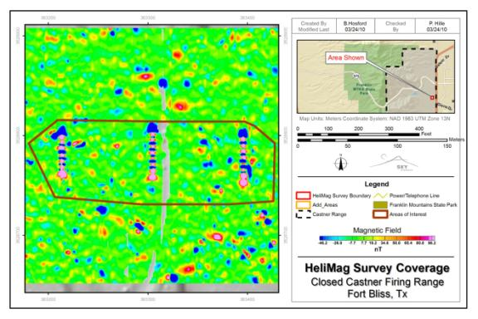

Figure 21. AOI 5 - Three parallel, linear 50m long features running N-S, laterally separated by 90m indicating anthropic activity.

*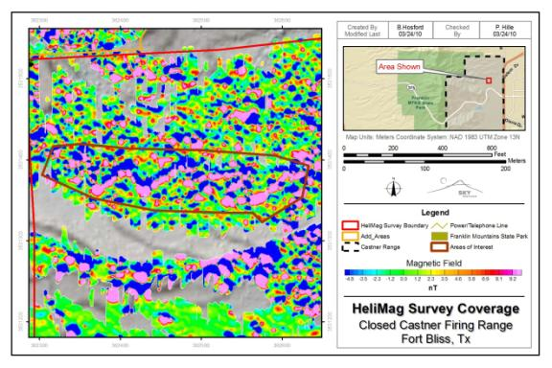* Figure 22. AOI 6 - Linear zig-zag type feature possible indication of human activity.

*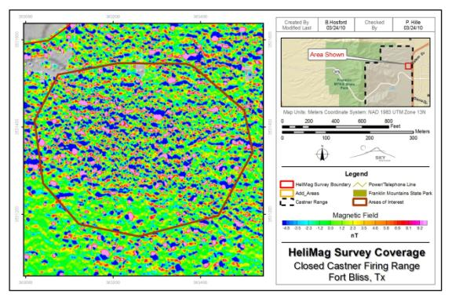* Figure 23. AOI 7 - Elevated anomaly density area. The anomaly distribution in this area is different in character from areas with elevated density levels that are more obviously of geologic origin. The size and distribution of anomalies is consistent with MEC related activities.

# Conclusions

The goal of the Aerial Magnetometer Survey (AMS) at the Closed Castner Range was to identify areas containing high densities of ferrous metallic objects on the surface and/or subsurface that may be indicative of munitions related metal objects. Site conditions, namely vegetation and geology, seriously compromised the utility of the data collected over much of the site.

There were a number of areas identified as being of interest due to clusters of magnetic signatures of obvious anthropic origin. The HeliMag data are not suitable for declaration of any areas to be devoid of UXO.

# HeliMag Data Deliverables

The following data deliverables specific to the HeliMag survey are provided as part of the overall project deliverables package:

* An Excel™ workbook containing a list of the raw target selections, the dipole analysis fit results and the target classification. A spreadsheet describing the contents of each column of the target list spreadsheets is included.
* For the Closed Castner Range survey area, a high resolution jpg and associated GIS data of:

De-median filtered total magnetic field image

HeliMag anomaly density

Anomaly distribution percentage of anomalies with depth < 1 m

Anomaly distribution percent of moment < 5 A-m2

Anomaly distribution percentage dipole angle < 60°

Areas of interest location

* HeliMag geophysical data archives (zipped ASCII Geosoft XYZ format including headers). These data are presented in WGS84 UTM Zone 18 coordinates.
* Geosoft™ grids of the final magnetic data.
* For each flight over the validation lane:
  + HeliMag geophysical data archives (zipped ASCII Geosoft XYZ format including headers) and a Geosoft™ grid of the final data. These data are presented in WGS84 UTM Zone 18 coordinates (filenames are provided in the Validation Lane Survey Log, Appendix D).
  + Images of the dipole fit results (filenames are provided in the Validation Lane Survey Log, Appendix D).

**REFERENCES**

Sky Research, Inc., 2008. Aerial Magnetometer Survey Operations Plan. Final.

Sky Research, Inc. 2005. Post Collection Final Report, Former Vieques Naval Training Range, LiDAR / Orthophotography Collection. Final. September

Sky Research, Inc. 2008. Final Report: Demonstration of Helicopter Multi-Towed Array Detection System (MTADS) Magnetometry Technology at Pueblo Precision Bombing Range #2, Colorado. ESTCP Project No. 200535: Innovative Multi-Sensor Airborne Wide Area Assessment of UXO Sites. August

Appendix A – Data Acquisition Log

Note: this log is also provided in combination with the data processing log as an Exceltm spreadsheet called “CCFR\_Data\_Acquisition\_Data\_Processing\_log.xls”

| **Date** | **Sortie** | **Site** | **Line File** | **Lines** | **Sensor Operator** | **Pilot** | **Ground Support** | **Data Processor** | **Project Geophysicist** | **Comments** |
| --- | --- | --- | --- | --- | --- | --- | --- | --- | --- | --- |
| 1/10/2010 | AA | Compensation | Biggs | 1 | Raul Fonda | John Olson | Jack Desmond | Rob Mehl | Raul Fonda | Bad Test |
| 1/10/2010 | AB | Compensation | Biggs | 1 | Raul Fonda | John Olson | Jack Desmond | Rob Mehl | Raul Fonda |  |
| 1/10/2010 | AC | Noise | Biggs | 1 | Raul Fonda | John Olson | Jack Desmond | Rob Mehl | Raul Fonda |  |
| 1/10/2010 | AD | Low Pass Runway | Biggs | 1 | Raul Fonda | John Olson | Jack Desmond | Rob Mehl | Raul Fonda |  |
| 1/11/2010 | AA | Static | Bliss\_IVS | 1 | Lars Lofgren | John Olson | Jack Desmond | Rob Mehl | Raul Fonda |  |
| 1/11/2010 | AB | Noise | Bliss\_IVS | 1 | Lars Lofgren | John Olson | Jack Desmond | Rob Mehl | Raul Fonda |  |
| 1/11/2010 | AC | IVS | Bliss\_IVS | 1,2 | Lars Lofgren | John Olson | Jack Desmond | Rob Mehl | Raul Fonda | 1m AGL |
| 1/11/2010 | AD | IVS | Bliss\_IVS | 1,2 | Lars Lofgren | John Olson | Jack Desmond | Rob Mehl | Raul Fonda | 2m AGL |
| 1/11/2010 | AE | IVS | Bliss\_IVS | 1,2 | Lars Lofgren | John Olson | Jack Desmond | Rob Mehl | Raul Fonda | 3m AGL |
| 1/11/2010 | AF | IVS | Bliss\_IVS | 1,2 | Lars Lofgren | John Olson | Jack Desmond | Rob Mehl | Raul Fonda | 4m AGL |
| 1/11/2010 | AG | IVS | Bliss\_IVS | 1,2 | Lars Lofgren | John Olson | Jack Desmond | Rob Mehl | Raul Fonda | 5m AGL |
| 1/11/2010 | AH | Area 2 | Area2\_1 | 1001-1015 | Lars Lofgren | John Olson | Jack Desmond | Rob Mehl | Raul Fonda |  |
| 1/11/2010 | AI | Area 2 | Area2\_1 | 1016-1031 | Lars Lofgren | John Olson | Jack Desmond | Rob Mehl | Raul Fonda |  |
| 1/11/2010 | AJ | Area 2 | Area2\_1 | 1032-1050 | Lars Lofgren | John Olson | Jack Desmond | Rob Mehl | Raul Fonda |  |
| 1/11/2010 | AK | Area 2 | Area2\_2 | 2001-2017 | Lars Lofgren | John Olson | Jack Desmond | Rob Mehl | Raul Fonda |  |
| 1/11/2010 | AL | Area 2 | Area2\_2 | 2018 | Lars Lofgren | John Olson | Jack Desmond | Rob Mehl | Raul Fonda |  |
| 1/11/2010 | AM | Area 2 | Area2\_2 | 2-18-2029 | Lars Lofgren | John Olson | Jack Desmond | Rob Mehl | Raul Fonda |  |
| 1/11/2010 | AN | Area 2 | Area2\_2 | 2030-2041 | Lars Lofgren | John Olson | Jack Desmond | Rob Mehl | Raul Fonda |  |
| 1/11/2010 | AO | Area 2 | Area2\_2 | 2042-2050 | Lars Lofgren | John Olson | Jack Desmond | Rob Mehl | Raul Fonda |  |
| 1/11/2010 | AP | Area 2 | Area2\_3 | 3001-3014 | Lars Lofgren | John Olson | Jack Desmond | Rob Mehl | Raul Fonda |  |
| 1/11/2010 | AQ | Area 2 | Area2\_3 | 3015-3023 | Lars Lofgren | John Olson | Jack Desmond | Rob Mehl | Raul Fonda |  |
| 1/11/2010 | AR | Area 2 | Area2\_2 | 3024-3036 | Lars Lofgren | John Olson | Jack Desmond | Rob Mehl | Raul Fonda |  |
| 1/11/2010 | AS | Area 2 | Area2\_3 | 3037-3044 | Lars Lofgren | John Olson | Jack Desmond | Rob Mehl | Raul Fonda |  |
| 1/11/2010 | AT | Area 2 | Area2\_3 | 3045-3050 | Lars Lofgren | John Olson | Jack Desmond | Rob Mehl | Raul Fonda |  |
| 1/11/2010 | AU | Area 2 | Area2\_4 | 4001-4007 | Lars Lofgren | John Olson | Jack Desmond | Rob Mehl | Raul Fonda |  |
| 1/11/2010 | AV | Area 2 | Area2\_4 | 4008-4012 | Lars Lofgren | John Olson | Jack Desmond | Rob Mehl | Raul Fonda |  |
| 1/11/2010 | AW | Area 2 | Area2\_4 | 4013-4018 | Lars Lofgren | John Olson | Jack Desmond | Rob Mehl | Raul Fonda |  |
| 1/11/2010 | AX | Area 2 | Area2\_4 | 4019-4025 | Lars Lofgren | John Olson | Jack Desmond | Rob Mehl | Raul Fonda |  |
| 1/11/2010 | AY | Area 2 | Area2\_4 | 4026-4030 | Lars Lofgren | John Olson | Jack Desmond | Rob Mehl | Raul Fonda |  |
| 1/11/2010 | AZ | Area 2 | Area2\_4 | 4031-4034 | Lars Lofgren | John Olson | Jack Desmond | Rob Mehl | Raul Fonda |  |
| 1/11/2010 | BA | Area 2 | Area2\_4 | 4035-4042 | Lars Lofgren | John Olson | Jack Desmond | Rob Mehl | Raul Fonda |  |
| 1/11/2010 | BB | Area 1 | Area1 | 1-12 | Lars Lofgren | John Olson | Jack Desmond | Rob Mehl | Raul Fonda |  |
| 1/11/2010 | BC | Area 1 | Area1 | 13-30 | Lars Lofgren | John Olson | Jack Desmond | Rob Mehl | Raul Fonda |  |
| 1/11/2010 | BD | Area 1 | Area1 | 31-36 | Lars Lofgren | John Olson | Jack Desmond | Rob Mehl | Raul Fonda |  |
| 1/11/2010 | BE | IVS | Biggs | 1,2 | Lars Lofgren | John Olson | Jack Desmond | Rob Mehl | Raul Fonda |  |
| 1/11/2010 | BF | Compensation | Biggs | 1 | Lars Lofgren | John Olson | Jack Desmond | Rob Mehl | Raul Fonda |  |
| 1/11/2010 | BG | Noise | Biggs | 1 | Lars Lofgren | John Olson | Jack Desmond | Rob Mehl | Raul Fonda |  |
| 1/11/2010 | BH | Static | Biggs | 1 | Lars Lofgren | John Olson | Jack Desmond | Rob Mehl | Raul Fonda |  |
| 1/12/2010 | AA | Static | Biggs | 1 | Lars Lofgren | John Olson | Jack Desmond | Rob Mehl | Raul Fonda |  |
| 1/12/2010 | AB | Noise | Biggs | 1 | Lars Lofgren | John Olson | Jack Desmond | Rob Mehl | Raul Fonda |  |
| 1/12/2010 | AC | IVS | Biggs | 1,2 | Lars Lofgren | John Olson | Jack Desmond | Rob Mehl | Raul Fonda |  |
| 1/12/2010 | AD | Area 5 | Area5\_1 | 1001-1002 | Lars Lofgren | John Olson | Jack Desmond | Rob Mehl | Raul Fonda | Bad RTK |
| 1/12/2010 | AE | Area 4 | Area4 | 1-14 | Lars Lofgren | John Olson | Jack Desmond | Rob Mehl | Raul Fonda |  |
| 1/12/2010 | AF | Area 4 | Area4 | 15-28 | Lars Lofgren | John Olson | Jack Desmond | Rob Mehl | Raul Fonda |  |
| 1/12/2010 | AG | Area 5 | Area5\_1 | 1001-1006 | Lars Lofgren | John Olson | Jack Desmond | Rob Mehl | Raul Fonda |  |
| 1/12/2010 | AH | Area 5 | Area5\_1 | 1007-1018 | Lars Lofgren | John Olson | Jack Desmond | Rob Mehl | Raul Fonda |  |
| 1/12/2010 | AI | Area 5 | Area5\_1 | 1019-1028 | Lars Lofgren | John Olson | Jack Desmond | Rob Mehl | Raul Fonda |  |
| 1/12/2010 | AJ | Area 5 | Area5\_1 | 1029-1035 | Lars Lofgren | John Olson | Jack Desmond | Rob Mehl | Raul Fonda |  |
| 1/12/2010 | AK | Area 5 | Area5\_1 | 1036-1040 | Lars Lofgren | John Olson | Jack Desmond | Rob Mehl | Raul Fonda |  |
| 1/12/2010 | AL | Area 5 | Area5\_1 | 1041-1050 | Lars Lofgren | John Olson | Jack Desmond | Rob Mehl | Raul Fonda |  |
| 1/12/2010 | AM | Area 5 | Area5\_2 | 2001-2002 | Lars Lofgren | John Olson | Jack Desmond | Rob Mehl | Raul Fonda |  |
| 1/12/2010 | AN | Area 5 | Area5\_2 | 2003-2009 | Lars Lofgren | John Olson | Jack Desmond | Rob Mehl | Raul Fonda |  |
| 1/12/2010 | AO | Area 5 | Area5\_2 | 2010-2014 | Lars Lofgren | John Olson | Jack Desmond | Rob Mehl | Raul Fonda |  |
| 1/12/2010 | AP | Area 5 | Area5\_2 | 2015-2020 | Lars Lofgren | John Olson | Jack Desmond | Rob Mehl | Raul Fonda |  |
| 1/12/2010 | AQ | Area 5 | Area5\_2 | 2021-2024 | Lars Lofgren | John Olson | Jack Desmond | Rob Mehl | Raul Fonda |  |
| 1/12/2010 | AR | Area 5 | Area5\_2 | 2025-2027 | Lars Lofgren | John Olson | Jack Desmond | Rob Mehl | Raul Fonda |  |
| 1/12/2010 | AS | Area 5 | Area5\_2 | 2028-2030 | Lars Lofgren | John Olson | Jack Desmond | Rob Mehl | Raul Fonda |  |
| 1/12/2010 | AT | Area 5 | Area5\_2 | 2031-2034 | Lars Lofgren | John Olson | Jack Desmond | Rob Mehl | Raul Fonda |  |
| 1/12/2010 | AU | Area 5 | Area5\_2 | 2035-2039 | Lars Lofgren | John Olson | Jack Desmond | Rob Mehl | Raul Fonda |  |
| 1/12/2010 | AV | Area 5 | Area5\_2 | 2040-2045 | Lars Lofgren | John Olson | Jack Desmond | Rob Mehl | Raul Fonda |  |
| 1/12/2010 | AW | Area 5 | Area5\_2 | 2046-2050 | Lars Lofgren | John Olson | Jack Desmond | Rob Mehl | Raul Fonda |  |
| 1/12/2010 | AX | Area 5 | Area5\_3 | 3001-3006 | Lars Lofgren | John Olson | Jack Desmond | Rob Mehl | Raul Fonda |
| 1/12/2010 | AY | Area 5 | Area5\_3 | 3007-3012 | Lars Lofgren | John Olson | Jack Desmond | Rob Mehl | Raul Fonda |  |
| 1/12/2010 | AZ | Area 5 | Area5\_3 | 3013-3016 | Lars Lofgren | John Olson | Jack Desmond | Rob Mehl | Raul Fonda |  |
| 1/12/2010 | BA | Area 5 | Area5\_3 | 3017-3020 | Lars Lofgren | John Olson | Jack Desmond | Rob Mehl | Raul Fonda |  |
| 1/12/2010 | BB | Area 5 | Area5\_3 | 3021-3024 | Lars Lofgren | John Olson | Jack Desmond | Rob Mehl | Raul Fonda |  |
| 1/12/2010 | BC | Area 5 | Area5\_3 | 3025-3028 | Lars Lofgren | John Olson | Jack Desmond | Rob Mehl | Raul Fonda |  |
| 1/12/2010 | BD | Area 5 | Area5\_3 | 3029-3032 | Lars Lofgren | John Olson | Jack Desmond | Rob Mehl | Raul Fonda |  |
| 1/12/2010 | BE | Area 5 | Area5\_3 | 3033-3036 | Lars Lofgren | John Olson | Jack Desmond | Rob Mehl | Raul Fonda |  |
| 1/12/2010 | BF | Area 5 | Area5\_3 | 3037-3040 | Lars Lofgren | John Olson | Jack Desmond | Rob Mehl | Raul Fonda |  |
| 1/12/2010 | BG | Area 5 | Area5\_3 | 3041-3046 | Lars Lofgren | John Olson | Jack Desmond | Rob Mehl | Raul Fonda |  |
| 1/12/2010 | BH | IVS | Biggs | 1,2 | Lars Lofgren | John Olson | Jack Desmond | Rob Mehl | Raul Fonda |  |
| 1/12/2010 | BI | Noise | Biggs | 1 | Lars Lofgren | John Olson | Jack Desmond | Rob Mehl | Raul Fonda |  |
| 1/12/2010 | BJ | Static | Biggs | 1 | Lars Lofgren | John Olson | Jack Desmond | Rob Mehl | Raul Fonda |  |
| 1/13/2010 | AA | Static | Biggs | 1 | Lars Lofgren | John Olson | Jack Desmond | Rob Mehl | Raul Fonda |  |
| 1/13/2010 | AB | Noise | Biggs | 1 | Lars Lofgren | John Olson | Jack Desmond | Rob Mehl | Raul Fonda |  |
| 1/13/2010 | AC | IVS | Biggs | 1,2 | Lars Lofgren | John Olson | Jack Desmond | Rob Mehl | Raul Fonda |  |
| 1/13/2010 | AD | Area 5 | Area5\_3 | 3047-3050 | Lars Lofgren | John Olson | Jack Desmond | Rob Mehl | Raul Fonda |  |
| 1/13/2010 | AE | Area 5 | Area5\_4 | 4001-4004 | Lars Lofgren | John Olson | Jack Desmond | Rob Mehl | Raul Fonda |  |
| 1/13/2010 | AF | Area 5 | Area5\_4 | 4005-4008 | Lars Lofgren | John Olson | Jack Desmond | Rob Mehl | Raul Fonda |  |
| 1/13/2010 | AG | Area 5 | Area5\_4 | 4009-4012 | Lars Lofgren | John Olson | Jack Desmond | Rob Mehl | Raul Fonda |  |
| 1/13/2010 | AH | Area 5 | Area5\_4 | 4013-4016 | Lars Lofgren | John Olson | Jack Desmond | Rob Mehl | Raul Fonda |  |
| 1/13/2010 | AI | Area 5 | Area5\_4 | 4017-4018 | Lars Lofgren | John Olson | Jack Desmond | Rob Mehl | Raul Fonda |  |
| 1/13/2010 | AJ | Area 5 | Area5\_4 | 4019-4022 | Lars Lofgren | John Olson | Jack Desmond | Rob Mehl | Raul Fonda |  |
| 1/13/2010 | AK | Area 5 | Area5\_4 | 4023-4028 | Lars Lofgren | John Olson | Jack Desmond | Rob Mehl | Raul Fonda |  |
| 1/13/2010 | AL | Area 5 | Area5\_4 | 4029-4034 | Lars Lofgren | John Olson | Jack Desmond | Rob Mehl | Raul Fonda |  |
| 1/13/2010 | AM | Area 5 | Area5\_4 | 4035-4040 | Lars Lofgren | John Olson | Jack Desmond | Rob Mehl | Raul Fonda |  |
| 1/13/2010 | AN | Area 5 | Area5\_4 | 4041-4042 | Lars Lofgren | John Olson | Jack Desmond | Rob Mehl | Raul Fonda |  |
| 1/13/2010 | AO | Area 5 | Area5\_4 | 4043-4045 | Lars Lofgren | John Olson | Jack Desmond | Rob Mehl | Raul Fonda |  |
| 1/13/2010 | AP | Area 5 | Area5\_4 | 4046-4050 | Lars Lofgren | John Olson | Jack Desmond | Rob Mehl | Raul Fonda |  |
| 1/13/2010 | AQ | Area 5 | Area5\_5 | 5001-5007 | Lars Lofgren | John Olson | Jack Desmond | Rob Mehl | Raul Fonda |  |
| 1/13/2010 | AR | Area 5 | Area5\_5 | 5008-5013 | Lars Lofgren | John Olson | Jack Desmond | Rob Mehl | Raul Fonda |  |
| 1/13/2010 | AS | Area 5 | Area5\_5 | 5014-5019 | Lars Lofgren | John Olson | Jack Desmond | Rob Mehl | Raul Fonda |  |
| 1/13/2010 | AT | Area 6 | Area6\_1 | 1001-1008 | Lars Lofgren | John Olson | Jack Desmond | Rob Mehl | Raul Fonda |  |
| 1/13/2010 | AU | Area 6 | Area6\_1 | 1009-1024 | Lars Lofgren | John Olson | Jack Desmond | Rob Mehl | Raul Fonda |  |
| 1/13/2010 | AV | Area 6 | Area6\_1 | 1025-1028 | Lars Lofgren | John Olson | Jack Desmond | Rob Mehl | Raul Fonda |  |
| 1/13/2010 | AW | Area 6 | Area6\_1 | 1029-1040 | Lars Lofgren | John Olson | Jack Desmond | Rob Mehl | Raul Fonda |  |
| 1/13/2010 | AX | Area 6 | Area6\_1 | 1041-1050 | Lars Lofgren | John Olson | Jack Desmond | Rob Mehl | Raul Fonda |  |
| 1/13/2010 | AY | Area 6 | Area6\_1 | 2001-2005 | Lars Lofgren | John Olson | Jack Desmond | Rob Mehl | Raul Fonda |  |
| 1/13/2010 | AZ | Area 3 | Area3\_1 | 1003-1006 | Lars Lofgren | John Olson | Jack Desmond | Rob Mehl | Raul Fonda | 1001-1002 no data hwy power lines |
| 1/13/2010 | BA | Area 3 | Area3\_1 | 1007-1019 | Lars Lofgren | John Olson | Jack Desmond | Rob Mehl | Raul Fonda |  |
| 1/13/2010 | BB | Area 3 | Area3\_1 | 1020-1034 | Lars Lofgren | John Olson | Jack Desmond | Rob Mehl | Raul Fonda |  |
| 1/13/2010 | BC | Area 3 | Area3\_1 | 1035-1040 | Lars Lofgren | John Olson | Jack Desmond | Rob Mehl | Raul Fonda |  |
| 1/13/2010 | BD | Area 5, Area 2 | Area5\_2, Area2\_4 | 4015,2002 | Lars Lofgren | John Olson | Jack Desmond | Rob Mehl | Raul Fonda | Reflights |
| 1/13/2010 | BE | Area 5 | Area5\_4 | 4043 | Lars Lofgren | John Olson | Jack Desmond | Rob Mehl | Raul Fonda | Reflights |
| 1/13/2010 | BF | Area 3 | Area2\_4 | 4016,4017 | Lars Lofgren | John Olson | Jack Desmond | Rob Mehl | Raul Fonda | Reflights |
| 1/13/2010 | BG | Area 2 | Area2\_North | 1-4 | Lars Lofgren | John Olson | Jack Desmond | Rob Mehl | Raul Fonda | Reflights |
| 1/13/2010 | BH | Area 2 | Area2\_South | 2-8 | Lars Lofgren | John Olson | Jack Desmond | Rob Mehl | Raul Fonda | Reflights |
| 1/13/2010 | BI | Area 5 | Area5\_North | 12-25 | Lars Lofgren | John Olson | Jack Desmond | Rob Mehl | Raul Fonda | Reflights |
| 1/13/2010 | BJ | Area 5 | Area5\_South | 4-7 | Lars Lofgren | John Olson | Jack Desmond | Rob Mehl | Raul Fonda | Reflights |
| 1/13/2010 | BK | Area 5 | Area5\_South | 8 | Lars Lofgren | John Olson | Jack Desmond | Rob Mehl | Raul Fonda | Power line and Highway Gap Infills |
| 1/13/2010 | BL | Area 5 | Area5\_South | 8,16-24 | Lars Lofgren | John Olson | Jack Desmond | Rob Mehl | Raul Fonda | Power line and Highway Gap Infills |
| 1/13/2010 | BM | Area 5 | Area5\_South | 10-16 | Lars Lofgren | John Olson | Jack Desmond | Rob Mehl | Raul Fonda | Power line and Highway Gap Infills |
| 1/13/2010 | BN | Area 5 | Area5\_South | 4042 | Lars Lofgren | John Olson | Jack Desmond | Rob Mehl | Raul Fonda | Power line and Highway Gap Infills |
| 1/13/2010 | BO | IVS | Biggs | 1,2 | Lars Lofgren | John Olson | Jack Desmond | Rob Mehl | Raul Fonda |  |
| 1/13/2010 | BP | Noise | Biggs | 1 | Lars Lofgren | John Olson | Jack Desmond | Rob Mehl | Raul Fonda |  |
| 1/13/2010 | BQ | Static | Biggs | 1 | Lars Lofgren | John Olson | Jack Desmond | Rob Mehl | Raul Fonda |  |
| 1/14/2010 | AA | Static | Biggs | 1 | Lars Lofgren | John Olson | Jack Desmond | Rob Mehl | Raul Fonda |  |
| 1/14/2010 | AB | Noise | Biggs | 1 | Lars Lofgren | John Olson | Jack Desmond | Rob Mehl | Raul Fonda |  |
| 1/14/2010 | AC | IVS | Biggs | 1,2 | Lars Lofgren | John Olson | Jack Desmond | Rob Mehl | Raul Fonda |  |
| 1/14/2010 | AD | Area 5 | Area5\_2 | 2002-2004 | Lars Lofgren | John Olson | Jack Desmond | Rob Mehl | Raul Fonda |  |
| 1/14/2010 | AE | Area 2 | Area2\_4 | 4001-4003 | Lars Lofgren | John Olson | Jack Desmond | Rob Mehl | Raul Fonda |  |
| 1/14/2010 | AF | Area 2 | Area2\_ADD | 1 | Lars Lofgren | John Olson | Jack Desmond | Rob Mehl | Raul Fonda | wind problem on top of mountain |
| 1/14/2010 | AG | Area 4 | Area4\_ADD\_1 | 1001-1004 | Lars Lofgren | John Olson | Jack Desmond | Rob Mehl | Raul Fonda |  |
| 1/14/2010 | AH | Area 4 | Area4\_ADD\_1 | 1005-1017 | Lars Lofgren | John Olson | Jack Desmond | Rob Mehl | Raul Fonda |  |
| 1/14/2010 | AI | Area 4 | Area4\_ADD\_1 | 1018-1025 | Lars Lofgren | John Olson | Jack Desmond | Rob Mehl | Raul Fonda |  |
| 1/14/2010 | AJ | Area 4 | Area4\_ADD\_1 | 1026-1032 | Lars Lofgren | John Olson | Jack Desmond | Rob Mehl | Raul Fonda |  |
| 1/14/2010 | AK | Valley |  | 1-6 | Lars Lofgren | John Olson | Jack Desmond | Rob Mehl | Raul Fonda | Boundary Flight |
| 1/14/2010 | AL | Valley |  | 1 | Lars Lofgren | John Olson | Jack Desmond | Rob Mehl | Raul Fonda | Boundary Flight |
| 1/14/2010 | AM | EW Best |  | 1 | Lars Lofgren | John Olson | Jack Desmond | Rob Mehl | Raul Fonda | Boundary Flight |
| 1/14/2010 | AN | EW Best |  | 1 | Lars Lofgren | John Olson | Jack Desmond | Rob Mehl | Raul Fonda | Boundary Flight |
| 1/14/2010 | AO | Area 4 | Area4\_ADD\_1 | 1033-1038 | Lars Lofgren | John Olson | Jack Desmond | Rob Mehl | Raul Fonda |  |
| 1/14/2010 | AP | Area 4 | Area4\_ADD\_1 | 1039-1050 | Lars Lofgren | John Olson | Jack Desmond | Rob Mehl | Raul Fonda |  |
| 1/14/2010 | AQ | Area 4 | Area4\_ADD\_2 | 2001-2014 | Lars Lofgren | John Olson | Jack Desmond | Rob Mehl | Raul Fonda |  |
| 1/14/2010 | AR | Area 4 | Area4\_ADD\_2 | 2015-2028 | Lars Lofgren | John Olson | Jack Desmond | Rob Mehl | Raul Fonda |  |
| 1/14/2010 | AS | Area 4 | Area4\_ADD\_2 | 2029-2050 | Lars Lofgren | John Olson | Jack Desmond | Rob Mehl | Raul Fonda |  |
| 1/14/2010 | AT | Area 4 | Area4\_ADD\_3 | 3001-3012 | Lars Lofgren | John Olson | Jack Desmond | Rob Mehl | Raul Fonda |  |
| 1/14/2010 | AU | Valley |  | 1001-1007 | Lars Lofgren | John Olson | Jack Desmond | Rob Mehl | Raul Fonda |  |
| 1/14/2010 | AV | BAD |  |  | Lars Lofgren | John Olson | Jack Desmond | Rob Mehl | Raul Fonda | BAD |
| 1/14/2010 | AW | Area 6\_ADD | Area6\_ADD | 1-9 | Lars Lofgren | John Olson | Jack Desmond | Rob Mehl | Raul Fonda |  |
| 1/14/2010 | AX | Area 6\_ADD | Area6\_ADD | 10-15 | Lars Lofgren | John Olson | Jack Desmond | Rob Mehl | Raul Fonda |  |
| 1/14/2010 | AY | Area 7 | Area 7 | 1001-1011 | Lars Lofgren | John Olson | Jack Desmond | Rob Mehl | Raul Fonda |  |
| 1/14/2010 | AZ | Area 7 | Area 7 | 1012-1020 | Lars Lofgren | John Olson | Jack Desmond | Rob Mehl | Raul Fonda |  |
| 1/14/2010 | BA | Area 7 | Area 7 | 1021-1040 | Lars Lofgren | John Olson | Jack Desmond | Rob Mehl | Raul Fonda |  |
| 1/14/2010 | BB | Area 7 | Area 7 | 1041-0148 | Lars Lofgren | John Olson | Jack Desmond | Rob Mehl | Raul Fonda |  |
| 1/14/2010 | BC | IVS | Biggs | 1,2 | Lars Lofgren | John Olson | Jack Desmond | Rob Mehl | Raul Fonda |  |
| 1/14/2010 | BD | Noise | Biggs | 1 | Lars Lofgren | John Olson | Jack Desmond | Rob Mehl | Raul Fonda |  |
| 1/14/2010 | BE | Static | Biggs | 1 | Lars Lofgren | John Olson | Jack Desmond | Rob Mehl | Raul Fonda |  |

Appendix B – Data Processing Log

Note: this log is also provided in combination with the data Acquisition log as an Exceltm spreadsheet called “CCFR\_Data\_Acquisition\_Data\_Processing\_log.xls”

| **Field Notes** | | **Data Processing Notes** | | | | | |  |
| --- | --- | --- | --- | --- | --- | --- | --- | --- |
| **Date** | **Sortie** | **Demedian Window** | **Low Pass Window** | **Aeromag.Comp.** | **Site Database** | **Grid name** | **Archive name** | **Gaps >0.4** |
| 1/10/2010 | AA | 30 pt | 5 pt | Yes |  |  |  |  |
| 1/10/2010 | AB | 30 pt | 5 pt | Yes |  |  |  |  |
| 1/10/2010 | AC | 30 pt | 5 pt | Yes |  |  |  |  |
| 1/10/2010 | AD | 30 pt | 5 pt | Yes |  |  |  |  |
| 1/11/2010 | AA | 30 pt | 5 pt | Yes |  |  |  |  |
| 1/11/2010 | AB | 30 pt | 5 pt | Yes |  |  |  |  |
| 1/11/2010 | AC | 30 pt | 5 pt | Yes |  |  |  |  |
| 1/11/2010 | AD | 30 pt | 5 pt | Yes |  |  |  |  |
| 1/11/2010 | AE | 30 pt | 5 pt | Yes |  |  |  |  |
| 1/11/2010 | AF | 30 pt | 5 pt | Yes |  |  |  |  |
| 1/11/2010 | AG | 30 pt | 5 pt | Yes |  |  |  |  |
| 1/11/2010 | AH | 30 pt | 5 pt | Yes | CCFR\_Area2\_Prelim.GDB | CCFR\_Area2\_Prelim.GRD | CCFR\_Area2\_Prelim.XYZ | < 0.1% |
| 1/11/2010 | AI | 30 pt | 5 pt | Yes | CCFR\_Area2\_Prelim.GDB | CCFR\_Area2\_Prelim.GRD | CCFR\_Area2\_Prelim.XYZ | < 0.1% |
| 1/11/2010 | AJ | 30 pt | 5 pt | Yes | CCFR\_Area2\_Prelim.GDB | CCFR\_Area2\_Prelim.GRD | CCFR\_Area2\_Prelim.XYZ | < 0.1% |
| 1/11/2010 | AK | 30 pt | 5 pt | Yes | CCFR\_Area2\_Prelim.GDB | CCFR\_Area2\_Prelim.GRD | CCFR\_Area2\_Prelim.XYZ | < 0.1% |
| 1/11/2010 | AL | 30 pt | 5 pt | Yes | CCFR\_Area2\_Prelim.GDB | CCFR\_Area2\_Prelim.GRD | CCFR\_Area2\_Prelim.XYZ | < 0.1% |
| 1/11/2010 | AM | 30 pt | 5 pt | Yes | CCFR\_Area2\_Prelim.GDB | CCFR\_Area2\_Prelim.GRD | CCFR\_Area2\_Prelim.XYZ | < 0.1% |
| 1/11/2010 | AN | 30 pt | 5 pt | Yes | CCFR\_Area2\_Prelim.GDB | CCFR\_Area2\_Prelim.GRD | CCFR\_Area2\_Prelim.XYZ | < 0.1% |
| 1/11/2010 | AO | 30 pt | 5 pt | Yes | CCFR\_Area2\_Prelim.GDB | CCFR\_Area2\_Prelim.GRD | CCFR\_Area2\_Prelim.XYZ | < 0.1% |
| 1/11/2010 | AP | 30 pt | 5 pt | Yes | CCFR\_Area2\_Prelim.GDB | CCFR\_Area2\_Prelim.GRD | CCFR\_Area2\_Prelim.XYZ | < 0.1% |
| 1/11/2010 | AQ | 30 pt | 5 pt | Yes | CCFR\_Area2\_Prelim.GDB | CCFR\_Area2\_Prelim.GRD | CCFR\_Area2\_Prelim.XYZ | < 0.1% |
| 1/11/2010 | AR | 30 pt | 5 pt | Yes | CCFR\_Area2\_Prelim.GDB | CCFR\_Area2\_Prelim.GRD | CCFR\_Area2\_Prelim.XYZ | < 0.1% |
| 1/11/2010 | AS | 30 pt | 5 pt | Yes | CCFR\_Area2\_Prelim.GDB | CCFR\_Area2\_Prelim.GRD | CCFR\_Area2\_Prelim.XYZ | < 0.1% |
| 1/11/2010 | AT | 30 pt | 5 pt | Yes | CCFR\_Area2\_Prelim.GDB | CCFR\_Area2\_Prelim.GRD | CCFR\_Area2\_Prelim.XYZ | < 0.1% |
| 1/11/2010 | AU | 30 pt | 5 pt | Yes | CCFR\_Area2\_Prelim.GDB | CCFR\_Area2\_Prelim.GRD | CCFR\_Area2\_Prelim.XYZ | < 0.1% |
| 1/11/2010 | AV | 30 pt | 5 pt | Yes | CCFR\_Area2\_Prelim.GDB | CCFR\_Area2\_Prelim.GRD | CCFR\_Area2\_Prelim.XYZ | < 0.1% |
| 1/11/2010 | AW | 30 pt | 5 pt | Yes | CCFR\_Area2\_Prelim.GDB | CCFR\_Area2\_Prelim.GRD | CCFR\_Area2\_Prelim.XYZ | < 0.1% |
| 1/11/2010 | AX | 30 pt | 5 pt | Yes | CCFR\_Area2\_Prelim.GDB | CCFR\_Area2\_Prelim.GRD | CCFR\_Area2\_Prelim.XYZ | < 0.1% |
| 1/11/2010 | AY | 30 pt | 5 pt | Yes | CCFR\_Area2\_Prelim.GDB | CCFR\_Area2\_Prelim.GRD | CCFR\_Area2\_Prelim.XYZ | < 0.1% |
| 1/11/2010 | AZ | 30 pt | 5 pt | Yes | CCFR\_Area2\_Prelim.GDB | CCFR\_Area2\_Prelim.GRD | CCFR\_Area2\_Prelim.XYZ | < 0.1% |
| 1/11/2010 | BA | 30 pt | 5 pt | Yes | CCFR\_Area2\_Prelim.GDB | CCFR\_Area2\_Prelim.GRD | CCFR\_Area2\_Prelim.XYZ | < 0.1% |
| 1/11/2010 | BB | 30 pt | 5 pt | Yes | CCFR\_Area1\_Prelim.GDB | CCFR\_Area1\_Prelim.GRD | CCFR\_Area1\_Prelim.XYZ | < 0.1% |
| 1/11/2010 | BC | 30 pt | 5 pt | Yes | CCFR\_Area1\_Prelim.GDB | CCFR\_Area1\_Prelim.GRD | CCFR\_Area1\_Prelim.XYZ | < 0.1% |
| 1/11/2010 | BD | 30 pt | 5 pt | Yes | CCFR\_Area1\_Prelim.GDB | CCFR\_Area1\_Prelim.GRD | CCFR\_Area1\_Prelim.XYZ | < 0.1% |
| 1/11/2010 | BE | 30 pt | 5 pt | Yes |  |  |  |  |
| 1/11/2010 | BF | 30 pt | 5 pt | Yes |  |  |  |  |
| 1/11/2010 | BG | 30 pt | 5 pt | Yes |  |  |  |  |
| 1/11/2010 | BH | 30 pt | 5 pt | Yes |  |  |  |  |
| 1/12/2010 | AA | 30 pt | 5 pt | Yes |  |  |  |  |
| 1/12/2010 | AB | 30 pt | 5 pt | Yes |  |  |  |  |
| 1/12/2010 | AC | 30 pt | 5 pt | Yes |  |  |  |  |
| 1/12/2010 | AD | 30 pt | 5 pt | Yes | CCFR\_Area5\_Prelim.GDB | CCFR\_Area5\_Prelim.GRD | CCFR\_Area5\_Prelim.XYZ | < 0.1% |
| 1/12/2010 | AE | 30 pt | 5 pt | Yes | CCFR\_Area4\_Prelim.GDB | CCFR\_Area4\_Prelim.GRD | CCFR\_Area4\_Prelim.XYZ | < 0.1% |
| 1/12/2010 | AF | 30 pt | 5 pt | Yes | CCFR\_Area4\_Prelim.GDB | CCFR\_Area4\_Prelim.GRD | CCFR\_Area4\_Prelim.XYZ | < 0.1% |
| 1/12/2010 | AG | 30 pt | 5 pt | Yes | CCFR\_Area5\_Prelim.GDB | CCFR\_Area5\_Prelim.GRD | CCFR\_Area5\_Prelim.XYZ | < 0.1% |
| 1/12/2010 | AH | 30 pt | 5 pt | Yes | CCFR\_Area5\_Prelim.GDB | CCFR\_Area5\_Prelim.GRD | CCFR\_Area5\_Prelim.XYZ | < 0.1% |
| 1/12/2010 | AI | 30 pt | 5 pt | Yes | CCFR\_Area5\_Prelim.GDB | CCFR\_Area5\_Prelim.GRD | CCFR\_Area5\_Prelim.XYZ | < 0.1% |
| 1/12/2010 | AJ | 30 pt | 5 pt | Yes | CCFR\_Area5\_Prelim.GDB | CCFR\_Area5\_Prelim.GRD | CCFR\_Area5\_Prelim.XYZ | < 0.1% |
| 1/12/2010 | AK | 30 pt | 5 pt | Yes | CCFR\_Area5\_Prelim.GDB | CCFR\_Area5\_Prelim.GRD | CCFR\_Area5\_Prelim.XYZ | < 0.1% |
| 1/12/2010 | AL | 30 pt | 5 pt | Yes | CCFR\_Area5\_Prelim.GDB | CCFR\_Area5\_Prelim.GRD | CCFR\_Area5\_Prelim.XYZ | < 0.1% |
| 1/12/2010 | AM | 30 pt | 5 pt | Yes | CCFR\_Area5\_Prelim.GDB | CCFR\_Area5\_Prelim.GRD | CCFR\_Area5\_Prelim.XYZ | < 0.1% |
| 1/12/2010 | AN | 30 pt | 5 pt | Yes | CCFR\_Area5\_Prelim.GDB | CCFR\_Area5\_Prelim.GRD | CCFR\_Area5\_Prelim.XYZ | < 0.1% |
| 1/12/2010 | AO | 30 pt | 5 pt | Yes | CCFR\_Area5\_Prelim.GDB | CCFR\_Area5\_Prelim.GRD | CCFR\_Area5\_Prelim.XYZ | < 0.1% |
| 1/12/2010 | AP | 30 pt | 5 pt | Yes | CCFR\_Area5\_Prelim.GDB | CCFR\_Area5\_Prelim.GRD | CCFR\_Area5\_Prelim.XYZ | < 0.1% |
| 1/12/2010 | AQ | 30 pt | 5 pt | Yes | CCFR\_Area5\_Prelim.GDB | CCFR\_Area5\_Prelim.GRD | CCFR\_Area5\_Prelim.XYZ | < 0.1% |
| 1/12/2010 | AR | 30 pt | 5 pt | Yes | CCFR\_Area5\_Prelim.GDB | CCFR\_Area5\_Prelim.GRD | CCFR\_Area5\_Prelim.XYZ | < 0.1% |
| 1/12/2010 | AS | 30 pt | 5 pt | Yes | CCFR\_Area5\_Prelim.GDB | CCFR\_Area5\_Prelim.GRD | CCFR\_Area5\_Prelim.XYZ | < 0.1% |
| 1/12/2010 | AT | 30 pt | 5 pt | Yes | CCFR\_Area5\_Prelim.GDB | CCFR\_Area5\_Prelim.GRD | CCFR\_Area5\_Prelim.XYZ | < 0.1% |
| 1/12/2010 | AU | 30 pt | 5 pt | Yes | CCFR\_Area5\_Prelim.GDB | CCFR\_Area5\_Prelim.GRD | CCFR\_Area5\_Prelim.XYZ | < 0.1% |
| 1/12/2010 | AV | 30 pt | 5 pt | Yes | CCFR\_Area5\_Prelim.GDB | CCFR\_Area5\_Prelim.GRD | CCFR\_Area5\_Prelim.XYZ | < 0.1% |
| 1/12/2010 | AW | 30 pt | 5 pt | Yes | CCFR\_Area5\_Prelim.GDB | CCFR\_Area5\_Prelim.GRD | CCFR\_Area5\_Prelim.XYZ | < 0.1% |
| 1/12/2010 | AX | 30 pt | 5 pt | Yes | CCFR\_Area5\_Prelim.GDB | CCFR\_Area5\_Prelim.GRD | CCFR\_Area5\_Prelim.XYZ | < 0.1% |
| 1/12/2010 | AY | 30 pt | 5 pt | Yes | CCFR\_Area5\_Prelim.GDB | CCFR\_Area5\_Prelim.GRD | CCFR\_Area5\_Prelim.XYZ | < 0.1% |
| 1/12/2010 | AZ | 30 pt | 5 pt | Yes | CCFR\_Area5\_Prelim.GDB | CCFR\_Area5\_Prelim.GRD | CCFR\_Area5\_Prelim.XYZ | < 0.1% |
| 1/12/2010 | BA | 30 pt | 5 pt | Yes | CCFR\_Area5\_Prelim.GDB | CCFR\_Area5\_Prelim.GRD | CCFR\_Area5\_Prelim.XYZ | < 0.1% |
| 1/12/2010 | BB | 30 pt | 5 pt | Yes | CCFR\_Area5\_Prelim.GDB | CCFR\_Area5\_Prelim.GRD | CCFR\_Area5\_Prelim.XYZ | < 0.1% |
| 1/12/2010 | BC | 30 pt | 5 pt | Yes | CCFR\_Area5\_Prelim.GDB | CCFR\_Area5\_Prelim.GRD | CCFR\_Area5\_Prelim.XYZ | < 0.1% |
| 1/12/2010 | BD | 30 pt | 5 pt | Yes | CCFR\_Area5\_Prelim.GDB | CCFR\_Area5\_Prelim.GRD | CCFR\_Area5\_Prelim.XYZ | < 0.1% |
| 1/12/2010 | BE | 30 pt | 5 pt | Yes | CCFR\_Area5\_Prelim.GDB | CCFR\_Area5\_Prelim.GRD | CCFR\_Area5\_Prelim.XYZ | < 0.1% |
| 1/12/2010 | BF | 30 pt | 5 pt | Yes | CCFR\_Area5\_Prelim.GDB | CCFR\_Area5\_Prelim.GRD | CCFR\_Area5\_Prelim.XYZ | < 0.1% |
| 1/12/2010 | BG | 30 pt | 5 pt | Yes | CCFR\_Area5\_Prelim.GDB | CCFR\_Area5\_Prelim.GRD | CCFR\_Area5\_Prelim.XYZ | < 0.1% |
| 1/12/2010 | BH | 30 pt | 5 pt | Yes |  |  |  |  |
| 1/12/2010 | BI | 30 pt | 5 pt | Yes |  |  |  |  |
| 1/12/2010 | BJ | 30 pt | 5 pt | Yes |  |  |  |  |
| 1/13/2010 | AA | 30 pt | 5 pt | Yes |  |  |  |  |
| 1/13/2010 | AB | 30 pt | 5 pt | Yes |  |  |  |  |
| 1/13/2010 | AC | 30 pt | 5 pt | Yes |  |  |  |  |
| 1/13/2010 | AD | 30 pt | 5 pt | Yes | CCFR\_Area5\_Prelim.GDB | CCFR\_Area5\_Prelim.GRD | CCFR\_Area5\_Prelim.XYZ | < 0.1% |
| 1/13/2010 | AE | 30 pt | 5 pt | Yes | CCFR\_Area5\_Prelim.GDB | CCFR\_Area5\_Prelim.GRD | CCFR\_Area5\_Prelim.XYZ | < 0.1% |
| 1/13/2010 | AF | 30 pt | 5 pt | Yes | CCFR\_Area5\_Prelim.GDB | CCFR\_Area5\_Prelim.GRD | CCFR\_Area5\_Prelim.XYZ | < 0.1% |
| 1/13/2010 | AG | 30 pt | 5 pt | Yes | CCFR\_Area5\_Prelim.GDB | CCFR\_Area5\_Prelim.GRD | CCFR\_Area5\_Prelim.XYZ | < 0.1% |
| 1/13/2010 | AH | 30 pt | 5 pt | Yes | CCFR\_Area5\_Prelim.GDB | CCFR\_Area5\_Prelim.GRD | CCFR\_Area5\_Prelim.XYZ | < 0.1% |
| 1/13/2010 | AI | 30 pt | 5 pt | Yes | CCFR\_Area5\_Prelim.GDB | CCFR\_Area5\_Prelim.GRD | CCFR\_Area5\_Prelim.XYZ | < 0.1% |
| 1/13/2010 | AJ | 30 pt | 5 pt | Yes | CCFR\_Area5\_Prelim.GDB | CCFR\_Area5\_Prelim.GRD | CCFR\_Area5\_Prelim.XYZ | < 0.1% |
| 1/13/2010 | AK | 30 pt | 5 pt | Yes | CCFR\_Area5\_Prelim.GDB | CCFR\_Area5\_Prelim.GRD | CCFR\_Area5\_Prelim.XYZ | < 0.1% |
| 1/13/2010 | AL | 30 pt | 5 pt | Yes | CCFR\_Area5\_Prelim.GDB | CCFR\_Area5\_Prelim.GRD | CCFR\_Area5\_Prelim.XYZ | < 0.1% |
| 1/13/2010 | AM | 30 pt | 5 pt | Yes | CCFR\_Area5\_Prelim.GDB | CCFR\_Area5\_Prelim.GRD | CCFR\_Area5\_Prelim.XYZ | < 0.1% |
| 1/13/2010 | AN | 30 pt | 5 pt | Yes | CCFR\_Area5\_Prelim.GDB | CCFR\_Area5\_Prelim.GRD | CCFR\_Area5\_Prelim.XYZ | < 0.1% |
| 1/13/2010 | AO | 30 pt | 5 pt | Yes | CCFR\_Area5\_Prelim.GDB | CCFR\_Area5\_Prelim.GRD | CCFR\_Area5\_Prelim.XYZ | < 0.1% |
| 1/13/2010 | AP | 30 pt | 5 pt | Yes | CCFR\_Area5\_Prelim.GDB | CCFR\_Area5\_Prelim.GRD | CCFR\_Area5\_Prelim.XYZ | < 0.1% |
| 1/13/2010 | AQ | 30 pt | 5 pt | Yes | CCFR\_Area5\_Prelim.GDB | CCFR\_Area5\_Prelim.GRD | CCFR\_Area5\_Prelim.XYZ | < 0.1% |
| 1/13/2010 | AR | 30 pt | 5 pt | Yes | CCFR\_Area5\_Prelim.GDB | CCFR\_Area5\_Prelim.GRD | CCFR\_Area5\_Prelim.XYZ | < 0.1% |
| 1/13/2010 | AS | 30 pt | 5 pt | Yes | CCFR\_Area5\_Prelim.GDB | CCFR\_Area5\_Prelim.GRD | CCFR\_Area5\_Prelim.XYZ | < 0.1% |
| 1/13/2010 | AT | 30 pt | 5 pt | Yes | CCFR\_Area6\_Prelim.GDB | CCFR\_Area6\_Prelim.GRD | CCFR\_Area6\_Prelim.XYZ | < 0.1% |
| 1/13/2010 | AU | 30 pt | 5 pt | Yes | CCFR\_Area6\_Prelim.GDB | CCFR\_Area6\_Prelim.GRD | CCFR\_Area6\_Prelim.XYZ | < 0.1% |
| 1/13/2010 | AV | 30 pt | 5 pt | Yes | CCFR\_Area6\_Prelim.GDB | CCFR\_Area6\_Prelim.GRD | CCFR\_Area6\_Prelim.XYZ | < 0.1% |
| 1/13/2010 | AW | 30 pt | 5 pt | Yes | CCFR\_Area6\_Prelim.GDB | CCFR\_Area6\_Prelim.GRD | CCFR\_Area6\_Prelim.XYZ | < 0.1% |
| 1/13/2010 | AX | 30 pt | 5 pt | Yes | CCFR\_Area6\_Prelim.GDB | CCFR\_Area6\_Prelim.GRD | CCFR\_Area6\_Prelim.XYZ | < 0.1% |
| 1/13/2010 | AY | 30 pt | 5 pt | Yes | CCFR\_Area6\_Prelim.GDB | CCFR\_Area6\_Prelim.GRD | CCFR\_Area6\_Prelim.XYZ | < 0.1% |
| 1/13/2010 | AZ | 30 pt | 5 pt | Yes | CCFR\_Area3\_Prelim.GDB | CCFR\_Area3\_Prelim.GRD | CCFR\_Area3\_Prelim.XYZ | < 0.1% |
| 1/13/2010 | BA | 30 pt | 5 pt | Yes | CCFR\_Area3\_Prelim.GDB | CCFR\_Area3\_Prelim.GRD | CCFR\_Area3\_Prelim.XYZ | < 0.1% |
| 1/13/2010 | BB | 30 pt | 5 pt | Yes | CCFR\_Area3\_Prelim.GDB | CCFR\_Area3\_Prelim.GRD | CCFR\_Area3\_Prelim.XYZ | < 0.1% |
| 1/13/2010 | BC | 30 pt | 5 pt | Yes | CCFR\_Area3\_Prelim.GDB | CCFR\_Area3\_Prelim.GRD | CCFR\_Area3\_Prelim.XYZ | < 0.1% |
| 1/13/2010 | BD | 30 pt | 5 pt | Yes | CCFR\_Area2\_Prelim.GDB | CCFR\_Area2\_Prelim.GRD | CCFR\_Area2\_Prelim.XYZ | < 0.1% |
| 1/13/2010 | BE | 30 pt | 5 pt | Yes | CCFR\_Area5\_Prelim.GDB | CCFR\_Area5\_Prelim.GRD | CCFR\_Area5\_Prelim.XYZ | < 0.1% |
| 1/13/2010 | BF | 30 pt | 5 pt | Yes | CCFR\_Area1\_Prelim.GDB | CCFR\_Area1\_Prelim.GRD | CCFR\_Area1\_Prelim.XYZ | < 0.1% |
| 1/13/2010 | BG | 30 pt | 5 pt | Yes | CCFR\_Area2\_Prelim.GDB | CCFR\_Area2\_Prelim.GRD | CCFR\_Area2\_Prelim.XYZ | < 0.1% |
| 1/13/2010 | BH | 30 pt | 5 pt | Yes | CCFR\_Area2\_Prelim.GDB | CCFR\_Area2\_Prelim.GRD | CCFR\_Area2\_Prelim.XYZ | < 0.1% |
| 1/13/2010 | BI | 30 pt | 5 pt | Yes | CCFR\_Area5\_Prelim.GDB | CCFR\_Area5\_Prelim.GRD | CCFR\_Area5\_Prelim.XYZ | < 0.1% |
| 1/13/2010 | BJ | 30 pt | 5 pt | Yes | CCFR\_Area5\_Prelim.GDB | CCFR\_Area5\_Prelim.GRD | CCFR\_Area5\_Prelim.XYZ | < 0.1% |
| 1/13/2010 | BK | 30 pt | 5 pt | Yes | CCFR\_Area5\_Prelim.GDB | CCFR\_Area5\_Prelim.GRD | CCFR\_Area5\_Prelim.XYZ | < 0.1% |
| 1/13/2010 | BL | 30 pt | 5 pt | Yes | CCFR\_Area5\_Prelim.GDB | CCFR\_Area5\_Prelim.GRD | CCFR\_Area5\_Prelim.XYZ | < 0.1% |
| 1/13/2010 | BM | 30 pt | 5 pt | Yes | CCFR\_Area5\_Prelim.GDB | CCFR\_Area5\_Prelim.GRD | CCFR\_Area5\_Prelim.XYZ | < 0.1% |
| 1/13/2010 | BN | 30 pt | 5 pt | Yes | CCFR\_Area5\_Prelim.GDB | CCFR\_Area5\_Prelim.GRD | CCFR\_Area5\_Prelim.XYZ | < 0.1% |
| 1/13/2010 | BO | 30 pt | 5 pt | Yes |  |  |  |  |
| 1/13/2010 | BP | 30 pt | 5 pt | Yes |  |  |  |  |
| 1/13/2010 | BQ | 30 pt | 5 pt | Yes |  |  |  |  |
| 1/14/2010 | AA | 30 pt | 5 pt | Yes |  |  |  |  |
| 1/14/2010 | AB | 30 pt | 5 pt | Yes |  |  |  |  |
| 1/14/2010 | AC | 30 pt | 5 pt | Yes |  |  |  |  |
| 1/14/2010 | AD | 30 pt | 5 pt | Yes | CCFR\_Area5\_Prelim.GDB | CCFR\_Area5\_Prelim.GRD | CCFR\_Area5\_Prelim.XYZ | < 0.1% |
| 1/14/2010 | AE | 30 pt | 5 pt | Yes | CCFR\_Area2\_Prelim.GDB | CCFR\_Area2\_Prelim.GRD | CCFR\_Area2\_Prelim.XYZ | < 0.1% |
| 1/14/2010 | AF | 30 pt | 5 pt | Yes |  |  |  |  |
| 1/14/2010 | AG | 30 pt | 5 pt | Yes | CCFR\_Area2Add\_Prelim.GDB | CCFR\_Area2Add\_Prelim.GRD | CCFR\_Area2Add\_Prelim.XYZ | < 0.1% |
| 1/14/2010 | AH | 30 pt | 5 pt | Yes | CCFR\_Area2Add\_Prelim.GDB | CCFR\_Area2Add\_Prelim.GRD | CCFR\_Area2Add\_Prelim.XYZ | < 0.1% |
| 1/14/2010 | AI | 30 pt | 5 pt | Yes | CCFR\_Area2Add\_Prelim.GDB | CCFR\_Area2Add\_Prelim.GRD | CCFR\_Area2Add\_Prelim.XYZ | < 0.1% |
| 1/14/2010 | AJ | 30 pt | 5 pt | Yes | CCFR\_Area2Add\_Prelim.GDB | CCFR\_Area2Add\_Prelim.GRD | CCFR\_Area2Add\_Prelim.XYZ | < 0.1% |
| 1/14/2010 | AK |  |  |  |  |  |  |  |
| 1/14/2010 | AL |  |  |  |  |  |  |  |
| 1/14/2010 | AM |  |  |  |  |  |  |  |
| 1/14/2010 | AN |  |  |  |  |  |  |  |
| 1/14/2010 | AO | 30 pt | 5 pt | Yes | CCFR\_Area2Add\_Prelim.GDB | CCFR\_Area2Add\_Prelim.GRD | CCFR\_Area2Add\_Prelim.XYZ | < 0.1% |
| 1/14/2010 | AP | 30 pt | 5 pt | Yes | CCFR\_Area2Add\_Prelim.GDB | CCFR\_Area2Add\_Prelim.GRD | CCFR\_Area2Add\_Prelim.XYZ | < 0.1% |
| 1/14/2010 | AQ | 30 pt | 5 pt | Yes | CCFR\_Area2Add\_Prelim.GDB | CCFR\_Area2Add\_Prelim.GRD | CCFR\_Area2Add\_Prelim.XYZ | < 0.1% |
| 1/14/2010 | AR | 30 pt | 5 pt | Yes | CCFR\_Area2Add\_Prelim.GDB | CCFR\_Area2Add\_Prelim.GRD | CCFR\_Area2Add\_Prelim.XYZ | < 0.1% |
| 1/14/2010 | AS | 30 pt | 5 pt | Yes | CCFR\_Area2Add\_Prelim.GDB | CCFR\_Area2Add\_Prelim.GRD | CCFR\_Area2Add\_Prelim.XYZ | < 0.1% |
| 1/14/2010 | AT | 30 pt | 5 pt | Yes | CCFR\_Area2Add\_Prelim.GDB | CCFR\_Area2Add\_Prelim.GRD | CCFR\_Area2Add\_Prelim.XYZ | < 0.1% |
| 1/14/2010 | AU | 30 pt | 5 pt | Yes | CCFR\_Area2Add\_Prelim.GDB | CCFR\_Area2Add\_Prelim.GRD | CCFR\_Area2Add\_Prelim.XYZ | < 0.1% |
| 1/14/2010 | AV |  |  |  |  |  |  |  |
| 1/14/2010 | AW | 30 pt | 5 pt | Yes | CCFR\_Area2Add\_Prelim.GDB | CCFR\_Area2Add\_Prelim.GRD | CCFR\_Area2Add\_Prelim.XYZ | < 0.1% |
| 1/14/2010 | AX | 30 pt | 5 pt | Yes | CCFR\_Area2Add\_Prelim.GDB | CCFR\_Area2Add\_Prelim.GRD | CCFR\_Area2Add\_Prelim.XYZ | < 0.1% |
| 1/14/2010 | AY | 30 pt | 5 pt | Yes | CCFR\_Area2Add\_Prelim.GDB | CCFR\_Area2Add\_Prelim.GRD | CCFR\_Area2Add\_Prelim.XYZ | < 0.1% |
| 1/14/2010 | AZ | 30 pt | 5 pt | Yes | CCFR\_Area2Add\_Prelim.GDB | CCFR\_Area2Add\_Prelim.GRD | CCFR\_Area2Add\_Prelim.XYZ | < 0.1% |
| 1/14/2010 | BA | 30 pt | 5 pt | Yes | CCFR\_Area2Add\_Prelim.GDB | CCFR\_Area2Add\_Prelim.GRD | CCFR\_Area2Add\_Prelim.XYZ | < 0.1% |
| 1/14/2010 | BB | 30 pt | 5 pt | Yes | CCFR\_Area2Add\_Prelim.GDB | CCFR\_Area2Add\_Prelim.GRD | CCFR\_Area2Add\_Prelim.XYZ | < 0.1% |
| 1/14/2010 | BC | 30 pt | 5 pt | Yes |  |  |  |  |
| 1/14/2010 | BD | 30 pt | 5 pt | Yes |  |  |  |  |
| 1/14/2010 | BE | 30 pt | 5 pt | Yes |  |  |  |  |

Appendix C – Data Analysis log

Note: this log is also provided in combination with the data Acquisition log as an Exceltm spreadsheet called “CCFR\_Data\_Analysis\_Log.xls”

|  |  |  |  |  |  |  |  |  |  |  |  |  |  |  |  |  |  |  |  |  |  |  |  |  |  |  |  |  |  |  |  |  |
| --- | --- | --- | --- | --- | --- | --- | --- | --- | --- | --- | --- | --- | --- | --- | --- | --- | --- | --- | --- | --- | --- | --- | --- | --- | --- | --- | --- | --- | --- | --- | --- | --- |
| **Total Magnetic Field Data** | | | | **Target Selections** | | | | | | | | | | | | | | | | | | **Dipole Fit Analysis** | | | | | | | | | | |
| **Site** | **Grid (\*.grd)** | **Archive (\*.xyz)** | | **Method** | **Analytic Signal Grid (\*.grd)** | | | **AS Threshold (nT/m2)** | | **Manual Selection Analyst** | | | | | **Prelim. List Name (\*.xyz)** | | **Target Selection QC** | | **Final List Name (\*.xyz)** | | | **Dipole Fit Analyst** | | | **Dipole Fit QC** | | | | **Output file (\*.csv)** | | | |
| 1 | CCFR\_1\_Final | CCFR\_1\_Final | | AS pk /manual | CCFR\_1\_AS\_Final | | | 1.5 | | RMehl | | | | | CCFR\_1\_Anomalies | | DWright | | CCFR\_Anomalies\_QC | | | SMcNamara | | | Dwright | | | | CCFR\_Target\_list\_QC | | | |
| 2 | CCFR\_2\_Final | CCFR\_2\_Final | | AS pk /manual | CCFR\_2\_AS\_Final | | | 1.5 | | RMehl | | | | | CCFR\_2\_Anomalies | | DWright | | CCFR\_Anomalies\_QC | | | SMcNamara | | | Dwright | | | | CCFR\_Target\_list\_QC | | | |
| 2Add | CCFR\_2Add\_Final | CCFR\_2Add\_Final | | AS pk /manual | CCFR\_2Add\_AS\_Final | | | 1.5 | | RMehl | | | | | CCFR\_2Add\_Anomalies | | DWright | | CCFR\_Anomalies\_QC | | | SMcNamara | | | Dwright | | | | CCFR\_Target\_list\_QC | | | |
| 3 | CCFR\_3\_Final | CCFR\_3\_Final | | AS pk /manual | CCFR\_3\_AS\_Final | | | 1.5 | | RMehl | | | | | CCFR\_3\_Anomalies | | DWright | | CCFR\_Anomalies\_QC | | | SMcNamara | | | Dwright | | | | CCFR\_Target\_list\_QC | | | |
| 4 | CCFR\_4\_Final | CCFR\_4\_Final | | AS pk /manual | CCFR\_4\_AS\_Final | | | 1.5 | | RMehl | | | | | CCFR\_4\_Anomalies | |  | |  | | |  | | |  | | | |  | | | |
| 5 | CCFR\_5\_Final | CCFR\_5\_Final | | AS pk /manual | CCFR\_5\_AS\_Final | | | 1.5 | | RMehl | | | | | CCFR\_5\_Anomalies | |  | |  | | |  | | |  | | | |  | | | |
| 6 | CCFR\_6\_Final | CCFR\_6\_Final | | AS pk /manual | CCFR\_6\_AS\_Final | | | 1.5 | | RMehl | | | | | CCFR\_6\_Anomalies | |  | |  | | |  | | |  | | | |  | | | |
|  | | |  | | |  |  | |  | |  |  | | |  | |  | |  | | |  | | | | |  | | | | | |  |
|  | | |  | | |  |  | |  | |  |  | | |  | |  | |  | | |  | | | | |  | | | | | |  |
| **GIS Mapping** | | | | | | | | | | | | |  |  | |  | |  | |  | | |  | | | | | | |  | | |  | | |  | |
| **Map Products** | | | | | | | | | | | | | **GIS Production** | | | | | | | | **GIS QC** |  | |  | |  | |  | | |  |  |  |  |  | |
| De-median filtered total magnetic field image | | | | | | | | | | | | | PHille | | | | | | | | DWright |
| HeliMag Anomaly Density | | | | | | | | | | | | | PHille | | | | | | | | DWright |
| Anomaly Distribution Percentage of Anomalies with Depth < 1 m | | | | | | | | | | | | | PHille | | | | | | | | DWright |
| Anomaly Distribution Percent of Moment < 5 A-m2 | | | | | | | | | | | | | PHille | | | | | | | | DWright |
| Anomaly Distribution Percentage Dipole Angle < 60 | | | | | | | | | | | | | PHille | | | | | | | | DWright |
| Areas of Interest Location | | | | | | | | | | | | | PHille | | | | | | | | DWright |

Appendix D – Validation Lane Survey Log

Note: this log is also provided in combination with the data Acquisition log as an Exceltm spreadsheet called “Validation\_Lane\_Survey\_Log\_Final.xls”

|  |  |  |  |  |  |  |  |  |  |  |  |  |  |  |
| --- | --- | --- | --- | --- | --- | --- | --- | --- | --- | --- | --- | --- | --- | --- |
| Client: | URS |  | **Data Quality Objectives** | | | | | | | | | | | |
| Site: | CCFR |  | **Dipole Fit Results** | | | | | |  | | | | | |
|  |  |  | Target Positioning | | Target Size | | Dipole angle | | Lag test | | Intrinsic Noise | | | |
| Date | File |  | Average Error (m) | <0.5m? | Average Variation (%) | <20% ? | Average Variation (degrees) | <20 degrees? | Complete / Incomplete | Reference Image (.pdf) | 20 sec Stdev | <1.0 nT? | xyz Data Files | notes |
| 11-Jan-10 | IVS\_011AC |  | 0.41 | Pass | 8% | Pass | 2.61 | Pass | Complete | IVS\_011AC\_report | 0.1 | Pass | IVS\_011AB\_noise |  |
| 11-Jan-10 | IVS\_011BE |  | 0.35 | Pass | 10% | Pass | 6.17 | Pass | Complete | IVS\_011BE\_report | 0.08 | Pass | IVS\_011BG\_noise |  |
| 12-Jan-10 | IVS\_012AC |  | 0.49 | Pass | 16% | Pass | 6.77 | Pass | Complete | IVS\_012AC\_report | 0.11 | Pass | IVS\_012AB\_noise |  |
| 12-Jan-10 | IVS\_012BH |  | 0.45 | Pass | 19% | Pass | 5.60 | Pass | Complete | IVS\_012BH\_report | 0.08 | Pass | IVS\_012BI\_noise |  |
| 13-Jan-10 | IVS\_013AC |  | 0.45 | Pass | 14% | Pass | 1.55 | Pass | Complete | IVS\_013AC\_report | 0.09 | Pass | IVS\_013AB\_noise |  |
| 13-Jan-10 | IVS\_013BO |  | 0.36 | Pass | 16% | Pass | 2.38 | Pass | Complete | IVS\_013BO\_report | 0.08 | Pass | IVS\_013BP\_noise |  |
| 14-Jan-10 | IVS\_014AC |  | 0.32 | Pass | 10% | Pass | 5.88 | Pass | Complete | IVS\_014AC\_report | 0.12 | Pass | IVS\_014AB\_noise |  |
| 14 Jan 10' | IVS\_014BC |  | 0.40 | Pass | 19% | Pass | 4.43 | Pass | Complete | IVS\_014BC\_report | 0.08 | Pass | IVS\_014BD\_noise |  |

Appendix E – Daily HeliMag Production Notes

**Date**: 01/11/2010 **Time started**: 0700 **Time comp**: 1700

**Helicopter Time:** 7.6 hr

**Pilot:** John Olson **Sensor Operator**: Lars Lofgren **GPS/Field Support**: Jack Desmond

**No. of refuels**: 5

**Sections flown**:  **1 2 3 4 5 6**

**Total Acreage for Today: 439 Total Acreage for Project: 439**

**HeliMag Equipment**: MD530FF, Qty 7 G-822 Magnetometers, Qty 2 Trimble MS750 GPS Receivers, 1 HDAS, Qty 4 Acoustics, Qty 1 Laser Altimeter, Toughbook\_\_\_\_\_\_\_\_

**Ground Equipment:** Qty 1 Trimble R7 GPS Base, Qty 2 Trimark III Data Radios, 750 gallon Jet-A Fuel Truck.

**IVS/Calibration Tests Completed: Y N**

**Photos taken? Y N**

**Significant problems encountered**

Issues getting fuel at the airport before 0800, have negotiated with local FBO to provide fuel at 0700.

**Date**: 01/12/2010 **Time started**: 0700 **Time comp**: 1700

**Helicopter Time:** 8.5 hr

**Pilot:** John Olson **Sensor Operator**: Lars Lofgren **GPS/Field Support**: Jack Desmond

**No. of refuels**: 5

**Sections flown**:  **1 2 3 4 5 6**

**Total Acreage for Today: 706 Total Acreage for Project: 1154**

**HeliMag Equipment**: MD530FF, Qty 7 G-822 Magnetometers, Qty 2 Trimble MS750 GPS Receivers, 1 HDAS, Qty 4 Acoustics, Qty 1 Laser Altimeter, Toughbook

**Ground Equipment:** Qty 1 Trimble R7 GPS Base, Qty 2 Trimark III Data Radios, 750 gallon Jet-A Fuel Truck.

**IVS/Calibration Tests Completed: Y N**

**Photos taken? Y N**

**Significant problems encountered**

GPS Solution High PDOP from 1015-1030, scheduled fuel stop during that time.

**Date**: 01/13/2010 **Time started**: 0700 **Time comp**: 1600

**Helicopter Time:** 7.5 hr

**Pilot:** John Olson **Sensor Operator**: Lars Lofgren **GPS/Field Support**: Jack Desmond

**No. of refuels**: 5

**Sections flown**:  **1 2 3 4 5 6**

**Total Acreage for Today: 432 Total Acreage for Project: 1577**

**HeliMag Equipment**: MD530FF, Qty 7 G-822 Magnetometers, Qty 2 Trimble MS750 GPS Receivers, 1 HDAS, Qty 4 Acoustics, Qty 1 Laser Altimeter, Toughbook

**Ground Equipment:** Qty 1 Trimble R7 GPS Base, Qty 2 Trimark III Data Radios, 750 gallon Jet-A Fuel Truck.

**IVS/Calibration Tests Completed: Y N**

**Photos taken? Y N**

**Significant problems encountered**

No Problems encountered.

**Date**: 01/14/2010 **Time started**: 0800 **Time comp**: 1600

**Helicopter Time:** 5.1 hr

**Pilot:** John Olson **Sensor Operator**: Lars Lofgren **GPS/Field Support**: Jack Desmond

**No. of refuels**: 4

**Sections flown**:  **1 2 3 4 5 6 7**

**Total Acreage for Today: 165 Total Acreage for Project: 1742**

**HeliMag Equipment**: MD530FF, Qty 7 G-822 Magnetometers, Qty 2 Trimble MS750 GPS Receivers, 1 HDAS, Qty 4 Acoustics, Qty 1 Laser Altimeter, Toughbook

**Ground Equipment:** Qty 1 Trimble R7 GPS Base, Qty 2 Trimark III Data Radios, 750 gallon Jet-A Fuel Truck.

**IVS/Calibration Tests Completed: Y N**

**Photos taken? Y N**

**Significant problems encountered**

No Problems encountered.

Appendix F – Aircraft Maneuver Noise Compensation

Each of the magnetometers on the boom of the helicopter senses not only the magnetic field of the earth but also distortions caused by the helicopter platform itself. The platform magnetic field is of no interest and can represent a significant noise source. Because the platform magnetic field depends primarily on the attitude of the vehicle relative to the earth's magnetic field, the effects of the platform are often called “heading errors.” For low-level surveys for detection of ordnance, we are only concerned about changes in the magnetic field of the helicopter that have spatial scales comparable to the wavelengths of the items of interest. We thus prefer to use the term maneuver noise.

There are three major components to the maneuver noise in a helicopter:

1. Permanent magnetization: So-called "permanent fields" actually arise from two sources: the permanently magnetized material in the helicopter, and the effects of current-carrying conductors, usually the major electrical feeds in the aircraft. As far as a magnetometer is concerned, these are indistinguishable.
2. Induced magnetization: The induced fields arise because of the interaction between the earth's magnetic field and the magnetically permeable material in the helicopter.
3. Eddy currents: Metallic surfaces of the helicopter act as conductive loops. When the helicopter orientation in the earth's magnetic field changes, so does the magnetic flux contained by these loops, and a secondary magnetic field is generated according to Lenz's Law. Unless the magnetometer is very close to a large conductive surface, these eddy current effects are generally at most a few tenths of a nT under normal survey conditions.

The first two effects can be modeled with knowledge of the attitude of the helicopter (easily measured with a flux-gate magnetometer), while the eddy current effect requires the rate of change of the helicopter attitude (obtained through the time-history of the flux-gate data).

In order to evaluate the components of the helicopter magnetic field as just described, it is necessary to acquire data in which these effects are enhanced and the interference of other sources, such as geology, is minimized. For this purpose, a compensation flight is performed in an area with low geological gradients. For aircraft, the compensation flight is carried out at as high an altitude as is feasible. The aircraft flies along the four sides of a square surrounding the compensation point, turning sharply at the end of each leg. Along each leg of the pattern, it is desirable to acquire roughly 30 seconds of data while performing each of: yaws of at least 5-degree amplitude, pitches of at least 5-degree amplitude, and rolls of at least 10-degree amplitude.

The magnetic field data from each sensor, along with the aircraft attitude and altitude are continuously recorded. A well-known 18-term model is then fit to the observed data and defines the maneuver noise characteristics of the helicopter. As shown in Figure F-1, the maneuver effects are approximately ± 25 nT for the outer sensors and ± 150-200 nT for the inner sensors. After compensation, the standard deviation in each of the sensors was around 0.4 to 0.5 nT, with Improvement Ratios (ratio of standard deviations before/after compensation) of between 40 and 220. It is of note that the maneuvers conducted during the compensation calibration flights are much more severe than those generally encountered during data acquisition. Thus the residual signals of 0.4 to 0.5 nT are expected to be well beyond the ‘worst case’ scenario encountered during the course of the survey.

|  |  |
| --- | --- |
| (a) Outer sensor  sensor1_compensation | (b) Inner sensor  sensor5_compensation |

Figure F-1. Top panels show the observed and predicted data during the aeromagnetic compensation calibration flight for (a) outer sensor and (b) inner sensor. The bottom panels show the corrected magnetic field data (observed minus predicted data). For the outer sensor the standard deviation was 18.5 nT before compensation and 0.45 nT afterwards (giving an Improvement Ratio of 41). For the inner sensor, the Improvement ratio was 219, with before/after standard deviations of 94 nT and 0.43 nT respectively.

Appendix G – Map Products

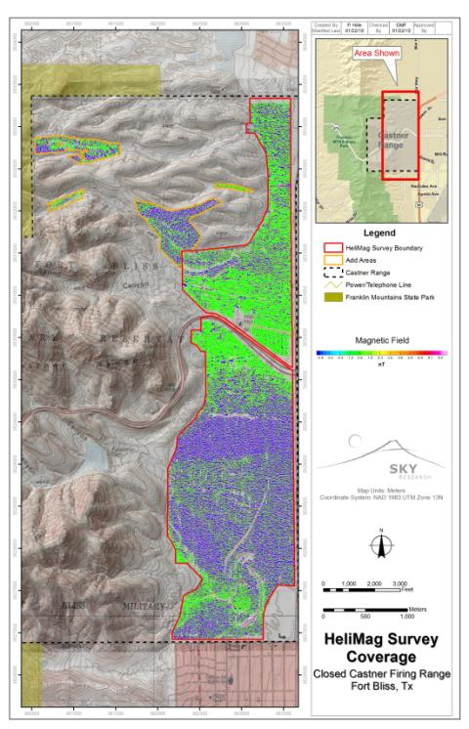

Figure 24. De-median filtered total magnetic field image. Areas where the helicopter was forced to fly higher than 4m AGL have been excluded from the final image.

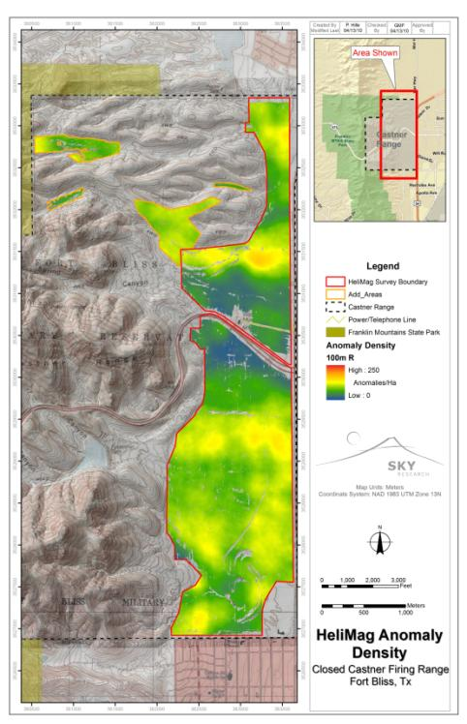

Figure 25. HeliMag anomaly density

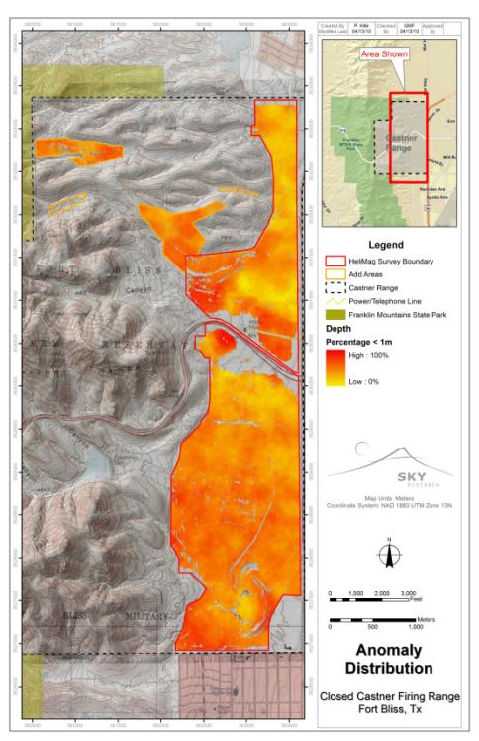

Figure 26. Anomaly distribution percentage of anomalies with depth < 1 m (all angles and sizes). Although these results are distorted by the presence of active geology, relative ‘highs’ may be indicative of anthropic activity, assuming that anthropic targets will on average have a shallow bias relative to geologic targets.

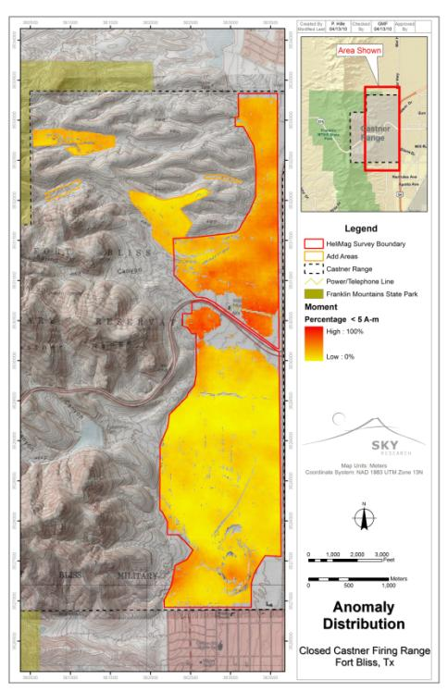

Figure 27. Anomaly distribution percent of moment < 5 Am2 (all angles and depths). Under the assumption that anthropic targets will in general provide smaller responses than geologic targets, a higher percentage of small targets might be indicative of anthropic activity. However, regions with extreme geologic activity may mask smaller targets, thus artificially lowering the percentage of small targets – this is likely the case for the southern half of the site.

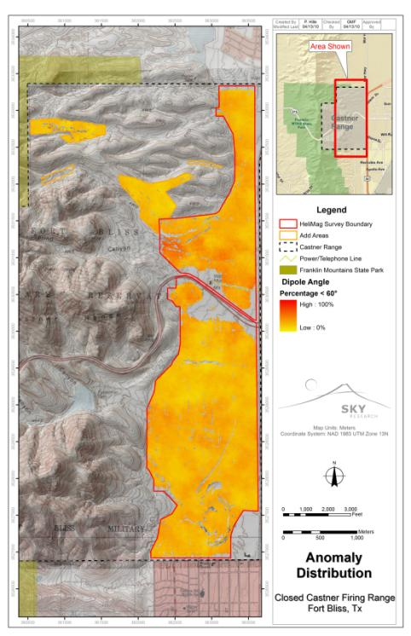

Figure 28. Anomaly distribution percentage dipole angle < 60° (all sizes and depths). A high percentage of dipole angles less than 60° indicate that many of the targets in the sample have little or no remanent magnetization. A lack of remanent magnetization is often consistent with MEC activity due to the phenomena of shock demagnetization.

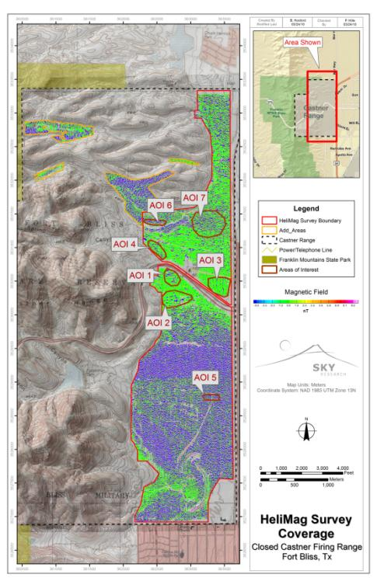

Figure 29. Seven AOIs within the HeliMag survey area