Enclosure 1
Maps of Castner Range, Fort Bliss, TX

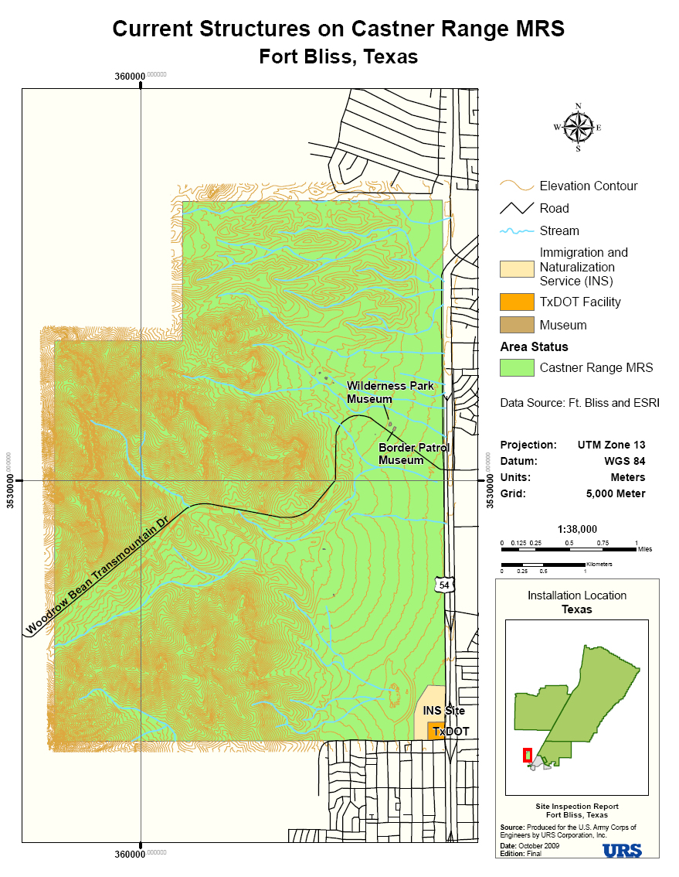

Enclosure 2
Fact Sheet

Military Munitions Response Program (MMRP)

The U.S. Army is the best-trained military force in the world, primarily because it trains as it fights, under realistic battle conditions. However, after years of activity, unexploded ordnance (UXO), discarded military munitions (DMM) and munitions constituents (MC) exist at many historical ranges and sites.

The Military Munitions Response Program (MMRP) was developed to manage the environmental, health, and safety issues presented by UXO, DMM and MC.

MMRP
- Requires DoD to establish and maintain an inventory of sites with UXO, DMM or MC, excluding land designated as operational ranges and permitted munitions disposal facilities
- Establishes the requirement to identify, characterize, track, and report data on MMRP sites and responses
- Requires a determination of risk to prioritize site cleanup and site-specific cost estimates to complete the response
- Requires installations to program and budget for MMRP responses

Background
The Department of Defense created the MMRP in 2002 as an element of the Defense Environmental Restoration Program (DERP). Under DERP, the Secretary of Defense carries out environmental restoration resulting from historical activities.

Until recently, DERP focused on restoration of sites contaminated with hazardous constituents – including explosive contaminants – through the Installation Restoration Program (IRP). IRP does not generally address UXO or DMM, whereas the MMRP primarily focuses on sites containing UXO, DMM and munitions constituents. Along with meeting the statutory goals of DERP, the MMRP is designed to enhance understanding of the nature of munitions response sites and manage response activities more effectively.

Range and Site Inventory
The Army completed the range and site inventory in 2003. Identified ranges and sites have been evaluated to determine their eligibility for MMRP, and site-specific data elements have been entered into a comprehensive site tracking and management database. This inventory fulfilled the requirement of a Preliminary Assessment under the Comprehensive Environmental Response, Compensation, and Liability Act (CERCLA).

Site Inspections
The second step under CERCLA is the site inspection. The MMRP site inspection program for active installations is a comprehensive effort to collect historical range and site use information, along with UXO, DMM and MC release data for all eligible sites.
The site inspection phase collects information to determine if additional actions are required at each site and what they are (i.e., further study, immediate response action or no further action). The data also allows the Army to refine costs and prioritization for each site.

The Army coordinates the site inspections with all applicable stakeholders (EPA, states, tribes, RABs and landowners) throughout the project.

Key milestones include completing a historical records review document, a site inspection work plan for field efforts and a final report. The Army is working towards its goal of completing all site inspections by September 2010.

Next Steps
Recommendations in the Site Inspection Report generally include one or more of the following: (1) further investigation; (2) immediate interim action; or (3) no further action. If DMM or UXO were found during the site inspection in areas where they pose an immediate explosive safety hazard to residents or workers, the site is recommended for an interim action, either a Time Critical Removal Action or a Non-Time Critical Removal Action. These actions usually involve fencing off the hazard or removing the explosive items causing the immediate hazard. Following the interim action, sites generally move into further investigation to complete all actions.

Under CERCLA, the step after the site inspection is the Remedial Investigation/Feasibility Study (RI/FS). During the RI/FS, detailed information is obtained about the site to allow the Army and stakeholders to recommend an appropriate remedy for the site. Following implementation of the remedy, most sites that had UXO or DMM will require land use controls because no current technologies have been proven 100% effective at removing munitions.

Enclosure 3
Agenda

Stakeholder Technical Project Planning Meeting
Castner Range WAA Technology Demonstration
October 16, 2009

1:00 – 1:30 TPP Members and Interest in Castner Range

1:30 – 2:00 Existing Site Information

2:00 – 2:30 Project Objectives

2:30 – 3:30 Wide Area Assessment Technologies & Data Derived from Each

3:30 – 4:30 Proposed Project Schedule

4:30 – 5:00 Questions & Wrap -Up

