*From: Explosives Safety Submission (ESS)*

*Ordnance and Explosives (OE) Removal Action*

*Castner Range, Fort Bliss, Texas – November 2002*

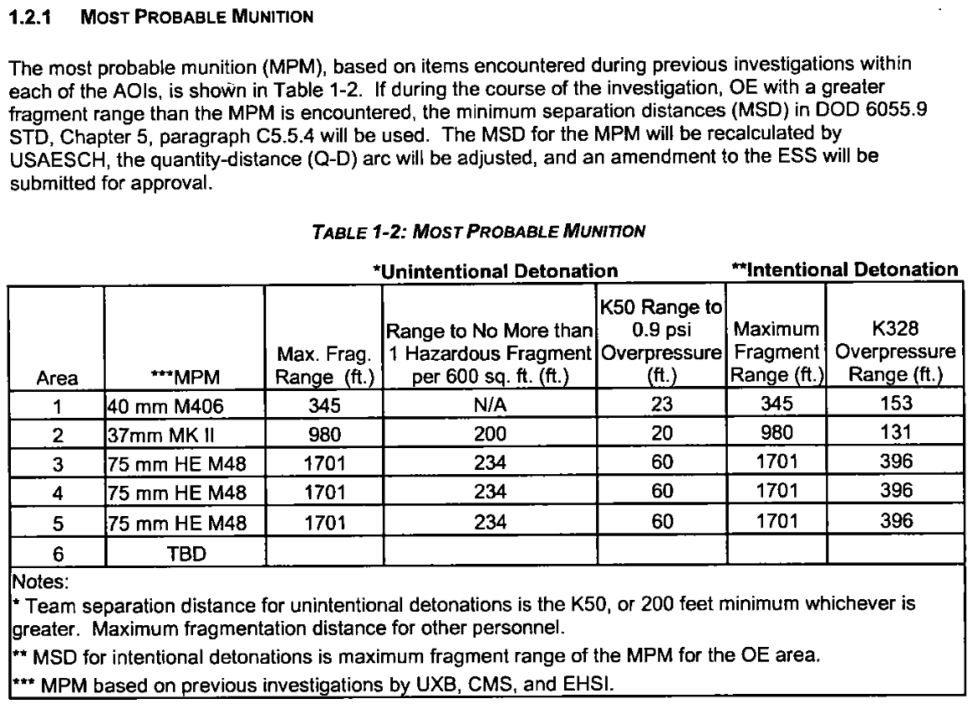

*From: Addendum 1 – Ordnance and Explosives (OE) Removal Action*

*At Area 6, Castner Range, Fort Bliss, Texas - July 9, 2004*

*Castner Range, Fort Bliss, Texas*

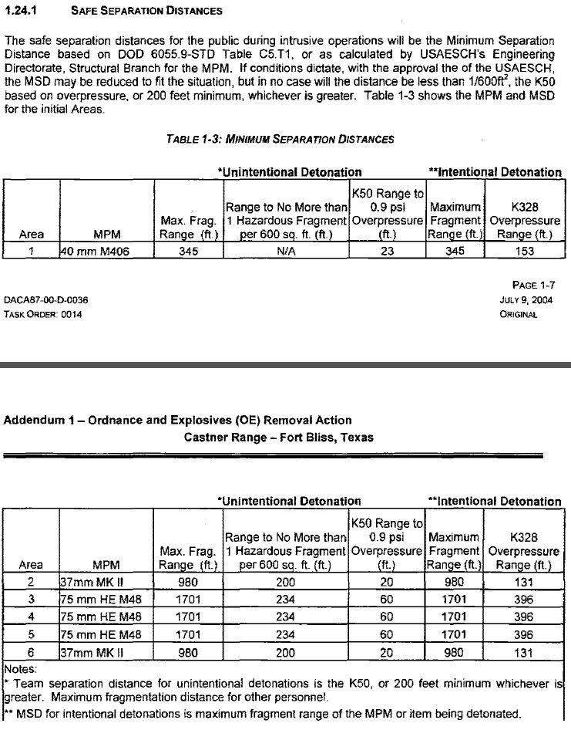

Definitions:

The **maximum fragment range** is used in determining Public Withdrawal Distance for both intentional and unintentional explosions.

The **hazardous fragment range** is used in establishing the Personnel Separation Distance for unintentional detonations. The hazardous fragment refers to the range of the farthest thrown hazardous fragment, where a hazardous fragment is defined as one with an energy impact.

The **K50 (Inhabited Building Distance)** distance corresponds to an overpressure level of 0.9 psi, and is the pressure distance used to determine personnel separation distance (PSD) for accidental explosions.

The **K328 (Temporary Threshold Shift Distance)** corresponds to a pressure level of 0.065 psi, and is the distance used for overpressure for public withdrawal distance (PWD) from intentional detonations.

(These two K values are of special interest in Ordnance and Explosives projects)

**Overpressure** is the pressure caused by a shock wave above normal atmospheric pressure. The shockwave is caused by the explosion. Overpressure can results in various levels of injury.