March 10, 2023
Bats: the rulers of the night

By Clint Vanermen Natural resources manager USAG Benelux

Bats, they are a common sight in our areas. Now that spring is back in the air these leathery friends of ours will begin to
go outside again. Belgium, the Netherlands and Germany is home to around twenty different bat species, of these twenty species eleven can be found on our bases. While it may seem that bats are quite common, they are actually quite vulnerable. Bats are not entirely solitary animals: they breed and live in colonies, and if there is any damage to their nesting places the whole colony could be wiped out. This vulnerability has led the European Commission to protect all bat species in the European region, under the habitat directive¹. USAG Benelux is investing in protecting these species, an example are the bat shelters at Chièvres airbase and Brunssum. Below are some examples of bats species found on the sites and some tips and tricks on what to do if you find a bat inside a building on one of our bases.
1 COUNCIL DIRECTIVE 92 /43 /EEC of 21 May 1992 on the conservation of natural habitats and of wild fauna and flora
Serotine bat
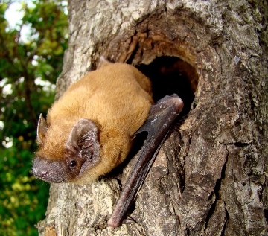 source: www.scotlink.org
For European bat species the serotine bat is relatively large with a wingspan of 37 centimeters and large ears. If found during daytime it can be recognized by the brown long fur on its back while the fur on the underparts has a yellowish color. The easiest way to identify the species is by looking at how it flies. They have characteristically broad wings and a slow agile flapping flight with occasional short gliding flights. Serotine bats form mating colonies from late May and almost exclusively in old buildings (the bats are rarely found in trees), these colonies consist solely of females. As this bat roosts solely in buildings it is quite vulnerable to human disturbance.
Brown Long-eared bat

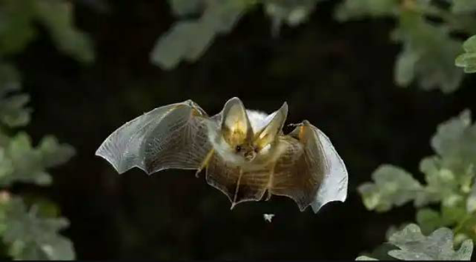

source: www.woodlandtrust.org.uk
The brown long-eared bat is smaller than the serotine bat with a wingspan of 20-30 centimeter. The bat has grayish-brown fur. The easiest way to recognize the bat is by looking at its ears, as the name say the bat has characteristically long ears, the ears can reach a size of 3.9 cm, this is large considering its body can only reach a maximum length of 4.8 cm. Unlike the serotine bat, the brown long-eared bat does not use echolocation to hunt for prey, the ears of the bat species are so large that it can hunt insects based on sound and visuals alone. These bats can be seen at night flying next to trees, due to its slow and hovering fly patterns the bats can look like big butterflies.
A bat in the building
During spring and especially summer bats will become more active and the likelihood of them accidentally ending up inside a building will increase, although it would still be very small. If the bat is flying around that means he is unharmed and is looking for an exit: try to make it as easy as possible for the bat to get out. The first thing to do is to seal of the area where the bat is located from the rest of the building so that it does not get further in the building. Make sure to open all available windows and exterior doors so that the bat can figure a way out of the building. Also a good trick is to leave the exterior lights on as they attract insects which will lure the bat outside.
If the bat is not flying around it is either a pup or injured and it will need your help. To help the bat it will have to be contained, a good place to contain the bat in is a shoe box with some holes in the top. Add a small towel in the box which it can use as a hiding place and a small plastic bottle cap with some water in it. Do not add any food (bats have a specialized diet). After constructing the container, it is time to catch the bat, this can be done either by catching the bat with the shoe box like you would catch a spider or by gently picking it up with a towel (make sure to wear gloves while catching the bat as there is a small chance they may carry some diseases). After containing the bat contact the Environmental Division (DSN: 597-5355, Belgium, or DSN:597-3145, Netherlands) they will make sure the bat will be helped by the right people and released in the wild.

