Amphibians: Living a double life

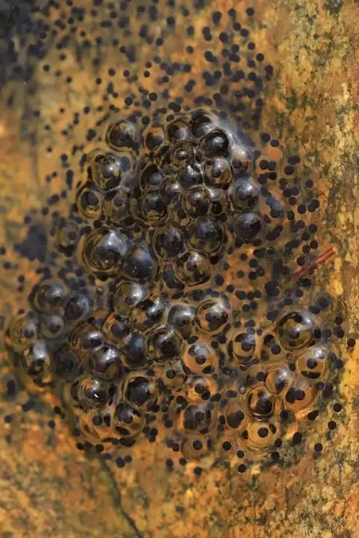
By Clint Vanermen, Natural Resources Manager USAG Benelux
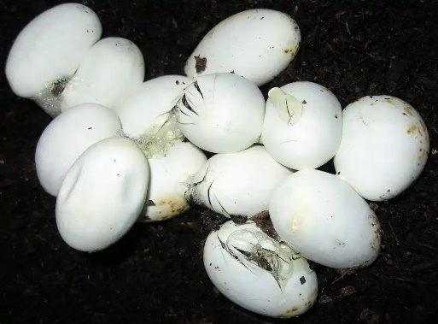
Figure 1: Amphibian eggs (left) and Reptile eggs (right), sources Pixabay.com

Today is international amphibians’ day, this day is a global celebration dedicated to the diverse and vital group of animals known as amphibians. To celebrate this day an introduction will be given on what exactly are amphibians and which amphibians occur on our sites.

Amphibians are often put by people in the same group with reptiles. This is understandable since they have similar characteristics like being cold blooded and having no hair or feathers. However this would be a big mistake as they are quite different. A big difference between the two animal groups are the eggs: reptile eggs have a protective outer layer, while amphibian eggs are made of a soft jelly-like substance. It is this protective outer shell that allows reptiles to lay their eggs on land, and while there are some amphibians that can live almost their entire life on land most of them have to go back to the water to lay their eggs. The word Amphibian comes from the Greek word ‘Amphibios’ and literally means living a double life which references to their ability to live on land and in water. Currently in the world there are still three groups of amphibians and in this article we will talk about two groups present on our bases.
The ones who jump
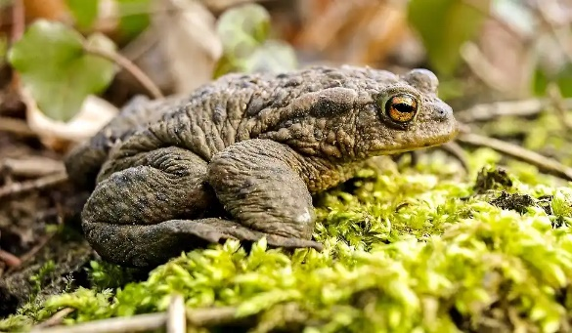
The biggest group of amphibians (7,360 known species) are the Salientia (coming from the Latin word ‘Salire’ for jumping). This group includes the frogs and toads. A common species from this group that can be found on our garrison sites is the Common toad (Bufo Bufo). The Common toad has a very widespread distribution and can be found nearly everywhere in Europe, when encountering the animal on base (at Chièvres air base they can often be found in the vicinity of the old German ruins) it is quite recognizable by its relatively (for an amphibian) large size of 6 inches (15 cm) and its greyish-brown skin with wart-like lumps. The chance of encountering the toad during the day is relatively small as it hides during the day and comes out at night to look for food. In case its necessary to pick up the animal make sure to wear gloves as your skin oils can be harmful to the animal and the toad itself produces toxins on its skin that could lead to light eye or skin irritations.
Figure 2 : Common toad (Bufo bufo), source Pixabay.com

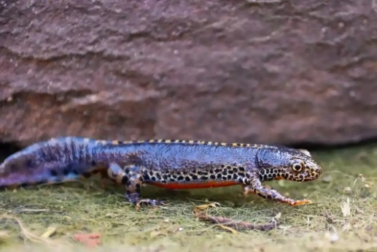
The ones with a tail
Figure 3 Alpine newt (Ichtyosaura alpestris), source Pixabay.com
The second group of amphibians is called the Caudata (coming from Latin meaning to wear a tail). This group contains all the living salamanders (764 known species). A common species of this group that can be found on our garrison sites is the Alpine newt (Ichtyosaura alpestris). The species is native to a large part of continental Europe, but its range is smaller when compared to the Common toad. The adults of the species can reach lengths of 4.3 inches (11 cm) and are easily recognisable by their dark marbled colouring with a bright orange underbelly. The species can be found on our sites near small ponds or other waterbodies at Chièvres air base, APS Zutendaal and APS Dülmen where they lay their eggs. As part of the newt group the Alpine newt has an interesting survival technique, if injured a newt can over time regrow a lost limb such as a tail or a leg. Steps have been taken to improve the habitat of these animals such as placing ramps at man made ponds to make it easier for the animals to enter and leave the ponds.

