Happy Halloween! … Trick or Treat?

Halloween is a fun and exciting event for kids. It is important that we keep safety in mind when the little ones are “Trick or Treating”. Here are some tips to help make that happen:
Costume Safety
To help ensure adults and children have a safe holiday, follow these Halloween safety tips:
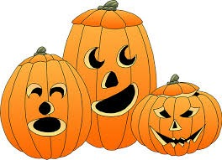
- Be sure to choose a costume that won't cause safety hazards; all costumes, wigs and accessories should be fire-resistant
- If children are allowed out after dark, fasten reflective tape to their costumes and bags, or give them glow sticks
- Choose non-toxic Halloween makeup over masks, which can obscure vision; always test makeup in a small area first to see if any irritation develops
- Remove all makeup before children go to bed to prevent skin and eye irritation
When They're on the Prowl
Here's a scary statistic: Children are more than twice as likely to be hit by a car and killed on Halloween than on any other day of the year. Lack of visibility because of low lighting at night also plays a factor in these incidents.
Keep these tips in mind when your children are out on Halloween night:
- A responsible adult should accompany young children on the neighborhood rounds
- If your older children are going alone, plan and review a route acceptable to yo
- Agree on a specific time children should return home
- Teach your children never to enter a stranger's home or ca
- Instruct children to travel only in familiar, well-lit areas and stick with their friends
- Tell your children not to eat any treats until they return home, and take care to avoid any food allergies
Safety Tips for Motorists
- Watch for children walking on roadways, medians and curbs
- Enter and exit driveways and alleys carefully
- At twilight and later in the evening, watch for children in dark clothing
- Discourage new, inexperienced drivers from driving on Halloween

*Source: National Safety Council*

