
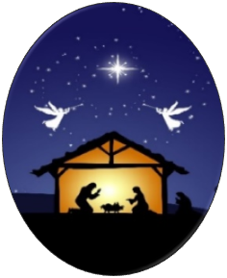
RELIGIOUS SUPPORT OFFICE HOLIDAY EVENTS
HEDULE

CHRISTIAN SERVICES

CATHOLIC MASS
Sat 30 Nov 1st Week of Advent 1600
Sun 01 Dec Advent Wreath Social 1600
Sat 07 Dec 2nd Week of Advent 1600
Mon 09 Dec Immaculate Concept 1700
Sat 14 Dec 3rd Week of Advent 1600
Sat 21 Dec 4th Week of Advent 1600
Tue 24 Dec Christmas Eve Mass 1700
Sat 28 Dec Feast of Holy Family 1600
Tue 31 Dec Solemnity of Mary 1700
Sat 04 Jan Solemnity of Epiphany 1600

PROTESTANT WORSHIP
Sun 01 Dec 1st Sun of Advent 1000
Sun 08 Dec 2nd Sun of Advent 1000
Sun 15 Dec 3rd Sun of Advent 1000
Sun 22 Dec 4th Sun of Advent 1000
Tues 24 Dec Candlelight Service 1900
Sun 29 Dec Worship Service 1000

GOSPEL WORSHIP
Sun 01 Dec 1st Sun of Advent 1200
Sun 08 Dec 2nd Sun of Advent 1200
Sun 15 Dec 3rd Sun of Advent 1200
Sun 22 Dec 4th Sun of Advent 1200
Sun 29 Dec Worship Service 1200
Tue 31 Dec Watch Night Svc 2230

Chapel POC:
Religious Support Office or Joyce Wood
APG Main Post Chapel, 410-278-4333
6441 Rock Island Street, Building 2485
APG Maryland 21005

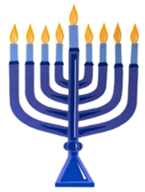

JEWISH SERVICES
CHANUKAH EVENTS
Wed 18 Dec Chanukah Party 1200
JEWISH POC:
Rabbi Chesky Tennebaum, 301-541-8770
RabbiCT@JewishUSAMD.org


Season’s Greetings to All,
May the Lord bless you and yours as you celebrate the season according to your own faith understanding.
I hope this Religious Support Office holiday events schedule will be helpful to your planning.
Blessings. Chaplain Jae Kim, Garrison Chaplain

