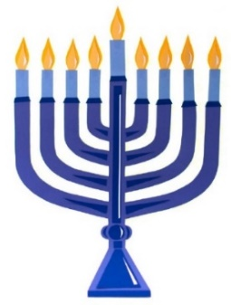
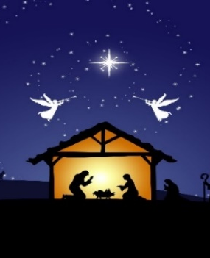
RELIGIOUS SUPPORT OFFICE

HOLIDAY EVENTS SCHEDULE

ALL EVENTS ARE HELD IN THE MAIN POST CHAPEL, BLDG. 2485

  CHRISTIAN SERVICES  CATHOLIC MASS  Sat 02 Dec 1st Week of Advent 1600  Sun 03 Dec Advent Wreath Social 1600  Fri 08 Dec Immaculate Conception 1700  Sat 09 Dec 2nd Week of Advent 1600  Sat 16 Dec 3rd Sun of Advent 1600  Sat 23 Dec 4th Sun of Advent 1600  Sun 24 Dec Christmas Eve Mass 1700  Sat 30 Dec Feast of Holy Family 1600  Sun 31 Dec Solemnity of Mary 1700  Sat 06 Jan Solemnity of Epiphany 1600  PROTESTANT WORSHIP  Sun 03 Dec 1st Sun of Advent 1000  Sun 10 Dec 2nd Sun of Advent 1000  Sun 17 Dec 3rd Sun of Advent 1000  Sun 24 Dec No 1000 Service  GOSPEL WORSHIP  Sun 03 Dec 1st Sun of Advent 1200  Sun 10 Dec 2nd Sun of Advent 1200  Sun 17 Dec 3rd Sun of Advent 1200  Sun 24 Dec No 1200 Service  Sun 31 Dec Watch Night Svc 2230    CHRISTMAS EVE CANDLELIGHT SERVICE  LESSONS AND CAROLS  Sun 24 Dec at 1900  Chapel POC:  Religious Support Office and / or Mrs. Joyce Wood  APG Main Post Chapel, 410-278-4333  6441 Rock Island Street, Building 2485  Aberdeen Proving Ground, Maryland 21005-5001 | JEWISH SERVICES  CHANUKAH EVENTS  Mon 13 Dec Chanukah Party 1200  Jewish POC:  Mr. Steven Raczkowski and / or  Harford Jewish Center, 410-939-3170  8 North Earlton Road  Have de Grace, Maryland 21078    Season’s Greetings to All,  May the Lord bless you and yours as you celebrate the season according to your own faith understanding.  I hope this Religious Support Office holiday events schedule will be helpful to your planning.  Blessings.  Chaplain Wyne Hutchings,  Aberdeen Proving Ground Garrison Chaplain

